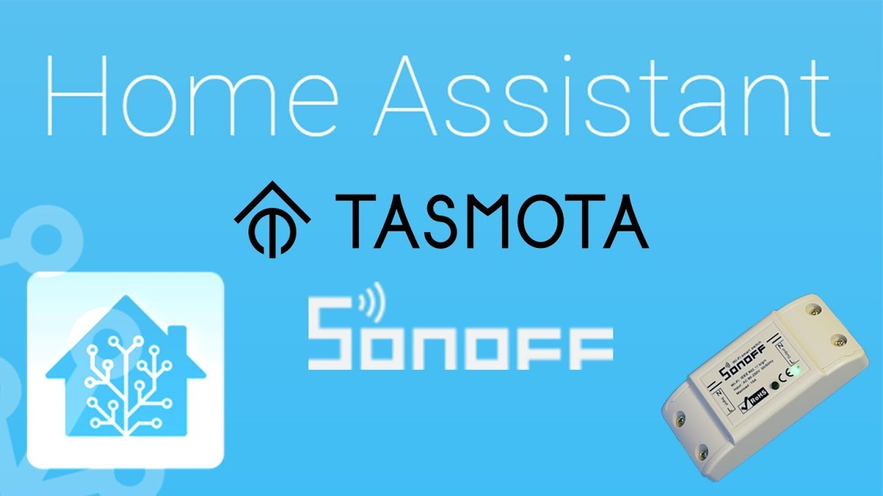

Inhaltsverzeichnis
1 Flashing Tasmota Software 2
1.1 Hardware Preparation 2
1.1.1 Serial Connection 2
1.1.2 Programming Mode 3
1.1.3 Common Mistakes 4
1.2 Flashing 4
1.3 Initial Configuration 5
1.4 After Configuration 6
1.5 Alternative Setup of IP-Configuration 6
1.6 Ermitteln der IP-Adresse des Tasmota -Geräts 7
2 Konfiguration: Sonoff R2 Basic 8
3 Konfiguration: Stromzähler D1 Mini 12
4 Konfiguration: D1 Mini und PN532 RFID-Reader 16
5 Integration der Tasmota Sensoren und Aktoren 20
5.1 Über Tasmota Plugin 20
5.1.1 Manuelles Erkennen der Tasmota-Geräte (Discovery) 20
5.1.2 Automatisierung um Status der Geräte zu lesen 21
5.2 Tasmota-Geräte über MQTT einbinden 22
5.2.1 MQTT Konfiguration für Sonoff Basic R2 22
5.2.2 MQTT Konfiguration für Stromzähler Steckdose 23
5.2.3 MQTT Konfiguration für D1-Mini+RFID-Reader 25
6 Veraltete MQTT Yaml Syntax 28

https://tasmota.github.io/docs/Getting-Started/#hardware-preparation

Flashing Tasmota Software

Hardware Preparation
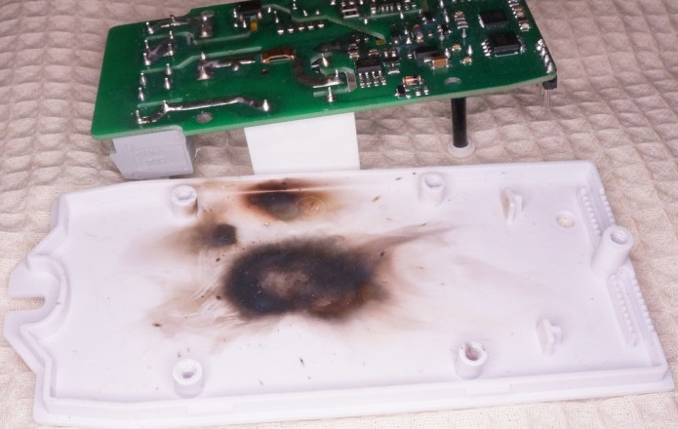
We need to connect to the serial programming interface of the ESP chip. This is done by connecting our serial-to-USB converter TX and RX pins to the ESP RX and TX pins and powering the chip with the 3.3V and GND pins.
In most cases those pins are available on the PCB in the form of pin holes or solder pads but pin headers or jumper wires need to be soldered or otherwise applied. In some cases you will need to solder wires directly on the chip's pins which requires some experience and good soldering equipment.
DO NOT CONNECT DEVICES TO MAINS AC POWER WHILE THE COVER IS OPEN AND CIRCUIT BOARD IS EXPOSED!!!
NEVER TRY TO FLASH WHILE YOUR DEVICE IS CONNECTED TO MAINS POWER!!!
YOU CAN BE ELECTROCUTED IF YOU DO NOT KNOW WHAT YOU ARE DOING!
If you are not careful, your own health will be in danger. Shorting your serial interface with mains AC power will fry your device and serial adapter and will also harm or destroy your computer. It is important to always have all mains power cables disconnected from the device while being connected via serial or even while the case of the device is opened.

Serial Connection
Each device has its pins labelled differently. If the labelling isn't visible on the PCB please refer to the devices flashing guide or search the Internet for correct pin locations. Device specific instructions and restrictions are documented in the Tasmota Supported Devices Repository. Pinouts for commonly used Wi-Fi modules are found here
When you have identified pins on your device, connect wires according to the table:
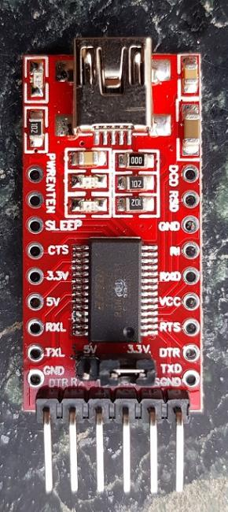
Serial adapter
Power jumper must be set to 3V3 V !

Jumer must be set to 3V3 !

Serial adapter | ESP device
3V3 | 3V3 or VCC
TX | RX
RX | TX
GND | GND

Note that TX from your adapter goes to RX on the ESP device and RX from adapter goes to TX on the device!

Programming Mode
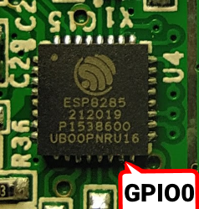
ESP needs to be put into programming mode or flash mode before the firmware can be uploaded. This is done by connecting GPIO0 pin to GND while the chip is booting.
On many devices the installed control button is connected to GPIO0 and GND, making entering Programming Mode easy. On others you will need to bridge the pins on the PCB or directly on the chip with a jumper wire. GPIO0 locations for popular modules can be found in Pinouts!
Device specific instructions are documented in Tasmota Supported Devices Repository..
To put the ESP into Programming Mode:
- Disconnect serial programmer and power
- Bridge GPIO0 and GND (by pressing the on-board button or connection with a wire)
- Connect the serial programmer to your computer
- After a few seconds disconnect GPIO0 from GND (release button or remove the wire connection). On devices that do not provide the GPIO0 connected button, it may be easier to leave the wired bridge in place throughout the entire flashing process (erase & upload). Doing so will not create any problems. After the firmware is uploaded successfully, remove the bridge. This allows the device to boot normally.
If everything went well, you are now in Programming Mode and ready to continue with flashing. If the flashing process is unable to start, disconnect the device and retry the steps.

Common Mistakes
- Wire connections and solder joints - Double check all connections and also check for solder overflow.
- Use a USB data cable - Some USB cables are for charging only and do not connect the data lines needed to load the firmware onto the device.
- Insufficient power delivered over the serial programmer. This leads to flashing failures or corrupted flash altogether. Supply more power with a separate 3.3V power supply or get an adapter with a better power supply. Be sure all DC voltages use the same GND line.
- Recheck your serial programmer so to ensure that it supplies 3.3V voltage and NOT 5V. 5V will damage the ESP chip!
- Releasing GPIO0 button/wire before booting is finished - It is safe to leave GPIO0 connected to GND during the entire programming process (erase & upload). Just be sure to remove the GPIO0 to GND bridge before booting the device for regular operation.
- Make sure that the RX pin is connected to the TX pin between the serial adapter and your ESP device, and vice versa.
- Erase the flash first and power cycle before uploading the Tasmota firmware binary. Not erasing can leave behind remnants of the previous flash contents which can interfere with the new firmware operation.

Flashing
If you have followed Hardware preparation,, your device should be in Programming Mode and ready for a Tasmota firmware binary to be installed.
You may want to back up the device manufacturer's firmware on the one in a million chance you don't like Tasmota.

Flash Tasmota directly from your web browser.

Web Installer (no support for firefox! Use Crome)

https://tasmota.github.io/install/
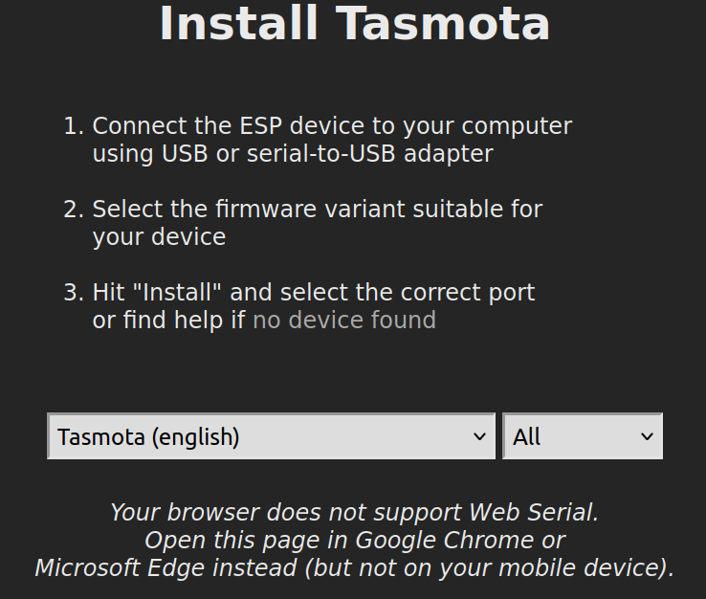

Initial Configuration
Once the installation is successful, click on NEXT. The installer will scan for Wi-Fi networks and select the strongest one. Use the dropdown to select between networks.
Enter the Wi-Fi password.

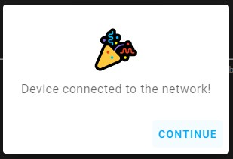

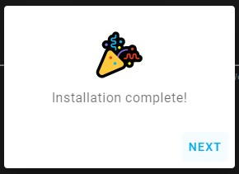

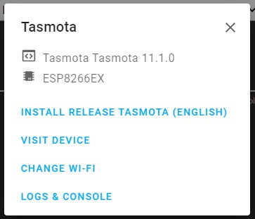

Wait until configuration completes and click CONTINUE

From here click on VISIT DEVICE to enter the WebUI for further configuration.

After Configuration
Your device running Tasmota is now ready to be controlled
Check out all the Tasmota features and ways to integrate it with other platforms.

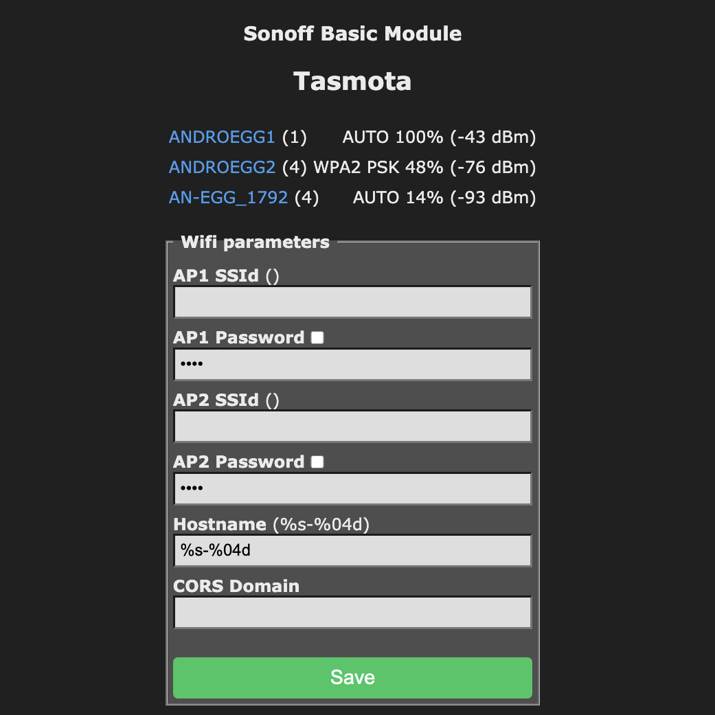
Alternative Setup of IP-Configuration
If the ESP8266/ESP32 device is not correctly configured for the home WLAN, the device will start its own hotspot. Connect to this TASMOTA_XXXXXX WLAN network. Then open a web-browser and enter ip 192.168.4.1 address.

Ermitteln der IP-Adresse des Tasmota -Geräts
Über den zentrale Router des LANs kann die Liste aller Geräte im Heimnetz ausgelesen werden. Die Fritzbox stellt über den Menüpunkt „Heimnetz → Netzwerk“ können die IP-Adressen von allen Geräten ausgelesen werden:
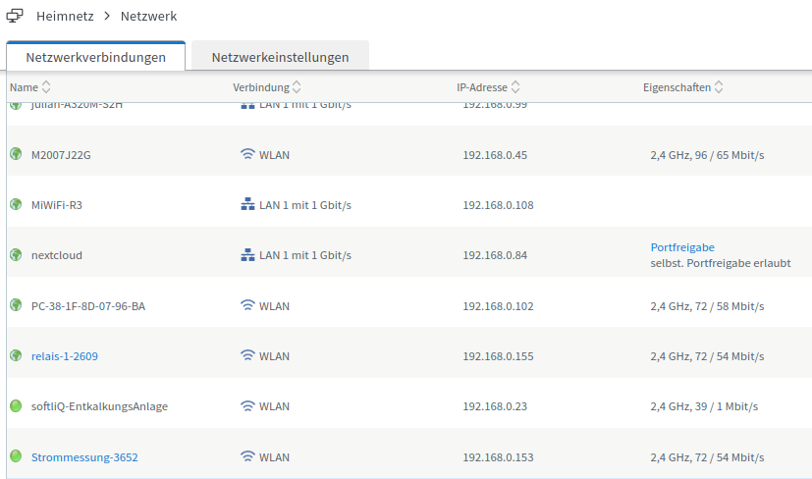

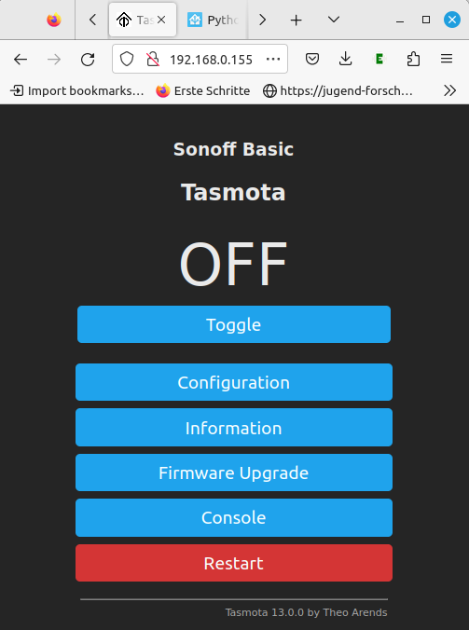
Das Tasmota Gerät kann über den Webbrowser konfiguriert werden. Hierzu wird die Adresse des Tasmota Geräts als URL in die oberste Zeile des Browsers eingetragen. Die Tasmota Software unterstützt nur den HTTP Dienst. Die IP-Adresse kann in die URL-Leiste des Browsers eingetragen werden: HTTP://192.168.XXX.XXX. ist die vom Router vergebene IP-Adresse.

If the IP-Address is e.g.192.168.0.155 the local configuration of the device can be opened, by entering the IP-adress in the URL line of the browser (e.g. http://192.168.0.155)

Konfiguration: Sonoff R2 Basic

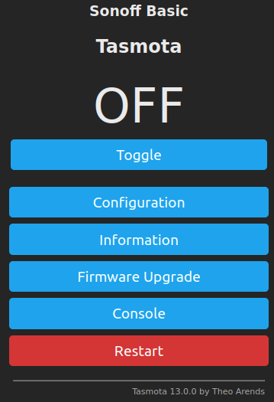

Configuration
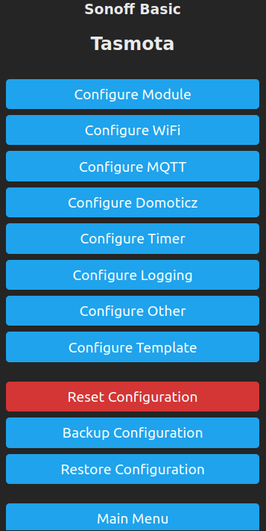

Configure Module
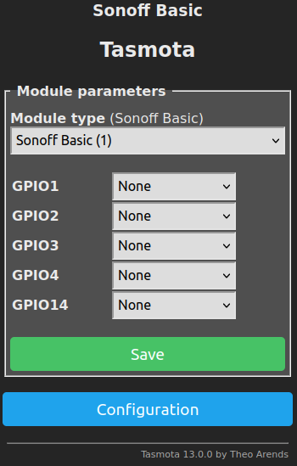

Configure WIFI
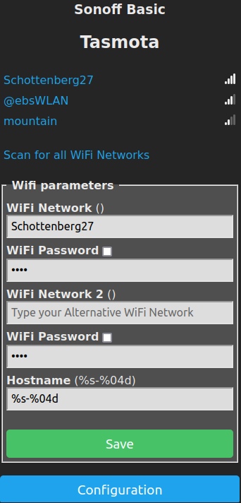

Configure MQTT
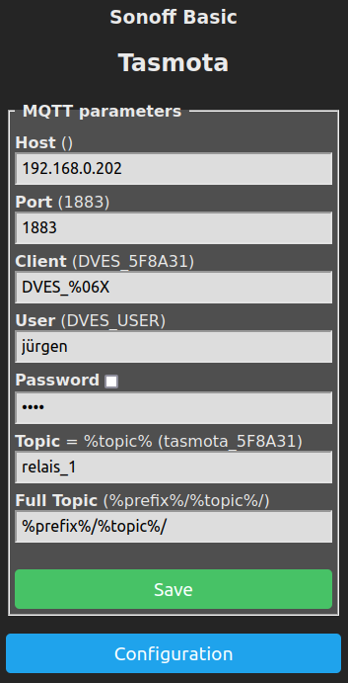

Configure Other
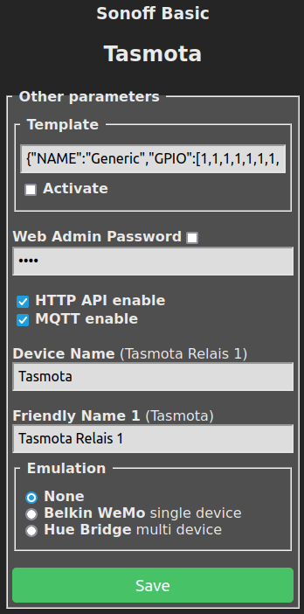

Settings:

WIFI:
WIFI Network(): SSID des Hausnetzes
WIFI Passowort: Passwort des angegebene Hausnetzes

MQTT
Host(): IP-Adress of MQTT broker (192.168.0.202)
User: User name configured in MQTT broker (jürgen)
Password: Passwort of the specified user (neuneuneuneu)
Topic: relais_1

Template:
{"NAME":"Generic","GPIO":[1,1,1,1,1,1,1,1,1,1,1,1,1,1],"FLAG":0,"BASE":18}
HTTP API: enabled
MQTT: enabled
Friendly Name1: Tasmota Relais 1

Konfiguration: Stromzähler D1 Mini
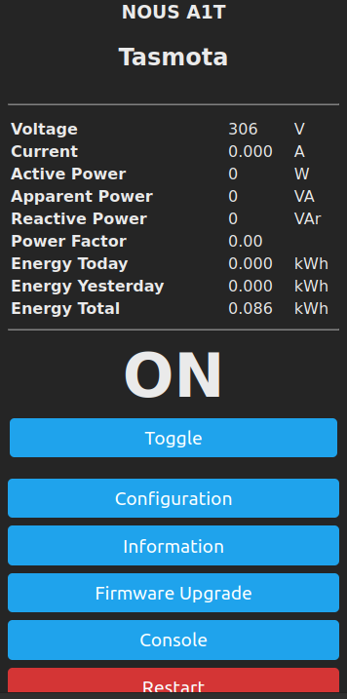

Configuration
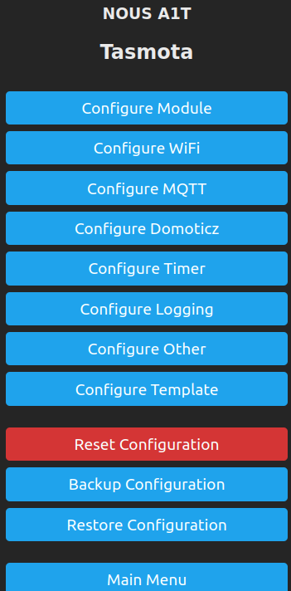

Configure Module

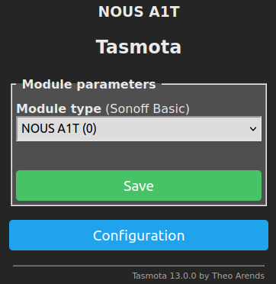

Configure WIFI
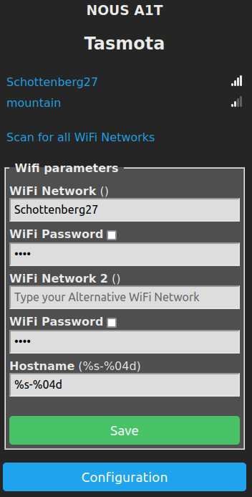

Configure MQTT

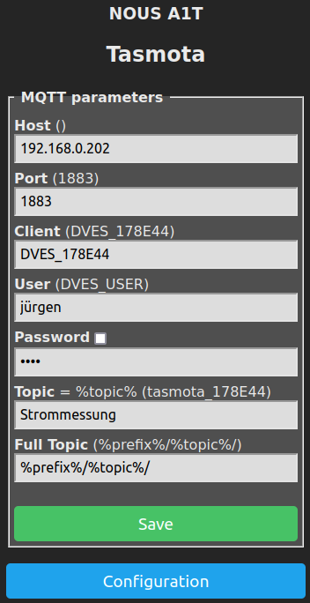

Configure Other
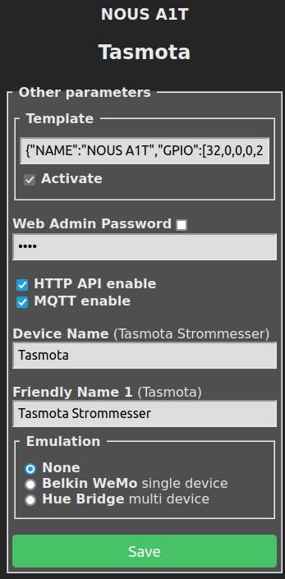

Settings:

WIFI:
WIFI Network(): SSID des Hausnetzes
WIFI Passowort: Passwort des angegebene Hausnetzes

MQTT
Host(): IP-Adress of MQTT broker (192.168.0.202)
User: User name configured in MQTT broker (jürgen)
Password: Passwort of the specified user (neuneuneuneu)
Topic: Strommessung

Template:
{"NAME":"NOUS A1T","GPIO":[32,0,0,0,2720,2656,0,0,2624,320,224,0,0,0],"FLAG":0,"BASE":49}
HTTP API: enabled
MQTT: enabled
Friendly Name1: Tasmota Strommesser

Konfiguration: D1 Mini und PN532 RFID-Reader
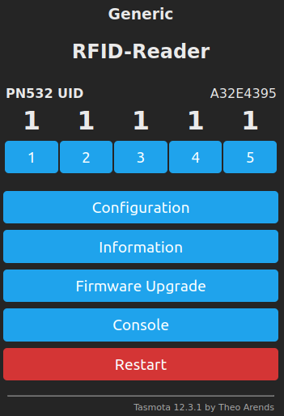

Configuration
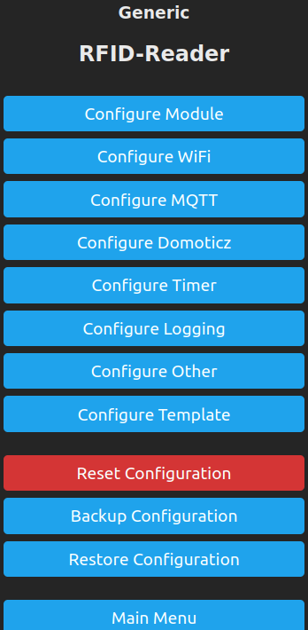

Configure Module
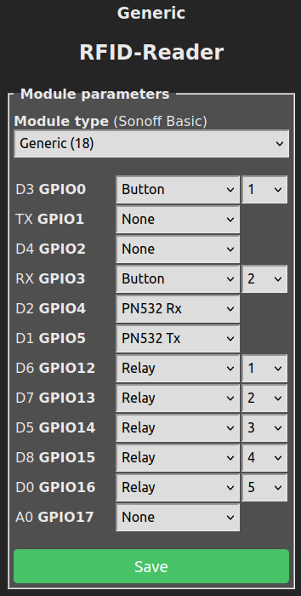

Configure WIFI
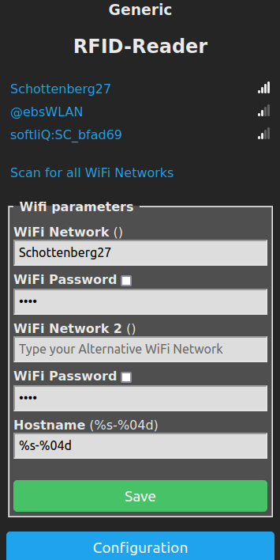

Configure MQTT
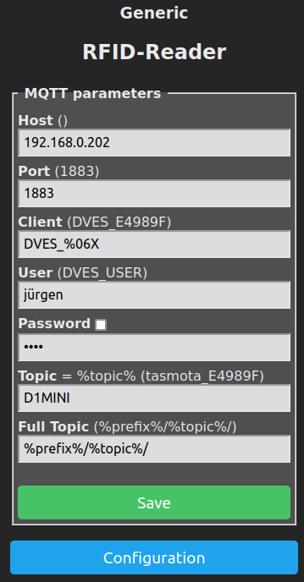

Configure Other
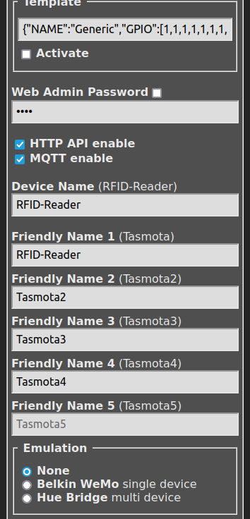

Settings:

WIFI:
WIFI Network(): SSID des Hausnetzes
WIFI Passowort: Passwort des angegebene Hausnetzes

MQTT
Host(): IP-Adress of MQTT broker (192.168.0.202)
User: User name configured in MQTT broker (jürgen)
Password: Passwort of the specified user (neuneuneuneu)
Topic: D1MINI

Template:
{"NAME":"Generic","GPIO":[1,1,1,1,1,1,1,1,1,1,1,1,1,1],"FLAG":0,"BASE":18}
HTTP API: enabled
MQTT: enabled
Friendly Name1: RFID-Reader

Integration der Tasmota Sensoren und Aktoren

Über Tasmota Plugin

Das Tasmota-Plugin muss hierzu als Integration installiert sein.
Siehe auch: https://tasmota.github.io/docs/Home-Assistant/

Das Tasmota-Plugin merkt sich alle Tasmota-Geräte, die es während der Laufzeit des Home-Assistant jemals gesehen hat.
Das bedeutet aber, wenn eine neues Tasmota Gerät im Haus installiert wird, muss das Tasmota-Plugin davon Kenntnis erhalten. Dieses Anlernen des Tasmota Plugin kann auf zwei Arten durchgeführt werden.

Manuelles Erkennen der Tasmota-Geräte (Discovery)

https://community.home-assistant.io/t/tasmota-and-setoption19-ha-discovery/112481

Über die Option19 steuert Tasmota die Tasmota discovery Funktion. Das heißt: soll ein Tasmota-Gerät von Home-Assistant erkannt werden, dann muss man die Option 19 einschalten und dann wieder ausschalten.
Tasmota-Geräte stellen über das Web-Interface eine Console bereit. Hier muss man den Befehl:
SetOption19 ON
eingeben und mit Enter bestätigen.
Danach muss man diese Option auch wieder abstellen, damit das Tasmota Gerät richtig funktioniert. D.h. 10-20 s nach dem Einschalten, kann die Funktion durch Senden des Befehls
SetOption19 OFF
auch wieder abgeschaltet werden.

Diese Funktion muss für jedes Tasmota-Gerät ausgeführt werden.

Automatisierung um Status der Geräte zu lesen
https://community.home-assistant.io/t/how-to-set-setoption19-tasmota-devices-marked-unavailable/561597/4

Alternativ kann eine Automatisierung im Home-Assistant gestartet werden, die den Status der jedes Tasmota-Geräts einliest.

configuration.yaml:

- id: '1565194745362'
alias: Status at start HA
trigger:
- event: start
platform: homeassistant
condition: []
action:
- data:
payload: ''
topic: cmd/tasmotas/status
service: mqtt.publish
Dieser Abschnitt muss für jedes Tasmota-Gerät angepasst und dann in die configuration.yaml Datei eingetragen werden.

Tasmota-Geräte über MQTT einbinden

MQTT Konfiguration für Sonoff Basic R2

Sonoff Basic R2, Smart Switch, WiFi für Tasmotta

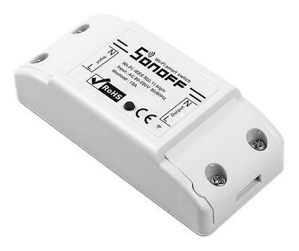

mqtt:
switch:
- name: "CONF: Sonoff Relais 1"
command_topic: "cmnd/relais_1/POWER"
state_topic: "stat/relais_1/POWER"
qos: 0
unique_id: 2225d76a-3370-11ee-baeb-325096b39f47

MQTT Konfiguration für Stromzähler Steckdose

NOUS Tasmota Steckdose A1T - Wlan smart plug 16A mini WiFi Steckdose

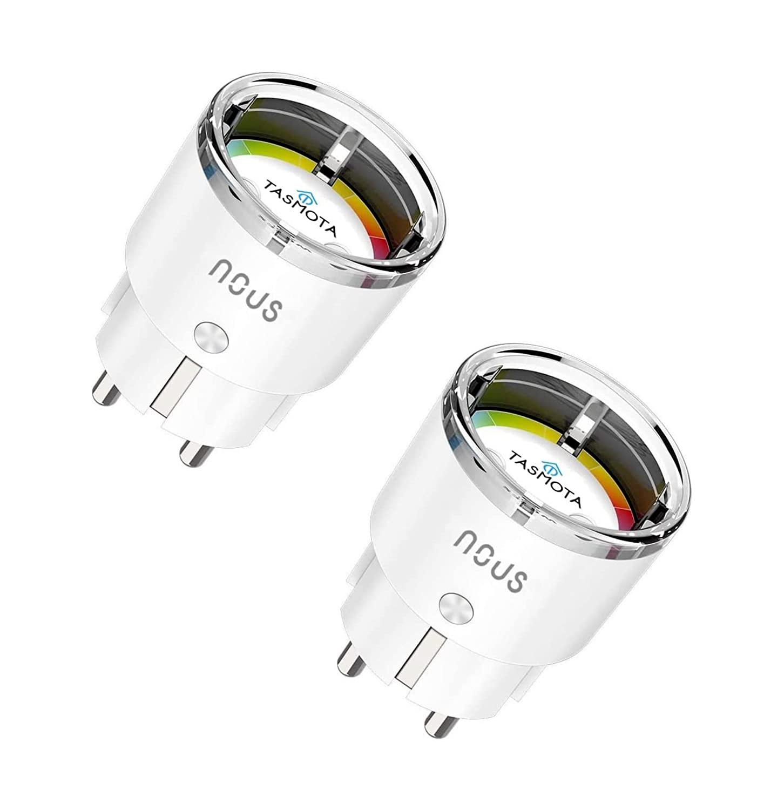

configuration.yaml:
mqtt:
#Intelligente Steckdose
sensor:
- name: "CONF: Stromzähler Leistung"
state_topic: "tele/Strommessung/SENSOR"
unit_of_measurement: "W"
value_template: "{{ value_json.ENERGY.Power }}"
device_class: power
unique_id: 0969280e-3370-11ee-b74b-325096b39f47

- name: "CONF: Stromzähler Spannung"
state_topic: "tele/Strommessung/SENSOR"
unit_of_measurement: "V"
value_template: "{{ value_json.ENERGY.Voltage }}"
device_class: voltage
unique_id: e0a1a72a-336f-11ee-b5a4-325096b39f47

mqtt:
switch:
- name: "CONF: Steckdosenschalter"
command_topic: "cmnd/Strommessung/POWER"
state_topic: "stat/Strommessung/POWER"
payload_on: "ON"
payload_off: "OFF"
unique_id:
3d751d56-3370-11ee-af30-325096b39f47

# {
# "Time": "2023-08-04T19:05:47",
#"ENERGY": {
# "TotalStartTime": "2023-07-30T17:52:55",
# "Total": 0.086,
# "Yesterday": 0,
# "Today": 0,
# "Period": 0,
# "Power": 0,
# "ApparentPower": 0,
# "ReactivePower": 0,
# "Factor": 0,
# "Voltage": 0,
# "Current": 0
# }
#}

MQTT Konfiguration für D1-Mini+RFID-Reader

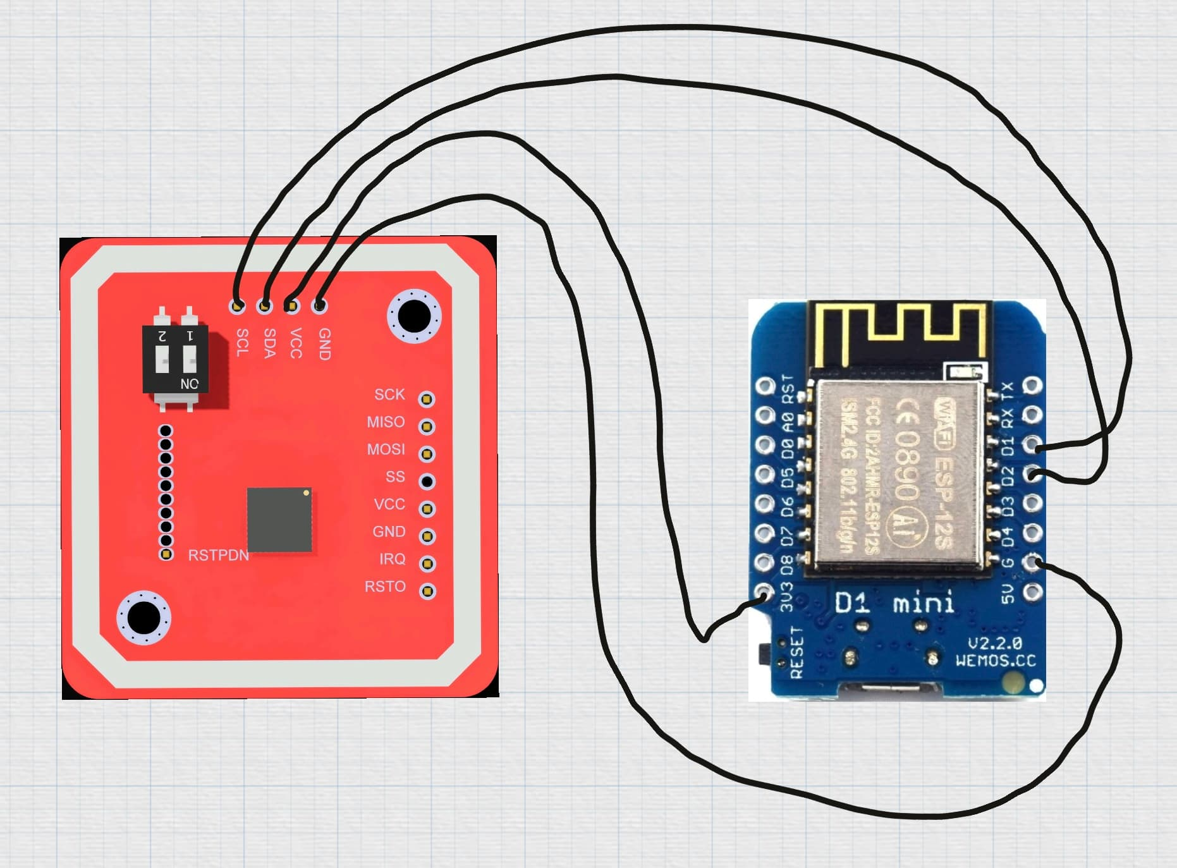
Rote Linien: Anschlüsse für Knöpfe (Steuerung von R1 und R2)
Blaue Linien: Anschlüsse für Releais oder LEDs R1 - R5

Buttons müssen gegen GND gelegt werden: Die Buttons sind als “Button” definiert: Button active low, internal pull-up resistor

siehe auch: https://tasmota.github.io/docs/Buttons-schematics/

Mit den beiden Buttons können die Schaltfunktionen R1 und R2 ausgeführt werden. Möchte man nur die Zustände der Buttons abfragen, dann dürfen an den Ausgängen D6 und D7 keine LEDs oder Relais angeschlossen werden.

configuration.yaml:
mqtt:
#Intelligente Steckdose
sensor:
#D1-Mini
- name: "CONF: RFID_Reader_Scan"
state_topic: tele/D1MINI/SENSOR
# {"Time":"2023-08-03T21:14:11","PN532":{"UID":"A32E4395"}}
qos: 0
value_template: "{{ value_json.PN532.UID | string}}"
unique_id: 259c276a-3370-11ee-baeb-325096b39f47

- name: "CONF: RFID_Reader_Update"
state_topic: tele/D1MINI/SENSOR
# {"Time":"2023-08-03T21:14:11","PN532":{"UID":"A32E4395"}}
qos: 0
value_template: "{{ value_json.Time }}"
unique_id: 259c276a-36750-11ee-baeb-32567839f47

switch:
#----------------------------------------------------
# D1 MINI
#----------------------------------------------------
#stat/D1MINI/RESULT = {"POWER1":"OFF"}
#tele/tasmota/SENSOR = {"Time":"2021-01-01T00:00:00","Switch1":"OFF"}
- name: "CONF: RFID relais 1"
command_topic: "cmnd/D1MINI/POWER1"
state_topic: stat/D1MINI/POWER1
qos: 0
value_template: "{{ value_json.POWER1 }}"
unique_id: 2526276a-36750-11ee-baeb-32567839f47

- name: "CONF: RFID relais 2"
command_topic: "cmnd/D1MINI/POWER2"
state_topic: stat/D1MINI/POWER2
qos: 0
value_template: "{{ value_json.POWER2 }}"
unique_id: 2527276a-36750-11ee-baeb-32567839f47

- name: "CONF: RFID relais 3"
command_topic: "cmnd/D1MINI/POWER3"
state_topic: stat/D1MINI/POWER3
qos: 0
value_template: "{{ value_json.POWER3 }}"
unique_id: 2529276a-36750-11ee-baeb-32567839f47

- name: "CONF: RFID relais 4"
command_topic: "cmnd/D1MINI/POWER4"
state_topic: stat/D1MINI/POWER4
qos: 0
value_template: "{{ value_json.POWER4 }}"
unique_id: 2523276a-36750-11ee-baeb-32567839f47

- name: "CONF: RFID relais 5"
command_topic: "cmnd/D1MINI/POWER5"
state_topic: stat/D1MINI/POWER5
qos: 0
value_template: "{{ value_json.POWER5 }}"
unique_id: 2529726a-36750-11ee-baeb-32567839f47

Veraltete MQTT Yaml Syntax

Alt:

mqtt:
broker: 127.0.0.1
sensor:
- platform: mqtt

Neu:

mqtt:
sensor:
- name: device01

Home Assistant unterstützt nur noch das neue Format! Das alte Format findet man häufig noch im Internet in Beispielen.

