Smart Wifi Socket NOUS A1

https://nous.technology/product/nous-smart-wi-fi-socket-a1.html

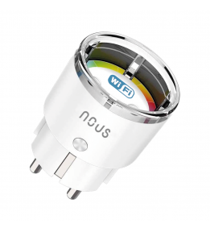

Inhaltsverzeichnis
1 Specifications 2
2 Description 3
3 CE-Certificate 6
4 Product Videos 7

Specifications

Network
Protocol | IEEE 802.11b/g/n
Compatibility with voice assistants | Amazon Alexa,Google Home
Type of wireless transmission | 2,4 GHz
Control from a smartphone | APP: NOUS Smart Home
System requirements | iOS 8 or Android 4.4 or higher
Main settings
Brand | NOUS
Certificate | CE, RoHS, RED
Special features | Energy Monitoring
Material | Plastic
Electric power | 3450W
Specifications
Level of moisture protection | IP20
Maximum load | 16A
Operating voltage range | 220-240V
Body material | Heat resistant plastic
Operating temperature | -10 ºC ~ 40 ºC
Device dimensions | 41*41*75 mm
Device weight | 60 g
Standby power consumption: | 0.53W
Other
Warranty | 24 Months
Accessory | Socket, user manual, packaging
The manufacturer | L-TRADE Sp z o.o., NIP:7010448013

Description

Smart Wifi Socket NOUS A1

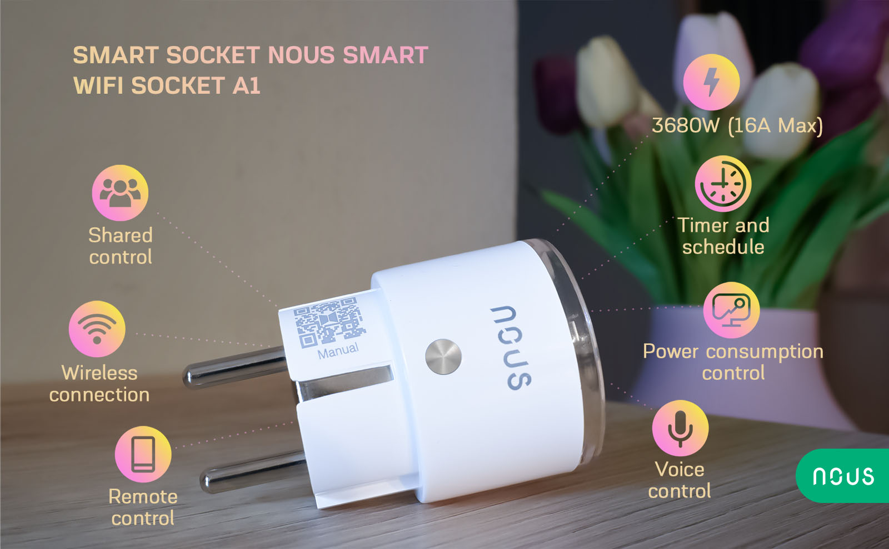
If you are looking for smart home devices that can make your life easier and more convenient, you should check out the Smart Wifi Socket NOUS A1. This smart socket is a versatile and powerful device that allows you to control and monitor your electrical appliances from anywhere with your smartphone or voice assistant. You can turn on/off your lamp, coffee maker, fan, heater, or any other device that plugs into a wall outlet with a simple tap or voice command. You can also set schedules and timers to automate your devices according to your daily routine or preferences.
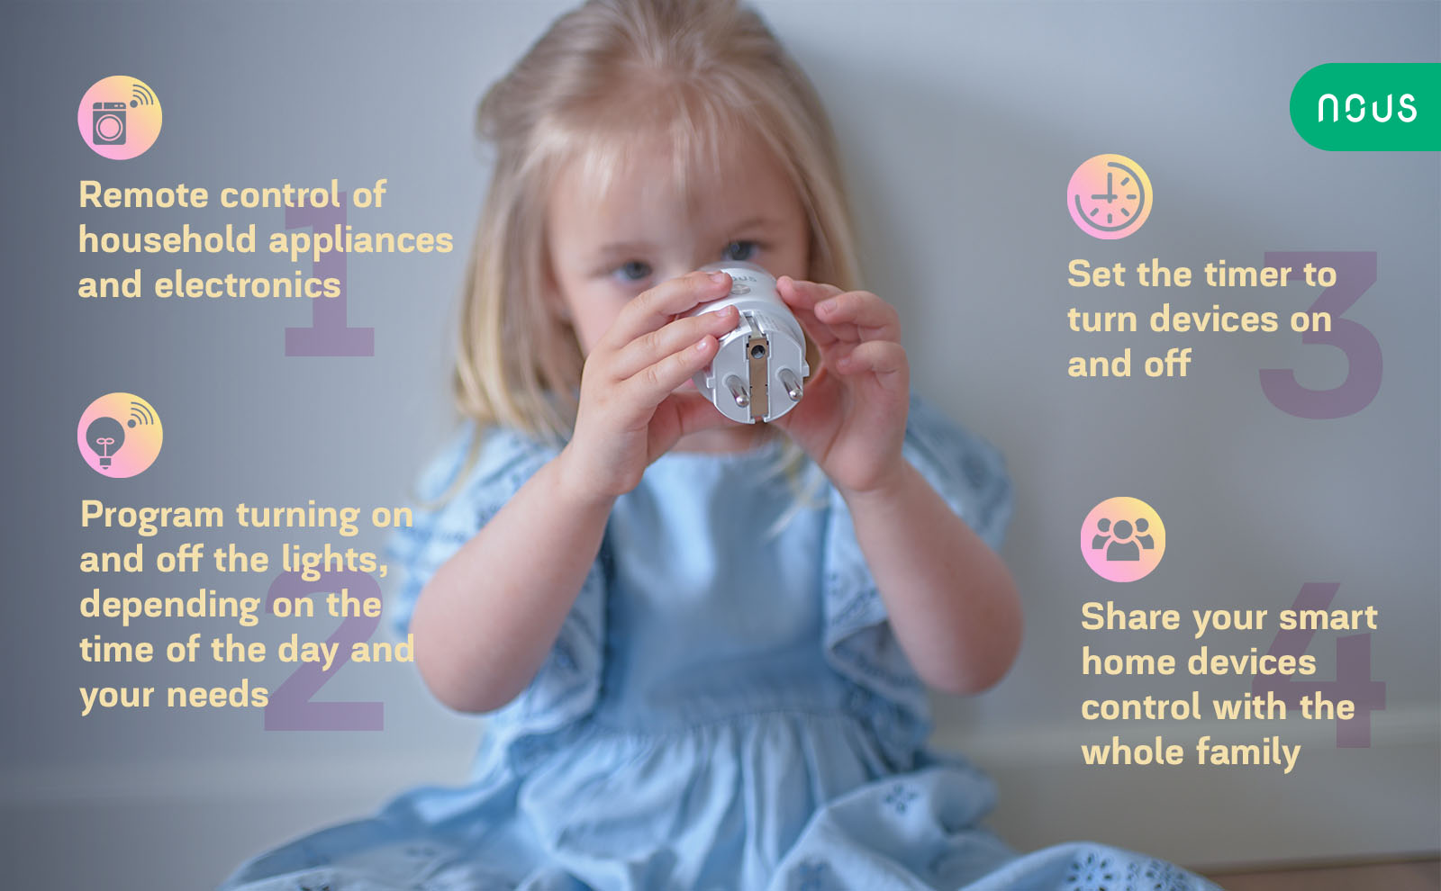
But that's not all. The Smart Wifi Socket NOUS A1 also features energy monitoring function that lets you track the power consumption of your devices in real time and view historical data on your app. You can see your power consumption and how much energy each device is using and how much it costs you per month. You can also set limits and alerts to avoid overloading or wasting energy. With this smart socket, you can save money and reduce your carbon footprint while enjoying the convenience and comfort of smart home technology.
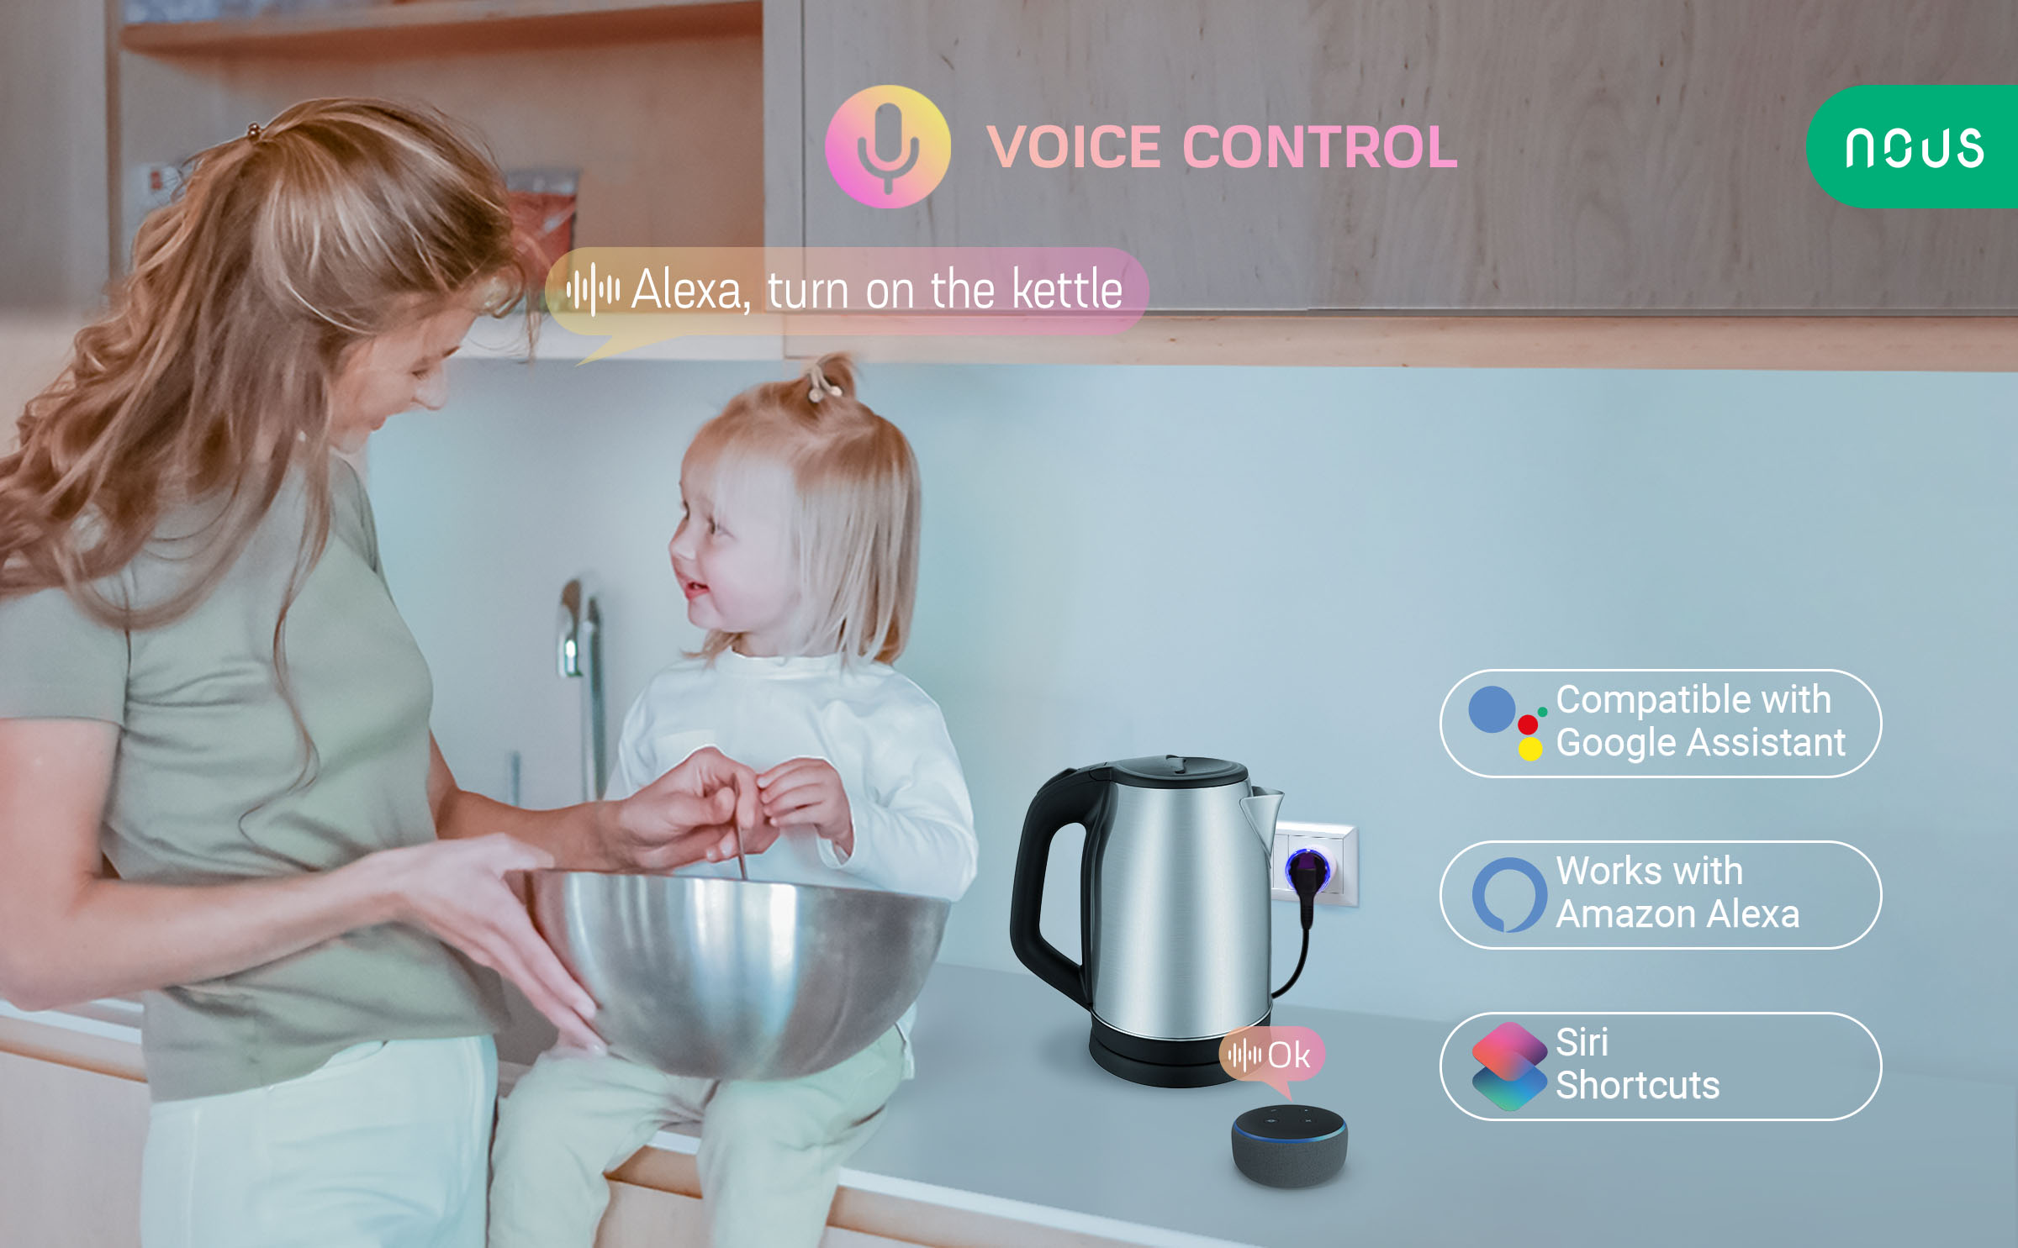
The Smart Wifi Socket NOUS A1 is compatible with Alexa and Google Assistant, so you can use your voice to control your devices hands-free. You can also integrate it with other smart home products from NOUS, such as smart bulbs, cameras, sensors, and more. NOUS is a leading brand in smart home solutions that offers innovative and reliable products that work seamlessly together to create a smart house ecosystem. Whether you want to enhance your bedroom, kitchen, living room, or any other space in your home, you can find the right smart devices and gadgets from NOUS to suit your needs and style.
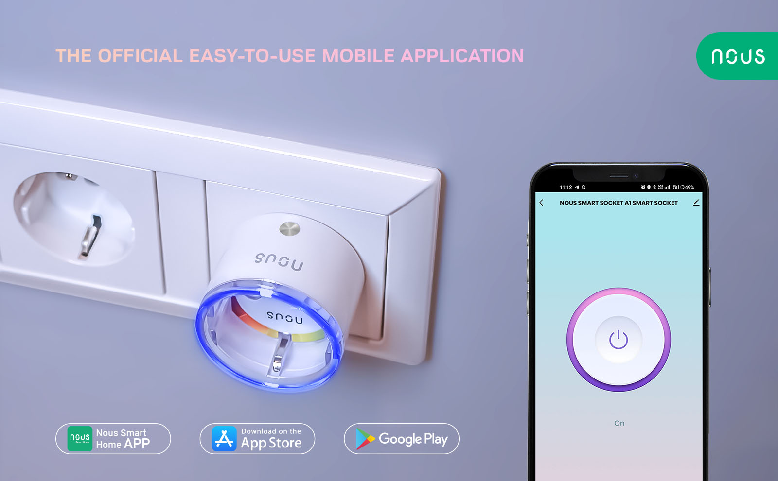
The Smart Wifi Socket NOUS A1 is easy to install and use. You just need to plug it into any standard wall outlet, download the Nous smart app or Tuya Smart app on your phone, and connect it to your wifi network. No hub or subscription required. You can then start controlling and monitoring your devices from anywhere with your phone or voice. You can also share the access with your family members or friends for added convenience and security.
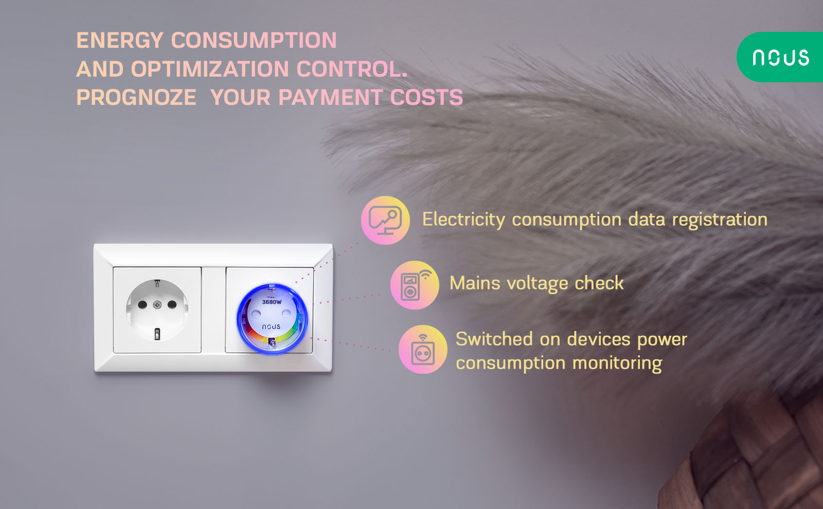
The Smart Wifi Socket NOUS A1 is more than just a smart socket. It is a smart home accessory that can transform your ordinary electrical appliances into smart ones. It is a smart device for home that can help you save energy, money, and time while improving your comfort and safety. It also can protect your devices from overvoltage and protect your house from potential fire, because it's made of fire resistant materials.
It is a smart gadget for home that can make your smart house more intelligent, connected, convenient and save. If you are looking for a smart socket with energy monitoring that works with Alexa and Google Assistant, look no further than the Smart Wifi Socket NOUS A1.

CE-Certificate

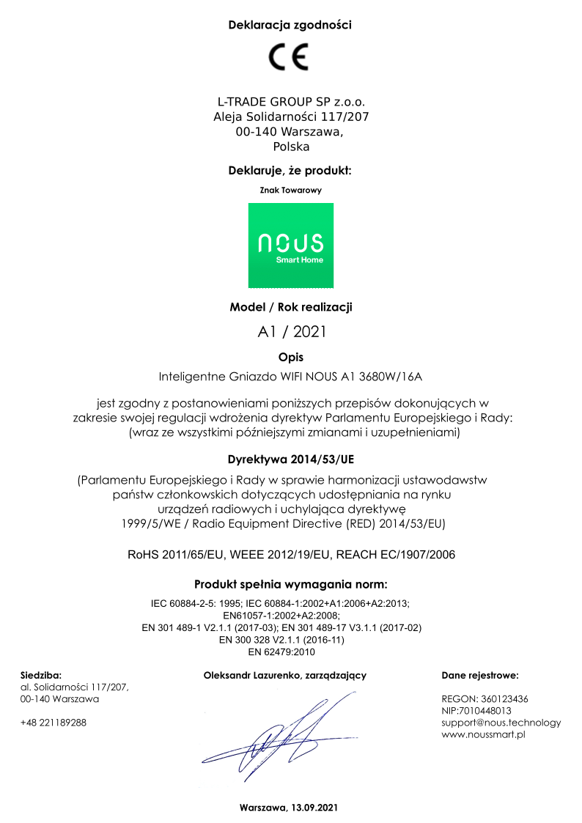

Product Videos
Videos

https://www.youtube.com/watch?v=C-gA77Bg28s

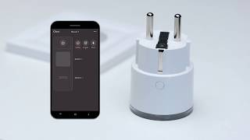
https://www.youtube.com/watch?v=y7j8YX1g6Y0

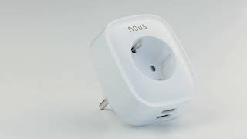
https://www.youtube.com/watch?v=rhltgIzprmU

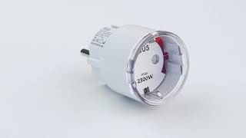
https://www.youtube.com/watch?v=iM08bR-rElI

