Wie verwendet man Python in Home Assistant
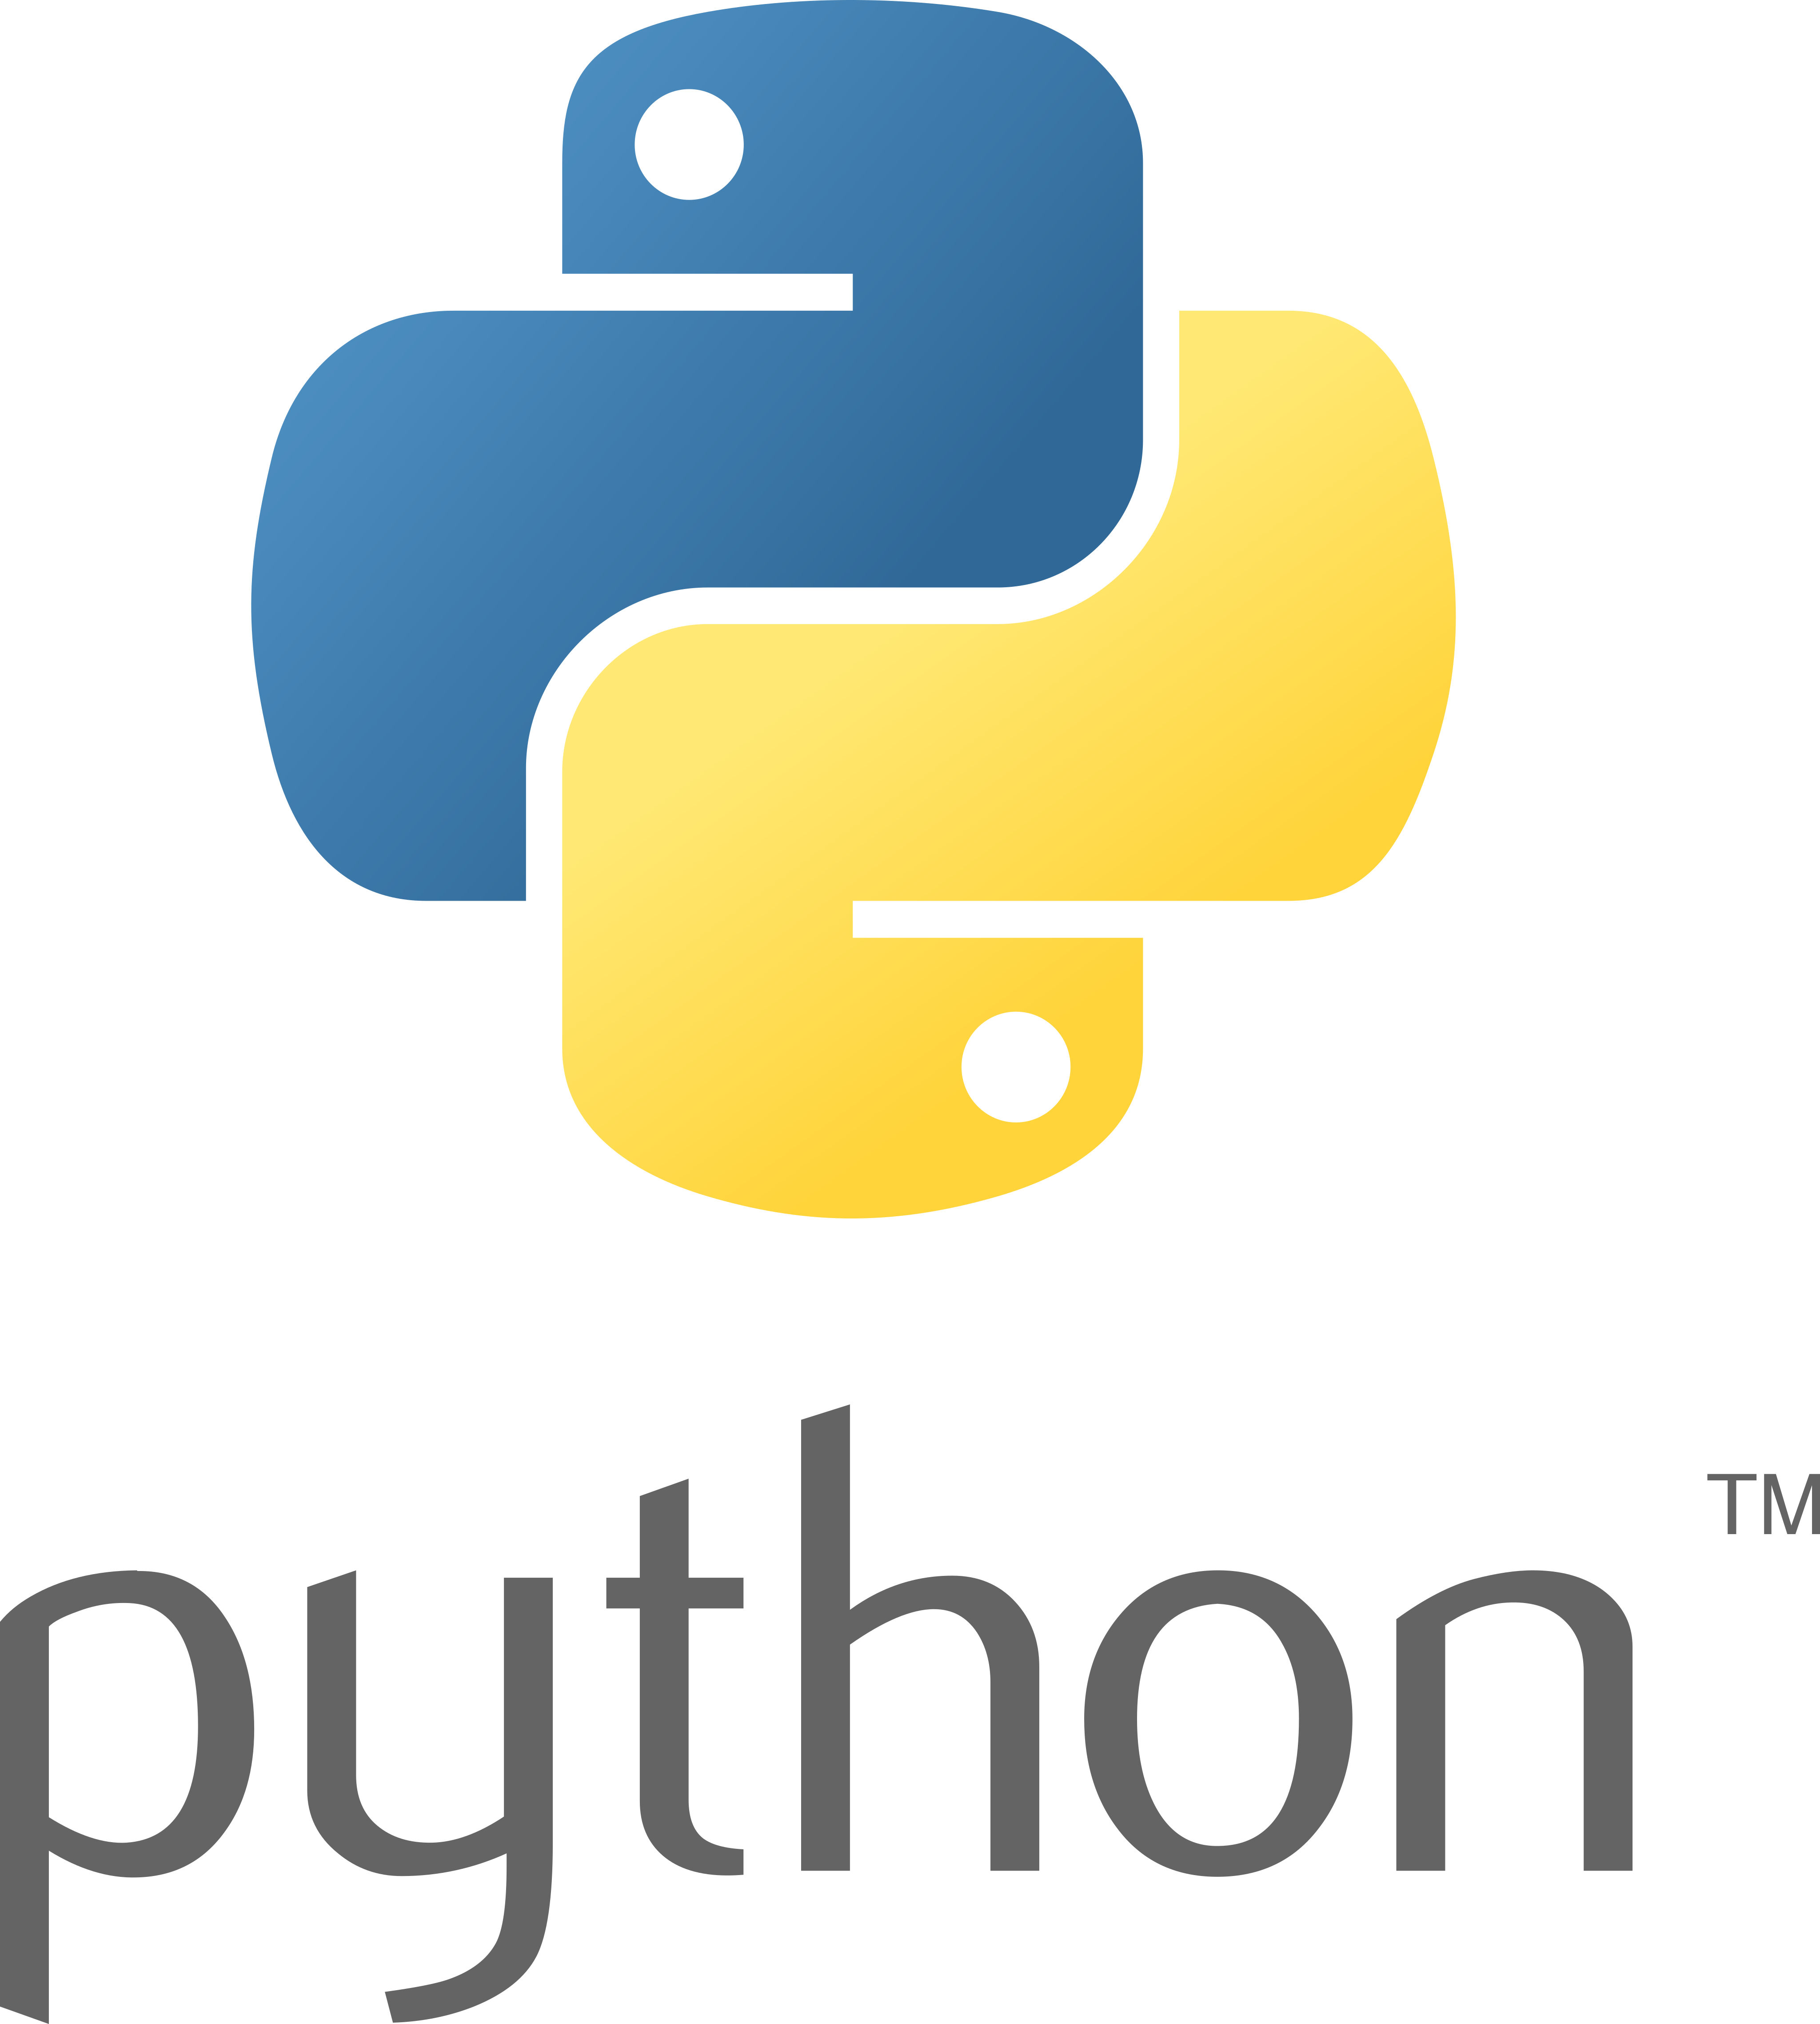
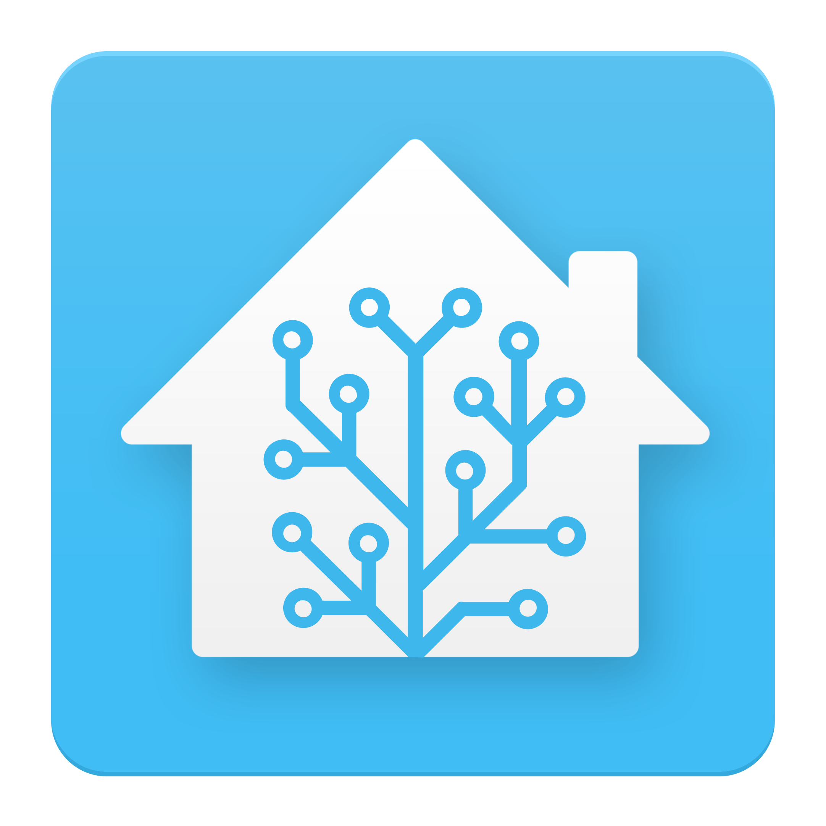

Inhaltsverzeichnis
1 Grundlagen 1
2 Installation und Nutzung von AppDemon 2

Grundlagen
Die Idee der Umsetzung einer Programmsteuerung in Python mit Home Assistant habe ich dem Video von Vaclav Chaloupka im Video: “Starting with AppDaemon in Home Assistant” entnommen: https://www.youtube.com/watch?v=vNib86rkEA0

Unter dem Video sind folgende Information hinterlegt:
This is a bonus video to the 2 part series about automating heating in Home Assistant. And I decided to make it as a separate video for 2 reasons:
1) I have tried to make it as a more general guide to starting with AppDaemon in Home Assistant. So it is not specific for the heating.
2) And if it is part of the original video, it would be too detailed.
This is an experiment – after the initial part, where we install AppDaemon, I will dive deep into the code and explain what it does and how it works. I guess it will be very boring for most people, or maybe interesting for someone – I have no idea. But it this helps one person to start writing AppDaemon automations in Home Assistant (or even start writing simple code in Python) I’ll be happy! Please let me know in the comments. The AppDaemon script is available here: https://github.com/bruxy70/Heating AppDaemon configuration: https://appdaemon.readthedocs.io/en/s... Home Assistant: https://www.home-assistant.io/ About me: https://www.linkedin.com/in/vaclavcha... #HomeAssistant #DIY

Installation und Nutzung von AppDemon

AppDemon4 ist Bestandteil der Home Assistant Dokumentation. Hier ist eine kurze Info zu finden:
https://community.home-assistant.io/t/home-assistant-community-add-on-appdaemon-4/163259
und hier das Handbuch:
https://appdaemon.readthedocs.io/en/latest/

