
MASENO UNIVERSITY

SCHOOL OF COMPUTING AND INFORMATICS
DEPARTMENT OF INFORMATION TECHNOLOGY

CIM 429: Individual Project Proposal Writing

PROJECT TITLE: CODE SECURITY SCAN SYSTEM (CSSS)

CIM/00045/021 WABWIRE LINUS

2ND MAY, 2025

DECLARATION
I hereby declare that this project proposal is my own original work. Where work or contributions of other individuals have been used, they have been duly acknowledged and relevant citations provided. To the best of my knowledge, no material herein has been previously presented to any other academic institution for examination, award of a degree, or any other award.

STUDENT:
Name: WABWIRE LINUS Reg No: CIM/00045/021
Signature: ________________________ Date: ________________________

SUPERVISOR:
I hereby certify that this project proposal has been presented for examination with my approval as the university-appointed supervisor.

Name: MR. MOSES WAINAINA Signature: ……………… Date: …………………….

DEDICATION
This project is dedicated to the Almighty God for wisdom and strength, to my supervisor Mr. Moses Wainaina for his guidance, and to every developer striving to build secure software in the age of AI.

ABSTRACT
The widespread adoption of AI code assistants like GitHub Copilot and ChatGPT has revolutionized software development but introduced significant security vulnerabilities. These tools often generate code containing insecure patterns such as SQL injection, cross-site scripting (XSS), and improper data handling, which developers may unknowingly integrate. Existing security tools like traditional Static Application Security Testing (SAST) operate late in the development pipeline, providing delayed feedback that increases remediation costs and risks. This project proposes the Code Security Scan System (CSSS), a real-time vulnerability scanner that integrates directly into developer workflows via Chrome and Visual Studio Code extensions. The system captures AI-generated code snippets from web interfaces and IDE editors, analyzes them using a backend security engine, and provides instant vulnerability alerts with actionable remediation guidance. By shifting security left into the coding phase, CSSS aims to reduce vulnerability introduction, enhance developer security awareness, and promote secure coding practices in AI-assisted development. The project will follow an Agile methodology, utilizing technologies such as JavaScript for extensions, Python for backend analysis, and PostgreSQL for data storage. Rigorous testing will ensure accuracy, usability, and performance, with a target response time of under 2 seconds per scan.

ACKNOWLEDGMENT
I wish to express my sincere gratitude to my supervisor, Mr. Moses Wainaina, for his invaluable guidance, expertise, and unwavering support throughout the development of this proposal. I also extend my appreciation to the Department of Information Technology and Maseno University for providing the academic resources and environment necessary for this research. Finally, I thank my family and peers for their encouragement and constructive feedback.

LIST OF ABBREVIATIONS
- CSSS – Code Security Scan System
- AI – Artificial Intelligence
- LLM – Large Language Model
- SAST – Static Application Security Testing
- IDE – Integrated Development Environment
- VS Code – Visual Studio Code
- XSS – Cross-Site Scripting
- SQLi – SQL Injection
- CVE – Common Vulnerabilities and Exposures
- OWASP – Open Web Application Security Project
- API – Application Programming Interface
- UI/UX – User Interface/User Experience
- JSON – JavaScript Object Notation

DEFINATION OF TERMS
- AI-Generated Code: Source code produced by artificial intelligence models (e.g., ChatGPT, Copilot) in response to natural language prompts.
- Real-Time Security Scanning: Immediate analysis of code for vulnerabilities as it is written or generated, without delay.
- Browser Extension: A software add-on for web browsers that enhances functionality, such as intercepting and analyzing code on webpages.
- IDE Extension: A plugin for Integrated Development Environments like VS Code that adds features such as inline security analysis.
- Vulnerability: A flaw or weakness in code that could be exploited to compromise security.
- Remediation Guidance: Specific, actionable recommendations provided to fix identified security vulnerabilities.
- Shift-Left Security: The practice of integrating security checks early in the software development lifecycle.
- Static Code Analysis: Examining source code without executing it to identify potential security issues.

TABLE OF CONTENTS

DECLARATION 2
DEDICATION 3
ABSTRACT 4
ACKNOWLEDGMENT 5
LIST OF ABBREVIATIONS 6
DEFINATION OF TERMS 7
TABLE OF CONTENTS 8
LIST OF TABLES 10
LIST OF FIGURES 11
1.0 CHAPTER ONE INTRODUCTION 12
1.1 Background/Introduction 12
1.2 Problem Statement 14
1.3 Objectives 14
1.3.1 General Objective 14
1.3.2 Specific Objectives 15
1.4 Research Questions 15
1.5 Scope of the research 15
1.6 Justification and Significance of the study 16
1.7 Research Assumption 16
1.8 Limitation of the research 16
2.0 CHAPTER TWO 18
2.1 Introduction 18
2.2 Related work 18
2.3 Related systems 18
2.3.1 GitHub Copilot 18
2.3.2 SonarQube 19
2.3.3 Snyk Code 19
2.3.4 Tabnine 19
2.3.5 Semgrep 20
2.4 The general gap 21
2.5 Conclusion 21
Chapter 3: Methodology 22
3.1 Introduction 22
3.2 Research Design 22
3.3 Target population 22
3.4 Sample size and justification 22
3.5 Data Collection Methods 22
3.6 Data Sources 23
3.7 Data Collection Instruments 23
3.8 Data Analysis Methods 23
3.9 System Design 24
3.9.1 System development methodology 24
3.9.2 Design tools 24
3.9.3 System Requirements 31
3.10 Validation and Testing 31
3.11 Ethical Considerations 32
REFERENCES 33
APPENDIX 1: ESTIMATED BUDGET 34
APPENDIX 2: GANTT CHART 35

LIST OF TABLES
Table 1 Summary of the related works 16
Table 2 ESTIMATED BUDGET 26
Table 3 GANTT CHART 27

LIST OF FIGURES

Figure 1 Context diagram 19
Figure 2 Use case diagram 20
Figure 3 Activity diagram 21
Figure 4 Entity relationship diagram 1 22
Figure 5 Entity relationship diagram 2 23

1.0 CHAPTER ONE INTRODUCTION

1.1 Background/Introduction
The integration of Artificial Intelligence (AI) and Large Language Models (LLMs) into software development has dramatically accelerated coding processes (Science Direct, 2025). Tools like GitHub Copilot and ChatGPT enable developers to generate code snippets, debug programs, and implement features quickly. However, this convenience comes with significant security risks. AI models are trained on vast datasets of public code, which often include vulnerable or outdated patterns. Consequently, AI-generated code may inadvertently introduce security flaws such as SQL injection, cross-site scripting (XSS), insecure authentication, and improper input validation.

The rise of AI-assisted development represents a paradigm shift in how software is created. According to recent industry surveys, over 92% of developers now use AI coding tools in some capacity, with adoption rates increasing exponentially year over year (Dey, 2023). GitHub Copilot alone has been adopted by millions of developers worldwide, while ChatGPT and similar conversational AI models have become indispensable tools for rapid prototyping, code explanation, and problem-solving. This democratization of coding capabilities has empowered both novice and experienced developers to build complex systems more efficiently than ever before. However, the speed and convenience offered by these tools have created a dangerous disconnect between code generation velocity and security awareness.

The fundamental challenge lies in the training methodology of these AI models. LLMs are trained on a massive publicly available source code from repositories like GitHub, Stack Overflow, and open-source projects. While this training data enables impressive code generation capabilities, it also embeds vulnerabilities that were present in the original code. Research has demonstrated that AI models can reproduce security anti-patterns, deprecated functions, and exploitable code structures that they encountered during training. A study by Pearce et al. (2022) revealed that approximately 40% of code suggestions from popular AI assistants contained exploitable security vulnerabilities, ranging from simple input validation issues to complex authentication bypass mechanisms.

Furthermore, the context-limited nature of AI code generation exacerbates these risks. When developers request code snippets through natural language prompts, the AI model generates responses based on pattern matching and statistical probability without understanding the broader security context of the application. For instance, an AI might suggest database query code that is syntactically correct and functionally appropriate but fails to implement parameterized queries, leaving the application vulnerable to SQL injection attacks. Similarly, AI-generated authentication mechanisms might use weak hashing algorithms or store sensitive credentials in plaintext simply because such patterns appeared frequently in the training data.

Traditional security testing tools, such as Static Application Security Testing (SAST), are typically applied late in the development pipeline often during CI/CD builds. This delayed feedback forces developers to revisit and fix vulnerabilities long after the code was written, increasing remediation costs and disrupting workflow. Studies indicate that fixing a security vulnerability during the design or coding phase costs approximately 5-10 times less than addressing it during testing, and up to 100 times less than fixing it in production (Functionize, 2023). Moreover, when security issues are discovered late, they often require substantial refactoring that can introduce new bugs or break existing functionality.

The Shift-Left Security paradigm advocates for integrating security checks early in the development lifecycle to address issues at their source. This approach recognizes that security is most effectively implemented when developers receive immediate feedback about potential vulnerabilities as they write code, rather than weeks later through automated scans or security audits. By embedding security analysis directly into the coding workflow, organizations can reduce technical debt, minimize remediation costs, and foster a culture of security awareness among development teams.

Despite the clear need for real-time security feedback in AI-assisted development environments, current solutions remain inadequate. Existing SAST tools like SonarQube and Checkmarx operate primarily in batch mode, analyzing entire codebases after code has been committed. While some tools like Snyk Code offer IDE integrations, they are not specifically optimized for the unique challenges posed by AI-generated code snippets from web interfaces. Additionally, these tools often generate excessive false positives, causing alert fatigue that leads developers to ignore or disable security warnings altogether.

The architecture of CSSS is designed with developer experience as a primary consideration. Rather than forcing developers to switch contexts or use separate security analysis tools, CSSS integrates seamlessly into existing workflows through lightweight browser and IDE extensions. When a developer receives code suggestions from ChatGPT, Copilot, or other AI assistants, CSSS automatically captures and analyzes the code in real-time, providing inline warnings and remediation guidance without interrupting the creative flow. This approach respects the cognitive load of developers while maintaining rigorous security standards.

1.2 Problem Statement
The rapid adoption of AI code generation tools has created a critical security gap at the initial stage of software development. Developers, especially under time constraints, often trust AI-generated code without security scrutiny, unintentionally introducing vulnerabilities into their projects. Existing security tools are reactive, operating post-development, which leads to inefficient feedback loops and higher mitigation costs. There is currently no widely adopted solution that provides real-time, inline security analysis for code generated by AI assistants in web interfaces (e.g., ChatGPT) and integrated development environments (e.g., VS Code). This absence allows vulnerabilities to propagate silently into codebases, increasing the risk of data breaches, financial loss, and system compromise.

1.3 Objectives

1.3.1 General Objective
To design a real-time Code Security Scan System (CSSS) that integrates into developer workflows via browser and IDE extensions to identify, explain, and suggest fixes for security vulnerabilities in AI-generated code.

1.3.2 Specific Objectives
- To analyze common security vulnerabilities introduced by AI code generation tools and identify key risk patterns.
- To design a client-server architecture for CSSS, enabling real-time code analysis through Chrome and VS Code extensions.
- To develop a functional prototype consisting of Chrome extension that intercepts and scans AI-generated code from web interfaces and VS Code extension that provides inline security analysis within the IDE.
- To test the system’s effectiveness in detecting a defined set of vulnerabilities and evaluate its usability, accuracy, and performance.

1.4 Research Questions
- What are the most prevalent security vulnerabilities in code generated by AI assistants?
- How can real-time security analysis be seamlessly integrated into developer workflows without causing disruption?
- What architectural design is most suitable for a scalable, real-time code security scanning system?
- How effective is the CSSS prototype in accurately identifying vulnerabilities and providing actionable remediation guidance?

1.5 Scope of the research
This project focuses on developing the Code Security Scan System (CSSS), which is defined by several key technical boundaries. The scope includes the development of a Chrome extension designed to scan code from web-based AI tools such as ChatGPT and Copilot, as well as a VS Code extension for real-time inline security analysis within the IDE. The system will provide support for common programming languages, specifically Python, JavaScript, and Java, and will focus on the detection of OWASP Top 10 vulnerabilities, including SQL injection (SQLi), cross-site scripting (XSS), and insecure deserialization. Furthermore, the system will provide users with actionable remediation suggestions to fix identified flaws; however, it is strictly limited to static analysis and will not perform dynamic analysis or runtime testing.

1.6 Justification and Significance of the study
Justification: The increasing reliance on AI for code generation necessitates proactive security measures. Current tools are either too late in the pipeline or lack real-time feedback, leaving developers vulnerable. CSSS addresses this gap by providing instant security analysis, reducing the cost and effort of fixing vulnerabilities later in the development cycle.

Significance:
- To Developers: Empowers with immediate security feedback, enhancing secure coding practices.
- To Organizations: Reduces security risks, prevents costly breaches, and supports compliance.
- To Academia: Contributes to research on AI security and DevSecOps integration.
- To Industry: Promotes the adoption of Shift-Left Security in AI-assisted development environments.

1.7 Research Assumption
- Developers use modern browsers (Chrome) and IDEs (VS Code) that support extensions.
- Users are willing to install and grant necessary permissions to the CSSS extensions.
- The backend security analysis engine will have reliable access to updated vulnerability databases.
- Internet connectivity will be stable for real-time scanning and communication.

1.8 Limitation of the research
- CSSS may not detect vulnerabilities that require full application context or runtime behavior.
- The accuracy of detection depends on the quality and timeliness of the vulnerability databases used.
- Initial support is limited to specific programming languages and vulnerability types.
- The system does not guarantee complete vulnerability elimination; it serves as an advisory tool.

2.0 CHAPTER TWO

2.1 Introduction
This chapter reviews existing literature and tools related to AI-generated code, static security analysis, and developer-centric security integrations. It identifies gaps in current solutions and positions CSSS within the evolving landscape of DevSecOps.

2.2 Related work
Recent studies highlight that AI code generation models frequently replicate vulnerabilities present in their training data. Research by Pearce et al. (2022) found that Copilot-generated code contained security flaws in approximately 40% of cases. The need for “guardrail” tools that provide real-time security feedback has been emphasized in multiple academic and industry reports, advocating for integrated, non-intrusive security scanning within developer workflows.

2.3 Related systems

2.3.1 GitHub Copilot
Created by SonarSource in 2008, SonarQube is the most widely adopted platform for continuous inspection of code quality. It performs deep Static Application Security Testing (SAST) and identifies "Security Hotspots." Its primary strength lies in its ability to integrate into CI/CD pipelines (e.g., Jenkins or GitHub Actions), where it acts as a quality gate to ensure that no code with known vulnerabilities is merged into the main production branch.

The fundamental limitation of SonarQube is that it is a "post-commit" tool. It typically scans code after it has already been written and pushed to a repository, creating a delayed feedback loop. For developers using AI assistants, this means they may integrate a vulnerable snippet and only discover the flaw hours or days later during the build process, which increases the cost and complexity of remediation.

2.3.2 SonarQube
Created by SonarSource in 2008, SonarQube is the most widely adopted platform for continuous inspection of code quality. It performs deep Static Application Security Testing (SAST) and identifies "Security Hotspots." Its primary strength lies in its ability to integrate into CI/CD pipelines (e.g., Jenkins or GitHub Actions), where it acts as a quality gate to ensure that no code with known vulnerabilities is merged into the main production branch.

The fundamental limitation of SonarQube is that it is a "post-commit" tool. It typically scans code after it has already been written and pushed to a repository, creating a delayed feedback loop. For developers using AI assistants, this means they may integrate a vulnerable snippet and only discover the flaw hours or days later during the build process, which increases the cost and complexity of remediation.

2.3.3 Snyk Code
Snyk Code was launched by Snyk in 2020 following their acquisition of DeepCode. It differentiates itself by using a "Semantic AI" engine that is significantly faster than traditional SAST tools. It provides real-time feedback within the IDE, highlighting vulnerable lines of code as the developer types. Snyk is highly regarded for its "developer-first" approach, offering clear explanations of why a piece of code is insecure and providing curated examples of how to fix it based on industry best practices.

While Snyk Code is excellent for scanning local files within a repository, it is not optimized for the modern "copy-paste" workflow associated with web-based AI tools. It lacks a mechanism to intercept and analyze code snippets generated in browser-based interfaces (like ChatGPT or Claude) before they are ever pasted into the editor, leaving a "security gap" at the moment of code acquisition.

2.3.4 Tabnine
Originally launched as Codota and rebranded in 2021, Tabnine was one of the first AI coding assistants to hit the market. A key benefit of Tabnine is its focus on privacy and enterprise security; it allows organizations to train private models on their own secure codebases. This ensures that the suggestions provided are contextually relevant to the specific project and helps avoid the legal and licensing risks often associated with tools trained on purely public data.

Similar to GitHub Copilot, Tabnine is primarily an efficiency tool rather than a security tool. While it excels at predicting the next line of code, it does not feature an active vulnerability scanning engine. It may still suggest logic that is syntactically correct but architecturally insecure, and it does not provide the "Shift-Left" security alerts necessary to warn a developer if they are about to implement a pattern that violates OWASP security standards.

2.3.5 Semgrep
Developed by Semgrep, Inc. (formerly r2c), Semgrep is an open-source, lightweight static analysis tool designed for the modern DevSecOps era. Its primary benefit is its incredible speed and its "code-as-syntax" rule engine, which allows security teams to write custom rules that look like the code they are trying to find. It is frequently used in pre-commit hooks to catch common errors like Cross-Site Scripting (XSS) or insecure API usage before the code ever leaves the developer’s machine.

Semgrep’s effectiveness depends heavily on the quality of its rule registry. While it is excellent at catching known patterns, it can struggle with the highly variable and "hallucinated" code structures often produced by AI models. Furthermore, Semgrep requires a file-based environment to run effectively; it does not offer a seamless browser-integrated solution to vet AI-generated code snippets in real-time as they are being generated on the web.

Summary of the related works
Table 1 Summary of the related works
Name of the related system | Benefit | Gap
GitHub Copilot | High-speed code generation, IDE integration | No real-time security scanning
SonarQube | Comprehensive vulnerability detection | Delayed feedback, not real-time
Snyk Code | Real-time analysis, developer-friendly | Limited focus on AI-generated web code
Tabnine | Private, secure AI models trained on internal codebases. | Focuses on completion velocity rather than active security auditing.
Semgrep | Ultra-fast, customizable rule engine for catching anti-patterns. | Lacks a "browser-to-IDE" bridge for real-time AI code vetting.

2.4 The general gap
No existing tool combines real-time security scanning with seamless integration into both web-based AI interfaces and IDEs specifically for AI-generated code. There is a clear need for a lightweight, non-intrusive system that provides instant vulnerability alerts as developers interact with AI coding assistants.

2.5 Conclusion
The literature confirms a significant gap in tools designed to secure AI-generated code in real time. CSSS aims to fill this gap by providing an integrated, developer-friendly solution that enhances security without compromising productivity.

Chapter 3: Methodology

3.1 Introduction
This chapter outlines the research and development methodology for the Code Security Scan System (CSSS). It describes the research design, data collection methods, system architecture, development approach, and evaluation strategies.

3.2 Research Design
This study integrates both qualitative and quantitative approaches to provide a comprehensive evaluation of the Code Security Scan System (CSSS). The qualitative component involves a systematic analysis of recurring vulnerability patterns in AI-generated code, utilizing an extensive literature review and detailed case studies to identify specific security risks introduced by Large Language Models. In parallel, the quantitative phase focuses on measuring technical performance through rigorous testing of system accuracy and response times, as well as the statistical analysis of developer feedback. By combining these methodologies, the research ensures that the system is validated both for its technical precision in detecting flaws and its practical usability within a real-world software development lifecycle.

3.3 Target population
- Software developers who use AI coding assistants.
- Cybersecurity students and professionals.
- DevSecOps practitioners and IT managers.

3.4 Sample size and justification
A purposive sample of 20 participants will be selected for usability testing: 15 developers for extension testing and feedback. 5 security experts for vulnerability detection validation.

3.5 Data Collection Methods
Data for this project will be collected through a combination of primary and secondary methods to ensure both empirical validity and theoretical depth. Primary data will be gathered using surveys and semi-structured interviews designed to capture developer experiences and expert insights regarding security workflows. Additionally, controlled code-scanning tests will be conducted to measure the system’s performance in real-world scenarios. These primary efforts will be supplemented by secondary data derived from an extensive analysis of public vulnerability databases, such as the Common Vulnerabilities and Exposures (CVE) and the OWASP Top Ten project. Furthermore, a comprehensive review of peer-reviewed academic papers and technical documentation from existing security tools will be performed to establish a robust foundation for the system's design and evaluation.

3.6 Data Sources
The research draws from three primary categories of data sources to ensure the system is built upon accurate and representative information. First, online code repositories such as GitHub and GitLab will be utilized to provide a diverse range of source code for testing and benchmarking. Second, the project will rely on authoritative vulnerability databases, including the National Vulnerability Database (NVD), the OWASP Top 10 project, and the Snyk Vulnerability Database, to establish the ground truth for security threats and remediation standards. Finally, AI-generated code snippets will be actively sourced from leading AI coding platforms, specifically ChatGPT, GitHub Copilot, and Tabnine, to provide the system with a realistic dataset of modern, machine-generated code patterns for real-time analysis.

3.7 Data Collection Instruments
- Structured questionnaire for user feedback.
- Interview guide for expert validation.
- Test suites containing vulnerable AI-generated code samples.

3.8 Data Analysis Methods
The data collected during this study will be analyzed using a multi-faceted approach to ensure robust and actionable findings. Descriptive statistics will be employed to evaluate technical performance metrics, specifically focusing on the system's accuracy in vulnerability detection and its average response time per scan. To understand the human element, qualitative content analysis will be used to interpret the subjective data gathered from participant interviews and open-ended feedback surveys, identifying recurring themes regarding usability and developer experience. Finally, a comparative analysis will be conducted to benchmark the CSSS prototype against established industry tools such as SonarQube and Snyk, highlighting its unique effectiveness in addressing the specific security gaps found in AI-assisted development workflows.

3.9 System Design

3.9.1 System development methodology
The Agile methodology will be adopted, using Scrum framework with two-week sprints to ensure iterative development, continuous feedback, and adaptive planning.

3.9.2 Design tools
Figma will be the primary tool for UI/UX design and prototyping. Developed by Dylan Field and Evan Wallace and released in 2016, Figma is a leading web-based collaborative design platform. It allows for the creation of high-fidelity prototypes that simulate the user journey. For this project, Figma is essential for designing the visual overlays and alert notifications for the Chrome and VS Code extensions, ensuring that security warnings are prominent yet non-intrusive to the developer’s workflow.

For high-level system modeling, the project will employ Draw.io (now officially known as diagrams.net). Developed by Gaudenz Alder of JGraph Ltd and released in its current prominent form in the early 2010s, it is a versatile, open-source diagramming software. Draw.io will be used to map out the system architecture and Universal Modeling Language (UML) diagrams, such as the context and use case diagrams. Its flexibility makes it an ideal choice for illustrating the data flow between the client-side extensions and the backend security engine.

Technical database design and complex logic mapping will be handled using Visual Paradigm. First released in 2002 by Visual Paradigm International, this tool is a sophisticated modeling suite used extensively in software engineering for enterprise-grade documentation. Within the CSSS project, Visual Paradigm will be used to generate detailed Entity Relationship Diagrams (ERD) and Activity Diagrams. These models are crucial for defining how the PostgreSQL database will store code snippets and scan reports, as well as outlining the step-by-step logic the system follows when a vulnerability is detected.

3.9.2.1 Context diagram
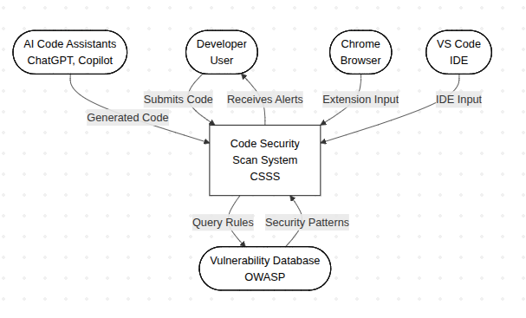
Figure 1 Context diagram

3.9.2.2 Use case diagram
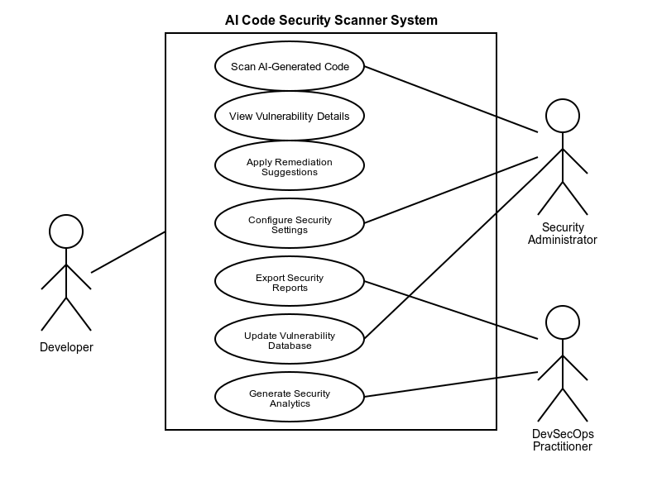
Figure 2 Use case diagram

3.9.2.3 Activity diagram
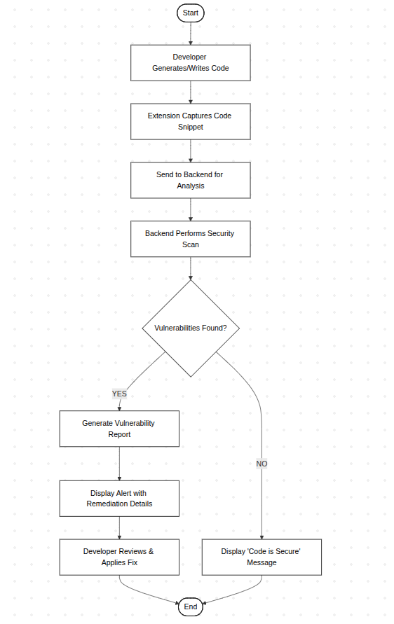
Figure 3 Activity diagram

3.9.2.4 Entity relationship diagram
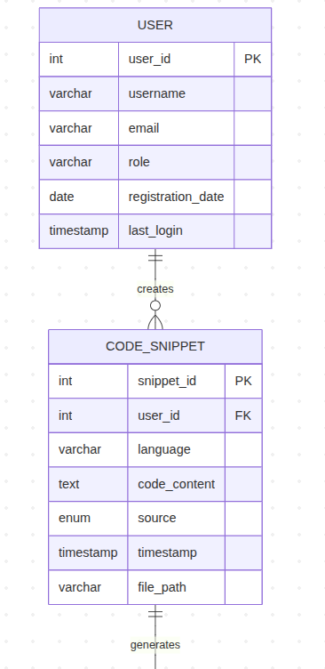
Figure 4 Entity relationship diagram 1
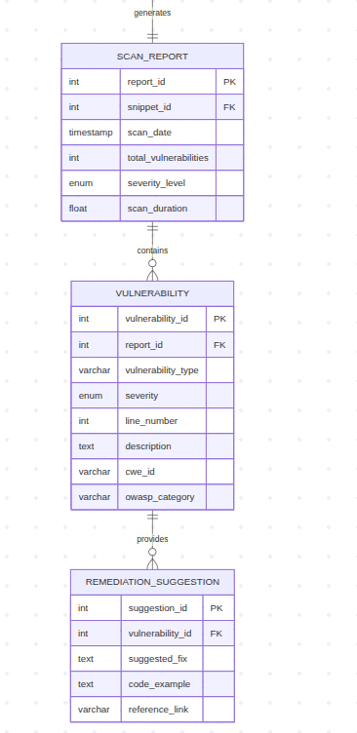
Figure 5 Entity relationship diagram 2

3.9.3 System Requirements

3.9.3.1 Hardware requirements
- Development Machine: Intel i5+, 16GB RAM, 512GB SSD.
- Server: 4GB RAM, 2-core CPU, 50GB storage (cloud-based).
- Network: Stable broadband internet.

3.9.3.2 Software requirements
- Frontend: JavaScript/TypeScript, Chrome Extension API, VS Code Extension API.
- Backend: Python (FastAPI), Security Libraries (Bandit, ESLint with security plugins).
- Database: PostgreSQL.
- Tools: Git, Docker, Postman, VS Code, Chrome DevTools.

3.10 Validation and Testing
The validation and testing phase is critical to ensuring the reliability, effectiveness, and efficiency of the CSSS prototype. This process will follow a structured hierarchy, beginning with Unit Testing, where individual software components such as specific browser extension functions and backend API endpoints are tested in isolation to verify they perform their intended tasks correctly. Once individual components are stabilized, Integration Testing will be conducted to evaluate the seamless flow of data and communication between the Chrome/VS Code extensions and the backend security engine. To ensure the system meets the high-speed demands of modern development, Performance Testing will be used to measure technical KPIs, specifically targeting a response time of under 2 seconds per scan and a detection accuracy rate of at least 90%. Finally, the project will culminate in User Acceptance Testing (UAT), where the target audience of software developers will interact with the system in a real-world environment to provide feedback on its usability and to ensure the final product effectively addresses the security gaps identified in the research.

3.11 Ethical Considerations

- Privacy: Code snippets will be anonymized and no sensitive data stored.
- Consent: Participants will provide informed consent for testing.
- Transparency: Users will be informed about data usage and analysis scope.
- Security: All data transmissions will be encrypted (HTTPS).

REFERENCES
GitHub. (2023, 10 2). GitHub Copilot Documentation. GitHub Copilot Documentation. Retrieved 2025, from https://docs.github.com/en/copilot
OWASP Foundation. (2025, 11 6). OWASP Top Ten. OWASP Top Ten. Retrieved 2025, from https://owasp.org/www-project-top-ten/
Pearce, H. (2022). Examining Zero-Day Vulnerabilities in AI-Generated Code. ACM Conference on Computer and Communications Security. Examining Zero-Day Vulnerabilities in AI-Generated Code. ACM Conference on Computer and Communications Security. Retrieved 11 30, 2025, from https://arxiv.org/pdf/2112.02125
Snyk. (2023, 10 2). Snyk Code: Real-Time SAST. Real-Time SAST. Retrieved 2025, from https://snyk.io/product/snyk-code/

APPENDIX 1: ESTIMATED BUDGET

Table 2 ESTIMATED BUDGET
ITEM | COST (KES) | DESCRIPTION
Software Licenses & Tools | 15,000 | Figma
Cloud Hosting | 12,000 | AWS
API Subscriptions | 8,000 | Vulnerability database access
Testing & User Incentives | 5,000 | Participant rewards
Miscellaneous | 5,000 | Documentation
TOTAL | 45,000

APPENDIX 2: GANTT CHART

Table 3 GANTT CHART
ACTIVITY | SEP 2025 | OCT 2025 | NOV 2025
CHAPTER 1
LITERATURE REVIEW
LITERATURE REVIEW
METHODOLOGY
METHODOLOGY

