Insert your centre number, name and candidate number into the header above.
Save this evidence document as evidence_ followed by your centre number_ candidate number. For example: evidence_ zz999_9999
Screenshots or program listings must be copied into appropriate cells in the following table.
Examiners must be able to read the contents including any screenshots without the use of a magnifying glass. Answers that are not readable or missing will not be awarded any marks.
Save this evidence document at regular intervals, for example every 10 minutes.
Question 1
Part 1(a)
global StackPointer # Integer
global StackData # Array

MaxLength = 10
StackData = [0 for i in range(MaxLength)]
StackPointer = 0
Part 1(b)
def PrintData():
global StackData
global StackPointer

for n in range(len(StackData)):
print(StackData[n])

print(StackPointer)
Part 1(c)
def Push(int):
global StackData
global StackPointer

if StackPointer == 10:
return False
else:
StackData[StackPointer] = int
StackPointer += 1
return True
Part 1(d)(i)
inx = 1
while inx <= 11:
num = int(input("Please enter an integer: "))
if Push(num):
print("Number was successfully added to the stack")
else:
print("Stack is full, number not added")
inx += 1
PrintData()
Part 1(d)(ii)
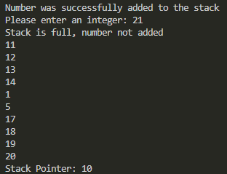
Part 1(e)(i)
def Pop():
global StackPointer
global StackData

if StackPointer == 0:
return -1
else:
item = StackData[StackPointer -1]
StackPointer -= 1
return item
Part 1(e)(ii)
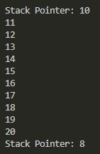
Question 2
Part 2(a)
Import random

arr = [[0]*10 for i in range(10)]
for i in range(len(arr)):
for j in range(len(arr[i])):
arr[i][j] = random.randint(1, 100)

Part 2(b)(i)
print("Before:")
printArr()

arrLength = 10
for x in range(0, arrLength):
for y in range(0, arrLength-1):
for z in range(0, arrLength-y-1):
if arr[x][z] > arr[x][z+1]:
temp = arr[x][z]
arr[x][z] = arr[x][z+1]
arr[x][z+1] = temp

print("After:")
printArr()

Part 2(b)(ii)
def printArr():
for a in range(len(arr)):
for b in range(len(arr[a])):
print(arr[a][b], " ", end='')
print("")
Part 2(b)(iii)
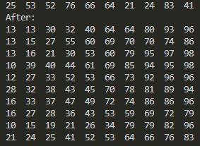
Part 2(c)(i)
def BinarySearch(array, lower, upper, value):
if upper >= lower:
mid = (lower+(upper-1))//2
if array[0][mid] == value:
return mid
elif array[0][mid] > value:
return BinarySearch(array, lower, mid-1, value)
else:
return BinarySearch(array, mid+1, upper, value)

return -1
Part 2(c)(ii)
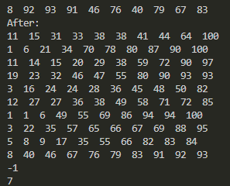
Question 3
Part 3(a)
class Card:
# Number - Integer
# Colour - String
def __init__(self, num, col):
self.__Number = num
self.__Colour = col
Part 3(b)
def GetNumber(self):
return self.__Number

def GetColour(self):
return self.__Colour
Part 3(c)
arr = [Card for i in range(30)]

try:
cardsFile = open('CardValues.txt', "r")
for i in range(0, 30):
currNum = int(cardsFile.readline())
currCol = cardsFile.readline()
arr[i] = Card(currNum, currCol)

cardsFile.close()
except IOError:
print("File could not be opened")
Part 3(d)
global chosen
chosen = []

def ChooseCard():
global chosen
available = False
while not available:
inx = int(input("Please input the index of the card you want (1-30): "))
if(inx > 0 and inx <= 30):
if inx in chosen:
print("That card has already been chosen please choose another.")
available = False
else:
chosen.append(inx)
available = True
else:
print("Please input a number between 1 and 30 only")
available = False
Part 3(e)(i)
Player1 = [] # of Card

while len(Player1) < 4:
Player1.append(arr[ChooseCard()])

for c in Player1:
print(c.GetNumber(), c.GetColour())
Part 3(e)(ii)
