To use the UART peripheral we have to install the software component in the project. With this component it includes all the neccesery files and the driver.

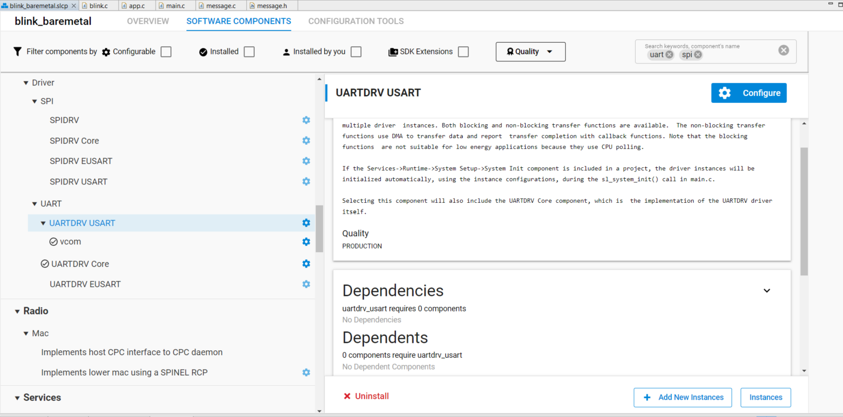

After that we have to enbale the sensor because it is built in the development board. To do this open the pin tool, then select PC09 (this is the sensor enable pin) click on edit and enable the IMU.

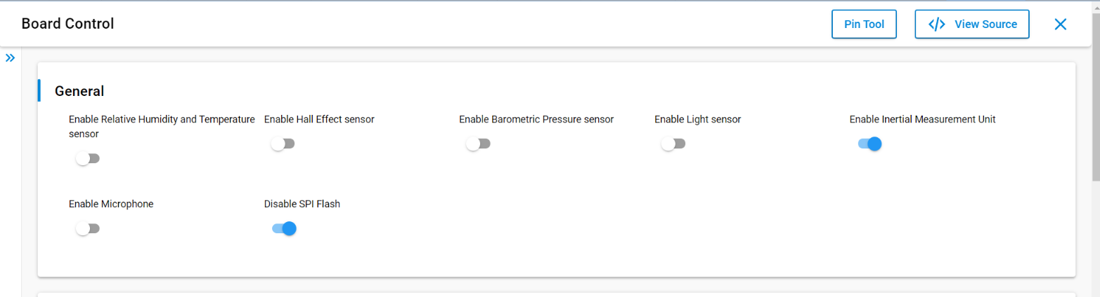

In the code, first initialize the sensor by:

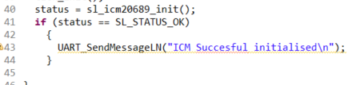

After that we can simply read the value of the accelerometer:

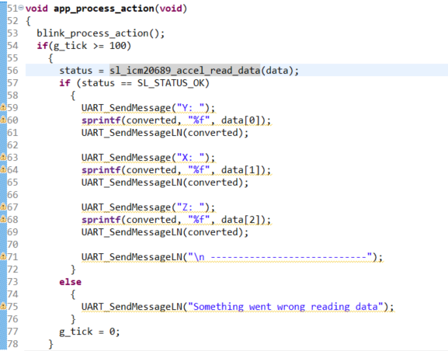

We can do the same for the gyroscope:

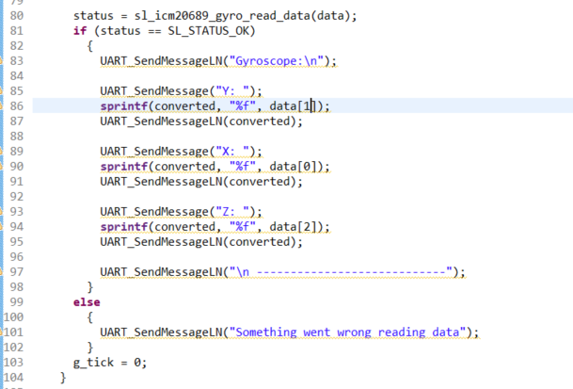

The received data looks like this:

