**Software Engineering Assessment**

*Guidelines:*

* *There are a wide variety of solutions here, it’s up to you how simple or complicated you would like approach this.*
* *This assessment is intended to take about 1 hour.*
* *Be prepared to discuss your solution.*
* *Please ask questions if needed for any clarification.*

You have been recruited to create software for a Spacecraft. The Spacecraft runs autonomously and communicates with the Mission Control using commands and telemetry. Commands are sent to the vehicle to control it, and telemetry is sent from the vehicle to Mission Control to describe the state of every system on board.

The telemetry is composed of nested data structures containing base values. For instance, there is a collection (or packet) of telemetry that contains information about the temperature, pressure, and power levels in the front of the vehicle.

In order for Mission Control to understand the telemetry, there is a database that contains the definition for every telemetry item that can be sent, and every telemetry collection (or packet). The database structure is shown in the diagram below.

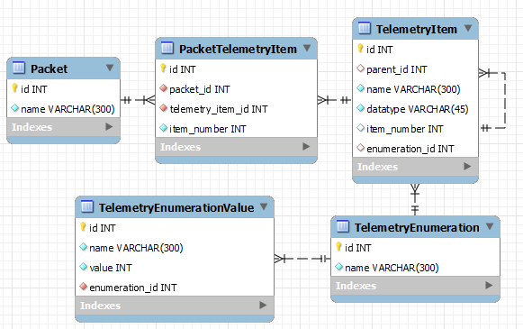

The database already contains the telemetry information, but other systems cannot talk to the database directly. In order to use the information, Mission Control needs a CSV file created per packet that contains all the telemetry information. This data export is already partially written in Python, but it runs too slowly currently, and it is missing nested telemetry items. The program files are attached with this document.

Your tasks are as follows:

1. Review the current export code. Identify and explain the current problems and determine how the code can be optimized. Also review the coding style and see how the code can be improved for future maintainability. Document your findings so the original developer can learn and improve.
2. Given your review, edit and optimize the code. Keep in mind execution speed, readability, and future maintainability by other developers.
3. Modify the code to include all nested telemetry items, in addition to the highest-level items. The output of the code should appear similar to the example below.

Sample data output

