**Task 1**

<https://www.jdoodle.com/a/7Ite>

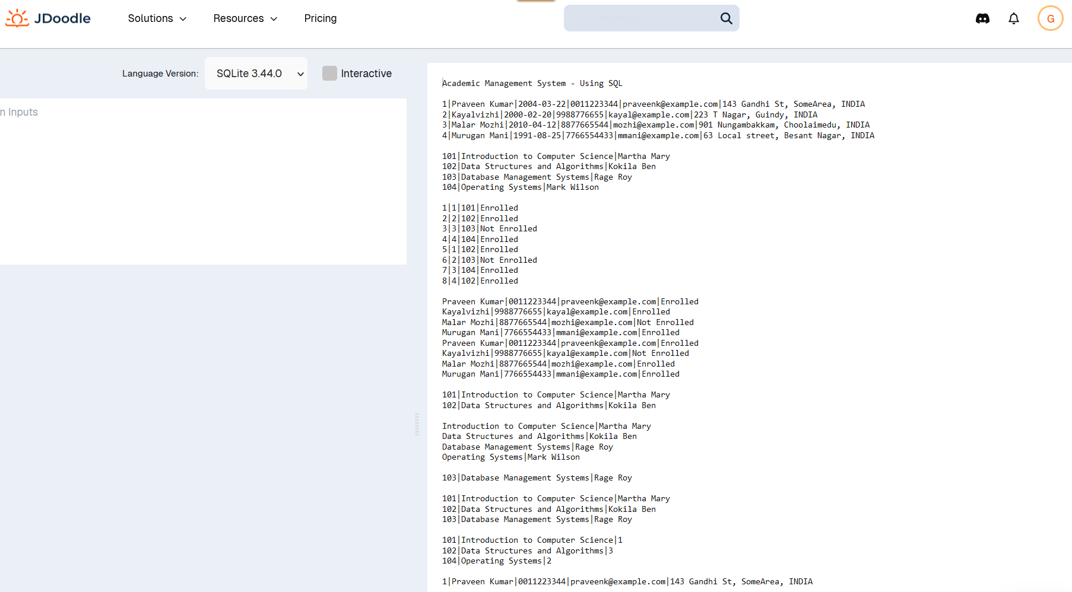

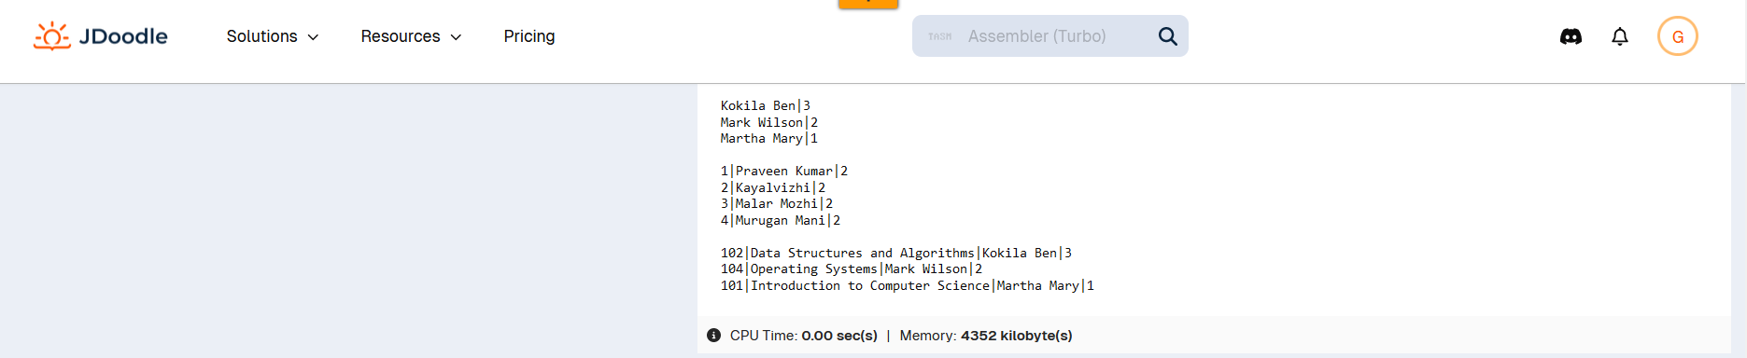

SELECT('Academic Management System - Using SQL');

SELECT(' ');

CREATE TABLE STUDENT_INFO (

STU_ID INT PRIMARY KEY,

STU_NAME VARCHAR(100),

DOB DATE,

PHONE_NO VARCHAR(15),

EMAIL_ID VARCHAR(100),

ADDRESS VARCHAR(255)

);

INSERT INTO STUDENT_INFO (STU_ID, STU_NAME, DOB, PHONE_NO, EMAIL_ID, ADDRESS)

VALUES

(1, 'Praveen Kumar', '2004-03-22', '0011223344', 'praveenk@example.com', '143 Gandhi St, SomeArea, INDIA'),

(2, 'Kayalvizhi', '2000-02-20', '9988776655', 'kayal@example.com', '223 T Nagar, Guindy, INDIA'),

(3, 'Malar Mozhi', '2010-04-12', '8877665544', 'mozhi@example.com', '901 Nungambakkam, Choolaimedu, INDIA'),

(4, 'Murugan Mani', '1991-08-25', '7766554433', 'mmani@example.com', '63 Local street, Besant Nagar, INDIA');

SELECT * FROM STUDENT_INFO;

SELECT(' ');

CREATE TABLE CoursesInfo (

COURSE_ID INT PRIMARY KEY,

COURSE_NAME VARCHAR(100),

COURSE_INSTRUCTOR_NAME VARCHAR(100)

);

INSERT INTO CoursesInfo (COURSE_ID, COURSE_NAME, COURSE_INSTRUCTOR_NAME)

VALUES

(101, 'Introduction to Computer Science', 'Martha Mary'),

(102, 'Data Structures and Algorithms', 'Kokila Ben'),

(103, 'Database Management Systems', 'Rage Roy'),

(104, 'Operating Systems', 'Mark Wilson');

SELECT * FROM CoursesInfo;

SELECT(' ');

CREATE TABLE EnrollmentInfo (

ENROLLMENT_ID INT PRIMARY KEY,

STU_ID INT,

COURSE_ID INT,

ENROLL_STATUS VARCHAR(20),

FOREIGN KEY (STU_ID) REFERENCES StudentInfo (STU_ID),

FOREIGN KEY (COURSE_ID) REFERENCES CoursesInfo (COURSE_ID)

);

INSERT INTO EnrollmentInfo (ENROLLMENT_ID, STU_ID, COURSE_ID, ENROLL_STATUS)

VALUES

(1, 1, 101, 'Enrolled'),

(2, 2, 102, 'Enrolled'),

(3, 3, 103, 'Not Enrolled'),

(4, 4, 104, 'Enrolled'),

(5, 1, 102, 'Enrolled'),

(6, 2, 103, 'Not Enrolled'),

(7, 3, 104, 'Enrolled'),

(8, 4, 102, 'Enrolled');

SELECT * FROM EnrollmentInfo;

SELECT(' ');

/*a*/

SELECT

s.STU_NAME,

s.PHONE_NO,

s.EMAIL_ID,

e.ENROLL_STATUS

FROM

STUDENT_INFO s

JOIN

EnrollmentInfo e ON s.STU_ID = e.STU_ID;

SELECT(' ');

/*b*/

SELECT

c.COURSE_ID,

c.COURSE_NAME,

c.COURSE_INSTRUCTOR_NAME

FROM

CoursesInfo c

JOIN

EnrollmentInfo e ON c.COURSE_ID = e.COURSE_ID

WHERE

e.STU_ID = 1

AND

e.ENROLL_STATUS = 'Enrolled';

SELECT(' ');

/*c*/

SELECT

COURSE_NAME,

COURSE_INSTRUCTOR_NAME

FROM

CoursesInfo;

SELECT(' ');

/*d*/

SELECT

COURSE_ID,

COURSE_NAME,

COURSE_INSTRUCTOR_NAME

FROM

CoursesInfo

WHERE

COURSE_ID = 103;

SELECT(' ');

/*e*/

SELECT

COURSE_ID,

COURSE_NAME,

COURSE_INSTRUCTOR_NAME

FROM

CoursesInfo

WHERE

COURSE_ID IN (101, 102, 103);

SELECT(' ');

/*Reporting - a*/

SELECT

c.COURSE_ID,

c.COURSE_NAME,

COUNT(e.STU_ID) AS NUM_ENROLLED

FROM

CoursesInfo c

LEFT JOIN

EnrollmentInfo e ON c.COURSE_ID = e.COURSE_ID

WHERE

e.ENROLL_STATUS = 'Enrolled'

GROUP BY

c.COURSE_ID, c.COURSE_NAME;

SELECT(' ');

/*Reporting - b*/

SELECT

s.STU_ID,

s.STU_NAME,

s.PHONE_NO,

s.EMAIL_ID,

s.ADDRESS

FROM

STUDENT_INFO s

JOIN

EnrollmentInfo e ON s.STU_ID = e.STU_ID

WHERE

e.COURSE_ID = 101

AND

e.ENROLL_STATUS = 'Enrolled';

SELECT(' ');

/*Reporting - c*/

SELECT

c.COURSE_INSTRUCTOR_NAME,

COUNT(DISTINCT e.STU_ID) AS NUM_ENROLLED_STUDENTS

FROM

CoursesInfo c

JOIN

EnrollmentInfo e ON c.COURSE_ID = e.COURSE_ID

JOIN

STUDENT_INFO s ON e.STU_ID = s.STU_ID

WHERE

e.ENROLL_STATUS = 'Enrolled'

GROUP BY

c.COURSE_INSTRUCTOR_NAME;

SELECT(' ');

/*Reporting - d*/

SELECT

s.STU_ID,

s.STU_NAME,

COUNT(e.COURSE_ID) AS NUM_COURSES_ENROLLED

FROM

STUDENT_INFO s

JOIN

EnrollmentInfo e ON s.STU_ID = e.STU_ID

GROUP BY

s.STU_ID, s.STU_NAME

HAVING

COUNT(e.COURSE_ID) > 1;

SELECT(' ');

/*Reporting - e*/

SELECT

c.COURSE_ID,

c.COURSE_NAME,

c.COURSE_INSTRUCTOR_NAME,

COUNT(e.STU_ID) AS NUM_ENROLLED_STUDENTS

FROM

CoursesInfo c

JOIN

EnrollmentInfo e ON c.COURSE_ID = e.COURSE_ID

WHERE

e.ENROLL_STATUS = 'Enrolled'

GROUP BY

c.COURSE_ID, c.COURSE_NAME, c.COURSE_INSTRUCTOR_NAME

ORDER BY

NUM_ENROLLED_STUDENTS DESC;

**Task 2**

1)

postgres=# CREATE DATABASE student_database;

CREATE DATABASE

postgres=# \l

psql -U postgres -d student_database

CREATE TABLE student_table (

Student_id INTEGER PRIMARY KEY,

Stu_name TEXT NOT NULL,

Department TEXT NOT NULL,

email_id TEXT NOT NULL,

Phone_no NUMERIC NOT NULL,

Address TEXT,

Date_of_birth DATE,

Gender TEXT,

Major TEXT,

GPA NUMERIC CHECK (GPA >= 0 AND GPA <= 4.0),

Grade TEXT CHECK (Grade IN ('A', 'B', 'C', 'D', 'F'))

);

2)

psql -U postgres -d student_database

INSERT INTO student_table (Student_id, Stu_name, Department, email_id, Phone_no, Address, Date_of_birth, Gender, Major, GPA, Grade) VALUES

(1, 'John Doe', 'Computer Science', 'johndoe@example.com', 1234567890, '123 Main St', '2000-01-15', 'Male', 'Software Engineering', 3.5, 'A'),

(2, 'Jane Smith', 'Biology', 'janesmith@example.com', 2345678901, '456 Elm St', '1999-02-20', 'Female', 'Genetics', 3.7, 'A'),

(3, 'Alice Johnson', 'Mathematics', 'alicejohnson@example.com', 3456789012, '789 Maple St', '2001-03-25', 'Female', 'Statistics', 3.2, 'B'),

(4, 'Bob Brown', 'Physics', 'bobbrown@example.com', 4567890123, '101 Oak St', '2000-04-30', 'Male', 'Astrophysics', 3.8, 'A'),

(5, 'Charlie Davis', 'Chemistry', 'charliedavis@example.com', 5678901234, '202 Pine St', '1998-05-05', 'Male', 'Organic Chemistry', 2.9, 'C'),

(6, 'Dana Evans', 'History', 'danaevans@example.com', 6789012345, '303 Birch St', '1997-06-10', 'Female', 'Medieval History', 3.4, 'B'),

(7, 'Evan Foster', 'Art', 'evanfoster@example.com', 7890123456, '404 Cedar St', '1999-07-15', 'Male', 'Graphic Design', 3.6, 'A'),

(8, 'Fiona Green', 'Literature', 'fionagreen@example.com', 8901234567, '505 Spruce St', '2000-08-20', 'Female', 'Modern Literature', 3.3, 'B'),

(9, 'George Harris', 'Philosophy', 'georgeharris@example.com', 9012345678, '606 Willow St', '1998-09-25', 'Male', 'Ethics', 3.1, 'B'),

(10, 'Hannah White', 'Economics', 'hannahwhite@example.com', 1234567899, '707 Ash St', '1997-10-30', 'Female', 'Microeconomics', 3.9, 'A');

3)

psql -U postgres -d student_database

SELECT * FROM student_table

ORDER BY Grade DESC;

4)

psql -U postgres -d student_database

SELECT * FROM student_table

WHERE Gender = 'Male';

5)

psql -U postgres -d student_database

SELECT * FROM student_table

WHERE GPA < 5.0;

6)

psql -U postgres -d student_database

UPDATE student_table

SET email_id = 'new_email@example.com', Grade = 'B'

WHERE Student_id = 1;

7)

psql -U postgres -d student_database

SELECT Stu_name,

DATE_PART('year', AGE(CURRENT_DATE, Date_of_birth)) AS Age

FROM student_table

WHERE Grade = 'B';

8)

psql -U postgres -d student_database

SELECT Department,

Gender,

AVG(GPA) AS Average_GPA

FROM student_table

GROUP BY Department, Gender

ORDER BY Department, Gender;

9)

psql -U postgres -d student_database

ALTER TABLE student_table RENAME TO student_info;

10)

psql -U postgres -d student_database

SELECT Stu_name

FROM student_info

WHERE GPA = (

SELECT MAX(GPA)

FROM student_info

);

**Task 3:**

1)

psql -U postgres

CREATE DATABASE EventsManagement;

\l

psql -U postgres -d EventsManagement

-- Create Events table

CREATE TABLE Events (

Event_Id SERIAL PRIMARY KEY,

Event_Name TEXT NOT NULL,

Event_Date DATE NOT NULL,

Event_Location TEXT,

Event_Description TEXT

);

-- Create Attendees table

CREATE TABLE Attendees (

Attendee_Id SERIAL PRIMARY KEY,

Attendee_Name TEXT NOT NULL,

Attendee_Phone TEXT,

Attendee_Email TEXT,

Attendee_City TEXT

);

-- Create Registrations table

CREATE TABLE Registrations (

Registration_id SERIAL PRIMARY KEY,

Event_Id INT NOT NULL,

Attendee_Id INT NOT NULL,

Registration_Date DATE NOT NULL,

Registration_Amount NUMERIC,

FOREIGN KEY (Event_Id) REFERENCES Events(Event_Id),

FOREIGN KEY (Attendee_Id) REFERENCES Attendees(Attendee_Id)

);

2)

psql -U postgres -d EventsManagement

-- Insert sample data into Events table

INSERT INTO Events (Event_Name, Event_Date, Event_Location, Event_Description)

VALUES

('Conference 2024', '2024-08-15', 'New York', 'Annual conference for technology enthusiasts'),

('Workshop on Data Science', '2024-09-20', 'San Francisco', 'Hands-on workshop covering data science techniques'),

('Networking Event', '2024-07-30', 'Chicago', 'Networking event for professionals in the industry');

-- Insert sample data into Attendees table

INSERT INTO Attendees (Attendee_Name, Attendee_Phone, Attendee_Email, Attendee_City)

VALUES

('John Doe', '123-456-7890', 'john.doe@example.com', 'New York'),

('Jane Smith', '987-654-3210', 'jane.smith@example.com', 'San Francisco'),

('Michael Johnson', '555-555-5555', 'michael.johnson@example.com', 'Chicago'),

('Emily Davis', '111-222-3333', 'emily.davis@example.com', 'Los Angeles');

-- Insert sample data into Registrations table

INSERT INTO Registrations (Event_Id, Attendee_Id, Registration_Date, Registration_Amount)

VALUES

(1, 1, '2024-08-01', 100.00),

(1, 2, '2024-07-25', 100.00),

(2, 3, '2024-09-10', 75.00),

(3, 4, '2024-07-20', 50.00),

(3, 1, '2024-07-25', 50.00);

3)a)

INSERT INTO Events (Event_Name, Event_Date, Event_Location, Event_Description)

VALUES ('Tech Expo 2025', '2025-05-20', 'London', 'Annual technology exhibition showcasing innovations');

3)b)

UPDATE Events

SET Event_Name = 'Updated Event Name',

Event_Date = '2025-06-15',

Event_Location = 'Paris',

Event_Description = 'Updated description for the event'

WHERE Event_Id = 1; -- Replace with the actual Event_Id of the event you want to update

3)c)

DELETE FROM Events

WHERE Event_Id = 1; -- Replace with the actual Event_Id of the event you want to delete

4)a)

INSERT INTO Attendees (Attendee_Name, Attendee_Phone, Attendee_Email, Attendee_City)

VALUES ('Alice Johnson', '555-123-4567', 'alice.johnson@example.com', 'New York');

4)b)

INSERT INTO Registrations (Event_Id, Attendee_Id, Registration_Date, Registration_Amount)

VALUES (1, 1, '2024-07-03', 0.00);

4)c)

SELECT Event_Id, Event_Name, Event_Date, Event_Location, Event_Description

FROM Events;

SELECT A.Attendee_Id, A.Attendee_Name, A.Attendee_Email, A.Attendee_City

FROM Attendees A

JOIN Registrations R ON A.Attendee_Id = R.Attendee_Id

WHERE R.Event_Id = 1; -- Replace with the Event_Id of the event you are interested in

SELECT E.Event_Id, E.Event_Name, COUNT(R.Attendee_Id) AS Attendee_Count

FROM Events E

LEFT JOIN Registrations R ON E.Event_Id = R.Event_Id

GROUP BY E.Event_Id, E.Event_Name

ORDER BY Attendee_Count DESC;

**Task 4:**

1)

CREATE DATABASE sales_database;

\l

CREATE TABLE sales_sample (

Product_Id INTEGER,

Region VARCHAR(50),

Date DATE,

Sales_Amount NUMERIC

);

2)

INSERT INTO sales_sample (Product_Id, Region, Date, Sales_Amount)

VALUES

(1, 'East', '2024-01-01', 1000.00),

(2, 'West', '2024-01-02', 1500.50),

(3, 'North', '2024-01-03', 800.75),

(1, 'East', '2024-01-04', 1200.25),

(2, 'West', '2024-01-05', 1350.30),

(3, 'North', '2024-01-06', 950.00),

(1, 'East', '2024-01-07', 1100.50),

(2, 'West', '2024-01-08', 1400.75),

(3, 'North', '2024-01-09', 850.25),

(1, 'East', '2024-01-10', 1300.20);

3)a)

SELECT

Region,

Product_Id,

SUM(Sales_Amount) AS Total_Sales_Amount

FROM

sales_sample

GROUP BY

Region, Product_Id

ORDER BY

Region, Product_Id;

3)b)

SELECT

Product_Id,

Region,

SUM(Sales_Amount) AS Total_Sales_Amount

FROM

sales_sample

GROUP BY

Product_Id, Region

ORDER BY

Product_Id, Region;

SELECT

COALESCE(Product_Id::TEXT, 'Total') AS Product_Id,

COALESCE(Region, 'Total') AS Region,

COALESCE(CAST(Date AS TEXT), 'Total') AS Date,

SUM(Sales_Amount) AS Total_Sales_Amount

FROM

sales_sample

GROUP BY

CUBE(Product_Id, Region, Date)

ORDER BY

Product_Id, Region, Date;

3)c)

SELECT

Product_Id,

Region,

Date,

Sales_Amount

FROM

sales_sample

WHERE

Region = 'East';

3)d)

SELECT

Product_Id,

Region,

Date,

Sales_Amount

FROM

sales_sample

WHERE

Date BETWEEN '2024-01-01' AND '2024-01-10';

3)e)

SELECT

Product_Id,

Region,

Date,

Sales_Amount

FROM

sales_sample

WHERE

Product_Id = 1

AND Region = 'East'

AND Date BETWEEN '2024-01-01' AND '2024-01-10';