Undergraduate Capstone Project

Submitted to the Faculty of the

Cavite State University – Bacoor Campus

Bacoor, Cavite

In partial fulfillment

Of the requirements for the degree of

Bachelor of Science in Information Technology

**PAULO AQUINO**

**LOUISE CARLO INTONG**

**AERON AMIEL RECTO**

November 2023

**PAULO AQUINO**

**LOUISE CARLO INTONG**

**AERON AMIEL RECTO**

An undergraduate capstone project manuscript submitted to the faculty of the Department of Information Technology, Cavite State University, Bacoor Campus, Bacoor, Cavite in partial fulfillment of the requirements for the degree Bachelor of Science in Information Technology. Contribution No. . Prepared under the supervision of Ms. Ely Rose L. Panganiban-Briones, MIT.

**INTRODUCTION**

In the lively cityscape of Bacoor, local services merge with the rhythm of daily life, serving as essential threads that bind the community together. From essential utilities and daily conveniences to specialized offerings, local businesses form the foundation of Bacoor's economic and social interconnectedness. These services cover various needs, including personal care services, healthcare, home maintenance, and unique artisanal products. Residents in Bacoor mostly rely on traditional searches, word of mouth recommendations, and social media to find the local services they need. Challenges related to affordability, quality expectations, information accessibility, and significant wait times underscore the complexities faced by the community.

Bacoor City thrives on the strengths of its local businesses, forming a unique blend of residential, commercial, and specialized providers. However, the survey draws attention to shortcomings in this composition and suggests areas for development. This sets the stage for the ServEase: Web-Based Local Services Marketplace system, a groundbreaking initiative poised to transform the local service landscape. ServEase strives to be a driver for positive change, enhancing accessibility, affordability, and service quality while fostering community engagement.

**Project Context**

The 'ServEase: Web-Based Local Services Marketplace System for the city of Bacoor' project is dedicated to enhancing the quality of life for residents through the introduction of an innovative platform. The primary objective is to create a user-friendly marketplace that addresses specific challenges faced by the residents of Bacoor City. The project aims to improve accessibility, making essential local services easily discoverable, while also addressing concerns about affordability, service quality, information accessibility, and reducing wait times. The platform actively promotes community engagement by encouraging collaboration between residents and local service providers.

The system is envisioned to cultivate community engagement by facilitating collaboration between residents and local service providers in our interconnected world. The project focuses on improving the overall quality of life for Bacoor City residents by introducing a user-friendly marketplace that allows for seamless communication and contributes to the diverse range of local services available. Serving as a medium for community connection, the system facilitates easy service exchanges and fosters trust throughout Bacoor City. In response to the city's evolving needs, the project maintains flexibility and cultural relevance, with the development team dedicated to shaping a system that is not only practical but also culturally aware, ensuring its success within the distinct context of Bacoor City.

Top of Form

Forming partnerships and adding features to the Local Services Marketplace System across Bacoor City help keep the project flexible and responsive to the city's different needs. Adapting to the growing needs of Bacoor City requires making the system flexible and culturally useful. By understanding the project's surroundings, the development team hopes to shape the system to be practical, culturally aware, and successful.

**Objectives of the Study**

The objective of the study was to develop a local services marketplace for the residents of Bacoor. The goals focus on meeting specific needs within Bacoor City while ensuring the system's success and lasting impact. The project aims to:

1. Create an easy-to-use digital platform that:
   1. brings together various local services across Bacoor City for easier access and efficient service.
   2. Improve communication and collaboration between residents and local service providers in Bacoor City, promoting community involvement and support.
   3. Enhance the efficiency of local service transactions citywide by simplifying processes, leading to quicker responses and happier customers.
   4. Support Bacoor City's economic growth by empowering local businesses through the marketplace, contributing to the city's overall development.
   5. Assess the system's impact on Bacoor City's community, gathering feedback to continuously improve and ensure long-term success.
2. Develop the website using the following:
   1. Django Framework
   2. Python for programming language
   3. PyCharm and Visual Studio Code for IDE
3. Test the system in terms of unit, integration, and system testing.
4. Prepare an implementation plan.

**Purpose and Description**

The project is designed to elevate Bacoor City's economic landscape and empower its community through the integration of technology, facilitating excellent connections between residents and local services. Its primary goal is to comprehend the unique needs of the city and develop a system that enhances accessibility to services while fostering the growth of local businesses.

This initiative adds value to the existing body of knowledge by presenting a practical and innovative solution that directly benefits the community. The project's innovation is demonstrated through its user-friendly features, streamlined service connections, and dedicated support for the prosperity of local businesses. By harnessing technology, the project aspires to create a significant impact on the local service landscape, ultimately contributing to the overall advancement of Bacoor City.

**Time and Place of the Study**

The study was primarily conducted at the residence of the researchers, which served as the main venue for the study. The residence is situated at Blk 18 Lot 28 Everlasting St., Queen's Row West, Bacoor, Cavite, and serves as the home of one of the project members. Another venue utilized for the study is the Cavite State University Bacoor Campus, located at Soldiers Hills IV, Molino VI, Bacoor City, Cavite. Both locations played significant roles in research activities and collaborative meetings.

Research sessions commenced in November 2023 and are presently ongoing, facilitating the continuous processes of data collection, discussions, and project development.

**Scope and Limitation of the Study**

This study aims to design and implement an efficient Local Services Marketplace System customized for Bacoor City, with a concentrated effort on crafting a user-friendly digital platform to facilitate better connections between residents and local service providers. The project encompasses technological components, including internet accessibility, user interface design, and features essential for service listing, search functionality, messaging, reviews, and local business promotion within Bacoor City.

While the goal is to create a comprehensive system, certain limitations may affect the effectiveness of the web-based platform. Challenges related to the availability and reliability of internet connectivity among Bacoor City residents could impact the system's functionality. Additionally, budget constraints for web development may pose challenges, potentially influencing the inclusion of certain features and limiting the system's scalability. The study acknowledges these constraints and aims to navigate them effectively to deliver a valuable and practical Local Services Marketplace System for Bacoor City.

**Conceptual Framework**

**Figure 1.** Conceptual Framework of the Study

**METHODOLOGY**

The chapter outlines the design and development process of the Web-Based Local Services Marketplace System for Bacoor City. It encompasses various critical phases, including the design of software, system development, testing procedures, evaluation methods, and an implementation plan tailored for the study.

**Design of Software, Systems, Product and/or Processes**

Figure 2 presents the hierarchical input-process-output diagram in Bacoor City's Local Services Marketplace System. The system responds to inputs such as user registration data, service listing input, and service searching. The data is processed by the system by creating user profiles, managing service listings, facilitating searches, enabling messaging, and handling reviews. The outcomes are displayed as User Profiles Display, Service Listings Display, Search Results Showcase, Messaging Interface, and Reviews and Ratings Display.

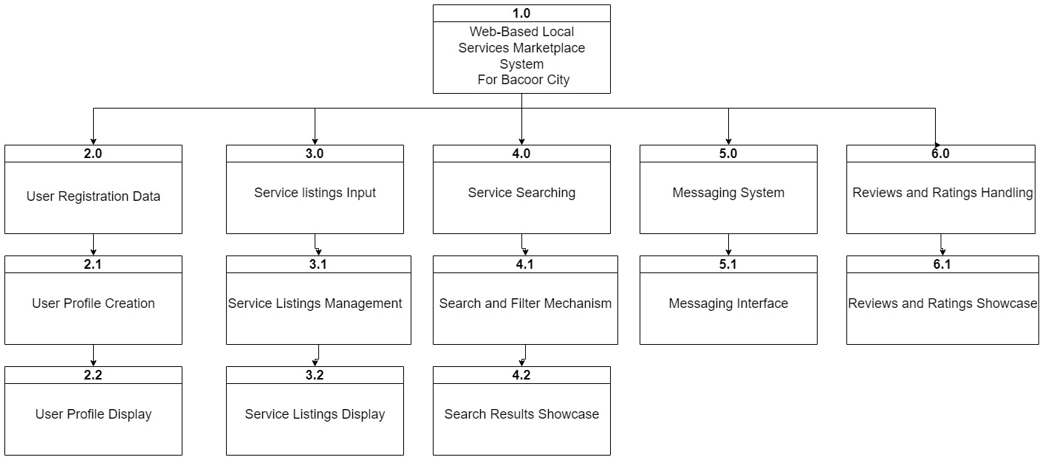

**Figure 2. HIPO diagram of the Local Services Marketplace System**

**Requirements Analysis**

The Researchers conducted interviews with skilled workers in our continued efforts to develop the Local Services Marketplace System to meet the unique needs of the Bacoor City community. The responses from this interview play an important role in improving the system's functions. Providing a smooth experience for our users, and the insights gained from interviews play an important part in accomplishing this objective.  
 Paying close attention to the diverse opinions and expectations of the residents of Bacoor City is essential as the survey findings are assessed. This collaborative approach guarantees that the Local Services Marketplace System is meticulously tailored to meet the diverse needs and expectations of the Bacoor City community, ensuring its relevance, usability, and effectiveness in enhancing the local service ecosystem.

**Requirements Documentation**

The system's required documentation encompasses a range of essential documents crucial for the effective development, implementation, and maintenance of the system. The Requirements Specification document serves to outline associated requirements, covering both functional and non-functional needs, along with system requirements constraints. The Design of System document provides comprehensive details about the system architecture, user interface design, and database structure. For testing purposes, the Test Planning document is essential, defining the testing approach, test scenarios, and acceptance criteria to verify the reliability of the platform.

The Deployment plan outlines the systematic process of releasing the system into a production environment, ensuring a seamless transition from development to live operation. After deployment, the Maintenance Plan comes into play, specifying how the system will be maintained. This document contains methods for upgrades, improvements, and ongoing support.

Gather valuable insights for continuous improvement, the Feedback and Evaluation document is designed to collect feedback from users and stakeholders. Finally, the Review and Approval process is detailed, outlining the procedures for reviewing and approving each document, involving relevant stakeholders in the decision-making process.

**System Development**

The Web-based Local Services Marketplace System was developed using the agile methodology, which consists of six iterative stages: planning, designing, developing, testing, deployment, review, and launching.

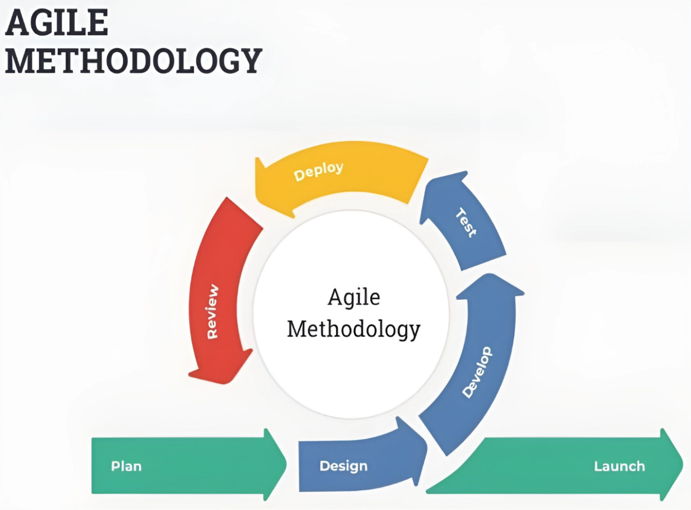

**Figure 3. Agile Model**

**Planning**

The planning phase is an iterative and ongoing process that occurs at multiple levels, from high-level release planning to detailed iteration planning. The project team engaged in extensive collaboration to meticulously outline the precise features and functionalities required for the Local Services Marketplace System.

**Designing**

The Designing phase in the software development process is a critical stage where the conceptualized system begins to take shape in terms of its structure, appearance, and functionality. During the Designing phase, the system's look and structure were planned out. The researchers aimed for an easy-to-use interface that suits Bacoor City's diverse population. They also set up the system's architecture, including databases and technical frameworks, for smooth and efficient functioning.

**Develop**

The Develop Phase is a pivotal stage where the actual coding and implementation of the software occur. The phase comes after the Planning and Designing phases and is followed by Testing, ultimately leading to the deployment of the software. In the development phase, their focus shifted towards materializing the planned features and functionalities outlined in the earlier stages, aiming to transform conceptual designs into tangible components of the system. They used the Django framework to build the initial front-end design.

**Testing**

The Test Phase is a crucial stage where the software is thoroughly tested to ensure its quality, functionality, and adherence to requirements. Testing involved implementing a comprehensive quality assurance process to verify the system's performance across various devices and browsers.

Real users from Bacoor City participate in user acceptance testing to identify any potential usability issues and ensure an ideal experience.

**Deployment**

The Deployment Phase, also known as the Release or Implementation Phase, is the stage where the developed and tested software is released to end-users or customers. This phase follows the Testing Phase and precedes ongoing maintenance and potential future development cycles.

**Review**

Sustaining engagement with residents and service providers persists to gather ongoing feedback. Iterative enhancements are then applied based on this feedback, allowing for continuous improvements to meet the evolving needs of the Bacoor City community.

**Launch**

The Launch Phase signifies the official release and introduction of the Web-based Local Services Marketplace System to the residents of Bacoor City, representing the peak of the development process and the initiation of its active use by the community.