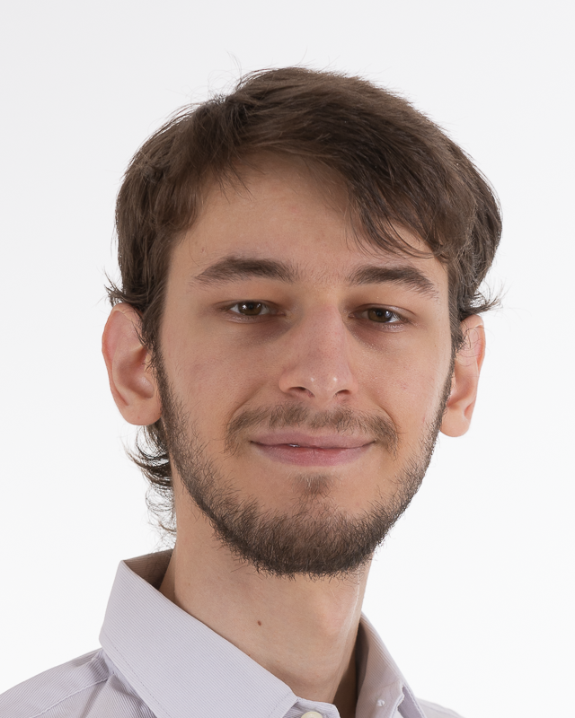
Computer science, Role-play games, Meme culture
Interests
Assets :Critical, Rigorous, Organised, Autonomous
Language :English (TOEIC 975), Notions of Italian (A2-B1)
Office software :Excel, Word, PowerPoint
Scientific :Signal (and image) processing, statistics, electronics, machine learning
Software :Git, Unity, Docker, Blender, Inkscape
Programming :C#, Java, JavaScript, C/C++, Python, ASM, VHDL
Skills
Development of a physics-based 2D game engine in Java
(Solo)
Creating 3D models for aforementioned game with Blender
(Solo)
Development of a multiplayer FPS game with Unity
(Duo)
Offline natural-language translator app in Python
(Team of 4)
Development of a turn-based dueling game in C++
(Team of 4)
Academic projects
Summer 2022Medical Devices Venture
-C# development of the Poladerme’s image acquisition software ;
-Study of acquisition time and optimisation of the capture sequence ;
-Development and dockerisation of the online database and its API.
Career
2018Bac S spé SI, mention Bien
2018-2020CPGE Maths/Physics – Lycée J.-B. Corot, Savigny-sur-Orge, France
2020-2021first year in ENSEA
2021-2022Second year at ENSEA, majors in electronics & signal processing,
option image processing & virtual reality
2022-2023Final year at ENSEA, specializing in computer science and systems
Education
Rémi Ovazza
3rd year of study at ENSEA
Looking for software engineer end-of-study internship
5+ months – starting Feb 2023
Birth date : 01/01/2000
15 Rue Pierre Brossolette, 91430 Igny, France
+33 6 52 69 30 63
remi.ovazza@ensea.fr
https://github.com/Gzethicus

Updated version on GitHub

