**Asignments 3**

1. **Quantitative analysis methods**

**To Trust Or Not To Trust A Classifier**

**Heinrich Jiang∗ Google Research heinrichj@google.com Been Kim Google Brain beenkim@google.com Melody Y. Guan† Stanford University** [**mguan@stanford.edu**](mailto:mguan@stanford.edu)

**Method : The Trust Score**

The approach proceeds in two steps outlined in Algorithm 1 and 2. first pre-process the training data, as described in Algorithm 1, to find the α-high-density-set of each class, which is defined as the training samples within that class after filtering out α-fraction of the samples with lowest density (which may be outliers)

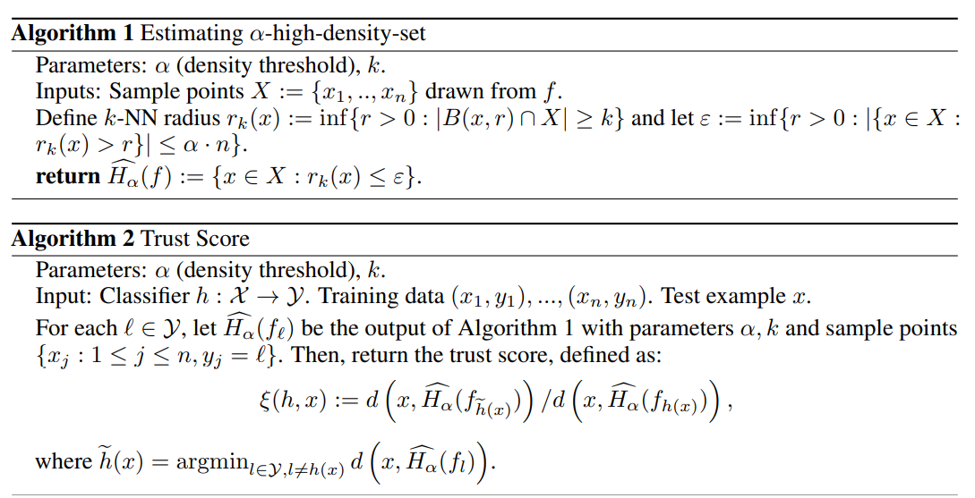

The method has two hyperparameters: k (the number of neighbors, such as in k-NN) and α (fraction of data to filter) to compute the empirical densities. It show in theory that k can lie in a wide range 3 and still give us the desired consistency guarantees. Throughout our experiments, we fix k = 10, and use cross-validation to select α as it is data-dependent. Remark 2. Observed that the procedure was not very sensitive to the choice of k and α. As will be shown in the experimental section, for efficiency on larger datasets, we skipped the initial filtering step of Algorithm 1 (leading to a hyperparameter-free procedure) and obtained reasonable results. This initial filtering step can also be replaced by other strategies. One such example is filtering examples whose labels have high disagreement amongst its neighbors, which is implemented in the open-source code release but not experimented with here.

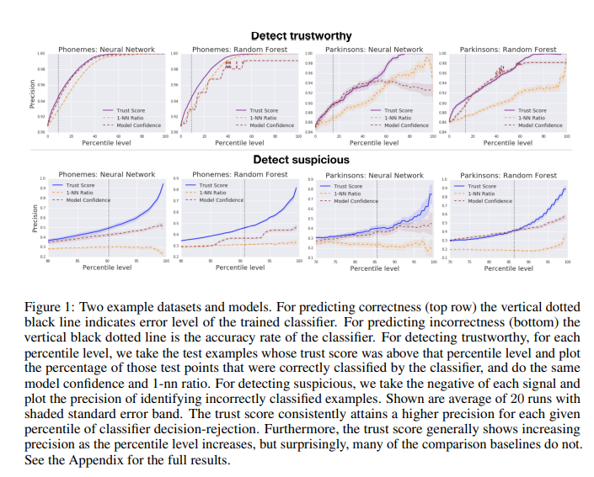

1. **Qualitative analysis methods**

**Julius Adebayo∗ , Justin Gilmer] , Michael Muelly] , Ian Goodfellow] , Moritz Hardt]† , Been Kim] juliusad@mit.edu, {gilmer,muelly,goodfellow,mrtz,beenkim}@google.com ]Google Brain †University of California Berkeley**

**Method : Independent Randomization**

As a different form of the model parameter randomization test, pendent layer-by-layer randomization with the goal of isolating the dependence of the explanations by layer. This approach allows us to exhaustively assess the dependence of saliency masks on lower versus higher layer weights. More concretely, for each layer and fix the weights of other layers to their original values, and randomize one layer at a time.

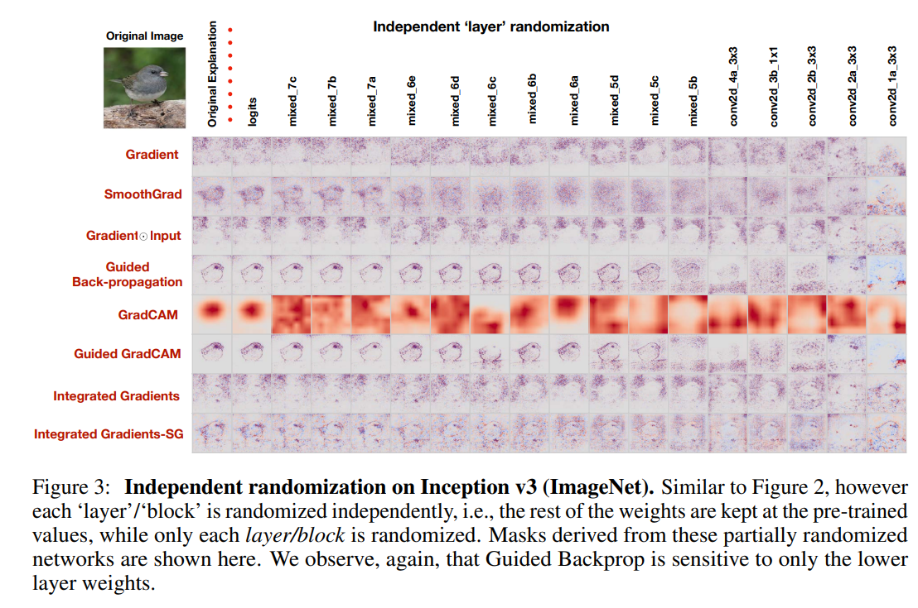

For Guided BackProp, the masks still highlight portions of the input that would seem plausible, given correspondence with the input, on naive visual inspection. For example, from the diverging masks, the Guided BackProp mask still assigns positive relevance across most of the digit for the network trained on random labels.

