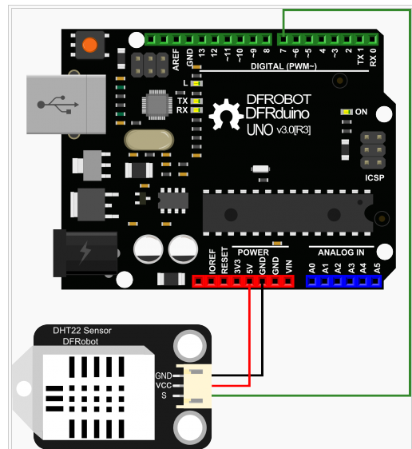
示例1
/*******************************************************

这个程序用来测试DHT22的温湿度。

********************************************************/
#include <dht.h>

dht DHT;
#define DHT22_PIN 7

void setup()
{
Serial.begin(115200);
Serial.println("DHT TEST PROGRAM ");
Serial.print("LIBRARY VERSION: ");
Serial.println(DHT_LIB_VERSION);
Serial.println();
Serial.println("Type,\tstatus,\tHumidity (%),\tTemperature (C)");
}

void loop()
{
Serial.print("DHT22, \t");
int chk = DHT.read22(DHT22_PIN); //读取数据
switch (chk)
{
case DHTLIB_OK:
Serial.print("OK,\t");
break;
case DHTLIB_ERROR_CHECKSUM:
Serial.print("Checksum error,\t");
break;
case DHTLIB_ERROR_TIMEOUT:
Serial.print("Time out error,\t");
break;
default:
Serial.print("Unknown error,\t");
break;
}
// 显示数据
Serial.print(DHT.humidity, 1);
Serial.print(",\t");
Serial.println(DHT.temperature, 1);

delay(1000);
}
示例2，请注意!目前最新版本的arduinoIDE 1.6.0版本无法正常使用该样例，您可以使用早前的版本1.0.X
/*******************************************************

这个程序用来测试DHT22的温湿度。

********************************************************/
#include <DHT22.h>
#include <stdio.h>

// 信号线接Arduino数字口7
#define DHT22_PIN 7

DHT22 myDHT22(DHT22_PIN);

void setup(void)
{
Serial.begin(9600);
Serial.println("DHT22 Library Demo");
}

void loop(void)
{
DHT22_ERROR_t errorCode;
delay(2000);
Serial.print("Requesting data...");
errorCode = myDHT22.readData();
switch(errorCode)
{
case DHT_ERROR_NONE:
Serial.print("Got Data ");
Serial.print(myDHT22.getTemperatureC());
Serial.print("C ");
Serial.print(myDHT22.getHumidity());
Serial.println("%");
char buf[128];
sprintf(buf, "Integer-only reading: Temperature %hi.%01hi C, Humidity %i.%01i %% RH",
myDHT22.getTemperatureCInt()/10, abs(myDHT22.getTemperatureCInt()%10),
myDHT22.getHumidityInt()/10, myDHT22.getHumidityInt()%10);
Serial.println(buf);
break;

case DHT_ERROR_CHECKSUM:
Serial.print("check sum error ");
Serial.print(myDHT22.getTemperatureC());
Serial.print("C ");
Serial.print(myDHT22.getHumidity());
Serial.println("%");
break;

case DHT_BUS_HUNG:
Serial.println("BUS Hung ");
break;

case DHT_ERROR_NOT_PRESENT:
Serial.println("Not Present ");
break;

case DHT_ERROR_ACK_TOO_LONG:
Serial.println("ACK time out ");
break;

case DHT_ERROR_SYNC_TIMEOUT:
Serial.println("Sync Timeout ");
break;

case DHT_ERROR_DATA_TIMEOUT:
Serial.println("Data Timeout ");
break;

case DHT_ERROR_TOOQUICK:
Serial.println("Polled to quick ");
break;
}
}

