**Team 7**

**Software specifications**

**Vending Machine**

**Table of Contents**

System Architecture 1

Software Specifications 2

S1: Main Interface 2

S1.1: Modify the amount of the chosen merchandise. 3

S1.2: Display the quantity of surplus merchandise. 3

S1.3: Enter the Maintenance Interface from the Main Interface. 4

S1.4: Put money into the machine. 4

S1.5: Implement buying operation. 5

S1.6: Retrieve the remaining money. 5

S2: Maintenance Interface 6

S2.1: Modify the amount of the remaining merchandise. 6

S2.2: Change the state of the machine. 7

S2.3: Extract all the money stored in the machine. 7

S2.4: Back to Main Interface from the maintenance interface. 7

S3 Password Interface 8

S3.1: Input password 8

S3.2: Check the correctness 8

S3.3: Enter the maintenance interface 8

## System Architecture

**The system architecture is shown below:**

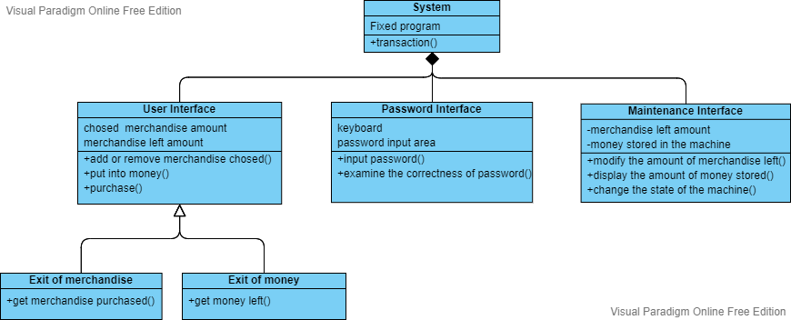

## Software Specifications

### S1: Main Interface

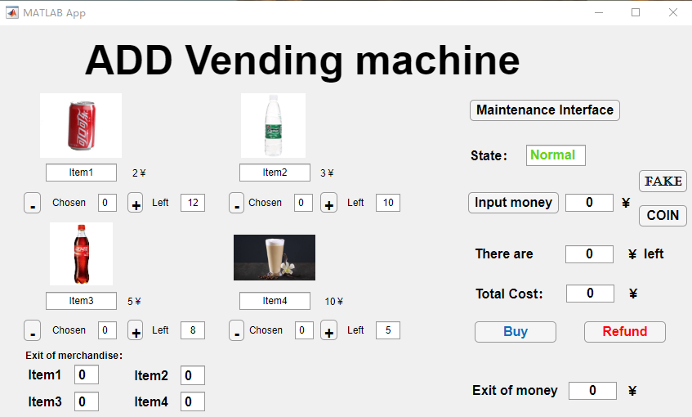

#### S1.1: Modify the amount of the chosen merchandise.

S1.1.1: Add the amount of the chosen merchandise

1. Press “+” button under the picture of the certain merchandise.
2. There is a parameter representing the amount the certain merchandise which is displayed in the pane and set to 0 initially.
3. When the “+” button is put, we will add 1 to the parameter, indicating that the amount of this is added 1.

S1.1.2: Subtract the amount of the Chosen merchandise

1. Press “-” button under the picture of the certain merchandise.
2. There is a parameter representing the amount the certain merchandise which is displayed in the pane.
3. When the “-” button is put, we will subtract this parameter by one, indicating that the amount of this is reduced by 1.

#### S1.2: Display the quantity of surplus merchandise.

S1.2.1: For every kind of merchandise, set a parameter representing the quantity of it. When a buying operation is done, the parameter will change to the right amount and then be updated on the screen. And these parameters will be synchronized with those in the maintenance interface.

#### S1.3: Enter the Maintenance Interface from the Main Interface.

S1.3.1: Press the “Maintenance Interface” button, the system will open a password interface, and then input right password. The maintenance interface will be opened.

#### S1.4: Put money into the machine.

S1.4.1: Users should input the quantity of money (bill) they want to put in the pane after the button. Then press the “input” button. There will be a parameter in the system to record the money users put in and also record the remaining quantity of their money.

S1.4.2: Users could put in a coin at one time by pressing the “COIN” button. The parameter recording the money will be added by one at one time, representing that users put a coin in.

S1.4.3: Users could simulate putting in fake money by press the “FAKE” button.

1. Users could input any amount of fake money they want in the numerical box. Then press the “FAKE” button.
2. The system will judge this money as fake money, the parameter in the machine won’t change, just like nothing is putting in. And naturally, the fake money cannot be retrieved by “Refund” button.

#### S1.5: Implement buying operation.

S1.5.1: On the premise of successful purchase, the parameter recording the remaining money will be subtracted by the total cost of all the merchandise purchased after pressing the “Buy” button.

S1.5.2: On the premise of successful purchase, all the merchandise purchased will be dropped out from the “Exit of merchandise”. Precise number will be displayed in the pane.

#### S1.6: Retrieve the remaining money.

The remaining money will be dropped put from the “Exit of money”. The parameter recording the remaining will be cleared to 0.

### S2: Maintenance Interface

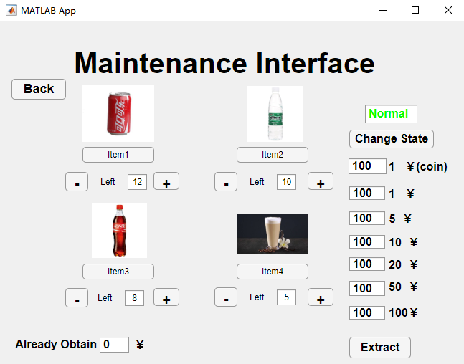

#### S2.1: Modify the amount of the remaining merchandise.

S2.1.1: Add the amount of the remaining merchandise

1. Press “+” button under the picture of the certain merchandise.
2. There is a parameter representing the amount the remaining merchandise which is displayed in the box and set to a certain number initially.
3. When the “+” button is put, we will add 1 to the parameter, indicating that the amount of this is added 1.

S2.1.2: Subtract the amount of the remaining merchandise

1. Press “-” button under the picture of the certain merchandise.

There is a parameter representing the amount the remaining certain merchandise which is displayed in the pane.

1. When the “-” button is put, we will subtract this parameter by one, indicating that the amount of this is reduced by 1.

#### S2.2: Change the state of the machine.

S2.2.1: After pressing “Change State” button, the value of state of the machine will change between “Normal” in green or “Error” in red.

S2.2.2: The value of state will reflect to the main interface. When it is error, users could not process buying operation in main interface.

#### S2.3: Extract all the money stored in the machine.

After pressing the “Extract” button, all the parameter recording the amount of the stored money will be reset to 0. And the money will be picked out.

#### S2.4: Back to Main Interface from the maintenance interface.

Pressing the “Back” button, and then the system will open a main interface.

### S3 Password Interface

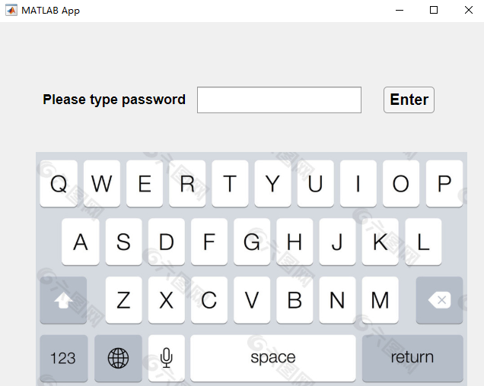

#### S3.1: Input password

Users could input password to the machine by the keyboard.

#### S3.2: Check the correctness

After pressing “Enter” button, the system will check whether the password input is right.

#### S3.3: Enter the maintenance interface

If the password input is the same with the right one, users can enter the maintenance interface to act as a maintainer.