H-0Y

Team 7

Traceability report

Vending Machine

**System Architecture**

**The system architecture is shown below:**

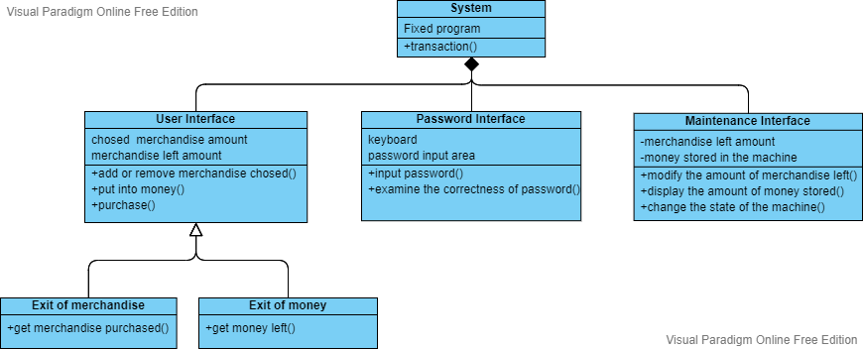

**Software Traceability**

**R1: User Interface:**

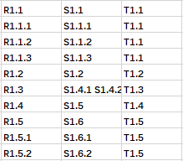

**R2: Maintenance Interface:**

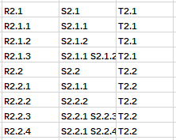

**R3: Password Interface:**



**R4(Validate):**



**Refer to model checking in model/validation document**