Team 7

**USER manual**

**Vending Machine**

**Table of Contents**

**System Architecture 1**

**User Manual 2**

**Main Interface 2**

**Main Menu Components 3**

**How to finish a buying operation 4**

**Password Interface 5**

**Main Menu Components 5**

**Maintenance Interface 6**

**Main Menu Components 6**

## System Architecture

**The system architecture is shown below:**

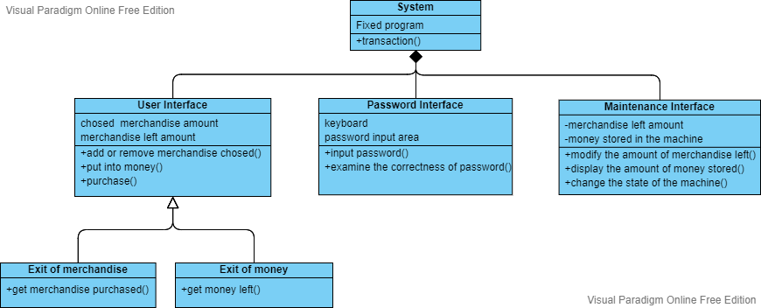

## User Manual

## Main Interface

**The user will be first shown with a vending machine main menu (Figure 1):**

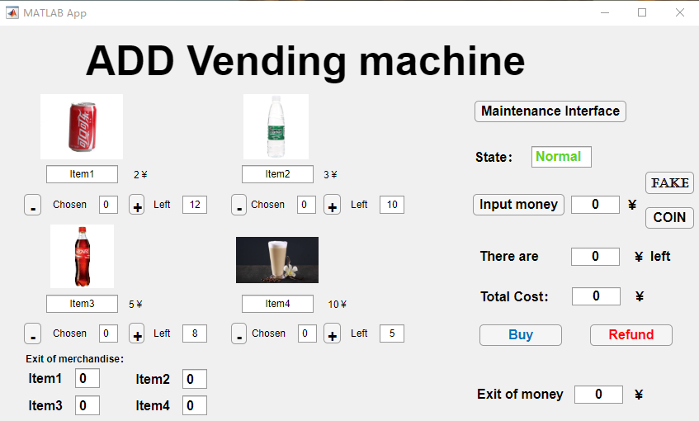

Figure 1

#### Main Menu Components

1. ** “item 1,2,3,4” beneath the graphs denote the names of the four kinds of merchandise and the numbers beside them represent their prices.**
2. **The “+” and “-” represent “add” and “reduce” operation for the amount of the chosen merchandise individually.**
3. **The numbers after the “chosen” sign represent the amount of the merchandise users have chosen currently.**
4. **The numbers after the “chosen” sign represent the amount of the merchandise left in the storage.**
5. **The “Maintenance Interface” button connects to the “Password Interface”, if users input right password, they could enter the maintenance interface.**
6. **The “Input money” button represents inputting bills in certain denomination.**

** “COIN” button represents inputting 1 coin. And the “FAKE” button represents inputting fake money. (the fake money cannot be retrieved).**

1. ** The “State” box shows the state of the machine. If the state of the machine is error which is in red, it could not work. If it’s normal, users can use it normally.**
2. ** “There are … left” shows how money the user input is left. And it can be taken out at one time.**
3. ** “Total Cost” shows the cost in all of the merchandise the user has chosen.**
4. ** “Buy” button represents processing the purchasing operation. After buying successfully the merchandise will be sent out from the exit of merchandise.**

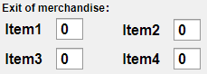

1. ** “Refund” button represents retrieving the money left at one time.** 

#### How to finish a buying operation

**First, we should confirm that the state of the machine is “Normal”.**

**Then we choose the amount of the merchandise we want by clicking the “+” and “-” buttons under it.**

**After that we should input true money which should be larger than the number shown in the “Total Cost” box.**

**And then we click “Buy” button, we will get our cargo from the exit of merchandise. We click the “Refund” button to retrieve our money left.**

### Password Interface

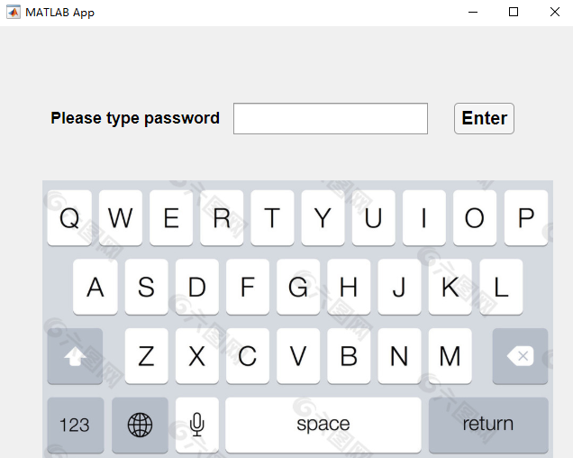

#### Main Menu Components

1. **There is a keyboard in the password interface. User input the password by clicking the keyboard to enter the Maintenance Interface.**
2. **The “enter” button represents testing whether the password users input is right.** 

### Maintenance Interface

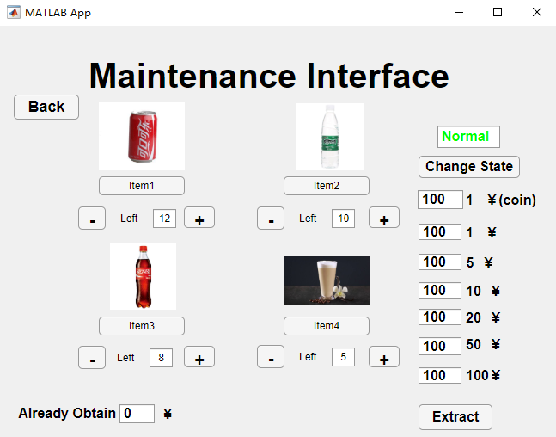

#### Main Menu Components

1. **The maintainer could go back to the Main Interface via the “Back” button.**
2. 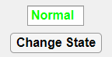**The maintainer could change the states of the machine between “Normal” and “Error” via the “Change State” button.**
3. 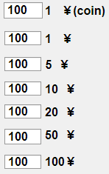**This represents the containers of money in different denomination. It has celling and floor. And there are 100 pieces of money in each denomination initially.**
4. **It shows the amount of money the machine has already earned.**
5. **Clicking this button could retrieve all the money stored in the machine at one time.**