H-0Y

Team 7

software requirement

Vending Machine

**Table of Contents**

**System Objective 1**

**Domain Analysis 2**

**System Architecture 5**

**Use Cases 6**

**Software Requirements 7**

**R1: Main Interface 7**

**R2: Maintenance Interface 7**

**R3: Password Interface 7**

**R4: Validate 8**

## System Objective

**In this project, we are developing a software that simulates the vending machine in our real life. The software will take care of the graphic interface, ensure valid movements and determine whether the goal is achieved, which offers the users a chance to use a vending machine on computer. Also a UPPAAL model will be provided to check whether the machine is working normally or not, and if it has, it will permit people to buy merchandise from the machine.**

## Domain Analysis

**The participants of activities of the vending machine can be categorized into the customers, admin and the machine itself.**

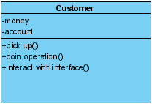 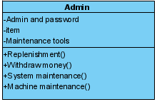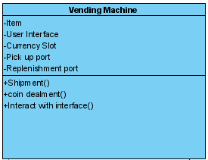

**The relationships among different participants are shown as follows:**

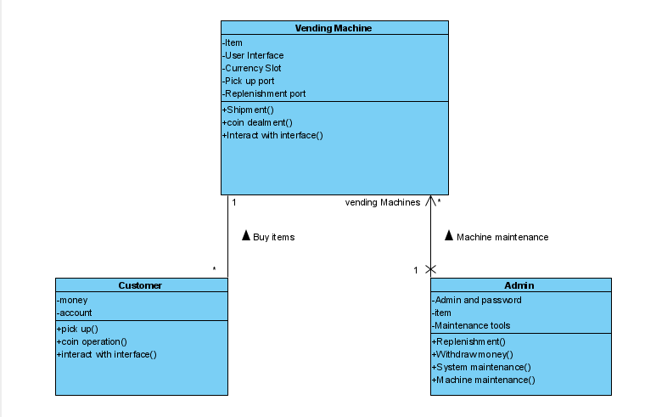

**Here is the sequence of events for playing a standard game:**

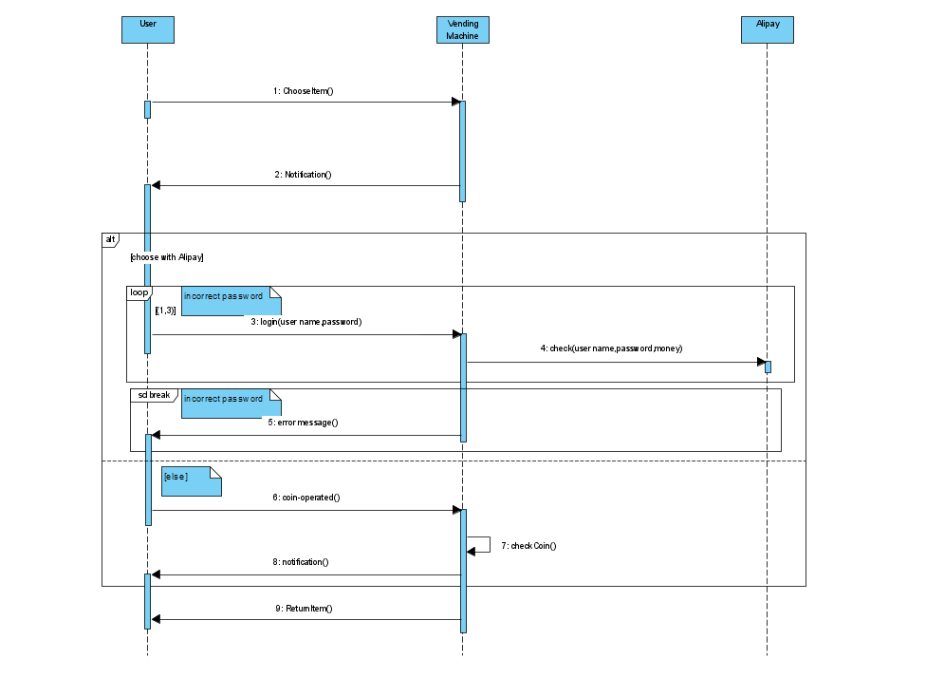

## System Architecture

**From the information above, we will design a software system that simulates the vending machine process: prepare the merchandise in the machine, allow users to purchase the cargo, decide whether the deal could be implemented. It also allows the users to input money of random amount. The system architecture is shown below:**

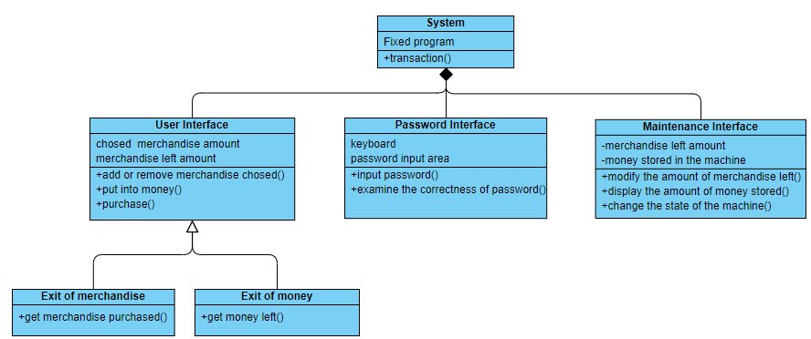

## Use Cases

**The system can achieve the following use cases from the user’s perspectives:**

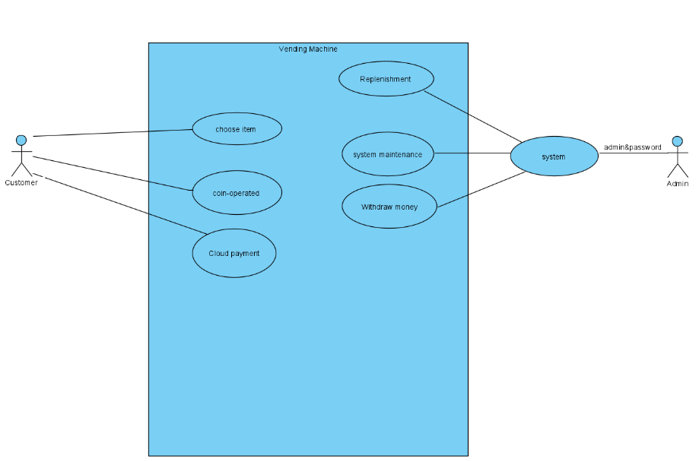

## Software Requirements

### R1: Main Interface

**• R1.1: The user should be able to modify the amount of the chosen merchandise.**

**o R1.1.1: The user should be able to add the amount.**

**o R1.1.2: The user should be able to decrease the amount.**

**o R1.1.3: The amount must not be larger than the amount left or fewer than 0.**

**• R1.2: The user can select certain kind of merchandise and input some money.**

**• R1.3: If the user input fake money, the money should not account and he should not be able to retrieve it.**

**• R1.4: The user can see the amount of certain kind of merchandise left and the left amount of money he input.**

**• R1.5: The player should be able to retrieve the merchandise he bought and the money left.**

**o R1.5.1: The user should be able to retrieve the merchandise he bought from the exit of merchandise.**

**o R1.5.2: The user should be able to retrieve the money left from the exit of money.**

### R2: Maintenance Interface

**• R2.1: The maintainer should be able to modify the amount of the merchandise left.**

**o R2.1.1: The maintainer should be able to add the amount of certain merchandise.**

**o R2.1.2: The maintainer should be able to reduce the amount of certain merchandise.**

**o R2.1.3: The amount of the merchandise should not be fewer than 0 or larger than 99.**

**• R2.2: The money should be stored correctly.**

**o R2.2.1: Different amount bills and coins should be stored at different containers.**

**o R2.2.2: The maintainer should be able to know the amount of money in different denominations.**

**o R2.2.3: There will be a counter which account the amount of the earned money.**

**o R2.2.4: There will be a certain container which specially store the fake money.**

### R3: Password Interface

**• R3.1: The password interface should examine the correctness of the password the user input.**

**o R3.1.1: If the user input the correct password, he could enter the maintenance interface.**

**o R3.1.2: If the user input the wrong password, he could not enter the maintenance interface and there will be a warning as a reminder.**

### R4: Validate

**• R4.1: The system should be able to validate any transaction situation.**

**o R4.1.1: For any money input, the system should be able to tell whether the transaction is successful or not.**

**o R4.1.2: If the state of the machine is error or the amount of merchandise left is not enough, the user couldn’t finish his shopping.**