|  |  |
| --- | --- |
| Assignment Case | Description: LogoBINUS-University |
| JavaH1Special |
| **Periode Berlaku** Semester Ganjil 2023/2024  ***Valid on*** *Odd Year 2023/2024* | **Software Laboratory Center**  **Assistant Recruitment 24-1** |

## Materi

*Material*

* Object Oriented Programming (OOP)
* SOLID Principle
* MySQL

## Soal

*Case*

**AX For AutoPets**

**AX For AutoPets** is an engaging online auto battler game where players strategically assemble and manage teams of diverse animals, each with unique abilities, to compete in automated battles. This innovative game aims to provide a captivating experience, combining strategy and fun as players build their ultimate teams to outsmart and outlast their opponents. The development of **AX For AutoPets** will utilize the **Java Programming Language** with **Object Oriented Programming** concepts such as **Encapsulation**, **Inheritance**, and **Polymorphism**, ensuring a robust and flexible gaming experience. Your mission as a programmer is to create this exciting game, focusing on seamless gameplay, balanced mechanics, and an enjoyable user experience.

* **Database ERD** :

Figure 1. Database ERD

* **Auth Page**

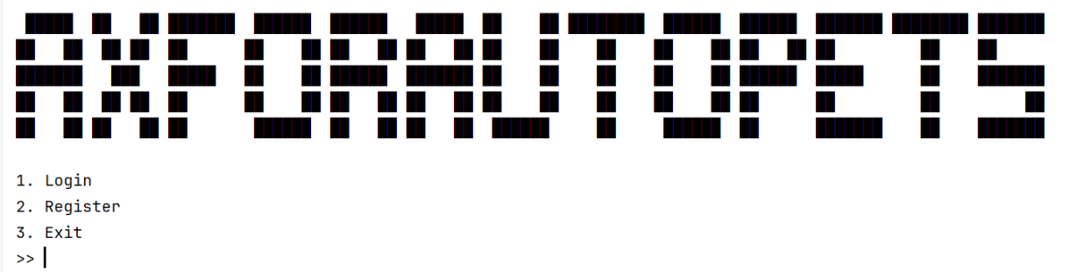

Figure 2. Auth Page

* In the beginning, the program will show **3 menus**, which are :

1. **Login**
2. **Register**
3. **Exit**

* If the user chooses **Login (Menu 1)**  then :
  + The program will ask the user to input the **username** and **password**.
  + The username and password must be in range 5 – 20 characters or else it will keep prompting.
  + Then, **validate** the **credentials** must **exist** in the **database**.
  + If the **credential** **does not exist**, then **show an error message**.
  + **Otherwise**, **redirect** the user **to menu based on their role**.

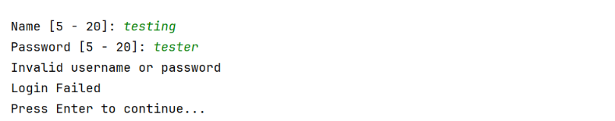

Figure 3. Login

* If the user choose **menu 2 (“Register”),** then :
  + Ask the user to input the **username**. Validate that the username **length** must be **between 5 and 20** **characters** **(inclusive)**. Validate that the username must also be **unique**.
  + Ask the user to input the **password**. Validate that the password **length** must be **between 5 and 20** **characters** **(inclusive)**.
  + If the **validation** is **successful**, then **insert the new user into the database**.

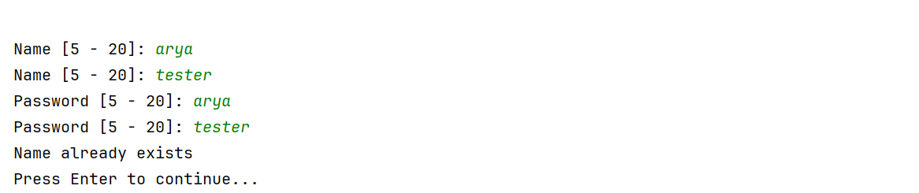

Figure 4. Register New User

* If the user choose **menu 3 (“Exit”)**, then the **program will be closed.**
* **Main Page**

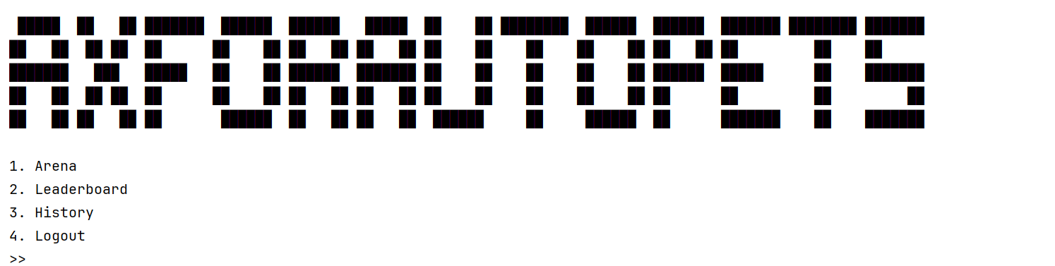

Figure 5. Main Page

* This page consist of **4 menus**, which are :

1. **Arena**
2. **Leaderboard**
3. **History**
4. **Logout**

* **Game (Arena Page)**

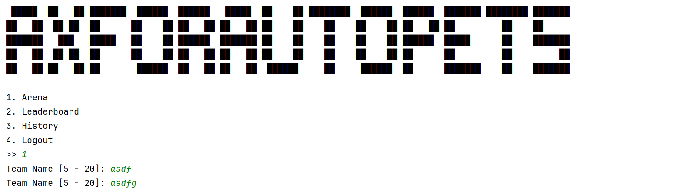

Figure 6. Team Prompt

When the **user first choose to go to the arena**, the user will be **prompted** to enter the **team name** to enter the arena. This name will be the **team name for the pets** and will appear when fighting other teams.

The arena has various attributes, below are the details for each of them:

* Round

This attribute indicates at what round you are in right now. Round will increase as you progress through the game. Each round will consist of 2 phase, namely the shopping phase and the battle phase. Round will also affect your shop which will be explained in the shop section.

* Life

When your life reaches 0 the game will end, and you will be redirected back to the main page. Your life will decrease by 1 everytime you lose a battle. At the start of the game you will start with 5 life.

* Win

Everytime you win a battle your win will increase by 1. This attribute is to keep count of how many win you got each match. This attribute will be used in the leaderboard section of the game to compete with other players.

* Money

You will get 10 money everytime you enter shopping phase. This may increase using pet abilities or by selling pets. This will be used to buy pet or food in the shop. When you leave shop the leftover money will not be saved for the next shop.

* **Shop Page**

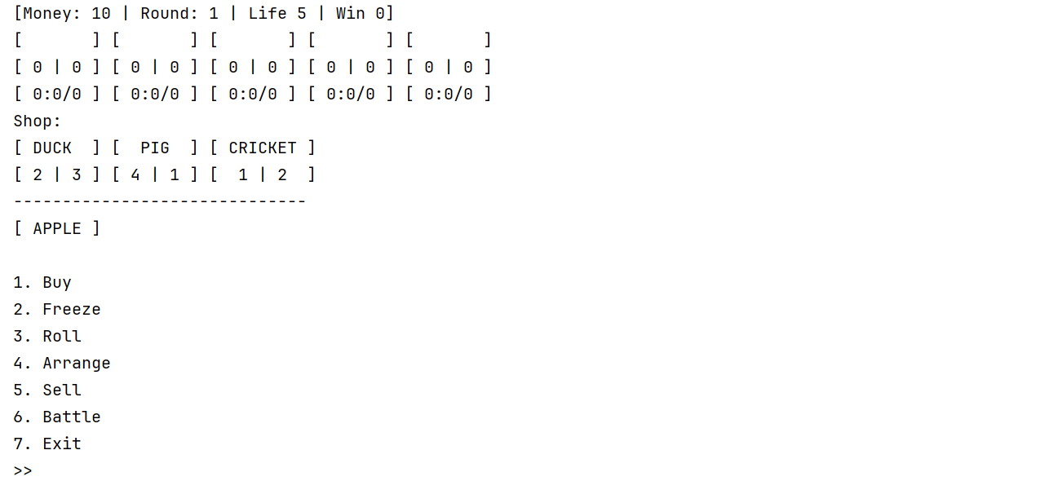

Figure 7. Shop Page

The shop page will show info about the player’s current state, namely the money, round, life, and win. Below it will be the player's team which will be displayed in 5 slots which will be filled with pets. Every pet will display info about its name, stats, and experience.

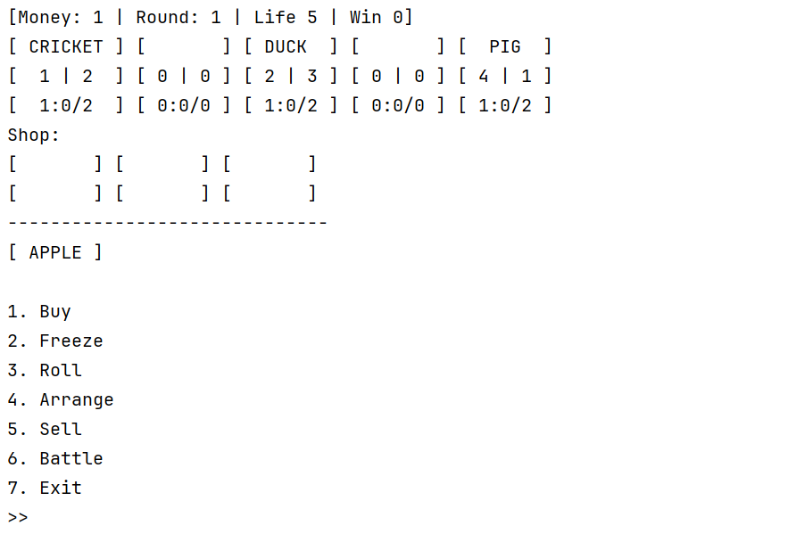

Figure 8. Example display for pet

The Shop has 6 levels. The level progresses alongside the round of the match. The shop will level up from 1 to 6 every 2 rounds. For example, the shop will be level 1 at round 1 but will level up to level 2 after round 3 or at the start of round 4. The shop level affects the item that will be displayed at the shop. Each level will correspond to the same tier for the pet and the food. For example, shop level 1 will show tier 1 items at the shop and level 2 shop will show tier 2 item at the shop. Your job is to make sure that you make the pets and foods up to tier 3, you may make it to tier 6 if you have the time however it will be optional. For the pets and the food you must make you may refer to this wiki link:

* <https://superautopets.wiki.gg/wiki/Turtle_Pack>

For each pet you must make sure to create the ability correctly, every ability will have 3 levels that will progress alongside the pet’s level. Every pet also have different trigger for their ability so please pay attention to that as well. Every pet can eat an infinite amount of food however if the food has perk, then the perk will attatch to the pet and replace previously atttatched perk. Perk functions just like pet ability, it has a trigger and an effect that will activate when the trigger is triggered.

The shop page consists of 7 menus each will be explained as their own page below this section. The 7 menus are:

1. **Buy**
2. **Freeze**
3. **Roll**
4. **Arrange**
5. **Sell**
6. **Battle**
7. **Exit**

* **Buy Page**

Figure 9. Buy Page

When the user enters buying page display all the available pets and food that the player can choose to buy. Make sure to also display the stat for each pets. Also pay attention that each slot is printed with center alignment. There is a rule for the shop slots, the shop slots will increase alongside the shop level. Below is the detail for the shop slots for each shop level:

* Level 1

3 pet slots, 1 fruit slot

* Level 2

3 pet slots, 1 fruit slot

* Level 3

4 pet slots, 2 fruit slots

* Level 4

4 pet slots, 2 fruit slots

* Level 5

5 pet slots, 2 fruit slots

* Level 6

5 pet slots, 2 fruit slots

Figure 10. Shop after buy pet

When you buy a pet or a food you must first choose which pet or food you want to buy then you must choose which slot do you want to place it in. In the example above I demonstrated placing a cricket at slot 5. After you buy pet or food the slot will be empty and will remain that way until it is regenerated either by rerolling or proceeding to new shop.

Figure 11. Validate empty slot

You must validate that the player cant buy empty slots. You must also make it so that when the player buy frozen slot the slot will be back to normal again. You must also validate when the player is trying to buy shop items then the player must type either Pet or Food which must be case sensitive. Then prompt the player to choose within the slot range for example, in the picture above there are only 3 slots then the player may only choose between 1 to 3 inclusive.

Figure 12. Gold validation

You must validate that the player must have atleast 3 golds to purchase item from shop. If the player does not have the required amount then just print the message and redirect the player back to the shop menu.

* **Freeze Page**

Figure 13. Freeze Page

When you enter the freeze page then you must prompt the user to choose either to freeze pet or food. After that then you must prompt the user to choose the slot to freeze the option is based on the amount of slots available in the shop.

Figure 14. After freeze

After freezing the shop item then you must change the brackets from square brackets to curly brackets. The brackets will stay curly as long as the slot is frozen, it will only go back to normal once the slot is back to normal.

Figure 15. Reroll frozen slot

When you reroll the frozen slot will not be rerolled and will stay the same as long as it is still frozen. Freezing a slot does not cost you anything. You can unfroze a slot by either choosing to freeze the same slot or by buying the frozen slot.

* **Roll Page**

Figure 16. Reroll gold validation

When you choose to reroll then you will regenerate all the shop slots except the frozen slots. Rerolling costs the player 1 gold. You must validate that the player has atleast 1 gold to be able to reroll.

* **Arrange Page**

Figure 17. Arrange page

When the player choose the arrange menu then the player will be prompted to choose 2 slots.

You must validate the chosen slot must be between 1 to 5 inclusive. From the example above since we choose to arrange a different pet (pigeon and beaver) then the pet will swap slots.

Figure 18. Swapped pet

However using the arrange menu you can do more than just swapping slots. When you choose to arrange pet of the same kind then it will merge as long as it is not max level and can still level up.

Figure 19. Merge pet

asdf

* **Sell Page**
* **Battle Page**
* **Exit Arena**
* **asd**

Please run the BAT or JAR file to see the sample program.

## Komponen Penilaian

*Scoring Component*

|  |  |  |
| --- | --- | --- |
| No | Component | Weight |
| 1 | OOP Concept | 15 |
| 2 | Design Pattern | 5 |
| 3 | CRUD | 20 |
| 4 | SOLID Principle | 30 |
| 5 | Architectural Design | 8 |
| 6 | Actions | 12 |
| 7 | Validations | 10 |