|  |  |
| --- | --- |
| **Assignment Case** |  |
| COMP6122  Framework Layer Architecture |
| **Computer Science** | **O213-COMP6122-SK01-02** |
| ***Valid on*** *Odd Semester Year 2020/2021* | **Revision 00** |

1. Seluruh mahasiswa tidak diperkenankan untuk:

*All students are not allowed to:*

* + 1. Melihat sebagian atau seluruh jawaban mahasiswa lain,

*Seeing a part or the whole answer from other student*

* + 1. Menyadur sebagian maupun seluruh jawaban dari buku,

*Adapted a part or the whole answer from the book*

* + 1. Mendownload sebagian maupun seluruh jawaban dari internet,

*Downloading a part or the whole answer from the internet,*

* + 1. Mengerjakan soal yang tidak sesuai dengan tema yang ada di soal,

*Working with another theme which is not in accordance with the existing theme in the matter of the case,*

* + 1. Melakukan tindakan kecurangan lainnya,

*Committing other dishonest actions,*

* + 1. Secara sengaja maupun tidak sengaja melakukan segala tindakan kelalaian yang menyebabkan hasil karyanya berhasil dicontek oleh orang lain / kelompok lain.

*Accidentally or intentionally conduct any failure action that cause the results of the project was copied by someone else / other groups.*

1. Jika mahasiswa terbukti melakukan tindakan seperti yang dijelaskan butir 1 di atas, maka **nilai mahasiswa** yang melakukan kecurangan (menyontek maupun dicontek) akan di – **NOL** – kan.

*If the student is proved to the actions described in point 1 above, the score of the student which committed dishonest acts (cheating or being cheated) will be “Zero”*

1. Perhatikan jadwal pengumpulan jawaban, segala jenis pengumpulan jawaban di luar jadwal tidak dilayani.

*Pay attention to the submission schedule, all kinds of submission outside the schedule will not be accepted*

1. Persentase penilaiaan untuk matakuliah ini adalah sebagai berikut:

*Marking percentage for this subject is described as follows:*

|  |  |  |
| --- | --- | --- |
| **Tugas Mandiri**  *Assignment* | **Proyek**  *Project* | **UAP**  *Final Exam* |
| 100% | - | - |

1. Software yang digunakan pada matakuliah ini adalah sebagai berikut:

*Software will be used in this subject are described as follows:*

|  |
| --- |
| **Software**  *Software* |
| Java 8  Eclipse 2020.6 |

## Ekstensi file yang harus disertakan dalam pengumpulan tugas mandiri dan proyek untuk matakuliah ini adalah sebagai berikut:

*File extensions should be included in assignment and project collection for this subject are described as follows:*

|  |  |  |
| --- | --- | --- |
| **Tugas Mandiri**  *Assignment* | **Proyek**  *Project* | **UAP**  *Final Exam* |
| JAVA, CLASS | - | - |

## Soal

*Case*

**AXForGirlfriend**

**Criteria**:

1. Template  
   First **Template**. **Template** pattern is a pattern that lets you break down an algorithm into a series of steps, turn these steps into methods, and put a series of calls to these methods inside a single template method.
2. State

Last **state**. **state** is a behavioral design pattern that lets an object alter its behavior when its internal state changes. It appears as if the object changed its class.

AXForGirlfriend is a dating simulator game. Here your goal is to make the girl you meet love you and want to be your girlfriend. Now you are a new programmer that assigns to develop this game. The program will be created with the following criteria:

1. **Menu**

First, the program will show the menu. In this menu, the lecturer can choose whether they want to **Ask For Girlfriend, How to play,** and **Exit**.

Figure 1. AXForGirlfriend Menu

1. **Ask For Girlfriend**

This menu will be the gameplay menu of the game. The gameplay always follow a template set of methods. Below is the sequence of methods that will be executed in the given order:

|  |  |  |
| --- | --- | --- |
| **Method** | **Player** | **Girlfriend** |
| String run() | This method will run all the method below in the given order | This method will run all the method below in the given order |
| Void introduction() | Player will print the current day | The girlfriend will greet the player according to its state |
| Void action() | Print the list of actions and prompt the user to choose 1 | Do nothing |
| Void updateResource() | Increment the current day by 1 | Take the action given by the player then give an appropriate response based on how much the girl likes the action (point). Also don’t forget to update the girlfriend’s happiness. |
| String response() | Return the action chosen by the player | If default state do nothing else if angry or happy state return a message to notify the game has finished |

If the player chooses **Ask For Girlfriend**, display the current day then show all the action and ask the user to input the option to select the action. The day always start from 0 and increment by 1 at the end of every turn. The list of available actions are as below:

* **Give Compliment**
* **Give Hug**
* **Spend Time Together**
* **Give a Gift**
* **Help With Chores**

When the player inputs an action validate the input must be **exactly the same** as the **action.**

Figure 2. Ask For Girlfriend

After choosing the action to perform for the girl, you need to play the scenario between the player and the girl. The girl will give a respond according to their liking. You need to generate each girl liking **by randomly assign 10 points across the five-given action**. Below are the criteria to determine if the girl likes the given action or not:

|  |  |
| --- | --- |
| **Points** | **Respond** |
| Less than 5 | ”Hehehe... thankyouu...” |
| 5 | “*GASP* Thankyou, dear.” |
| More than 5 | “*GASP* Thankyou!!!"” |

Every action the player perform for the girl will increase the girl’s happiness meter for a certain point based on how much the girl likes the action. There are 3 possible criteria that could happen based on the girlfriend happiness meter :

|  |  |  |
| --- | --- | --- |
| **Case** | **Scenario** | **Trigger** |
| The girlfriend despise the given action (has 0 point for it) | The girlfriend will be disappointed and now despise you. This will result in the player losing the game and redirect them back to main menu. | When the player do an action that the girl has 0 point of liking for |
| The girlfriend accept the given action (has positive point for it) | The girlfriend accepts the action and the happiness meter will continue to accumulate. The player will now continue to play until the happiness meter reaches 10. | This is the default state, the girlfriend will always start in this state |
| The girlfriend has fallen in love (current happiness meter had reached 10 points) | The girlfriend is now in love with the player, thus resulting in you winning the game. | When the girl’s happiness point reaches 10 |

Below are the screenshot for every scenario above:

Figure 4. When the girlfriend accepts the action

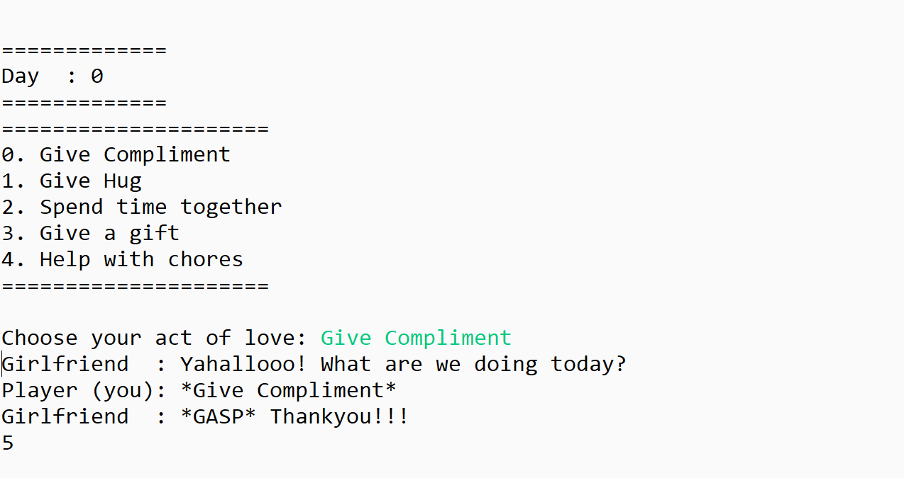

Figure 4. When the girlfriend accepts the action

Figure 5. When the girlfriend accepts the action

1. **Exit**  
   If user choose **Exit,** Exit the program clearly.

***If there are any problems, please ask your assistant!***