|  |  |
| --- | --- |
| **Project Case** | Description: LogoBINUS-University |
| Java2BP |
| **Periode Berlaku** Semester Ganjil 2022/2023  ***Valid on*** *Odd Year 2022/2023* | **Software Laboratory Center**  **Assistant Recruitment 23-1** |

***Note:******Please focus on the main logic and main feature!***

*(Splash screen and design are not scored)*

## Soal

*Case*

**MaximoAXion**

As a full-time programmer at a small company and a freelancer in your spare time, you have been approached by a friend who is developing a new survival game called MaximoAXion. Your friend knows that you are always looking for exciting new projects, and has asked you to create a simulation game that will challenge players to survive in a harsh and unforgiving wilderness. Your task will be to design a game that requires players to gather resources, build shelter, and defend themselves against dangerous creatures, all while managing their stamina and health. Your friend is willing to pay generously for your expertise, and is eager to see what kind of game you can create. Are you up for the challenge?

* **Home Page** (**Menu 1**)
* The program start with displaying the game’s name. **Prompt** user to **press enter**.



Figure 1. Game’s Name

* After user **press enter**. Program will **show home page** that contains of 3 menus, which are **Play**, **Register**, **Highscore** and **Exit**.
* **Prompt** userto **input chosen menu**. **Validate** the input must **between 1 and 4 inclusively**.

Figure 2. Home Page

1. If user choose **Play** (**Menu 1**), then:
   * **Prompt** user to **input username and password**. **Validate** the data must **match with player data**. If the player credentials matched, the user will be **logged in** and the **game will start.**

Figure 3. Play Page

1. If user choose **Register** (**Menu 2**), then:
   * **Prompt** user to **input the new player’s username**. **Validate** the data must **be between 5 to 20 characters**.
   * **Prompt** user to **input the new player’s password**. **Validate** the data must **be between 5 to 20 characters**.

Figure 4. Register Page

1. If user choose **Highscore** (**Menu 3**), then:
   * **Display** **top 3** player **order** **by** **highest score**.
   * **Prompt** user to **press enter** to go back to the **Home Page.**

Figure 5. Highscore Page

1. If user choose **Exit** (**Menu 4**), then the program stop running.

* **Game Page**

After the user **successfully logged in**, the user will be **redirected** to **game page**. Please make sure to update the game screen every time a change occurs. For example the game screen will update if a event occurs or stop, or if the player took damage, perform an action etc. The game page contains several elements, which are:

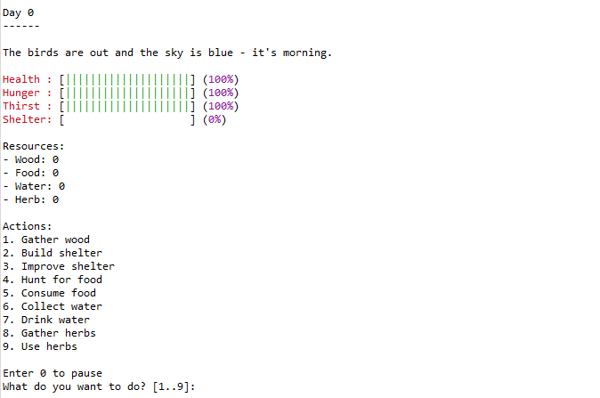

Figure 6. Game Page

1. **Day**

Figure 7. Day Element

* The **game** will **start** from **day 0**.
* Every time the **game changes day**, you must **display** what **day** it is.
* A **day** **consists** of **6 different times**.

1. **Time**

* This **game** have **6 different times**.
* The **time** will **cycle** from **Dawn 🡪 Morning 🡪 Noon 🡪 Dusk 🡪 Night 🡪 Midnight**. However please **keep in mind** that when you first **start the game** the time will **start** from **morning**.
* Each **time** will be **20 seconds long**.
* **Don’t forget to** **include** a **message** for **each** individual **time**, so that the **player** may be **reminded** of what **time** it is **via the message**.

1. **Events**

Figure 8. Events Element

* This **game** have **10 different events**.
* Each **event** has its own **unique effect** on the **player**.
* Every **event** will **last for 10 seconds** and **then** **dissapear**.
* The **world** has **5% chance of triggering an event** which will **increase by 1% each second**. **After** it **successfully** **triggered** an **event**, the **event chance** will **reset back to 5%**. This process will **keep on repeating** for the **entire game**.
* Just like Time, **every event** will also be **represented** to the **player** via a **status message**. So, please **add** a **status message** for **every event**.
* **Every event** will be **running** on **its own thread**. For **damaging events**, it will **trigger its damage every second**. So, if there are **2 damaging events**, they **will not** be **damaging** the **player in the same second**. For example:

Event A: [1.3]------------------[2.3]----------

Event B: ----------[1.6]-------------------[2.6]

* There are **3 types of event**: events that can occur on **both night and day**, those that **only** **occurs at day**, and those that **only occurs at night**. You can **refer** to the **table below**.

**Neutral event**: no. 1 - 4

**Day event**: no. 5 - 6

**Night event**: no. 7 – 10

|  |  |  |  |
| --- | --- | --- | --- |
| **No.** | **Event** | **Message** | **Effects** |
| 1 | Volcanic eruption | The ground is shaking and the sky is darkened by ash - a volcano has erupted! | Damage Random 1 – 5. |
| 2 | Massive thunderstorm | The sky is dark and lightning is striking everywhere - a massive thunderstorm is raging! | Damage Random 3 – 7. |
| 3 | Massive bird migration | The sky is filled with birds of all kinds, moving in a massive migration. | Damage Random 1 – 3. |
| 4 | Massive earthquake | The ground is shaking violently and buildings are collapsing - a massive earthquake is underway! | Damage Random 1 – 4. |
| 5 | Solar eclipse | The sun is obscured by the moon, casting an eerie shadow on the world - it's a solar eclipse! | Prevent player from performing gathering actions.  Damage Random 4 – 8. |
| 6 | Scorching sun | The sun is burning hot and the air is stifling - it's a scorching day! | Prevent player from gathering water. |
| 7 | Blood moon | The moon is red and the sky is eerie - it's a blood moon! | Damage Random 5 – 10. |
| 8 | Massive bats invasion | The sky is filled with swarms of bats, covering the world in darkness. | Damage Random 3 – 5. |
| 9 | Alien invasion | Strange objects are falling from the sky and people are running in fear - it's an alien invasion! | Damage Random 5 – 8. |
| 10 | Blackout | The world is dark and silent, as a massive blackout has plunged everything into darkness. | Prevent player from performing gathering actions. |

1. **Damage**

Figure 9. Damage Element

* **Make sure** to **inform** the **player** for **every damage they took**.

1. **Player status**

Figure 10. Player Status Element

**Player status** will be **consisting** of **4 different stats**. The player will have **Health**, **Hunger**, **Thirst**, and **Shelter stats**. Health, Hunger, and Thirst will **start** from **full**. Below are the **requirements** for every **status**:

* **Every** **stats** will be **represented** **using** a **stats bar** and **a percentage** on **its right**.
* The **bar** will **consist** of **20 pipeline** and the **percentage** **must** be **accurate**.
* Please **make** **sure** that the **bar** and the **percentage** is **dynamic** and will **change** **depending** on the current stats value.

1. **Resources**

Figure 11. Resources Events

The **player** **has 4 different resources available**. The resources will be: **Wood**, **Food**, **Water**, and **Herb**. Below are the **requirements** for every **resource**:

* All 4 of the **resources** will **start from 0**.
* **Make sure** that the **resource** **can’t go below 0**, thus **player** can **only** **use** the **available** **amount** of **resources** **they** **have**.

1. **Actions**

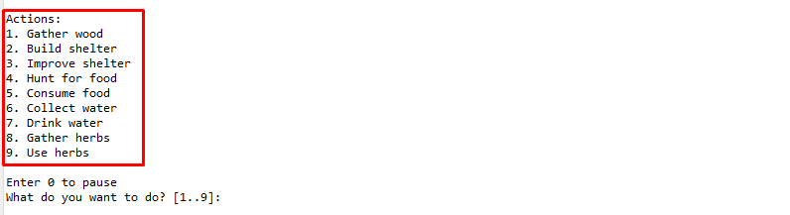

Figure 12. Actions Element

The game will have 9 different actions. Every action has its own use and comes at its own price. There are mainly 2 types of action, gathering actions and consume actions. Gathering actions will give the player resource while consume action will consume the player resource to help the player. Every action performed by player will have its own message which will be displayed after the player performs the action.

Figure 13. Action Message

Every time you gather anything your hunger and thirst stat will go down and you will get the gathered item with a random amount. When you gather resource your hunger and thirst will decrease by 5 (Accumulative), so you must generate a random number to decrease the thirst and hunger however they must accumulate to 5 and only 5. The number of resource gained from gathering will also vary from 5 to 10.

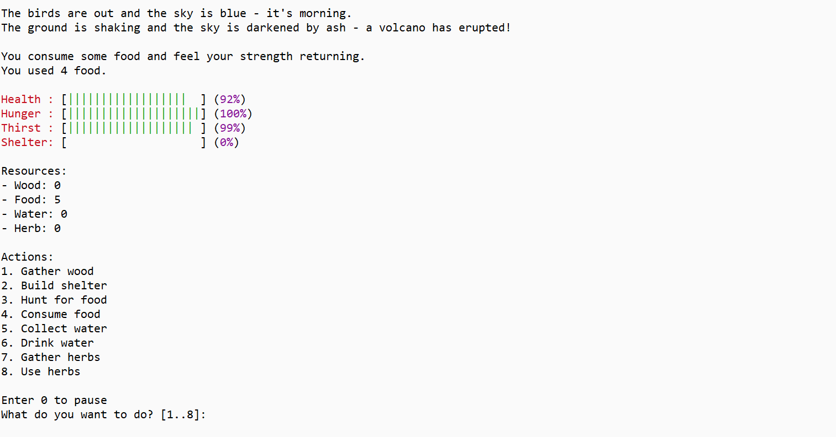Figure 14. Consume Message

Consume action will not decrease the player hunger and thirst when performed. Please make sure that the maximum number of resource consumed per action is only 10, so if the player has 15 food and decides to perform consume food action the player will only consume 10 food. You also need to make sure that we can’t have negative resource, thus you can’t consume more than what you have.

Figure 15. Interruption Message

Gathering actions if performed at night (Dusk, Night, Midnight) Will trigger an Interruption event. Interruption events will decrease the player health based on how much damage the event deals. Below are the list of Interruption events:

|  |  |  |
| --- | --- | --- |
| Event | Message | Damage |
| Fall | It's too dark, you trip sice you can't see clearly | 5 |
| Wolf Attack | This is a wolf territory and they don't like intruders | 8 |
| Shadow Attack | A figure attacks you from the dark | 15 |

In order to keep the game balance we decided to adjust the chance of the event triggered based on the time of the world. Below are the list of the chances for the interruption events:

|  |  |  |  |
| --- | --- | --- | --- |
| Time | Fall | Wolf Attack | Shadow Attack |
| Dusk | 50% | 30% | 20% |
| Night | 30% | 50% | 20% |
| Midnight | 20% | 30% | 50% |

In order to add some randomness to the game we decided to give every interruption events an additional damage from 1 to 3. Please generate the damage carefully. Every time an interruption event takes place you must display the player a message that informs them that they got interrupted. Please make sure that you show them how much damage they took from said interruption event.

Please run the EXE file to see the sample program.