|  |
| --- |
| Reversible Computation |
| User Manual |
| V2 |

|  |
| --- |
|  |

# Table of Contents

Table of Contents 1

Project Introduction 2

Sprint 1 Features 3

Create Account 3

Login 3

Sprint 2 Features 4

Sprint 3 Features 4

Papers 4

View Papers 4

Search Papers 5

Upload a Paper 6

Feed 8

View Feed 8

Create a Post 8

# Project Introduction

This guide will show you how to use the application and demonstrate its features and functions.

Reversible Computation is about the ability to begin in any state of a program and execute the program in reverse, restoring each intermediate state.

This application serves as a home for Reversible Computation Research. It introduces the concept to new visitors, whilst also providing a place for researchers to share information and collaborate.

Some of the main features are as follows. Users can upload resources, which can be viewed by other users. Users can also create posts to share their thoughts on the topic with other visitors of the application. The application also allows for visitors to view and search through papers published in regards to the field. All these functionalities allow people to interact and collaborate with each other.

# Sprint 1 Features

## Create Account

To create an account, click on the ‘Get Started’ button in the center of the index page

You’ll be redirected to the registration page

Enter your desired account details in the input boxes and ensure the details are valid

Enter a valid email address:

* Must include an ‘@’ symbol
* Must include a domain name
* Mustn’t include invalid characters

Then click the ‘Register’ button, the page will be refreshed  
And a message will appear if your registration was successful.

## Login

To access the login page  
  
Click on the ‘Already got an account’ prompt on the register page

You’ll be redirected to the login page

Enter your email and password you created when registering and click the ‘Login button’

After logging in, you’ll be redirected to the homepage

# Sprint 2 Features

No features completed in this sprint

# Sprint 3 Features

## Papers

### View Papers

To view papers click on the ‘Papers’ section on the Navigation Bar

You’ll be redirected to the ‘Papers’ page (Shown below)

On this page, you can view all the papers that have been uploaded to the website.

For each paper, you can view the Author (user that uploaded the paper), the description (description of the paper that user wrote), and the upload date (date and time the paper was uploaded).

You can also view the paper by clicking on the file name (in this View Paper column). The paper will be downloaded to your default download location.

You can view the file using your browser (or external software, such as Adobe Acrobat).

### Search Papers

On the ‘Papers’ page, there is a search bar, which allows you to search and filter the uploaded papers.



Using the drop-down menu on the left, you can specify how you want to search through the papers, e.g. you can search by the Author, or you can search by Upload Date, etc.

The middle section is where you enter your search query. So in the example below, we’re searching by Author with the name ‘Woo’.



When you’re satisfied with the query you’ve made, you can submit it using the ‘Search’ button on the right of the bar.

After your query is submitted and processed, the table on the ‘Papers’ page only shows papers that match your query.

### Upload a Paper

To upload a paper click on the ‘Upload a Paper’ button on the ‘Papers’ page.

You’ll be redirected to the ‘Upload Paper’ page (Shown below)

On this page, you can enter information about the paper you want to upload.

The ‘File Name’ represents the name that the file will be stored under once uploaded. ‘Description’ is a brief overview of the paper that you’re uploading.

To select the paper you want to upload, click the ‘Choose file button’

Once the button is clicked, your file explorer is opened and you’re able to select the paper. Note that you’re only allowed to upload files of ‘.pdf’ format, if you try uploading a file of the incorrect format, you’ll get an error.

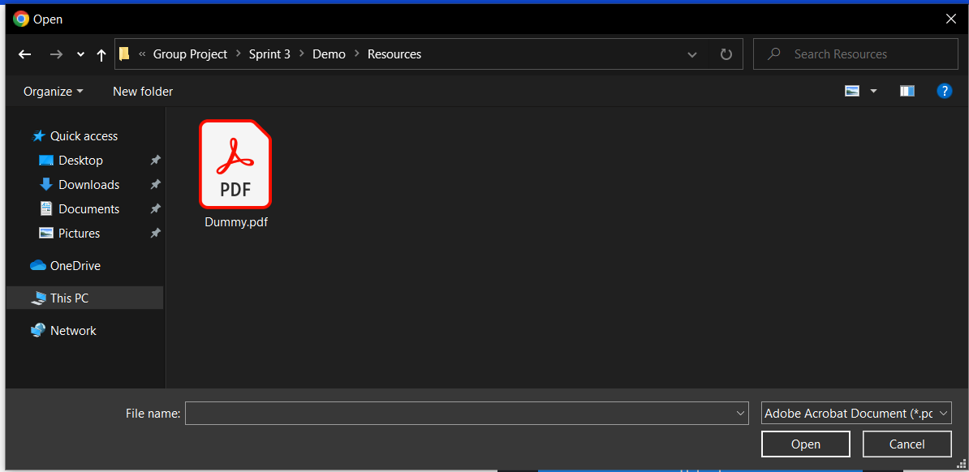

After filling in all the input fields and selecting the paper you want to upload, click the ‘Upload’ button to submit your paper.

Once uploaded, you’re redirected back to the ‘Papers’ page. The top-most row of the table represents the most recent paper upload, i.e. the paper you just uploaded.



## Feed

### View Feed

To view the feed click on the ‘Feed’ section on the Navigation Bar

You’ll be redirected to the ‘Papers’ page (Shown below)

On this page, you can view all posts that have been created, and information about recent paper uploads.

For each post, the left-most text in the header represents the Title of the post, the middle text in the header is the Author’s name, and the right-most text is the post date (the date that this post was made).  
The content of the post is displayed under the header.

### Create a Post

To create a post click on the ‘Create a Post’ button on the ‘Feed’ page.

You’ll be redirected to the ‘Create a Post’ page (Shown below)

On this page, you can enter information about the post you want to create.

The ‘Title’ represents the title of the post, and the ‘Text’ represents the content of the post.

After filling in all the input fields, click the ‘Post’ button to submit your post.

Once posted, you’re redirected back to the ‘Feed’ page. The top-most row of the feed represents the most recent post, i.e. the post you just created.

