|  |
| --- |
| Reversible Computation |
| User Manual |
| V2 |

|  |
| --- |
|  |

# Table of Contents

Table of Contents 1

Project Introduction 3

**Sprint 1 Features** 4

Create Account 4

Login 4

**Sprint 2 Features** 5

**Sprint 3 Features** 5

Papers 5

View Papers 5

Search Papers 7

Upload a Paper 7

Feed 9

View Feed 9

Create a Post 10

**Sprint 4 Features** 12

Profile 12

View About Me! 12

View Comments 13

Create Comments 13

View Posts 14

Edit Information 14

Search For User 16

Events 17

View Event 17

Search For Event 17

Create Event 18

Simulator 19

Current Memory State 19

Variable Initialization 20

Stacks 20

Program Creation 21

Program Creation Buttons 21

Variable Assignment 22

Permitted input box values 22

Sprint 3 Features………………………………………………………………………………………………………………………………..9

Profile 10

View About Me! 10

Comments 10

View Comments 10

Create Comments 11

View Posts 11

Users 13

View Users 13

Search Users 13

Edit Information 12

Events 14

View Events 14

Search for an Event 14

Create an Event 15

Simulator 19

# Project Introduction

This guide will show you how to use the application and demonstrate its features and functions.

Reversible Computation is about the ability to begin in any state of a program and execute the program in reverse, restoring each intermediate state.

This application serves as a home for Reversible Computation Research. It introduces the concept to new visitors, whilst also providing a place for researchers to share information and collaborate.

Some of the main features are as follows. Users can upload resources, which can be viewed by other users. Users can also create posts to share their thoughts on the topic with other visitors of the application. The application also allows for visitors to view and search through papers published in regards to the field. All these functionalities allow people to interact and collaborate with each other.

# **Sprint 1 Features**

## Create Account

To create an account, click on the ‘Get Started’ button in the center of the index page

You’ll be redirected to the registration page

Enter your desired account details in the input boxes and ensure the details are valid

Enter a valid email address:

* Must include an ‘@’ symbol
* Must include a domain name
* Mustn’t include invalid characters

Then click the ‘Register’ button, the page will be refreshed  
And a message will appear if your registration was successful.

## Login

To access the login page  
Click on the ‘Already got an account’ prompt on the register page

You’ll be redirected to the login page.

Enter your email and password you created when registering and click the ‘Login button

After logging in, you’ll be redirected to the homepage

# **Sprint 2 Features**

No features completed in this sprint

# **Sprint 3 Features**

## Papers

### View Papers

To view papers click on the ‘Papers’ section on the Navigation Bar

You’ll be redirected to the ‘Papers’ page (Shown On Next Page)

On this page, you can view all the papers that have been uploaded to the website.

For each paper, you can view the Author (user that uploaded the paper), the description (description of the paper that user wrote), and the upload date (date and time the paper was uploaded).

You can also view the paper by clicking on the file name (in this View Paper column). The paper will be downloaded to your default download location.

You can view the file using your browser (or external software, such as Adobe Acrobat).

### Search Papers

On the ‘Papers’ page, there is a search bar, which allows you to search and filter the uploaded papers.

Using the drop-down menu on the left, you can specify how you want to search through the papers, e.g. you can search by the Author, or you can search by Upload Date, etc.



The middle section is where you enter your search query. So in the example below, we’re searching by Author with the name ‘Woo’.

When you’re satisfied with the query you’ve made, you can submit it using the ‘Search’ button on the right of the bar.

After your query is submitted and processed, the table on the ‘Papers’ page only shows papers that match your query.

### Upload a Paper

To upload a paper click on the ‘Upload a Paper’ button on the ‘Papers’ page.

You’ll be redirected to the ‘Upload Paper’ page (Shown below)

On this page, you can enter information about the paper you want to upload.

The ‘File Name’ represents the name that the file will be stored under once uploaded. ‘Description’ is a brief overview of the paper that you’re uploading.

To select the paper you want to upload, click the ‘Choose file button’

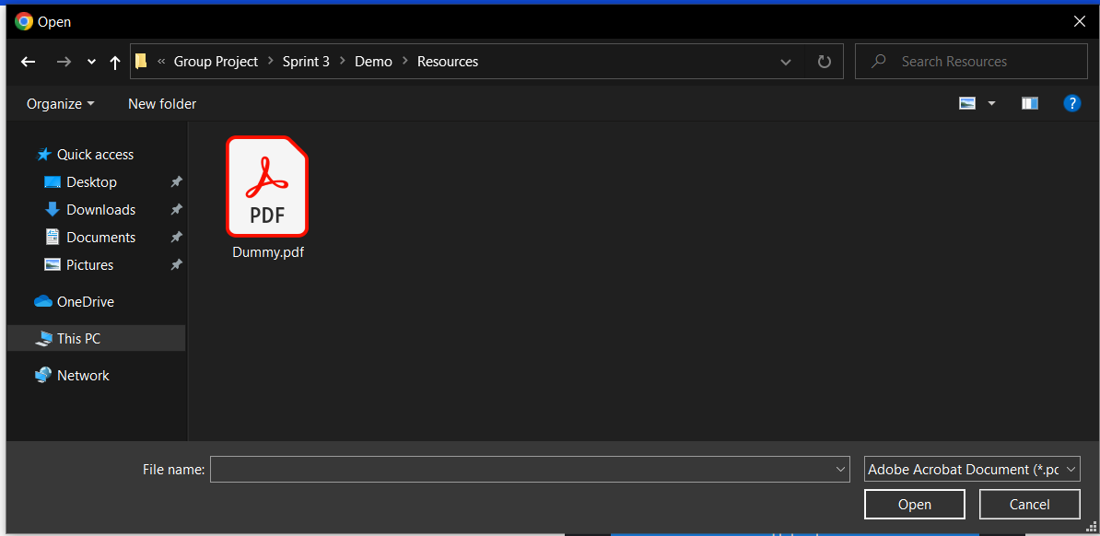

Once the button is clicked, your file explorer is opened and you’re able to select the paper. Note that you’re only allowed to upload files of ‘.pdf’ format, if you try uploading a file of the incorrect format, you’ll get an error.

After filling in all the input fields and selecting the paper you want to upload, click the ‘Upload’ button to submit your paper.

Once uploaded, you’re redirected back to the ‘Papers’ page. The top-most row of the table represents the most recent paper upload, i.e. the paper you just uploaded.



## Feed

### Text Description automatically generatedView Feed

To view the feed click on the ‘Feed’ section on the Navigation Bar

You’ll be redirected to the ‘Papers’ page (Shown on next page)

On this page, you can view all posts that have been created, and information about recent paper uploads.

For each post, the left-most text in the header represents the Title of the post, the middle text in the header is the Author’s name, and the right-most text is the post date (the date that this post was made).  
The content of the post is displayed under the header.

### Graphical user interface, text, application, email Description automatically generatedCreate a Post

To create a post click on the ‘Create a Post’ button on the ‘Feed’ page.

You’ll be redirected to the ‘Create a Post’ page (Shown below)

On this page, you can enter information about the post you want to create.

The ‘Title’ represents the title of the post, and the ‘Text’ represents the content of the post.

After filling in all the input fields, click the ‘Post’ button to submit your post.

Once posted, you’re redirected back to the ‘Feed’ page. The top-most row of the feed represents the most recent post, i.e. the post you just created.

# **Sprint 4 Features**

## Profile

### Graphical user interface, text, application Description automatically generatedView About Me!

In order to view your About Me! navigate your mouse to the top right of whatever webpage you are on, and hover over the circle labeled profile, a dropdown will appear displaying three options, click on “Profile” (Circled in red below).

You will be redirected towards your own profile “About Me!” page.

### Graphical user interface, text, application, chat or text message Description automatically generatedView Comments

In order to view your profile comments, navigate to profile “About Me!” page, and click on the button labelled “Comments” (Circled in red above).

Your comments will appear on the left hand side (Circled in red and green above).

### Graphical user interface, text, application Description automatically generatedCreate Comments

In order to create a comment on page, navigate to the “Comments” page as shown above. Once you have done this locate the “Create Comment” panel (Circled in red below).

Now type your comment in the text input box and click the button opposite labelled “Comment”, you will then be redirected to the about me page and can view the comment by clicking on the “Comments” button in the center of your screen.

### Graphical user interface, text, application Description automatically generatedView Posts

In order to view the posts on your profile, you should navigate to the button labelled “Posts” (Circled in red below) in the center of your screen from any profile webpage e.g. About me or Comments.

You will then see all posts this profile has made(As shown below).

### Graphical user interface, text, application Description automatically generatedEdit Information

In order to edit your information navigate your mouse to the top right of whatever webpage you are on, and hover over the circle labeled profile, a dropdown will appear displaying three options, click on “Edit Information” (Circled in red above).

You will be shown a page with multiple input text boxes with relevant labels as to their purpose, for example if you want to change your age navigate to the box labelled “Enter Age” enter your age and click “Change Age”.

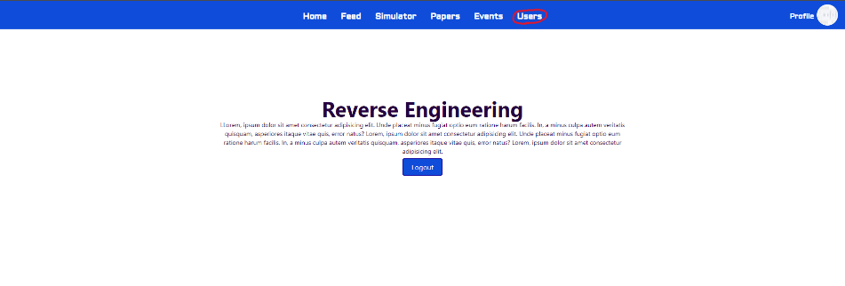View Users



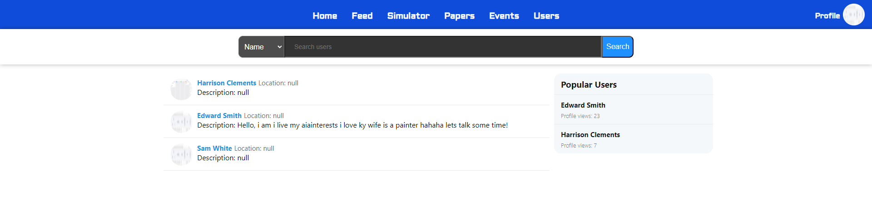In order to see users you should navigate to the “Users” tab in the tab navigation bar.

This will display all users.

### Search For User

Locate the search bar at the top of the screen.

Select what attribute you’d like to search for, enter a key word and results will appear below.

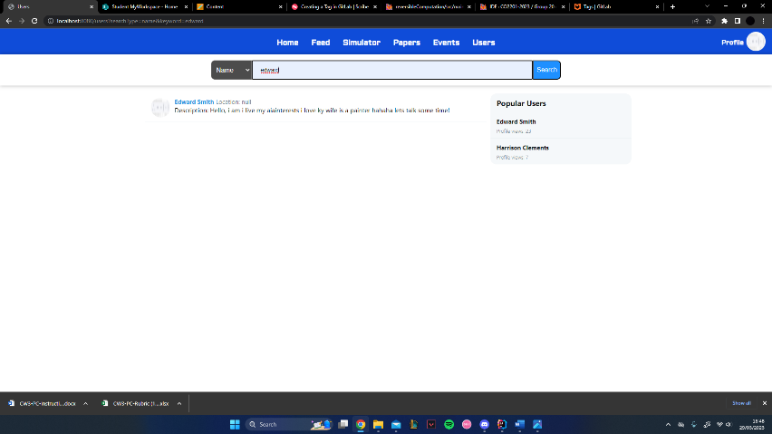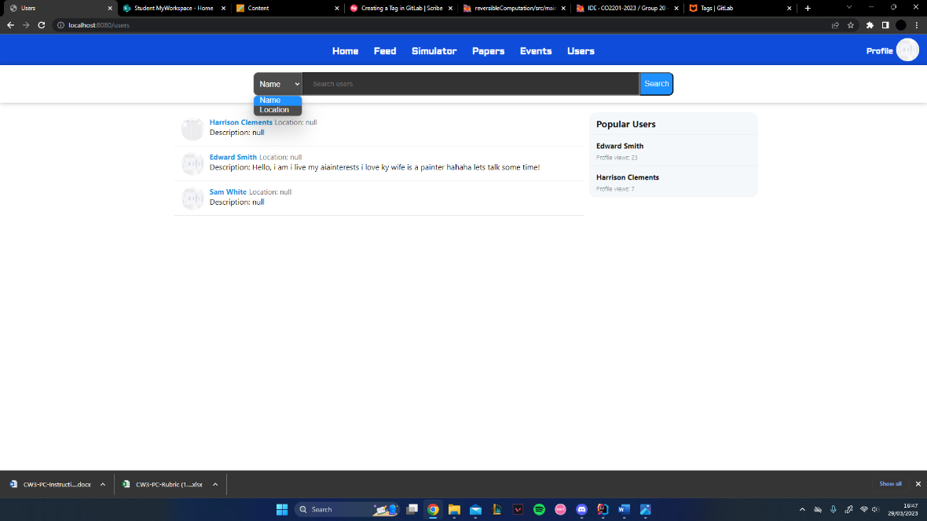

## Events

### View Event



In order to see your events you should navigate to the events tab in the tab navigation bar.

This will display all events scheduled.

### A screenshot of a computer Description automatically generatedSearch For Event

Locate the search bar.

Select what attribute you’d like to search for, enter a key word and results will appear below.

### Graphical user interface, application Description automatically generatedCreate Event

To create an event, click on the “Create an Event” button.

Now enter the Title of event, description, select a date in the future, time, duration, and location, all respective of the label in each text box, then click create.

## Simulator



To navigate to the simulator page, click the simulator link in the navigation bar as shown above.

Here is the simulator page that aims to demonstrate reversable computation.

### Current Memory State

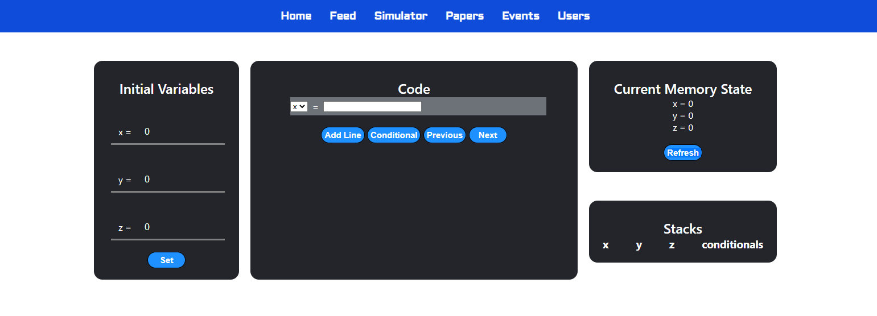

The box on the top right indicates the current state of the 3 variables you will be working with during the code execution (x, y and z).

### Variable Initialization



The box on the left-hand side allows the user to set the initial state of the variables before execution. To do so enter the desired values and click the set button.

### Stacks



The bottom right box shows the current state of the variable and conditional stacks. The stacks are currently empty as execution hasn’t begun however once its begun it will list all the previous values of the variables (and conditional decisions; true or false).

### Program Creation



Here is where the magic happens. The main section is to actually create your custom program that allows for variable assignment and conditional code execution.

### Program Creation Buttons

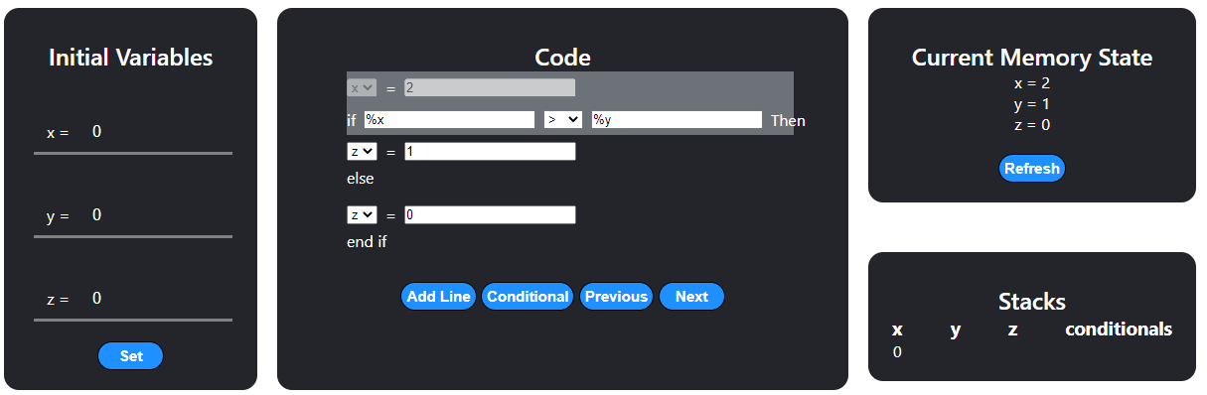

Using the 4 buttons you can:

* **Add Line** [adds an extra line of code to the main box for variable assignment]
* **Conditional** [adds and if else conditional to the program]
* **Next** [executes the next line of code]
* **Previous** [goes back a line of code and updates current memory state using stacks (see bottom left box)]

### Variable Assignment

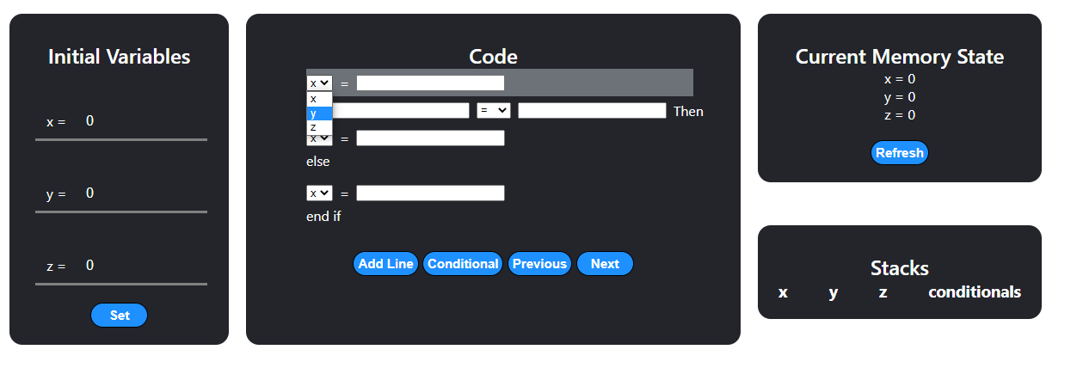

To chose which variable you want to assign click on the drop down menu on the left (default value will be x).

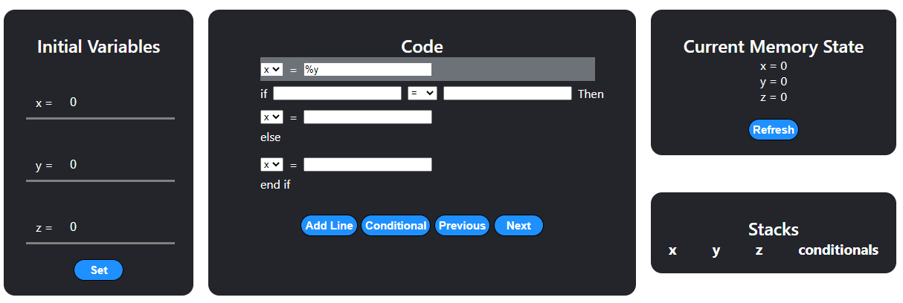Next type in the value you want to assign to the chosen variable using the input box on the right.

You can also assign variables to variables using the percentage “%” key before the corresponding letter.

### Permitted input box values

|  |  |
| --- | --- |
| 2 | Accepted |
| 2+2 | Accepted |
| 2-2+3 | Accepted |
| (2-2)*4 | Accepted |
| %x | Accepted |
| %y*4 | Accepted |
| %x+%y | Accepted |
| x+y | Invalid |
| abc | Invalid |
| Hello world | Invalid |



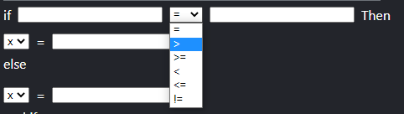After pressing the conditional button, you will see a block of code similar to this.

The drop down menu shown above will allow you to set which mathematical comparison operator to use for the condition.