# First, you need to create your own Telegram-bot:

Telegram’s robot is a powerful platform for internet of things. First you should search “@Botfather” in your telegram account, when you enter the chat-room, you will see this message:

BotFather is the one bot to rule them all. Use it to create new bot accounts and manage your existing bots.

In order to start making our telegram robot, click on **/Start**

Robot will send this message:

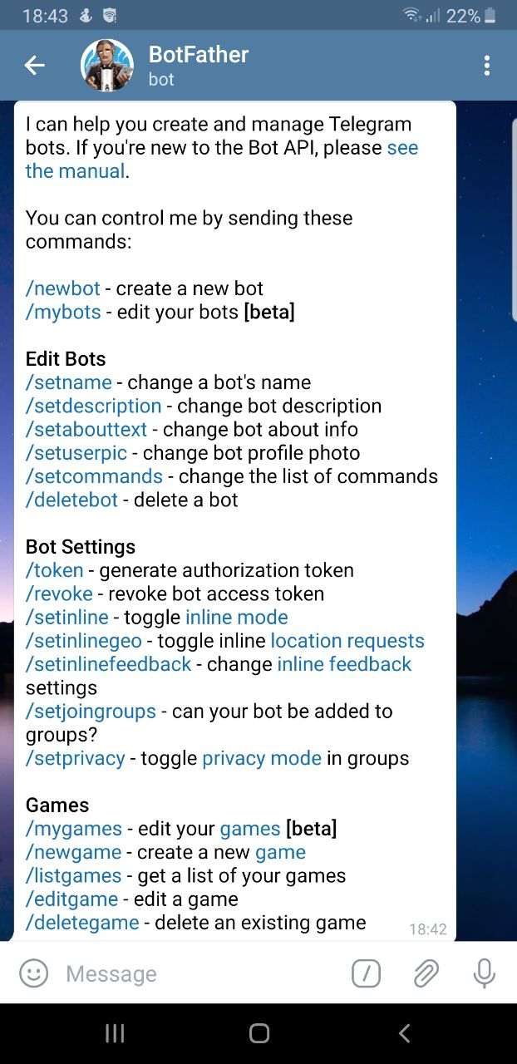

To create a robot, we enter **/newbot**

Then, the robot will ask us a name for our new robot, which this name is different from user, so you can input any name you like.

After choosing a name, you should choose a username for your robot. This name should be unique and finish with “bot”.

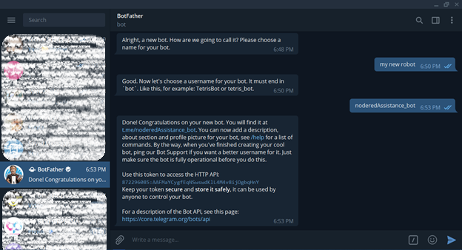

As you can see, my robot has been created and telegram give me an API, which is necessary to make any connection with that robot.

# Then we can add telegram node to node-red

In order to add new nodes, you just need to choose “Manage Palette” from Menu. Then, go to the tab “Install”, search for telegram, and install “node-red-contrib-telegrambot”.

After you add telegram-bot to your project, it is time to add “telegram sender” node to the project and configure it.

As first step, we need to introduce our telegram-bot to node-red:

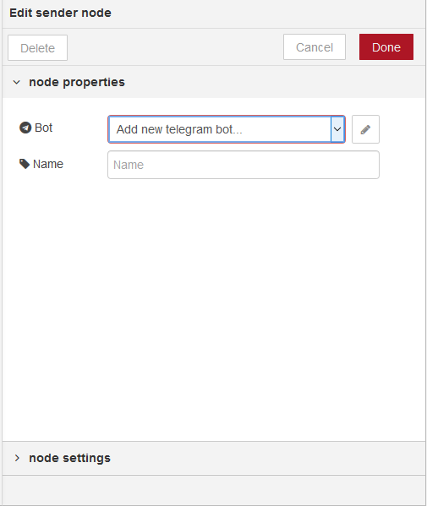

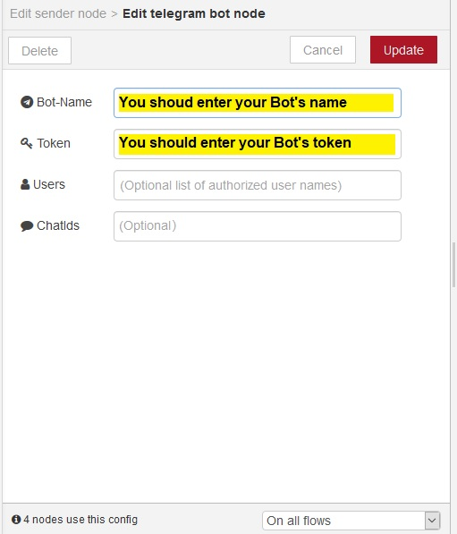

After these steps, your Telegram node should be shown as connected.