**Lab07**

**AIMS Data Modeling**

**1. CONCEPTUAL DATA MODEL**

* **AIMS System ERD**

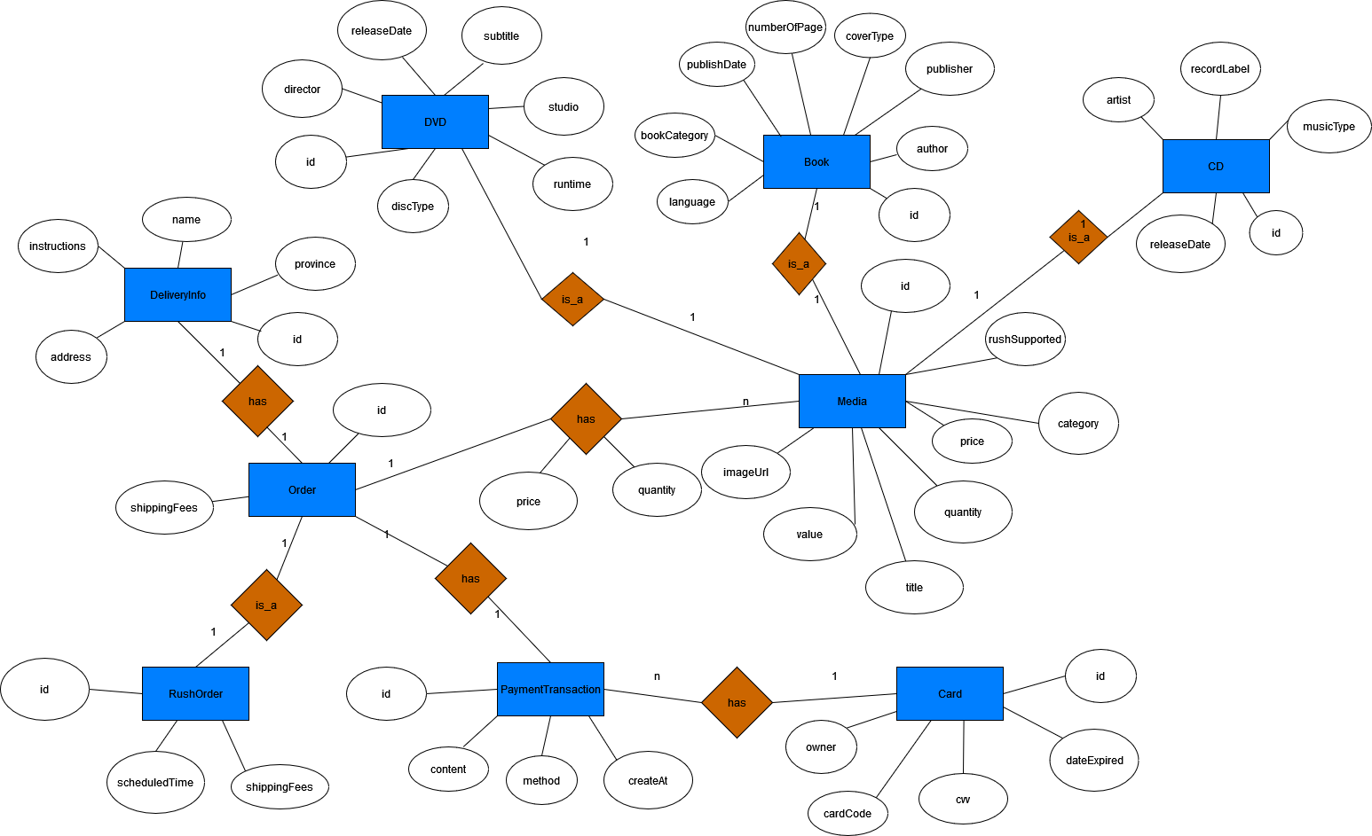

**2. DATABASE DESIGN**

**- Logical Data Model**

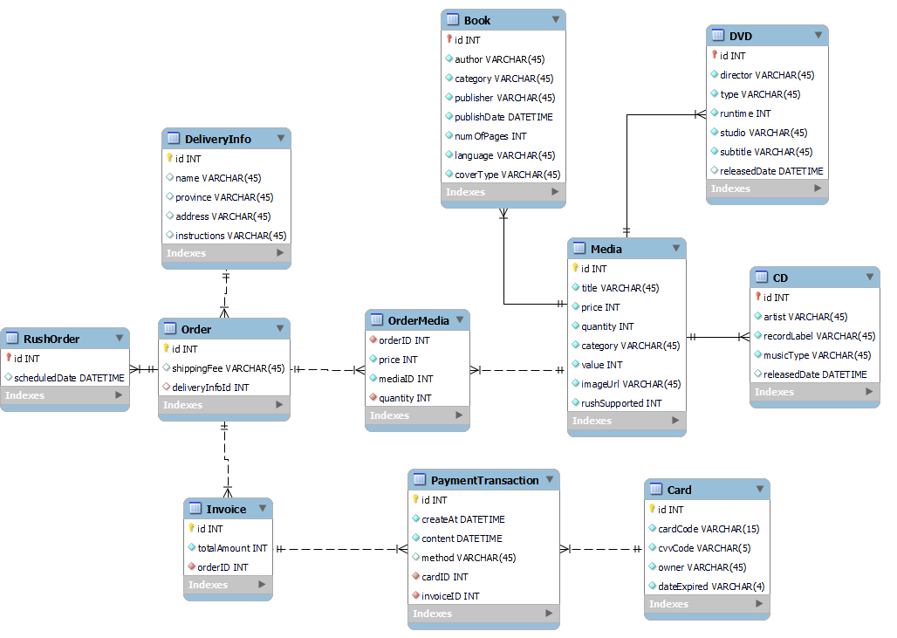

**- Physical Data Model**

* + - 1. **Media**

|  |  |  |  |  |  |  |
| --- | --- | --- | --- | --- | --- | --- |
| # | PK | FR | Column Name | Data type | Mandatory | Description |
|  | x |  | id | Integer | Yes | ID, auto increment |
|  |  |  | title | VARCHAR(45) | Yes | Media type, e.g., CD, DVD |
|  |  |  | price | Integer | Yes | Current price |
|  |  |  | quantity | Integer | Yes | Number of products |
|  |  |  | category | VARCHAR(45) | Yes | Product name |
|  |  |  | value | Integer | Yes | Value of the product |
|  |  |  | imageUrl | VARCHAR(45) | Yes | Product image path |
|  |  |  | rushSupported | Boolean | Yes | Rush Order supported or not |

* + - 1. **CD**

|  |  |  |  |  |  |  |
| --- | --- | --- | --- | --- | --- | --- |
| # | PK | FK | Column Name | Data type | Mandatory | Description |
|  | x | x | id | Integer | Yes | ID, same as ID of Media of which type is CD |
|  |  |  | artist | VARCHAR(45) | Yes | Artist’s name |
|  |  |  | recordLabel | VARCHAR(45) | Yes | Record Label |
|  |  |  | musicType | VARCHAR(45) | Yes | Music genres |
|  |  |  | releasedDate | DATE | Yes | Released date |

* + - 1. **Book**

|  |  |  |  |  |  |  |
| --- | --- | --- | --- | --- | --- | --- |
| # | PK | FK | Column Name | Data type | Mandatory | Description |
|  | x | x | id | Integer | Yes | ID, same as ID of Media of which type is Book |
|  |  |  | author | VARCHAR(45) | Yes | Author |
|  |  |  | category | VARCHAR(45) | Yes | Cover type |
|  |  |  | publisher | VARCHAR(45) | Yes | Publishing house |
|  |  |  | publishDate | DATETIME | Yes | Date of publishing |
|  |  |  | numOfPages | Integer | Yes | Page number |
|  |  |  | language | VARCHAR(45) | Yes | Language |
|  |  |  | coverType | VARCHAR(45) | Yes | Book category |

* + - 1. **DVD**

|  |  |  |  |  |  |  |
| --- | --- | --- | --- | --- | --- | --- |
| # | PK | FK | Column Name | Data type | Mandatory | Description |
| 1 | x | x | id | Integer | Yes | ID, same as ID of Media of which type is DVD |
| 2 |  |  | director | VARCHAR(45) | Yes | Disc type |
| 3 |  |  | type | VARCHAR(45) | Yes | Director |
| 4 |  |  | runtime | Integer | Yes | Duration |
| 5 |  |  | studio | VARCHAR(45) | Yes | Manufacturer |
| 6 |  |  | subtitle | VARCHAR(45) | Yes | Subtitles |
| 7 |  |  | releasedDate | VARCHAR(45) | Yes | Release date |
| 8 |  |  | filmType | VARCHAR(45) | Yes | Genres |

* + - 1. **Card**

|  |  |  |  |  |  |  |
| --- | --- | --- | --- | --- | --- | --- |
| # | PK | FK | Column Name | Data type | Mandatory | Description |
| 1 | x |  | id | Integer | Yes | ID, auto increment |
| 2 |  |  | cardCode | VARCHAR(45) | Yes | Card code |
| 3 |  |  | cvvCode | VARCHAR(45) | Yes | Card holders |
| 4 |  |  | owner | VARCHAR(3) | Yes | CVV Code |
| 5 |  |  | dateExpired | VARCHAR(4) | Yes | Expiration date |

* + - 1. **DeliveryInfo**

|  |  |  |  |  |  |  |
| --- | --- | --- | --- | --- | --- | --- |
| # | PK | FK | Column Name | Data type | Mandatory | Description |
| 1 | x |  | id | Integer | Yes | ID, auto increment |
| 2 |  |  | name | VARCHAR(45) | Yes | Receiver name |
| 3 |  |  | province | VARCHAR(45) | Yes | Provinces |
| 4 |  |  | address | VARCHAR(200) | No | Delivery instructions |
| 5 |  |  | instructions | VARCHAR(100) | Yes | Delivery address |

* + - 1. **Order**

|  |  |  |  |  |  |  |
| --- | --- | --- | --- | --- | --- | --- |
| # | PK | FK | Column Name | Data type | Mandatory | Description |
| 1 | x |  | id | Integer | Yes | ID |
| 2 |  |  | shippingFees | VARCHAR(45) | Yes | Shipping fee |
| 3 |  | x | deliveryInfoID | Integer | Yes | Delivery Info ID |

* + - 1. **OrderMedia**

|  |  |  |  |  |  |  |
| --- | --- | --- | --- | --- | --- | --- |
| # | PK | FK | Column Name | Data type | Mandatory | Description |
| 1 |  | x | orderID | Integer | Yes | Media ID |
| 2 |  | x | price | Integer | Yes | Order ID |
| 3 |  |  | mediaID | Integer | Yes | Selling price |
| 4 |  |  | quantity | Integer | Yes | Number |

* + - 1. **Invoice**

|  |  |  |  |  |  |  |
| --- | --- | --- | --- | --- | --- | --- |
| # | PK | FK | Column Name | Data type | Mandatory | Description |
| 1 | x |  | id | Integer | Yes | ID |
| 2 |  |  | totalAmount | Integer | Yes | Total |
| 3 |  | x | orderID | Integer | Yes | Order ID |

* + - 1. **PaymentTransaction**

|  |  |  |  |  |  |  |
| --- | --- | --- | --- | --- | --- | --- |
| # | PK | FK | Column Name | Data type | Mandatory | Description |
| 1 | x |  | id | Integer | Yes | ID |
| 2 |  |  | createAt | DATETIME | Yes | Date of creation |
| 3 |  |  | content | VARCHAR(45) | Yes | Transaction contents |
| 4 |  |  | method | VARCHAR(45) | Yes | Payment methods |
| 5 |  | x | cardID | Integer | Yes | ID of used card |
| 6 |  | x | invoiceID | Integer | Yes | Invoice ID |

**- Database Script**

BEGIN;

CREATE TABLE "aims"."Media"(

"id" INTEGER PRIMARY KEY AUTOINCREMENT NOT NULL,

"category" VARCHAR(45) NOT NULL,

"price" INTEGER NOT NULL,

"quantity" INTEGER NOT NULL,

"title" VARCHAR(45) NOT NULL,

"value" INTEGER NOT NULL,

"imageUrl" VARCHAR(45) NOT NULL,

“rushSupported” BOOLEAN NOT NULL);

CREATE TABLE "aims"."CD"(

"id" INTEGER PRIMARY KEY NOT NULL,

"artist" VARCHAR(45) NOT NULL,

"recordLabel" VARCHAR(45) NOT NULL,

"musicType" VARCHAR(45) NOT NULL,

"releasedDate" DATE,

CONSTRAINT "fk_CD_Media1”

FOREIGN KEY("id")

REFERENCES "Media"("id")

);

CREATE TABLE "aims"."Book"(

"id" INTEGER PRIMARY KEY NOT NULL,

"author" VARCHAR(45) NOT NULL,

"coverType" VARCHAR(45) NOT NULL,

"publisher" VARCHAR(45) NOT NULL,

"publishDate" DATETIME NOT NULL,

"numOfPages" INTEGER NOT NULL,

"language" VARCHAR(45) NOT NULL,

"bookCategory" VARCHAR(45) NOT NULL

CONSTRAINT "fk_Book_Media1"

FOREIGN KEY("id")

REFERENCES "Media"("id")

);

CREATE TABLE "aims"."DeliveryInfo"(

"id" INTEGER PRIMARY KEY AUTOINCREMENT NOT NULL,

"name" VARCHAR(45),

"province" VARCHAR(45),

"instructions" VARCHAR(200),

"address" VARCHAR(100)

);

CREATE TABLE "aims"."Card"(

"id" INTEGER PRIMARY KEY AUTOINCREMENT NOT NULL,

"cardCode" VARCHAR(15) NOT NULL,

"owner" VARCHAR(45) NOT NULL,

"cvvCode" VARCHAR(3) NOT NULL,

"dateExpired" VARCHAR(4) NOT NULL

);

CREATE TABLE "aims"."DVD"(

"id" INTEGER PRIMARY KEY NOT NULL,

"discType" VARCHAR(45) NOT NULL,

"director" VARCHAR(45) NOT NULL,

"runtime" INTEGER NOT NULL,

"studio" VARCHAR(45) NOT NULL,

"subtitle" VARCHAR(45) NOT NULL,

"releasedDate" DATETIME,

CONSTRAINT "fk_DVD_Media1"

FOREIGN KEY("id")

REFERENCES "Media"("id")

);

CREATE TABLE "aims"."Order"(

"id" INTEGER NOT NULL,

"shippingFees" VARCHAR(45),

"deleveryInfoId" INTEGER NOT NULL,

PRIMARY KEY("id","deleveryInfoId"),

CONSTRAINT "fk_Order_DeleveryInfo1"

FOREIGN KEY("deleveryInfoId")

REFERENCES "DeleveryInfo"("id")

);

CREATE INDEX "aims"."Order.fk_Order_DeleveryInfo1_idx" ON "Order"("deleveryInfoId");

CREATE TABLE "aims"."OrderMedia"(

"orderID" INTEGER NOT NULL,

"price" INTEGER NOT NULL,

"quantity" INTEGER NOT NULL,

"mediaId" INTEGER NOT NULL,

PRIMARY KEY("orderID","mediaId"),

CONSTRAINT "fk_ordermedia_order"

FOREIGN KEY("orderID")

REFERENCES "Order"("id"),

CONSTRAINT "fk_OrderMedia_Media1"

FOREIGN KEY("mediaId")

REFERENCES "Media"("id")

);

CREATE INDEX "aims"."OrderMedia.fk_ordermedia_order_idx" ON "OrderMedia"("orderID");

CREATE INDEX "aims"."OrderMedia.fk_OrderMedia_Media1_idx" ON "OrderMedia"("mediaId");

CREATE TABLE "aims"."Invoice"(

"id" INTEGER PRIMARY KEY NOT NULL,

"totalAmount" INTEGER NOT NULL,

"orderId" INTEGER NOT NULL,

CONSTRAINT "fk_Invoice_Order1"

FOREIGN KEY("orderId")

REFERENCES "Order"("id")

);

CREATE INDEX "aims"."Invoice.fk_Invoice_Order1_idx" ON "Invoice"("orderId");

CREATE TABLE "aims"."PaymentTransaction"(

"id" INTEGER NOT NULL,

"createAt" DATETIME NOT NULL,

"content" VARCHAR(45) NOT NULL,

"method" VARCHAR(45),

"cardId" INTEGER NOT NULL,

"invoiceId" INTEGER NOT NULL,

PRIMARY KEY("id","cardId","invoiceId"),

CONSTRAINT "fk_PaymentTransaction_Card1"

FOREIGN KEY("cardId")

REFERENCES "Card"("id"),

CONSTRAINT "fk_PaymentTransaction_Invoice1"

FOREIGN KEY("invoiceId")

REFERENCES "Invoice"("id")

);

CREATE INDEX "aims"."PaymentTransaction.fk_PaymentTransaction_Card1_idx" ON"PaymentTransaction" ("cardId");

CREATE INDEX "aims"."PaymentTransaction.fk_PaymentTransaction_Invoice1_idx"ON "PaymentTransaction" ("invoiceId");

COMMIT;