1) Have Finish the reading of Chapter 1, 2, 3.

2) Approximately 1.86 billion transistors are in the Intel Core i7 (Quad) CPU? Approximately 6.8 billion transistors are in the Xilinx Virtex-7 FPGA?

3) Convert the following numbers to 12-bit signed binary numbers.

a) 13510 = 000010000111

b) –13510 = 111101111001

c) 35F16 =001101101111

d) –57610 =110111111110

4) 完成下列8位无符号二进制数的计算，并给出相应的十进制数。

a) 10101010 + 00111011 =11100101=22910

b) 00111101 + 01110100 =10110001=17710

c) 11100011 + 11110011 =111010110=47010

d) 11000111 + 10010110 =101011101=34910

5) Derive the truth table for the function *F*(*x*,*y*,*z*) = [(*x*+*y'* ) + (*xz*)*'* ] (*xy'* + *y'z*)

|  |  |  |  |
| --- | --- | --- | --- |
| X | Y | Z | F |
| 0 | 0 | 0 | 0 |
| 0 | 0 | 1 | 1 |
| 0 | 1 | 0 | 0 |
| 0 | 1 | 1 | 0 |
| 1 | 0 | 0 | 1 |
| 1 | 0 | 1 | 1 |
| 1 | 1 | 0 | 0 |
| 1 | 1 | 1 | 0 |

6) Derive the truth table and equation for the following circuit. Do not simplify the equation.



F=[(x’z’)’][(w’xy’)’][(wyz’)’]’

|  |  |  |  |  |
| --- | --- | --- | --- | --- |
| W | X | Y | Z | F |
| 0 | 0 | 0 | 0 | 1 |
| 0 | 0 | 0 | 1 | 1 |
| 0 | 0 | 1 | 0 | 1 |
| 0 | 0 | 1 | 1 | 1 |
| 0 | 1 | 0 | 0 | 1 |
| 0 | 1 | 0 | 1 | 1 |
| 0 | 1 | 1 | 0 | 1 |
| 0 | 1 | 1 | 1 | 0 |
| 1 | 0 | 0 | 0 | 1 |
| 1 | 0 | 0 | 1 | 1 |
| 1 | 0 | 1 | 0 | 1 |
| 1 | 0 | 1 | 1 | 1 |
| 1 | 1 | 0 | 0 | 1 |
| 1 | 1 | 0 | 1 | 0 |
| 1 | 1 | 1 | 0 | 1 |
| 1 | 1 | 1 | 1 | 0 |

7)Derive the Boolean function for the following truth table, and simplify it by using Karnaugh Maps.

|  |  |  |  |
| --- | --- | --- | --- |
| *a* | *b* | *c* | *F* |
| 0 | 0 | 0 | 1 |
| 0 | 0 | 1 | 0 |
| 0 | 1 | 0 | 0 |
| 0 | 1 | 1 | 1 |
| 1 | 0 | 0 | 1 |
| 1 | 0 | 1 | 1 |
| 1 | 1 | 0 | 1 |
| 1 | 1 | 1 | 0 |

F=a’b’c’+a’bc+ab’c’+ab’c+abc’

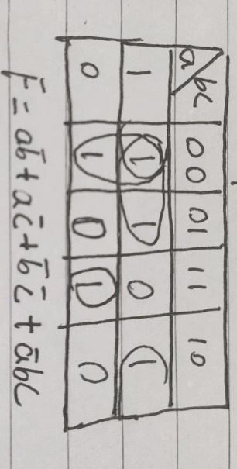

8)Derive the Boolean function for the following truth table, and simplify it by using Karnaugh Maps. (See next page)

|  |  |  |  |  |
| --- | --- | --- | --- | --- |
| *w* | *x* | *y* | *z* | *F* |
| 0 | 0 | 0 | 0 | 1 |
| 0 | 0 | 0 | 1 | 0 |
| 0 | 0 | 1 | 0 | 1 |
| 0 | 0 | 1 | 1 | 0 |
| 0 | 1 | 0 | 0 | 1 |
| 0 | 1 | 0 | 1 | 1 |
| 0 | 1 | 1 | 0 | 0 |
| 0 | 1 | 1 | 1 | 0 |
| 1 | 0 | 0 | 0 | 1 |
| 1 | 0 | 0 | 1 | 0 |
| 1 | 0 | 1 | 0 | 1 |
| 1 | 0 | 1 | 1 | 0 |
| 1 | 1 | 0 | 0 | 0 |
| 1 | 1 | 0 | 1 | 0 |
| 1 | 1 | 1 | 0 | 1 |
| 1 | 1 | 1 | 1 | 0 |

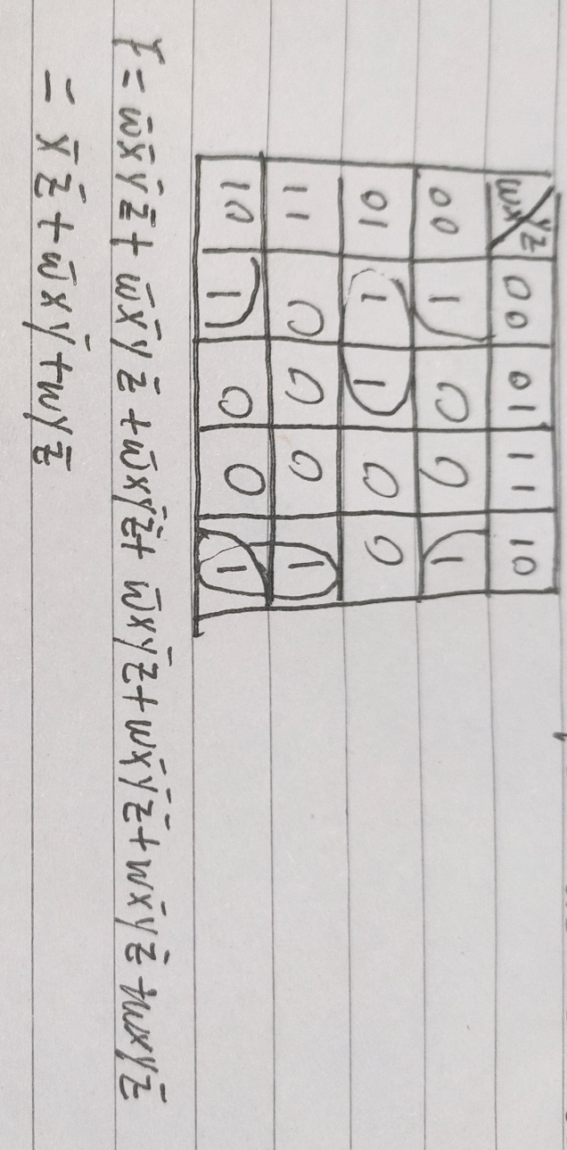

9)Have installed