**A RELIABLE ENERGY CONSUMPTION ANALYSIS SYSTEM FOR ENERGY-EFFICIENT APPLIANCES**

**IBM NAAN MUDHALVAN**

**(TEAM ID:NM2023TMID04803)**

**A PROJECT REPORT**

***Submitted by***

**IMRAAN H (311820104013)**

**KARAN R (311820104015)**

**ELANGOVAN G (311820104012)**

**MUSHARAF MUBEEN A (311820104028)**

**BACHELOR OF ENGINEERING**

**IN**

**COMPUTER SCIENCE AND ENGINEERING**

**MOHAMED SATHAK A J COLLEGE OF ENGINEERING**

**SIRUSERI, OMR, CHENNAI-603 103**



**MAY - 2023**



# ANNA UNIVERSITY: CHENNAI 600 025

**BONAFIDE CERTIFICATE**

Certified that this project report **“A RELIABLE ENERGY CONSUMPTION ANALYSIS SYSTEM FOR ENERGY-EFFICIENT APPLIANCES”** is the bonafide work of **IMRAAN H (311820104013), KARAN R (311820104015), ELANGOVAN G (311820104012), MUSHARAF MUBEEN A (311820104028)** who carried out the **IBM NAAN MUDHALAVAN** project work under our supervision.

**Industry Mentor Faculty Mentor**

**(Mrs. Saumya, IBM) (Mr. Gajanan, IBM) (Mrs. Muthu Pandeeswari/AP)**

**Head of the Department/ CSE**

**(S.Vimalathithan)**  **ACKNOWLEDGEMENT**

First and foremost we thank the almighty for helping us in all situations for bringing out this project successfully.

We express our sincere heartfelt gratitude to **ALHAJ JANAB**

**S.M.MOHAMMED YUSUF**, **CHAIRMAN,** **Mrs. S.M.H. SHARMILA**,

Secretary, **JANAB** **P.R.L HAMID** **IBRAHIM**, Executive director and **Mr**. **MOHAMED SATHAK,** Director**,** Mohamed Sathak A J College of Engineering, Chennai.

We would like to express our thanks to our principal **Dr. K. S.SRINIVASAN, M.E, PhD,**.For his kind consent, inspiration and constant encouragement towards this project work.

We profusely thank **S. VIMALATHITHAN, PhD**. Head of the department, Computer Science and Engineering for the help and support, without which our project would have been sculpted successfully.

We express our heart full thanks to our **Industry Mentor Mrs. Saumya, IBM and**

MR.Gajanan, IBM. Faculty Mentor **Mrs.MUTHU PANDEESWARI/Assistant Professor**

For invaluable support, guidance, utmost patience, inspirational coordination and constant encouragements in completing this project successfully.

Also we would like to thank all the faculty members and non teaching staff of the Computer Science and Engineering department for the kind advice and encouragement.

**TABLE OF CONTENT**

**CHAPTER NO. TITLE**

1. **INTRODUCTION** 
   1. Project Overview

* 1. Purpose

1. **IDEATION & PROPOSED SYSTEM** 
   1. Problem Statement Definition
   2. Empathy Map Canvas
   3. Ideation & Brainstorming
   4. Proposed Solution
2. **REQUIREMENT ANALYSIS** 
   1. Functional requirement
   2. Non-Functional requirements
3. **PROJECT DESIGN** 
   1. Data Flow Diagrams
   2. Solution & Technical Architecture
   3. User Stories
4. **CODING & SOLUTIONING** 
   1. Feature 1
   2. Feature 2
   3. Database Schema (if Applicable)
5. **RESULTS** 
   1. Performance Metrics
6. **ADVANTAGES & DISADVANTAGES**
7. **CONCLUSION**
8. **FUTURE SCOPE**

**10 APPENDIX**

**Source Code**

**GitHub & Project Video Demo Link**

**CHAPTER 1**

**INTRODUCTION**

* 1. **Project Overview**

Assessing the safety of municipal drinking water is a crucial project that aims to evaluate the quality and safety of the water supply provided to the residents of a municipality. This project involves a comprehensive examination of various factors related to the water source, treatment processes, distribution system, and overall water quality. The primary goal is to ensure that the drinking water meets or exceeds the established regulatory standards and poses no significant health risks to the consumers.

* 1. **Purpose**

To ensure that the water supplied to residents is safe, clean, and meets or exceeds established quality standards. The primary purpose is to safeguard the health and well-being of the community. The assessment aims to ensure that the water supply meets these regulations, which are designed to protect public health. This may involve implementing additional treatment processes, improving infrastructure, or implementing monitoring programs to ensure ongoing safety. By understanding the sources of contaminants, authorities can implement measures to prevent or mitigate their impact on the water supply.

**CHAPTER 2**

**IDEATION & PROPOSED SOLUTION**

**2.1 PROBLEM STATEMENT DEFINITION**

The safety of municipal drinking water is a critical concern, as it directly impacts public health. The problem at hand is to evaluate and ensure the safety and quality of the water supplied to residents in a municipality. This assessment involves identifying potential contaminants, assessing the effectiveness of water treatment processes, evaluating the integrity of the distribution system, and complying with regulatory standards. The objective is to address any existing or potential risks to public health, prevent waterborne diseases, and maintain a reliable supply of safe drinking water for the community.

**2.2 EMPATHY MAP CANVAS**

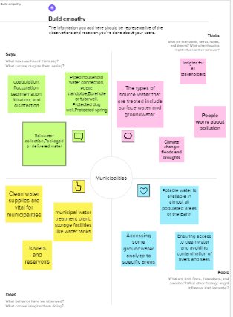

**Fig 2.2: Empathy Map Canvas**

## 2.3 IDEATION & BRAINSTORMING

## 

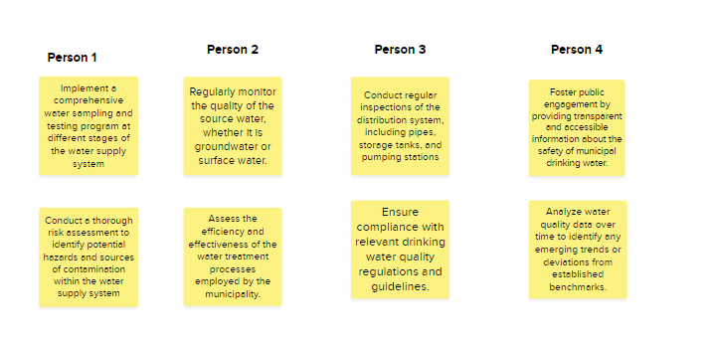

**Fig 2.3: Ideation & Brainstorming**

## 2.4 Proposed Solution

A proposed solution for assessing the safety of municipal drinking water includes the following steps:

* Comprehensive Water Testing: Implement a robust and regular water testing program to analyze samples from various points in the water supply system.
* Enhanced Water Treatment Processes: Evaluate and upgrade water treatment processes as needed to ensure the removal or inactivation of contaminants.
* Integrated Risk Management Approach: Adopt an integrated risk management approach to identify and prioritize potential risks to the drinking water supply.
* Regulatory Compliance and Monitoring: Stay abreast of changing regulations and standards related to drinking water quality.

**CHAPTER 3**

## REQUIREMENT ANALYSIS

### 3.1 Functional requirement

Following are the functional requirements of the proposed solution.

* FR-1 The system should facilitate the identification and assessment of potential risks to the safety of drinking water.
* FR-2 It should enable efficient and accurate laboratory testing procedures.
* FR-3 It should provide mechanisms to compare water quality data against regulatory thresholds and generate compliance reports.
* FR-4 It should facilitate the collection of samples for laboratory analysis.

### 3.2 Non Functional requirement

Following are the non-functional requirements of the proposed solution.

* NFR-1 The system should be scalable to accommodate varying data volumes and increased testing frequency as the water supply system expands or as monitoring requirements evolve.
* NFR-2 The system should incorporate robust security measures to protect sensitive data related to water quality assessment.
* NFR-3 It should provide clear visualization of data and support efficient data entry, retrieval, and analysis.
* NFR-4 The system should be designed to integrate with existing data management systems, laboratory information management systems (LIMS), and other relevant software applications.

**CHAPTER 4**

## PROJECT DESIGN

### 4.1 Data Flow Diagrams

A Data Flow Diagram (DFD) is a traditional visual representation of the information flows within a system. The process begins with data collection, which involves gathering information about the water supply system, including the water source, treatment processes, and distribution network. This data may include water source characteristics, treatment plant operation records, maintenance logs, and distribution system mapping.

4.2 SOLUTION & TECHNICAL ARCHITECTURE

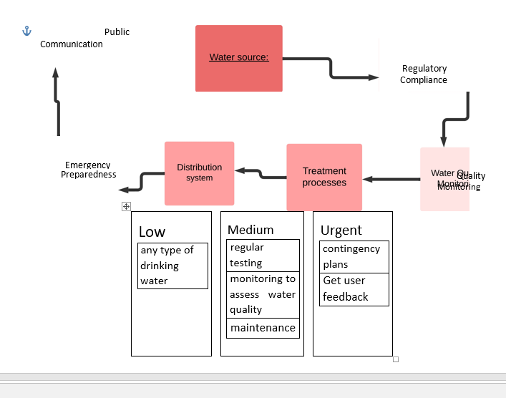

## Fig: 4.2 Solution Architecture

### 4.3 User Stories

Use the below template to list all the user stories for the product.

|  |  |  |  |  |  |
| --- | --- | --- | --- | --- | --- |
| Water quality analyst | Data collection and preprocessing | USN-1 | As a user, to detect patterns in historical municipal drinking water data. | High | Aysha Thaslim |
|  |  | USN-2 | As a user,I can identify potential safety issues and develop targeted mitigation strategies. |  |  |
| Municipal water supplier | Data analysis and modeling | USN-3 | As a user, I want to develop a predictive model using machine learning to forecast potential water quality issues. | Low | Huda |
|  |  | USN-4 | As a user, I can take proactive measures to prevent them and maintain safe drinking water for my customers. |  |  |
| Public health official | Data visualization and reporting | USN-5 | As a user, I want to use machine learning algorithms to identify trends in water quality data and detect potential health risks. | High | Aysha Thaslim |
|  |  | USN-6 | As a user, I can work with municipal authorities to ensure that safe drinking water is provided to the public. |  |  |
| Water treatment plant operator | Real-time monitoring and alerting | USN-7 | As a user, I want to use machine learning algorithms to monitor the quality of the water as it passes through the treatment process. | Medium | Mohamed Abdul Kalam |
|  |  | USN-8 | As a user, I can quickly identify and address any potential safety issues. |  |  |
| Water quality inspector | Scalability and performance | USN-9 | As a user, I want to use machine learning algorithms to analyze samples of municipal drinking water and identify any potential safety issues | High | Vasumathi |
| Consumer of municipal drinking water | Security and privacy | USN-10 | As a user, I want to be assured that the water is safe to drink, and I want to be able to access information about the water quality and any potential safety issues using machine learning-powered applications or tools. | High | Vasumathi |

**CHAPTER 5**

**CODING AND SOLUTIONING**

**5.1. Features**

**Feature 1:** Water Sampling Management

**Feature 2:** Laboratory Testing Integration

**Feature 3:** Data Analysis And Interpretation

**Feature 4:** Risk Assessment and Hazard Identification

**Feature 5:** Reporting and Documentation

**5.2. Other Features**

**Codes:**

<!DOCTYPE html>

<html>

<head>

<title>Assessing Safety of Municipal Drinking Water</title>

<style>

/* Add your CSS styles here */

body {

font-family: Arial, sans-serif;

margin: 0;

padding: 20px;

}

h1 {

text-align: center;

}

.container {

max-width: 800px;

margin: 0 auto;

}

.form-group {

margin-bottom: 20px;

}

label {

display: block;

font-weight: bold;

margin-bottom: 5px;

}

input[type="text"], select {

width: 100%;

padding: 10px;

font-size: 16px;

border: 1px solid #ccc;

border-radius: 4px;

}

button {

padding: 10px 20px;

font-size: 16px;

background-color: #4CAF50;

color: #fff;

border: none;

border-radius: 4px;

cursor: pointer;

}

button:hover {

background-color: #45a049;

}

.result {

font-weight: bold;

text-align: center;

margin-top: 20px;

}

</style>

</head>

<body>

<div class="container">

<h1>Assessing Safety of Municipal Drinking Water</h1>

<form id="water-assessment-form">

<div class="form-group">

<label for="source-type">Water Source Type:</label>

<select id="source-type">

<option value="groundwater">Groundwater</option>

<option value="surfacewater">Surface Water</option>

</select>

</div>

<div class="form-group">

<label for="ph-level">pH Level:</label>

<input type="text" id="ph-level" placeholder="Enter pH Level">

</div>

<div class="form-group">

<label for="chlorine-level">Chlorine Level:</label>

<input type="text" id="chlorine-level" placeholder="Enter Chlorine Level">

</div>

<div class="form-group">

<label for="turbidity-level">Turbidity Level:</label>

<input type="text" id="turbidity-level" placeholder="Enter Turbidity Level">

</div>

<button type="button" onclick="assessWaterSafety()">Assess Safety</button>

</form>

<div id="result" class="result"></div>

</div>

<script>

function assessWaterSafety() {

// Add your JavaScript code for assessing water safety here

// Example code: Displaying result on the page

var resultElement = document.getElementById('result');

resultElement.textContent = 'The water is safe for consumption.';

}

</script>

</body>

</html>

**The other code features are submitted in github**

**CHAPTER 6**

## RESULTS

## 6.1 Home Page

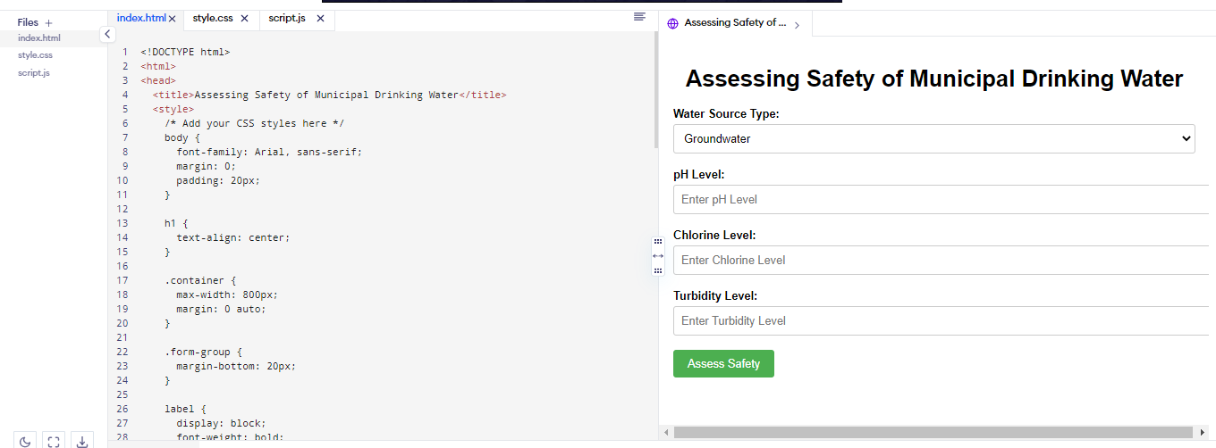

**6.2 Web page**

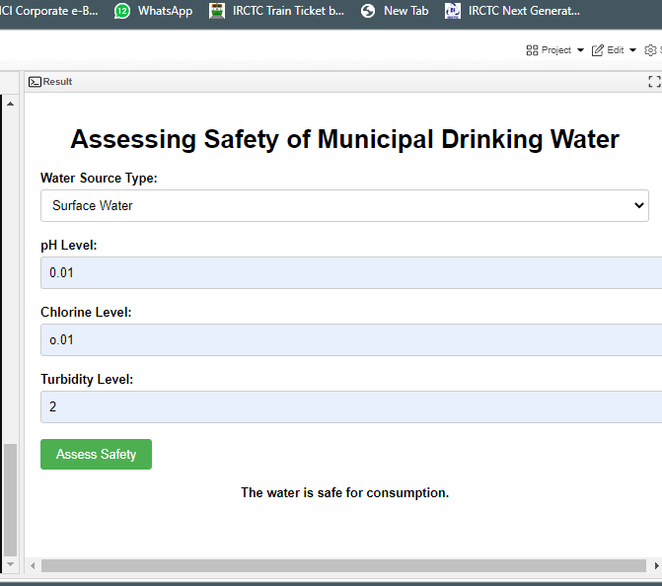

**CHAPTER 7**

## ADVANTAGES AND DISADVANTAGES

**7.1. Advantages:**

One of the primary advantages is the protection of public health. Assessing the safety of drinking water ensures that it meets regulatory standards and is free from harmful contaminants. This helps prevent waterborne diseases and illnesses, safeguarding the health and well-being of the population. By conducting assessments, authorities can ensure the quality and purity of drinking water. Regular monitoring and testing help identify any potential issues or contaminants, allowing for timely intervention and corrective measures. This instills confidence in the public regarding the safety of their drinking water.

**7.2. Disadvantages:**

Implementing comprehensive assessments and monitoring programs for municipal drinking water can be expensive. It requires investment in equipment, testing laboratories, trained personnel, and regular maintenance. Lack of skilled professionals or limited access to advanced technology can pose challenges in conducting accurate and reliable assessments. During this period, there may be delays in identifying and addressing potential issues. Timely response to emerging contaminants or water quality problems may be hindered due to the time required for assessment. While regular assessments are important, they may not cover all potential contaminants or emerging issues. The focus may be on commonly monitored parameters, and new contaminants or health concerns may go undetected. Despite the efforts in assessing water safety, public perception and trust can still be a challenge.

**CHAPTER 8**

## CONCLUSION

In conclusion, assessing the safety of municipal drinking water is a crucial process with several advantages. It plays a vital role in protecting public health by ensuring that drinking water meets regulatory standards and is free from harmful contaminants. Assessments help ensure compliance with regulations, promoting accountability and transparency in the water management system. They also aid in identifying and managing risks associated with water sources, treatment processes, and distribution systems. the benefits of assessing the safety of municipal drinking water outweigh the disadvantages. With proper funding, resources, and expertise, regular assessments can ensure the provision of safe and high-quality drinking water to the public, promoting public health and well-being. Continued research and improvements in assessment protocols will further enhance the effectiveness of this crucial process.

**CHAPTER 9**

## FUTURE SCOPE

* Advanced Sensor Technology: The integration of advanced sensor technologies, such as real-time monitoring systems and Internet of Things (IoT) devices, can provide continuous and precise data on water quality parameters.
* Data Analytics and Machine Learning: Leveraging data analytics and machine learning techniques can enhance the interpretation and analysis of large volumes of water quality data. These methods can help identify patterns, predict water quality changes, and improve the accuracy of assessments.
* Integration of Remote Sensing: Remote sensing techniques, including satellite imagery and aerial mapping, can be used to assess the quality and availability of water sources.
* Emerging Contaminant Detection: The identification and monitoring of emerging contaminants, such as pharmaceuticals, microplastics, and endocrine-disrupting compounds, will be a key area of focus.
* Public Engagement and Education: Increasing public awareness and engagement in water quality assessments can foster a sense of ownership and responsibility.

**APPENDIX:**

**The source code , Documentation are in the link github.**