

***ITCS4322  – Human and computer interaction***

# *Al-Azhar University – Gaza*

***Faculty of Engineering &***

***Information Technology***

***Department of IT***

**Main Document**

for

**Amazon App**

**Student:**

**Ahmed Salama Abu Zaiter**

**Khaled Muen Abu Algalel**

**Hussein Khaled Qarmout**

**Majd Nabil Allouh**

**Supervised by:**

**Shadi Hilles**

**Second Semester – 2022/23**

**Description:**

Amazon App displays products sequentially to make it easier for the customer to choose the product at the same time as choosing the same product in other colors and choosing the type of payment, running on Android and iPhone phones.

**The application consists of slides (pages):**

**1-Sign in**

**The first sign up interface is displayed to enter a customer's email and password to access the Splash Screen page.**

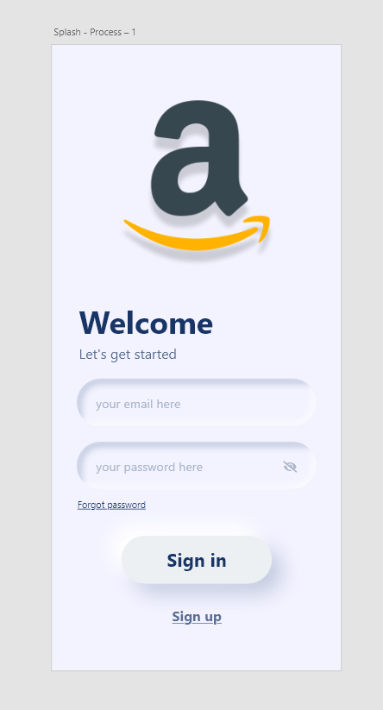

**2-Sign up**

**If he does not have an account, sign up goes to enter the name, email and password and then press sign up button to have an account in the app.**

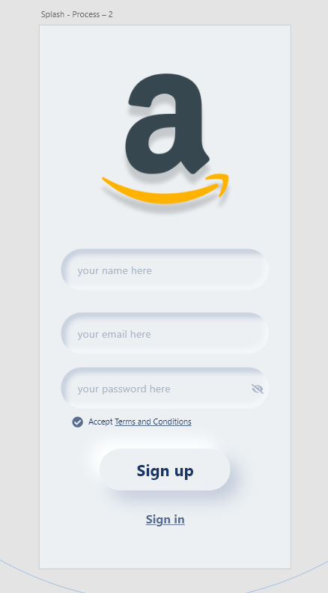

**3-** **Home page**

**In Home page products are shown serially,**

**The new products are displayed on the top interface of the page until the customer's attention is turned and then the products are displayed with their prices and names.**

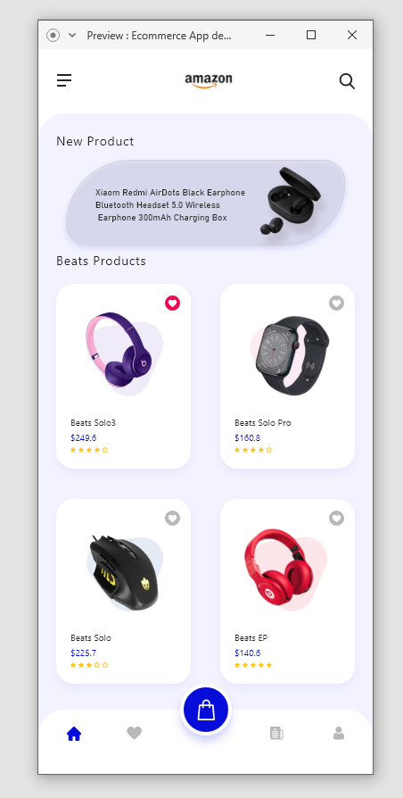

**4-** **Menu**

**After clicking on the list at the top of the page on the left, the profile is displayed. Go to the customer such as selfie, username, emails and some commands. There is a logout button at the bottom and after clicking it goes to Sign in page.**

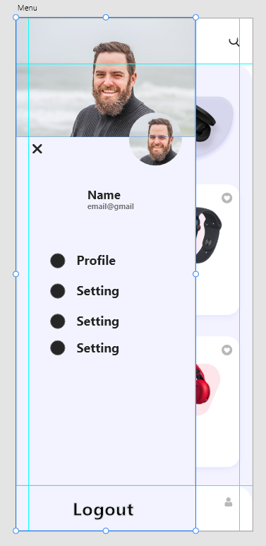

**5-** **Detail Screen**

**After selecting the desired product, the description and color option available for the same product are displayed by pulling.**

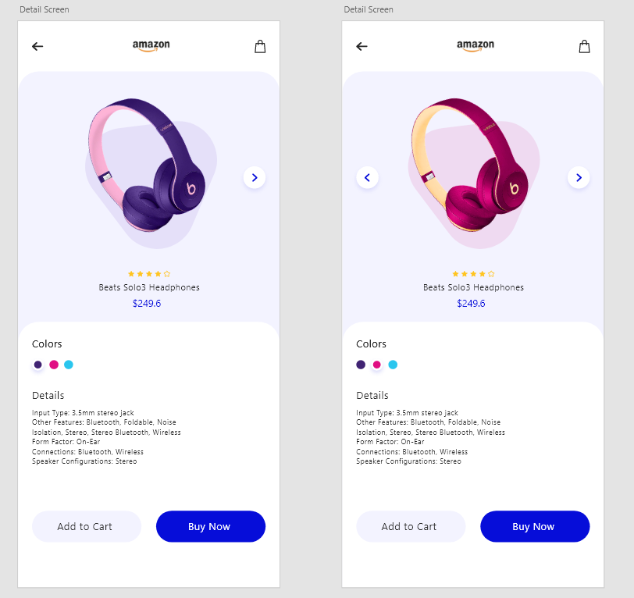

**7-Payment**

**After selecting the minge the Add to Cart button is pressed and then go to the payment page the customer visa data is entered and then press pay and then it goes to the Home page.**

