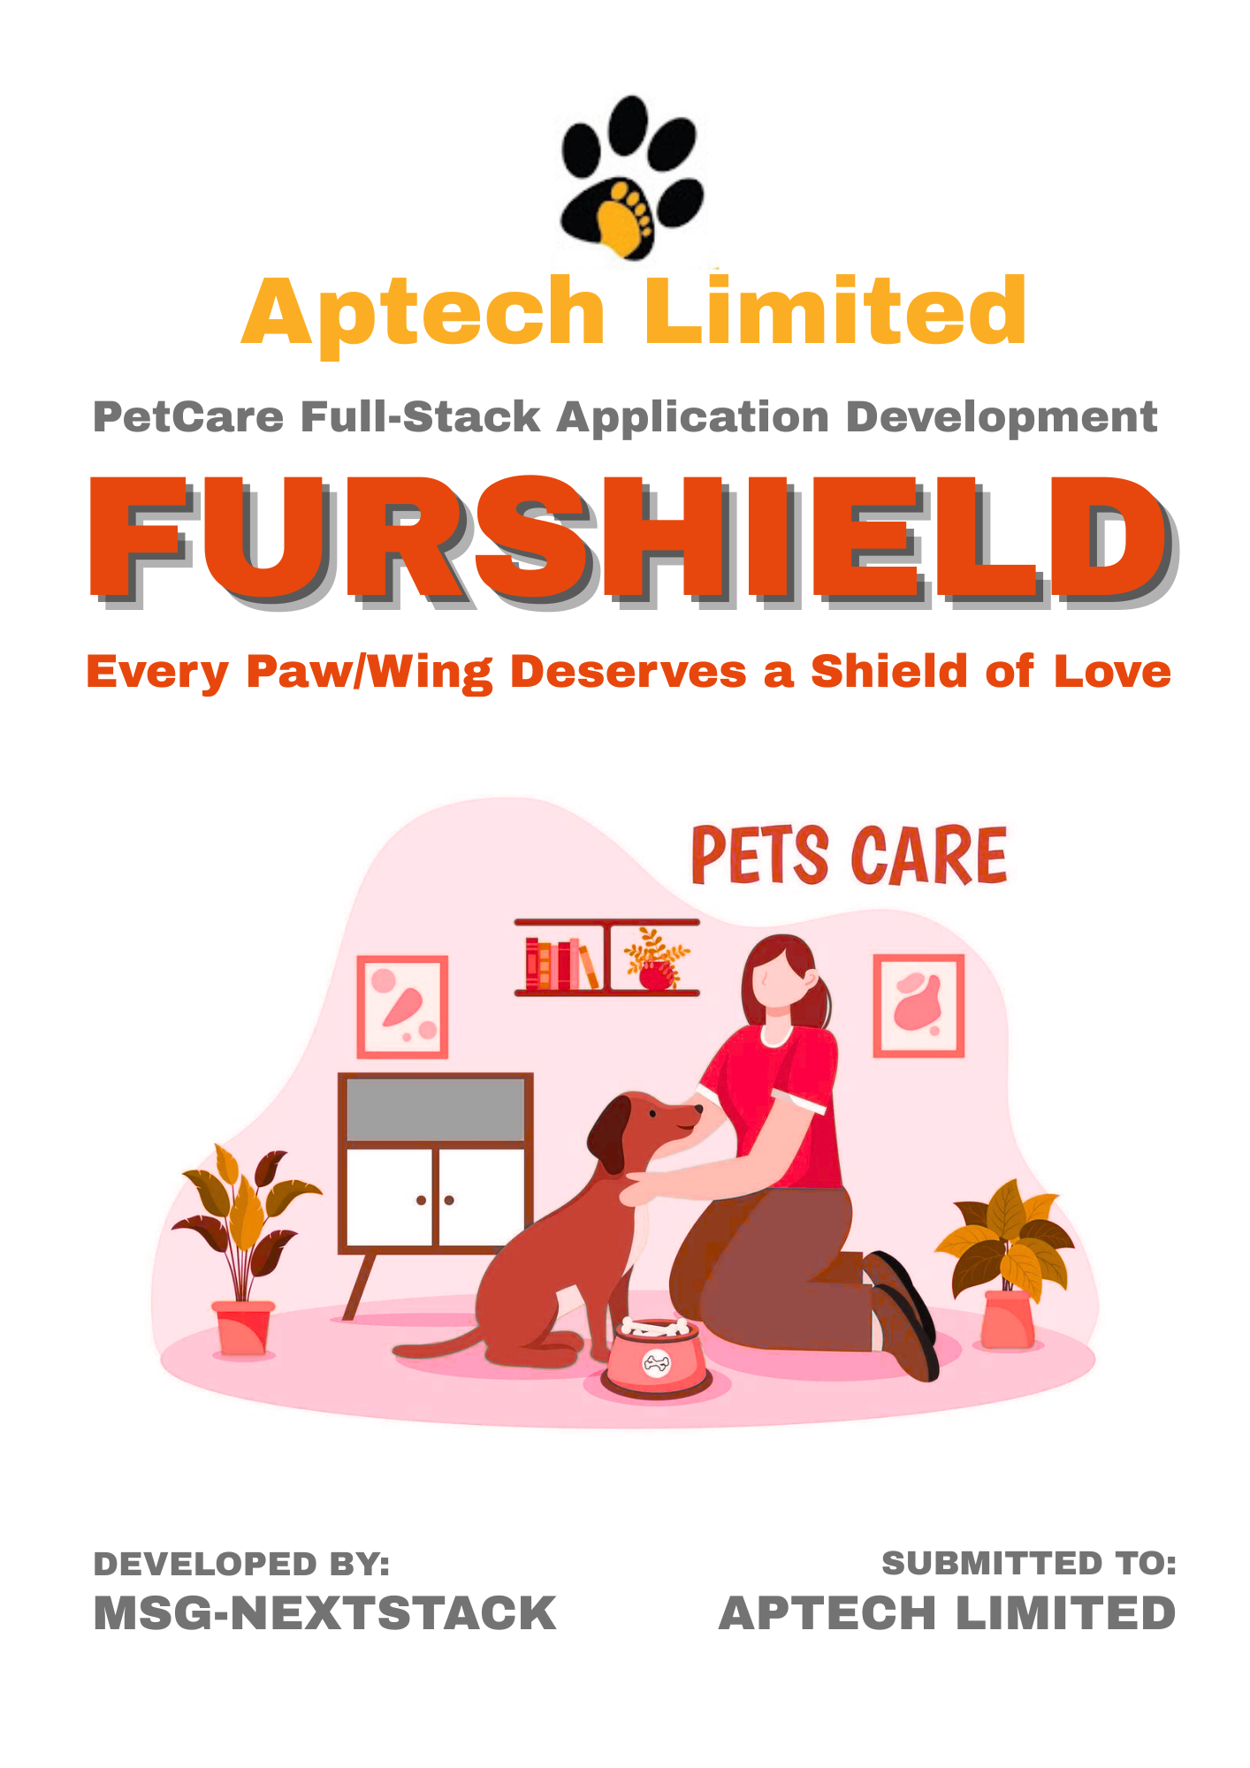

**Executive Summary**

Pet ownership is rising worldwide, yet millions of owners struggle to manage essential care activities. Health records, vaccination schedules, grooming routines, and adoption processes often remain scattered across different platforms, leading to confusion and inconsistent care. Veterinarians lack centralized access to pet histories, and shelters face difficulties in connecting with adopters. The result is inefficiency, miscommunication, and compromised pet well-being.  
To solve this, our team presents **FurShield Where “Every Paw/Wing Deserves a Shield of Love”**, a full-stack web application that unites pet owners, veterinarians, and animal shelters on one digital platform. FurShield allows pet owners to build profiles, track health milestones, and book vet appointments. Veterinarians can access medical records, log treatments, and manage schedules efficiently. Shelters can list adoptable pets, maintain care logs, and connect directly with interested families.  
What sets FurShield apart is its **scalability, security, and global relevance**. Built with modern web technologies, it features responsive dashboards, role-based access, and robust data management. The platform also includes a product browsing module for food, grooming, and accessories—creating the foundation for future e-commerce expansion. Planned enhancements like **AI-driven pet care assistance, mobile app integration, and payment gateways** ensure long-term growth and adoption worldwide.  
By combining convenience, transparency, and innovation, FurShield transforms how pet care is managed. It not only promotes responsible ownership but also empowers veterinarians and shelters to deliver better outcomes. With its global scalability, FurShield has the potential to become the digital backbone of modern pet care ensuring that every pet receives a true **Shield of Love**.

**Acknowledgement**

This project would not have been possible without the guidance and encouragement we received throughout the competition.

We sincerely thank our mentors, faculty, and the TECHWIZ 6 organizers for providing us with the platform to showcase our skills on a global stage.

Their continuous support, timely feedback, and motivation inspired us to push boundaries and refine **FurShield** into a solution with real-world impact.

We are truly grateful for this opportunity and look forward to contributing our innovation to the global IT community.

**“Until one has loved an animal, a part of one’s soul remains unawakened.”**

**– ANATOLE FRANCE**

**Declaration**

We, the undersigned team members, hereby declare that the project titled **“FurShield – Every Paw/Wing Deserves a Shield of Love**” has been conceptualized, designed, and developed by us as an original work for the TECHWIZ 6 Global IT Competition.

This project report and application reflect our independent effort, guided by the competition’s objectives of testing skills, proficiency, time management, and teamwork. Any external references, frameworks, or tools used have been duly acknowledged within the documentation.

We affirm that:

* The work presented here is free from plagiarism and has not been submitted elsewhere.
* All modules, diagrams, and functionalities described represent our team’s collective understanding and implementation.
* The project aligns with the ethical standards of software development and the spirit of global collaboration.

Through this declaration, we take full responsibility for the authenticity, accuracy, and originality of the work presented.

**Team Members:  
H Muhammad Abdullah Khan**

**Muhammad Sami Khan**

**Kashaf Jamil**

**Mahnoor**

**Waqar Elahi**

**Table of Contents**

1. Introduction **..................................................................**
2. Problem Definition **..........................................................**
3. Objectives of the Project ............................................
4. Scope of the Project ....................................................
5. System Architecture .....................................................
6. Workflow ………………....................................................
7. Use Case Diagrams .......................................................
8. Entity–Relationship (ER) Diagram .................................
9. Database Schema & Table Design ................................
10. Functionalities & Roles .................................................
11. Technology Stack Used .................................................
12. Security Measures .....................................................….
13. Testing & Quality Assurance .................................……..
14. Screenshots of Application UI ......................................
15. Limitations & Future Enhancements ............................
16. Conclusion & Global Impact .........................................

**Introduction**

Pet ownership is growing rapidly across the world, making pets an important part of families. Yet, managing their care remains a challenge. Health records, vaccination schedules, grooming routines, adoption details, and vet appointments are often scattered across multiple sources, leading to confusion and gaps in pet well-being.

To solve this problem, our team created **FurShield “Every Paw/Wing Deserves a Shield of Love”,** a full-stack web application that unifies pet owners, veterinarians, and animal shelters on one platform. Pet owners can build profiles, track vaccinations, and book appointments. Vets can access medical histories, log treatments, and manage schedules. Shelters can list adoptable pets, update care logs, and coordinate with adopters.

FurShield is built on modern, scalable technologies with a focus on security, responsive design, and user-friendly dashboards. While the current version excludes payment gateways, it lays a strong foundation for future enhancements such as AI-driven pet care support, mobile integration, and e-commerce.

In summary, FurShield is a global-ready digital solution that simplifies pet care, strengthens collaboration among stakeholders, and ensures every pet receives consistent, responsible care

**“Technology, when used with compassion, has the power to transform lives.”**

**Problem Definition**

Despite the growing number of pet owners worldwide, pet care remains fragmented and inefficient. Owners often rely on scattered notes, paper files, or multiple apps to track vaccinations, medical records, feeding routines, and grooming schedules. This lack of centralization leads to missed vaccinations, delayed treatments, and inconsistent care.

Veterinarians face similar challenges as they rarely have access to complete medical histories, making diagnosis and treatment less effective. Animal shelters also struggle to manage adoptable pets, track their health, and connect efficiently with potential adopters. The absence of a unified digital platform creates gaps in communication, reduces efficiency, and negatively impacts pet well-being.

Therefore, there is a strong need for a **comprehensive, secure, and user-friendly solution** that brings together pet owners, veterinarians, and animal shelters to streamline pet care management, improve coordination, and promote responsible ownership on a global scale.

**Objectives of the Project**

The primary goal of **FurShield – “Every Paw/Wing Deserves a Shield of Love”** is to provide a unified digital platform for pet owners, veterinarians, and animal shelters. The objectives of the project are:

* **Centralized Pet Care Management:** Enable pet owners to create and maintain pet profiles, health records, vaccination schedules, and grooming logs in one secure platform.
* **Streamlined Veterinary Services:** Allow veterinarians to access medical histories, log treatments, prescribe medications, and manage appointments efficiently.
* **Support for Animal Shelters:** Provide shelters with tools to list adoptable pets, maintain care logs, and coordinate seamlessly with adopters and veterinary professionals.
* **User-Friendly & Scalable System:** Design a responsive, intuitive, and secure application that adapts to different devices and can scale to meet global demand.
* **Future-Ready Enhancements:** Build a foundation for advanced features such as AI-powered pet care advice, mobile app integration, payment gateways, and e-commerce capabilities.

By achieving these objectives, FurShield aims to **simplify pet care, improve coordination among stakeholders, and promote responsible ownership globally.**

**Scope of the Project**

The **FurShield** web application aims to centralize pet care management for **owners, veterinarians, and animal shelters**.

* **Pet Owners** can create profiles, track health and vaccination records, book appointments, receive reminders, and browse pet care products.
* **Veterinarians** can manage profiles, access pet histories, log treatments, and organize appointments.
* **Animal Shelters** can list adoptable pets, update care logs, and coordinate with adopters.
* **Common Features** include secure login, role-based access, notifications, and a responsive design for desktop and mobile.

**Exclusions:** Payment gateways, product delivery, and vet credential verification are not included in the current scope.

The system is **secure, user-friendly, and scalable**, with potential for future expansion into AI-driven care, mobile apps, and e-commerce.

**System Architecture**

The **FurShield** system follows a **three-tier architecture** that ensures scalability, security, and smooth communication between components.

**System Architecture**

1. **Presentation Layer (Frontend):**

* Built using modern web technologies (HTML5, CSS3, Bootstrap, React/Angular).
* Provides role-based dashboards for pet owners, veterinarians, and shelters.
* Ensures responsive design for desktops, tablets, and mobile devices.

1. **Application Layer (Backend):**

* Developed using ASP.NET Core
* Handles business logic such as appointment scheduling, health record management, and adoption workflows.
* Implements authentication and authorization for secure access.

1. **Data Layer (Database):**

* Centralized relational database (MySQL / SQL Server).
* Stores pet profiles, medical records, appointments, adoption listings, and product catalogs.
* Supports search, filter, and analytics for quick data retrieval.

**Workflow Overview**

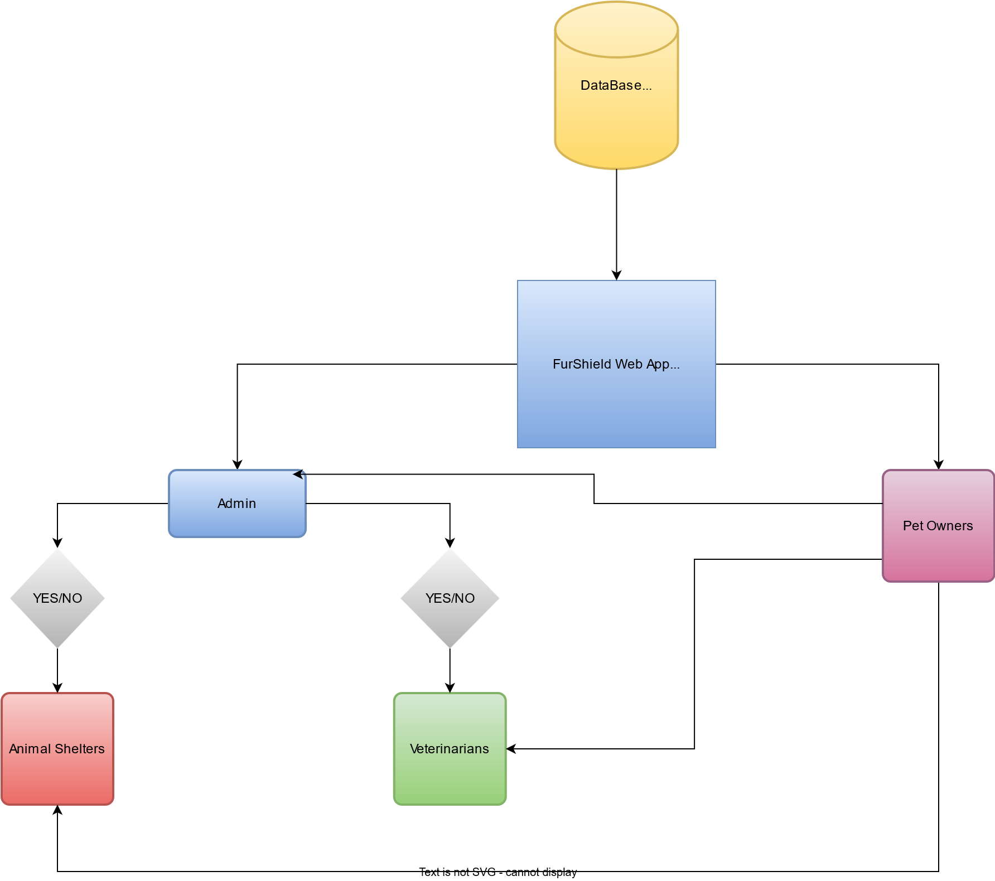

**Pet Owners** log in, create pet profiles, and manage health data. They can book appointments, view reminders, and explore pet care products.

**Veterinarians** access scheduled appointments, review pet medical histories, and update treatment records.

**Shelters** add adoptable pets, update health logs, and respond to adoption requests.

The **system** ensures notifications are sent for upcoming vaccinations, appointments, or updates.

All interactions are processed by the backend and stored securely in the database, with results displayed via responsive dashboards.

**Use Case Diagrams**

**Entity–Relationship Diagram**

**Database Schema & Table Design**

The database of **FurShield** has been designed to ensure data integrity, scalability, and smooth interaction between different system components. The schema supports **pet owners, veterinarians, animal shelters, pets, health records, appointments, products, orders, and adoption listings.**

**Key Entities and Attributes**

**Users Table**

Stores information about all registered users of the FurShield platform.

* **Table Name:** **Users**
* **Purpose:** Manages user authentication and general profile information.
* **Columns:**
  + **UserID** (INT, PK, IDENTITY): Unique identifier for each user.
  + **Username** (NVARCHAR(50), UNIQUE, NOT NULL): User's chosen username for login.
  + **Email** (NVARCHAR(100), UNIQUE, NOT NULL): User's email address, used for communication and login.
  + **PasswordHash** (NVARCHAR(255), NOT NULL): Hashed password for security.
  + **UserType** (NVARCHAR(20), NOT NULL): Defines the user's role (e.g., 'PetOwner', 'Shelter', 'Admin').
  + **RegistrationDate** (DATETIME, NOT NULL, DEFAULT GETDATE()): Timestamp of user registration.
  + **IsActive** (BIT, NOT NULL, DEFAULT 1): Indicates if the user account is active.

**PetOwners Table**

Extends the **Users** table for pet owner-specific details.

* **Table Name:** **PetOwners**
* **Purpose:** Stores additional profile information for pet owners.
* **Columns:**
  + **PetOwnerID** (INT, PK, FK to **Users.UserID**): Foreign key referencing the **Users** table.
  + **FirstName** (NVARCHAR(50), NOT NULL): Pet owner's first name.
  + **LastName** (NVARCHAR(50), NOT NULL): Pet owner's last name.
  + **PhoneNumber** (NVARCHAR(20)): Contact phone number.
  + **Address** (NVARCHAR(255)): Pet owner's physical address.

**Shelters Table**

Extends the **Users** table for animal shelter-specific details.

* **Table Name:** **Shelters**
* **Purpose:** Stores additional profile information for animal shelters.
* **Columns:**
  + **ShelterID** (INT, PK, FK to **Users.UserID**): Foreign key referencing the **Users** table.
  + **ShelterName** (NVARCHAR(100), NOT NULL): Name of the animal shelter.
  + **ContactPerson** (NVARCHAR(100)): Primary contact person at the shelter.
  + **PhoneNumber** (NVARCHAR(20)): Shelter's contact phone number.
  + **Address** (NVARCHAR(255)): Shelter's physical address.
  + **LicenseNumber** (NVARCHAR(50), UNIQUE): Unique license number for the shelter.

**Pets Table**

Contains information about individual pets managed by the application.

* **Table Name:** **Pets**
* **Purpose:** Stores details for each pet available for adoption or owned by a pet owner.
* **Columns:**
  + **PetID** (INT, PK, IDENTITY): Unique identifier for each pet.
  + **OwnerID** (INT, FK to **PetOwners.PetOwnerID**, NULLABLE): References the **PetOwners** table if the pet is owned.
  + **ShelterID** (INT, FK to **Shelters.ShelterID**, NULLABLE): References the **Shelters** table if the pet is under a shelter's care.
  + **Name** (NVARCHAR(50), NOT NULL): Pet's name.
  + **Species** (NVARCHAR(50), NOT NULL): e.g., 'Dog', 'Cat', 'Bird'.
  + **Breed** (NVARCHAR(50)): Pet's breed.
  + **Age** (INT): Pet's age in years (or months, with a separate unit column if needed).
  + **Gender** (NVARCHAR(10)): 'Male', 'Female', 'Unknown'.
  + **Description** (NVARCHAR(MAX)): Detailed description of the pet.
  + **IsAdopted** (BIT, NOT NULL, DEFAULT 0): Indicates if the pet has been adopted.
  + **DateAdded** (DATETIME, NOT NULL, DEFAULT GETDATE()): Date the pet was added to the system.
  + **ProfilePictureURL** (NVARCHAR(255)): URL to the pet's profile picture.

**Products Table**

Lists products available for purchase in the marketplace.

* **Table Name:** **Products**
* **Purpose:** Manages product inventory and details.
* **Columns:**
  + **ProductID** (INT, PK, IDENTITY): Unique identifier for each product.
  + **ProductName** (NVARCHAR(100), NOT NULL): Name of the product.
  + **Description** (NVARCHAR(MAX)): Detailed product description.
  + **Price** (DECIMAL(10, 2), NOT NULL): Product price.
  + **StockQuantity** (INT, NOT NULL): Current stock level.
  + **Category** (NVARCHAR(50)): e.g., 'Food', 'Toys', 'Accessories'.
  + **ImageURL** (NVARCHAR(255)): URL to the product image.
  + **DateAdded** (DATETIME, NOT NULL, DEFAULT GETDATE()): Date the product was added.

**Orders Table**

Records customer orders for products.

* **Table Name:** **Orders**
* **Purpose:** Tracks product purchases made by pet owners.
* **Columns:**
  + **OrderID** (INT, PK, IDENTITY): Unique identifier for each order.
  + **PetOwnerID** (INT, FK to **PetOwners.PetOwnerID**, NOT NULL): References the pet owner who placed the order.
  + **OrderDate** (DATETIME, NOT NULL, DEFAULT GETDATE()): Timestamp of the order.
  + **TotalAmount** (DECIMAL(10, 2), NOT NULL): Total cost of the order.
  + **OrderStatus** (NVARCHAR(50), NOT NULL): e.g., 'Pending', 'Processing', 'Shipped', 'Delivered', 'Cancelled'.
  + **ShippingAddress** (NVARCHAR(255), NOT NULL): Address for order delivery.

**OrderItems Table**

Details the individual products within each order.

* **Table Name:** **OrderItems**
* **Purpose:** Links products to specific orders and records quantities.
* **Columns:**
  + **OrderItemID** (INT, PK, IDENTITY): Unique identifier for each order item.
  + **OrderID** (INT, FK to **Orders.OrderID**, NOT NULL): References the parent order.
  + **ProductID** (INT, FK to **Products.ProductID**, NOT NULL): References the purchased product.
  + **Quantity** (INT, NOT NULL): Quantity of the product ordered.
  + **UnitPrice** (DECIMAL(10, 2), NOT NULL): Price of the product at the time of order.

**Appointments Table**

Schedules appointments between pet owners and shelters.

* **Table Name:** **Appointments**
* **Purpose:** Manages scheduling for pet viewings, adoptions, or other interactions.
* **Columns:**
  + **AppointmentID** (INT, PK, IDENTITY): Unique identifier for each appointment.
  + **PetOwnerID** (INT, FK to **PetOwners.PetOwnerID**, NOT NULL): References the pet owner requesting the appointment.
  + **ShelterID** (INT, FK to **Shelters.ShelterID**, NOT NULL): References the shelter involved in the appointment.
  + **PetID** (INT, FK to **Pets.PetID**, NULLABLE): References the specific pet if the appointment is pet-related.
  + **AppointmentDateTime** (DATETIME, NOT NULL): Scheduled date and time of the appointment.
  + **AppointmentType** (NVARCHAR(50), NOT NULL): e.g., 'Viewing', 'Adoption Interview', 'General Inquiry'.
  + **Status** (NVARCHAR(50), NOT NULL): e.g., 'Pending', 'Confirmed', 'Completed', 'Cancelled'.
  + **Notes** (NVARCHAR(MAX)): Any additional notes for the appointment.

**Messages Table**

Facilitates communication between users.

* **Table Name:** **Messages**
* **Purpose:** Stores direct messages between pet owners and shelters/admins.
* **Columns:**
  + **MessageID** (INT, PK, IDENTITY): Unique identifier for each message.
  + **SenderID** (INT, FK to **Users.UserID**, NOT NULL): User who sent the message.
  + **ReceiverID** (INT, FK to **Users.UserID**, NOT NULL): User who received the message.
  + **Content** (NVARCHAR(MAX), NOT NULL): The message text.
  + **Timestamp** (DATETIME, NOT NULL, DEFAULT GETDATE()): When the message was sent.
  + **IsRead** (BIT, NOT NULL, DEFAULT 0): Indicates if the message has been read by the receiver.

**Key Relationships**

* **One-to-One:**
  + **Users** to **PetOwners** (via **UserID** and **PetOwnerID**)
  + **Users** to **Shelters** (via **UserID** and **ShelterID**)
* **One-to-Many:**
  + **PetOwners** to **Pets** (a pet owner can own multiple pets)
  + **Shelters** to **Pets** (a shelter can care for multiple pets)
  + **PetOwners** to **Orders** (a pet owner can place multiple orders)
  + **Orders** to **OrderItems** (an order can have multiple items)
  + **Products** to **OrderItems** (a product can be in multiple order items)
  + **PetOwners** to **Appointments** (a pet owner can have multiple appointments)
  + **Shelters** to **Appointments** (a shelter can have multiple appointments)
  + **Users** to **Messages** (a user can send/receive multiple messages)

**Indexing Strategy**

Appropriate indexes will be created on primary keys, foreign keys, and frequently queried columns (e.g., **Users.Email**, **Products.Category**, **Appointments.AppointmentDateTime**) to optimize query performance.

**Functionalities & Roles**

The **FurShield** application is designed with distinct user roles to ensure focused access, secure operations, and efficient collaboration among stakeholders. Each role is assigned specific functionalities through role-based dashboards.

**1. Core Functionalities**

FurShield offers a robust suite of features categorized to address the diverse needs of its user base:

**1.1. User Management & Authentication**

* **Secure Registration & Login:** Users can securely register and log in to the platform, with distinct pathways for Pet Owners and Shelters. Password hashing and secure authentication protocols are implemented to protect user credentials.
* **Profile Management:** Users can create and manage their personal or organizational profiles, including contact information, addresses, and profile pictures.
* **Role-Based Access Control (RBAC):** Access to specific features and data is strictly controlled based on the user's assigned role (Pet Owner, Shelter, Admin), ensuring data security and preventing unauthorized actions.

**1.2. Pet Management & Adoption**

* **Pet Profile Creation & Management:** Shelters can create detailed profiles for pets under their care, including species, breed, age, gender, medical history, behavioral notes, and high-quality images. Pet Owners can also create profiles for their personal pets.
* **Search & Filter Pets:** Pet Owners can efficiently search and filter available pets based on various criteria such as species, breed, age, location, and special needs.
* **Adoption Application Process:** A guided workflow for Pet Owners to submit adoption applications for specific pets, including questionnaires and document uploads.
* **Adoption Status Tracking:** Both Pet Owners and Shelters can track the real-time status of adoption applications.
* **Pet Ownership Transfer:** Secure process for transferring pet ownership records upon successful adoption.

**1.3. Marketplace for Pet Products**

* **Product Listing & Catalog:** A comprehensive catalog of pet products (food, toys, accessories, grooming supplies) with detailed descriptions, pricing, and images.
* **Shopping Cart & Checkout:** Intuitive shopping cart functionality allowing users to add, remove, and manage products before a secure checkout process.
* **Order Placement & Tracking:** Pet Owners can place orders and track their delivery status from purchase to fulfillment.
* **Order History:** Users can view their past order history and reorder items.
* **Product Reviews & Ratings:** Users can leave reviews and ratings for purchased products, fostering community engagement and informed decision-making.

**1.4. Appointment Scheduling**

* **Flexible Appointment Booking:** Pet Owners can request appointments with Shelters for various purposes (e.g., pet viewing, adoption interviews, general inquiries).
* **Calendar Integration:** Shelters can manage their availability and view scheduled appointments through an integrated calendar interface.
* **Automated Notifications:** System-generated email and in-app notifications for appointment confirmations, reminders, and status updates.
* **Appointment Management:** Users can view, modify, or cancel their appointments, subject to predefined policies.

**1.5. Communication & Messaging**

* **In-App Messaging System:** A secure and private messaging system enabling direct communication between Pet Owners and Shelters, and between Admins and other user types.
* **Notification Center:** A centralized hub for all system-generated alerts, updates, and messages.
* **Support & Inquiry System:** Dedicated channels for users to submit support requests or general inquiries to platform administrators.

**1.6. Administrative Tools**

* **Dashboard & Analytics:** Comprehensive dashboards providing administrators with insights into platform activity, user statistics, adoption trends, and marketplace performance.
* **Content Moderation:** Tools for reviewing and moderating user-generated content, such as pet profiles and product reviews.
* **User Account Management:** Ability for administrators to manage user accounts, including activation, deactivation, role assignment, and password resets.
* **System Configuration:** Tools for configuring platform settings, managing categories, and updating system-wide information.

**2. User Roles and Privileges**

FurShield implements a clear role-based access control system to ensure that each user interacts with the platform in a manner consistent with their responsibilities and needs.

**2.1. Pet Owner**

* **Description:** Individuals looking to adopt pets, purchase pet products, or manage their existing pets.
* **Key Privileges:**
  + Register and manage personal profile.
  + Browse and search for adoptable pets.
  + Submit adoption applications.
  + View adoption application status.
  + Browse and purchase products from the marketplace.
  + Manage shopping cart and checkout.
  + View order history and track orders.
  + Request and manage appointments with shelters.
  + Send and receive private messages with shelters.
  + Create and manage profiles for their own pets.
  + Submit product reviews and ratings.

**2.2. Shelter**

* **Description:** Animal shelters or rescue organizations that list pets for adoption and manage adoption processes.
* **Key Privileges:**
  + Register and manage shelter profile.
  + Create, update, and delete pet profiles for adoption.
  + Review and process adoption applications.
  + Update adoption application statuses.
  + Manage appointment schedules and availability.
  + Confirm, reschedule, or cancel appointments.
  + Send and receive private messages with pet owners.
  + Access reports on adoption rates and pet inventory.
  + Manage shelter-specific information and contact details.

**2.3. Administrator**

* **Description:** Oversees the entire FurShield platform, managing users, content, and system settings.
* **Key Privileges:**
  + Full access to all platform functionalities.
  + Manage all user accounts (Pet Owners, Shelters, other Admins).
  + Approve or reject new shelter registrations.
  + Monitor and moderate all content (pet profiles, product listings, reviews, messages).
  + Manage product catalog, pricing, and inventory.
  + View and manage all orders and appointments.
  + Access comprehensive analytics and reporting tools.
  + Configure system-wide settings and policies.
  + Provide technical support and resolve user issues.

**Technology Stack Used**

**“The advance of technology is based on making it fit in so that you don’t really even notice it, so it’s part of everyday life.”**

**– Bill Gates**

The FurShield application leverages a modern, scalable, and secure technology stack designed to deliver high performance, maintainability, and a seamless user experience. The selected technologies are globally recognized and widely adopted, ensuring long-term support, community engagement, and compatibility with diverse deployment environments.

**1. Backend Technologies**

**.NET 8.0 (ASP.NET Core)**

* **Justification:**  
  .NET 8.0 is the latest iteration of Microsoft's cross-platform, open-source framework for building high-performance web applications and APIs. It offers:
  + **Cross-platform support:** Runs on Windows, Linux, and macOS, enabling flexible deployment options.
  + **High performance:** Optimized runtime and asynchronous programming model for scalable applications.
  + **Robust ecosystem:** Rich libraries, tools, and integration with Entity Framework Core for database access.
  + **Security:** Built-in features for authentication, authorization, and data protection.
  + **Global adoption:** Used by enterprises worldwide, ensuring a large talent pool and community support.

**Entity Framework Core 9.0**

* **Justification:**  
  EF Core is a modern Object-Relational Mapper (ORM) that simplifies database interactions by allowing developers to work with data using .NET objects. It provides:
  + **Productivity:** Reduces boilerplate code for CRUD operations.
  + **Cross-database compatibility:** Supports multiple database providers, including SQL Server.
  + **Migrations:** Facilitates database schema evolution.
  + **Performance:** Optimized query generation and caching.
  + **Community and support:** Widely used in .NET applications globally.

**2. Database**

**Microsoft SQL Server**

* **Justification:**  
  SQL Server is a powerful, enterprise-grade relational database management system (RDBMS) known for:
  + **Reliability and scalability:** Handles large volumes of data with high availability.
  + **Security:** Advanced encryption, auditing, and compliance features.
  + **Integration:** Seamless integration with .NET applications and tools.
  + **Global presence:** Trusted by organizations worldwide, with extensive documentation and support.

**3. Frontend Technologies**

**ASP.NET Core Razor Pages / MVC with Blazor (if applicable)**

* **Justification:**  
  These technologies enable the creation of dynamic, responsive web interfaces using C# and HTML, offering:
  + **Unified development:** Allows full-stack development using a single language (.NET/C#).
  + **Performance:** Server-side rendering and client-side interactivity.
  + **Maintainability:** Strong typing and tooling support.
  + **Global adoption:** Supported by Microsoft and widely used in enterprise web applications.

**JavaScript and CSS Frameworks (Bootstrap, ApexCharts)**

* **Justification:**  
  Popular frontend libraries and frameworks are used to enhance user experience:
  + **Bootstrap:** Provides responsive design and pre-built UI components, ensuring consistent look and feel across devices.
  + **Chart.js / ApexCharts:** Enables interactive data visualization.
  + **Global community:** Extensive resources, plugins, and support.

**4. Communication & Messaging**

**SignalR (ASP.NET Core SignalR)**

* **Justification:**  
  SignalR facilitates real-time web functionality, such as live chat and notifications, by:
  + **Simplifying real-time communication:** Abstracts complex WebSocket and fallback mechanisms.
  + **Integration:** Native support in ASP.NET Core.
  + **Scalability:** Supports multiple clients and backplane configurations.
  + **Global usage:** Adopted in many real-time applications worldwide.

**5. Security & Identity**

**ASP.NET Core Identity / JWT Authentication**

* **Justification:**  
  Provides robust authentication and authorization mechanisms:
  + **Secure user management:** Password hashing, multi-factor authentication support.
  + **Token-based authentication:** JWT enables stateless, scalable security.
  + **Industry standards:** Compliant with OAuth2 and OpenID Connect.
  + **Global relevance:** Widely used in modern web applications.

**6. Development & Build Tools**

**Visual Studio / Visual Studio Code**

* **Justification:**  
  Industry-standard IDEs offering:
  + **Comprehensive tooling:** Debugging, code analysis, and refactoring.
  + **Cross-platform support:** VS Code supports Windows, Linux, and macOS.
  + **Extensive extensions:** Support for multiple languages and frameworks.
  + **Global developer community:** Large user base and continuous updates.

**Security Measures**

Security is a paramount concern for FurShield, ensuring that sensitive data—including medical records, user credentials, and adoption details—are rigorously protected. The application integrates industry best practices and adheres to global IT security standards to maintain a secure and trustworthy platform.

**Authentication & Authorization**

* **Role-Based Access Control (RBAC):** Access privileges are strictly managed based on user roles such as Pet Owners, Vets, and Shelters, ensuring users can only perform authorized actions.
* **Secure Login:** Passwords are securely stored using strong hashing and salting techniques to prevent credential compromise.
* **Session Management:** Robust session controls prevent unauthorized access and session hijacking.

**Data Protection**

* **Database Security:** The database schema employs foreign keys, constraints, and indexing to maintain data integrity and prevent tampering.
* **Encryption:** Sensitive information is encrypted at rest and in transit, leveraging industry-standard cryptographic methods.
* **Secure Communication:** All client-server interactions use HTTPS protocols to safeguard data transmission.

**Application Security**

* **Input Validation:** Comprehensive validation mechanisms prevent common vulnerabilities such as SQL Injection, Cross-Site Scripting (XSS), and Cross-Site Request Forgery (CSRF).
* **OWASP Compliance:** The application follows the OWASP Top 10 guidelines to mitigate prevalent web application security risks.
* **Error Handling:** System errors are managed carefully to avoid leaking sensitive information that could aid attackers.

**Privacy & Compliance**

* **GDPR-Ready Design:** Data storage and processing comply with GDPR requirements, supporting international scalability and user privacy.
* **User Data Control:** Users have full control over their personal data, including options to update or delete their records in accordance with privacy regulations.

**Backup & Recovery**

* **Regular Backups:** Automated database backups are performed routinely to prevent data loss.
* **Disaster Recovery:** Established recovery procedures ensure rapid restoration of services with minimal downtime in case of incidents.

**Testing & Quality Assurance**

The quality of **FurShield** has been ensured through structured testing at different stages of development. The focus is on **functionality, security, usability, and performance**, aligning with global IT standards.

**Unit Testing**

* Validation of registration and login forms.
* CRUD operations for pet profiles, medical records, and adoption listings.
* Appointment booking and status updates.
* Product browsing and cart operations.

*Outcome:* Confirms that individual modules work as expected.

**2. Integration Testing**

* Pet owner booking → Veterinarian approval → Updated appointment status.
* Shelter listing → Adoption interest → Notification workflow.
* Health record creation → Vet treatment logging → Owner access.

*Outcome:* Ensures smooth interaction between modules.

**3. System Testing**

* End-to-end flow tested across all user roles (Owner, Vet, Shelter).
* Notifications, search/filter, and role-based dashboards validated.
* Compatibility across devices and major browsers.

*Outcome:* Confirms system meets functional and non-functional requirements.

**4. User Acceptance Testing (UAT)**

* Sample users (pet owners, vets, shelter staff) simulated to test usability.
* Feedback gathered on **UI clarity, responsiveness, and ease of use**.

*Outcome:* Ensures platform is user-friendly and competition-ready.

**5. Quality Assurance Practices**

* Code versioning with **GitHub** for collaboration and tracking.
* Regular peer reviews to maintain coding standards.
* Automated testing scripts for regression checks (where applicable).

With these steps, **FurShield** guarantees a reliable, secure, and user-friendly experience while meeting global software quality standards.

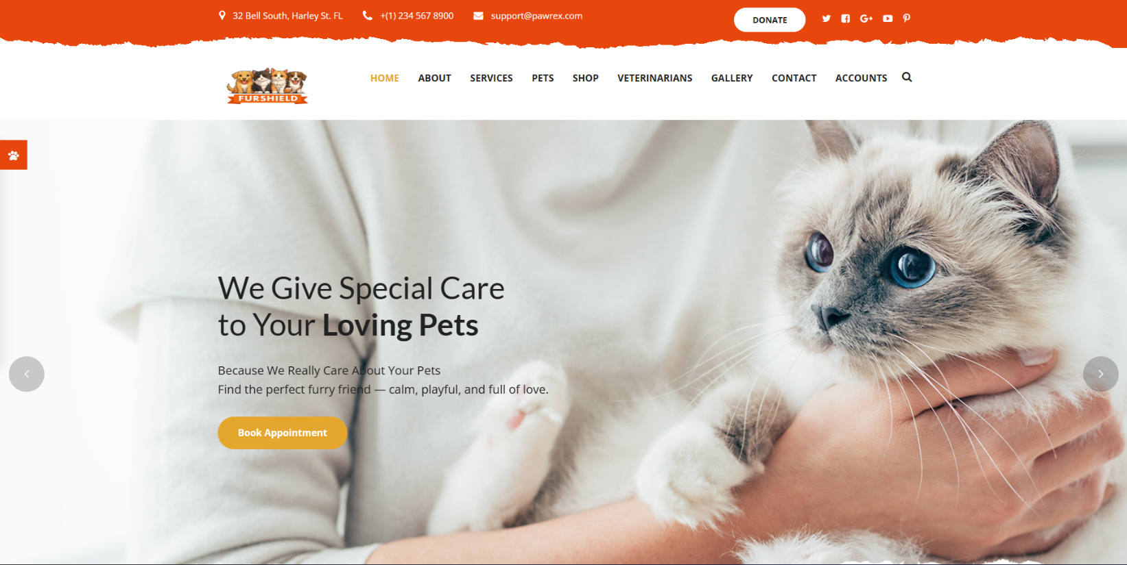Screenshots of Application UI

**Limitations & Future Enhancements**

**Current Limitations**

* No integrated **payment gateway** or product delivery system.
* Verification of veterinarian credentials not implemented.
* Mobile app version not yet available.
* Limited to **basic search and filter** without advanced AI recommendations.

**Future Enhancements**

* **E-commerce Integration:** Payment gateways and logistics support for product purchases.
* **AI-Driven Support:** Smart chatbot for 24/7 pet care advice and predictive health alerts.
* **Mobile Application:** Native Android/iOS apps for on-the-go accessibility.
* **Global Compliance:** Full alignment with **GDPR, HIPAA**, and other international data protection standards.
* **Advanced Analytics:** Insights into pet health trends, adoption success rates, and user behavior.

These improvements will ensure **FurShield evolves from a web application into a globally scalable ecosystem**, capable of serving millions of users with advanced pet care solutions.

**Conclusion & Global Impact**

The **FurShield** platform demonstrates how technology can transform pet care by connecting **owners, veterinarians, and shelters** within a secure, user-friendly ecosystem. Through features like **digital health records, appointment management, adoption workflows, and product access**, it simplifies processes while improving the well-being of animals.

At a global scale, FurShield has the potential to:

* Standardize **digital pet healthcare** across countries.
* Support **animal adoption drives** worldwide, reducing shelter overcrowding.
* Enable **data-driven insights** into veterinary care and pet wellness.
* Promote responsible ownership through reminders, alerts, and education.

In essence, **FurShield is not just an application but a vision** — one that can revolutionize the pet care industry globally, foster compassion, and leverage technology to create a healthier future for pets and their communities.

**“The greatness of a nation and its moral progress can be judged by the way its animals are treated.”**

**– Mahatma Gandhi**