

**FINAL REPORT OF TERM PROJECT**

**CMSE 201**

**Fundamentals of Software Engineering**

**Team members**

**Hussein El Hajj Ali Barada 20801182**

**Mahamat Hassan Mahadjir Hassan 20910394**

**Abdulaziz Mahmoud Omar 18700859**

**Mahmoud Mohammad Mahmoud Younis 20801210**

**GROUP NO: 2**

**PROJECT NAME: Android Blood Donation and Blood Bank Finder**

**PROJECT START DATE: 16/10/2021**

**PROJECT END DATE:**

**SUPERVISOR: Assoc. Prof. Dr. DUYGU ÇELİK**

**SEMESTER TERM: Fall 2021-22**

# ABSTRACT

Many people suffer from blood related illnesses such as Anemia and Cancer, these illnesses require blood transfusions; However, there are serious blood shortages in hospitals and blood banks. Hence, our aim is to develop a mobile application that will allow patients to call for blood donors easily and efficiently It will also incentivize individuals to donate blood via a variety of interactive features. We will follow the waterfall methodology for this project. The application will have all the necessary features to satisfy the aim of the project. The application will be built using special mobile development tools incorporated with other programming languages, server cluster and communication with external systems. The application will be verified and validated using different tests. This document covers a variation of UML diagrams and UIs that describe the mentioned points in detail.

**Keywords:** Hospitals, Blood, Android, Mobile, Application

# Table of Contents

ABSTRACT II

Table of Contents III

LIST OF FIGURES V

LIST OF TABLES VI

1. INTRODUCTION 1

2. PROJECT PLANNING AND MANAGEMENT 2

3. REQUIREMENTS ANALYSIS 3

3.1 Functional Requirements 3

3.2 Non-Functional Requirements 3

3.3 Realistic constraints 3

3.4 Ethical issues 3

4. DESIGN 4

4.1 High level design (architectural) 4

4.2 Software design 4

5. IMPLEMENTATION 5

5.1 Tools, technologies and platforms used 5

5.2 Algorithms 5

5.3 Standards 5

5.4 Detailed description of the implementation (coding) 5

6. TESTING 6

7. USER GUIDE OF THE SYSTEM 7

8. DISCUSSION 8

9. CONCLUSION 9

10. REFERENCES 10

APPENDICES 11

A. Instructions for installing the system 11

B. Code for the system 11

C. Other relevant material 11

# LIST OF FIGURES

Figure 2.3 Network Diagram

Figure 2.8 Gantt Chart

Figure 4.1.2.1 Use case diagram

Figure 4.1.2.2 Use case diagram

Figure 4.2.1 Activity diagram

Figure 4.2.2 Architecture diagram

Figure 4.2.3 Sequence diagram

Figure 4.2.4 Sequence diagram

Figure 4.2.5 Data flow diagram

Figure 4.2.6 State Machine diagram

# LIST OF TABLES

Table 2.2 Work Breakdown Structure

Table 2.4 PERT

Table 2.5 Critical Path Management

Table 2.6 Required Resources

Table 2.7 List of Work Packages

Table 2.9 Risk analysis

# 1. INTRODUCTION

Many patients rely on their communities to find blood donors as hospitals can have bloods shortages, nevertheless this process is hectic and unreliable. Unfortunately, past attempts to solve this issue were ineffective as they relied on calling for volunteers through a thin line of communication (e.g. mails that end up being flagged as spam). This application will serve positive impact on the reduction of death caused by blood related illnesses.

# 2. PROJECT PLANNING AND MANAGEMENT

# 2.1 Introduction to project

|  |
| --- |
| **Aim of Project** |
| Finding a blood donor on time is very crucial as a person's life may depend on it. Locating an appropriate donor is typically time consuming and inefficient due to lack of communication. Our aim is to provide a platform that eases this process by delivering a user interface for communication as well as providing necessary information. |

|  |
| --- |
| **Summary of Project** |
| This application will allow users in need of blood to submit a request calling for donors in case of blood shortage in hospitals. In addition, users will be able to register for blood donation to a blood bank, a live chat will be open between the donor and the requester. Furthermore, the app will provide information related to hospitals such as blood type availability and locations. The app will notify users on events such as appropriate donor requests and chat messages. |

|  |
| --- |
| **Scope of the Project** |
| Working together with Hospitals and blood banks in Cyprus will help accelerate the growth of our application via raising awareness of the app and providing access to beneficial information such as blood type availability, verification of successful blood donor matchups and blood donor related statistics. Our team will take inspiration from countries that have embedded a similar functionality as our project into their web-based health systems. |

|  |
| --- |
| **Target Users** |
| This application is intended for any audience, whether they’re a patient in need of blood or an individual that wants to help those that are in need. |

# 2.2 Work Breakdown Structure

|  |  |  |  |  |  |
| --- | --- | --- | --- | --- | --- |
| Activity | Task | Start Date | End Date | Duration | Predecessor |
| Project Feasibility and Pre-research | | 18.10.2021 | 05.11.2021 | 21 days |  |
| A | Project Process and Economic Feasibility |  |  | 7 |  |
| B | Technological Feasibility | 7 | A |
| C | Technological Feasibility | 7 | B |
| System Design Technology | | 04.11.2021 | 17.11.2021 | 12 days |  |
| D | Determining the System Parameters |  |  | 2 | C |
| E | Design of System | 2 | D |
| F | Selection of the device to be used | 2 | E |
| G | Evaluation of System Design | 4 | F |
| H | Analysis and Estimates | 2 | F |
| Development of System Software | | 17.11.2021 | 10.12.2021 | 24 days |  |
| I | Creating Database |  |  | 2 | H |
| J | Software Development | 3 | I |
| K | Establishment of Structure | 2 | J |
| L | Algorithm Modeling | 3 | K |
| M | creating a database connection between web services | 2 | L |
| N | user interface design and programming | 2 | M |
| O | Software Integration | 3 | N |
| P | creating of link between web services and database | 2 | O |
| Q | User Interface Testing | 2 | P |
| R | System Testing | 3 | Q |
| Prototype Implementation and Test Study | | 10.12.2021 | 25.12.2021 | 15 days |  |
| S | Interface Tests |  |  | 3 | R |
| T | Mobile application testing | 2 | L |
| U | Test results analysis and system evaluation | 2 | T |
| V | Establishing Standards Certification | 3 | U |
| W | Completion of Improvements | 3 | V |
| X | Project Closure | 2 | W |

## 2.3 Network Diagram

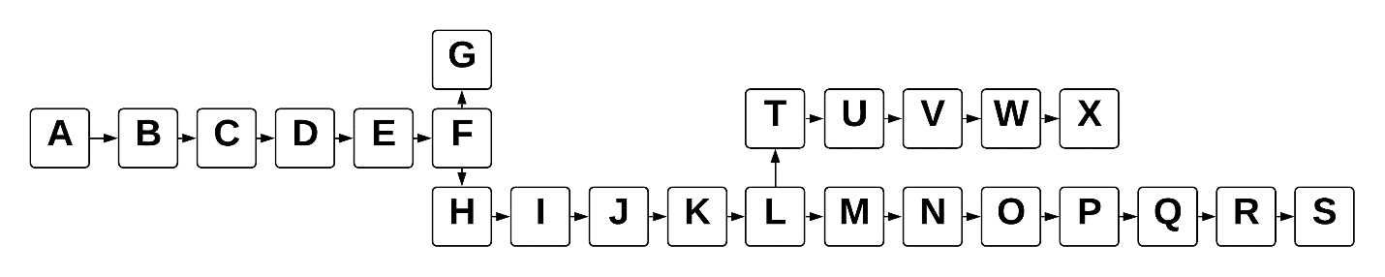

|  |  |  |  |  |  |
| --- | --- | --- | --- | --- | --- |
| Activity | Duration | Optimistic Time | Most Likely | Pessimistic Time | Expected Duration |
| A | 7 | 6 | 7 | 10 | 7.33 |
| B | 7 | 6 | 7 | 10 | 7.33 |
| C | 7 | 6 | 7 | 9 | 7.167 |
| D | 2 | 1 | 2 | 5 | 1.667 |
| E | 2 | 1 | 1 | 3 | 1.5 |
| F | 2 | 1 | 2 | 3 | 1.5 |
| G | 4 | 2 | 3 | 6 | 3.3 |
| H | 2 | 1 | 2 | 4 | 2.167 |
| I | 3 | 2 | 2 | 5 | 2.5 |
| J | 2 | 1 | 2 | 4 | 2.1667 |
| K | 2 | 1 | 2 | 4 | 2.1667 |
| L | 3 | 2 | 3 | 6 | 3.33 |
| M | 2 | 1 | 2 | 4 | 2.1667 |
| N | 2 | 1 | 2 | 4 | 2.1667 |
| O | 3 | 2 | 2 | 5 | 2.5 |
| P | 2 | 1 | 2 | 4 | 2.1667 |
| Q | 2 | 1 | 2 | 4 | 2.1667 |
| R | 3 | 2 | 3 | 5 | 3.1667 |
| S | 2 | 1 | 2 | 4 | 2.166 |
| T | 2 | 1 | 2 | 4 | 2.166 |
| U | 3 | 2 | 3 | 5 | 3.1667 |
| V | 3 | 2 | 3 | 5 | 3.1667 |
| W | 2 | 1 | 2 | 4 | 2.1667 |
| X | 2 | 1 | 2 | 3 | 2 |

## 2.4 PERT

## 2.5 Critical Path Management

|  |  |
| --- | --- |
| Path | Expected Duration |
| ABCDEFG | 29.787 |
| ABCDEFHIJKIMNOPQRS | 55.051 |
| ABCDEFHIJKLTUVWX | 51.4547 |
| ABCDEFGHIJKLMNOPQRS | 58.351 |
| ABCDEFGHIJKLTUVWX | 54.7547 |

Critical path: **ABCDEFGHIJKLMNOPQRS**

# 2.6 Required Resources

|  |  |
| --- | --- |
| Project Name | |
| Line no | Instrument / Equipment / Software / Publication Name | | No. of Item | Technical specification | Purpose of Project Activities | Post-Project Place of Use / Purpose | | Unit Price (USD) | Unit Price (TL) | Total Amount (TL) |
| R & D | Production |
| 1 | Android devices | | 2 |  | Testing user experience |  | Yes | $800 | ₺6,800 | ₺13,600 |
| 2 | Office 2019 | | 2 | Excel, word, power-point | Used in many areas of the project such as documentation | Yes | Yes | free | free | free |
| 3 | MS project tools | | 1 | Project Management Software | Used for Gantt chart | Yes | Yes | free | free | free |
| 4 | Laptop device | | 2 | Linux | organization | Yes |  | $1,200 | ₺10,200 | ₺20,400 |
| 5 | Figma | | 2 | User Interface Design Tool | used to draw a User Interface for our system |  | Yes | free | free | free |
| 6 | Android studio | | 2 | Android Integrated Development Environment (IDE) | Main IDE used for development of our project |  | Yes | free | free | free |
| 7 | Visio/lucid chart | | 2 | Software Design Tool | Used to draw software design diagrams |  | Yes | free | free | free |
| 8 | Domain server | | 1 |  |  |  |  | $20 per year | ₺170 per year | ₺170 per year |
| 9 | Dedicated servers | | 2 | Type Application and Database server |  |  |  | $90 per month | ₺765 per month | ₺1,530 per month |
|  |  | |  |  |  |  |  |  | TOTAL | 35,700TL |

# 2.7 List of Work Packages

|  |  |
| --- | --- |
| **Work Package No** | 1.1 |
| **Work Package Name** | Project Feasibility and Pre-Research (Feasibility Analysis) |
| **Start-End Date & Time** | 18.10.2021 - 5.11.2021 |
| **Related Organizations** |  |

|  |
| --- |
| **1- List the activities of work packages.** |
| **1.1.1 Project Process and Economic Feasibility:**   * Project initiation * Economic feasibility analysis * Analysis of similar products * Identification of requirements cost analysis of relevant sectors * Analysis of workflow * Establish communication with hospitals / blood banks   **1.1.2 Technological Feasibility:**   * Output technical and technological requirements analysis * Determine the technological resources will be needed in the project * Literature and patent research * Examination of similar national and international projects made be applied technology * Conceptual design * Potential research approaches and methods * Software requirements analysis |
| **2- Describe the methods and parameters that will be used for work package.** |
| We will be using the internet to perform the following tasks:   * Sector examination * Technical requirements * Data collection * Surveys |
| **3- List the experiments, tests, and analysis in the work package.** |
| * Representation of collected statistics using graphs * Design, distribution, and analysis of surveys * Evaluation of the required utilities |
| **4- List the output of work package and its success criteria.** |
| **Outputs:**   * Necessary server power and software tools * Inspection of web-based health systems with similar functionality * Gather relevant statistics such as annual blood shortages. * Public feedback   **Success Criteria:**   * An accurate approximation of the needed server power. * Acquirable set of software tools * Statistics are reliable and well-documented * Constructive feedback |
| **5- Explain the relation of output with other work packages** |
| This work package will guide the succeeding packages by defining the scope of the project, meta data of the design and key-points to consider during the development stage |

|  |  |
| --- | --- |
| **Work Package No** | 1.2 |
| **Work Package Name** | **Based System Design Technology (Analysis & Design stage)** |
| **Start-End Date & Time** | 04.11.2021 - 10.11.2021 |
| **Related Organizations** |  |

|  |
| --- |
| **1- List the activities of work packages.** |
| * Determining the system parameters * Produce sketches of the user interface using Figma * Design of system architecture * Selection of the device to be used * Material and supplier Selection * Evaluation of system Design and revisions |
| **2- Describe the methods and parameters that will be used for work package.** |
| The philosophy of the system design will follow these parameters:   * Incorporation of design paradigms * Principles of HCI (Human-Computer Interaction) * Database design * UI (User Interface) sketches |
| **3- List the experiments, tests, and analysis in the work package.** |
| * Quality assurance * Assessment of work required * Reestablishment of potential license requirements * Recalibration of functions to be implemented |
| **4- List the output of work package and its success criteria.** |
| **Outputs:**   * System design * Architecture design * Component design * UI design   **Success Criteria:**   * Satisfies outlined requirements * Highly modular design * Highly flexible components * Maintainable * User-friendly interface |
| **5- Explain the relation of output with other work packages** |
| This is the backbone of the project, it will define the end goal of the development stage, constraints of the system and allow the developers to work fast and effectively. |

|  |  |
| --- | --- |
| **Work Package No** | 1.3 |
| **Work Package Name** | **Development of System Software (Development Stage)** |
| **Start-End Date & Time** | 10.11.2021 - 3.12.2021 |
| **Related Organizations** |  |

|  |
| --- |
| **1- List the activities of work packages.** |
| **1.3.1 Concept Development and needs analysis**   * System Concept for software development * System requirements/ needs analysis * Finding appropriate models to handle server traffic   **1.3.2 Creating a database**   * Categorization of data stored into relevant tables * Developments of inquiry module * Accuracy optimization studies   **1.3.3 Software development**   * Establishment of the structure and the establishment of the necessary sever software * Algorithm modeling * User interface Design * Creating user reports received by the information   **1.3.4 Software Integration**   * User interface testing * Establishment of the structure and establishment of the necessary sever software * Deploy a cluster composing of an RESTUL API, database and domain server * API testing * Security integration * The creation of user reports * System Testing and required revisions |
| **2- Describe the methods and parameters that will be used for work package.** |
| A GitHub repository will be open to allow the development team to coordinate with each other. We will develop using various programming languages and IDEs:   * Frontend * Android studio * React Native * Backend * NodeJS * WebStorm IDE * SQL * Bash scripting |
| **3- List the experiments, tests and analysis in the work package.** |
| * Mobile application pen testing * Structural database testing * Functional testing * Server stress testing * UI testing * Trace route testing to evaluate RTT |
| **4- List the output of work package and its success criteria.** |
| **Outputs:**   * Relational database * Application User Interface * API documentation * Application, domain and mySQL servers * APK file   **Success Criteria:**   * Database queries are fast and efficient * API is well documented and easy to integrate * Responsive and consistent User interface * Deployable and secure APK file * Backend able to handle traffic asynchronously and in-parallel |
| **5- Explain the relation of output with other work packages** |
| This package will provide a fully integrated system that is ready to be tested, reviewed, and maintained. |

|  |  |
| --- | --- |
| **Work Package No** | 1.4 |
| **Work Package Name** | **Prototype Implementation and Test Study and Maintenance (Test & Maintenance stage)** |
| **Start-End Date & Time** | 03.12.2021 - 16.12.1021 |
| **Related Organizations** |  |

|  |
| --- |
| **1- List the activities of work packages.** |
| * Interface tests * Mobile application testing * Testing of database and application server * Testing on real users of the system * Displaced by the implementing agency assessment and testing * Test results analysis and System evaluation * Establishing standard certification * Completion of improvements * Project closure |
| 2- Describe the methods and parameters that will be used for work package. |
| A series of tests will be done through:   * Bash scripts * Android emulators * Gathered volunteers * Sector expertise |
| **3- List the experiments, tests, and analysis in the work package.** |
| * Unit test * Acceptance test * Responsiveness test * Expertise validation of data matching with regards to blood types * Test the compatibility and usability of the application in android emulators |
| **4- List the output of work package and its success criteria.** |
| **Outputs:**   * Completeness of the app * Performance of the app * Analytics of responsiveness * Expertise feedback on sector-related data * Compatibility and usability of the app   **Success Criteria:**   * Fulfillment of all the specified requirements * Responsiveness is fast and consistent * High performance and low memory consumption * Accurate and constructive feedback from the expertise * High compatibility and simplicity of the app |
| **5- Explain the relation of output with other work packages** |
| The application is now ready to be deployed into the app store given that it has fulfilled its success criteria |

## 2.8 Gantt Chart

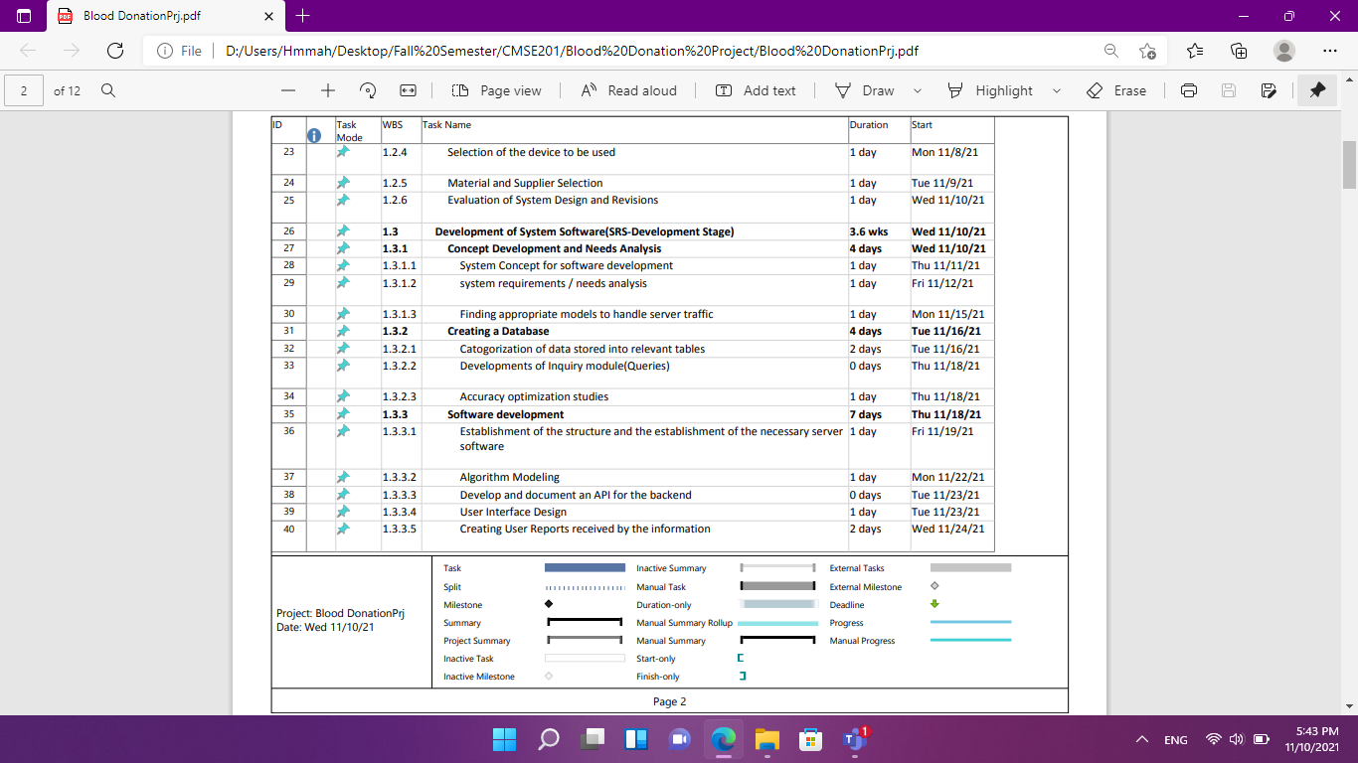

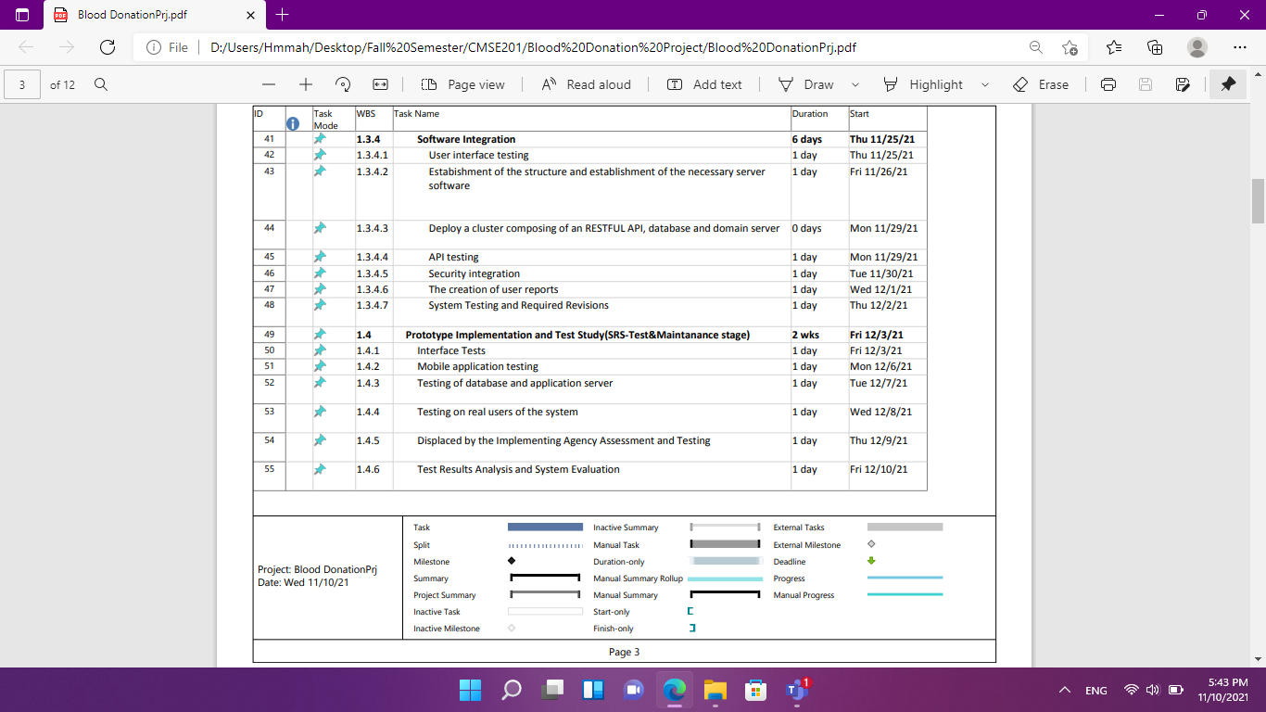

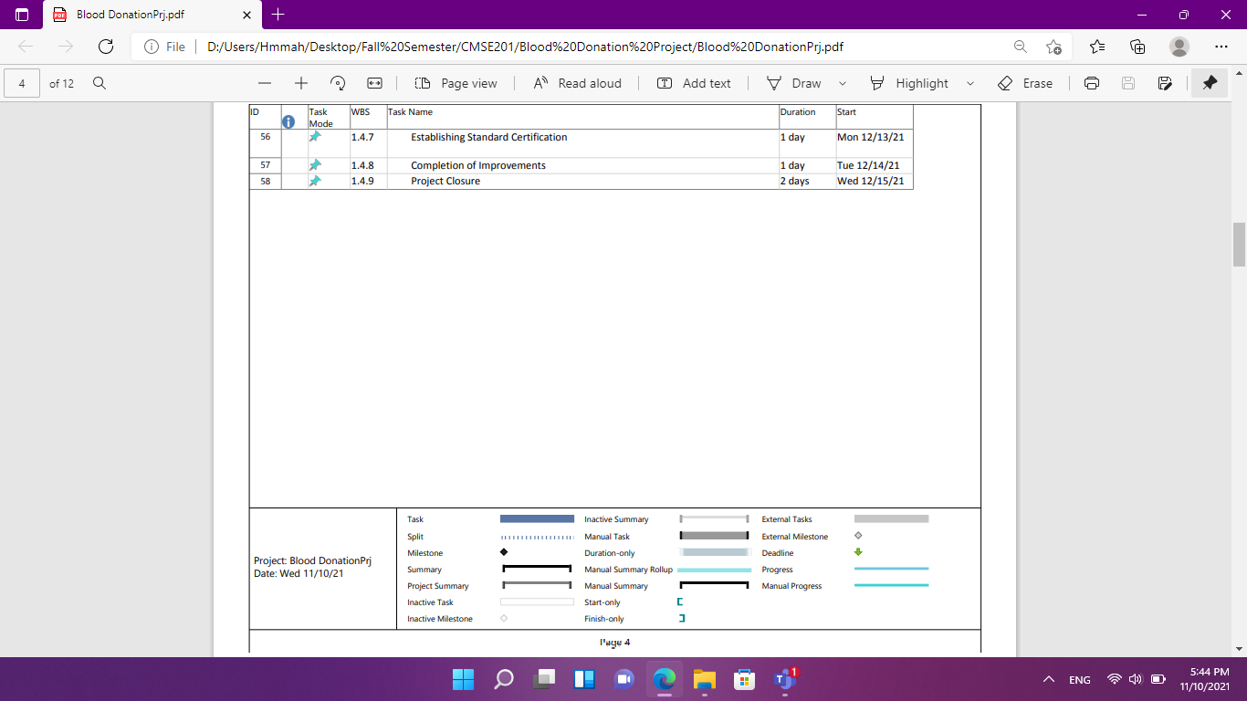

## 2.9 Risk Analysis

|  |  |  |  |
| --- | --- | --- | --- |
| Risk | Probability | Effects | Your Strategy |
| The time required to develop the software is underestimated. | Moderate | Tolerable | Divide the stages into smaller components and develop them in parallel |
| Software tools cannot work together in an integrated way. | Low | High | Proper research on the compatibility of different software tools before development |
| Customers fail to understand the impact of requirements changes. | Moderate | Tolerable | Continuous feedback from customers during the development of the User interface |
| The rate of defect repair is underestimated. | Moderate | Tolerable | Replace potentially defective components with more reliable bought-in components. |
| The size of the software is underestimated. | High | Serious | Use code generator frameworks |
| Code generated by code generation tools is inefficient. | Moderate | insignificant |  |
| Key staff are ill at critical times in the project. | Moderate | Serious | Reorganize team so that there is more overlap of work and people therefore understand each other’s jobs. |
| The database used in the system cannot process as many transactions per second as expected. | Moderate | Serious | Investigate the possibility of buying a higher-performance database. |

**3. REQUIREMENTS ANALYSIS**

## 3.1 Functional Requirements

REQ1: The system should allow the user to register.

* Collect user information (Name, Email, phone number, Password, medical report, nationality, birthday, gender)
* Check if the medical report information is valid
* check if the email and phone number has not been used before
* If information is valid, save and add user to database
* Send confirmation message to user’s email or the phone number.

REQ2: The system should allow user to login.

* They should enter their email and password.
* check if the information given has been saved in database.
* If the information is not correct shall be denied.

REQ3: The system should allow user to logout.

REQ4: The system should allow user to change if they forgotten password

* Collect user email or usernames or phone number
* Send change password message to user’s email or phone number
* Collect user’s new password
* Save and edit user’s password in database.

REQ5: The system should allow user to see and edit their profile.

* User shall be allowed to edit old information by entering new information
* The information will be replacing the old one in the database
* The system will show users their information as saved in the database.

REQ6: The system should allow the user to add address

* The user should select their home address

REQ7: The system should allow the user to see all blood bank locations

* The system will use the user address to display all nearest blood bank.

REQ8: the system should allow the user to see all blood bank details

* The system will display all blood bank that are open and closed.
* The system will display all blood bank feedbacks.

REQ9: The system should allow the user to search for blood banks.

* The system will display a log bar for search

REQ10: The system should allow the user to see all request for blood

* The system will display all information about request (blood type, age, name)
* The system will display the location about request(place)

REQ11: The system should allow the user to have communication between the receive and the donor

* The system will have chat room for the receive and donate.

REQ12: The system should allow the user to accept/reject request.

* The system will display all request for blood.

REQ13: The system should allow the user to add a request

* The system will use the user information to create a request for blood.

REQ14: The system should allow the user to see all places that have more request for blood

* The system will display place the lack of blood

REQ15: The system should allow the user to search for personal

* The system will display a search bar
* The system will display the user profile
* The system will use the information that given by the user to search

REQ16: The system should allow the user to get notification

* The system will display all notification

REQ17: The system should allow the user to get notification about ever event.

REQ18: The system should allow the user to search for special blood type

* The system will display all users that have the same blood type

REQ19: The system should allow the user to add Appointment for donate blood.

* The system will display the information about (hospital place, time, date)

REQ20: The system should allow the user to see all Appointment

* The system will display all information about the appointment (date, time, place)

REQ21: The administrators should be able ban any account

REQ22: The administrators should be able to delete any appointment

## 3.2 Non-Functional Requirements

5.1 Performance Requirements:

* The loading time for the user interface should take less than 5 seconds
* The log in information should be verified within five seconds
* Queries shall return results within 3 seconds
* The system should be able to withstand millions of users at the same time without a drop in performance
* Overall, the system should not take more than 3 seconds to respond

5.2 Security Requirements:

* All communications between clients should be encrypted
* All client’s personal data should be protected from cyber threats and access to it should be restricted
* The database should be backed up on a cloud

5.3 Reliability Requirements:

* The system should be available at all times
* The system failure rate should be less than 0.01

5.4 Usability Requirements:

* The system should include a document on how to use the system
* The system user interface should be easy to use
* The system should have a complaints page for clients

# 4. DESIGN

## 4.1 High level design (architectural)

A context Diagram showing the system and its main modules, including the relationship between them is shown below. The context diagram shows the most basic functions of the system. The recipient and Donor are external entities which interact with the system. The user request blood, which is sent to the Donor by the system. The Donor responds by either accepting the request or declining it. This response is sent to the user by the system.

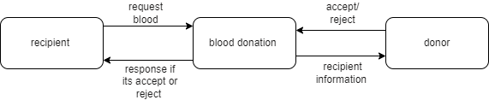

Figure1. Context diagram

## 4.1.2 Low level design (components used)

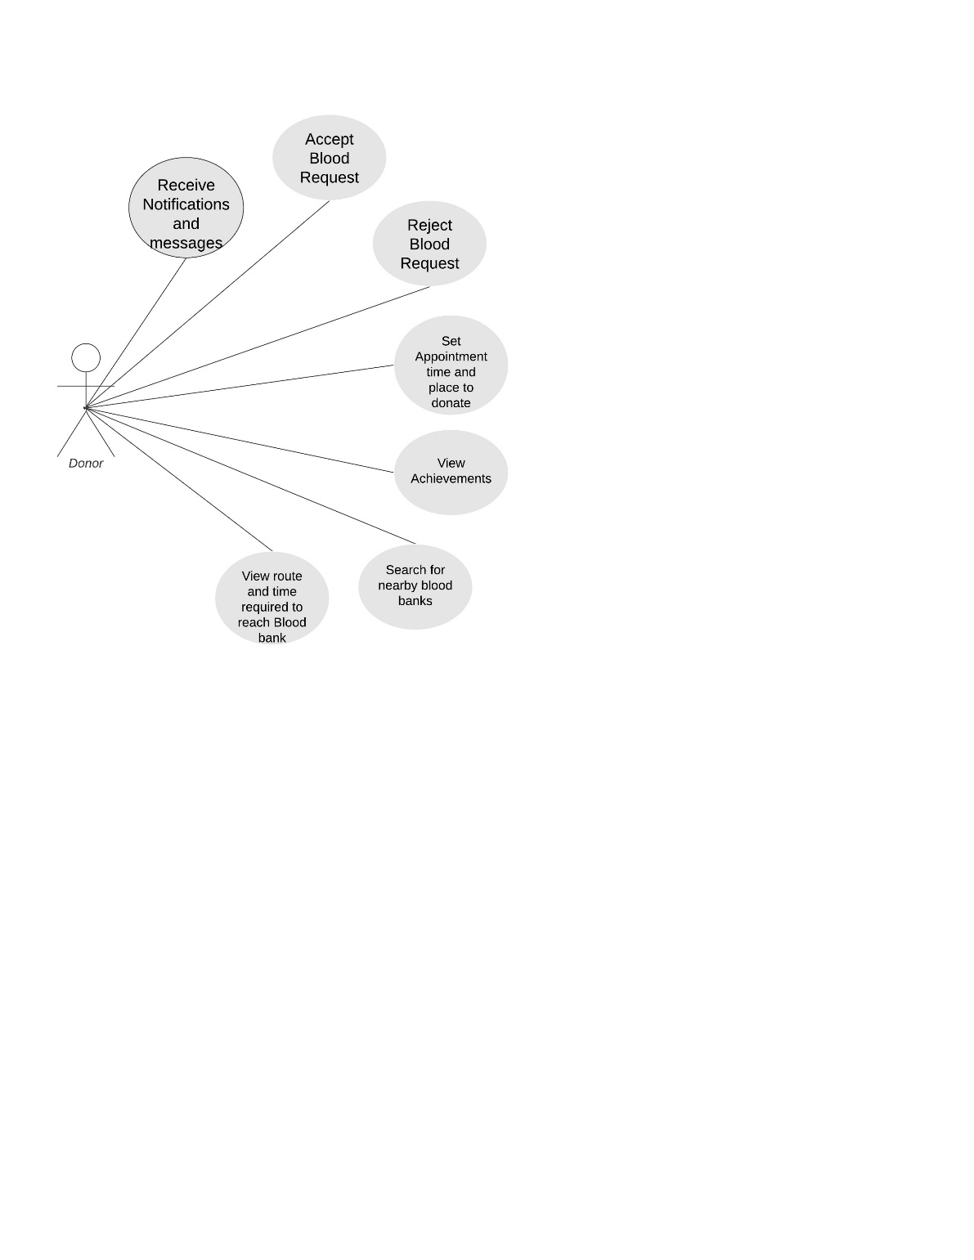

4.1.2.1 Donor Use Case

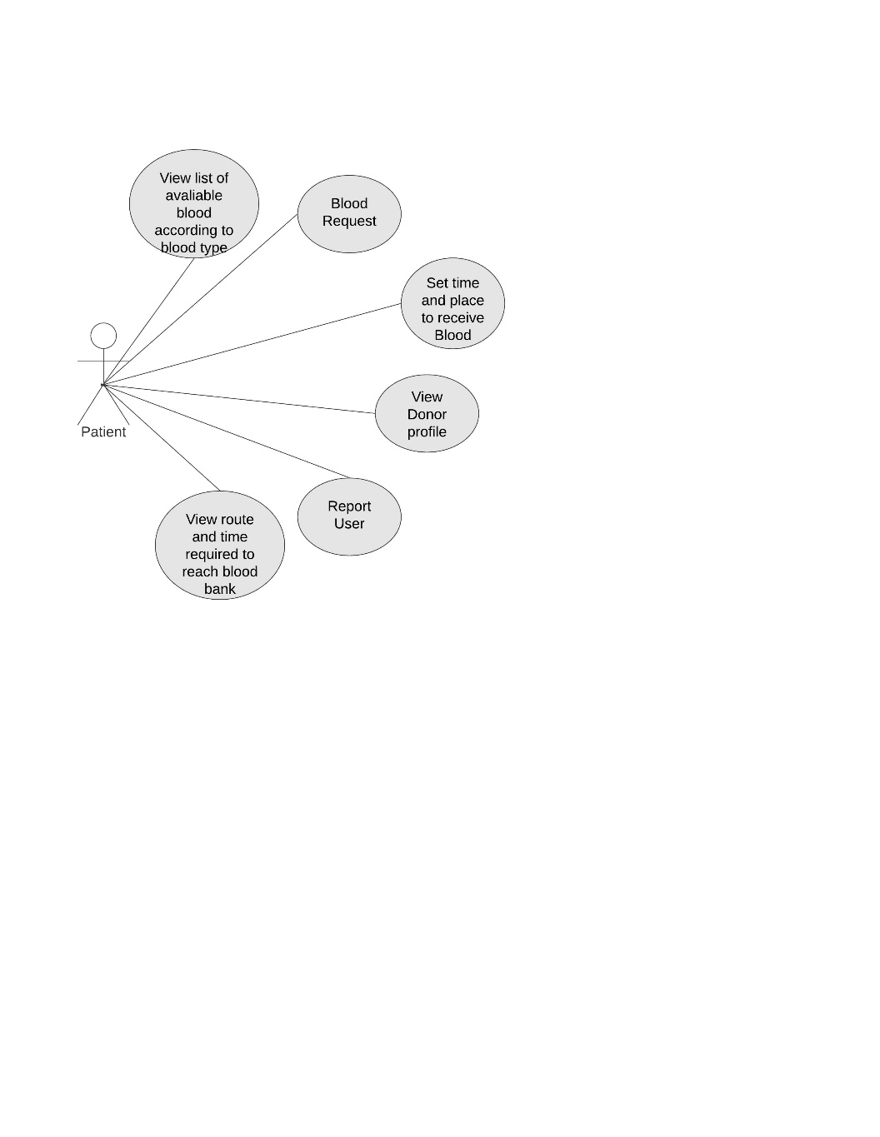

4.1.2.2 Patient Use Case

|  |  |
| --- | --- |
| **Use case-1** | Register |
| **Actor** | Patients, Benefactors |
| **Goal** | To create an account |
| **Preconditions** | The system displays the register page |
| **Stimulus** | The user wishes to create a new account |
| **Scenario** | 1. The user selects ’Register’ from the homepage menu 2. The system prompts the user for information (Name, Email, Birth day, Phone number, Nationality, Gender, Password and Confirm Password) 3. The user fills in the data fields 4. The system analyses the user’s data for validity 5. A security confirmation link is sent to the user’s email or phone number 6. The user confirms their identity by clicking on the link or enter the code was sent to the phone number. |
| **Exceptions** | Invalid information is inputted by the user |

|  |  |
| --- | --- |
| **Use case-2** | Login |
| **Actor** | Patients, Benefactors |
| **Goal** | Enable user accessing the system |
| **Preconditions** | The user requests access to the system |
| **Stimulus** | 1-The user already has a valid username and password  2- The suer in not already logged in |
| **Scenario** | 1-The user selects ‘login’ from the menu  2-The system prompts the user form their username and password  3-The user enters their username and password  4-The system grants access to the user |
| **Exceptions** | The user enters invalid username or password |

|  |  |
| --- | --- |
| **Use case-3** | Logout |
| **Actor** | Patients, Benefactors |
| **Goal** | Disable user access to the system |
| **Preconditions** | The user is already logged in |
| **Stimulus** | The user no longer requires access to the system |
| **Scenario** | 1-The user selects ‘logout’ from the menu  2-The system disable access |
| **Exceptions** |  |

|  |  |
| --- | --- |
| **Use case-4** | Search for Blood donor |
| **Actor** | Patients |
| **Goal** | Enable user to find donors |
| **Preconditions** | The user is logged in |
| **Stimulus** | The patient wishes to see whom would be able to help them from donors |
| **Scenario** | 1-The patient clicks on the search box in the homepage  2- The patient types a name of a certain donors  3-system displays result |
| **Exceptions** | The name is not in the data base of the Blood donation App |

|  |  |
| --- | --- |
| **Use case-5** | Search for nearby blood banks |
| **Actor** | Patients, Benefactors |
| **Goal** | Enable user to find the nearest blood bank |
| **Preconditions** | The user is logged in |
| **Stimulus** | The patient \ benefactor wishes to find a close blood bank |
| **Scenario** | 1-The patient clicks on the search box in the homepage  2- The patient types ‘Find blood banks’  3-Patient selects a specific area to search in  4-system displays result  5-Patient click on blood bank to see the location of it |
| **Exceptions** |  |

|  |  |
| --- | --- |
| **Use case-6** | Direction of Blood banks |
| **Actor** | Patients, Benefactors |
| **Goal** | Enable user to find a path to a blood bank |
| **Preconditions** | The user must select the blood bank name |
| **Stimulus** | The patient \ benefactor wishes to follow a path to reach the blood bank |
| **Scenario** | 1-The user selects their current location  2- The system shows the nearest way to reach the blood bank. |
| **Exceptions** | User don’t select a blood bank name |

|  |  |
| --- | --- |
| **Use case-7** | Request Blood |
| **Actor** | Patients |
| **Goal** | Enable patient request blood |
| **Preconditions** | User is logged in |
| **Stimulus** | The patient wishes look for a certain blood type to request |
| **Scenario** | 1-patient sees Donor names  2-patient clicks to see Donor profile  3-patient requests a blood by click on the request button |
| **Exceptions** |  |

|  |  |
| --- | --- |
| **Use case-8** | Edit profile |
| **Actor** | Patients, donors |
| **Goal** | Enable users to correct \ update information in the profile |
| **Preconditions** | User is logged in |
| **Stimulus** | The user wishes to update or correct their information in the system |
| **Scenario** | 1-user click on the profile icon from the main page  2-User will see their profile  3-user click on the setting icon  4-user changes their information  5-user click on the save button to save changes  6-system displays new information the profile section |
| **Exceptions** |  |

|  |  |
| --- | --- |
| **Use case-9** | Accept Request |
| **Actor** | donors |
| **Goal** | The donor chooses to accept a blood request |
| **Preconditions** | Request is already sent to the donor |
| **Stimulus** | The donor wants to help a patient |
| **Scenario** | 1-Donor clicks on notification icon from the homepage  2-System displays requests have been sent to the donor  3-Donor chooses a requests  4-Donor clicks to see request information  5-System displays request details  6-Donor clicks ‘Accept’ |
| **Exceptions** |  |

|  |  |
| --- | --- |
| **Use case-10** | Reject Request |
| **Actor** | donors |
| **Goal** | The donor chooses to reject a blood request |
| **Preconditions** | Request is already sent to the donor |
| **Stimulus** | The donor will not be able to help a patient |
| **Scenario** | 1-Donor clicks on notification icon from the homepage  2-System displays requests have been sent to the donor  3-Donor chooses a requests  4-Donor clicks to see request information  5-System displays request details  6-Donor clicks ‘Reject’ |
| **Exceptions** |  |

|  |  |
| --- | --- |
| **Use case-11** | Chat |
| **Actor** | Patients, donors |
| **Goal** | Provide a way of communication between patients and donors |
| **Preconditions** | User is logged in |
| **Stimulus** | The patient wishes to communicate with donors |
| **Scenario** | 1-User clicks on the message icon in the homepage  2-User search for donor name or donor search for patient name  3-System displays search results  4-User click on the name  5-System opens a chat screen  6-User types a message  7-User sends massage to receiver(donor)  8-Donor receives a massage  9-Donor replies to the massage |
| **Exceptions** |  |

|  |  |
| --- | --- |
| **Use case-12** | Appointments |
| **Actor** | Donor |
| **Goal** | Organize time and date for donor to donate |
| **Preconditions** | Donor accepts a blood donation request |
| **Stimulus** | The donor whishes to see their appointments |
| **Scenario** | 1-Donor accepts the request  2-Donor chooses a suitable date and time and blood bank to go to  3-system displays date, time, location of blood bank in the main page |
| **Exceptions** | No request has been accepted |

|  |  |
| --- | --- |
| **Use case-13** | Change username |
| **Actor** | Donor, Patients |
| **Goal** | Enable user to change their username |
| **Preconditions** | User must be logged in |
| **Stimulus** | The donor wishes to apply a change in their username |
| **Scenario** | 1-user click on the profile icon from the main page  2-User will see their profile  3-user click on the setting icon  4-user changes their username  5-user click on the save button to save changes |
| **Exceptions** | If user enters invalid username |

|  |  |
| --- | --- |
| **Use case-14** | Change password |
| **Actor** | Donor, Patients |
| **Goal** | Enable user to change their password |
| **Preconditions** | User must be logged in |
| **Stimulus** | The donor wishes to apply a change in their password |
| **Scenario** | 1-user click on the profile icon from the main page  2-User will see their profile  3-user click on the setting icon  4-user changes their password  5-user click on the save button to save changes |
| **Exceptions** | If user enters invalid password |

|  |  |
| --- | --- |
| **Use case-15** | Ban Account |
| **Actor** | Donor, Patients |
| **Goal** | Enable user to ban other users to conduct them |
| **Preconditions** | User must be logged in |
| **Stimulus** | The donor/patient wishes to stop communication between patients/donor |
| **Scenario** | 1-User clicks on message icon  2-User selects the name from chat  3-User choose block to ban |
| **Exceptions** |  |

|  |  |
| --- | --- |
| **Use case-16** | Delete Account |
| **Actor** | Donor, Patients |
| **Goal** | Enable user to delete their account in the App |
| **Preconditions** | User must be logged in |
| **Stimulus** | User no longer gets benefit from the app |
| **Scenario** |  |
| **Exceptions** |  |

## 4.2 Software design

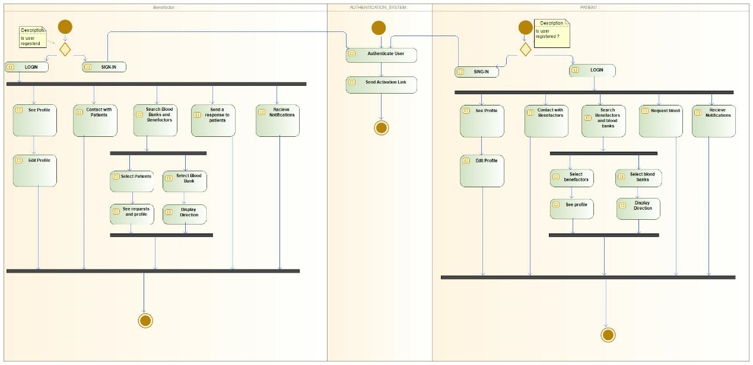

4.2.1 Activity diagram

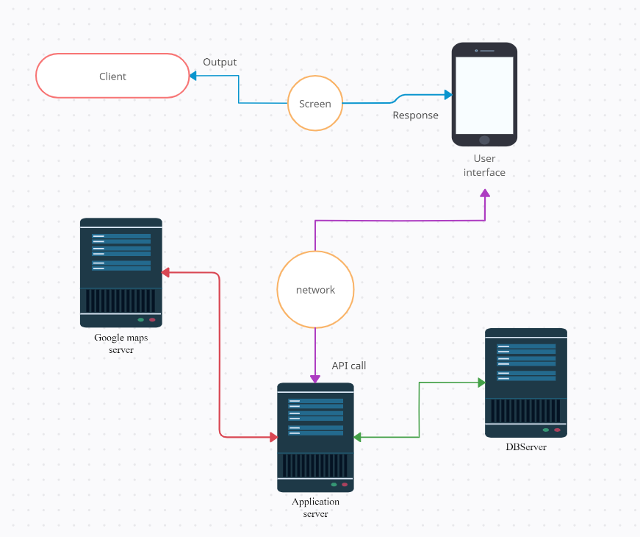

4.2.2 Architecture Diagram

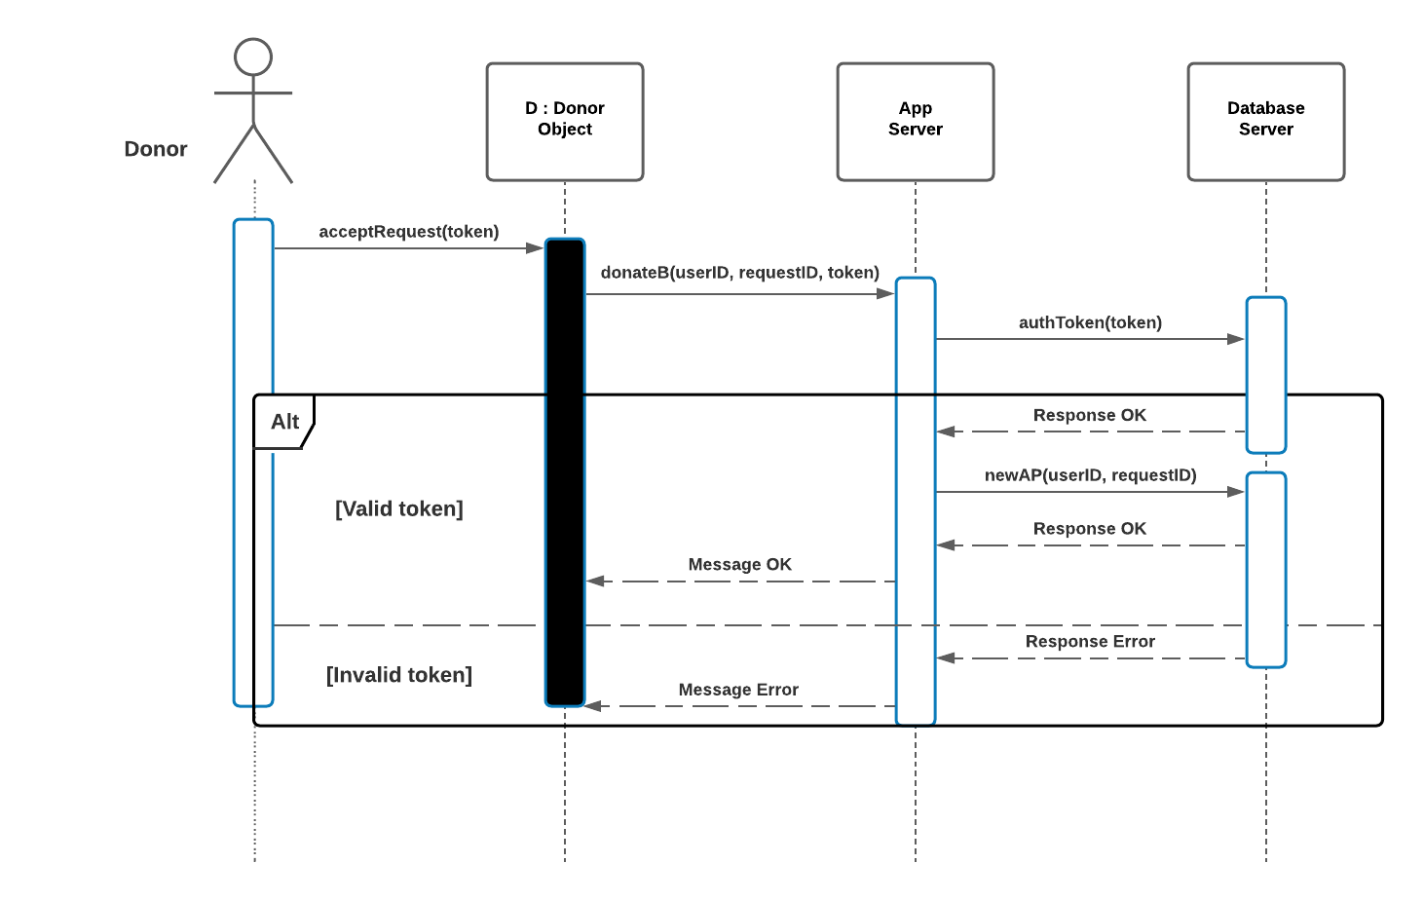

4.2.3 Sequence Diagram for Donor

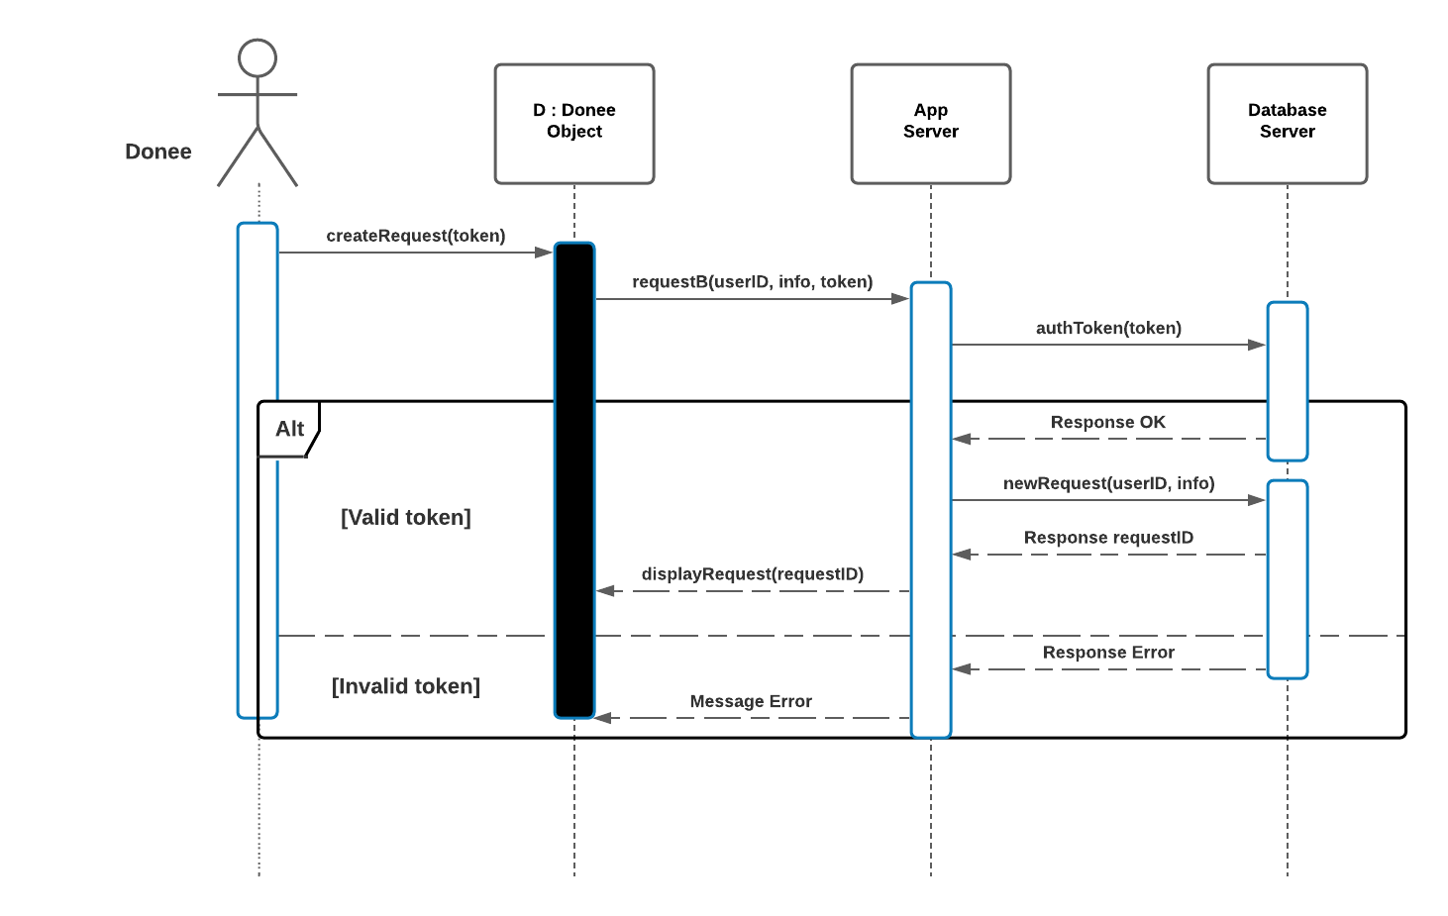

4.2.4 Sequence Diagram for Donee

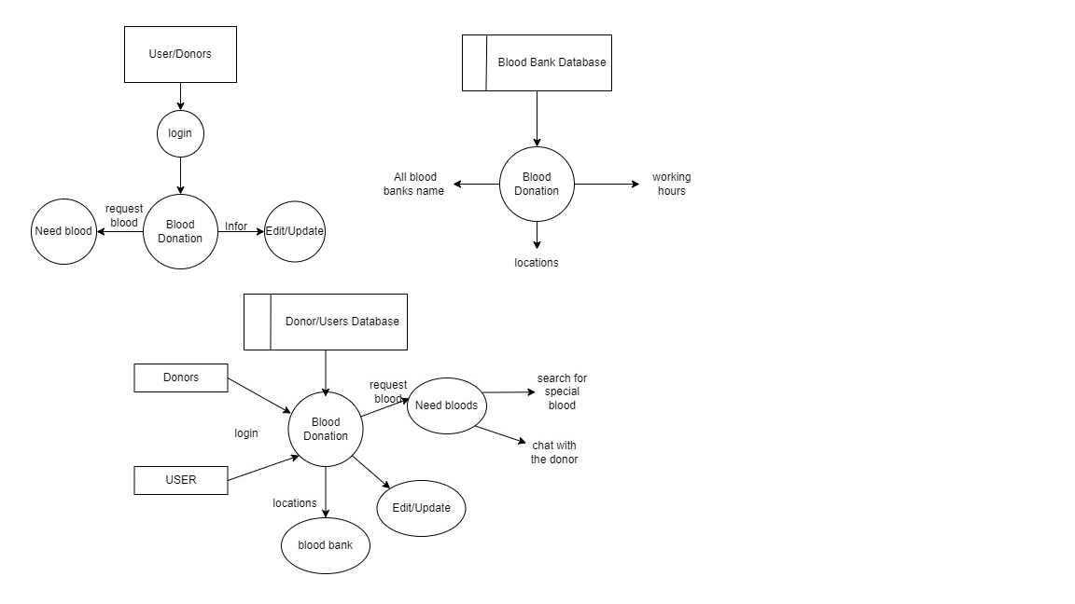

4.2.5 data flow Diagram

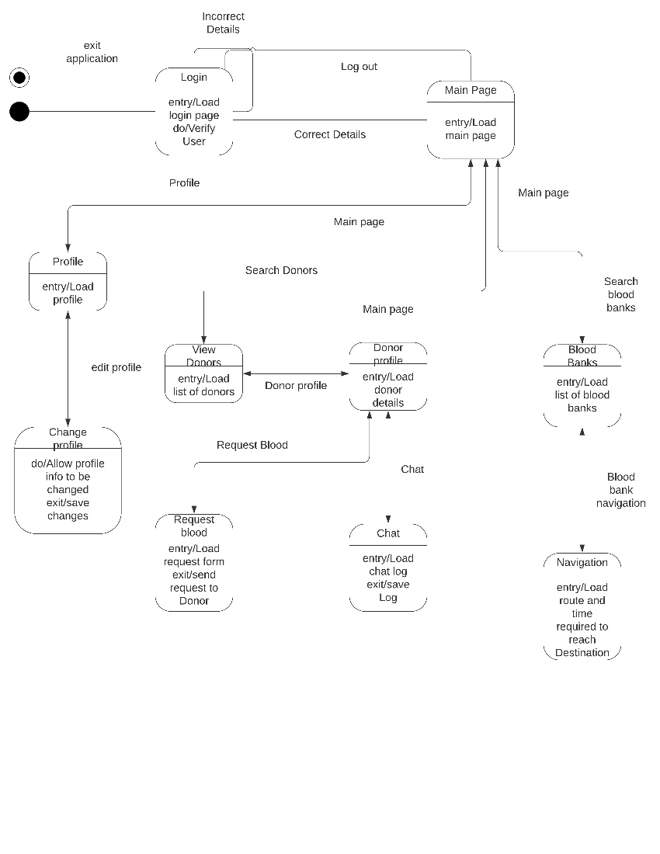

4.2.6 State machine diagram

# 5. IMPLEMENTATION

## 5.1 Tools, technologies and platforms used

For frontend, Android studio and react native. For backend, Nodejs, SQL and bash scripting

## 5.2 Standards

Object oriented programming is used. For the interface, we follow the standards of HCI (Human Computer Interaction)

# 6. TESTING

We plan to perform unit tests, component test, system test. We will do several tests such as server stress testing, RTT (round trip time) testing.

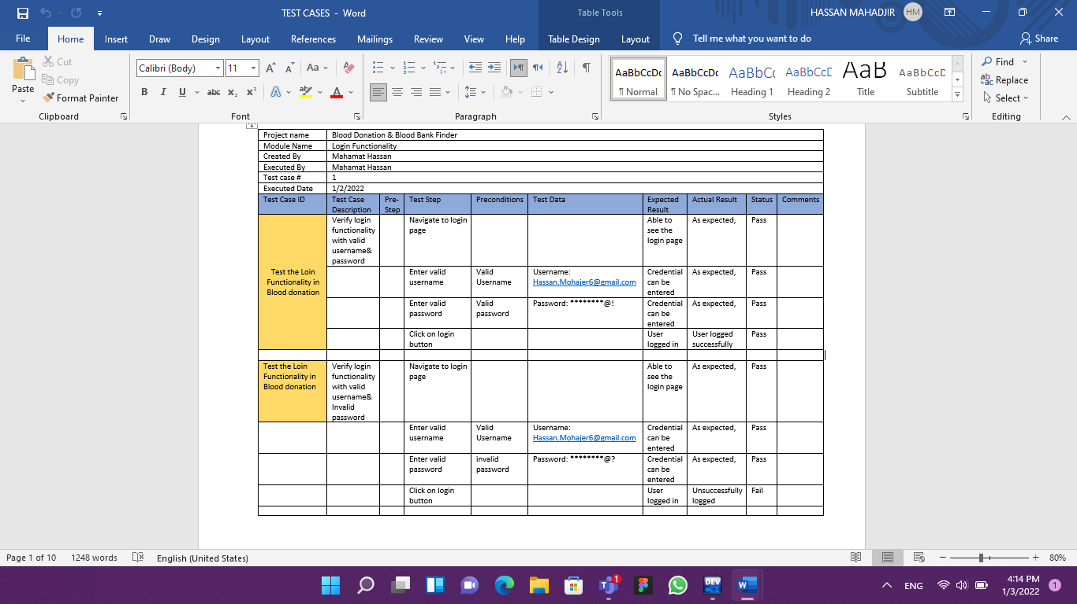

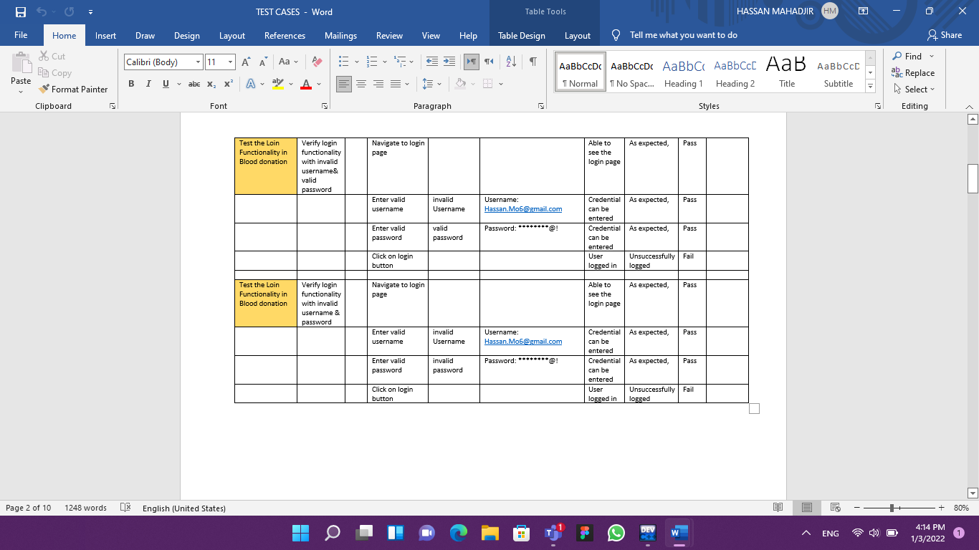

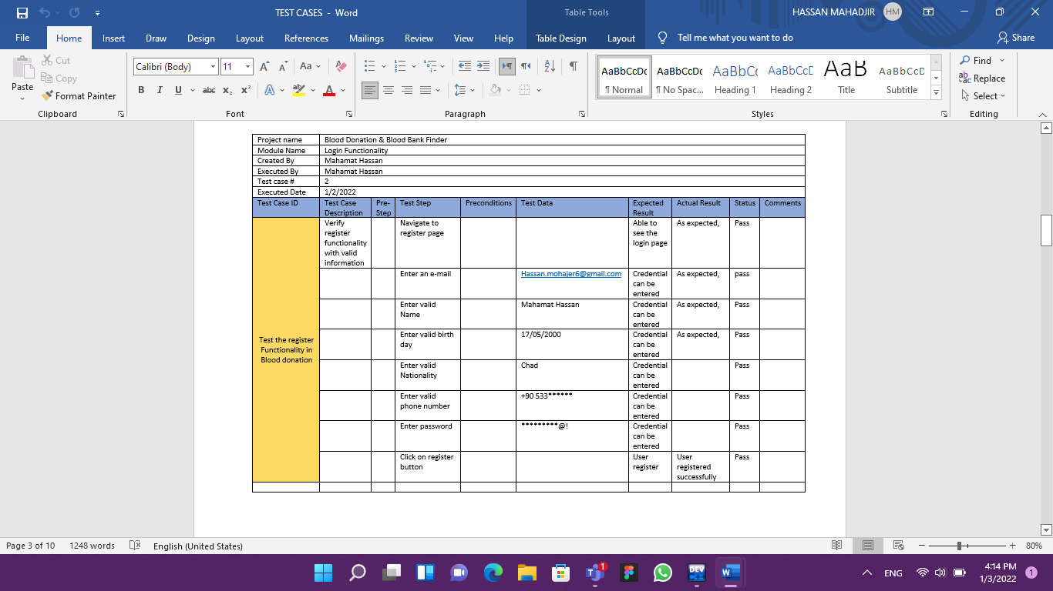

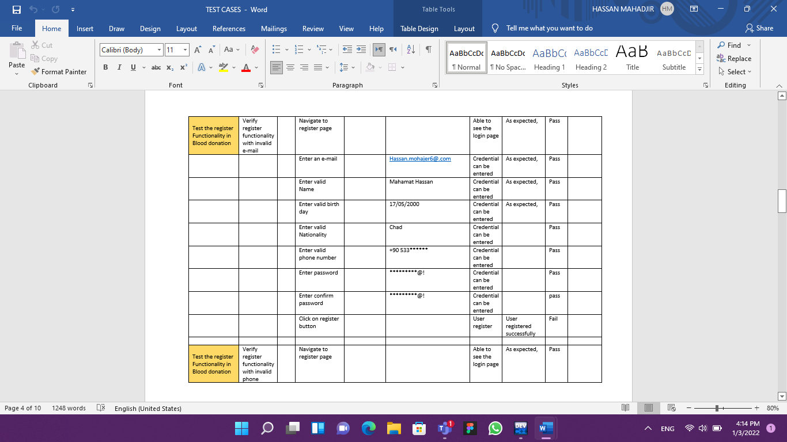

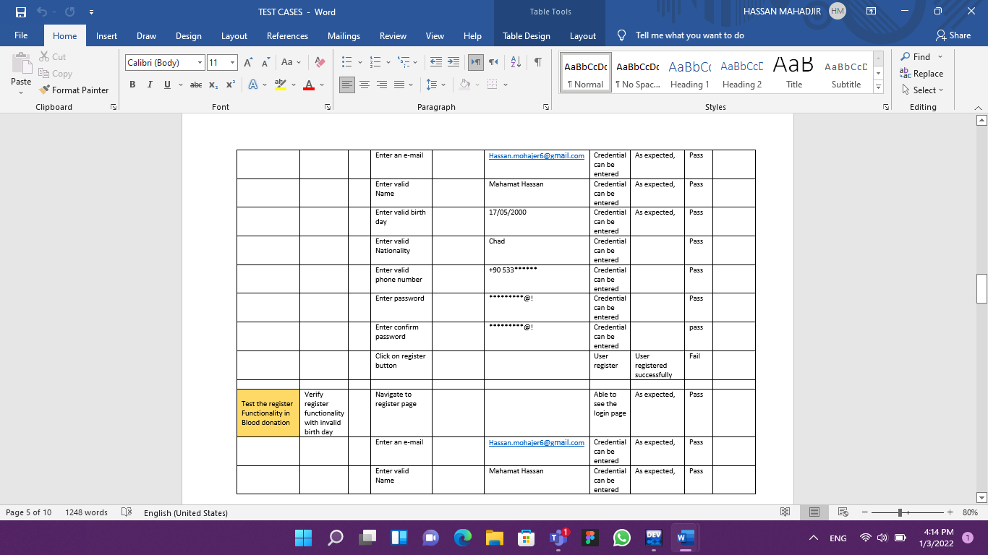

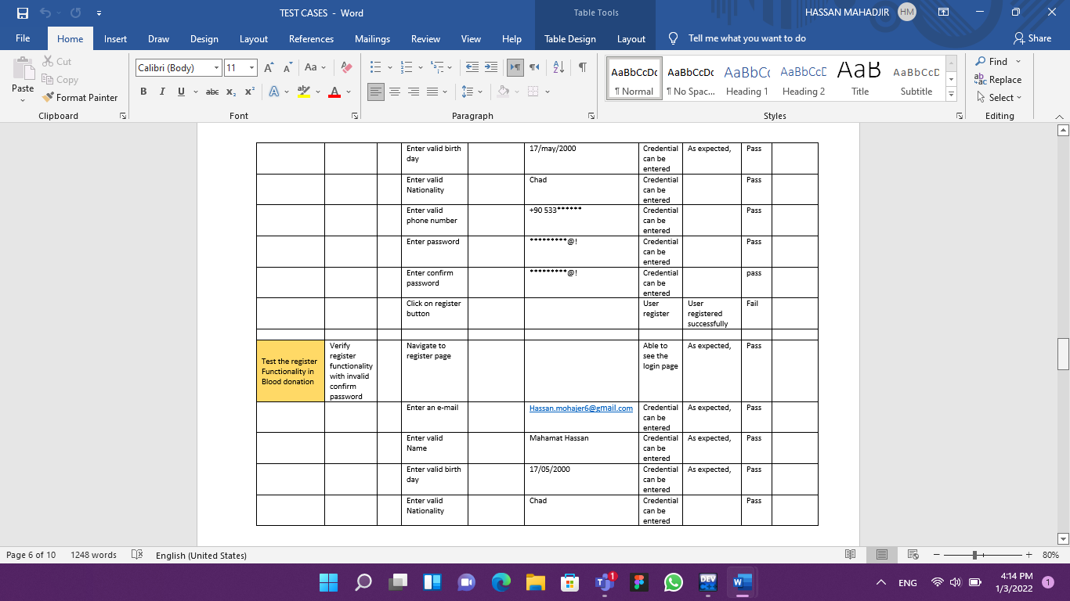

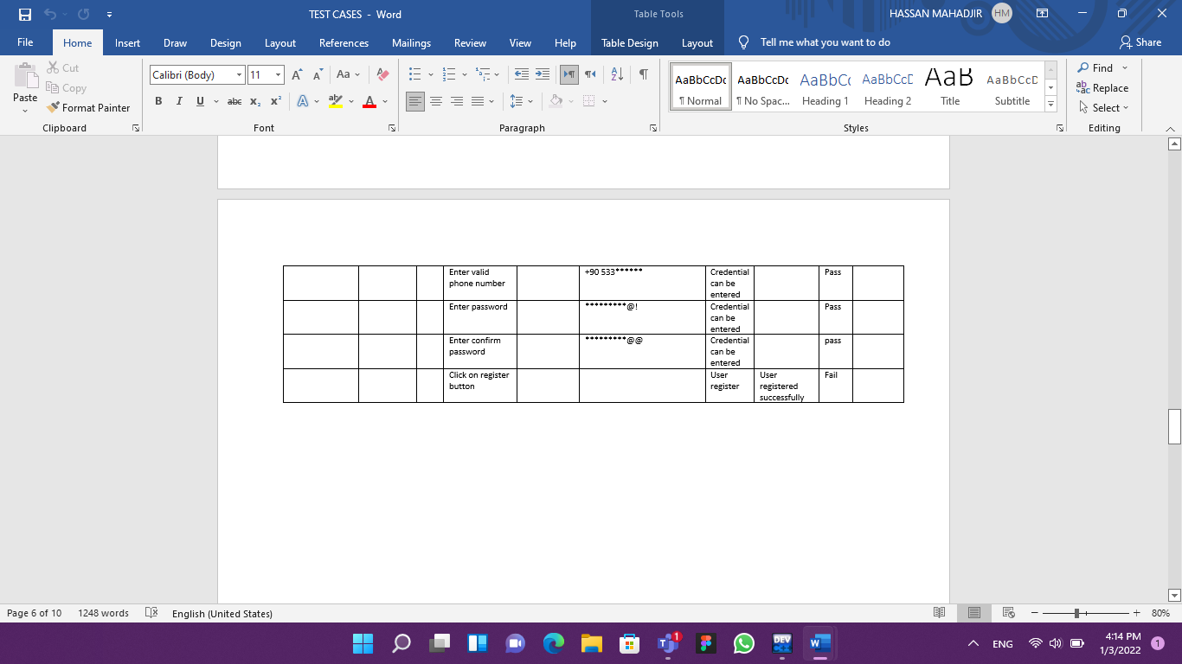

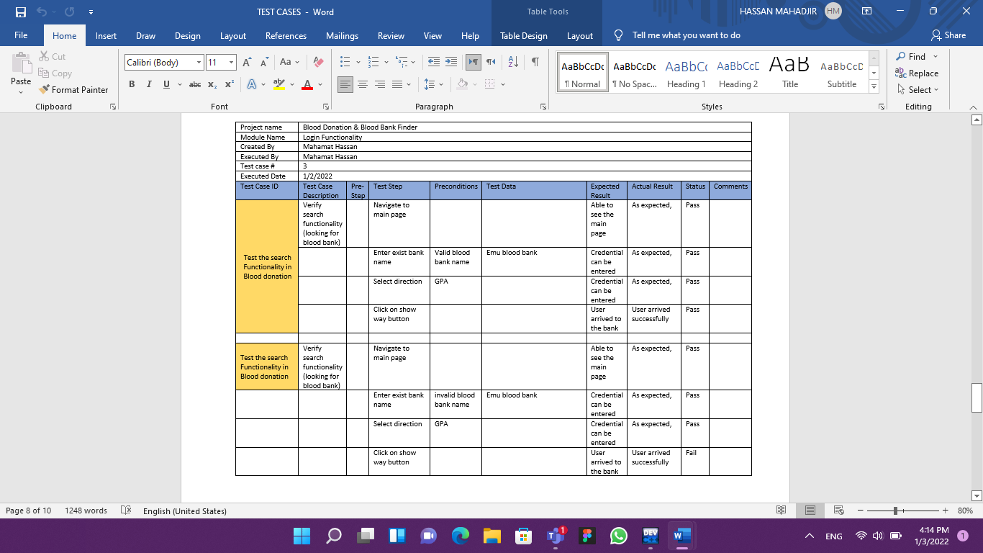

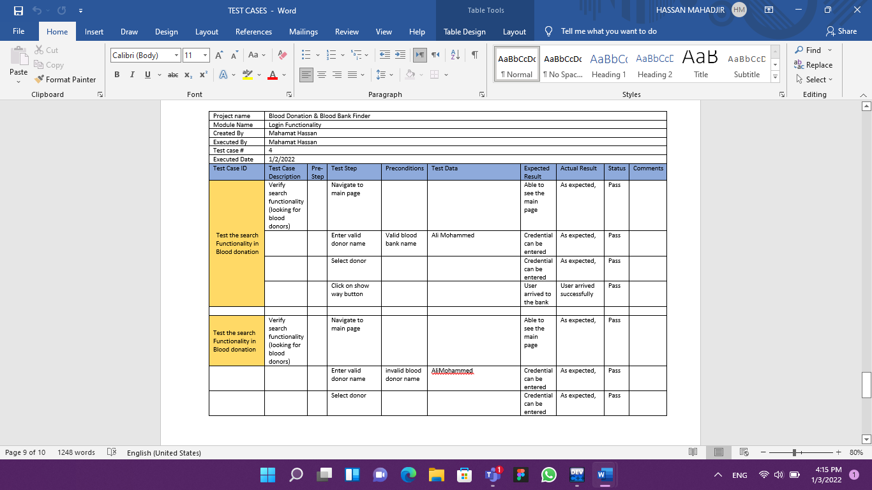

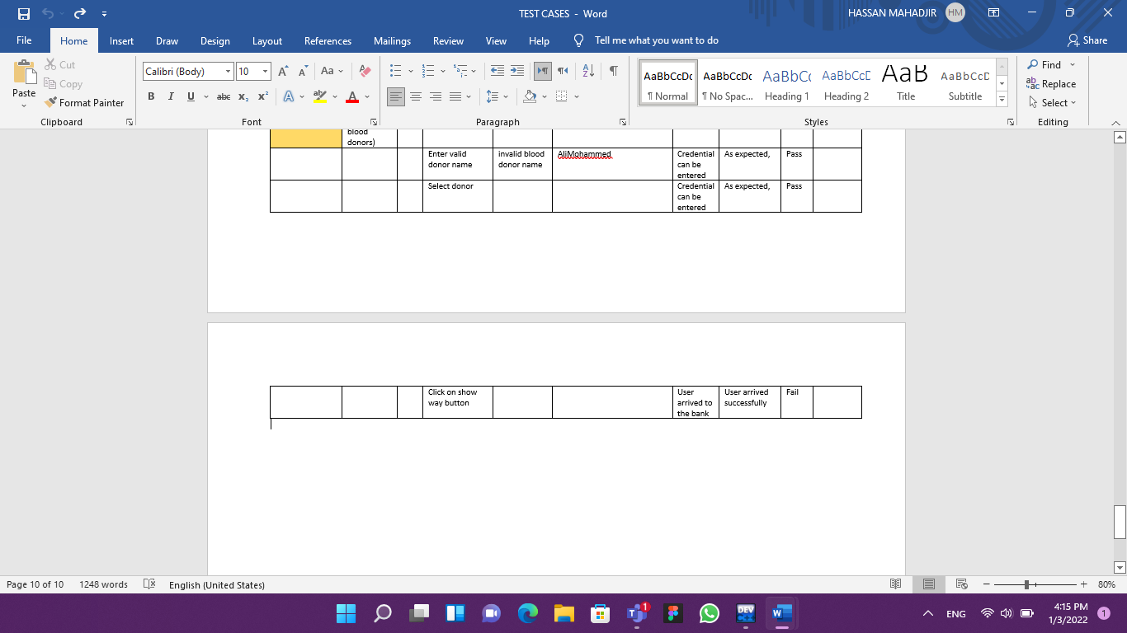

# 7. USER GUIDE OF THE SYSTEM

Each user interface for Blood donation and bank finder will be explained along with some screenshots in this section. These user interfaces were created using Figma.

7.1 Opening Page:

This page allow user to register to Blood Donation and bank finder application or to long-in if they are already registered.

# 

Press to go to log-in page

Press to create a new account

7.2 Register Screen

This scree is the register screen, it will be available to all new users who wish to register on Blood Donation and bank finder. This screen will provide rooms to enter the necessary information that the system needs the new user to enter. Moreover, this page provides authentication procedures to authorize the account.

­

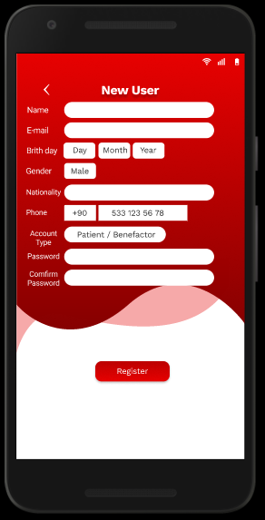

Press to complete registration

7.3 Log-in Screen

This part of the application will allow user to enter the main page of Blood donation and bank finder.

# 

If user forgets their username or password can get help.

7.4 Main page:

This is the main interface where the user can choose what they wish to do such as searching for benefactors and blood banks using the search box, additianlly, users will be able to see the calender and greeting message with thier names. Moreover, the main page contain icons of all the services that the Blood donation and bank finder provides.

# 

Calender

Greeting Messages

Notification icon

Chat icon

Home/main page icon

Profile icon

User Image

Appointments that user have

7.5 Direction to a blood bank

This section shows the way to benefactors and patients to the blood bank which they wish to go to. 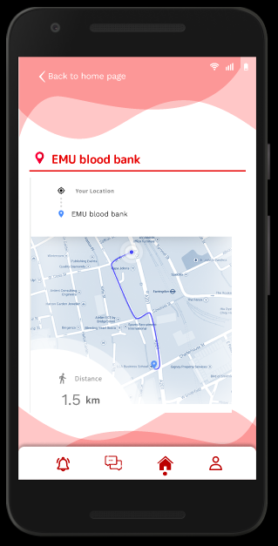

Distance in KM

Showing Path

7.6 Finding benefactors

In this part allow patients to search for benefactors and request blood from them.

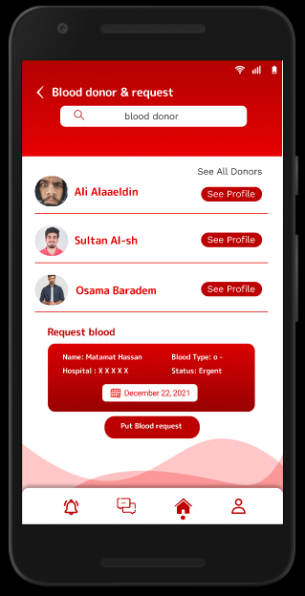

To Search for a specific name

Fill request form

Benefactors in the system

7.7 Donor Profile

This section displays the donors’ profile and confirm requests.

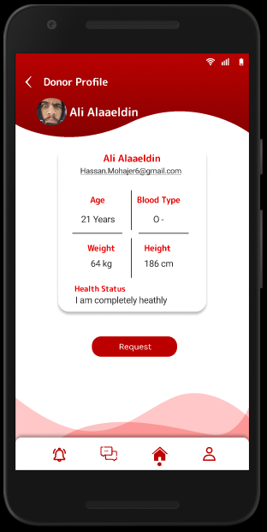

Press to request blood form this donor

Some initial information from donor

7.8 User profile

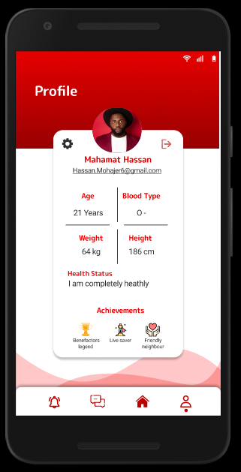

Awards received

App setting and change profile info

Logout button

7.9 Changing information

This screen gives users access to change their profile details which will be immediately updated/deleted in the database.

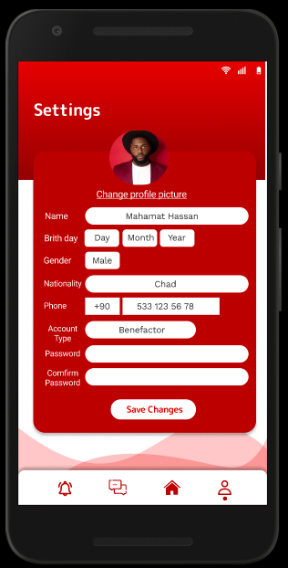

7.10 Chat screen

Allow users to communicate with each other.

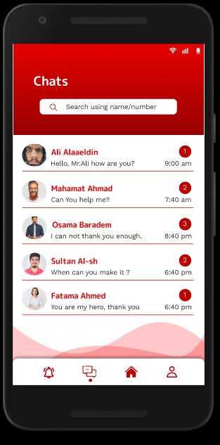

Number of messages

To Search for a specific name

7.11 Inside the Chat

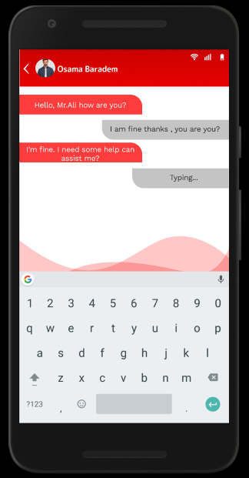

Messages received

(receiver)

Messages sent

(sender)

7.12 Notifications

This part shows the notifications that users receive.

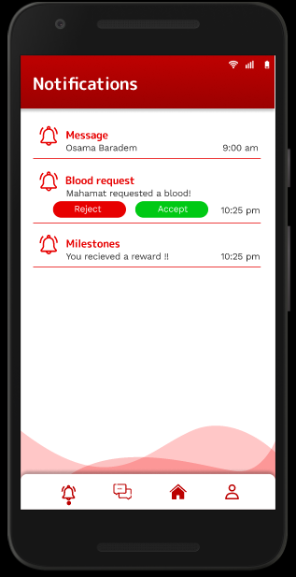

Accept a request

Reject a request

Notification types

# 8. DISCUSSION

We foresee a positive impact on the hospitalization and death rates of individuals suffering from blood related diseases/injuries. This project will bond the community and help increase their productivity. The process of finding blood donors will become simpler and easier than ever. People will be become more motivated to donate blood and rewarded in a non-monetary way. The application will also help individuals search and walk to hospitals/blood banks and socialize with other patients/donors.

# 9. CONCLUSION

This project was initially inspired by an anecdote; However, looking through articles and statistics, it has become apparent that blood shortages is a serious problem, in fact, according to the World Health Organization 90% of people eligible to donate blood don’t do so during their lifetime. This application will revolutionize the process of blood donation by allowing patients in need to call for donors in a simpler and easier fashion.

# APPENDICES

## A. Other relevant material

Give other material that is not included in the main body of your report which you think is relevant for your project here.