EE4105: ELECTRONICS PROJECT

WORKSHOP ASSIGNMENT 01

NAME : HARIHARASAKTHY N.

REG NO. : EG/2020/3956

SEMESTER : 04

DATE : 16/07/2023

1. Illustrate the circuit in Proteus.

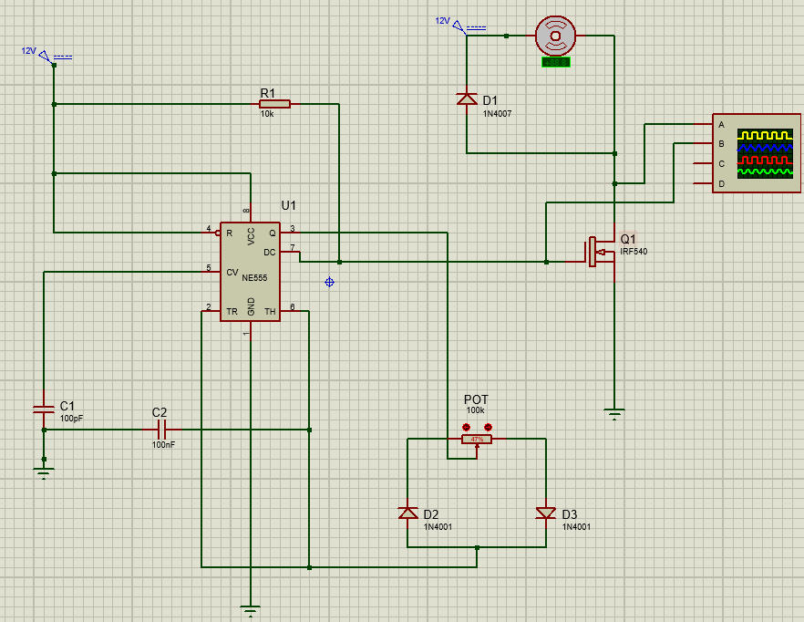

Figure :The circuit diagram of a PWM based DC motor speed controller

1. Connect an oscilloscope to observe the Gate and Drain PWM voltage signals separately.

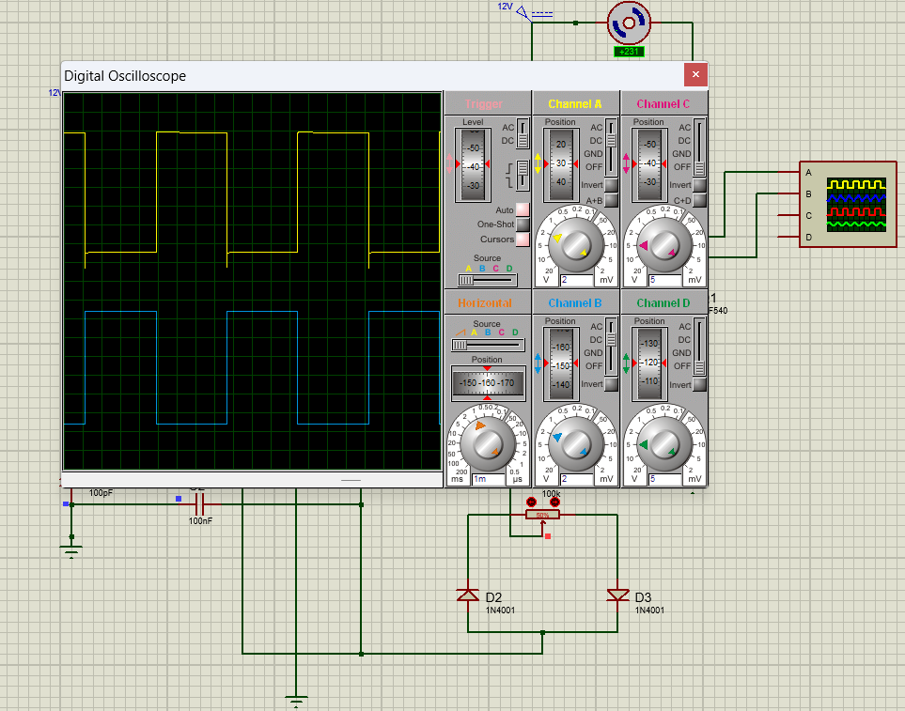

Figure :The Gate and Drain PWM voltage signals when potentiometer value is 50%

1. Simulate the circuit and observe the speed variation of the motor and the PWM signals on the oscilloscope by changing the potentiometer values.

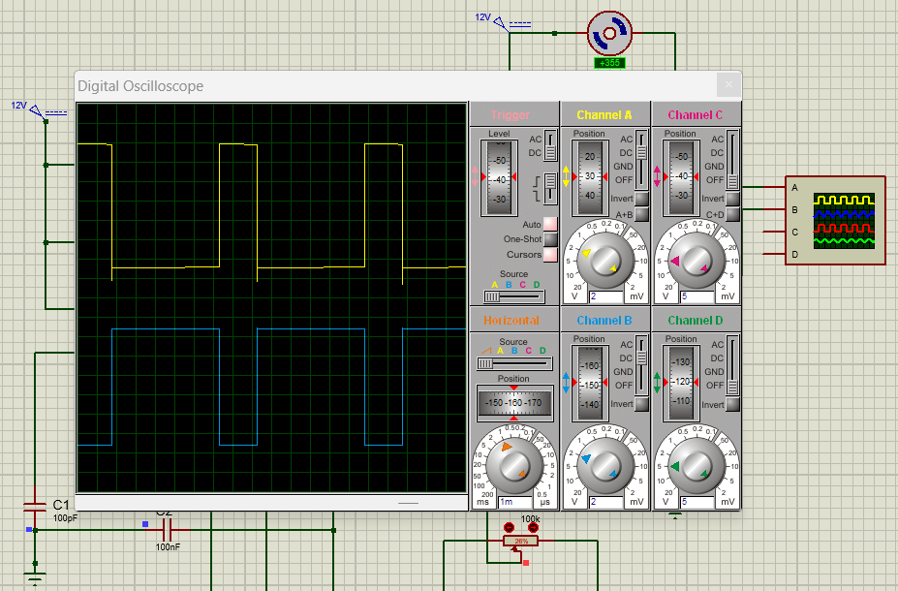

Figure :The Gate, Drain PWM voltage signals and the speed of the DC motor when potentiometer value is decreased (26%)

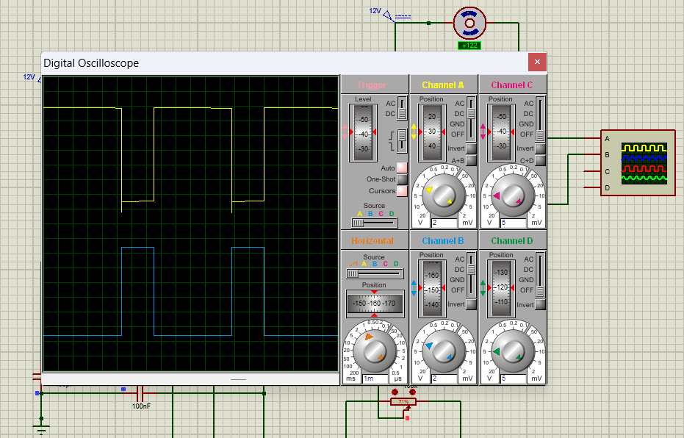

Figure :The Gate, Drain PWM voltage signals and the speed of the DC motor when potentiometer value is increased (71%)

1. Which parameter of the PWM signals vary when changing the potentiometer values?

When changing the potentiometer values, duty cycle of the PWM signals is varying. Duty

cycles mean that the percentage of the time that the signal is “on” or un the high state compared

to the total period of the signal. But amplitude & frequency are remaining constant to both of the

signals.

In addition to that, by the observations of Figure 3 & Figure 4 ,it is clear that when the

potentiometer value is increasing, the duty cycle of the Drain PWM voltage signal is decreasing

& the duty cycle of the gate PMW voltage signal is increasing.

1. Measure the Maximum voltage, Minimum voltage, and frequency values of both PWM signals and explain how these two signals are interrelated.

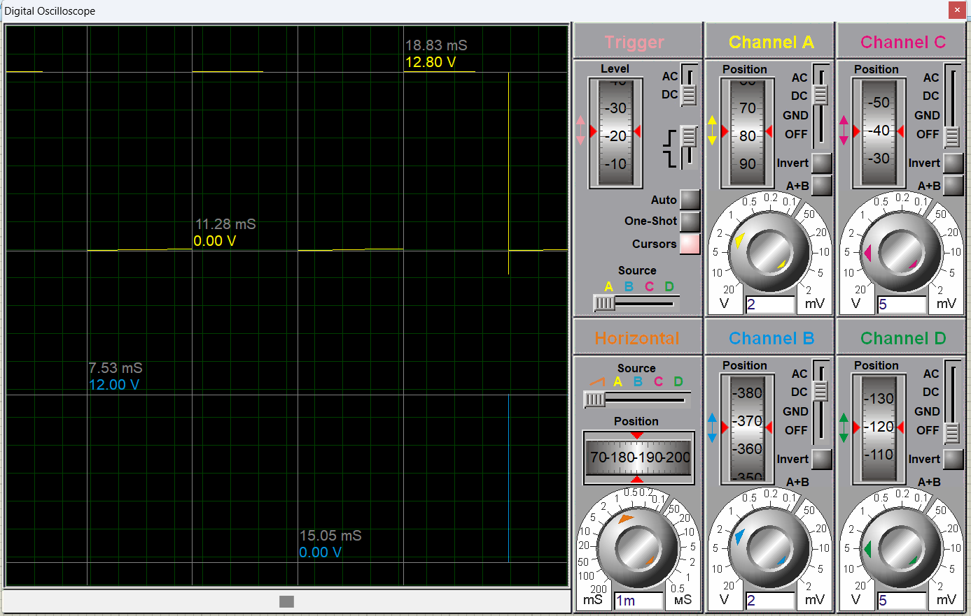

Figure :Obtained measurements of the maximum voltages, minimum voltages & frequencies of the PWM signals using cursors in both signals

Table :Measurements of the maximum voltages, minimum voltages & frequencies of the PWM signals

|  |  |  |  |  |
| --- | --- | --- | --- | --- |
| Oscilloscope  Channel | Signal | Minimum value | Maximum value | Frequency |
| A | Drain Voltage | 0.00V | 12.80V | 132.45Hz |
| B | Gate Voltage | 0.00V | 12.00V | 132.97Hz |

Drain & Gate PWM Signals have approximately equal amplitudes & frequencies according to

the observation in the above table. But these two signals have 180∘ phase difference.

1. Hence, explain how changing the potentiometer values can vary the speed of the DC motor.

(Mathematical calculations are not required).

According to the observations in Figure 3 & Figure 4 when increasing the potentiometer

values ,the speed of the motor is increasing. At the same time ,when decreasing potentiometer

values ,the speed of the motor is also decreasing.

If we want to illustrate more this point, when we increasing the potentiometer values the drain

voltage is in low level of voltage for a long time .So the voltage across the motor remains

higher value in this longer period. Then the speed of the DC motor is increasing because of the

proportionality relationship between Supplied voltage between DC motor & motor speed.

1. Suggest a method to change the frequency of the PWM signals.

The reason of the signals’ frequency is passive elements such as resistors & capacitors of the

circuit in our case. Hence, the frequency of the PWM signals can be changed by the capacitor

& resistor values.