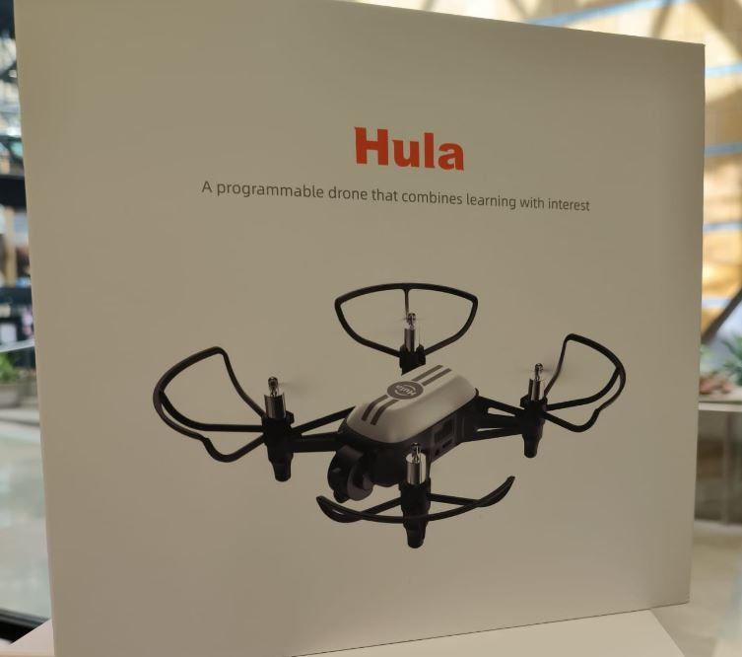
HULA DRONE ACADEMY
From First Flight to First Line of Code
A Hands-On Coding & Robotics Program for Schools

A New Way to Teach Coding
Most coding classes ask students to imagine what their program is doing. This program lets them watch it happen. Every lesson ends with a real, physical drone taking off, flying a pattern, avoiding an obstacle, or completing a mission — because the students told it to, in code they wrote themselves.
The result is a program that holds students' attention in a way a screen alone rarely can, while teaching the same foundational skills as any strong computer science curriculum: logical thinking, problem-solving, and step-by-step program design.
The drone software used in this program is openly documented and independently verified against real hardware, rather than a closed, black-box product — giving schools full visibility into exactly what students are being taught and how it works.

The Hardware: Built for the Classroom
The program is built around “Hula,” a small, lightweight educational drone designed specifically for indoor, supervised use — not a consumer or hobbyist product. It is intentionally small, slow, and shielded, so the emphasis stays on learning rather than on managing a hazard.
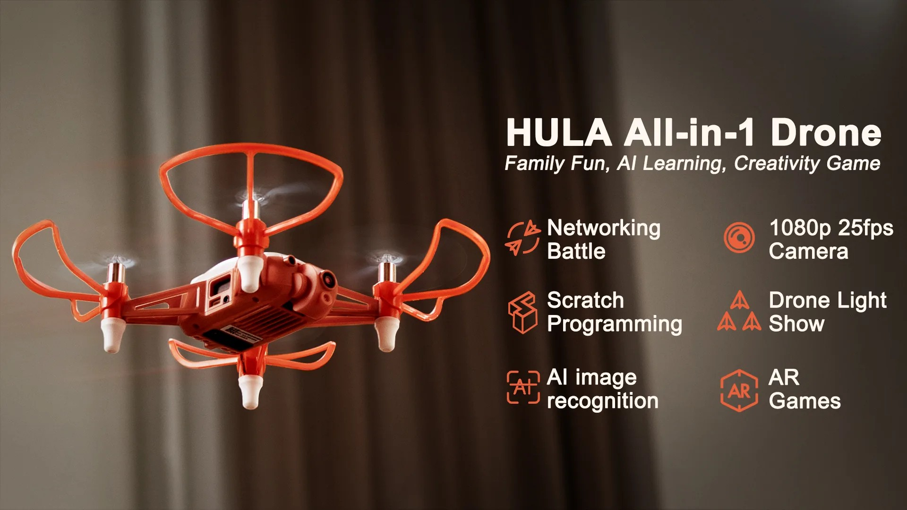
The Hula drone and its core classroom-relevant capabilities: onboard camera, AI recognition, and visual programming.
Feature | What it means for the classroom
Weight | About 100 grams — lighter than a tennis ball
Size | Fits in one hand (about 19 × 18 × 5 cm)
Flight time | Approx. 10 minutes per charge
Camera | Onboard camera for photo and video capture
Top speed | Gentle indoor speeds, well suited to a classroom
Maximum height | 10 meters — easily managed indoors
Safety features | Full propeller guards, obstacle sensing, auto-landing safeguards
Compatibility | Controlled from Android, iPhone, or a Windows computer
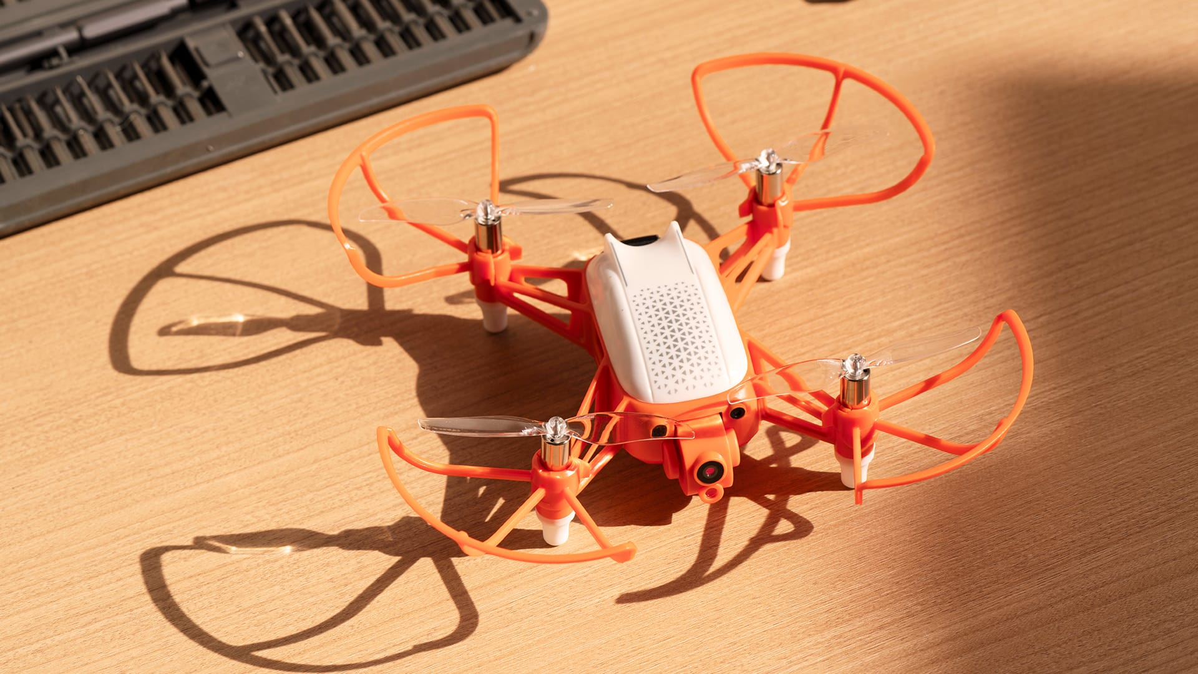
A close-up view of the drone — note the full propeller guards surrounding all four rotors.

The Program: Three Phases, One Progression
The program is designed so that no student is ever asked to learn two hard things at once. They master flying before they program, they master visual logic before real code, and every new program is tested safely before it ever flies. Schools can offer any single phase as a standalone workshop, or the full progression as a semester elective, club, or camp.
Phase | Length | Starting Point | What Students Leave With
Phase 1  Flight Foundations | 1 day | No experience needed | Confidence and safe habits flying a real drone as a team
Phase 2  Visual Programming | 5 days | No coding background needed | The ability to build working programs using drag-and-drop logic, including simple AI features
Phase 3  Real Coding | 5 days | Completion of Phase 2 (or equivalent) | A working program written in Python, a professional programming language, that flies a real mission

Phase 1 — Flight Foundations
A single, supervised session in which small teams work together around one drone, learning to set it up safely, connect to it, and fly it with confidence — taking off, hovering, moving, turning, and landing.
Every student rotates through a role: pilot, safety spotter, mission lead, recorder, or equipment lead — so the session builds teamwork and shared responsibility, not just individual skill. Teams progress through a series of small challenges, ending in a friendly precision challenge, and are scored heavily on safety and control rather than speed.

Phase 2 — Visual Programming
Over five days, students move from flying the drone by hand to instructing it with a simple, visual, drag-and-drop programming tool — the same style of tool used in many introductory computer science classes worldwide.
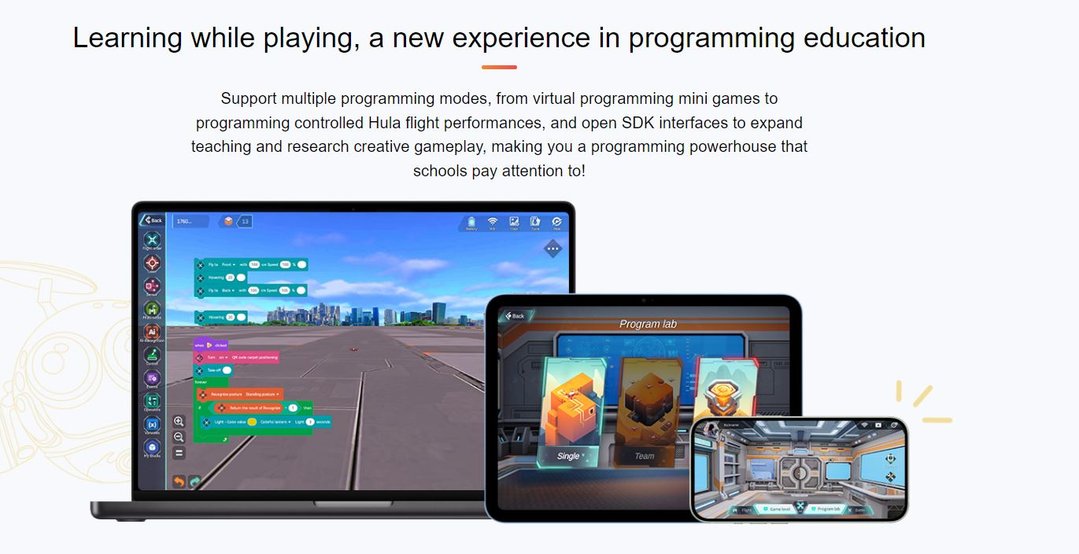
The actual drag-and-drop programming environment students use, shown running on laptop, tablet, and phone.
Students build up steadily: first a simple program that takes off and lands, then programs that use repeated steps and simple logic, then programs that react to the drone's own sensors — for example, turning when it detects something in its path. By the end of the week, students combine these ideas with the drone's onboard camera and simple recognition features (such as following a marked path or responding to a printed symbol) to complete a final mission.
Every program is tested safely in an on-screen simulation before it is ever run on the real drone — a required step, not an optional one.

Phase 3 — Real Coding
The final phase moves students from visual blocks to writing genuine, professional-grade code, in Python — one of the most widely taught and widely used programming languages in the world, in schools and industry alike.
The first two days are spent entirely on laptops, with no drone in the room, learning the building blocks of the language itself: how to store information, make decisions, repeat steps, and organize code into reusable pieces. Only once those fundamentals are solid do students bring their code into the air — first flying simple shapes and patterns they've written themselves, then writing programs that read the drone's sensors and react automatically, and finally designing, coding, and presenting a complete mission of their own.
The program is required to run successfully more than once before it counts — reinforcing that reliable, working software matters more than a single lucky run, a core professional habit as much as a coding skill.

Safety Is Built Into Every Level
For a program that puts flying hardware in front of students, safety is treated as a design requirement, not an afterthought, at every phase:
- A dedicated safety spotter role is part of every team, at every phase, empowered to stop an attempt at any time.
- New programs are always tested in a safe, on-screen simulation before they are ever run on a real drone.
- Scoring at every phase weights safety and control more heavily than speed or difficulty — unsafe behavior ends an attempt immediately.
- The drones themselves are lightweight, fully propeller-guarded, and fly at gentle, classroom-appropriate speeds and heights.
- Even the code students write is required to safely land the drone automatically if anything goes wrong or a program is interrupted.
- Drones are only flown with adequate battery charge, and low-battery drones are automatically prevented from taking off.

Why This Approach Works
- Every lesson ends with a real, visible result — a flying drone — which sustains engagement in a way that a screen alone often cannot.
- The progression is deliberately gradual: students master flying before coding, and visual logic before written code, so they are never learning two hard things at the same time.
- Team roles and group missions build collaboration and communication alongside technical skill.
- Students leave the program having written real, working software in a professional programming language — not just having played with a toy.
- Because the underlying software is open and fully documented, schools and instructors retain full visibility into what is being taught — nothing is a hidden, proprietary black box.

Who This Program Is For
Designed for middle school through high school students, with no prior coding or drone experience required. Schools can start small — a single introductory day — or commit to the full three-phase progression as a semester elective, an after-school club, or a school break camp.

Let's Talk
This document describes the program at a concept level — the goal here is simply to share the idea and open a conversation. We would welcome the chance to talk through how a program like this could fit your school: which phases make sense to start with, how it could run alongside your existing schedule, and what support your students and staff would need.
We look forward to hearing your thoughts.

