Learn to Code by Flying a Real Drone
A proposal for three introductory coding sessions
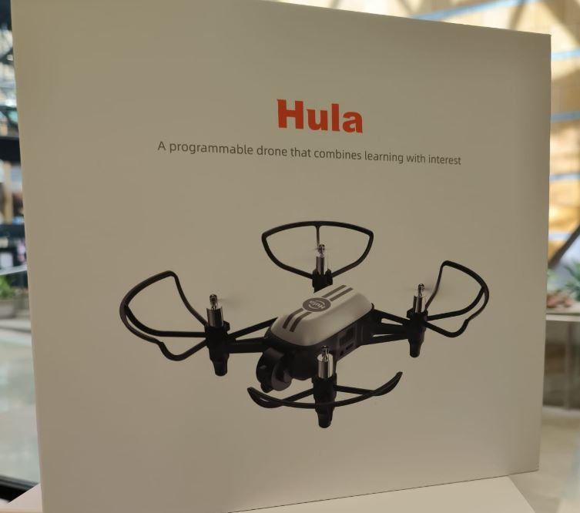
The Hula drone: small, lightweight, propeller-guarded, and built specifically for indoor, supervised classroom use — not a consumer or hobbyist drone.
We'd like to propose three introductory sessions that give students a first, hands-on taste of programming — not on a screen alone, but through a real drone that takes off, flies, and completes a mission because they told it to in code. The pitch to students is simple: learn to code by flying a drone.
Each session is a self-contained trial run. If they land well with students and teachers, we'd follow up with a proposal for a full, paid course for whichever students want to continue.

The Format
3  intro sessions (batches) | 3  drones per session | 3-4  students per drone
9-12  students per session | 2-3 hrs  per session | 6th-8th  grade target

Each session runs 2–3 hours with three drones in the room, and students working in small teams of 3–4 per drone — enough that everyone gets real hands-on flight time, with a partner to think through the program with. We'd run three separate sessions (batches), so we can reach more students and compare how the format lands with different groups before proposing anything longer-term.
Audience: 6th–8th graders. No coding or drone experience required — the whole session is designed for a first-timer.

What Students See and Use
This is a hands-on session, not a lecture. Every student handles the physical materials:
The drone | Their own Hula drone, unboxed and set up at the table — a small, lightweight, propeller-guarded drone built specifically for safe indoor flight in a classroom, not a consumer or hobbyist drone.
The QR cards | Printed QR cards students scan mid-flight to trigger drone behaviors — an early, tangible bridge from “code” to “action.”
The flight mat | A printed course laid on the floor with marked zones, gates, and landing pads — the “board” their programs fly on.
The visual programming app | Drag-and-drop, Scratch-style blocks (no typing or syntax) that compile straight to real flight commands on their drone.

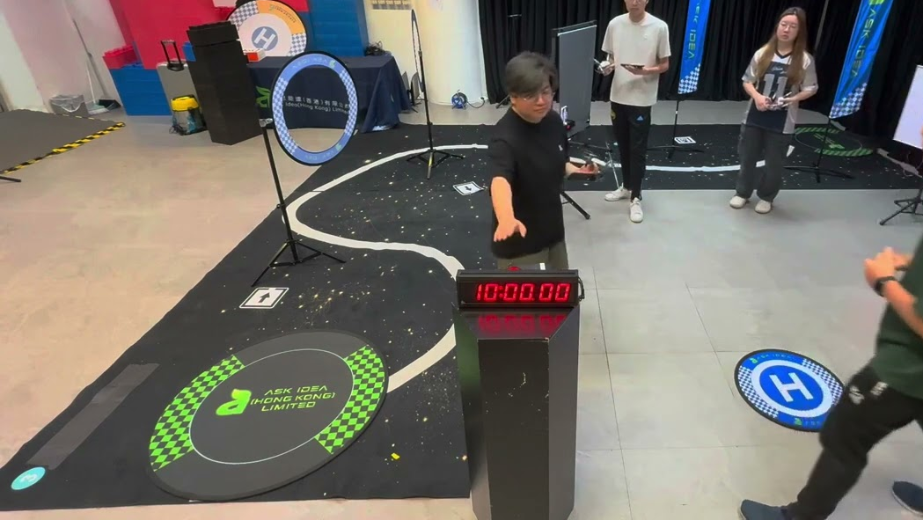  The actual Hula flight mat, set up at a real event — a printed track with QR landing pads and direction markers. | 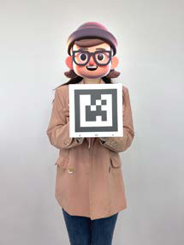  One of the actual QR cards included in the box — held up for the drone's camera to scan.
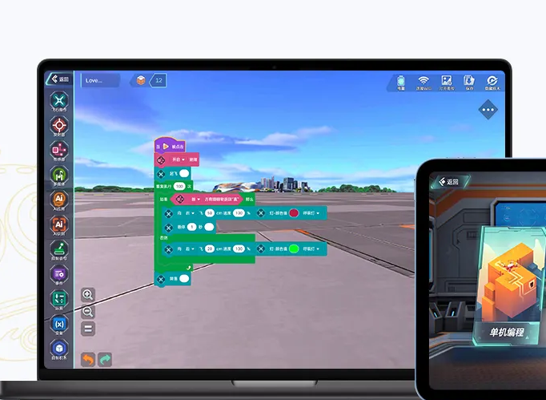
The web app's visual, drag-and-drop programming blocks — Scratch-style, no typing required.

How It's Marketed to Students
We'd position this to students and parents as visual programming, not “drone flying” or “drone racing” — the drone is the hook, but the headline skill is programming:
- “Learn to code by flying a real drone” — approachable, no prior experience implied.
- Scratch-style, drag-and-drop blocks — familiar to any student who's used Scratch in class, and readable to parents and teachers at a glance.
- Every session ends with a visible result: a flight the student programmed themselves.

If the Pilot Goes Well
These three sessions are intentionally low-commitment — a chance for us and the school to see how students respond before discussing anything further. If there's real interest, the natural next step is a full, paid course open to whichever students want to keep going, building from these visual-programming basics toward more advanced missions and, eventually, real code.

What We'd Need From the School
- A room with roughly 20–25 ft of clear, obstacle-free floor space per drone for indoor flight.
- Three scheduled time slots (2–3 hours each) for the three intro batches.
- A class or sign-up list, so we can pre-assign students into groups of 3–4 per drone.
- A school point of contact to coordinate logistics and permission slips if required.
We bring the drones, mats, QR cards, and devices running the programming app — students don't need to install or own anything.

Next Steps
We'd love to find a time to walk through scheduling and answer any questions — including safety, supervision, and space requirements. Looking forward to hearing your thoughts.
Contact: [Your name] · [email] · [phone]

