INFERRING HUMAN ACTIVITY STATES FROM SMARTPHONE MOTION DATA USING A HIDDEN MARKOV MODEL
Passive rehabilitation-adherence monitoring after knee or hip replacement
HonourGod Kilechukwu Levison | Machine Learning Techniques II | Formative 2
Repository Link - GitHub

1. BACKGROUND AND MOTIVATION
After a knee or hip replacement, the prescription is almost entirely about movement, yet the surgeon observes none of it, and adults misestimate their own activity badly when recall is checked against direct measurement (Prince et al., 2008). I built this project around passive adherence monitoring on the phone a patient already carries, where walking is the mobilisation dose, standing is weight-bearing tolerance, jumping is impact loading that should raise an alert, and still means the phone lying on a surface, so not carried at all. That last state is the hard one, since a system that cannot separate a resting patient from a phone on a table logs non-wear as clinical inactivity (Choi et al., 2011). The activity itself is never measured, only a noisy orientation-dependent stream, so the state is hidden; and since activities persist and change in patterned ways, the sequence carries information a per-window classifier discards (Rabiner, 1989).

2. DATA COLLECTION AND PRE-PROCESSING

2.1 Collection protocol and video documentation
All recordings are mine, made with Sensor Logger v1.68 on one Xiaomi 2312DRA50G running Android 36, logging accelerometer and gyroscope. The training session gave 52 files, 13 per activity, phone held in hand at waist level. A later unseen session gave 12 more, three per activity, deliberately changed in two ways: a different room, and the phone in a trouser pocket. I also recorded two continuous 94 s circuits through all four activities, tapping the annotation button at each change, since these are the only recordings with real transitions. Still always means the phone is on a flat surface, representing non-wear rather than a posture. Video documentation is at:
https://drive.google.com/drive/folders/1jfF0QRI9SgRetKKAMbNT-0WUdd2tBeEx?usp=sharing
Still, Standing, Walking and Jumping Log Evidence.mp4 | Sensor Logger Evidence.mp4

2.2 Resampling, trimming and window length
Three timing problems had to be resolved first. The delivered rate is not the 50 Hz requested, averaging 51.33 Hz with jitter, though a maximum gap of 0.019 s means no dropouts. The two sensors are written to separate files on separate nanosecond clocks whose rows are not mutually aligned. And the annotations use a third clock, 7.96 days behind the sensors’ Unix epoch, so only intervals between taps are meaningful. I resolve all three by interpolating both streams onto one uniform 50 Hz grid, so that values sharing an index are simultaneous. I then keep the central 8.0 s, which puts every file inside the 5 to 10 s band at 104 s per activity and removes contamination rather than signal, the first and last 1.5 s carrying 1.3 to 1.8 times the standard deviation of the middle.
Each clip is cut into 2.0 s windows with a 1.0 s hop, and every part of that follows from the 50 Hz rate. At 50 Hz a 2.0 s window is exactly 100 samples, and an integer count matters because it fixes the FFT bins identically in every window, so a spectral feature means the same thing throughout. That length also gives 0.5 Hz resolution, fine enough to separate the walking cadence I measured near 1 Hz from jumping near 3.6 Hz. The 50 per cent overlap doubles the window count to 364, at the cost of not localising a transition better than about a second, visible as lag in Figure 5. It is close to the 2.56 s window of the UCI benchmark (Anguita et al., 2013).
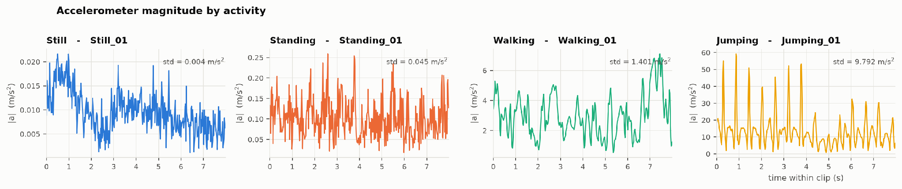
Figure 1. Accelerometer magnitude for one clip of each activity, on separate axes because the amplitudes span three orders of magnitude.

2.3 Feature extraction
A window of 100 samples across eight channels is 800 mostly redundant numbers, so each is reduced to descriptors of how the signal moves. The channels are the six raw axes plus the two Euclidean magnitudes, which are invariant to phone rotation while the axes are not, and from each I take 14 time-domain and 9 frequency-domain descriptors, giving 192 per window (Bao & Intille, 2004; Figo et al., 2010). Variance, standard deviation, RMS and signal magnitude area measure movement energy, which discriminates most directly because the activities span three orders of magnitude: 0.003 m/s² for still, 0.048 for standing, 1.26 for walking and 9.59 for jumping. Mean absolute jerk and the zero-crossing rate describe how abruptly and how often the signal reverses, skewness and kurtosis separate the peaked profile of jumping from the near-symmetric one of walking, and axis-pair correlation catches the vertical-forward coupling of gait.
The frequency features come from the Hann-windowed FFT of the mean-removed signal. Dominant frequency is the clearest physical separator in the set, since walking sits near 1 Hz, jumping near 3.6 Hz, and the static postures have no periodic component. Spectral energy separates motion from rest independently of waveform shape; entropy is low for regular periodicity and high for the noise dominating still, and the centroid rises with impact. Four band-energy ratios over 0.5–1.5, 1.5–3, 3–10 and 10–25 Hz span postural sway up to sensor noise at Nyquist, starting at 0.5 Hz because the mean-removed signal leaves a 0–0.5 Hz band with no bins at all. Rather than justify 192 features one by one, I ranked them by Fisher ratio: acc_mag_mean scores 50.2 and acc_z_jerk 27.8, so amplitude and jerk dominate, while the frequency features score lower but generalise far better.

2.4 Normalisation and dimensionality reduction
The 192 features sit on very different scales, since a variance in (m/s²)² is thousands of times larger than a correlation bounded in [-1, 1], so I standardise all of them with Z-scores, for three reasons. PCA maximises variance, so without rescaling the components would be chosen by whichever features carry the largest raw numbers rather than by how informative they are (Jolliffe, 2002). My emissions are diagonal-covariance Gaussians, so a high-variance feature would dominate the log-likelihood and silence the others. And landing impacts give genuine extremes, so min-max scaling would be driven by single outliers. The scaler, pruning and PCA basis are fitted on training windows alone, since fitting them on everything would leak held-out information.
Pruning constant and correlated features above |r| = 0.95 leaves 121, still too many emission parameters for 364 windows, so PCA follows. I did not choose the component count by variance share: 90 per cent of variance needs 27 components, which would mean 216 emission parameters from 364 observations. Instead, I took the smallest dimension reaching the accuracy plateau of a diagonal-covariance Gaussian classifier — exactly the HMM’s emission model — under five-fold cross-validation grouped by recording: 0.9392 at two dimensions, 0.9971 at three, 1.0000 from four to twelve. I use four, which retain only 67.9 per cent of the variance, so variance share and discriminative power are clearly different quantities.

3. HMM SETUP AND IMPLEMENTATION DETAILS
Table 1. The five HMM components as instantiated in this project.
Element | Instantiation
Hidden states Z | 4 — Still, Standing, Walking, Jumping
Observations X | 4-dimensional PCA feature vector per 2 s window
Transitions A | 4 × 4 row-stochastic, from the two circuits
Emissions B | Multivariate Gaussian per state, diagonal covariance
Initial state π | 4-vector over the first window of each sequence

3.1 Implementation and choice of algorithms
The model is implemented from scratch in NumPy with no HMM library, and every routine runs in log space using logsumexp, since a 100-step product of small Gaussian densities underflows float64 almost immediately and a linear-space implementation returns zero silently rather than failing loudly. Across nine modules, I implement the forward and backward recursions, the γ and ξ posteriors, Viterbi decoding (Viterbi, 1967), posterior decoding, closed-form supervised estimation, Baum-Welch expectation-maximisation (Baum et al., 1970), and Hungarian matching of learned states onto activity names (Kuhn, 1955). I also verify nineteen properties against synthetic data, two decisive: the forward algorithm matches brute-force enumeration over all 3⁷ = 729 paths of a three-state model to within 1e-9, and Viterbi returns exactly the brute-force argmax path. All nineteen pass.
The three algorithms do different jobs, and only one produces my evaluation numbers. The forward algorithm gives P(X | λ), a model-level score I use to compare the supervised and Baum-Welch fits, but it yields no per-window label and so cannot produce sensitivity or specificity at all. Baum-Welch is the learning algorithm when labels are unavailable; mine are labelled, so closed-form estimation replaces it, and Baum-Welch is run separately to test whether the activities are recoverable without supervision. Viterbi is what matters for the metrics, since its output is the predicted state per window, which is what the confusion matrix, and so every figure in Table 2, is built from. It is also the right choice rather than a convenient one, because maximising the whole path suppresses isolated flips that would reach a clinician as spurious one-second alerts.

3.2 Estimating the transition matrix
The 52 isolated clips each hold one activity and therefore zero observed transitions, so a matrix estimated from them is the smoothing prior and nothing else, with every off-diagonal entry identical at 0.0122. The two circuits are the only real source, and I count at the segment level: a segment of D seconds contributes D/hop − 1 self-transitions and one transition onward, which uses only the order of activities and their dwell times. Both survive the roughly 2 s reaction error in my hand-placed taps, whereas per-window counting would inherit it precisely at the boundaries. I use a smoothing constant of 0.1 rather than Laplace +1, because the rows hold only 23 to 84 counts and adding 1 to every cell of a row of 23 halves the dwell times encoded in the diagonal, while 0.1 keeps the smallest entry at 0.0012, finite in log space. One Circuit_02 boundary also needed a documented correction, the taps reading standing at 76.1 s where the envelope shows jumping to about 84 s.

4. RESULTS AND INTERPRETATION
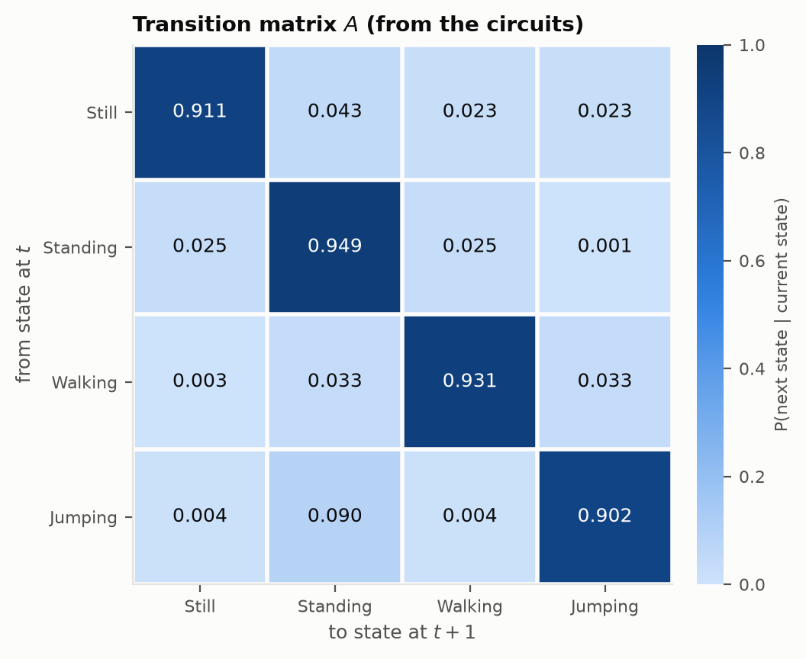
Figure 2. Transition matrix A from the two circuits; self-transitions of 0.90 to 0.95 reflect activities that persist across many windows.
The transition matrix is interpretable in a way the degenerate one is not. The largest off-diagonal entry is jumping to standing at 0.0897, which is what happens physically since a person lands and then stands; the smallest is standing to jumping at 0.0012, which is also right because people take a step before leaping; and walking to still is near zero at 0.0030, since a phone is not set down on a table mid-stride. Implied mean dwells, hop / (1 − A[k,k]), are 11.3, 19.6, 14.5 and 10.2 s against measured means of 12.1, 16.9, 11.3 and 11.1 s. In honesty, that agreement only appeared after I reduced the smoothing: at +1 the implied dwells were about half the measured values, which I would have written up as evidence against the geometric dwell assumption.
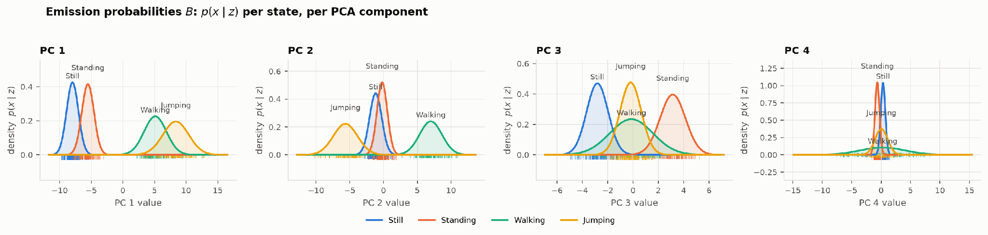
Figure 3. Emission probabilities B, the density p(x | z) per state along each PCA component, with training windows as a rug. PC 1 separates low- from high-motion states, PC 2 separates walking from jumping, PC 3 separates still from standing.

4.1 Evaluation on unseen data
The unseen data is a separate session on a later day, in a different room, with the phone in a trouser pocket. It went through the same pipeline with the scaler and PCA basis fitted on the training session alone. For reference, the same model on twelve held-out training recordings, split by recording so overlapping windows cannot leak, classifies all 84 windows correctly.
Table 2. Per-state evaluation on the unseen session (84 windows). Sensitivity is TP/(TP+FN), specificity TN/(TN+FP), accuracy the one-versus-rest (TP+TN)/total. Overall accuracy is 0.6548, macro F1 is 0.6111.
State (Activity) | Samples | Sensitivity | Specificity | Overall Accuracy
Still | 21 | 0.1429 | 1.0000 | 0.7857
Standing | 21 | 0.4762 | 0.7302 | 0.6667
Walking | 21 | 1.0000 | 0.8095 | 0.8571
Jumping | 21 | 1.0000 | 1.0000 | 1.0000

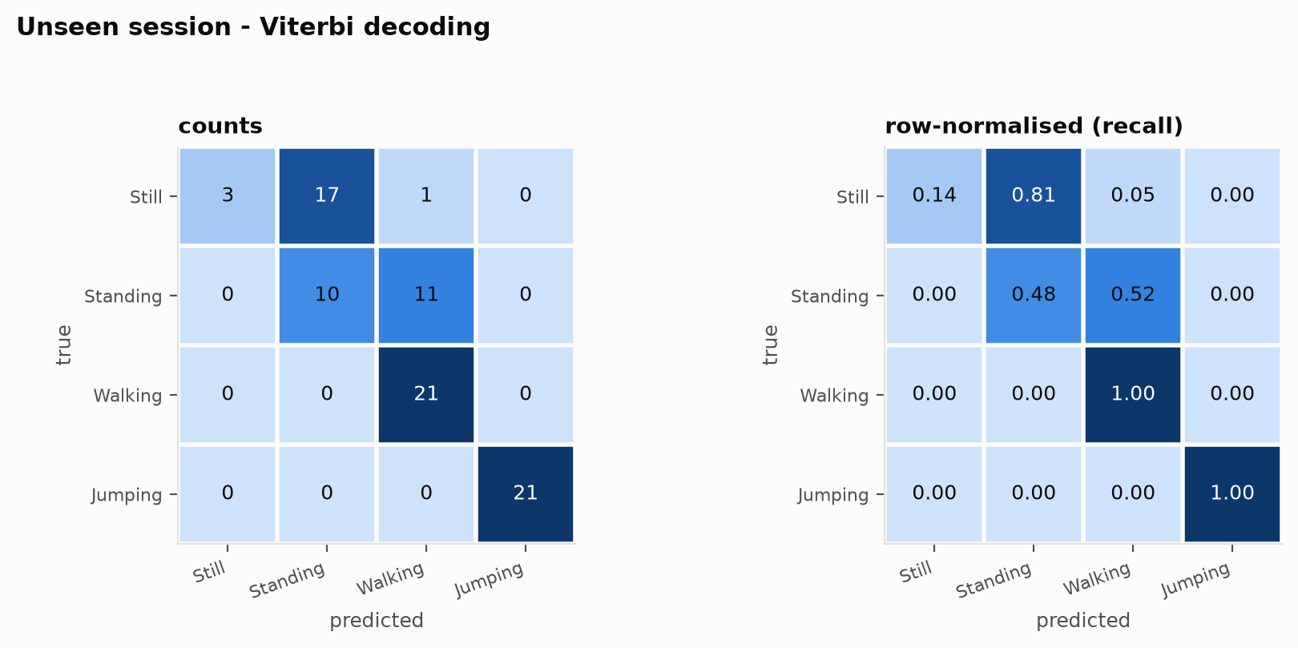
Figure 4. Confusion matrix on the unseen data, as counts and row-normalised. Every error shifts one step up the amplitude ladder, none the other way.
The model does not generalise well here, and how it fails is more informative than the headline number. Accuracy falls from 1.0000 on held-out recordings to 0.6548, but the errors are not scattered: still is read as standing in 16 of 21 windows and standing as walking in 11 of 21, while nothing is misread in the opposite direction. A pocket inflated and widened every amplitude distribution, so each quiet class came to resemble the next louder one, unseen standing alone spanning the amplitude range where training still, standing and walking all lie. Walking and jumping were untouched at sensitivity 1.0000, because a cadence is a shape rather than a scale and survives a change in carriage as raw amplitude does not.

4.2 Continuous decoding, the role of A, and unsupervised fitting
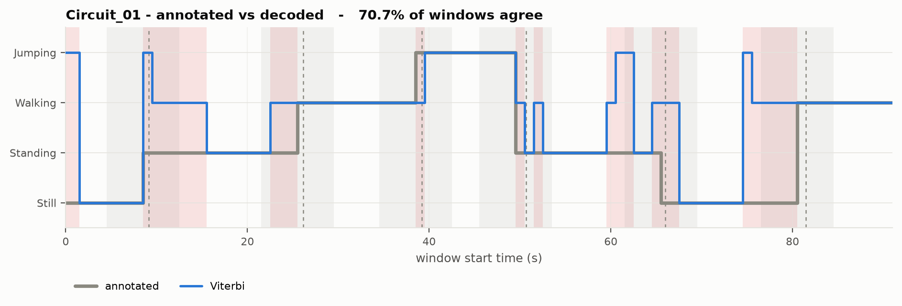
Figure 5. Annotated against decoded state sequence for Circuit_01. Grey bands are the three-second guard at each boundary, red bands disagreement; agreement is 70.7 per cent.
The circuits are the only recordings with real transitions and so the only place a decoded sequence can be shown against ground truth. Because their boundaries carry tap reaction error I exclude windows within three seconds of a boundary, which raises accuracy from 0.6237 across all 186 windows to 0.6778 across the 90 clean ones, reported as secondary results. Substituting the degenerate matrix tests what A contributes: circuit accuracy is 0.6237 either way, the decoded paths differ on 1 of 186 windows, and on the unseen session Viterbi and posterior decoding agree on all 84, so the emissions dominate and the transition structure does interpretive rather than predictive work. Finally, Baum-Welch with the labels withheld converges monotonically in three iterations and, once the arbitrary state numbering is resolved, agrees with the true labels on all 364 training windows — good evidence of genuinely separable clusters rather than categories the supervised model was told to find.

5. DISCUSSION AND CONCLUSION
Jumping was easiest by a wide margin and held sensitivity and specificity of 1.0000 even on unseen data in a different placement, because it is the only activity with a distinctive frequency signature near 3.6 Hz as well as a large amplitude, and walking was robust for the same reason. Still and standing were the hard pair, and hard in a specific way: on same-session data they separate perfectly, since a phone on a table reads the noise floor at 0.003 m/s² while a phone in a hand picks up postural sway at 0.048, but in a pocket that sixteen-fold gap closes, because body contact transmits micro-movement to a phone previously decoupled from it. The 50 Hz rate was comfortably sufficient, Nyquist at 25 Hz sitting far above the roughly 5 Hz ceiling of activity energy; the real constraint is the quiet end, where still sits at the noise floor, so every statistic undefined on a constant signal had to be guarded explicitly in my feature code.
The highest-value improvement would be orientation- and scale-invariant features, because the unseen failure is entirely a change in signal scale, so per-recording normalisation, or features built from spectral shape rather than absolute amplitude, should recover much of the lost accuracy. Beyond that, multiple placements would make the emissions placement-agnostic; more than one participant would stop the model learning one person’s gait, and a barometer would respond to the vertical displacement of jumping independently of the accelerometer. A hidden semi-Markov model would relax the geometric dwell distribution a standard HMM imposes on every state, which poorly describes activities whose durations cluster around a mean (Yu, 2010). My A also rests on only two circuits and twelve observed transitions, though a uniform π changes none of the reported results.
In conclusion, a four-state Gaussian hidden Markov model implemented from scratch separates the four activities perfectly on recordings held out from the training session, and Baum-Welch recovers the same four states with no labels at all. On genuinely unseen data recorded on a different day, in a different room and with the phone in a pocket, accuracy falls to 0.6548, and the structure of that failure is the most useful result here: jumping and walking, identified by frequency, survive at sensitivity 1.0000, while still and standing, distinguished only by amplitude, collapse into their louder neighbours. A system built on amplitude features would therefore produce adherence data that looked plausible while being wrong in one direction, overstating how much a patient had moved. The remedy is specific: describe the shape of the motion rather than its size.

REFERENCES
Anguita, D., Ghio, A., Oneto, L., Parra, X., & Reyes-Ortiz, J. L. (2013). A public domain dataset for human activity recognition using smartphones. ESANN 2013, 437–442.
Bao, L., & Intille, S. S. (2004). Activity recognition from user-annotated acceleration data. Pervasive Computing, LNCS 3001, 1–17.
Baum, L. E., Petrie, T., Soules, G., & Weiss, N. (1970). A maximization technique occurring in the statistical analysis of probabilistic functions of Markov chains. The Annals of Mathematical Statistics, 41(1), 164–171.
Choi, L., Liu, Z., Matthews, C. E., & Buchowski, M. S. (2011). Validation of accelerometer wear and nonwear time classification algorithm. Medicine & Science in Sports & Exercise, 43(2), 357–364.
Figo, D., Diniz, P. C., Ferreira, D. R., & Cardoso, J. M. P. (2010). Preprocessing techniques for context recognition from accelerometer data. Personal and Ubiquitous Computing, 14(7), 645–662.
Jolliffe, I. T. (2002). Principal component analysis (2nd ed.). Springer.
Kuhn, H. W. (1955). The Hungarian method for the assignment problem. Naval Research Logistics Quarterly, 2(1–2), 83–97.
Prince, S. A., Adamo, K. B., Hamel, M. E., Hardt, J., Connor Gorber, S., & Tremblay, M. (2008). A comparison of direct versus self-report measures for assessing physical activity in adults: A systematic review. International Journal of Behavioral Nutrition and Physical Activity, 5, 56.
Rabiner, L. R. (1989). A tutorial on hidden Markov models and selected applications in speech recognition. Proceedings of the IEEE, 77(2), 257–286.
Viterbi, A. J. (1967). Error bounds for convolutional codes and an asymptotically optimum decoding algorithm. IEEE Transactions on Information Theory, 13(2), 260–269.
Yu, S.-Z. (2010). Hidden semi-Markov models. Artificial Intelligence, 174(2), 215–243.

