Manahil Aamir - 24441 Humera Raheel - 24446

PRoject report

IBA MAPS

**Ideation:**We got an idea of creating such an app, because we believed that there should be something to guide students who for the first time stepped into this campus. In fact, we and our fellow batchmates also struggled to find our classes on our first day in Main Campus and sometimes still do.

**Objective:**   
The objective of this project is to design a navigation system that enables users to successfully navigate around the campus, find classes in different buildings, and easily understand the path to their destination. Navigational ease provided in the following cases:

* Travelling from one building/gate/ground/cafe to other
* Travelling from one building/gate/ground/cafe to a class in any class on the campus
* Moving from one classroom/room/office to another within the building
* On the same floor
* On a different floor
* Travelling from a classroom/office to another building/gate/ground/cafe
* Travelling from a classroom in on building to a classroom in any different building across the campus

**Methodology:**

-A* Algorithm was used to navigate within the campus

-DFS was used to navigate on floors

**Data Collection:**

A* Algorithm:

* Data for g(n) of the A* algorithm was collected from Google Maps.The distance between two buildings was obtained.
* The straight-line distance between buildings was used as the heuristic for the algorithm. The function h(n) was calculated as the shortest direct distance between two buildings using the app "Measure Map."
* In addition, the longitude and latitude values for each building were obtained from Google Maps to ensure accurate display of distance to users.
* The excel sheets of h(n) and g(n) are present in data folder.

DFS Algorithm:

* Data for the DFS algorithm was collected manually by observing each floor/building since the university did not have any pre-made floor plans.

**Evaluation:**

A* Algorithm:  
The A* algorithm generated paths that were based on the given g(n) and h(n) values. These paths closely resembled the paths that most people familiar with the campus would take daily, and they were generally shorter than alternative routes. The algorithm was able to accurately find the shortest path between campus buildings, reducing the time it takes for users to navigate between buildings.

DFS Algorithm:  
The DFS algorithm was able to guide users from the entrance of a particular floor to the class they wished to go to.

**Limitations:**

* Due to time constraints, the user interface is not as user-friendly as it could be. Further work is needed to improve the user experience.
* If the user wishes to go to any room in the Fauji building, they will only be guided until the building itself and not within it. This is because the Fauji building is an administrative building, so it didn't seem right to allow any user to be able to navigate inside it.

**Running:**

**Instructions For Running:**1) For Running the java folder: Should have java ide  
2) Libraries javafx and jxmapviewer are added (We have provided the zip files). Import them to project structures->libraries  
3) For Map Application class, which is the main class, go to edit configuration, Add VM option. Then in that option, type: --module-path "location of your javafx lib folder" --add-modules javafx.controls, javafx.fxml, javafx.base, javafx.graphics, javafx.media, javafx.swing, javafx.web

Eg **:--module-path "C:\Users\hrahe\Downloads\openjfx-19.0.2.1_windows-x64_bin-sdk\javafx-sdk-19.0.2.1\lib" --add-modules javafx.controls,javafx.fxml,javafx.base,javafx.graphics,javafx.media,javafx.swing,javafx.web**

4)when the start/end screen is visible, enter the building and/or class

(To avoid running in any invalid input, go to data folder provided with submissible and only use data given in BuildingsList file)

(we have provided an apk file to show our app as well. However, the display is restricted to buildings only. We plan on presenting the entire//completed app during presentation. You can find apk in AndoidStudio🡺apk)

**On Running:**For start and end, enter locations from given list: Buildings List (attached in data folder)  
Example of output  
(Start = MAC2 and End = MCC10)  
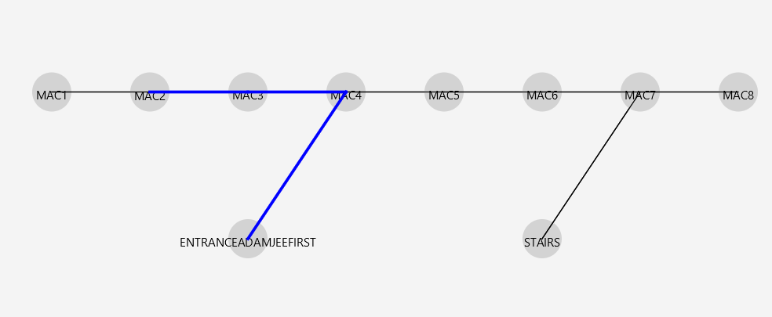

-navigate from MAC2 to the exit/entrance point of the building

-the next map shows display to go from the current building to the building in which the next classroom is

-then displayed floor of that building shows floor number of the respective floor and where to proceed once the user is on that floor

