EE4705 Robotics — Project 2
Collision-Free Path Planning for Robot Manipulators with STOMP
Group 9 — Report and Code
Joshua Lim · Hu Jiamo · Dexter
National University of Singapore, AY 2026/27
Submitted 10 November 2026
We implement the Stochastic Trajectory Optimization for Motion Planning (STOMP) algorithm in MATLAB and use it on two 7-DOF manipulators. Task 1 completes the provided sample code for the Kinova Gen3. Tasks 2–5 use the Franka Emika Panda: a Task-1-like scene (Task 2), forward kinematics by the Product of Exponentials instead of getTransform (Task 3; identical results to 1e-15, 39x faster FK and 13x faster STOMP iterations), three multi-obstacle scenarios that are all solved for every one of 10 random seeds (Task 4), and an end-effector orientation constraint that keeps the gripper y-axis upright within 1.9° instead of 36.8° (Task 5). Beyond the tasks we fix ten bugs of the sample code, make STOMP respect joint limits, add sample reuse (fewer iterations), handle the ±π joint-angle discontinuity, fit the collision spheres to the robot meshes, and verify every result with a mesh-based collision check at and between the waypoints.

Contents
1 Introduction and code organisation 3
2 STOMP formulation and implementation 3
3 Task 1 — Completing the sample code (Kinova Gen3) 4
4 Task 2 — A different manipulator: Franka Emika Panda 4
4.1 Choice of robot and model 4
4.2 Scene 4
4.3 Collision spheres fitted to the robot meshes 5
5 Task 3 — Forward kinematics by the Product of Exponentials 6
5.1 Determining the screw axes 6
5.2 Efficient implementation 7
5.3 Effect on planning 7
6 Task 4 — Custom multi-obstacle scenarios 7
7 Task 5 — End-effector orientation constraint 9
7.1 Constraint cost and scene 9
7.2 Choice of the weight 9
7.3 Result with and without the constraint 10
8 Improvements and additional features 11
8.1 Bugs fixed in the provided code 11
8.2 STOMP extensions: joint limits and sample reuse 11
8.3 Joint-angle discontinuity at ±π 12
8.4 Further practical features 12
9 Limitations 12
10 Contributions 13
References 13

1 Introduction and code organisation
STOMP [1] optimises a whole joint-space trajectory at once: it perturbs the current trajectory with smooth noise, scores every noisy trajectory with a cost that penalises collisions (and, in Task 5, a violated orientation), and moves the trajectory towards the low-cost perturbations. It needs no gradient of the cost, which suits the non-smooth collision cost of a voxelised world.
The submission is one code base. common/ holds the shared planner, kinematics, world model and plotting functions; each task has a folder with one entry script (main_task1.m … main_task5.m), plus Bonus_STOMPExtensions/main_bonus.m for the additional experiments and Videos/make_videos.m for the presentation videos. Every script sets its own path and seeds the random number generator, so a run reproduces our numbers exactly; the README lists the toolboxes and run times. The results/ folders in the zip contain the figures, tables and videos of the final run. All parameters live in common/config/defaultConfig.m (Table 1) and the robot of Tasks 2–5 in robotConfig.m.

2 STOMP formulation and implementation
A trajectory is a matrix θ ∈ ℝ^{n×N} of N = 20 waypoints of the n = 7 joint angles; the start θ₁ = q₀ and the goal θ_{N} = q_{T} are fixed (inverse kinematics of the given end-effector poses). The robot is approximated by spheres placed along the straight segments between consecutive joint frames, and the world by a 2 cm voxel grid with its signed Euclidean distance transform d(x) (bwdist). The local cost of waypoint i and the total cost are
S(θᵢ) = w_{obs} · q_{o}(θᵢ) + w_{con} · q_{c}(θᵢ), Q(θ) = Σᵢ S(θᵢ) + ½ Σⱼ θⱼᵀ R θⱼ (1)
with the obstacle cost of Eq. (13) of [1], summed over the spheres b of the arm (radius r_{b}, centre speed ‖ẋ_{b}‖ from finite differences) and the safety margin ε:
q_{o}(θᵢ) = Σ_{b} max(ε + r_{b} − d(x_{b}), 0) · ‖ẋ_{b}‖ (2)
R = AᵀA is the finite-difference acceleration matrix. Each iteration draws K = 20 noisy trajectories θ + ε_{k} with ε_{k,j} ~ N(0, Σ) per joint, Σ ∝ R⁻¹ (smooth noise), evaluates S for every sample and waypoint, converts the costs into probabilities per waypoint (Eq. (11) of [1]) and updates θ with the probability-weighted noise, smoothed by M (R⁻¹ normalised per column):
P(θ_{k,i}) = exp(−h·(S_{k,i} − min_{k} S_{k,i})/(max_{k} S_{k,i} − min_{k} S_{k,i})) / Σ_{l} exp(·) (3)
δθᵢ = Σ_{k} P(θ_{k,i}) · ε_{k,i} , θ ← θ + M δθ (4)
The loop stops when |Q_{new} − Q_{old}| < 0.1 for three consecutive iterations (a single iteration in the original code, where one small change can be a coincidence of the random sampling) or at the iteration cap. A planned trajectory is accepted only if MATLAB's mesh-based checkCollision finds no contact at any waypoint and at nine joint-space sub-steps between every pair of waypoints (the robot moves continuously); this ground truth is independent of the sphere model that STOMP optimises.
Table 1. STOMP parameters (common/config/defaultConfig.m, robotConfig.m).
Parameter | Value | Meaning
N, K | 20, 20 | waypoints (incl. start/goal), noisy samples per iteration
h | 10 | sensitivity of the probabilities, Eq. (3)
Σ scale | 1.5 | exploration noise Σ = 1.5·R⁻¹ / sum(R⁻¹)
w_{obs} | 1000 | weight of the obstacle cost
ε | 0.05 m (Kinova), 0.02 m (Panda) | safety margin in Eq. (2) (Panda: see Section 4.3)
sphere radius | 0.05 m (Kinova), 0.103–0.155 m (Panda) | Panda: fitted per link to the meshes
stop rule | |ΔQ| < 0.1 three times | iteration cap 50 (Tasks 1–3), 200 (Tasks 4–5)
extensions | joint limits, 5 reused samples | Section 8.2; off = original algorithm

3 Task 1 — Completing the sample code (Kinova Gen3)
The provided script was turned into functions (runSTOMP replaces helperSTOMP) and the five incomplete files were completed:
- runSTOMP: the main loop of Section 2 — sampling, local costs of all samples, probabilities, probability-weighted update smoothed by M, total cost and the stopping rule.
- updateJointsWorldPosition: positions and poses of all joint frames and the end-effector. getTransform is called with the configuration vector directly (DataFormat column) instead of building a configuration struct on every call as the sample code did.
- stompSamples: per joint, K samples of the interior waypoints from N(0, Σ) with mvnrnd, padded with zeros at the fixed start and goal.
- stompDTheta: δθ of Eq. (4) for every joint and waypoint.
- stompObstacleCost: Eq. (2) with the signed distance looked up in the voxel grid.
While completing them we found and fixed several bugs of the sample code (Section 8.1), e.g. samples leaving the voxel world got zero obstacle cost and therefore looked like the best samples. With the original scene (box of 16 cm in the way, start and goal as given), the straight-line initial trajectory collides at 8 of 20 waypoints; STOMP finds a collision-free trajectory in 23 iterations (13.4 s with getTransform). Figure 1 overlays the intermediate configurations; the animation plays at the end of main_task1.m.
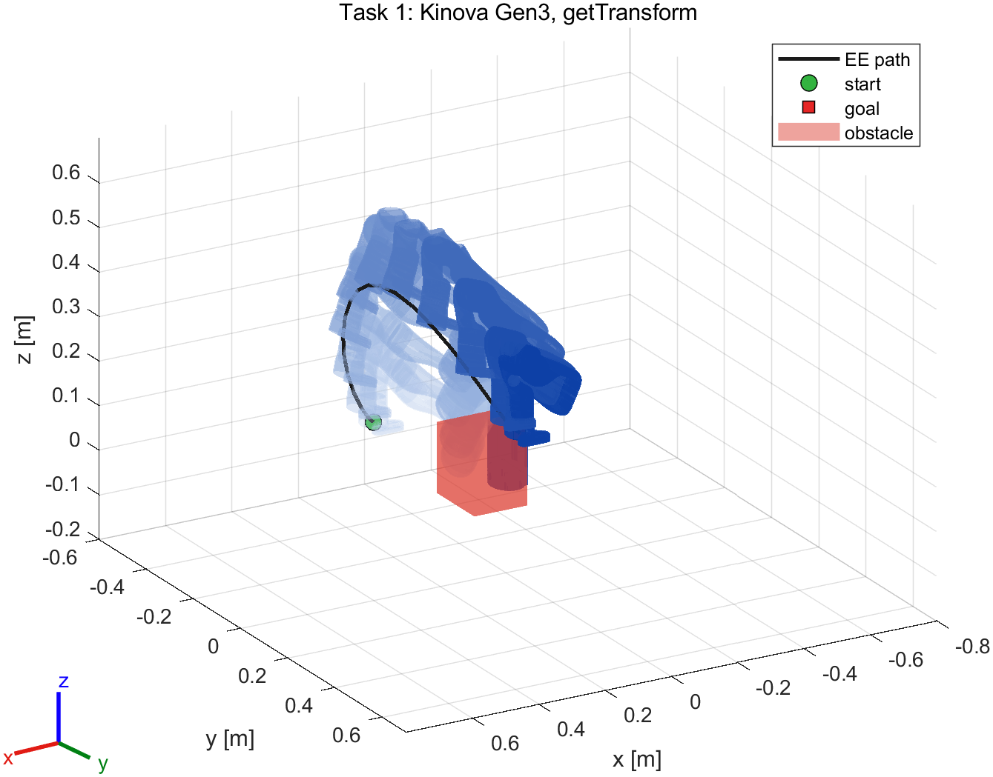 | 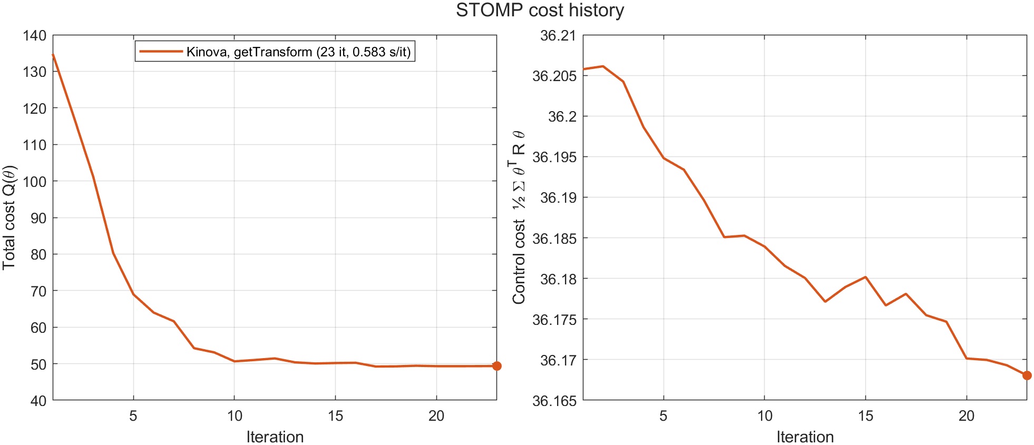
Figure 1. Task 1, Kinova Gen3: planned trajectory (light = start, dark = goal, black = end-effector path) and cost history.

4 Task 2 — A different manipulator: Franka Emika Panda

4.1 Choice of robot and model
We chose the Franka Emika Panda (loadrobot('frankaEmikaPanda'), URDF from franka_ros 0.6.0). It has seven revolute joints like the Kinova but a different geometry that the planner and the PoE code must handle: no continuous joints and tight limits (joint 4 ∈ [−3.07, −0.07] rad, joint 6 ∈ [−0.02, 3.75] rad), coincident frames (link 1/2 and link 5/6), 8.25 cm elbow offsets, and a gripper with two prismatic finger joints. buildRobotModel keeps only the movable joints of the base-to-end-effector chain in configuration order, freezes the finger joints (they are not planned), and adds a virtual tool-centre point panda_tcp 0.1034 m along the hand z-axis (between the fingertips), so that task poses refer to the grasp point.

4.2 Scene
The scene follows Task 1: same start pose and a 16 cm box. As the handout warns, the Task-1 goal does not suit the Panda; the goal was moved to [0.30, 0.60, 0.45] m (tool down) where IK succeeds with clearance, and the box was placed on the joint-space straight line between start and goal (waypoint 12), so that the initial trajectory collides (7 of 20 waypoints). STOMP plans a collision-free trajectory in 13 iterations (Figure 3).

4.3 Collision spheres fitted to the robot meshes
The first version used 5 cm spheres for every link, as for the Kinova. Drawing them over the Panda meshes showed that they lie inside the links: the Panda links are thick and the joint frames are offset from the link axes, so the median mesh distance to the sphere segments is 6–10 cm. Only the 5 cm safety margin kept the arm away from obstacles. We therefore fit one radius per segment (fitSphereRadii): for 200 random configurations inside the joint limits, every vertex of every collision mesh (the meshes checkCollision uses) is assigned to its nearest sphere segment, and the radius is the 99th percentile of these distances (Table 2). The spheres now contain 99 % of the robot, and the safety margin ε is a real 2 cm margin. Figure 2 shows the coverage; all Panda scenes remain solvable (Sections 6–8).
Table 2. Fitted collision-sphere radii of the Panda (segment k runs from frame k−1 to frame k). Zero-length segments (coincident frames) take the previous radius. robotConfig uses these values rounded up to mm.
Segment ends at | Mesh vertices | Median distance [m] | Radius = 99th pct. [m] | Max [m]
panda_link1 | 296 | 0.098 | 0.155 | 0.155
panda_link2 | 0 | 0.000 | 0.155 | 0.000
panda_link3 | 217 | 0.055 | 0.129 | 0.129
panda_link4 | 86 | 0.098 | 0.111 | 0.117
panda_link5 | 292 | 0.093 | 0.129 | 0.152
panda_link6 | 0 | 0.000 | 0.129 | 0.000
panda_link7 | 102 | 0.081 | 0.130 | 0.153
panda_tcp | 211 | 0.081 | 0.103 | 0.153

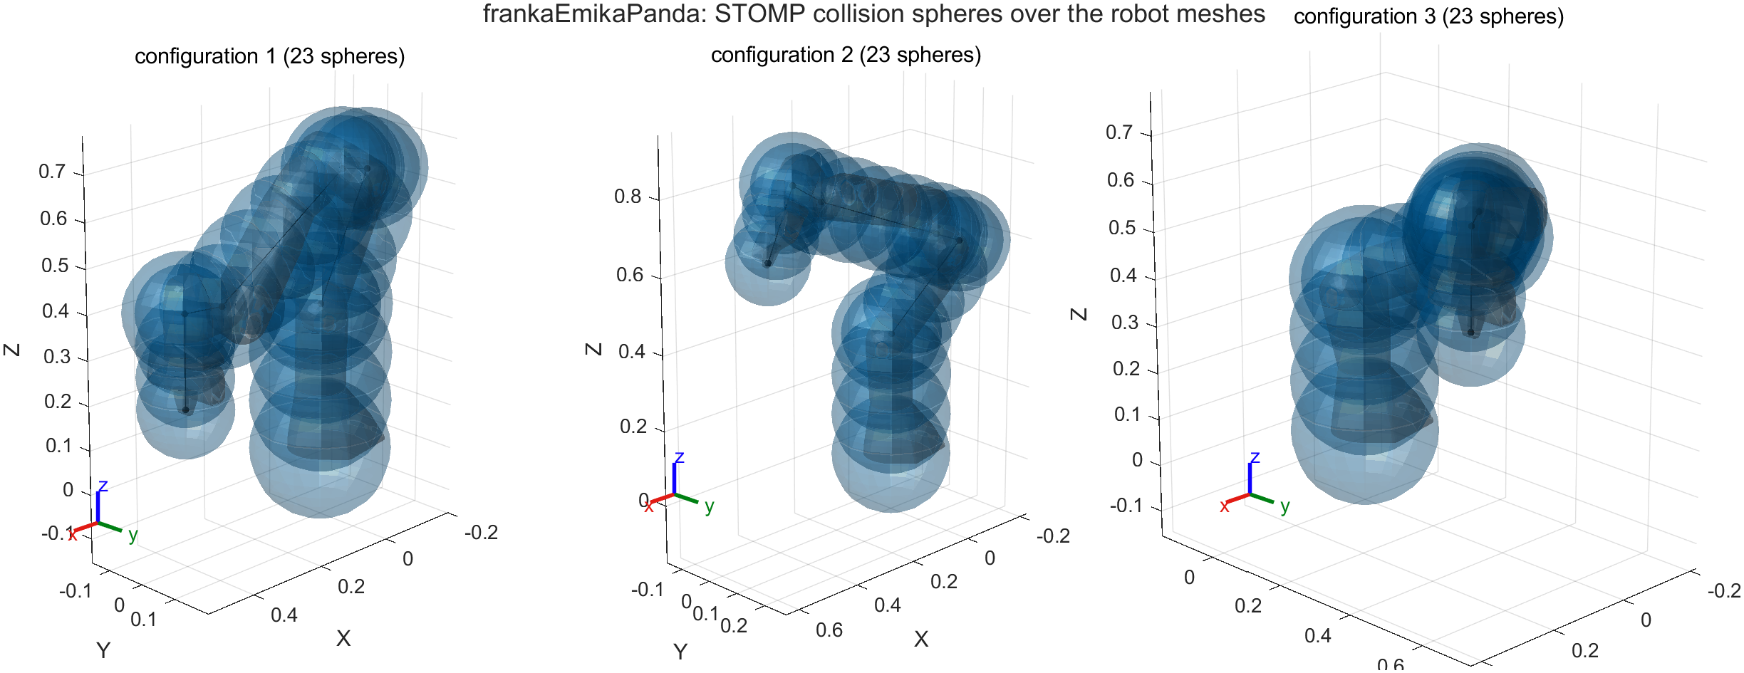
Figure 2. Fitted collision spheres over the Panda meshes at the start, middle and goal waypoint of Task 2.
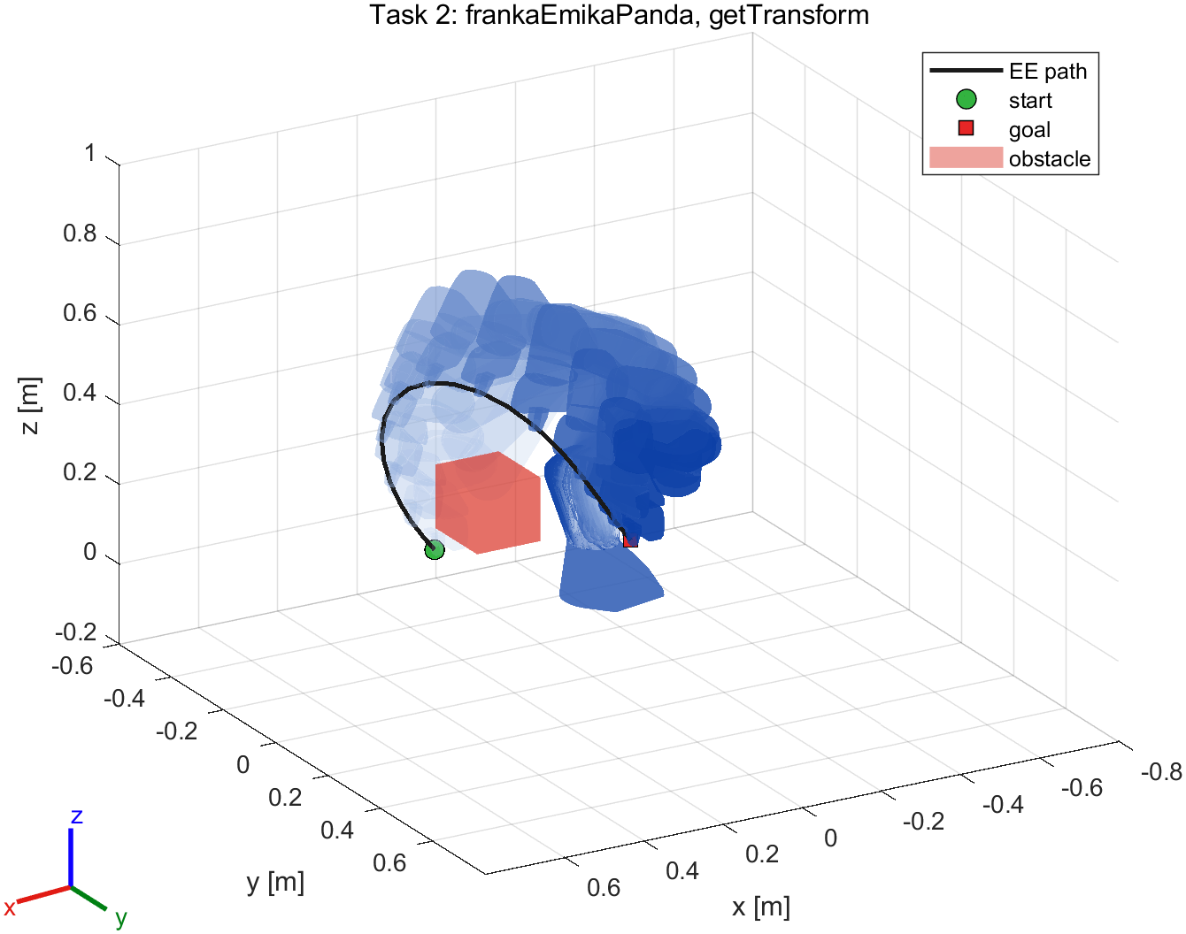 | 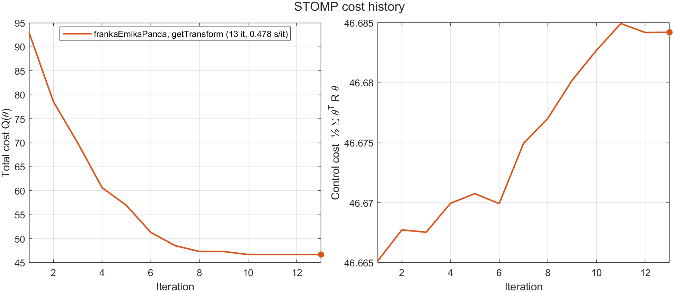
Figure 3. Task 2, Panda: planned trajectory and cost history.

5 Task 3 — Forward kinematics by the Product of Exponentials

5.1 Determining the screw axes
With all joint angles zero as the reference configuration, the pose of frame k is
T_{k}(θ) = e^{[S₁]θ₁} e^{[S₂]θ₂} ⋯ e^{[Sₖ]θₖ} M_{k} (5)
where S_{i} = (ω_{i}, v_{i}) is the space-frame screw axis of joint i and M_{k} the pose of frame k at the reference configuration. The screw axes are computed once (in buildRobotModel) from the robot description, as in the planar car example of the lecture:
- ω_{i}: the joint axis (JointAxis, given in the joint frame — not in the base frame, cf. the URDF <axis>) rotated into the base frame with the joint pose at the reference configuration (getTransform of the child body times the inverse ChildToJointTransform).
- q_{i}: the origin of that joint frame, a point on the axis; v_{i} = −ω_{i} × q_{i}. Prismatic joints would give S_{i} = (0, ω_{i}).
- M_{k} = getTransform of frame k at the reference configuration.
We use the zero configuration and not homeConfiguration (the Panda home pose has θ₄ = −1.57), so that Eq. (5) holds with θ measured from zero; the zero pose lies outside the limits of joints 4 and 6 but is only a reference, the planner never goes there. As a cross-check (method 2 of the handout), each screw axis was also recovered with the matrix logarithm: moving only joint i by α = 0.7 rad gives T_{i}(α) = e^{[Sᵢ]α} M_{i}, so [S_{i}] = log(T_{i}(α) M_{i}⁻¹)/α. Both methods agree to 4.4e-16 for both robots. Table 3 lists the Panda axes next to the URDF data; Figure 4 draws them. For the Kinova, the table and figure in the results show ω₁ = (0, 0, −1): the URDF rotates joint 1 by rpy = (π, 0, 0), so its z-axis points down — exactly why the URDF axis cannot be used in the base frame directly.
Table 3. Space-frame screw axes of the Panda at the zero configuration (screw_axes_frankaEmikaPanda.csv; the URDF origin is relative to the parent link).
Joint | ω_{i} | q_{i} (closest axis point) [m] | v_{i} = −ω_{i} × q_{i} | URDF origin xyz
joint1 | (0, 0, 1) | (0, 0, 0) | (0, 0, 0) | (0, 0, 0.333)
joint2 | (0, 1, 0) | (0, 0, 0.3330) | (-0.3330, 0, 0) | (0, 0, 0)
joint3 | (0, 0, 1) | (0, 0, 0) | (0, 0, 0) | (0, -0.316, 0)
joint4 | (0, -1, 0) | (0.0825, 0, 0.6490) | (0.6490, 0, -0.0825) | (0.0825, 0, 0)
joint5 | (0, 0, 1) | (0, 0, 0) | (0, 0, 0) | (-0.0825, 0.384, 0)
joint6 | (0, -1, 0) | (0, 0, 1.0330) | (1.0330, 0, 0) | (0, 0, 0)
joint7 | (0, 0, -1) | (0.0880, 0, 0) | (0, 0.0880, 0) | (0.088, 0, 0)

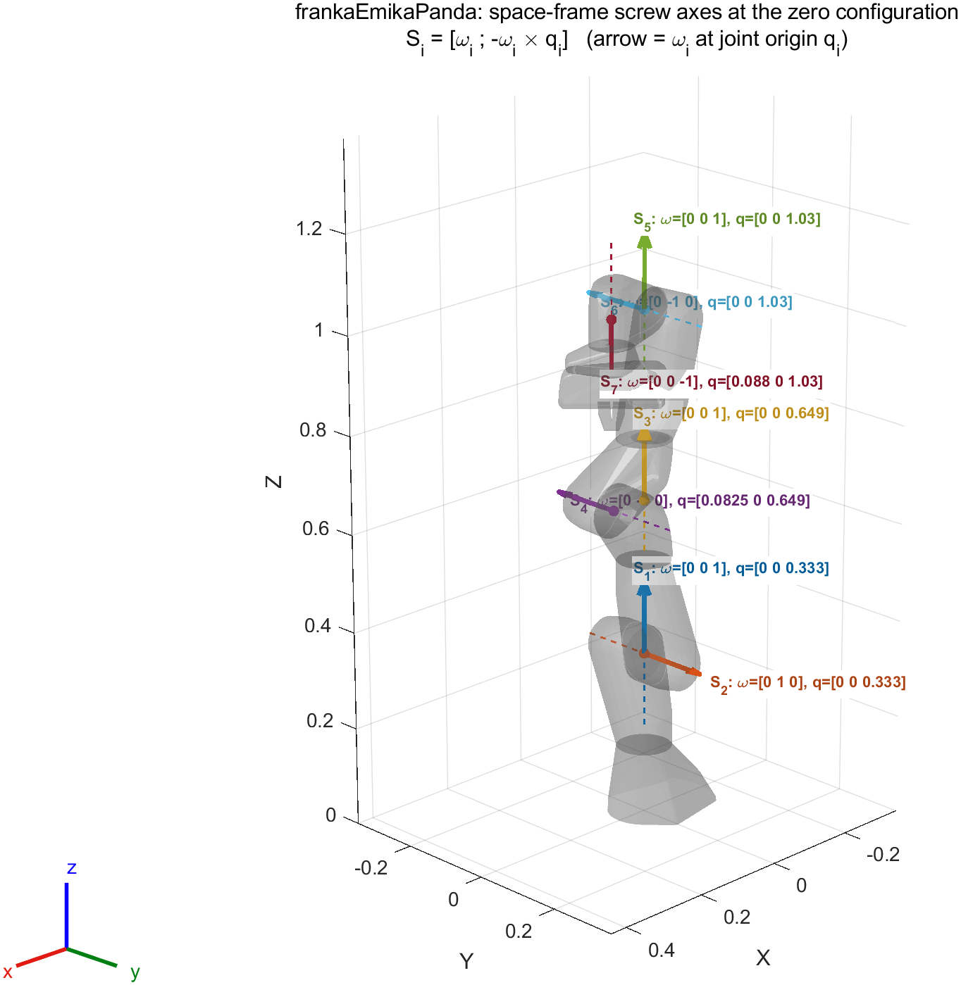
Figure 4. Screw axes of the Panda drawn at the zero configuration (arrow = ω_{i} at the joint origin q_{i}); the Kinova version is task3_screw_axes_kinovaGen3.png in the results.

5.2 Efficient implementation
The planner needs every joint frame (for the collision spheres), not only the end-effector. fkPoE therefore forms the product of Eq. (5) once from left to right and reads off T_{k} after the k-th factor: one exponential and one matrix product per joint, O(n) instead of O(n²) for n separate end-effector-style calls. Each exponential uses the closed form (Assignment 2), R = I + sin θ [ω] + (1 − cos θ)[ω]², p = (Iθ + (1 − cos θ)[ω] + (θ − sin θ)[ω]²) v, instead of the general expm. The screw axes are computed once per robot, not per call.
Table 4. PoE vs getTransform over all frames of 500 random configurations within the joint limits; time per call to compute all frames (median of timeit). "expm per frame" is a naive PoE that recomputes the product with expm for every frame.
Robot | Max position error [m] | Max rotation error | getTransform [µs] | PoE [µs] | expm per frame [µs] | Speed-up
Panda | 8.6e-16 | 1.1e-15 | 1577 | 40.2 | 536 | 39x
Kinova | 1.0e-15 | 1.8e-15 | 1132 | 36.4 | 475 | 31x

5.3 Effect on planning
Planning the Task-2 scene with the same seed gives the identical trajectory with both FK methods (same number of iterations, 13, and the same final cost 46.684), which confirms the implementation end to end. The mean STOMP iteration takes 614 ms with getTransform and 48 ms with PoE (12.9x faster), because FK of all frames is evaluated K·N = 400 times per iteration. Tasks 3–5 and the additional experiments use PoE; this is what makes the multi-seed studies of Sections 6–8 affordable.

6 Task 4 — Custom multi-obstacle scenarios
buildVoxelWorld was extended from one cube to any list of obstacles: boxes (optionally rotated by roll-pitch-yaw), spheres and upright cylinders. Curved and rotated shapes are voxelised by testing the voxel centres, padded by half a voxel so that thin shapes (a 3 cm post) are not under-sampled; obstacles that extend beyond the world are clamped instead of making sub2ind fail. The same obstacles are created as collision objects for the mesh-based check. The three scenarios (Figures 5 and 6) are designed so that the joint-space straight line collides and the robot has to make a real detour:
- S1 — over the wall: start and goal on either side of a 25 cm wall, tool down at 12 cm height; a post blocks the short way round the inner end, so the arm must lift the gripper over the wall.
- S2 — under the shelf: start above a 70 cm-wide shelf plate, goal under it with the tool horizontal; the arm must reach round the plate edge between the two legs while re-orienting the tool.
- S3 — around the column: a large re-orientation from in front of the robot to its left side past a 70 cm column, a ball on the floor and a panel rotated by 30°.
Table 5. Task 4 results (task4_summary.csv). Iterations/time: showcase run with seed 0. Robustness: STOMP from the same start and goal with seeds 1–10, success = no collision at or between the waypoints. Clearance: smallest distance between a collision sphere and an obstacle along the plan.
Scenario | Obstacles | Initial guess colliding | Iterations | Time [s] | Collision-free over 10 seeds | Median iterations | Min. sphere clearance [cm]
S1 Over the wall | 2 (box, cylinder) | 10 / 20 | 32 | 0.9 | 10 / 10 | 44 | 5.8
S2 Under the shelf | 3 (box, cylinder) | 6 / 20 | 20 | 0.9 | 10 / 10 | 23 | 1.0
S3 Around the column | 3 (box, cylinder, sphere) | 5 / 20 | 94 | 3.8 | 10 / 10 | 82 | -0.1

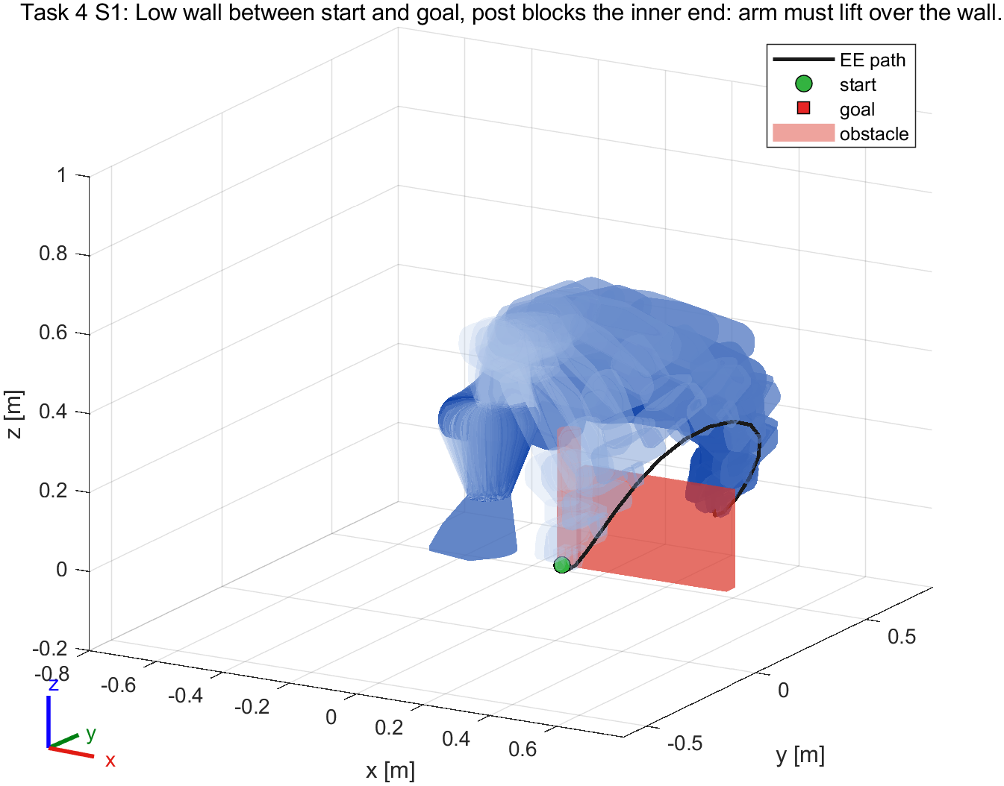 | 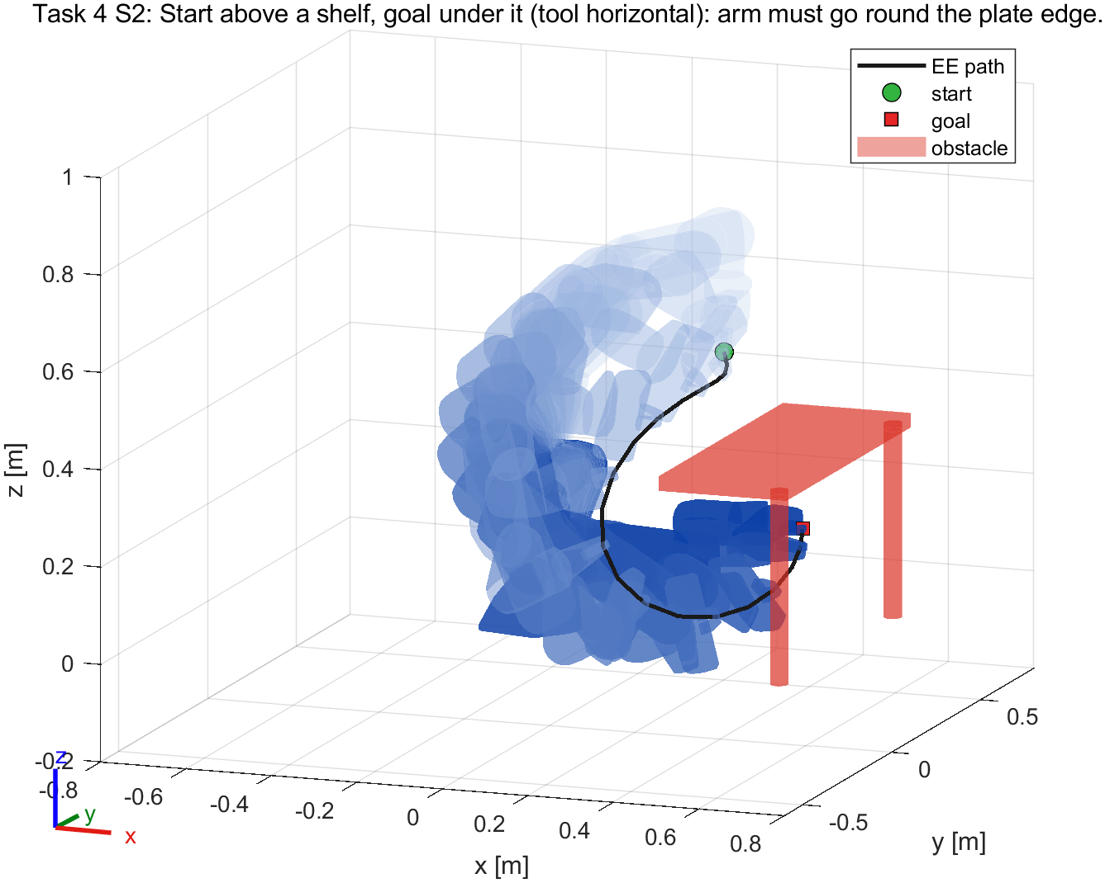
Figure 5. Task 4 scenarios S1 (left) and S2 (right): planned trajectories.
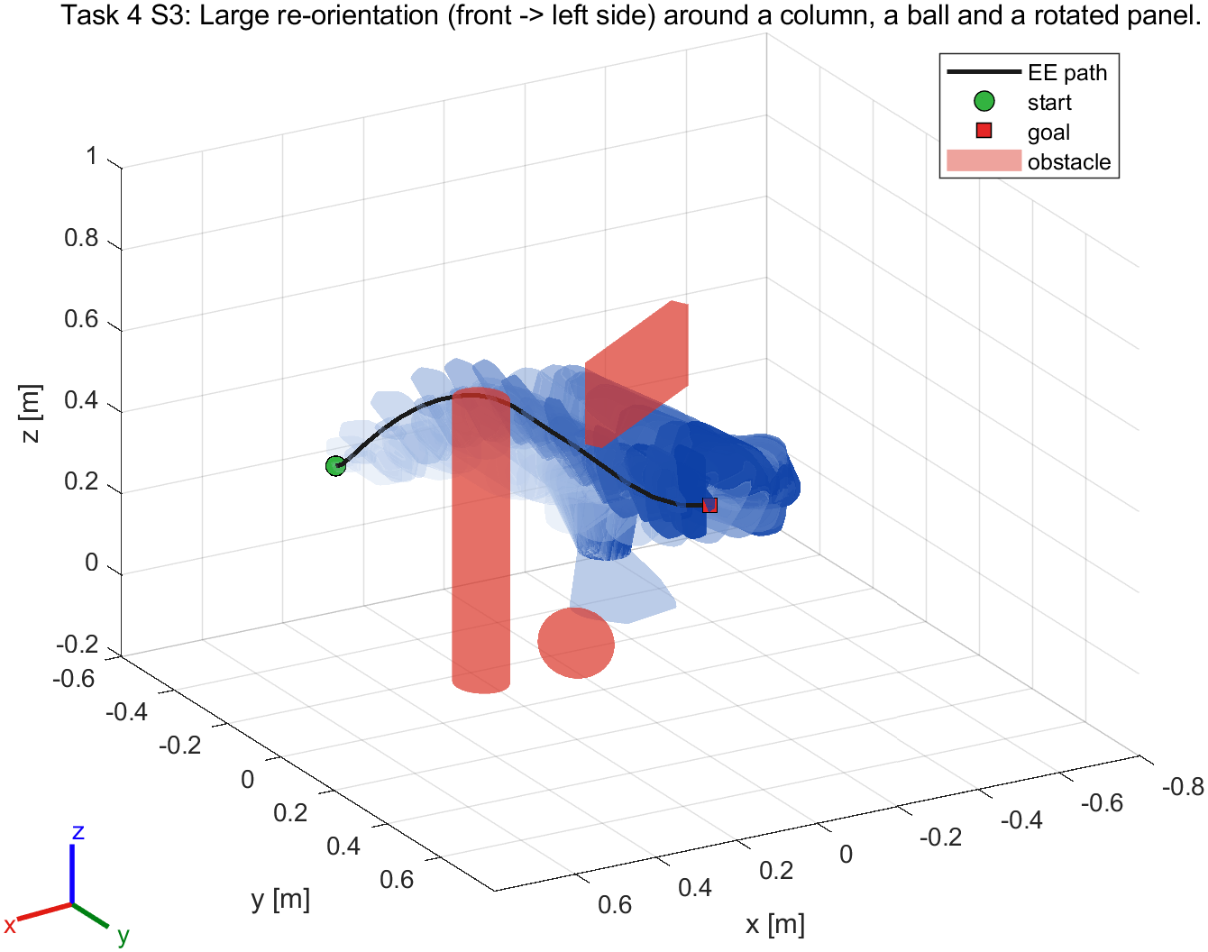 | 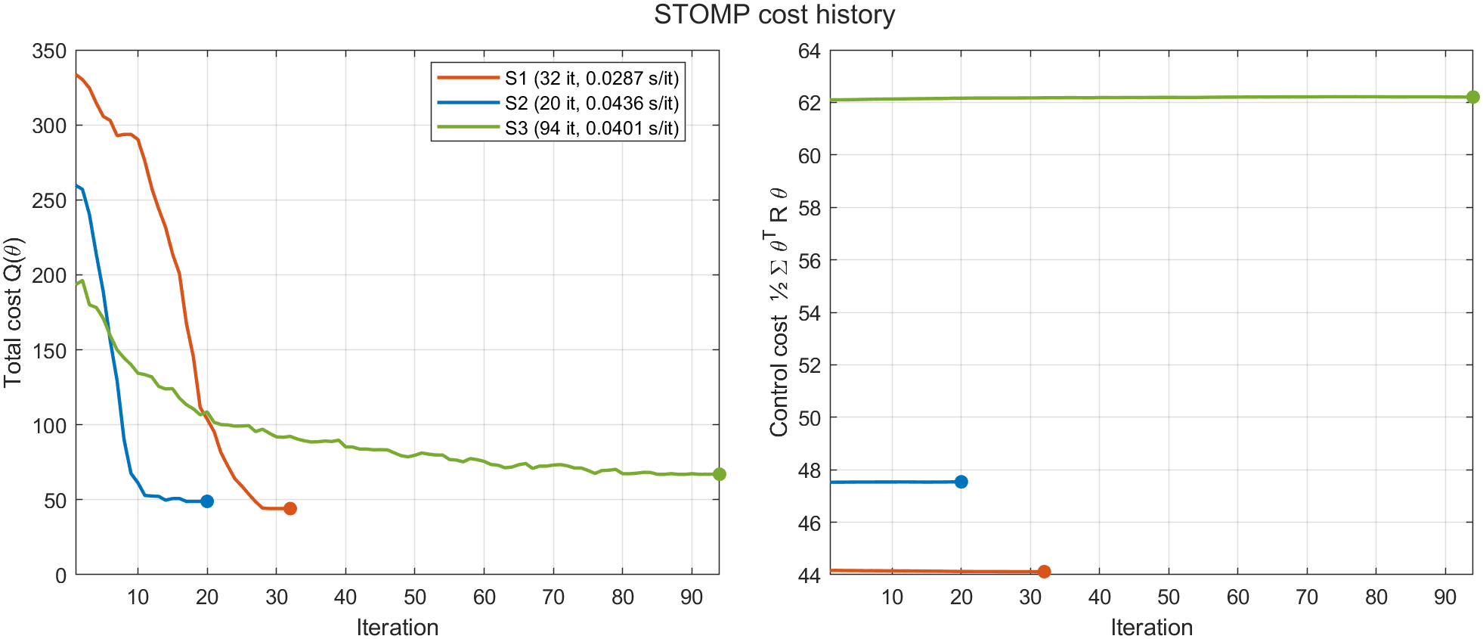
Figure 6. Task 4 scenario S3 (left) and the cost histories of the three scenarios (right).
S3 is the hardest scenario for the planner (most iterations over the seeds); the plan of S3 passes closest to the obstacles (one collision sphere reaches 0.1 cm into the voxelised obstacle — below the 2 cm voxel size and inside the 2 cm safety margin; the mesh-based check at and between the waypoints confirms that the robot itself stays clear). The iteration cap was raised from 50 to 200 for these scenes because the detours are longer than in Task 1; with 50 iterations a few waypoints were still in collision.

7 Task 5 — End-effector orientation constraint

7.1 Constraint cost and scene
Task 5 keeps the gripper y-axis upright ("carrying a cup of coffee"). Following option 2 of the handout, the constraint cost of a waypoint is the ℓ1 norm of the difference between the end-effector y-axis in the world frame, ŷ_{sb} (second column of the rotation part of T_{sb}, available from FK at no cost), and the world z-axis:
q_{c}(θᵢ) = ‖ŷ_{sb}(θᵢ) − ẑ_{s}‖₁ = Σ_{j=1..3} |ŷ_{sb,j} − ẑ_{s,j}| (6)
It enters S(θᵢ) with the weight w_{con} (Eq. (1)). Only the axis direction is constrained, the gripper may still turn about the vertical. As the handout suggests, start and goal are themselves upright: both are at 0.5 m from the base axis (azimuth −35° and 60°) with the tool pointing radially outward and its y-axis vertical, and a 16 cm box on the arc between them forces a detour. Our first version used a height of 0.30 m, which the Panda cannot reach with this orientation (IK stopped 2.8 cm away with joint 5 at its limit, even with 30 random restarts); at 0.20 m both poses are reached exactly, and the box was lowered with them. The initial trajectory collides at 6 of 20 waypoints.

7.2 Choice of the weight
STOMP normalises the local costs per waypoint before the probabilities (Eq. (3)), so only the ratio of constraint and obstacle cost matters. One run per weight can mislead because STOMP is stochastic; each weight was therefore run with 5 seeds (Table 6, Figure 7). The rule picks the smallest positive weight that is collision-free for every seed with a median worst-case tilt below 5°. Small weights already keep the tilt around 1°, while large weights (300, 1000, 3000) make the constraint dominate the obstacle term and collisions reappear — the trade-off the weight controls.
Table 6. Task 5 weight sweep, 5 seeds per weight (task5_weight_sweep.csv). w_{con} = 0 is the planner without the constraint.
w_{con} | Collision-free | Median max tilt [°] | Worst max tilt [°] | Median mean tilt [°] | Median iterations
0 | 5 / 5 | 38.00 | 39.96 | 19.80 | 24
10 | 5 / 5 | 1.26 | 1.66 | 0.49 | 173
30 | 5 / 5 | 0.92 | 1.10 | 0.37 | 200
100 | 5 / 5 | 1.32 | 1.98 | 0.42 | 200
300 | 4 / 5 | 0.85 | 0.97 | 0.38 | 200
1000 | 0 / 5 | 0.76 | 0.84 | 0.32 | 200
3000 | 0 / 5 | 0.71 | 0.98 | 0.30 | 200

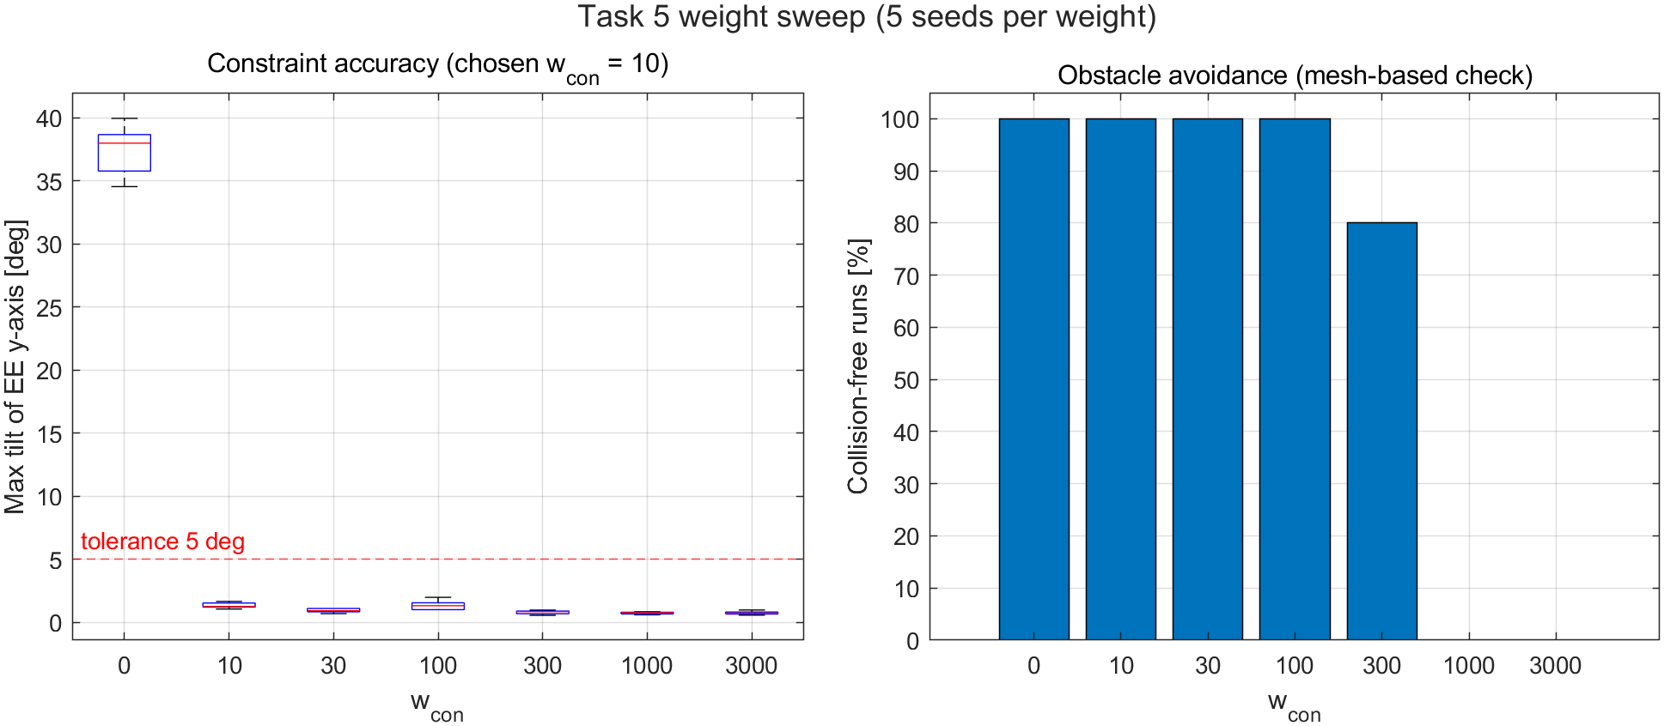
Figure 7. Weight sweep: spread of the maximum tilt over the seeds (left) and collision-free runs (right).

7.3 Result with and without the constraint
With the chosen weight w_{con} = 10 and the same seed as the unconstrained run, the maximum tilt of the gripper y-axis drops from 36.8° to 1.9° and the mean tilt from 19.1° to 0.8° (Table 7, Figures 8 and 9); both trajectories are collision-free. Without the constraint the planner tilts the gripper by up to 37° in the middle of the detour, where it is free to do so. The price of the constraint is more iterations (27 → 124): the planner has to find a detour that is also upright, a much smaller set of trajectories. The constraint is a soft cost, so the tilt is small but not exactly zero.
Table 7. Task 5 before / after (task5_comparison.csv).
Run | Max tilt [°] | Mean tilt [°] | EE path [m] | Iterations | Time [s] | Collision
without constraint | 36.78 | 19.13 | 0.839 | 27 | 1.1 | no
with constraint | 1.92 | 0.82 | 0.821 | 124 | 5.4 | no

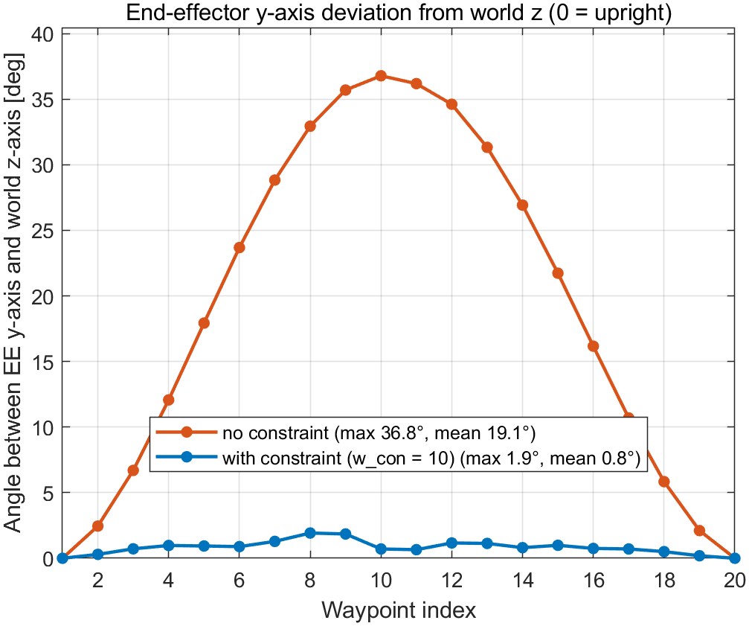
Figure 8. Angle between the gripper y-axis and the world z-axis at every waypoint, without and with the constraint.
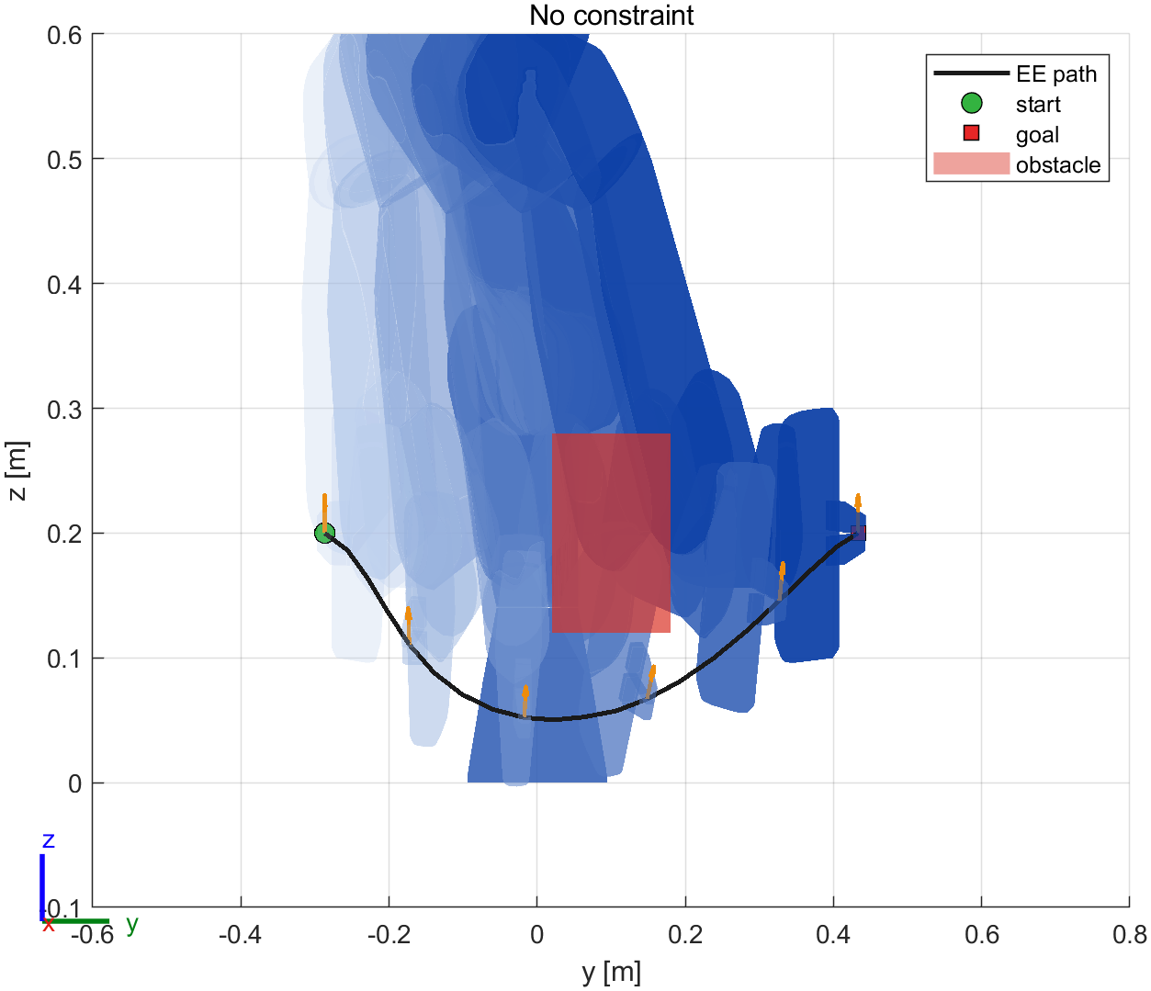 | 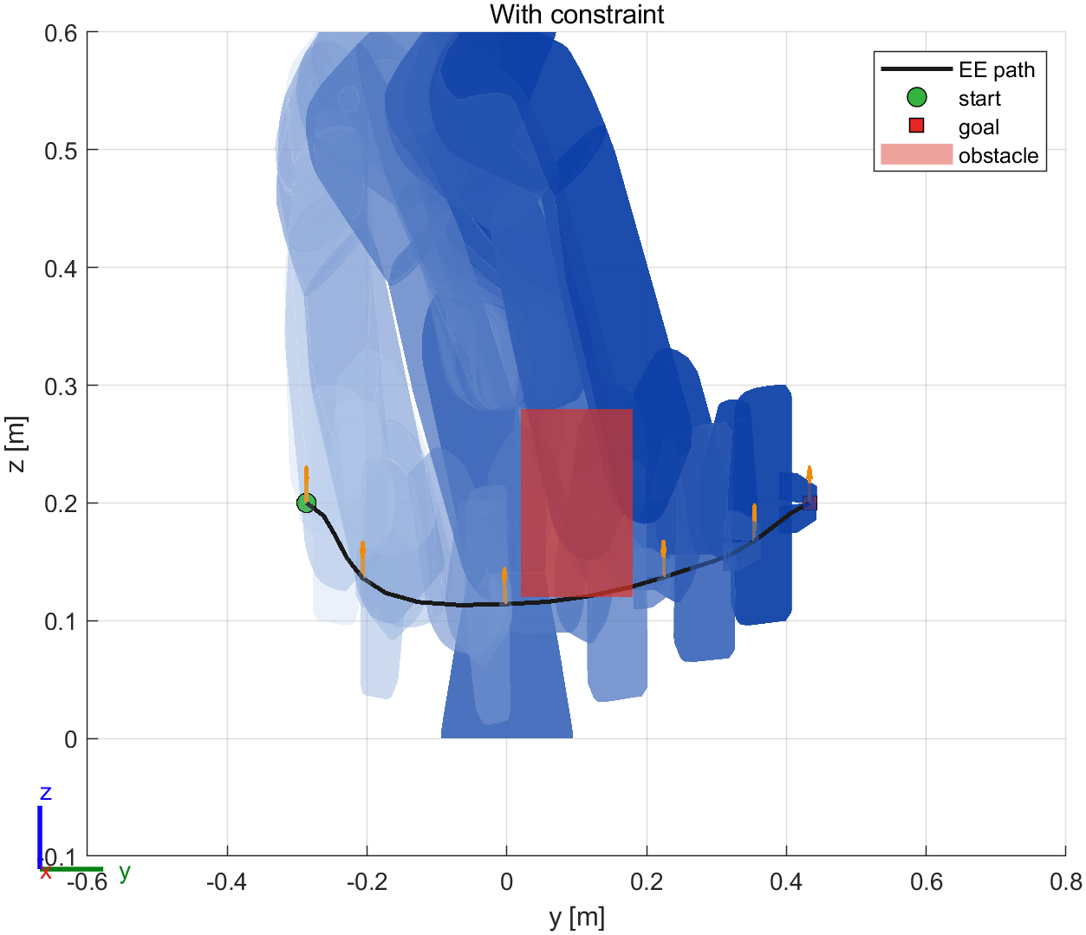
Figure 9. Task 5 trajectories without (left) and with (right) the constraint, side view (y–z plane); orange arrows: gripper y-axis at every 4th waypoint. The tilt is quantified in Figure 8; 3D and top views are in the results folder.

8 Improvements and additional features

8.1 Bugs fixed in the provided code
- Samples outside the voxel world: sub2ind failed, the try/catch returned obstacle cost 0, so a sample that left the workspace looked like the best one. Indices are now clamped.
- Control cost: sum(θRθᵀ, 'all') added cross-joint terms; replaced by the trace (Σⱼ θⱼᵀ R θⱼ).
- qc_cost = 0 inside the loop overwrote the constraint-cost vector with a scalar.
- The safety margin was hard-coded (0.05 m) while the main script's safetyDistance was never used.
- The training video created an empty file when disabled and indexed past the end of the animation.
- The zero-update stop test used sum(…) == 0, which positive and negative entries can satisfy.
- Kinova: the end-effector link was not among the FK frames, so the last link had no spheres.
- wrapToPi was applied to every joint — wrong for prismatic joints and for revolute joints whose limits reach beyond π (Panda joint 6 up to 3.75 rad); now only continuous joints are wrapped.
- Coincident frames (Panda link 1/2, 5/6) have length 0 with getTransform but ~1e-17 with PoE; ceil then changed the number of spheres between waypoints and the velocity term failed.
- An obstacle partly outside the voxel world made sub2ind fail in the voxelisation.

8.2 STOMP extensions: joint limits and sample reuse
The original STOMP ignores the joint limits: the noise and the update can push a joint beyond its limit, and the planned trajectory is then not executable. This happened in our scenes (up to 0.52 rad, Table 8). We project every noisy sample and every updated trajectory into the limits (the noise becomes the clamped sample minus the mean), in the spirit of the joint-limit filter of the ROS STOMP implementation [5]. Projection alone made the tightest scenes harder; reusing samples fixes this: the five cheapest noisy trajectories of the previous iteration take part in the next update. Their costs are already known, so reuse costs no extra FK. We also tried shrinking the exploration noise every iteration (0.98 per iteration); it made the hard scenes fail, because the noise becomes too small before the detour is found, so it is off by default.
Table 8. Ablation over 7 scenes (Tasks 1, 2, 4 S1–S3, 5 without / with constraint) × 5 seeds (bonus_ablation.csv; per-scene numbers in the CSV and Figure 10).
Variant | Collision-free runs | Worst limit violation [rad] | Median iter. T4 S1 | Median iter. T4 S3 | Median iter. T5 constr.
original STOMP | 35 / 35 | 0.52 | 64 | 79 | 174
joint limits | 31 / 35 | 0.00 | 64 | 147 | 200
limits + reuse (default) | 35 / 35 | 0.00 | 43 | 85 | 162
limits + noise decay | 29 / 35 | 0.00 | 73 | 78 | 200
limits + reuse + decay | 35 / 35 | 0.00 | 53 | 69 | 78

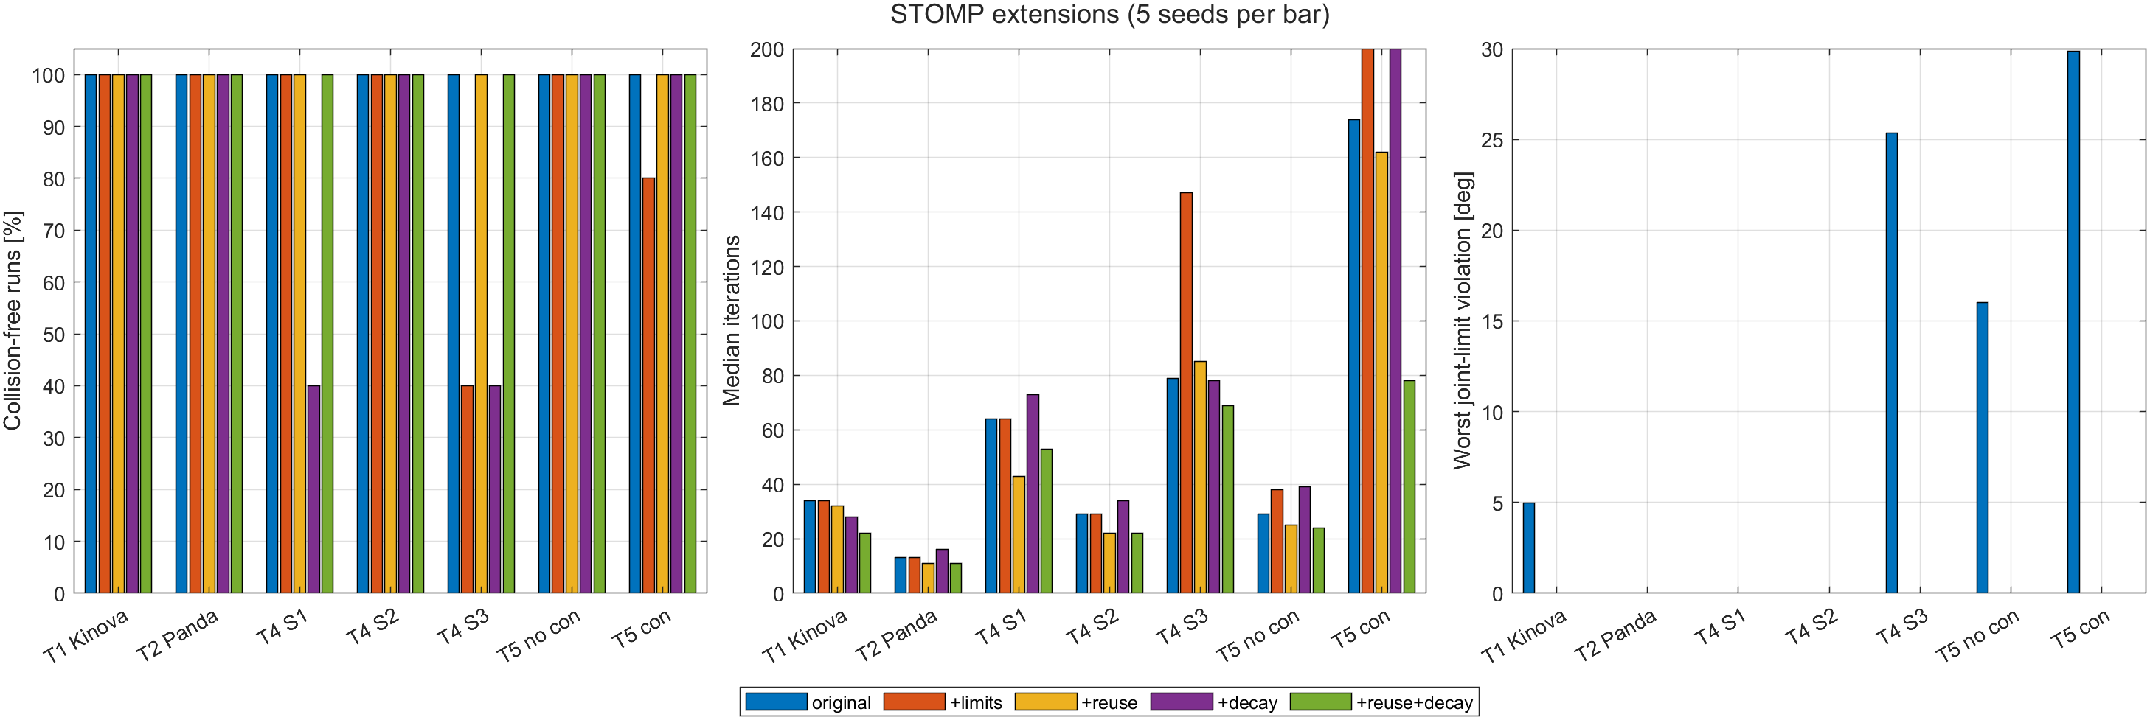
Figure 10. Ablation of the STOMP extensions: collision-free runs, median iterations and worst joint-limit violation.

8.3 Joint-angle discontinuity at ±π
Continuous joints (Kinova joints 1, 3, 5, 7) are wrapped to [−π, π] after IK, so a plain straight line in joint space can turn a joint the long way round. For continuous joints initTrajectory now interpolates along the shortest angle, wrapToPi(q_{T} − q₀). In a demonstration the Kinova base turns from 2.8 to −2.8 rad (the Task-1 configurations rotated behind the robot): the naive line turns it 5.6 rad through the front of the robot and STOMP keeps that detour (end-effector path 3.31 m); the shortest-angle line turns it 0.68 rad (path 0.79 m). Both are collision-free, but STOMP is a local optimiser and cannot repair a bad initial guess of this kind (Figure 11).
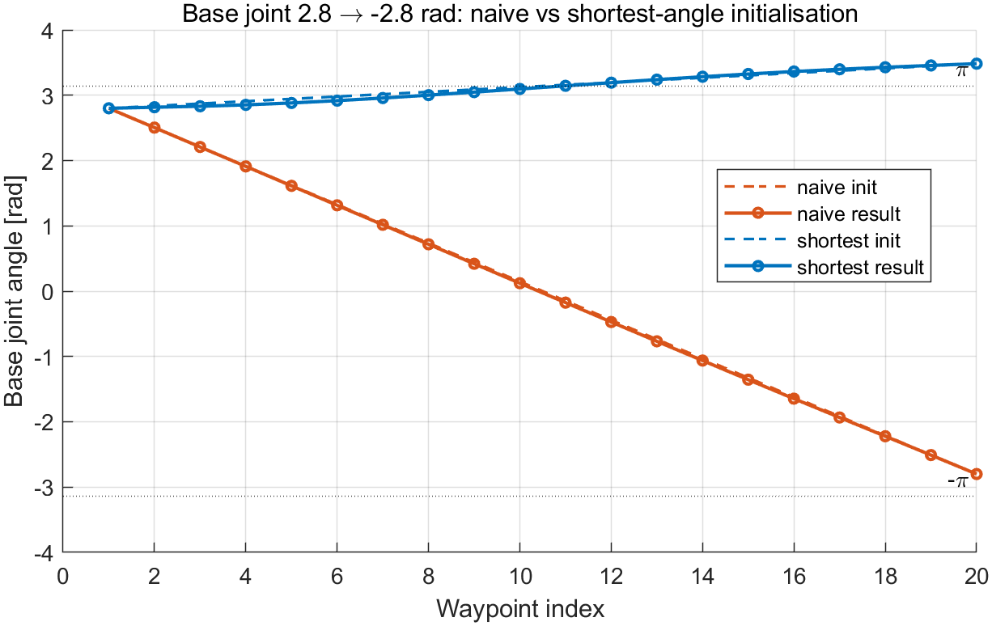
Figure 11. Base-joint angle along the trajectory, naive vs shortest-angle initialisation.

8.4 Further practical features
- Efficiency: PoE FK with a single running product (Section 5.2); getTransform without struct configurations; reused samples (Section 8.2).
- Verification: mesh-based collision check at the waypoints and between them; every final trajectory is also checked against the joint limits (all within limits).
- Fitted collision spheres (Section 4.3) instead of a hand-picked radius.
- Robustness studies with several seeds per scenario / weight instead of a single run.
- Convergence patience: stop only after three consecutive small cost changes.
- Reproducibility: one code base, seeded runs, results and videos shipped in the zip; a clean-copy check runs every script from the unpacked submission.

9 Limitations
- The sphere model contains 99 % of the mesh; the remaining corners (e.g. of the hand) are covered only by the 2 cm margin. The mesh-based check guarantees the final results, not the sphere model.
- The collision check between waypoints uses nine sub-steps per segment, not a continuous sweep.
- Constrained runs often reach the iteration cap: the stop rule uses an absolute cost change, and the constraint keeps the cost fluctuating. The trajectories are nevertheless collision-free and upright.
- STOMP is a local, stochastic optimiser; success depends on the initial guess (Section 8.3) and the seed, which is why we report multi-seed success rates.
- Start and goal come from IK of fixed poses; an unreachable pose (Section 7.1) must be fixed in the scene.

10 Contributions
Every member implemented and presents their own part; the shared code was agreed in the README ("shared interfaces") and reviewed through pull requests.
Table 9. Contributions of the group members.
Member | Contributions
Joshua Lim | Task 1: completion of the STOMP main loop and the incomplete functions (getTransform FK, sampling, δθ, obstacle cost) and the related bug fixes. Task 2: choice of the Panda, robot model with virtual TCP, Task-2 scene. Framework (runPipeline, configuration).
Hu Jiamo | Task 3: screw axes (two methods), PoE FK, accuracy/speed/planning comparison, screw-axis figure. Task 4: multi-obstacle voxelisation, three scenarios, multi-seed robustness study. STOMP extensions and ablation, joint-angle discontinuity, fitted collision spheres, between-waypoint collision check, re-tuning of the Task-5 scene for the Panda, videos, packaging and clean-copy reproduction check.
Dexter | Task 5: orientation-constraint cost, upright start/goal scene, weight sweep and automatic choice, before/after analysis and EE-axis deviation plot. Shared plotting functions (configuration overlay, cost history). Report and slides integration.

References
[1] M. Kalakrishnan, S. Chitta, E. Theodorou, P. Pastor and S. Schaal, "STOMP: Stochastic trajectory optimization for motion planning," in Proc. IEEE ICRA, 2011, pp. 4569–4574.
[2] K. M. Lynch and F. C. Park, Modern Robotics: Mechanics, Planning, and Control. Cambridge University Press, 2017.
[3] The MathWorks, Robotics System Toolbox documentation: loadrobot, getTransform, inverseKinematics, checkCollision, R2023b.
[4] Franka Emika, franka_ros 0.6.0 robot description (frankaEmikaPanda URDF shipped with MATLAB).
[5] ROS-Industrial, stomp_ros / stomp_moveit: STOMP implementation for MoveIt, including a joint-limits noise filter.

