Introduction
The Distributor is a system for the creation, maintenance, and processing of complex aggregates. The power of the Distributor is in things that aren’t important as individual objects, but only as a collection. The Distributor offers several benefits.
- It allows you to work at a higher level of abstraction. If you want to make a forest, you can work on it as a forest, rather than as 100 trees.
- It automatically does many things that you would do, but wouldn’t enjoy doing. It attempts to take on as much of the grunt work as possible, freeing you to concentrate on the art work.
- It makes for assets more robust in the face of change. Major restructuring of the underlying terrain will generally require no reworking of the ground cover under control of the Distributor system.
- It allows for higher optimizations in the rendering. Because the system as a whole has more information about what is being attempted and how it is constructed, it can perform optimizations that couldn’t be applied to generic scene geometry.
- It insulates the assets from changes in system requirements. The generated geometry is currently generated offline and exported as normal scene data. But on a different platform (e.g. Xbox), or over a slow bandwidth network, it would probably prove more efficient to generate the data at runtime on the client machine. The Distributor allows technical restructuring as needed without having to rework assets.

Terms
- Cluster – the master component, runs the Distributors
- Distributor – actually distributes replicant geometry over scene surfaces according to user parameters.
- Replicant – an individual mesh to be replicated and distributed over one or more surfaces.
- Surface – the mesh or meshes over which you will be distributing replicants.

General Tips
- Limit the number of materials you use, preferably to one per distributor. Tile your plant bitmaps into a single texture, and use your UV mapping to select which plant each replicant gets.
- Don’t hand edit the output of the Cluster. Adjust with the Distributor parameters. Any hand editing of the output will be lost the next time the scene is generated.
- Reuse your Fade Out (and Fade In) parameters. Setting one distributor to fade out at 60 feet and another to fade out at 65 feet will not give much of a perceptual difference, but it will prevent the system from batching the output of the two Distributors together.
- No you can't use View Facing on distributed objects as the cost would be prohibitive. The system will ignore you if you try.
- No you can't add shadows to distributed objects yet…maybe later.
- You can use as many distribution probability maps as you need. Different distributors can use specific maps or share maps with other distributors depending on what replicants you want where.
- The wind can't move mesh distributions in waves. You can randomize the motions somewhat with the flexibility component and by making secondary distributions attached to secondary child Wind Bones with different values.
- When using 'Surf Offset Min/Max' [Conformity to Surface] to make floating objects, remember that the distributor will be filling a volume rather than covering a surface. You can fit *many* more objects into a volume than on a surface with any given set of density and spacing values.

Getting Started
The most basic usage is straightforward and simple. Start off just seeing your replicants getting spread about, and then work into more control with the various parameters.

To start, you will need at least one surface (e.g. the terrain mesh(s)) over which you want to distribute stuff.

Second, you will need at least one object to distribute.

Once you have these two Max objects, you need at least two components.

For each distinct distribution of replicants, you need a Distributor Component. The Distributor Component is attached to the mesh or meshes over which you will be distributing replicants (the Surface). One Distributor can distribute any number of replicants, but they will all be distributed with the same pattern. One surface may have any number of distributions, and hence Distributors, over it. Surfaces may also share Distributors, one Distributor may be applied to a group of surface meshes, and the distribution will logically span all those surfaces.

The second component is the Cluster Component. The Cluster Component manages the multiple Distributors, and optimizes the output. It should be attached to all the meshes which have Distributors it will manage.

Apply the Distributor and the Cluster Component to your surface mesh(s). Select the Distributor in the Component Util. Go to the Replicant Objects rollup (the first one and only one open). Click on Add. Now select your replicant object. Okay, you’re ready to go. Select the Cluster Component in the Component Util. Hit Go. The rest is just fine tuning the parameters, as described below.

If you are trying to adjust the Distribution, you want one of these rollups:
Spacing
Orientation Dependence
Altitude Dependence
Probability Bitmap

If you are trying to adjust Appearance, you want one of these rollups:
Replicants
Scaling
Replicant Orientation
Conformity to Surface
LOD Fade
Wind Effect

Distributor Roll outs – Attach to Base Surface Mesh

Replicants
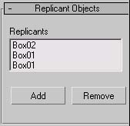
The list of objects you want distributed over the surface. To add to the list, click on the Add button, then select the object you want to replicate, either by mouse picking in the scene or through select by name. To remove an object from the list, click on the object’s name in the list box, and click the Remove button.
A Distributor can have any number of objects to replicate. For each position it decides to drop a replicant into the scene, it will randomly select one replicant from the list. Adding an object into the list twice will double its chances of getting picked, and therefore double its frequency of occurrence in the scene. For example, if the replicant list consists of ObjectA once, and ObjectB four times, the output will be a mix consisting of 1/5 ObjectA and 4/5 ObjectB.
All replicants within a Distributor should share the same material. The Scale of all replicant’s transforms should be reset before adding them to a distributor. The orientation of the replicant can optionally affect its placement in the world. See Replicant Orientation below.
The placement of the pivot point on the replicants is key. The pivot point should be at the ground level of the replicant (the base), with the Z axis pointing toward the end protruding out of the surface.

Spacing
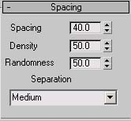

Spacing
The nominal spacing between replicants distributed over the surface. In feet.

Density
The overall probability that a spot on the spacing grid will receive a replicant. A lower density reduces the number of replicants, a higher density will produce a more even coverage. In Percent.
So if Density is 100.0 you get as many replicants as will fit Spacing ft apart. If you set Density to 0 you get no replicants (don’t do that).

Randomness
Amount to randomly perturb the replicant positions from a hypothetical grid. A randomness of 0% will put the replicants on a somewhat regular grid (with distance between grid points of Spacing), a randomness of 100% will produce a totally random coverage.

Separation
Amount to prevent interpenetration between replicants. In abstract, the system will place a protected zone around each replicant. The system won’t place the replicant anywhere that would make its protected zone intersect any other protected zone. Once the replicant is placed in the scene, no other replicant will be added in a way that would make its protected zone intersect the first’s. The options relate to the size of the protected zone, and are:
None – Allow replicants to be placed directly on each other.
Low – Create a one foot cube protected zone around each replicant.
Medium – Protected zone is the replicant’s bounding box.
High – Protected zone is a box of size Spacing cubed.

Tip on Spacing
You can decrease the number of replicants distributed over your surface either by increasing the Spacing or decreasing the Density. Note that the distribution process will go faster if you increase the Spacing versus decreasing the Density. Try to use the Spacing first to get about the right density, and then tweak with the Density setting.

Scaling
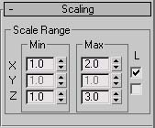

Scale Range Min/Max
Amount to randomly scale replicants as they are added to the scene. You may supply a minimum and a maximum amount to scale in each dimension. The system will pick a random scale amount in that range for each replicant. The dimensions are in the replicant’s native space based on its pivot point. A scale value of 2.0 will double the size of the replicant.

Lock
By default, this is a non-uniform scale. For example, if you have minimum and maximum scales of 1.0 and 2.0 respectively for all three dimensions, the system might select a scale of 1.0 in X, 1.5 in Y and 2.0 in Z.
There may be times that this isn’t what you want. There are two check boxes to lock dimensions of the scale (on the right). The first check box locks the X and Y scaling. So from top down, replicants will remain constant in their proportions, but their height will vary independently. When the XY lock is selected, the Y scale values will be greyed out and ignored, as X and Y will both be scaled by the same amount, as determined from the X scale range.
The second scale lock check box will tie all three scale dimension. When selected, the Y and Z scale ranges will be greyed out and ignored, as X, Y, and Z will be scaled by the amount determined from the X scale range. When selected, replicants will vary in size, but remain constant in their proportions in all three dimensions.

Replicant Orientation
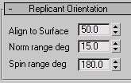
Control over the orientation of replicants distributed over the surface.

Align to Surface
Amount to base the “up” direction of the replicant on the surface normal at the position the replicant is being placed, versus the “up” direction of the original replicant object. (The “up” direction of the replicant is the direction the Z (blue) axis of its pivot point points.)With a value of 100%, the “up” direction of each replicant will point directly out of the surface. With a value of 0%, the “up” direction of each replicant will be the same as the original. So to make vines that hang straight down, turn your original vine upside down and set Align to Surface to 0%.
Note that in no case will the system allow a replicant to poke down into the surface over which it is being distributed. If you applied the hanging vines to a surface which faces up, the vines will lay flat on the ground pointing down as much as they can. Sometimes this is what you want, for other cases see the Orientation Dependence section.

Normal Range deg
Amount in degrees to randomize the “up” direction. The up of the replicants in the scene will fill a cone of this angle. This randomness is applied after the check for meeting Orientation Dependence requirements (see Orientation Dependence below).

Spin Range deg
Amount to randomize the spin of the object about its “up” direction. With a spin range of zero, replicants will try to keep the Y axis of their pivot points aligned with the source replicant’s. 180 degrees will apply a random spin to each replicant placed in the scene.

Use Surface Face Normals Checkbox
Rather than interpolate the vertex normals to the position on the face at which the replicant is being dropped, use the flat face normals. This has proven useful for objects which mate with the surface over an extended area (e.g. crater decals), particularly over rough surfaces. Note that this also affects the Orientation Dependence described below.

Orientation Dependence
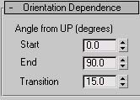
Establishes a dependence on the surface normal of whether to place a replicant at that position. The angles are based on the angle between the surface normal and the UP direction. So 0 is up, 180 is down, 90 is in the XY plane.
Note that the angle is based on the surface normal, not the up direction of the output replicant. So even if you force all your replicants to point straight up (Align to Surface = 0), they will still fail the Orientation Dependence test if the surface they are applied to fails.
Note also that the surface normal used IS affected by the Use Surface Face Normals checkbox in Replicant Orientation (described above).

Start
Minimum angle from up to allow replicants.

End
Maximum angle from up to allow replicants

Transition
Number of degrees over which to transition from not allowing replicants to allowing full coverage.
For example, say the Start angle is 45 degrees, the End angle is 90 degrees, and the Transition is 5 degrees. Then where the surface normal is within 45 degrees of pointing up there will be no replicants placed. At 45 degrees there will be very few, ramping up to full coverage at 50 degrees (5 degree transition). There will be full coverage from 50 degrees to 85 degrees. Coverage will ramp down from 85 to 90 degrees. There will be no replicants where the surface normal is more than 90 degrees from up (i.e. where the surface is vertical or at all downward facing).
The angles 0 and 180 are treated slightly differently. If 0 or 180 is specified as Start or End, then there is no transition to that angle, full coverage is maintained all the way to straight up (0) or straight down (180). For example, setting Start to 1, End to 90, and transition to 10 would cause no coverage between 0 and 1 degrees from up, ramping up to full coverage at 11 degrees, full coverage from 11 to 80 degrees, ramping down to no coverage at 90 degrees. But setting Start to 0, End to 90 and transition to 10 would cause full coverage from 0 to 80 degrees, ramping down to no coverage at 90 degrees.
Set Start and End to zero (0) to disable.

Altitude Dependence
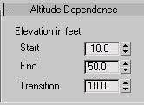
These are very analogous to the Orientation Dependence. Altitude Dependence can be used, for example, to limit a type of fern to only appearing close to sea level. Set Start and End to zero (0) to disable. All units are in feet in Max’s world coordinates.

Start
The minimum height at which to allow replicants.

End
The maximum height at which to allow replicants.

Transition
The distance over which to transition from not allowing replicants to allow full coverage.

Conformity to Surface
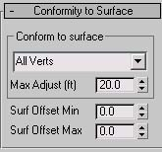

Conform to surface (type)
Options on how to conform to underlying surface. The choices are:
None – Just make sure the pivot of the source replicant is on the surface.
Check – Make sure all vertices are over the surface. Prevents extended replicants from hanging over edges. See Max Adjust below.
All Verts – Distort the replicant mesh copy so that each vertex keeps its original height (relative to its pivot point) over the surface onto which it is being distributed. See Max Adjust below.
Bottom – Like All Verts option, but distorts based on height (relative to pivot point). Verts at the base of the replicant conform exactly to the surface, verts at the top of the replicant don’t conform at all, and verts in the middle conform half way. See Max Adjust below.
Base – Like Bottom option, but only vertices at the very base (within 6 inches) are adjusted. See Max Adjust below.

The following illustrate the different conform type behaviors.

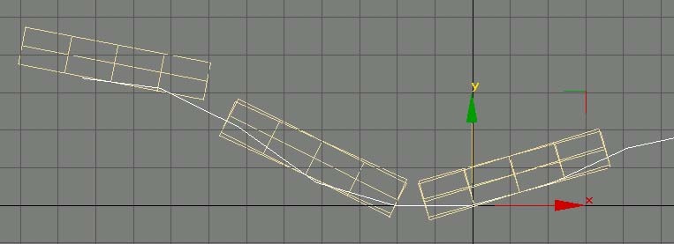
Conform None – Note the box hanging off the left edge.

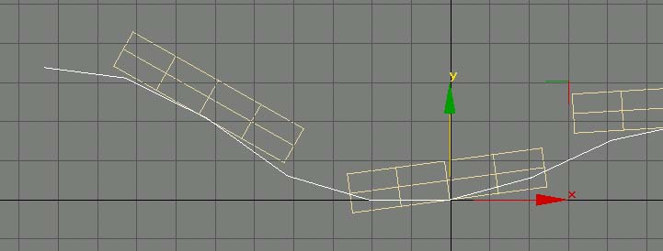
Conform Check – Same as None, but the boxes have shifted to avoid hanging off the edge.

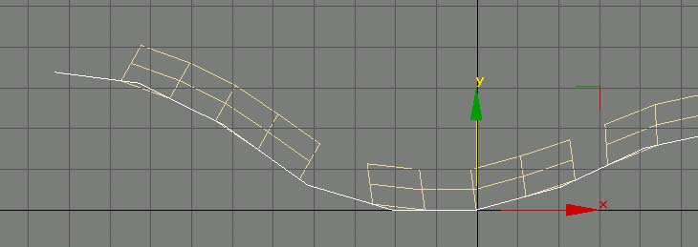
Conform All Verts – The entire boxes conform to the underlying surface.

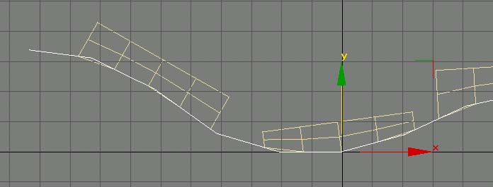
Conform Bottom – Conformity to underlying surface decreases toward the top of the boxes.

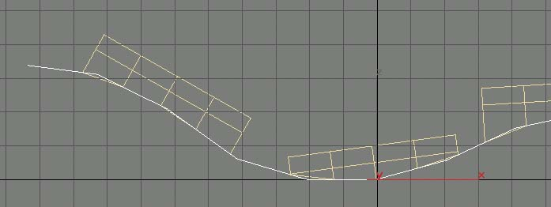
Conform Base – Only the base of the boxes conform to the surface.

Max Adjust (ft)
The maximum distance to allow the surface being distributed over to drop from under a replicant or rise up into a replicant.

Surf Offset Min/Max
Specifies a range to offset replicants over the surface onto which they are being distributed. For example, Offset Min and Max of 10.0 and 15.0 respectively would distribute the replicants in a layer five feet thick starting ten feet off the ground.

Probability Bitmap
The Probability Bitmap allows distributions to be hand painted onto a surface. The bitmap won’t be exported, so it can be any size convenient. Unless you already happen to have a convenient UV mapping, you should apply the mapping to one of the upper channels which Plasma otherwise ignores.

Probability Texmap
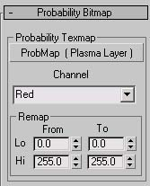
The bitmap to use. You can drag and drop from the Material Editor here.

Channel
Which color or combination of colors from the bitmap to base the distribution on. This allows the same bitmap to convey different distributions.

Remap
Allows remapping of bitmap values into distribution probabilities. For example, to invert a bitmap distribution, leave From Lo and Hi at 0 and 255 respectively, but swap To Lo and Hi to 255 and 0 respectively.

LOD Fade
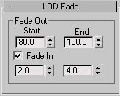
The Distributor generally distributes more polygons into your scene than you can afford to render all the time. You can use the LOD Fade parameters to limit how far away you can see your replicants, and how quickly they blend in. All parameters are in feet.

Fade Out
Start/End – Replicants will be fully visible up to Start distance from the camera, and then fade out gradually becoming fully invisible at End distance from the camera. Set Start and End to zero to disable.

Fade In
Checkbox – Check this check box to enable the Fade In.
Start/End – Replicants will be fully invisible closer than Start distance from the camera. They will gradually fade in becoming fully visible at End distance from the camera.

Wind Effect
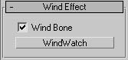
The replicants distributed can optionally be affected by wind through hardware skinning. The Wind Bone can either be a manually animated object or, preferably, animated via the Wind Component described below. See also the Flexibility Component description below for controlling the effect of the wind on individual replicants.

Wind Bone Checkbox
Check this check box to enable selection of a wind bone. If unchecked, any selected Wind Bone is ignored.

Wind Bone Select Box
Click on the select box and select the object to use as a Wind Bone by mouse picking in the scene or through the select by name dialog.

Randomization
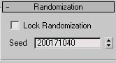

Lock Randomization Checkbox
Once randomization is locked, the system will attempt to generate the same set of replicants each time they are distributed. Keep in mind that changing the distributor parameters or large changes to the underlying geometry will prevent the same set of replicants from being generated.

Seed
The random number seed currently used.

Actions
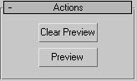
When setting up a specific Distributor, you can use the Preview function to get a quick rough idea of what your current settings will generate. The output of the Preview should be considered a rough draft and not exported. Keep in mind that interactions between different Distributors (e.g. through the Spacing/Separation) may cause somewhat different output than generated through Preview.

Clear Preview
Clears anything generated from Preview.

Preview
Runs the Preview generation.

Related Components

Cluster – Attach to Base Surface Mesh
The Cluster Component runs the Distributors, collects their output, and optimizes it. There can be only one Cluster Component on an object, but the same Cluster Component can be on many surfaces. It is attached to the base mesh(s) of the surface(s) over which you will be distributing replicants.
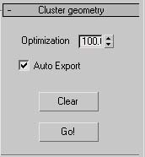

Optimization
Level controls how much optimization is performed. It should generally be left at 100%.

Auto Export
The output of the Distributor system can be large and unwieldy. You generally don’t want the output cluttering up your Max file and slowing things down. If this box is checked, then at export the Cluster Component will check to see if it has been cleared. If so, it will automatically run all its Distributors before the export process and clear them back out again after the export is done.

Clear
Clears all the distributed replicants generated by this Cluster Component out of the Max File.

Go
Finds all Distributors attached to all Max objects this Cluster Component is attached to, runs them, and optimizes the output. The optimized output will appear as objects prefixed with the Cluster Components name, and be available as a selection set of the same name as the generating Cluster Component.

Wind Bone – Attach to Dummy Wind Representative
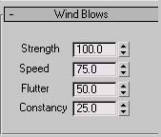
The Wind Bone Component applies a procedural wind effect to an object, making it suitable for use as a Wind Bone in a Distributor. Wind Bones may be cascaded. Typically, you would set up a hierarchy of bones, with Parents having more Strength and Children having more flutter.

Strength
Overall strength of the wind effect, as a percentage from 0% to 100%.

Speed
The general rate of smooth oscillations, with lower values oscillating slower, and higher values oscillating faster.

Flutter
Flutter or twitchiness of the wind. Higher values will put more flutter into the wind.

Constancy
With a constancy of 0%, the wind will blow for a while, then completely die, then blow some more. With a constancy of 100%, the wind will always be blowing (although it will blow with varying amounts).

Flexibility – Attach to Replicant
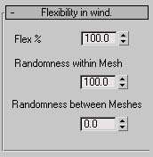

Flex %
The overall flexibility of this mesh. The Flexibility Component is typically attached to the replicant meshes that a Distributor with a Wind Bone will be distributing. A Flexibility Component currently has no effect without a Wind Bone specified on the Distributor.
A flexibility of 100% will have the top of the mesh move in unison with its Wind Bone, while the base of the mesh remains planted. This is generally more than you want. Values are typically around 30%. A very small value will keep the mesh from swaying at all, base and top remaining fixed.
A value of zero (0) is treated differently. For a flexibility of zero, the mesh will no longer bend, but the base will no longer remain fixed. The entire mesh will move as a unit with the Wind Bone. So to make a rigid plant, use a flexibility of something like 1%.

Randomness within Mesh
This governs how much variation within a mesh there is in reaction to wind. With a value of 0%, the replicant will bend uniformly with the wind. With a value of 100%, different parts of the replicant will bend different amounts.

Randomness between Meshes
The amount of variation in bend amount between different replicants. With a value of 0% (and 0% Randomness within Mesh), all replicants will bend in reaction to the wind in unison. With a value of 100%, each replicant will bend a slightly different amount.

X-Form Component – Attach to Replicant
The X-Form Component is attached to replicants to let the system know that that’s what they are. This lets the system shade them differently, preventing shading artifacts from giving away the trick. The X-Form Component currently has no options.
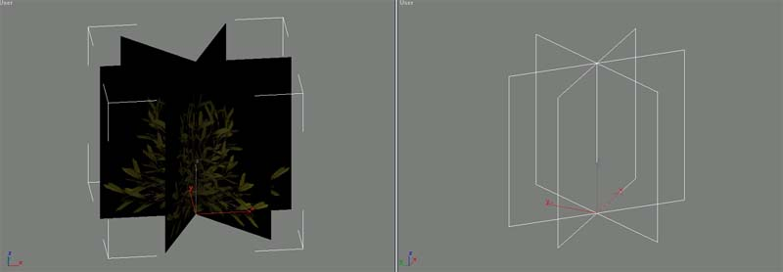
Typical X-Form

