12/9/2018

Mohamed Yousef Alzarooni H00237253

Ahmed Shaheen Alhosani H00332663

Bader Ahmed Alattar H00330175

Khalfan Jamal Buamim H00294187

HCT – Dubai men’s college

Cloud App Development

CIA 3403 - Project

Description

We are creating a cloud application for McDonald’s which will have a database called restaurantdb. The application will be able to Add, Update, Delete and Read records stored in the cloud using mlab database. We will test the application by using Mongodb we will be creating a database with records in it.

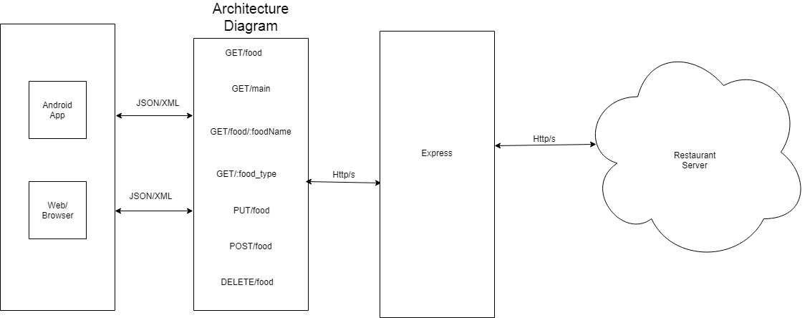

app.GET/food_type

app.DELETE/food

app.POST/food

app.PUT/food

app.GET/food/:foodName

app.GET/food

app.GET/main

MongoDB

On mLab

* GET/food route is the default route to display all the documents.
* GET/main route will display only the food type that have main.
* GET/food/:foodName will allow to search specifically for a food by its name.
* GET/:food_type will show the type of food
* PUT/food this route will update the data in the collection
* POST/food will add a new food to the collection.
* DELETE/food will delete food by typing in the name of the food.