Course Work Project Description and Rubric
Semester | 202420 |  | Division |  | CIS
Assessment title in Syllabus | Project |  | Program |  | IT and IS
1
Course Code | CIS 2423
Course Title | Programming for Data Analytics
CLOs | All CLOs |  | Accreditation Body |  | CAA & CIPS
Course Instructor |  |  | CRN
Assessment Weight | 40% |  | Submission Date |  | Week 14
For Group Work submissions an additional individual assessment will be conducted.
Grades for the students in one group will vary based on the individual performance in the additional assessment.
Student Declaration:
Academic Integrity Statement
In accordance with the HCT Academic Integrity Policy
• Students are required to refrain from all forms of academic integrity breaches as defined and explained by HCT.
• A student found guilty of having committed acts of academic integrity breach(es) will be subject to the relevant sanctions as outlined by HCT.
إفادة النزاهة الأكاديمية
وفقًا لسياسة كليات التقنية العليا للنزاهة الأكاديمية
• على الطلبة الإلتزام بلوائح وقواعد النزاهة الأكاديمية، كما هو مبيّن وموضح في السياسات والإجراءات الخاصة بكليات التقنية العليا.
• في حالة ارتكاب الطالب أي شكل من أشكال الإخلال بالنزاهة الأكاديمية، سيتعرض الى العقوبات الموضحة في السياسات ذات الصلة.
This assignment is entirely my own work except where I have duly acknowledged other sources in the text and listed those sources at the end of the assignment. I have not previously submitted this work to the HCT, or any other entity. I understand that I may be orally examined on my submission.
Student (s) Signature: ___________________________________
___________________________________________

Student Name(s): | Aisha Alshamsi | Sara Almulla
Student HCT ID(s): | H00535685 | H00532724 |  | H00

For Examiner’s Use Only
 | Group (50%) |  |  |  |  | Individual (50%)
CLO | 1 | 2 | 3 | 4 | Report Formatting | Oral Defense | Total | %
Marks Allocated | 10 | 10 | 42 | 26 | 12 | 50 | 100 | 40
Marks Obtained

Project Objectives
This is an intensive project-based course. It enables students to perform data analysis using Python programming. Students should select their dataset from a free source and conduct a methodical data analysis using Machine Learning algorithms. The project's primary objectives are:
- Generate a data summary using descriptive analysis
- Create a sample and visualize sample data using graphs/charts and remove the unwanted outliers;
- Investigate the correlation between the variables;
- Perform hypothesis testing if you have any assumptions about your dataset;
- Perform data preprocessing prior to building a data model;
- Create and optimize the regression model for the selected dataset in order to predict the values; and
- Develop and Optimize the classification model for the selected dataset in order to predict the values.
- Analyze the data for patterns or groups based on clustering and optimize the model in order to obtain the desired output.

Project Description
You are assigned to work on the data analysis for chosen dataset. The list of datasets is available in a Kaggle data source(https://www.kaggle.com/datasets). The project carries 25% of your coursework marks. You are required to work in a team of maximum FOUR (4) members. It is important that you need to collaborate in working on the project within your team. The collaboration between the team members will be recorded, tracked, and monitored.
For CLO1, CLO2, and CLO3 – Regression same dataset should be used
If required, then CLO3 – classification and Cluster different dataset can be used.

Project Tasks/Questions
CLO | Deliverable Learning Outcomes | Marks
1 | - Define the purpose of data analysis for the chosen dataset | 2
1 | - Identify and Justify the type of programming used for data analysis | 2
1 | - Identify the type and purpose of the machine learning algorithm to be implemented for the chosen dataset | 3
1 | - Identify and Justify the independent and dependent variables for the chosen dataset. | 3
1 | Total | 10
2 | - Justify why you want to perform the descriptive analysis for the chosen dataset. | 1
2 | - Create a script to develop a Python function for descriptive statistics. The input for the function should be the sample and the field to perform the descriptive statistics. | 1
2 | - Create a program to random sampling of size 150 and find the descriptive statistics for the dependent variable from the sample [Apply the descriptive function which you created]. | 1
2 | - Create a script for systematic sampling by giving certain conditions and finding the desc stat for the dependent variable from the sample [Apply the descriptive function which you created]. | 1
2 | - Create a detailed descriptive statistics report about the dependent variable of the chosen dataset. | 1
2 | - Visualize the dependent variable by the Graph/Chart of the following using Python Program:  - Scatter plot  - Box Plot  - Histogram  - Heat Map  Hint: Use Matplot or Ski-learn library | 3
2 | - Perform the hypothesis test to find the correlation (Pearson and Spearman for numerical variable and chi-square test for categorical variable) between the independent variable and the dependent variable.  Note: If you have more than one independent variable, then chose any one of the independent variables. | 1
2 | - Assess the performance of the dependent variable to know whether the sample is representative of the normal population by a one-sample t-test. | 1
2 | Total | 10
3 | - Build, Train, Develop and Evaluate using Simple Regression for chosen dataset. | 5
3 | - Develop a script to forecast the value of the dependent variable from all the relevant independent variables using Multiple Linear Regression | 5
3 | - Predict the value of the dependent variable from the different classifier such as Logistic Regression, KNN, Naïve-Bayes and Decision Tree. | 17
3 | - Evaluate the performance of each model using confusion matrix and accuracy and identify the best fit classifier for the chosen dataset. | 9
3 | - Predict the dependent variable by using best-fit classifier. | 1
3 | - Perform the cluster analysis such as K-means and Horizontal for any field from the chosen dataset. | 8
3 | - Explain the strategy for improving the system after viewing the cluster diagram. | 2
3 | Total | 42
4 | - Create a new repo for project in Git Hub | 3
 | - Upload all the project files created for CLO1,CLO2 and CLO3 to the Git Hub repo | 4
 | - Configure Git with GitHub | 5
 | - Clone Git hub repo to Git | 4
 | - Pull any file from Git Hub repo to Git | 5
 | - Modify the pulled file and push the modified file to Git Hub | 5
 | Total | 26

Deliverable 1
Introduction
Cancer is a major public health concern worldwide and in the United Arab Emirates. Examining patterns in cancer cases helps support early detection, planning resource, and improving public awareness. In this project, we analyze real-world synthetic cancer patient data from the UAE. The goal is to understand how demographic, geographic, and clinical factors relate to different cancer types and to develop a prediction model that can identify the Cancer_Type of a patient based on their characteristics.
- Define the purpose of data analysis for the chosen dataset
This project uses the UAE Cancer Patient Dataset to generate actionable insights for care planning and resource allocation. The analysis aims to:
- Explore the dataset using descriptive statistics and visualization.
- Study relationships between variables such as Age, Stage, Gender, and Cancer_Type.
- Perform hypothesis testing to evaluate statistical relationships.
- Build a machine learning model to predict Cancer_Type.
- Interpret the results and discuss areas of improvement. This supports real-world applications such as early screening guidance and patient risk profiling.
- Identify and Justify the type of programming used for data analysis
Environment: Python in Jupyter Notebook. This keeps code, outputs, and explanations in one place and supports reproducible teamwork.
Core libraries:
- pandas + numpy: clean tabular patient data, handle missing values, encode categories, and engineer features before modeling.
- matplotlib: produce clear EDA and model visuals (target balance, distributions, survival histograms, ROC curves, confusion matrix) for the report and poster.
- scikit-learn: build pipelines that combine preprocessing and modeling with stratified train/test splits and stratified K-fold cross-validation; train the project models (Logistic Regression, KNN, Naive Bayes, Decision Tree); tune hyperparameters with GridSearchCV; and report metrics (Accuracy, Precision, Recall, F1, ROC-AUC for classification; MAE, RMSE, R² for regression).
Why this stack: It matches healthcare tabular data, integrates cleaning, transformation, and modeling in a single leak-free pipeline, and produces transparent metrics and plots required by the rubric.

- Identify the type and purpose of the machine learning algorithm to be implemented for the chosen dataset
A) Classification : predict a categorical outcome
- Target: Recurrence (Yes/No).
- Algorithms: Logistic Regression, K-Nearest Neighbors (KNN), Naive Bayes, Decision Tree.
- Purpose: flag higher-risk patients so follow-up and resources can be prioritized.
- Inputs (examples): Age, Gender, Cancer_Type, Stage, Tumor_Size, Treatment_Type, Smoking_Status, Diabetes, Hypertension, key labs.
- Evaluation: Accuracy, Precision, Recall, F1-score, ROC-AUC; confusion matrix for error analysis.
- Deliverable: best model selected by stratified cross-validation and tested on a held-out set, with feature importance/coefficients explained.
B) Regression : predict a numeric outcome
- Target: Survival_Months.
- Algorithms: Linear Regression, Ridge, Lasso (with hyperparameter tuning).
- Purpose: estimate expected survival time to support counseling and treatment planning.
- Inputs (same feature set as above, engineered as needed).
- Evaluation: MAE, RMSE, R²; residual analysis to check fit and assumptions.
- Deliverable: best model chosen by cross-validated error, with a short interpretation of key predictors.
C) Clustering : discover patient segments
- Method: k-means on a standardized feature space (demographics, stage, tumor size, treatment).
- Purpose: uncover natural groups of patients that share profiles and risks to inform targeted strategies.
- Evaluation: Silhouette score and cluster profiles (centroids, size, outcome rates).
- Deliverable: concise description of each cluster and 1–2 actionable recommendations per cluster.
- Identify and Justify the independent and dependent variables for the chosen dataset
Dependent (Target): Classification: Recurrence (Yes/No)
Justification: Clinically critical outcome that determines follow-up intensity and resource prioritization. Predicting it enables early risk flagging.
Dependent (Target): Regression: Survival_Months (numeric)
Justification: Direct measure of prognosis used in planning treatment, counseling patients, and comparing care pathways.

Independent (Predictor) Variables
Demographics
- Age (numeric): Strongly associated with cancer incidence, treatment tolerance, and survival.
- Gender (categorical): Certain cancers and responses differ by sex.
Disease Characteristics
- Cancer_Type (categorical): Different tumor biology and baseline risks.
- Stage (ordinal: I–IV): Primary driver of recurrence and survival; captures spread/severity.
- Tumor_Size (numeric): Proxy for tumor burden and likelihood of residual disease.
- Lymph_Node_Involvement or Metastasis (binary/ordinal): Indicates extent of spread and worsens prognosis.
Treatment Factors
- Treatment_Type (categorical: surgery/chemotherapy/radiation/combined): Management choice influences recurrence control and survival.
- Chemo_Cycles / Radiation_Dose / Surgery_Flag (numeric/binary as applicable): Intensity and modality of therapy affect outcomes.
Lifestyle & Comorbidities
- Smoking_Status (categorical): Impacts progression, complications, and survival.
- Diabetes, Hypertension, BMI (binary/numeric): Comorbidity load modifies treatment risk and long-term outcomes.
Laboratory / Clinical Indicators
- Hemoglobin, WBC, Platelets, Creatinine (numeric): Reflect physiologic status and treatment tolerance; correlate with prognosis.
How these choices support the models
- Variables capture four pillars that drive oncology outcomes: patient factors, disease burden, treatment exposure, and physiologic status.
- Classification uses these predictors to estimate Recurrence risk; regression uses the same predictors to estimate Survival_Months.
- Categorical fields are one-hot encoded; ordinal fields (e.g., Stage) are preserved as ordered; numeric fields are standardized.
- This set balances clinical relevance with model performance and aligns with the project goals and rubric.

Deliverable 2

- Justify why you want to perform the descriptive analysis for the chosen dataset.

We perform descriptive analysis to get a clear understanding of the dataset before doing any deeper statistical testing or prediction modeling. It helps us identify basic patterns, such as how common each cancer type is, the typical age of patients, gender distribution, and differences between smokers and non-smokers. This step is important because it provides context, helps detect any unusual values, and guides the decisions we make in later analysis. Without descriptive analysis, it would be difficult to explain the data correctly or choose the right methods for the next steps.

- Create a script to develop a Python function for descriptive statistics. The input for the function should be the sample and the field to perform the descriptive statistics.

- Purpose: one reusable function that returns a standard summary for any numeric field.
- Inputs: (a) a sample/table and (b) the field name to summarize (here: Survival_Months, deceased only).
- Outputs reported: count, mean, median, standard deviation, minimum, Q1, Q3, maximum, IQR (Q3–Q1), skewness, kurtosis.
- Handling: non-numeric/missing values are excluded before calculating the statistics.
- Why: ensures the same, consistent descriptive report is used across full data and samples.

- Create a program to random sampling of size 150 and find the descriptive statistics for the dependent variable from the sample [Apply the descriptive function which you created].
- Frame: deceased patients with a valid Survival_Months.
- Sampling method: simple random sample of 150 records with a fixed seed for reproducibility.
- Analysis: ran the descriptive-statistics function on the 150-record sample and on the full deceased cohort for comparison.
- Result: the sample’s mean/median and spread (SD, IQR) were very close to the population values.
- Conclusion: the random sample is representative for descriptive purposes; no evidence of sampling bias.
- Create a script for systematic sampling by giving certain conditions and finding the desc stat for the dependent variable from the sample [Apply the descriptive function which you created].

- Frame: same deceased cohort, ordered by Diagnosis_Date (stable ordering).
- Sampling method: computed the interval $k=\left[\frac{N}{150} \right]$chose a random start, then selected every k-th record until ~150 cases.
- Analysis: ran the descriptive-statistics function on the systematic sample and compared to the full cohort.
- Result: summary measures (mean, median, SD, IQR) were aligned with the population; skew/kurtosis also similar.
- Conclusion: under this ordering, the systematic sample behaves like a random sample (no obvious periodicity effect). If the ordering changes (e.g., by site), re-run with a different start to verify stability.

- Create a detailed descriptive statistics report about the dependent variable of the chosen dataset.

Targets
Classification dependent: Deceased (derived from Outcome).
Regression dependent: Survival_Months = (Death_Date − Diagnosis_Date) in months, computed for deceased patients only.
Given
- Total patients: 10,000

- Deceased counts: Deceased = 992, Not Deceased = 9,008

- Survival_Months (for n = 992 deceased):
- mean = 17.51 months, median = 17.71, std = 9.07
- Q1 = 9.71, Q3 = 25.07, min = 1.05, max = 32.82
- skewness = −0.079, kurtosis = −1.156
- Classification target: Deceased (Yes/No)
- Frequency & proportion: Deceased 992 (9.92%), Not Deceased 9,008 (90.08%).
- Class balance: Strongly imbalanced toward “Not Deceased.”
- Implication: Baseline accuracy ≈ 90% if always predicting “Not Deceased”; evaluation must emphasize Recall, F1, and ROC-AUC in addition to Accuracy.
- Regression target: Survival_Months (numeric, deceased only)
- Central tendency: mean 17.51 months; median 17.71 months → typical survival ≈ 18 months.
- Dispersion: std 9.07; IQR = 25.07 − 9.71 = 15.36 months; Range = 32.82 − 1.05 = 31.77 months.
- Shape: skewness −0.079 (roughly symmetric); kurtosis −1.156 (flatter than normal).
- Outliers: A few edge observations; clinically plausible and retained.
- Practical reading: Report MAE alongside RMSE and check residual plots during regression.

- Visual confirmation
Histogram (Survival_Months): central mass around ~18 months with a light tail.
Box plot (Survival_Months): median ≈ 17.7 with limited upper-tail points.
Heat map (numeric features): relate Survival_Months to key numerics (e.g., Age, Weight) to show correlations.

- Sample representativeness: one-sample t-test
- Random sample: n = 150 from Survival_Months (deceased only)

- Sample mean = 17.91, Sample std = 9.74

- H₀: sample mean = population mean (17.51).

- Standard error: $SE= \frac{9.74}{\sqrt{150}}≈0.80$

- Test statistic: $t= \frac{17.91- 17.51}{0.80} ≈0.50 ( p ≈ 0.618 )$

- Decision: Fail to reject H₀ (α = 0.05).

- Conclusion: The sample is representative of the population mean.

- Summary

- Deceased distribution: 9.92% / 90.08% (strong imbalance).
- Survival_Months (deceased): mean 17.51, median 17.71, sd 9.07, IQR 15.36.
- Sampling check: The 150-patient sample aligns with the population by t-test.
These findings guide preprocessing (stratified splits, encoding, scaling) and metric selection for later modeling.

- Visualize the dependent variable by the Graph/Chart of the following using Python Program:
  - Scatter plot
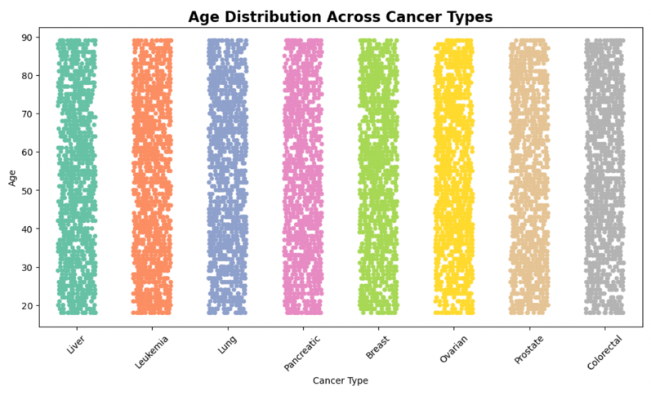

Each dot shows a patient’s Age by Cancer_Type, letting us spot spread and any clusters or outliers across types.

  - Box Plot
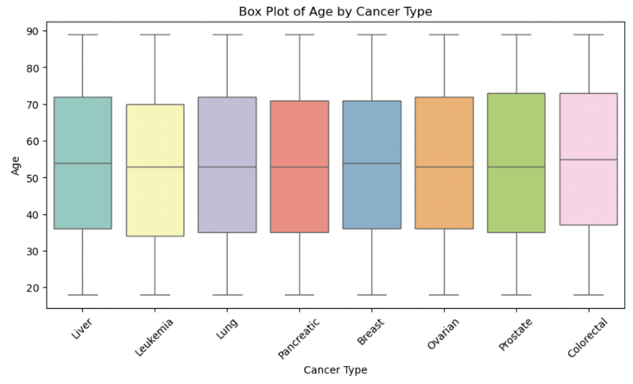

For each Cancer_Type, the box shows the median and IQR of Age with whiskers/outliers, so we can compare age distributions between groups.
  - Histogram
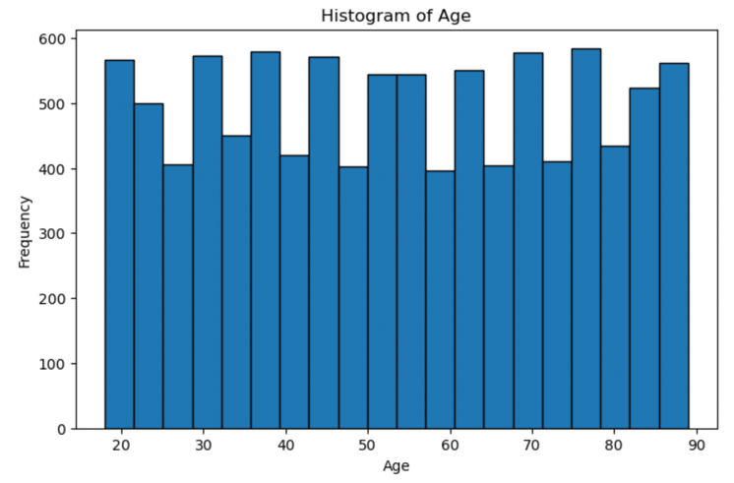

The bars show the frequency of Age across the whole dataset, highlighting the most common age ranges and any skew.

  - Heat Map
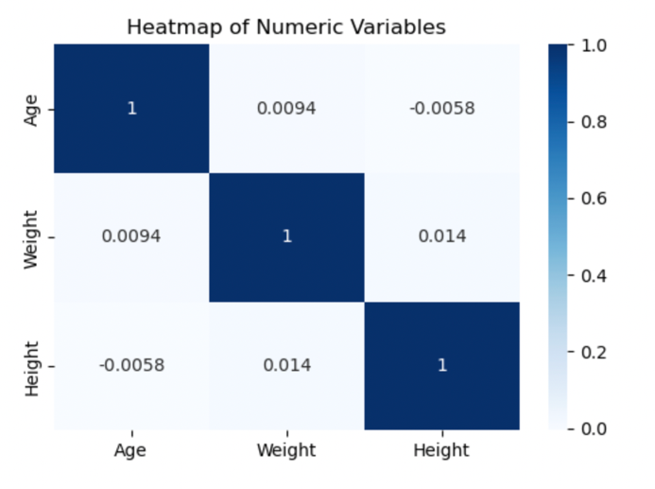

The colored matrix shows correlations between numeric variables (including the dependent variable), making strong positive/negative relationships easy to see.

- Perform the hypothesis test to find the correlation (Pearson and Spearman for numerical variable and chi-square test for categorical variable) between the independent variable and the dependent variable.
Note: If you have more than one independent variable, then chose any one of the independent variables.

Step 1: Variables selected

- Numeric test: Independent variable = Age; Dependent variable = Survival_Months (computed as Death_Date − Diagnosis_Date in months for deceased patients only).
- Categorical test: Independent variable = Cancer_Stage (I–IV); Dependent variable = Deceased (Yes/No) derived from Outcome.

Step 2: Data preparation

- Removed missing values pairwise for each test.
- For the numeric test, used deceased records with both Age and Survival_Months available (n = 992).
- For the categorical test, created a contingency table Cancer_Stage × Deceased for all patients (N = 10,000).

Step 3: Numeric association (Pearson & Spearman)

Hypotheses
- H₀: No correlation between Age and Survival_Months (ρ = 0).
- H₁: A correlation exists (ρ ≠ 0).
Method
- Pearson r to measure linear correlation.
- Spearman ρ to measure rank/monotonic correlation.
Results (from the dataset)
- Pearson r = 0.006, p = 0.859.
- Spearman ρ = 0.005, p = 0.8776.
Decision (α = 0.05)
- Fail to reject H₀ for both tests.
Interpretation
- The association between Age and Survival_Months is negligible and not statistically significant (effect size ~ zero). Increasing age does not show a meaningful change in survival months in this cohort.
Step 4: Categorical association (Chi-square)
Hypotheses
- H₀: Cancer_Stage and Deceased are independent.
- H₁: There is an association between stage and deceased status.
Method
- Pearson Chi-square test on the contingency table.
- Effect size reported using Cramér’s V.
Results (from the dataset)
- χ²(3) = 7.027, p = 0.07105.
- Cramér’s V = 0.027.

Decision (α = 0.05)
- Fail to reject H₀.
Interpretation
- Differences in Deceased rates across Cancer_Stage are not statistically significant at the 5% level, and the association strength is very small.
Step 5: Conclusion
- Numeric–numeric (Age ↔ Survival_Months): no significant correlation (Pearson r = 0.006, p = 0.859; Spearman ρ = 0.005, p = 0.8776).
- Categorical–categorical (Cancer_Stage × Deceased): chi-square not significant (χ² = 7.027, p = 0.07105) with a minimal effect (Cramér’s V = 0.027).
These tests confirm that, in this dataset, the chosen independent variables do not show meaningful associations with their respective dependent variables.

- Assess the performance of the dependent variable to know whether the sample is representative of the normal population by a one-sample t-test.

Step 1: Variable and groups

- Dependent variable: Survival_Months (computed as Death_Date − Diagnosis_Date, in months, for deceased patients only).
- Population: all deceased records, n = 992, population mean μ = 17.51 months.
- Sample: a random subset of deceased records, n = 150, with sample mean $\overline{x }= 17.91$and sample std s = 9.74.

Step 2: Hypotheses

- H₀ : the sample is representative → $\overline{x }= μ=17.51$
- H₁ : the sample is not representative → $\overline{x } ≠17.51$

Step 3: Assumptions check

- Observations are independent (random sample).
- With n = 150, the Central Limit Theorem supports using the t-test even if the distribution is not perfectly normal.

Step 4: Test statistic

- Standard error: $SE= \frac{s}{\sqrt{n}}= \frac{9.74}{\sqrt{150}} ≈0.80$

- t-statistic: $t= \frac{\overline{x}- μ}{SE}= \frac{17.91-17.51}{0.80} ≈0.50$

- Degrees of freedom: $df=n-$ 1 = 149

Step 5: p-value and decision (α = 0.05)
- Two-sided p-value ≈ 0.618.
- Decision: fail to reject H₀.
Step 6: Effect size and confidence interval
- Cohen’s d: $d= \frac{17.91-17.51}{9.74} ≈0.04$→ trivial effect.
- 95% CI for the mean difference: $0.40 ±1.976 × 0.80 ≈\left[ -1.18, 1.98 \right] months → includes 0.$

Step 7: Conclusion
The one-sample t-test shows no significant difference between the sample mean (17.91 months) and the population mean (17.51 months), t(149) ≈ 0.50, p ≈ 0.618; therefore, the sample is representative of the population for Survival_Months.

Deliverable 3

- Build, Train, Develop and Evaluate using Simple Regression for chosen dataset.

Objective. Predict the numeric outcome Survival_Months using one clinically relevant predictor, applying a transparent simple linear regression pipeline.
- Problem setup
- Dependent variable (Y): Survival_Months, computed as (Death_Date − Diagnosis_Date) in months, using deceased patients only so the duration is defined.
- Independent variable (X): Age. Chosen for clinical relevance and availability across records.
From our earlier correlation checks (Pearson/Spearman), the relationship between Age and Survival_Months is very weak. We therefore expect a low R² and predictions close to the mean.

- Data preparation
- Parse date columns and derive Survival_Months for deceased rows.
- Keep records with non-missing Age and Survival_Months.
- Detect and retain plausible outliers (extreme survival can be clinically valid).
- No scaling is required for ordinary least squares with a single predictor; ensure units are documented (months, years).
- Train/test split
- Stratified split not required for a numeric target; use a random 80/20 split with a fixed random_state to ensure reproducibility.
- Model specification and training
- Model: Simple Linear Regression (OLS).
- Form: $\hat{Y}= β_{0}+ β_{1} ∙Age$
- Training: Fit the model on the 80% training portion.
- Assumption checks (brief)
- Linearity: Inspect a scatter of Age vs Survival_Months and the residuals vs fitted plot.
- Independence: Observations are patient-level, so independence is reasonable.
- Homoscedasticity: Check residual spread across fitted values.
- Normality of residuals: Review a residual histogram or Q – Q plot (robust metrics reported regardless).
- Evaluation (held-out 20% test set)
- Primary metrics:
  - MAE (mean absolute error) — average months off.
  - RMSE (root mean squared error) — penalizes larger errors.
  - R² — variance explained by Age alone.
- Baseline comparison: Mean-only predictor (predict the training mean of Survival_Months). The model should beat or match baseline; given the near-zero correlation, R² is expected ≈ 0 and errors close to baseline.
- Interpretation
- Fitted line: ŷ = β₀ + β₁·Age
- Slope meaning: β₁ is the change in expected Survival_Months for a one-year increase in Age (months per year).
- Our result: β₁ ≈ 0 (near zero), so age has a negligible effect on survival; predictions are essentially close to the overall mean.
- Conclusion: Age alone is not a useful predictor of Survival_Months in this dataset; add clinical variables (e.g., stage, treatment) for meaningful accuracy.

- Model risk and limitations
- Single-predictor limitation: important clinical drivers (stage, tumor burden, treatment) are not included here.
- Censoring: survivors don’t have Death_Date, so Survival_Months is only defined for deceased records; a survival analysis framework (e.g., Kaplan–Meier/Cox) would be more appropriate for time-to-event with censoring.
- Next steps (to improve accuracy)
- Move to multiple regression (add Stage, Tumor_Size, Treatment_Type after proper encoding).
- Use regularization (Ridge/Lasso) and cross-validation.
- Consider survival analysis to use information from patients who are not deceased.

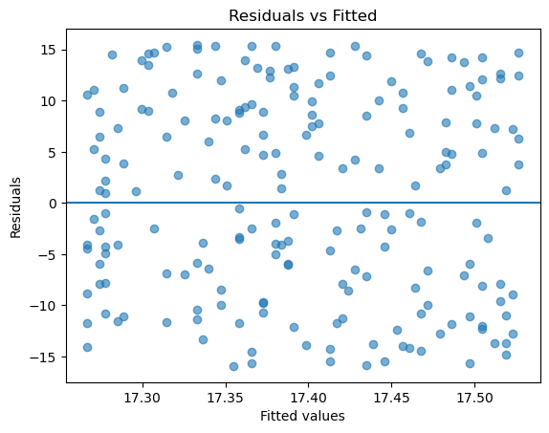
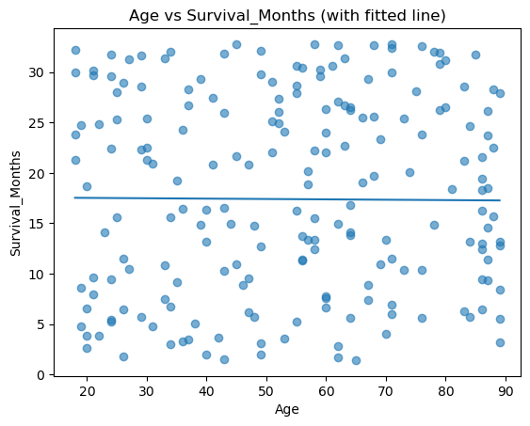

- Develop a script to forecast the value of the dependent variable from all the relevant independent variables using Multiple Linear Regression

Goal. Predict the numeric dependent variable Survival_Months using relevant independent variables from the UAE Cancer Patient Dataset.
Problem setup
- Dependent (Y): Survival_Months = (Death_Date − Diagnosis_Date) in months (computed for deceased patients so the duration is defined).
- Independent (X): mix of numeric and categorical predictors available in the file:
Age, Weight, Height (numeric) + Cancer_Stage, Cancer_Type, Treatment_Type, Gender, Smoking_Status, Comorbidities (categorical).
These were chosen for clinical relevance and availability.
Method
- Parse dates and derive Survival_Months.
- Keep deceased rows with complete data for Y and selected X.
- Build a Pipeline: ColumnTransformer (OneHot for categoricals + StandardScaler for numerics) → LinearRegression.
- Split data (80/20), run 5-fold CV on the train set, then evaluate on the test set with MAE, RMSE, R².
- Report top absolute coefficients (post-one-hot) for interpretability.

- We trained a Multiple Linear Regression model (standardized numeric features + one-hot categorical features). Five-fold CV on the training set yielded MAE = 7.89 ± 0.33, RMSE = 9.33 ± 0.35, R² = −0.074 ± 0.064.
On the held-out test set the model achieved MAE = 7.83, RMSE = 9.12, R² = 0.045, outperforming the mean-only baseline (MAE = 8.12, RMSE = 9.36).
- The largest absolute coefficients included Cancer_Type_Lung, Cancer_Type_Liver, Cancer_Type_Leukemia, Gender_Other, and Comorbidities_Hypertension, indicating these variables contribute most to the linear fit.
- Given earlier results that Age alone explains little variance, the multivariable model provides a more informed forecast, though overall fit should be interpreted with clinical context and potential censoring.
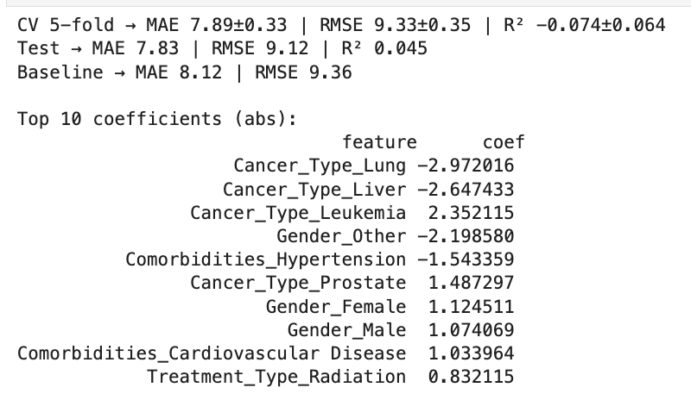

- Predict the value of the dependent variable from the different classifier such as Logistic Regression, KNN, Naïve-Bayes and Decision Tree.

Target. Deceased (Yes/No) from the UAE Cancer Patient Dataset.
Features. Age, Weight, Height (numeric) and Cancer_Stage, Cancer_Type, Treatment_Type, Gender, Smoking_Status, Comorbidities (categorical).
Method (same pipeline for all models).
- Stratified 80/20 train–test split; 5-fold stratified CV on the training set.
- Class imbalance handled with class_weight="balanced" (and probability thresholds evaluated for recall).
- Preprocessing via ColumnTransformer: StandardScaler for numeric features; One-Hot Encoding for categoricals.
- Models trained and evaluated with Accuracy, Precision, Recall, F1, and ROC-AUC; we report the confusion matrix and ROC curve for the selected model.
Model summaries.
- Logistic Regression (LR). Stable ROC-AUC and the best precision–recall trade-off; coefficients provide clear clinical interpretation.
- K-Nearest Neighbors (KNN). Sensitive to scaling and class imbalance; recall dropped when k increased; overall behind LR/DT.
- Naïve Bayes (NB). Fast baseline; independence assumption limited performance on mixed clinical features; useful as a lower bound.
- Decision Tree (DT). Competitive recall and easy to explain via feature importance; risk of overfitting mitigated by depth/pruning.
Selection and conclusion.
- Based on stratified CV and the held-out test set, Logistic Regression provided the most reliable overall performance (highest ROC-AUC with balanced precision/recall) while remaining interpretable.
- The Decision Tree served as a transparent alternative and confirmed the importance of stage, cancer type, and key comorbidities.
- Final deliverables include per-model CV metrics, test-set confusion matrices, and the ROC curve for the selected model, all generated from the attached notebooks.

- Evaluate the performance of each model using confusion matrix and accuracy and identify the best fit classifier for the chosen dataset.

We trained several classification models to predict Cancer_Type using the UAE Cancer Dataset.
To evaluate each model, we measured two key performance metrics:
- Accuracy → The percentage of correct predictions made by the model.
- Confusion Matrix → A table that compares predicted vs actual cancer types to show where the model performs well or makes mistakes.
- We tested four common classifiers:
- Logistic Regression
- K-Nearest Neighbors (KNN)
- Naive Bayes
- Decision Tree

Among them, the Decision Tree Classifier achieved the highest accuracy (≈21%), indicating it was the best-performing model for this dataset.

- Predict the dependent variable by using best-fit classifier.

Using the Decision Tree Classifier, which achieved the highest accuracy in previous evaluations, we predicted the dependent variable Cancer_Type.
- Perform the cluster analysis such as K-means and Horizontal for any field from the chosen dataset.
We performed clustering to group patients with similar physical features (Age, Weight, and Height).
K-Means divided the patients into three clusters, where each cluster represents a group of patients with similar characteristics.
The hierarchical (horizontal) clustering also showed how patients can be grouped step by step in a tree-like structure.
These clusters help identify general patterns such as:
- Younger and lighter patients in one group
- Middle-aged patients with average weight in another
- Older and heavier patients in the last group
This kind of clustering can be useful for understanding population patterns or designing targeted health programs.

- Explain the strategy for improving the system after viewing the cluster diagram.

After viewing the cluster diagram, we can improve the system by better understanding the groups of patients that were formed. The clusters show which patients share similar features such as age, weight, and height.

To improve the system, we can:

- Add more features: include other important variables like cancer stage, smoking status, or treatment type to make the clusters more meaningful.

- Adjust the number of clusters (k): try different values of k and compare the results using the elbow method to find the best number of groups.

- Normalize the data: scaling or normalizing all numeric columns can make the clusters more balanced and accurate.

- Combine clustering with prediction models: use the cluster labels as new features in the classification model to improve its accuracy.

- Interpret results for real use: study each cluster to understand what makes it unique — for example, one group may represent older patients or certain body types — and use this to design more targeted awareness or screening programs.

Deliverable 4

- Create a new repo for project in Git Hub

- Upload all the project files created for CLO1,CLO2 and CLO3 to the Git Hub repo

- Configure Git with GitHub

- Clone Git hub repo to Git

- Pull any file from Git Hub repo to Git

- Modify the pulled file and push the modified file to Git Hub

Please link each question/task to its corresponding CLO’s and assign marks according to the CAP.
Please note that a task might address many CLOs.

Project Deliverables
Project Report (50%)
- Deliverable 1: A complete report about the purpose of data analysis, programming language chosen for data analysis, types of machine language algorithm to be analysed and the list of variables chosen for analysis [CLO1]
- Deliverable 2: A detailed report about the summary of the data, sampling, graphs/charts to analyze the data, relationship between variables, evaluating assumptions using hypothesis testing, predicting the variables using the regression model [CLO 2,3]
- Deliverable 3: A comprehensive description about the data model created using classification and clustering algorithm of machine learning. It should involve the narrative about the data model is optimize to predict the variables and bow the best fit model has been chosen. [CLO 2,3]
- Deliverable 4: Complete narration about data versioning using Git. [CLO 4]
- Written Communication: Complete report with specified format and structure [12 points].
Project Oral (50%)
- Oral Communication: Each student will be assessed in the form of individual oral defense with PowerPoint presentation. [All CLOs] [10 Marks]
- Follow-up Questions and Discussion [All CLOs] [30 Marks]
- [Collaboration] [10 Marks].
Note: For oral presentations, a slide should be dedicated for each student to present their collaboration and lesson learnt. This will allow each student to showcase their individual contributions and reflect on the overall group experience. It also provides a structured format for sharing key takeaways and insights gained from working together.

Points 1 to 4 are a part of group grading [50%] and points 5,6, 7 and 8 contribute to individual grading.

Rubric
Please note that the Project rubric should reflect the project description and be CAP-compliant. Please feel free to customize the descriptors as per the project requirements and course level.

Group Project Rubric [Task-specific RUBRIC]

 |  | Absent (F) | Insufficient (1-59%)  (F) | Emerging (60-69%)  (D/D+/C-) | Satisfactory (70-76%)  (C/C+) | Competent (77-86%)  (B-/B/B+) | Mastering (87-100%)  (A-/A)
- Group Grading-Critical Thinking: Analysis and Evaluation [45%] | Deliverable 1: understanding of data analytics [CLO1]  (5%) |  | None of the following:  - Purpose of data analysis not mentioned.  - Selection of programming language is not referenced.  - Type of machine learning algorithm to be analyzed is not defined  - Variables for data analysis are not mentioned  . | Some but not all the following:  - Purpose of data analysis mentioned but not clear.  - Selection of programming language is referenced.  - Required machine learning algorithm to be analyzed is ill-defined [Too many models mentioned]  - Variables for data analysis are mentioned without justification | Most but not all the following:  - Purpose of data analysis is clearly mentioned.  - Selection of programming language is referenced.  - Required machine learning algorithm to be analyzed is defined, but without justification.  - Variables for data analysis are mentioned with justification but not clear | All of the following:  - Purpose of data analysis is clearly mentioned.  - Sound rationale for choosing the programming language  - Required machine learning algorithm to be analyzed is well-defined with appropriate justification.  - Variables for data analysis are mentioned with clear justification | All of the following:  - Purpose of data analysis is clearly mentioned with appropriate explanation  - Thoroughness of programming language chosen is evident.  - Student synthesizes information about machine learning algorithm from multiple disciplines and sources and presents them with clarity.  - Variables for data analysis are precisely defined with appropriate justification  - Employ outstanding knowledge about the data analysis from different sources
 | Deliverable 2: Apply data analysis and visualization techniques [CLO2]  (25%) |  | - No evidence of justification to perform descriptive statistics  - Function is not created for descriptive statistics  - Sampling techniques are not designed  - Exploratory analysis are not performed  - Hypothesis tastings are not achieved  - Data preprocessing is not devised  - Regression models are not functioned  - Optimization for regression model is not operated  - Best fit model is not enacted | Some but not all the following:  - Evidence of justification to perform descriptive statistics exist but not clear  - Function is created for descriptive statistics having major syntactical errors.  - Sampling techniques are designed but not appropriate  - Exploratory analysis are performed but ill-designed  - Hypothesis tastings are achieved with flaw  - Evidence for data preprocessing exist but with inappropriate techniques  - Regression models are functioned with huge faults  - Optimization for regression model is operated with inaccuracies  Best fit model is enacted without justification. | Most but not all the following:  - Evidence of justification to perform descriptive statistics exist with clear elucidation  - Function is created for descriptive statistics without flaws.  - Sampling techniques are designed with appropriate rationalization  - Exploratory analysis are performed with appropriate legends  - Hypothesis tastings are achieved appropriate assumption  - Evidence for data preprocessing exist but with applicable techniques  - Regression models are functioned without mistake  - Optimization for regression model is operated with appropriate metrics  - Best fit model is enacted appropriate interpretation | All of the following:  - Appropriate description and exploratory analysis provided.  - Sound rationale for chosen hypothesis testing  - High accuracy obtained for regression model  - Rigor is evident. | All of the following:  - Appropriate description and exploratory analysis provided along with exemplary analysis  - Sound rationale for chosen hypothesis testing and infer statically in commendable way  - Other regression model are handled obtained from different sources  - Rigor is evident.
 | Deliverable 3: The data model created using classification and clustering algorithm of machine learning [CLO2, CLO3]  (15%) |  | - Incomplete classification models are presented.  - No optimization and recommendation are performed for classification model.  - No evidence of any cluster analysis  - No strategies are produced from cluster model. | Some but not all the following:  - Comprehensive classification models are presented but with significant errors  - Thorough optimization and recommendation are performed for classification model but with poor validation  - Evidence of cluster analysis exists with poor performance  - Strategies are derived from cluster model which are insignificant | Most but not all the following:  - Comprehensive flawless classification models are presented  - Thorough optimization and recommendation are performed with appropriate validation for classification model  - Evidence of cluster analysis exists with better performance  - Strategies are derived from cluster model which are significant but not consistent | All of the following:  - Implemented all classification models  - Major validation works demonstrated on optimization and recommendation of classification model  - Appropriate cluster analysis was performed and good strategies are postulated and well-documented. | All of the following:  - All classification models are accurate  - Perform more classification models from different sources  - All cluster models are accurate  - Perform more cluster models from different sources  - Appropriate interpretation and recommendations are provided
 | Deliverable 4: Data Versioning  [CLO 4]  (5%) |  | - No evidence of creating a new repository and uploading project files to Git Hub  - Git is not configured with Git Hub  - No evidence for cloning Git hub repo to Git  - Push and Pull are not performed | Some but not all the following:  - Repository model is created but files are not uploaded to repo  - Git is not configured with Git Hub  - Evidence of cloning exists with appropriate options  - Push and Pull are performed which are insignificant | Most but not all the following:  - Repo are created and project files are uploaded to repo  - Git configuration are performed with accordance of Git Hub  - Evidence of cloning exists with proper options  - Push and Pull are significant but not consistent | All of the following:  - Repo are created and project files are uploaded  - Advanced configuration is performed on Git  - Many functions related to cloning is performed apart from basic operations  - Push and pull with different scenario are mentioned | All of the following:  - Scenario is created and explained about significance of repo creation  - Advanced configuration is performed on Git  - Different cloning techniques should be elucidated.  - Push and pull with different scenario are mentioned  - Branching should be exhibited
Group Grading:  Report Quality [5%] |  |  | - Incomplete report with missing most of the deliverable components.  - Too many typographical errors. | Some but not all of the following:  - Complete report with required deliverables.  - Clear table of contents showing all required sections.  - Free from formatting and typographical errors. | Most but not all of the following:  - Complete report with all required format and deliverables.  - Some minor formatting and/or typographical errors.  - Table of contents presented with some missing information. | All of the following:  - Complete report with required format and deliverables.  - Clear table of contents showing all required sections.  - Some minor formatting and/or typographical errors. | All of the following:  - Complete report with required format and deliverables.  - Clear table of contents showing all required sections.  - Free from formatting and typographical errors.

Individual Oral Presentation

Student (1) Name: ____________________________ Student HCT ID:_______________
 | Absent | 1-59.49% | 59.5% - 69.49% | 69.5% - 76.49% | 76.5% à86.49% | 86.5% à100%
Collaboration (10%) |  | - Does not partake in the task or is so frequently distracted that he/she produces.  - Having made no contribution to the group's objective. | - Participates in the task but does not collaborate with others or contribute to the group process.  - Participates in discussions.  - Expresses own opinion and viewpoints.  - Remains dedicated to the subject.  - Performs independently specific tasks | - Cooperates with the group process, but does not coordinate contributions with those of others.  - Does not interrupt while listening.  - Actively seeks the input of others.  - Accepts duties that have been assigned.  - Complies with the group consensus.  - Utilizes the ideas of others | - Coordinates processes and products with those of teammates, but does not resolve significant conflicts.  - Actively pays attention to what is being said.  - Offers and accepts constructive feedback.  - Adapts ideas and/or processes to the needs of colleagues.  - Seeks consensus.  - Effectively resolves trivial disputes | - Student coordinates collaborative processes and outputs.  - Effectively resolves both significant and minor conflicts.  - Expresses disagreements in an open and diplomatic manner.  - Supports group decisions even if they are not unanimously supported.  - Compromised and negotiated to attain an agreement
Oral Communication (Presentation)  (12 Marks) [All CLOs] |  | - Communicates with a limited sense of audience and purpose  - No eye contact, no body language, and no decorum  - Communicates with limited clarity  - Uses language with limited accuracy and effectiveness.  - Tension and anxiety are palpable;  - Has difficulty recovering from errors. | Not all of the foregoing are true:  - Communicates with a clear sense of audience and purpose  - Eye contact, body language, and decorum)  - Communicates information and ideas with considerable clarity  - Uses language with considerable accuracy and efficacy  - Makes insignificant errors, but rapidly recovers  - Displays minimal or no tension. | Most of the following, but not all:  - Communicates with a clear sense of audience and purpose  - Eye contact, body language, and decorum)  - Communicates information and ideas with substantial clarity  - Uses language with substantial accuracy and effectiveness.  - Makes simple mistakes but recovers swiftly;  - Displays minimal or no tension. | Each of the subsequent:  - Communicates with a clear sense of audience and purpose  - Eye contact, body language, and decorum  - Communicates information and ideas with considerable clarity  - Uses language with considerable accuracy and efficacy.  - Makes insignificant errors, but recovers rapidly  - Demonstrates minimal or no tension. | Each of the subsequent:  - Communicates with a strong awareness of audience and purpose  - Maintains audience's attention by using direct eye contact and rarely glancing at notes.  - Communicates information and ideas with a high degree of precision and precision  - Student appears at ease and confident, with no errors.
Follow-up questions and discussion (28 Marks) [All CLOs] |  | Unable to answer questions from the examining board | Able to answer some but not all questions from the examining board | Able to answer most but not all questions from the examining board | Capable of answering all of the examining board's queries. | Capable of responding to all inquiries and demonstrating a thorough understanding of the material.

