LegalSkillEvolve: Evolving Skill Memory for Fact Elicitation in Simulated Legal Consultation
[PENDING METADATA — authors, affiliations and corresponding author]
Working manuscript · Protocol synchronized to the reviewed implementation on 11 September 2026 · Main training in progress; empirical results pending

Abstract
Effective legal consultation depends on eliciting material information without imposing unnecessary questioning. We introduce LegalSkillEvolve, a framework that accumulates reusable natural-language consultation skills while keeping the underlying language models frozen. In the reviewed implementation, an opening-only planner is skill-blind; a fixed session bundle is supplied only to the consultation policy, and a deterministic StopGate can redirect premature termination or actions disallowed by encoded structural and stopping rules. Across eight sequential blocks, four full trajectories per training case provide reward-separated, outcome-typed contrasts for fact elicitation, evidence-gap recognition and efficient stopping. A teacher abstracts cumulative evidence into candidate skill documents, which enter the working library only after static format, provenance, information-boundary, duplication and capacity checks. These gates establish admissibility, not legal correctness or effectiveness. The planned final evaluation crosses 30 adaptation-held-out Chinese DLawBench cases with four client personas. The primary estimand is the case-level mean of session new-fact-bearing-question rates, accompanied by separate fact and question outcomes, quality metrics and failure counts. [PENDING RESULT — insert the designated L8-versus-Base effect, 95% case-level confidence interval and the separately supported fact and question conclusions]
Keywords: legal consultation; large language models; fact elicitation; skill memory; experience-based learning; interaction efficiency

1. Introduction
The usefulness of a legal consultation depends on the information elicited before advice is formulated. A client may initially describe only a consequence, omit a relevant event or express a belief inconsistent with available evidence. The consultant must decide which uncertainty to address next, distinguish information the client can supply from evidence that must be obtained elsewhere, and stop when additional questioning is unlikely to improve the consultation. These decisions jointly determine the completeness of the resulting account and the burden placed on the client.
Recent legal benchmarks evaluate doctrinal reasoning, long-context synthesis, multi-turn consultation and agentic workflows [1–3,18–22]. DLawBench is especially relevant because it represents consultation as an interaction with clients who differ in disclosure behavior [3]. This setting raises a process question beyond final-answer quality: can an agent learn reusable interviewing procedures that increase information obtained per question? Higher final quality achieved through substantially more questioning is not equivalent to more efficient elicitation, while a short dialogue that omits material facts is not successful.
External memory can adapt behavior without changing model weights. Verbal reflection, accumulated experience, workflow memory and evolving context have all been used to guide later agent actions [4–8]. For legal consultation, however, reward differences alone do not reveal whether a better trajectory asked a more informative question, recognized an external evidence requirement or stopped at an appropriate point. LegalSkillEvolve therefore records outcome-typed trajectory contrasts as evidence for procedural hypotheses; the final library, rather than any admitted document, is the treatment evaluated on held-out cases.
The system separates online consultation from offline evidence accumulation. The opening-only planner constructs an initial investigation agenda without skill context. During dialogue, a policy receives a fixed session bundle selected from the current library; a shared memorandum renderer sees only the visible record. Between blocks, a teacher proposes compact procedures from cumulative training evidence. Static trust gates govern admission, while prequential diagnostics and the final frozen-library comparison evaluate the consequences of accumulation.
The study makes three bounded contributions: an implementation-auditable skill-memory framework for simulated legal consultation; outcome-typed evidence records linking full-trajectory variation to reusable procedural hypotheses; and an evaluation design that treats elicitation yield, absolute facts, question burden, quality and failures as distinct outcomes. The empirical contribution remains prospective until the frozen experiments are complete.

2. Related work

2.1. Legal reasoning and interactive consultation
LegalBench and LawBench evaluate broad legal capabilities [1,2], while DLawBench models multi-turn consultation using finite client beliefs, reference facts and evaluation rubrics [3]. LeCoDe, UCL-Bench, MILE, LegalAgentBench and PLawBench further illustrate the move toward realistic legal documents, interactive environments and agentic legal tasks [18–22]. We evaluate a modified local consultation system on the public 30-case Chinese DLawBench subset; this is not a reproduction of the benchmark's full simulator or scoring configuration. The project-level holdout claim is limited to exclusion from adaptation and tuning, not absence from foundation-model pretraining.

2.2. Learning through external experience and skill memory
Reflexion uses verbal feedback to improve later attempts [4], ExpeL extracts reusable experience [5], and Agent Workflow Memory induces recurring workflows [6]. TF-GRPO organizes group-relative feedback into an evolving experience representation without weight updates [7], while ACE studies the maintenance of structured agent context [8]. LegalSkillEvolve uses group-relative reward only to organize observational trajectory contrasts; it performs neither gradient-based policy optimization nor a counterfactual estimate of action effects.
Recent work also studies evolving skills. SAGE combines sequential skill accumulation with parameter-updating reinforcement learning [9], and SkillOpt refines strategy documents through bounded edits and validation-based selection [10]. LegalSkillEvolve instead directly admits source-bound natural-language procedures after static gates and evaluates the accumulated library. This combination is a design contribution, not a claim that skill memory or group-relative experience is new; a static prompt control and a simpler adaptive experience-memory baseline are therefore necessary for the present attribution claim.

2.3. Evaluating efficiency and model-based assessment
Consultation efficiency requires both a numerator and a denominator. We distinguish first-disclosed client fact identifiers from opening content and repeated disclosures, and report question counts so that a favorable ratio cannot conceal reduced information recovery. Model-based assessment remains useful for semantic inquiry and memorandum quality, but agreement between language-model judges is not independent legal validation [11]. Event reconstruction, controlled perturbations, a second model, and domain-expert review answer different validity questions. SimulatorArena similarly underscores that environment validity is part of agent evaluation rather than a background assumption [23]. Statistical inference therefore uses cases as the independent units [12,13].

3. Problem formulation
Let a consultation case contain a public opening $o$, a finite collection of client beliefs, hidden reference facts and offline evaluation criteria. The lawyer observes the opening, the visible dialogue and a structured investigation state $s_{t}$. It does not observe the client’s undisclosed beliefs, the court record or the scoring rubric. A frozen policy with parameters $θ$ conditions on a fixed session skill bundle $M$ to produce the next action:
$a_{t}∼π_{θ}\left( ⋅∣o,h_{t},s_{t},M \right), θ \text{fixed}.$ (1)
The interaction ends when the policy chooses to finalize, or when the environment terminates an invalid run. A separate shared renderer produces a memorandum from the visible record. For a completed trajectory $τ$, let $F\left(τ\right)$ be the number of distinct client fact identifiers first disclosed after the opening, and let $Q\left(τ\right)$ count questions actually presented to the client. The primary efficiency endpoint is
$Y\left(τ\right)=\frac{F\left(τ\right)}{max\{Q\left(τ\right),1\}}.$ (2)
Writing completed sessions with index i, an immediate finalization has Y_i=0. Opening repetitions and repeated disclosures do not increase F_i. On the normal contract path—at most one fact identifier per response, disclosure triggered by a question, and exceptional fallbacks reported separately—Y_i equals the fraction of question turns that produce a new fact and is bounded by one. It does not measure the number of facts a human might bundle into an open-ended answer. The primary aggregate is the mean of session ratios after averaging personas within cases; the pooled ratio ΣF/ΣQ is a sensitivity analysis, not the same estimand. Client beliefs are statements, not automatically legal or factual truth.
The primary confirmatory claim concerns yield. The stronger phrase “more facts with fewer questions” is used only if the directional evidence jointly supports ΔF>0 and ΔQ<0. Equality of quality outcomes is not assumed from a non-significant difference; preservation claims require a prespecified non-inferiority design or appropriately narrow descriptive wording.

4. LegalSkillEvolve

4.1. System overview and information boundaries
Figure 1 reflects the reviewed implementation. The online process uses a frozen Qwen3-8B snapshot for an opening-only, skill-blind investigation plan, policy decisions and memorandum rendering [14]. Active skills are supplied only to the policy. The policy proposes an action, after which a deterministic StopGate can execute it, redirect it to a clarification or information request, or invoke a factual fallback. The client router and offline judge use frozen gpt-oss-20b weights [15]. Offline learning occurs only between experience blocks.
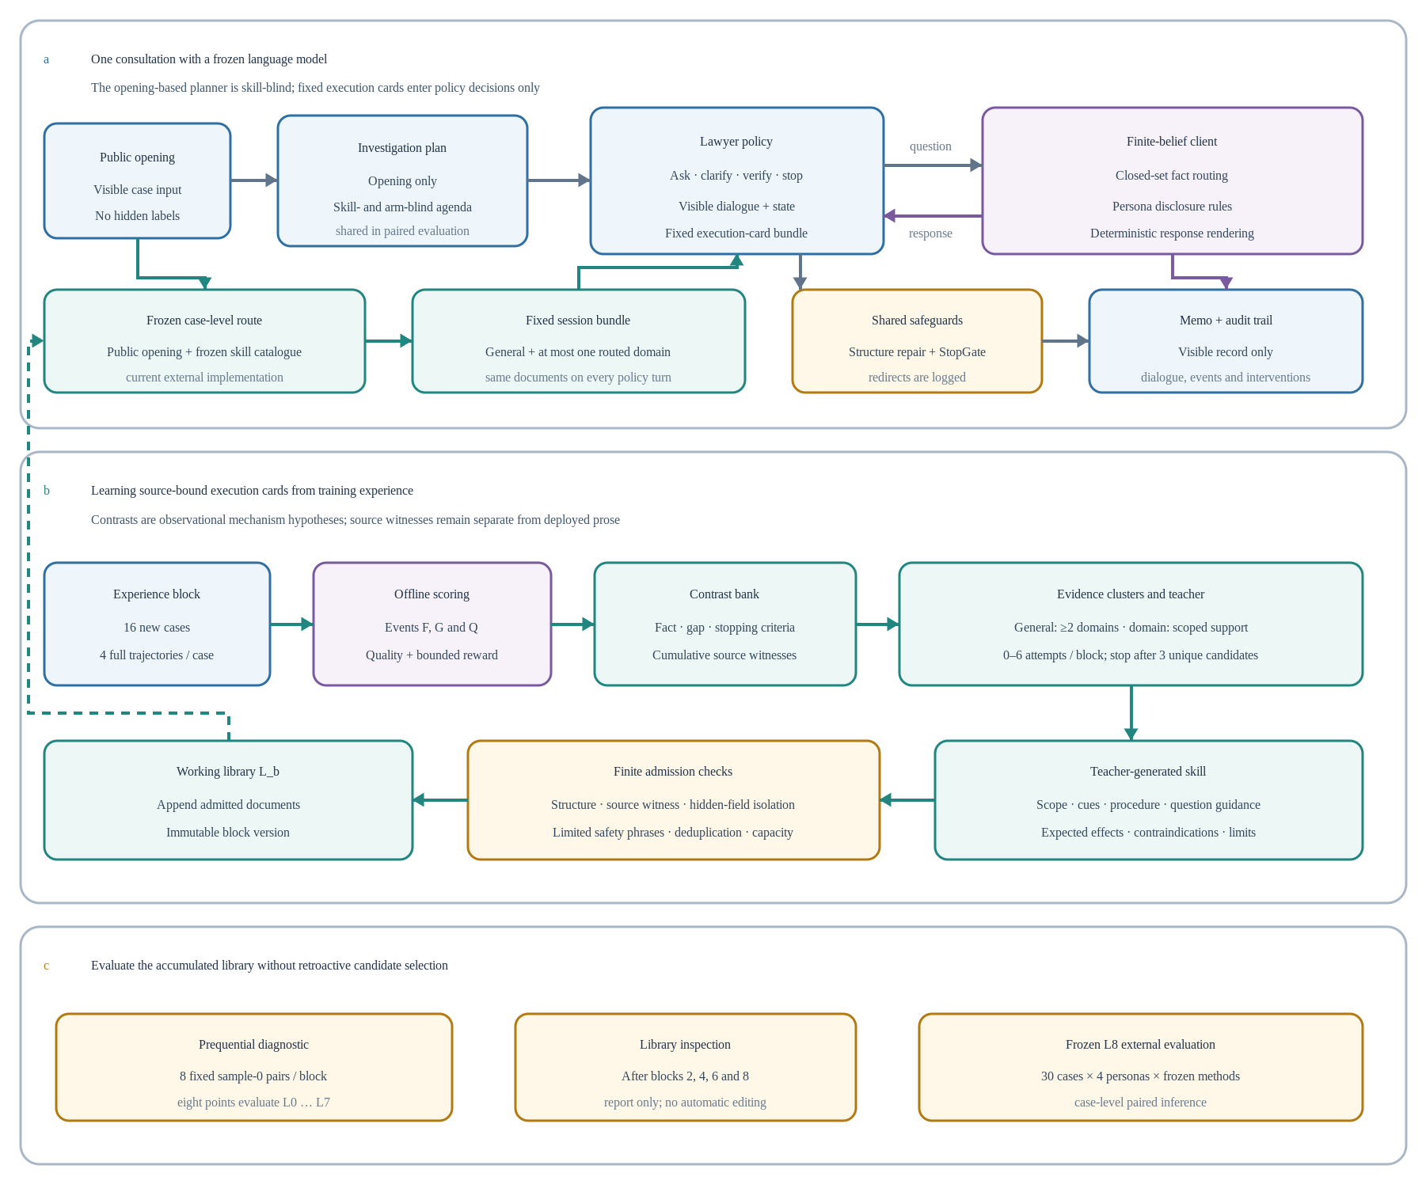
Figure 1. Current LegalSkillEvolve protocol. (a) The planner receives the public opening but no skill text; the policy receives the fixed session bundle. Public-opening routing currently selects general skills and at most one domain bundle, and the StopGate can alter the executed action. (b) Four trajectories per case provide outcome-typed observational contrasts. At each block, the teacher may make up to six attempts and stops after three unique proposal fingerprints; qualified documents enter the next library. (c) Blocks L0–L7 provide prequential development diagnostics, while the frozen L8 library is designated for external evaluation.
The client is implemented through a frozen gpt-oss-20b closed-set router [15], a persona disclosure policy and a deterministic response renderer. The router sees the current question and the complete, consistently ordered client-belief pool, but not the active skills, arm label, court record or evaluation rubric. It does not use the disclosure history to change the semantic match. Previously disclosed facts are recognized as repetitions after routing. Cooperative and dependent clients disclose matched information directly; withdrawn and adversarial clients additionally use a bounded classifier of disclosure conditions. The answer renderer remains tied to the permitted client belief.
The offline judge uses a stateless prompt but the same frozen gpt-oss-20b weights as client routing. Prompt, input and cache isolation prevents direct state sharing; shared weights nevertheless remain a potential common source of model bias. The teacher receives training evidence only. Neither an additional model judge nor these architectural separations constitute legal-expert validation.

4.2. Skills as fixed session context
A skill is a structured natural-language document with scope, recognition cues, a procedure, question guidance, expected effects, contraindications and failure modes. These fields advise the policy; they are not compiled into executable triggers. System-owned evidence records separately retain source cases, trajectories and reference labels. Independently of skills, the StopGate may redirect a proposed action, so original and executed actions must both be logged and reported.
At session start, the system selects and deterministically orders active general skills and, when routed, at most one domain-scoped set. The rendered bundle remains fixed for the consultation and is supplied to the policy only—not to the opening planner or memorandum renderer. Each policy-facing document is limited to 2,000 characters and each applicable bundle to 8,000 characters including its wrapper. These are character limits rather than tokenizer-derived budgets.
For the reviewed external path, a Qwen3 router sees the public opening together with the active skill catalogue and predicts a general-plus-domain route. That prediction is passed to both arms and stored in policy-visible state. Consequently, an empty skill bundle alone does not guarantee that Base and Ours differ only by skill text: the learned library can affect the shared route. [PENDING PROTOCOL — before any confirmatory external execution, freeze and verify a library-independent route (for example, public metadata fixed identically across arms or a general-only route); treat results produced before this freeze as exploratory]

4.3. Independent trajectory groups and relative feedback
The 128-case training corpus is partitioned into eight disjoint blocks B_1,…,B_8 of 16 cases. The initial library L_0 is empty. Within block b, each case is run under the same block-start library L_{b−1} and cooperative persona. Four sampling streams produce independent complete trajectories. Their opening plans are independently sampled by the skill-blind planner, so trajectories need not share a plan or intermediate state.
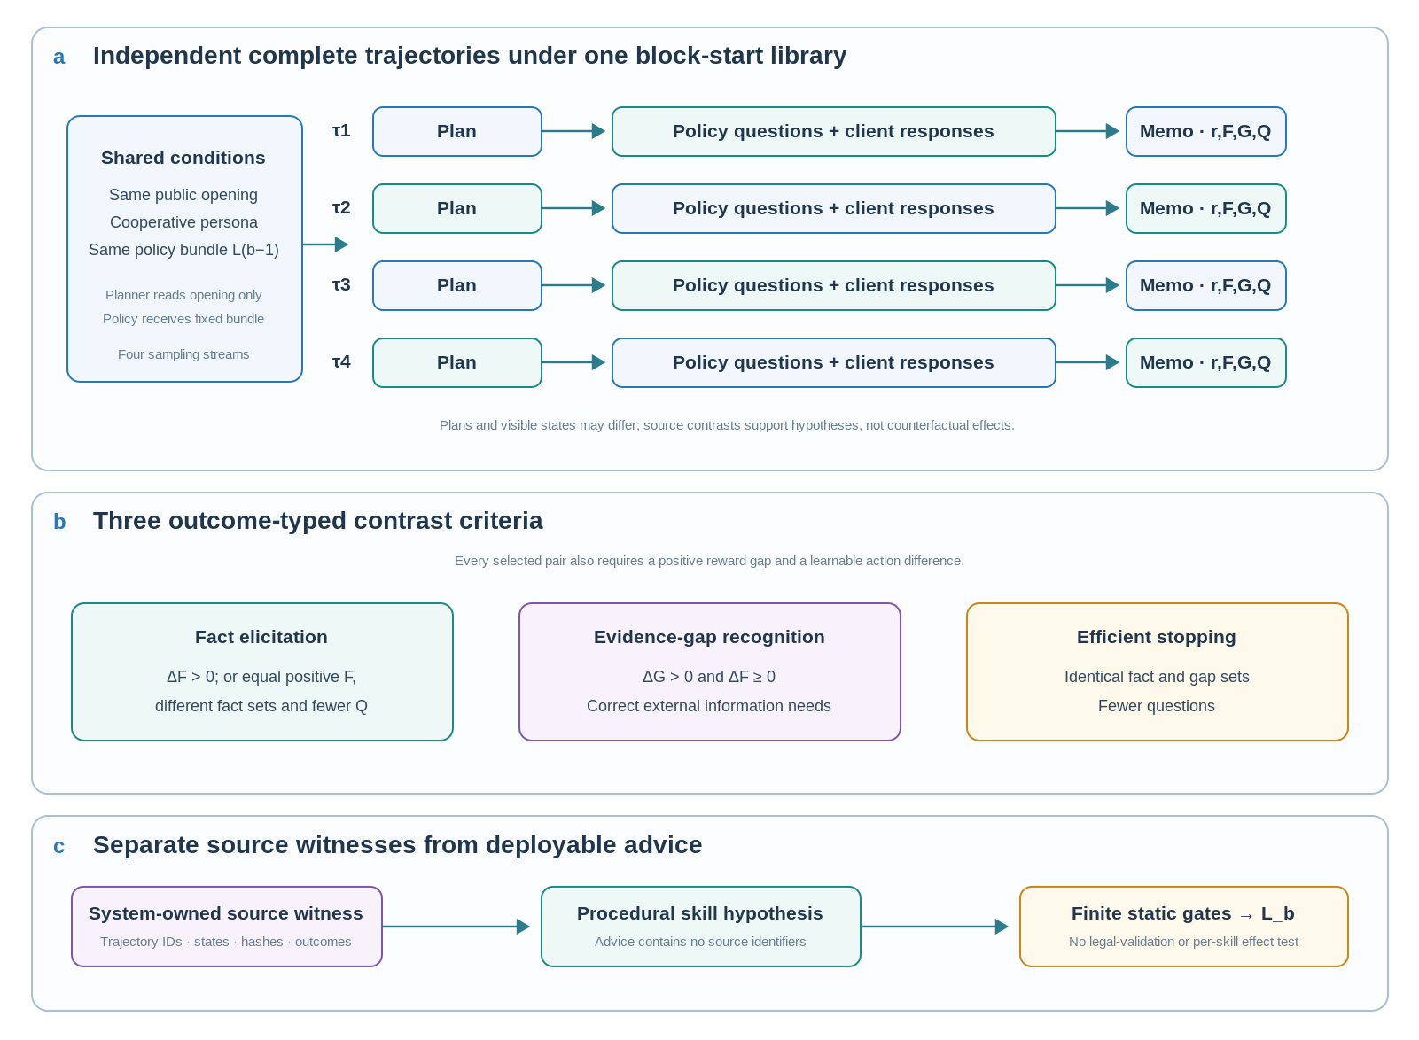
Figure 2. From full-trajectory variation to reusable skill hypotheses. (a) Four consultations share the opening, persona and block-start library but may differ in plans and visible histories. (b) A positive reward difference is paired with an observable outcome type: fact elicitation, evidence-gap recognition or efficient stopping. Stopping additionally requires equality of the corresponding identifier sets. (c) Immutable source witnesses remain separate from deployed advice. These criteria create auditable observational hypotheses; they do not identify an isolated causal effect of an action or skill.
Training reward combines an elicitation component, a resolution component and memorandum fidelity, with penalties for additional and repeated questions:
$r_{raw}=0.45E_{tr}+0.45R_{tr}+0.10Fid−0.02max\{Q−1,0\}−0.05Rep.$ (3)
The elicitation component $E_{tr}$ is the harmonic mean of event-based disclosure coverage and substantive inquiry coverage. The resolution component $R_{tr}$ averages elicited-correct-fact coverage and issue-resolution coverage. Caps apply to premature finalization, unsupported claims and absence of substantive inquiry; hidden-information leakage sets reward to zero. The final reward is bounded below by zero. Appendix A distinguishes this training signal from the reported DLawBench-style metrics.
For a four-trajectory group, the recorded relative advantage is
$A_{k}=\frac{r_{k}−\overline{r}}{σ_{r}+{10}^{−8}}, k=1,…,4,$ (4)
Here r̄ is the within-group mean reward and σ_r is its population standard deviation. This is GRPO-inspired relative-feedback bookkeeping, not gradient optimization. Mechanism selection additionally requires a positive reward gap between eligible trajectories. A group without informative variation cannot generate a positive contrast.
Runtime health is assessed separately from strategic performance. Repeated, broad or unproductive questions and an early stop remain legitimate negative learning examples when their execution is valid. Broken protocols, hidden-field leakage, non-attributable fallbacks and incomplete groups do not constitute reliable source evidence. The configured block requires at least 12 healthy, scoreable case groups out of 16 before learning proceeds.

4.4. Mechanism-specific contrast selection
Let $F^{+}$ and $F^{−}$ be the sets of newly disclosed fact identifiers in two trajectories, and let $G^{+}$ and $G^{−}$ identify correctly recognized external evidence gaps. Every selected pair must have positive reward difference and an observable difference in a learnable action. The selector then considers three mechanisms.
Fact elicitation. A pair is eligible when the higher-reward trajectory discloses more facts. It is also eligible when both disclose the same positive number of facts, recover different fact sets and the higher-reward trajectory asks fewer questions. The latter condition concerns equal counts, not preservation of identical information. A fact contrast does not additionally require non-decreasing evidence-gap coverage.
Evidence-gap recognition. A pair is eligible when the higher-reward trajectory identifies more valid external evidence gaps without reducing the number of disclosed facts. A gap records an information need that must be resolved outside the client’s available knowledge; it is not itself an additional client fact.
Efficient stopping. A pair is eligible when both trajectories have identical disclosed-fact and evidence-gap sets and the higher-reward trajectory uses fewer questions. This mechanism avoids attributing efficiency to the loss of already attainable information within that pair. It does not, by itself, prove that either trajectory found every material fact in the case.
The selector retains at most one pair per mechanism per case group. It records the first learnable action difference, each trajectory's own visible state and source-bound outcome evidence. The two witnesses are not required to share an identical plan, history or pre-action state. A source witness therefore demonstrates compatibility with the selection rule and provenance, not entailment, counterfactual sufficiency or causal effect.

4.5. Cumulative evidence and teacher abstraction
Selected contrasts enter an accumulated source bank with trajectory and evaluation hashes. A source group retains the library under which it was generated; the bank can therefore contain evidence collected under different earlier libraries. Empty-library diagnostic shadows never enter this bank.
Evidence is clustered by mechanism, action transition and behavioral family. A general-scope cluster requires source evidence from at least two domains, whereas a domain-scoped cluster is restricted to its declared domain. The latter may be supported by one source case and should not be described as independently replicated evidence. Scope variants can share underlying contrasts.
At each block end, the system can attempt up to six previously unattempted evidence fingerprints and stops once three unique proposal fingerprints have been obtained. Selection favors mechanism and domain coverage. A growing cluster may be reconsidered when its source-group fingerprint changes. Teacher context is bounded to 15 source groups, at most two per source case, while preserving the cross-domain rule for a general proposal.
The teacher, configured through the mutable deployment alias gpt-5.6-luna, emits a candidate document or no-operation response. Across eight blocks, the configured hard ceiling is 48 teacher attempts, while at most three unique proposal fingerprints per block can proceed toward admission (24 across the run). No-operation responses, repeated fingerprints, hard-check rejection and capacity exclusion can reduce the number of admitted skills. Attempts, unique proposals and admitted skills are distinct counts.

4.6. Direct admission and library inspection
Each proposed document undergoes static checks for schema and procedural content, source-witness consistency, prohibited hidden information, bounded legal and operational language, duplication and joint prompt capacity. These checks verify conformity to the encoded rules. They do not establish legal correctness, safety in real consultations, effectiveness on source cases or an individual treatment effect.
Duplication checks combine structural identity, scope redundancy and a lexical near-duplicate filter. These checks do not amount to exhaustive semantic equivalence or legal-conflict detection. Candidates that pass the hard checks are appended to the active working library at that block’s end; candidates that fail remain in the audit record. The update can be expressed as
$L_{b}=L_{b−1}∪C_{b}^{admitted}, b=1,…,8.$ (5)
The union denotes an immutable versioned collection with jointly feasible applicable bundles. There is no waiting period in which a subsequent block accepts or rejects an individual candidate. Figure 3 makes the temporal order explicit. Inspection after blocks 2, 4, 6 and 8 reports library validity, duplication and capacity together with available diagnostics. In the reviewed implementation, this inspection performs no automatic merge, deletion or reward-based pruning. A condition requiring operator review must be reported as a protocol event.

4.7. Prequential diagnostics and final freezing
For each experience block, eight case identifiers are selected in advance without reference to outcomes. Their sample-0 trajectories under the current library are paired with empty-library shadow consultations using the same case, persona and sampling stream. The current-library observation is neither the best of four trajectories nor their average. If the current library is empty, the identity shortcut yields a zero comparison without generating duplicate shadows.
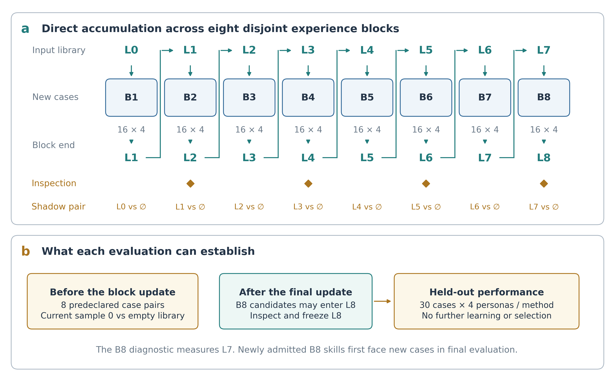
Figure 3. Direct accumulation and library-level evaluation. Each block runs under L_{b−1} and can add qualified candidates to L_b. Diamonds denote report-only inspections. Prequential diagnostics compare eight predeclared sample-0 trajectories from each block with matched empty-library shadows; the block-1 identity shortcut avoids duplicate runs. These are development diagnostics for L0–L7. The final confirmatory comparison uses the designated frozen L8 library, including any additions made after block 8.
Prequential observations are collected before learning from their own block, but the cases later become training evidence and the case set changes across blocks. They are therefore diagnostic, not a repeated fixed-test learning curve or a confirmatory trend test. Current-library observations reuse learning-temperature trajectories, whereas the final paired experiment uses the frozen evaluation configuration. Empty-library shadows do not enter teacher selection or admission.

5. Experimental design

5.1. Research questions and data
The primary question is whether the designated L8 skill library changes case-level mean new-fact-bearing-question rate relative to an empty library under an intervention-isolated route. A static generic procedure tests the value of learned rather than merely present context. A simpler reward-gap memory tests whether mechanism typing adds value beyond adaptive trajectory-derived advice. SFT is an optional, resource-intensive contrast rather than a prerequisite for the bounded external-memory claim. All confirmatory methods, prompts, diagnostics, judge models and analysis families must be frozen before any official outcome is inspected.
Table 1. Data and nominal execution units for the reviewed protocol; qualification, retries, added baselines and independent reviews are reported separately.
Partition or stage | Cases and conditions | Role and execution budget
Skill-learning corpus | 128 cases; 14 domains; 852 fact pairs | Eight disjoint blocks; all are training cases
Main learning rollout | 16 cases/block × 4 trajectories; cooperative persona | 512 full consultations per learning run
Prequential diagnostic | Eight fixed pairs/block; sample 0 | At most 56 extra empty-library consultations after block 1
Official external test | 30 Chinese cases × 4 personas × seed 42 | 120 consultations/method; 240 for the current Base/Ours executor and 480 for the planned four-method matrix
Dialogue-seed sensitivity | Six fixed external cases × 4 personas × seeds 43 and 44 | 48 additional consultations/method; 96 for two arms or 192 for four methods
The training corpus contains AI-authored consultation scenarios grounded in 128 selected case units from 35 public Supreme People’s Court source pages. It includes 266 disputed and 586 undisputed fact pairs, 699 inquiry items and 683 memorandum expectations. Source quotations and consultation-time information boundaries are audited in the supplied corpus records. These scenarios are source-constrained research annotations, not transcripts of real clients or independently expert-certified gold labels.
The 30-case Chinese collection is excluded from training, teacher input, skill selection and outcome-informed tuning. Public availability precludes any claim about foundation-model pretraining exposure. The reviewed software can hash its bytes and the current adapter can parse records during executor initialization; hashing, record parsing, model-prompt exposure and human inspection are therefore reported as separate access levels. The defensible present claim is “held out from project adaptation,” not “never accessed” or “sealed blind.” [PENDING PROTOCOL — before confirmatory evaluation, freeze the complete analysis and routing contract, record a parent-manifest hash, and document every official-set byte access, record parse, model exposure and human exposure]

5.2. Comparison methods and fairness
Table 2 defines the comparison matrix needed for the current attribution claim. Only Base and Ours are implemented as main external arms in the reviewed executor. Static and reward-gap memory should be implemented and frozen before confirmatory evaluation. SFT is optional and should be reported outside the minimum matrix if compute or engineering validation is insufficient. Blank table cells are prospective reporting structure, not evidence.
Table 2. Comparison methods and their intended control of alternative explanations.
Method | Adaptation | Comparison purpose and status
Base | Frozen Qwen3-8B; empty policy skill bundle | No-memory control after library-independent route isolation
Static† | Frozen model; one development-frozen generic procedure | Controls for procedural context and prompt overhead
Reward-gap memory† | Frozen model; adaptive trajectory-derived advice without outcome-typed mechanism filtering | Tests the incremental value of mechanism-specific evidence selection
SFT‡ | Training-only supervised adapter on visible-state demonstrations | Optional parameter-adaptation comparator with separately reported compute
Ours | Frozen model; outcome-typed contrasts and direct skill accumulation | Current LegalSkillEvolve treatment arm
† Required planned extension for the current attribution claim; not implemented as a main external arm in the reviewed archive. ‡ Optional extension. Every adaptive baseline must generate its own training-only memory or checkpoint and must not receive Ours' selected evidence.
All compared arms use the same cases, personas, dialogue seeds, client environment, StopGate and offline evaluation. Pairwise equality is conditional on freezing a route that does not depend on the learned library. Static uses the same document interface and should report realized characters and model-token counts; a length-matched inert or generic control can diagnose context overhead. Reward-gap memory matches the training cases, four-trajectory budget and teacher-attempt ceiling while omitting outcome-type filtering. It must construct its own adaptive history.
If SFT is included, demonstrations must come only from development cases and use visible-state inputs with valid consultant actions as targets. Hidden labels may support offline selection but may not enter online inputs. Adapter settings, checkpoint selection, planning-policy scope, training compute and failure criteria require separate reporting; SFT is not compute-equivalent merely because it uses the same cases. [PLANNED EXPERIMENT — decide outcome-blind whether SFT is in scope; if included, freeze demonstrations, optimizer, checkpoint rule and budget before official evaluation]

5.3. Endpoints and the fact–question trade-off
The primary session endpoint is Y_i=F_i/Q_i for Q_i>0 and zero for Q_i=0, where F_i counts distinct first-disclosed client fact identifiers after the opening and Q_i counts questions presented to the client. Persona sessions are averaged within each case; the primary effect is the mean of 30 paired case differences. Mandatory companions are F and Q. Fact Coverage, Elicitation, Resolution, Fidelity and disputed-fact recall assess quality. Correct evidence-gap recall is paired with precision or false-positive counts. Repeated questions, unsupported-claim rate, StopGate redirects, factual fallbacks, premature stopping and invalid sessions are reported with explicit denominators. The pooled ratio ΣF/ΣQ is secondary.
We will also report cumulative newly disclosed facts after question budgets $k∈\{1,…,10\}$, denoted $F@k$. After a valid autonomous stop, the final fact count is carried forward at later budgets, so early-stopping sessions remain in the comparison. This is a trajectory-prefix information curve, not a measure of memorandum quality under an enforced budget. A fixed-budget memorandum experiment would require an explicitly defined rerun or renderer intervention. The present 24-step circuit breaker is an abnormal-termination safeguard, not a target consultation length or evidence of real-world time savings.

5.4. Paired statistical analysis
The designated L8 library is the sole primary learned treatment. For each method, metrics are averaged across four personas within a case before computing paired differences. With 30 cases, not 120 sessions, the plan uses 10,000 case-bootstrap resamples for percentile intervals and 20,000 Monte Carlo paired sign flips, with a frozen random seed and add-one correction, for the primary yield effect. Estimates are conditional on the realized library. Every independently learned replicate is first analyzed against Base as its own 30-case experiment; sessions from 30×R case–run cells are not treated as independent.
The confirmatory hierarchy is frozen before official outcomes: (i) primary two-sided yield comparison; (ii) the stronger directional conjunction ΔF>0 and ΔQ<0 assessed by an intersection–union test, with both one-sided component nulls rejected, or Holm adjustment if separate component discoveries are claimed; (iii) a Benjamini–Hochberg family for prespecified quality endpoints that does not duplicate F; and (iv) Holm-adjusted yield contrasts across additional baselines. Failure to detect a quality difference is not equivalence. Non-inferiority requires a justified margin and a prespecified test.
All planned cells, failures and repairs will be disclosed. Invalid execution is not silently removed. Report the complete matrix, paired valid-case analysis, a conservative failure sensitivity, raw case differences and leave-one-case-out influence. Design sensitivity or simulation-based power uses only prespecified plausible case-level distributions and the smallest scientifically meaningful effect; calculations designed after viewing official outcomes are labelled descriptive. [PENDING ANALYSIS — freeze estimands, directional hypotheses, multiplicity families, failure/missing-data rules, non-inferiority margins if any, and outcome-blind design-sensitivity assumptions]

5.5. Automatic qualification and sensitivity without human raters
The run-bound client qualification used 51 development cases, 142 chains and 144 frozen contrasts. Match selection was correct for 137/144 contrasts (0.951): 96/101 matched items (0.950) and 41/43 unmatched items (0.953). Disclosure decisions were correct for 144/144 (1.000), response kind for 137/144 (0.951), persona transitions for 2/2 (1.000), and contract fallbacks occurred in 0/144 (0.000). The frozen semantic judge passed its controlled eight-case development protocol. These numerator/denominator results qualify encoded behaviors only; full-precision values and hashes remain in the artifacts and do not estimate the method's treatment effect or legal validity.
Validation should separate three samples: a case-level review of 30–40 stratified sessions for question relevance, stopping and memorandum errors; a skill-level review of every L8 document (at most 24) for source support, actionability, contraindications and legal risk; and a route-level audit of opening labels independent of treatment. A second frozen model measures judge sensitivity but is not a legal expert. Claims about legal correctness, safety or real-client usefulness require qualified legal reviewers; without them, conclusions remain limited to the finite simulator and encoded rubrics. [PLANNED EXPERIMENT — freeze sampling frames, reviewer qualifications, blinded adjudication, rubrics, agreement statistics and handling of conflicts before selecting cases for review]

5.6. Mechanism ablations and learning replication
The main treatment-attribution ablation is a fresh learning run that removes outcome-typed mechanism filtering while preserving reward-gap trajectory evidence, case order, model calls and teacher-attempt budget. Further fresh runs can replace the cumulative bank with current-block evidence only or remove the additional-question reward penalty. Each ablation learns its own library; the primary library is never retroactively selected using external results. The question-cost ablation must report its realized source-mechanism mix because other stopping incentives remain.
Lower-cost frozen-library diagnostics include general-only skill delivery, an active-library-derived routing sensitivity against the isolated primary route and length-matched context controls. They identify sensitivity of the final system conditional on the already learned L8 library; they do not substitute for relearning a mechanism ablation. A no-skill policy condition is not equivalent to Base while the route itself is derived from the active library. Prompt character count and tokenizer-derived token count accompany every component comparison.
The primary estimate uses the library and randomization stream designated before external evaluation. If resources permit, at least three complete outcome-blind learning replications assess training variability. Each replicate receives its own paired case-level effect. A secondary run-level analysis can use a hierarchical run×case bootstrap or an explicitly specified mixed model; it must not treat 30×R observations as mutually independent. Dialogue seeds 43 and 44 on six cases assess sampling sensitivity only, not learning replication. [PLANNED EXPERIMENT — freeze the primary run, replicate seeds, run-specific analysis and any hierarchical secondary analysis before official execution]

5.7. Reproducibility and computational cost
The reviewed configuration pins Qwen3-8B to revision b968826d9c46dd6066d109eabc6255188de91218 and gpt-oss-20b to revision 6cee5e81ee83917806bbde320786a8fb61efebee. Policy temperature is 0.7 during learning and 0.2 in paired external evaluation. The teacher is a deployment alias rather than a dated weight snapshot, so reproduction requires call timestamps, client version, request/response hashes and retained outputs; exact teacher-weight reproduction cannot be claimed.
The active run identifier is main_experiment_128_legalskillevolve_formal_20260911_runtime01. At the 11 September 2026 13:48 CST manuscript snapshot, its run manifest still reported status=initialized, content_sha256=349885d608e2f6f875f234de3e738ccd07989297d29eaa7bc18e783a91060dda and file SHA-256 def4ee88ab6e45d3d09a72831691d26f54714167c845524669336ac6a7e19363; status is dynamic and does not establish block completion. The nominal single-run budget is 512 main consultations, up to 56 non-learning shadows and up to 48 teacher attempts, before retries and qualification. [PENDING METADATA — regenerate the final manifest and report Python/package lock, vLLM/CUDA stack, hardware, wall time, role-specific tokens, failures, final library hash and actual per-arm costs]

6. Results

6.1. Main held-out comparison
No learned-library effectiveness experiment was complete in the supplied evidence at manuscript revision time. Tables 3–5 therefore retain explicit yellow pending markers. Qualification results in Section 5.5 and historical replay checks are not substituted for confirmatory external effects.
Table 3. Planned main results on 30 adaptation-held-out Chinese cases crossed with four personas. Entries are case-level macro means; arrows show favorable directions. † Required planned control; ‡ optional comparator. The primary paired effect and uncertainty are reported in Table 4.
Metric | Base | Static† | Reward-gap memory† | SFT‡ | Ours
New-fact-bearing-question rate Y ↑ | [PENDING RESULT] | [PENDING RESULT] | [PENDING RESULT] | [PENDING RESULT] | [PENDING RESULT]
New client facts F ↑ | [PENDING RESULT] | [PENDING RESULT] | [PENDING RESULT] | [PENDING RESULT] | [PENDING RESULT]
Questions Q ↓ | [PENDING RESULT] | [PENDING RESULT] | [PENDING RESULT] | [PENDING RESULT] | [PENDING RESULT]
Fact Coverage ↑ | [PENDING RESULT] | [PENDING RESULT] | [PENDING RESULT] | [PENDING RESULT] | [PENDING RESULT]
Elicitation ↑ | [PENDING RESULT] | [PENDING RESULT] | [PENDING RESULT] | [PENDING RESULT] | [PENDING RESULT]
Resolution ↑ | [PENDING RESULT] | [PENDING RESULT] | [PENDING RESULT] | [PENDING RESULT] | [PENDING RESULT]
Fidelity ↑ | [PENDING RESULT] | [PENDING RESULT] | [PENDING RESULT] | [PENDING RESULT] | [PENDING RESULT]
Disputed-fact recall ↑ | [PENDING RESULT] | [PENDING RESULT] | [PENDING RESULT] | [PENDING RESULT] | [PENDING RESULT]
Evidence-gap recall / precision | [PENDING RESULT] | [PENDING RESULT] | [PENDING RESULT] | [PENDING RESULT] | [PENDING RESULT]
Unsupported-claim rate ↓ | [PENDING RESULT] | [PENDING RESULT] | [PENDING RESULT] | [PENDING RESULT] | [PENDING RESULT]
Invalid sessions / planned sessions ↓ | [PENDING RESULT] | [PENDING RESULT] | [PENDING RESULT] | [PENDING RESULT] | [PENDING RESULT]
Every pending cell is unmeasured. No rank, significance marker or imputed value is assigned before results exist. The reviewed executor currently implements only Base and Ours; † controls require an extension and ‡ is optional. Lower question counts are favorable only when interpreted with information and quality outcomes. Ours-versus-each-baseline paired differences, 95% case intervals and n appear in a companion effect table.
Table 4. Planned paired case-level estimates for the main efficiency claim. Differences are Ours minus Base. The directional fact–question conjunction is assessed only under the frozen intersection–union rule.
Endpoint | Mean difference | 95% case CI | Prespecified p-value | Decision / adjusted p where applicable
Yield ΔY | [PENDING RESULT] | [PENDING RESULT] | [PENDING RESULT] | Primary two-sided test
New facts ΔF | [PENDING RESULT] | [PENDING RESULT] | [PENDING RESULT] | [PENDING RESULT]
Questions ΔQ | [PENDING RESULT] | [PENDING RESULT] | [PENDING RESULT] | [PENDING RESULT]
[PENDING RESULT — complete Tables 3–4; report ΔY and its 95% case interval, raw case differences, prespecified Monte Carlo p-values, failure denominators, and whether ΔF>0 and ΔQ<0 are jointly supported]

6.2. Skill accumulation and mechanism analysis
The block-level report will give healthy source groups, mechanism counts, teacher attempts, unique proposals, no-operation responses, rejections, admitted general/domain skills, character and token lengths, exposure counts, StopGate redirects and fallbacks. Admission is not effectiveness. Prequential differences are indexed by their input library L_{b−1}; post-update sizes refer to L_b.
Table 5. Planned attribution and routing analyses. The full-method row reports case-level means (95% CI; n); each other row reports variant-minus-full paired Δ (95% case CI; n). Fresh-learning rows and frozen-library diagnostics answer different questions; every value remains pending.
Variant | Required experiment | Yield $Y$ | Facts $F$ | Questions $Q$
Full method | Primary learned library | [PENDING RESULT] | [PENDING RESULT] | [PENDING RESULT]
No mechanism filter | Fresh learning run | [PENDING RESULT] | [PENDING RESULT] | [PENDING RESULT]
Current-block evidence only | Fresh learning run | [PENDING RESULT] | [PENDING RESULT] | [PENDING RESULT]
No extra-question penalty | Fresh learning run | [PENDING RESULT] | [PENDING RESULT] | [PENDING RESULT]
General-only skill delivery | Frozen-L8 diagnostic rerun | [PENDING RESULT] | [PENDING RESULT] | [PENDING RESULT]
Active-library-derived routing sensitivity | Frozen-L8 exploratory rerun | [PENDING RESULT] | [PENDING RESULT] | [PENDING RESULT]
[PENDING RESULT — complete the skill ledger and mechanism analyses; add a paired F-versus-Q plot, an F@k curve with valid-stop carry-forward, prequential diagnostics, route/StopGate counts and uncertainty with actual denominators]

6.3. Transfer, failure modes and cost
Persona estimates separate the trained cooperative condition from dependent, withdrawn and adversarial transfer. Dialogue-seed sensitivity and each independently learned library are shown without best-run selection. Qualitative cases use complete paired trajectories and distinguish original policy actions from StopGate-executed actions. Case-level human review, skill-level legal review and route audit use separately frozen samples rather than outcome-selected anecdotes.
[PENDING RESULT — report persona, dialogue-seed, learning-replication, route-sensitivity, independent-judge and human/expert-review results, including adverse cases and all runtime failures]
[PENDING RESULT — report role-specific input/output tokens, latency, wall time, teacher/API cost, local compute, memory overhead, retries, repairs and failed calls]

7. Discussion and limitations
LegalSkillEvolve treats skill documents as source-bound procedural hypotheses available to a frozen consultation policy. Direct admission supports cumulative development without reserving later blocks as candidate-specific acceptance sets, but plausible documents can be ineffective, conflict or consume context. The designated L8 comparison estimates the combined system—including routing and StopGate—unless those pathways are experimentally isolated. It cannot identify an individual skill's causal effect.
The primary endpoint has a deliberately narrow interpretation: because the simulator discloses at most one matched identifier per response, Y is a new-fact-bearing-question rate. A shorter dialogue may reflect better targeting, earlier stopping, StopGate intervention or omitted investigation. Joint reporting of Y, F, Q, quality, remaining targets at stop and prefix curves helps distinguish these mechanisms, but cannot reproduce multi-fact human answers, emotional burden or real consultation time.
Source-constrained data and deterministic audits improve traceability but do not provide professional validation. Training annotations are AI-authored; the primary client router and judge share model weights; and a second model judge tests only model sensitivity. Without qualified legal reviewers, conclusions are restricted to consistency with the finite simulator and encoded rubrics. Claims about legal correctness, safety or deployment require separate expert assessment, privacy review and real-world validation.
The external set contains only 30 public Chinese cases. Case-level inference respects the experimental unit, but power, domain generalization and subgroup precision remain limited. Current active-library-derived routing threatens treatment isolation until corrected. A single learned library gives a conditional estimate, and the mutable teacher alias limits exact reproduction. [PENDING ANALYSIS — add result-dependent interpretation, smallest supported effect, negative findings, influential cases, learning-run variability and a bounded statement of practical scope]

8. Conclusion
LegalSkillEvolve provides an auditable protocol for accumulating external procedural memory from full simulated consultations while keeping model weights fixed. Outcome-typed contrast records, static admission gates and case-level paired evaluation make the intended attribution testable, provided external routing is isolated and the full analysis is frozen before outcome exposure. [PENDING RESULT — state only the empirical yield, fact, question and quality conclusions supported by the designated held-out experiment]

Declarations
Data and code availability. The working repository is H00RU/LegalSkillGuard; the repository name does not define the method name. [PENDING METADATA — add release tag/DOI, executable environment, immutable artifact manifest, access levels for restricted evaluation data, and licenses for code, annotations, sources and benchmark materials]
Ethics, privacy and review scope. The study uses public court-derived research scenarios and simulated clients; it currently contains no study with real clients and no independent legal-expert assessment. Public legal records can still contain personal or sensitive information and require purpose limitation, minimization and documented redistribution decisions. [PENDING METADATA — record institutional ethics determination, privacy/de-identification review, source permissions, benchmark license compatibility, retention policy and reviewer consent/compensation if human review is added]
Funding, competing interests and author contributions. [PENDING METADATA — insert verified journal-form declarations and CRediT roles]
Use of generative AI. AI systems assisted corpus authoring and manuscript preparation; authors remain responsible for source verification, analysis and claims. [PENDING METADATA — provide the target journal's required model/tool disclosure, dates, retained records and author-verification statement]

References
[1] Guha N, Nyarko J, Ho DE, et al. LegalBench: A collaboratively built benchmark for measuring legal reasoning in large language models. 2023. arXiv:2308.11462.
[2] Fei Z, Shen X, Zhu D, et al. LawBench: Benchmarking legal knowledge of large language models. 2023. arXiv:2309.16289.
[3] Zhang L, Shi Y, Hu Y, et al. DLawBench: Evaluating LLMs through multi-turn legal consultation. 2026. arXiv:2606.13931.
[4] Shinn N, Cassano F, Berman E, et al. Reflexion: Language agents with verbal reinforcement learning. 2023. arXiv:2303.11366.
[5] Zhao A, Huang D, Xu Q, Lin M, Liu YJ, Huang G. ExpeL: LLM agents are experiential learners. 2023. arXiv:2308.10144.
[6] Wang ZZ, Mao J, Fried D, Neubig G. Agent Workflow Memory. 2024. arXiv:2409.07429.
[7] Cai Y, Cai S, Shi Y, et al. Training-Free Group Relative Policy Optimization. 2025. arXiv:2510.08191.
[8] Zhang Q, Hu C, Upasani S, et al. Agentic Context Engineering: Evolving contexts for self-improving language models. 2025. arXiv:2510.04618.
[9] Wang J, Yan Q, Wang Y, et al. Reinforcement learning for self-improving agent with skill library. Proceedings of ACL 2026;1529–1550. doi:10.18653/v1/2026.acl-long.69.
[10] Yang Y, Gong Z, Huang W, et al. SkillOpt: Executive strategy for self-evolving agent skills. 2026. arXiv:2605.23904.
[11] Zheng L, Chiang WL, Sheng Y, et al. Judging LLM-as-a-judge with MT-Bench and Chatbot Arena. 2023. arXiv:2306.05685.
[12] Dror R, Baumer G, Shlomov S, Reichart R. The hitchhiker’s guide to testing statistical significance in natural language processing. Proceedings of ACL 2018;1383–1392. doi:10.18653/v1/P18-1128.
[13] Agarwal R, Schwarzer M, Castro PS, Courville A, Bellemare MG. Deep reinforcement learning at the edge of the statistical precipice. Advances in Neural Information Processing Systems 2021;34:29304–29320. Publisher record.
[14] Yang A, Li A, Yang B, et al. Qwen3 technical report. 2025. arXiv:2505.09388.
[15] OpenAI. gpt-oss-20b model card. Official model record. Model revision used in this study is given in Section 5.7.
[16] Benjamini Y, Hochberg Y. Controlling the false discovery rate: A practical and powerful approach to multiple testing. Journal of the Royal Statistical Society B 1995;57:289–300. doi:10.1111/j.2517-6161.1995.tb02031.x.
[17] Holm S. A simple sequentially rejective multiple test procedure. Scandinavian Journal of Statistics 1979;6:65–70. Publisher archive.
[18] Yuan W, Song K, Jiang Z, et al. LeCoDe: A Benchmark Dataset for Interactive Legal Consultation Dialogue Evaluation. Proceedings of ACL 2026;36019–36048. https://doi.org/10.18653/v1/2026.acl-long.1667.
[19] Gan R, Feng D, Zhang C, et al. UCL-Bench: A Chinese User-Centric Legal Benchmark for Large Language Models. Findings of NAACL 2025;7960–8003. https://doi.org/10.18653/v1/2025.findings-naacl.444.
[20] Yue S, Huang T, Jia Z, et al. Multi-Agent Simulator Drives Language Models for Legal Intensive Interaction. Findings of NAACL 2025;6552–6585. https://doi.org/10.18653/v1/2025.findings-naacl.365.
[21] Li H, Chen J, Yang J, et al. LegalAgentBench: Evaluating LLM Agents in Legal Domain. Proceedings of ACL 2025;2322–2344. https://doi.org/10.18653/v1/2025.acl-long.116.
[22] Shi Y, Liu H, Hu Y, et al. PLAWBENCH: A Rubric-Based Benchmark for Evaluating LLMs in Real-World Legal Practice. Proceedings of ACL 2026;10067–10116. https://doi.org/10.18653/v1/2026.acl-long.458.
[23] Dou Y, Galley M, Peng B, et al. SimulatorArena: Are User Simulators Reliable Proxies for Multi-Turn Evaluation of AI Assistants? Proceedings of EMNLP 2025;35212–35290. https://doi.org/10.18653/v1/2025.emnlp-main.1786.

Appendix A. Metric and reward definitions
Let $N$ be the total number of fact pairs; $D$ the number of distinct first-disclosed client facts; $C_{memo}$ the number of fact items covered in the memorandum under the frozen semantic partition; and $C_{elicited,correct}$ the number both elicited and correctly resolved. Inquiry is the fraction of inquiry rubrics substantively addressed; Issue Resolution is the fraction of memorandum-resolution rubrics satisfied. The reported DLawBench-style Fact Coverage is $C_{memo}/N$, Elicitation is the arithmetic mean of Fact Coverage and Inquiry, and Resolution averages correct-fact coverage under the frozen partition and Issue Resolution. Fidelity is the fraction of assessed memorandum claims supported by the dialogue or reference record, following the benchmark’s union-grounding convention. A reference-supported but undisclosed fact is not a newly elicited client fact.
Training instead uses $E_{tr}=H\left(D/N,Inquiry\right)$, where $H\left(x,y\right)=2xy/\left(x+y\right)$ for positive $x,y$ and zero otherwise. It uses $R_{tr}=\left(C_{elicited,correct}/N+IssueResolution\right)/2$. Reward caps are 0.35 for premature finalization and 0.25 for either unsupported claims or zero substantive inquiry, followed by the nonnegative bound. Leakage sets reward to zero. Exact normalized question repetitions form Rep. These quantities guide source selection; none replaces the held-out efficiency endpoint. The final reproducibility release should include the exact semantic partition and denominator rules, including empty-claim handling, rather than relying only on aggregate scores.

