DESIGN & ANALYSIS OF ALGORITHMS · CIA 3 · INNOVATIVE ASSIGNMENT

Corridor.
An emergency-routing atlas for Bengaluru
Requirements and Design Document

This document states what the Corridor prototype is required to do, describes how it is built module by module, and records the evidence that it works: ten executable tests and a benchmark on eight city sizes. Every screenshot was taken from the running prototype and every number was read from it on the date below.
PREPARED BY | Nebin Stanly
REGISTER NUMBER | 2443142
CLASS | 6BCA-B, Computer Science (Yeshwanthpur)
COURSE | Design and Analysis of Algorithms
STAFF-IN-CHARGE | Dr. P. Margaret Savitha
DOCUMENT VERSION | 1.0, 9 October 2026
LIVE PROTOTYPE | https://h0gr1d3r-code.github.io/corridor-routing-atlas/
SOURCE CODE | https://github.com/H0GR1D3R-CODE/corridor-routing-atlas

CONTENTS
1 | Introduction | purpose, problem statement, scope, definitions
2 | Overall description | users, use cases, environment, constraints
3 | System architecture | layers, data flow of one request, data model
4 | Functional requirements | twenty-four numbered requirements
5 | Module descriptions | every screen, with annotated screenshots
6 | Algorithms and design justification | the five searches, the heuristic, complexity
7 | Non-functional requirements | performance, portability, accessibility
8 | Verification and results | tests, stories, scenes, benchmarks
9 | Deployment and operation | where it runs and how to run it
10 | Limitations and future work
11 | Traceability to the assignment rubric

AT A GLANCE
MEASURE | VALUE | MEASURE | VALUE
Junctions (graph nodes) | 832 | Algorithms implemented | 5, plus hospital dispatch
Road segments (edges) | 1,630 | Executable tests | 10 of 10 passing
Named places | 62 | Benchmark city sizes | 8 (from 64 to 8,011 junctions)
Hospitals | 15 | Scene controls | 5 day types, 4 skies, 8 events
Named highways and ring roads | 11 + 4 | Third-party libraries | None

1 Introduction

1.1 Purpose
Corridor is a working prototype built for the CIA 3 Innovative Assignment, which asks for an algorithm applied to a practical routing problem, with performance analysis and a justification of the algorithm chosen. This document is its requirements and design record. It is written so that an examiner can check each requirement against a screen, a module and a test.

1.2 Problem statement
When an ambulance is called, the dispatcher needs two answers within a second: which hospital, and which roads. Neither can be read off a printed map, because the time a road takes depends on the hour, the weather and what else is happening in the city. The shortest road is often not the fastest.
In algorithm terms this is a shortest-path problem on a weighted graph whose edge weights are a function of the current scene, queried repeatedly, with edges that can disappear when a road floods or is closed.
ITEM | DEFINITION
Input | A road graph of 832 junctions and 1,630 road segments; an origin; either a destination or the set of 15 hospitals; the scene (day type, hour, sky, events); siren on or off; the set of closed roads.
Output | The route with the smallest total travel time, its ETA, distance, mean speed and the named roads it uses. For dispatch, every hospital ranked by ETA.
Constraints | Travel times are never negative. The answer must be provably optimal, because a wrong route is worse than a slow one. Each query must finish in milliseconds.
Chosen algorithms | A* with an adaptive admissible heuristic for a trip from A to B. Multi-target Dijkstra for "nearest hospital". Dijkstra, bidirectional Dijkstra, Bellman–Ford and greedy best-first are implemented as comparisons.

1.3 Scope
IN SCOPE | OUT OF SCOPE
Fastest route between any two junctions | Turn-by-turn navigation or voice guidance
Fastest hospital from an incident, with a ranked list | Live traffic feeds: traffic is a model, not measured data
A scene model: day type, hour, weather, events, siren, closures | Real street geometry: the mesh between real places is generated
Visual explanation: search replay, race, step-through | Fleet scheduling across several ambulances
Built-in correctness tests and benchmarks | User accounts, storage or any server component

1.4 Definitions
TERM | MEANING IN THIS DOCUMENT
Junction | A node of the road graph: a place where roads meet.
Road segment | An edge of the graph, joining two junctions. All segments are two-way.
Weight | The minutes needed to travel one road segment in the current scene.
Scene | The conditions that set the weights: day type, hour, sky, events, siren and closed roads.
ETA | Estimated time of arrival: the total weight of the route, in minutes.
Expanded (settled) | A junction whose shortest time is final. The count of these measures how far a search spread.
Edge examined (relaxation) | One check of a road to see whether it gives a faster way to its far end. The unit of work used for comparisons.
Heuristic h | A quick estimate of the time still needed to reach the goal. Admissible means it never over-estimates.
CSR | Compressed sparse row: the adjacency lists of all junctions packed into flat arrays.
Dispatch | Finding the fastest hospital for an incident, without knowing the destination in advance.

2 Overall description

2.1 Product perspective
Corridor is a single web page. It needs no installation, no build step and no server: the road graph is generated in the browser when the page loads, and every search, test and benchmark runs on the viewer's own machine. The only network requests are for two typefaces, and the page falls back to system fonts if they are unavailable.

2.2 Users and use cases
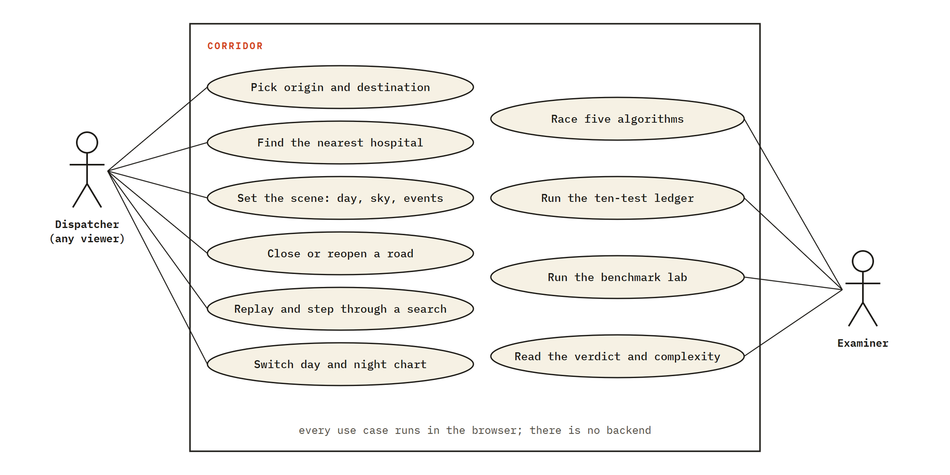
Figure 1. Use cases. A viewer acts as dispatcher; an examiner additionally runs the race, the tests and the benchmark.
ID | USE CASE | WHAT THE USER DOES | WHAT THE SYSTEM RETURNS
UC-1 | Route A to B | Picks two places from the lists or clicks the map | Fastest route, ETA, roads used, search statistics
UC-2 | Dispatch | Marks an incident and leaves the destination on "Nearest hospital" | Fastest hospital, route to it, all hospitals ranked
UC-3 | Change the scene | Taps a preset or sets day, hour, sky and events | New road times, re-planned route, slowdown explained
UC-4 | Close a road | Shift-clicks a road on the map | Road shown closed; route re-planned around it
UC-5 | Understand a search | Presses Replay or Big picture | The search replayed step by step, with live counters
UC-6 | Compare algorithms | Runs the race | Five searches on one trip, ranked by work done
UC-7 | Verify correctness | Scrolls to the proof ledger | Ten tests run live, each with its evidence
UC-8 | Measure performance | Scrolls to the lab | Timings and work on eight city sizes, as charts and a table

2.3 Operating environment
- Any current desktop or mobile browser (Chrome, Edge, Firefox, Safari). No plug-ins.
- Screens from 375 px wide phones to wide desktop monitors.
- Works offline once loaded; opened directly from disk or from any static web host.

2.4 Assumptions and constraints
- The 62 places, 15 hospitals, lakes and highway bearings are real and positioned from approximate latitude and longitude. The street mesh between them is generated.
- Free-flow speeds are assumed: 28 km/h on local streets, 45 km/h on ring roads, 55 km/h on highways.
- The strength of each weather and event effect, and the siren factor of 0.45, are assumptions, not measurements.
- Roads are two-way; signals, one-way streets and turn delays are not modelled.

3 System architecture

3.1 Layers and modules
The code is split so that the routing engine knows nothing about the page. The engine files can be loaded in Node and tested without a browser, which is how the tests were first run. One controller file connects the controls to the engine and tells the drawing modules what to show.
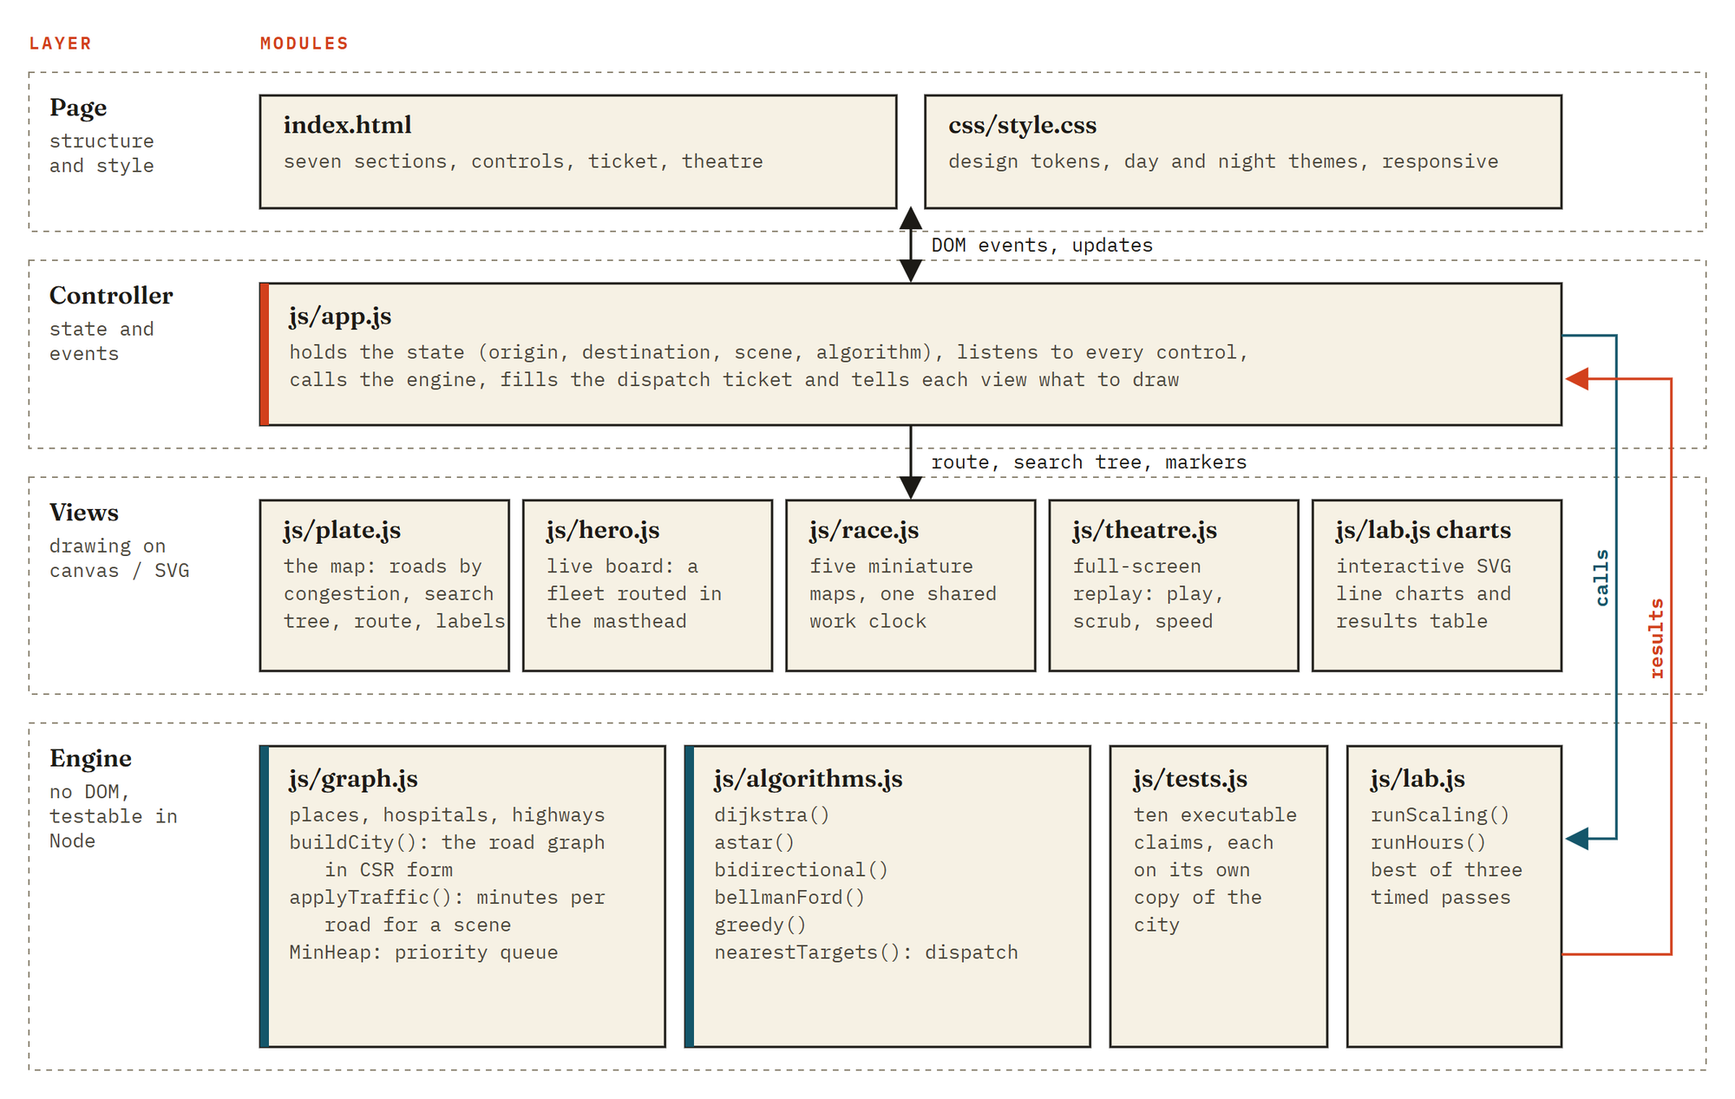
Figure 2. Architecture. The controller calls the engine and passes its results to the views; the engine has no dependency on the page.
FILE | LINES | LAYER | RESPONSIBILITY
index.html | 431 | Page | The seven sections, the controls, the dispatch ticket and the full-screen replay markup.
css/style.css | 493 | Page | Colour and type tokens, day and night themes, responsive layout.
js/app.js | 621 | Controller | Application state; place pickers; scene chips; ticket; replay; wiring of every control.
js/graph.js | 569 | Engine | Place data, city generation, CSR graph, the traffic model applyTraffic(), the binary heap.
js/algorithms.js | 246 | Engine | Dijkstra, A*, bidirectional Dijkstra, Bellman–Ford, greedy best-first, multi-target dispatch.
js/tests.js | 214 | Engine | Ten executable tests, each on its own copy of the city.
js/lab.js | 314 | Engine + view | The two experiments and the interactive SVG charts.
js/plate.js | 347 | View | The canvas map: roads, closures, search tree, route, labels, ambulance.
js/hero.js | 122 | View | The live board in the masthead.
js/race.js | 92 | View | Five miniature maps driven by one shared work clock.
js/theatre.js | 159 | View | The full-screen step-through replay.

3.2 Data flow of one request
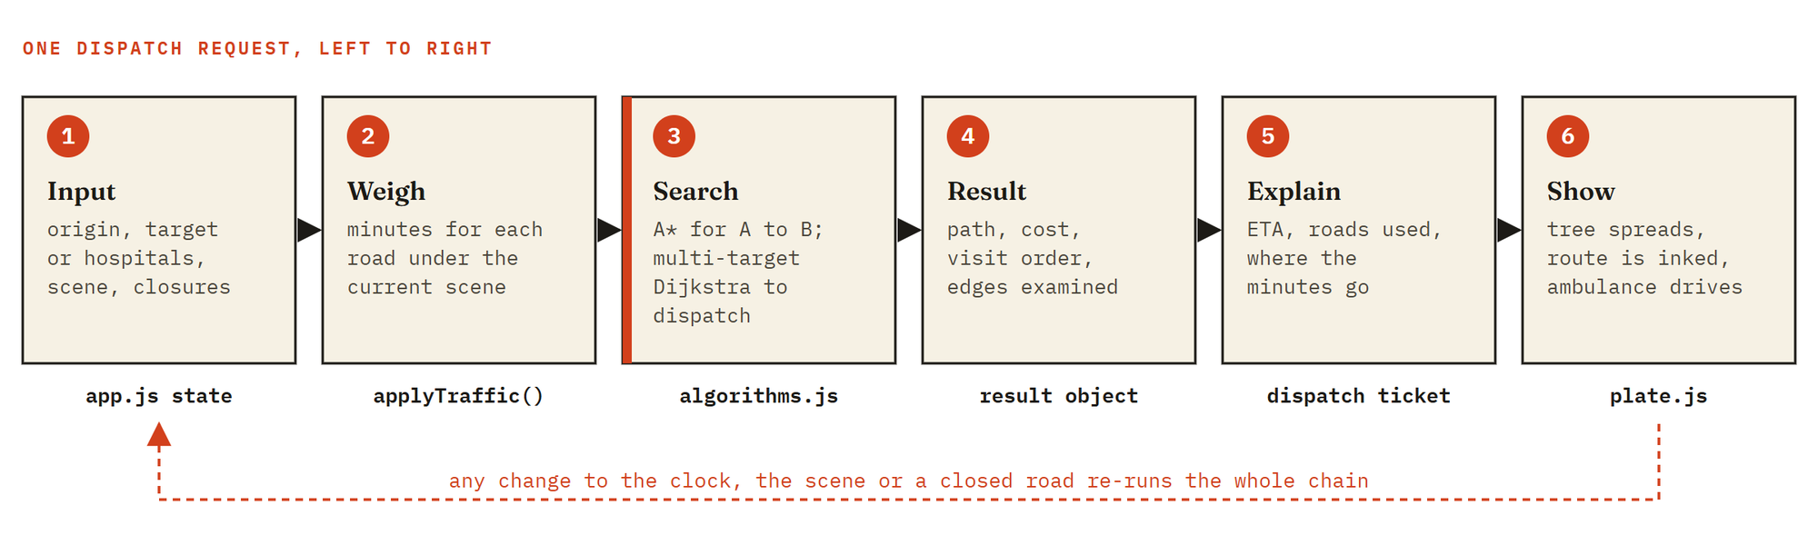
Figure 3. What happens between a click and an ambulance moving on the map.
Because the chain is short and each search takes well under a millisecond on this city, the whole chain is simply re-run whenever anything changes. Dragging the clock re-plans the route continuously.

3.3 Data model
The road network is stored in compressed sparse row form: three flat typed arrays hold every junction's neighbours, and one array per attribute holds the properties of each road. Only the array W, the minutes each road takes now, changes when the scene changes.
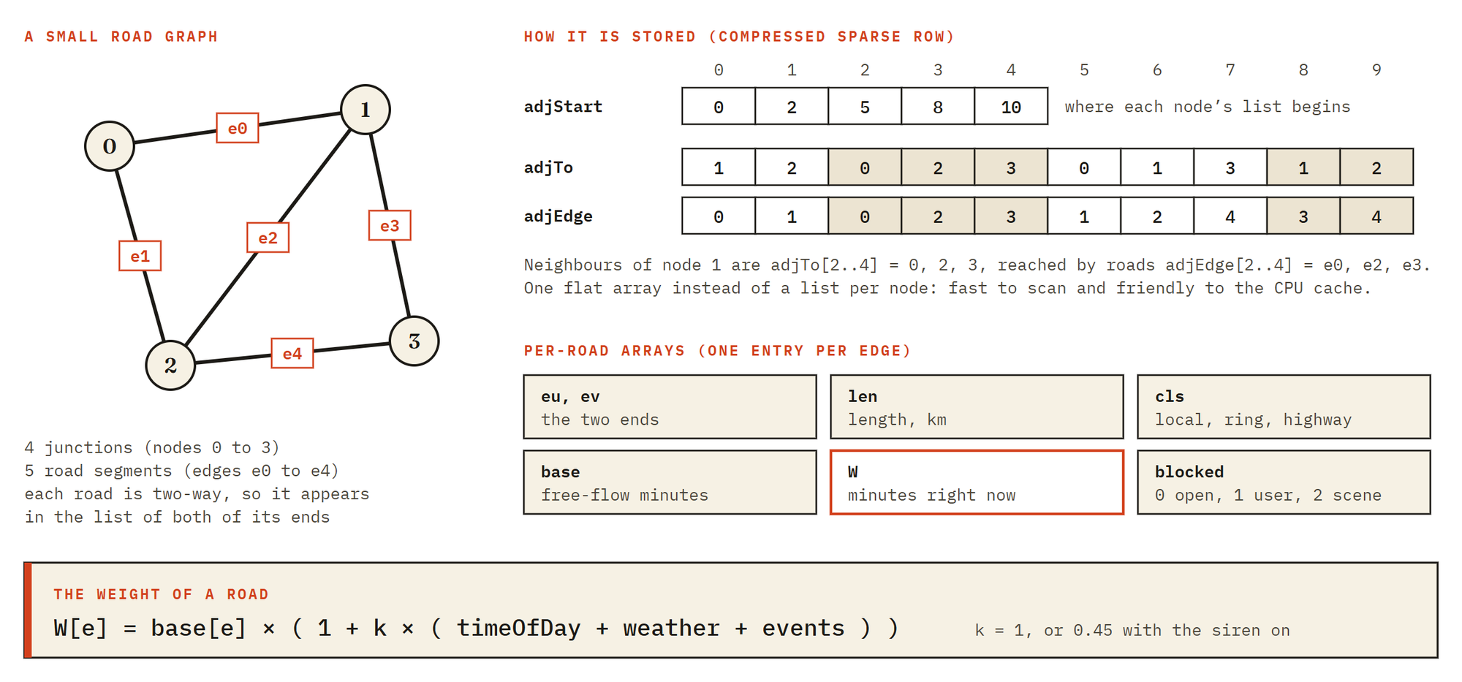
Figure 4. The graph data structure, shown on a four-junction example, and the formula that sets each road's weight.
PROPERTY OF THE CITY | VALUE | PROPERTY OF THE CITY | VALUE
Junctions | 832 | Local streets | 28 km/h free flow
Road segments | 1,630 | Ring roads (4) | 45 km/h free flow
Named places | 62 | Highways (11) | 55 km/h free flow
Hospitals | 15 | Lakes and parks | 11
City radius | about 29 km | Zones for the pickers | 7

4 Functional requirements
Each requirement is implemented in the prototype. The last column says where it can be seen or which test checks it. Section numbers refer to this document; T-numbers refer to the test ledger in section 8.
ID | REQUIREMENT | MODULE | SHOWN OR VERIFIED
Map and places

FR-01 | Show the road network with every road coloured by its current congestion. | plate.js | §5.2
FR-02 | Offer 62 named places and 15 hospitals through searchable lists grouped by zone. | app.js | §5.2.1
FR-03 | Accept any junction as origin or destination by clicking the map. | app.js, plate.js | §5.2.2
FR-04 | Swap origin and destination in one action. | app.js | §5.2.1
Routing

FR-05 | Compute the minimum-time route between two junctions and report ETA, distance, mean speed and named roads used. | algorithms.js | T1, T5, T7
FR-06 | Find the fastest hospital for an incident and rank all hospitals by ETA. | algorithms.js | T9
FR-07 | Report an unreachable destination as unreachable; never return a made-up route. | algorithms.js | T3
FR-08 | Provide five interchangeable algorithms on the same graph. | algorithms.js | §6, T5
FR-09 | Report junctions expanded, edges examined and search time for every search. | algorithms.js | §5.2.4
Scene

FR-10 | Let the user set the day type (5), the time in 15-minute steps, the sky (4) and any of 8 events. | app.js | §5.2.3
FR-11 | Recompute every road's travel time for the scene and re-plan the current trip at once. | graph.js | §3.2, T10
FR-12 | Close roads automatically in a flood or accident, and let the user close or reopen any road. | graph.js, app.js | T4
FR-13 | Model a siren that reduces every delay for the ambulance. | graph.js | T10
FR-14 | Explain the slowdown: city-wide by cause, and per trip as "where the minutes go". | app.js | §5.2.3, §5.2.4
FR-15 | Offer one-tap scene presets (8) and stories that set a trip and a scene together (6). | app.js | §8.2, §8.3
Explanation

FR-16 | Animate the search in the order junctions were visited, then the route, then an ambulance driving it; replay on demand. | plate.js, app.js | §5.2.2
FR-17 | Offer a full-screen replay with play, pause, scrubbing, speed control and a switch between algorithms. | theatre.js | §5.4
FR-18 | Race the five algorithms on one trip using a shared clock of edges examined, and rank them. | race.js | §5.3
FR-19 | Show a live board on which ambulances are dispatched continuously; clicking one opens that dispatch. | hero.js | §5.1
Verification

FR-20 | Run ten correctness tests in the browser and show each result with its evidence. | tests.js | §5.5, §8.1
FR-21 | Benchmark the algorithms on eight city sizes, chart the results interactively and export them as CSV. | lab.js | §5.6, §8.4
FR-22 | Show how the advantage of A* changes through the day; clicking an hour sets the console clock. | lab.js | §5.6
Presentation

FR-23 | Provide a day and a night colour theme. | style.css | §5.8
FR-24 | Remain usable on a 375 px phone and from the keyboard (pickers and charts). | style.css, app.js | §5.8, §7

5 Module descriptions
The page has seven numbered sections. This chapter walks through each screen in the order a viewer meets it.

5.1 Masthead and live board
The first screen states the question and shows it being answered. The live board is a strip of central Bengaluru on which a small fleet is always at work: an incident appears at a random junction, one multi-target Dijkstra search finds the fastest hospital under the current traffic, and an ambulance drives the route it returned. Each ambulance carries a flag naming its hospital and the minutes left. Clicking one opens that dispatch in the console. Nothing on the board is scripted; it follows whatever scene the console is set to.
Figure 5. Masthead: title, problem in one sentence, the live board with three dispatches in progress, key figures and section navigation.

5.2 Dispatch console
The console is the prototype proper. Everything the assignment calls "the routing solution" happens here.
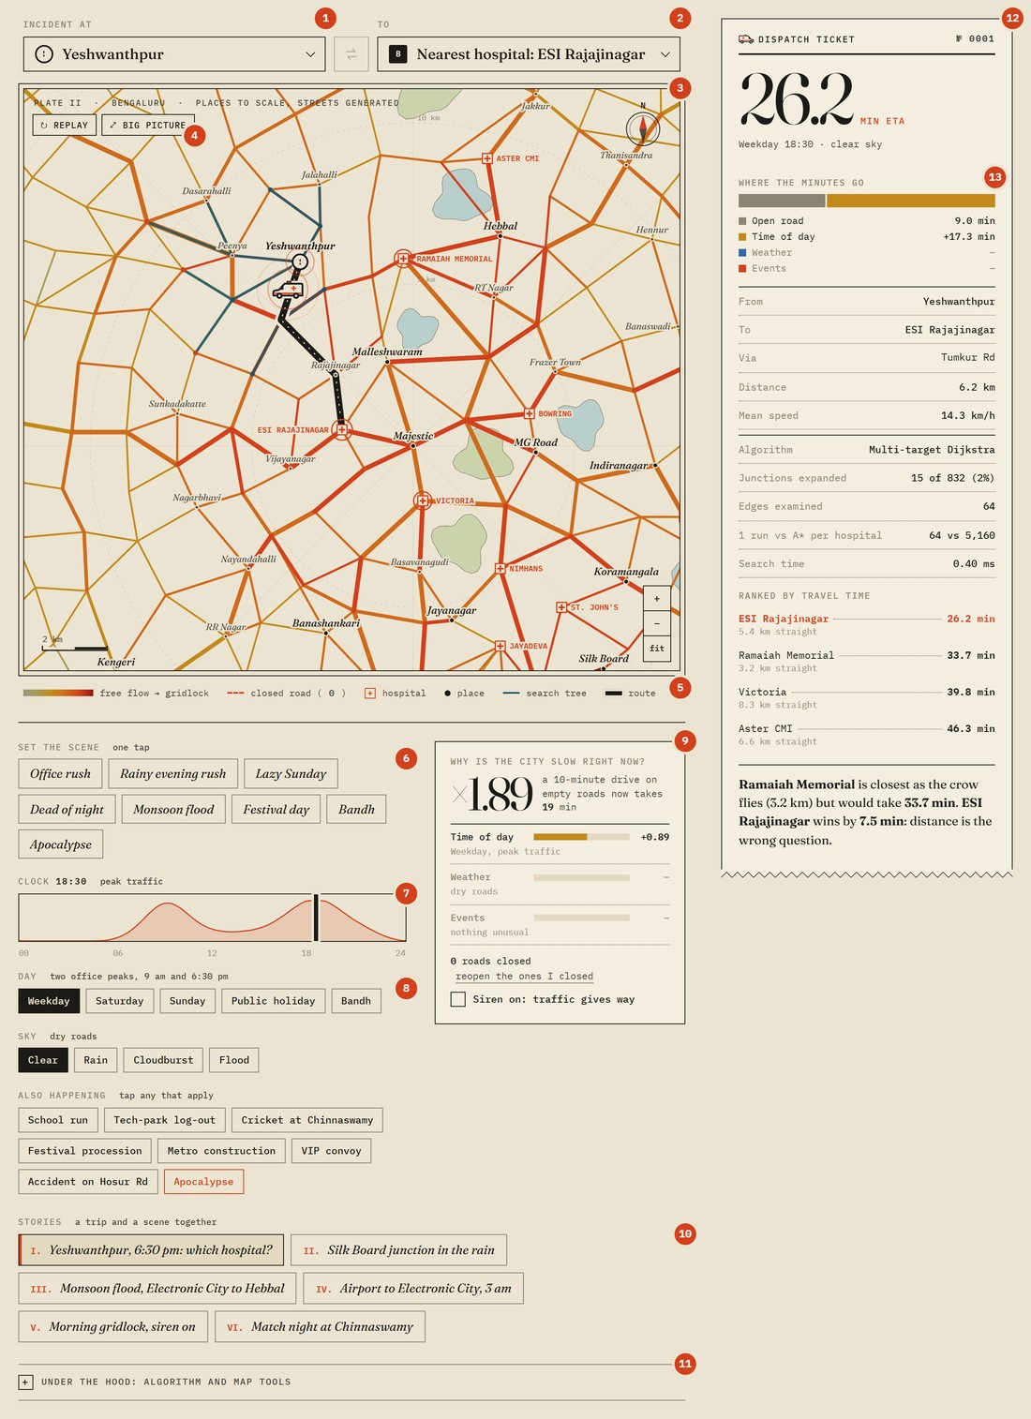
Figure 6. Anatomy of the console. The numbered parts are described in the table below.
NO. | PART | WHAT IT DOES
1 | From / Incident at | Searchable list of places for the origin. The label and marker change to "Incident at" in dispatch mode.
2 | To | Destination. "Nearest hospital" switches to dispatch; choosing a place switches to an A-to-B trip.
3 | Map | Roads coloured by congestion, hospitals, places, the search tree, the route and the ambulance.
4 | Replay, Big picture | Re-run the search animation, or open it full screen for step-by-step study.
5 | Legend | Colour ramp from free flow to gridlock, closed roads (with a live count), symbols.
6 | Set the scene | Eight one-tap presets from "Dead of night" to "Apocalypse".
7 | Clock | Time of day in 15-minute steps, drawn over the traffic curve for the chosen day type.
8 | Day, Sky, Also happening | Five day types, four skies, and eight events that can be combined.
9 | Why is the city slow? | Average slowdown on every road, split into time of day, weather and events; closed-road count; siren.
10 | Stories | Six prepared cases, each a trip and a scene together.
11 | Under the hood | Collapsed by default: the algorithm selector and the click tool (place a point, or close a road).
12 | Dispatch ticket | ETA, route details, search statistics, hospitals ranked by travel time, and a one-line verdict.
13 | Where the minutes go | The ETA of this route split into open road, time of day, weather and events.

5.2.1 Place pickers
Origin and destination are chosen from 62 places and 15 hospitals. The list is grouped into seven zones and shows each place's distance and direction from Majestic. Typing filters the list, with names that start with the text ranked first; arrow keys and Enter work without a mouse. The destination list begins with "Nearest hospital", so one control covers both kinds of question.
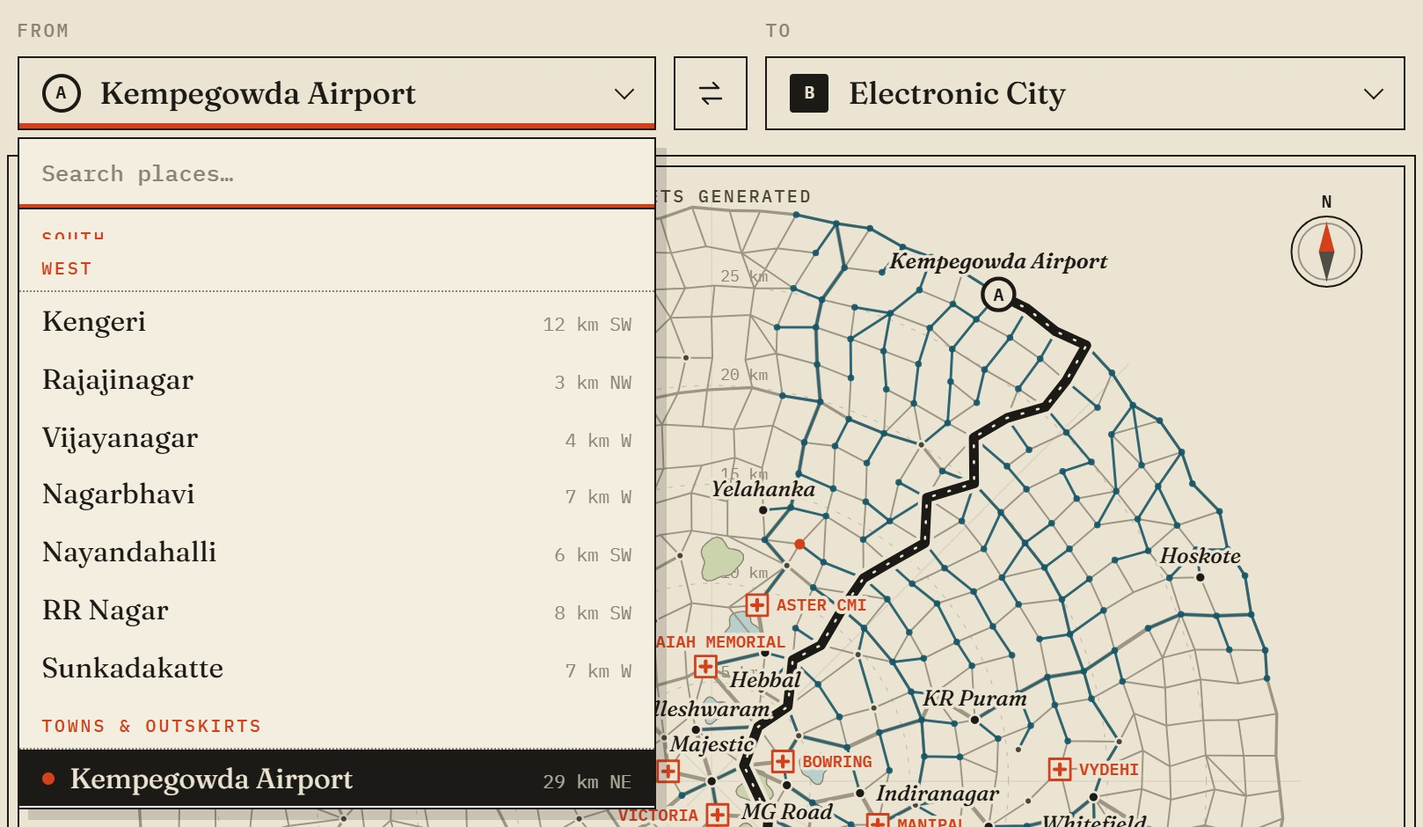 | 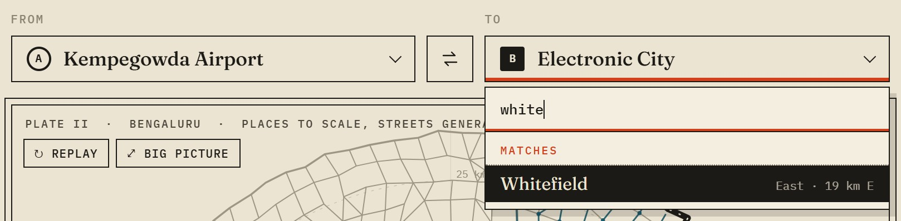
Figure 7. Place pickers: the grouped list for the origin (left) and a search for "white" in the destination list (right).

5.2.2 The map
The map is drawn on a canvas and redrawn every frame while anything is moving. A search is replayed in the order the algorithm visited junctions, so the teal tree spreads exactly as the search did. When it reaches the goal the route is inked in black on a paper-coloured casing, the one colour the traffic ramp never uses, and an ambulance drives it. The camera glides to frame each new trip, so a short trip zooms in and reveals smaller localities.
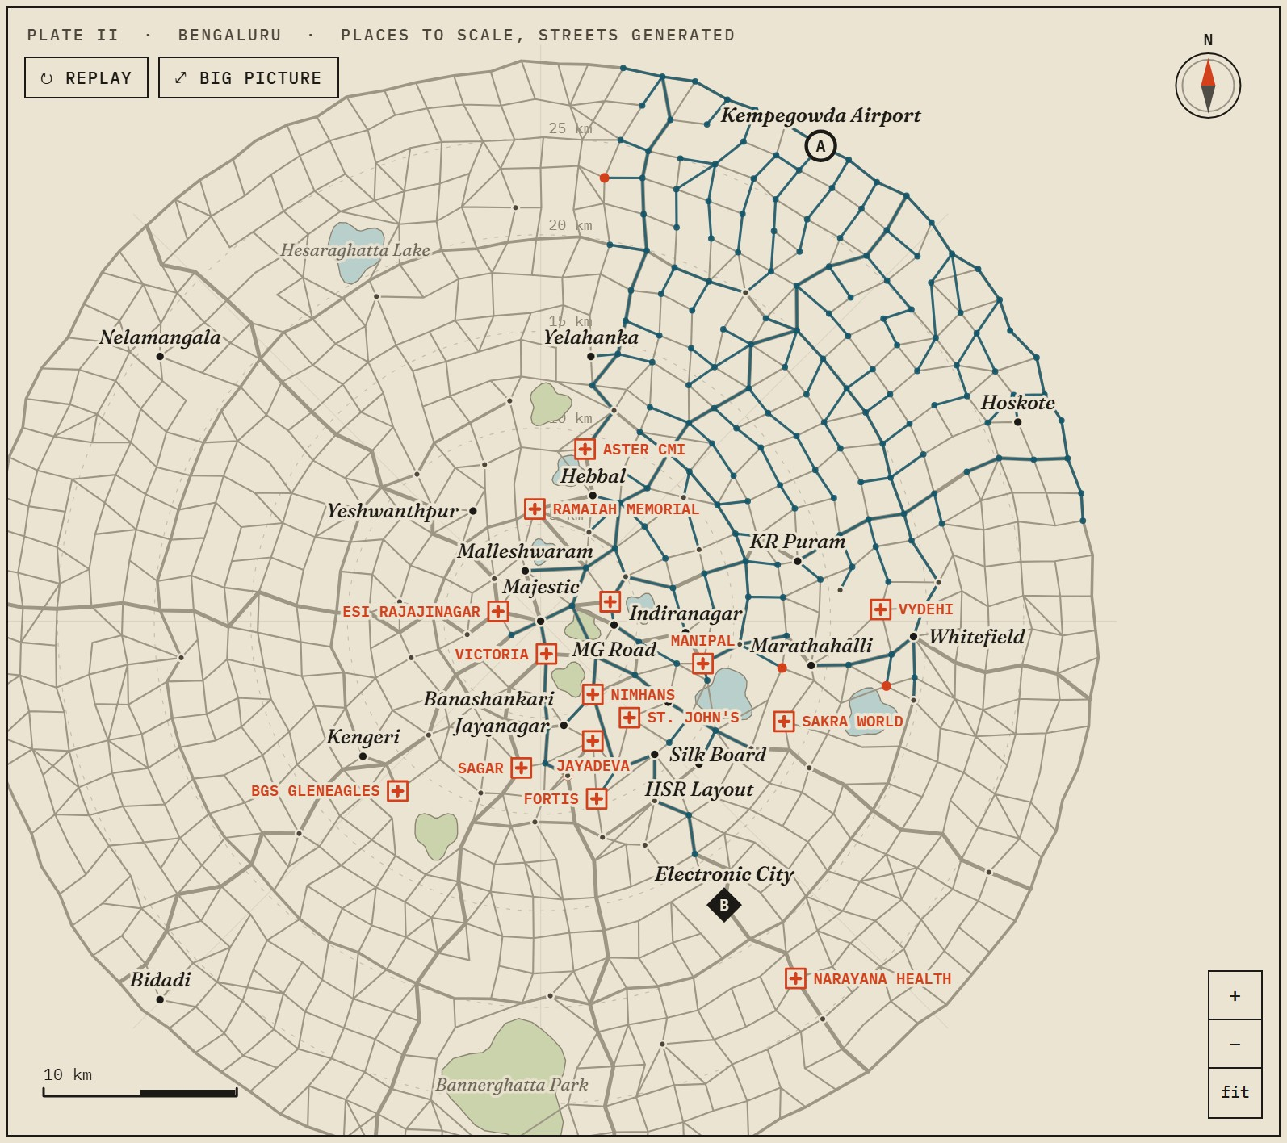 | 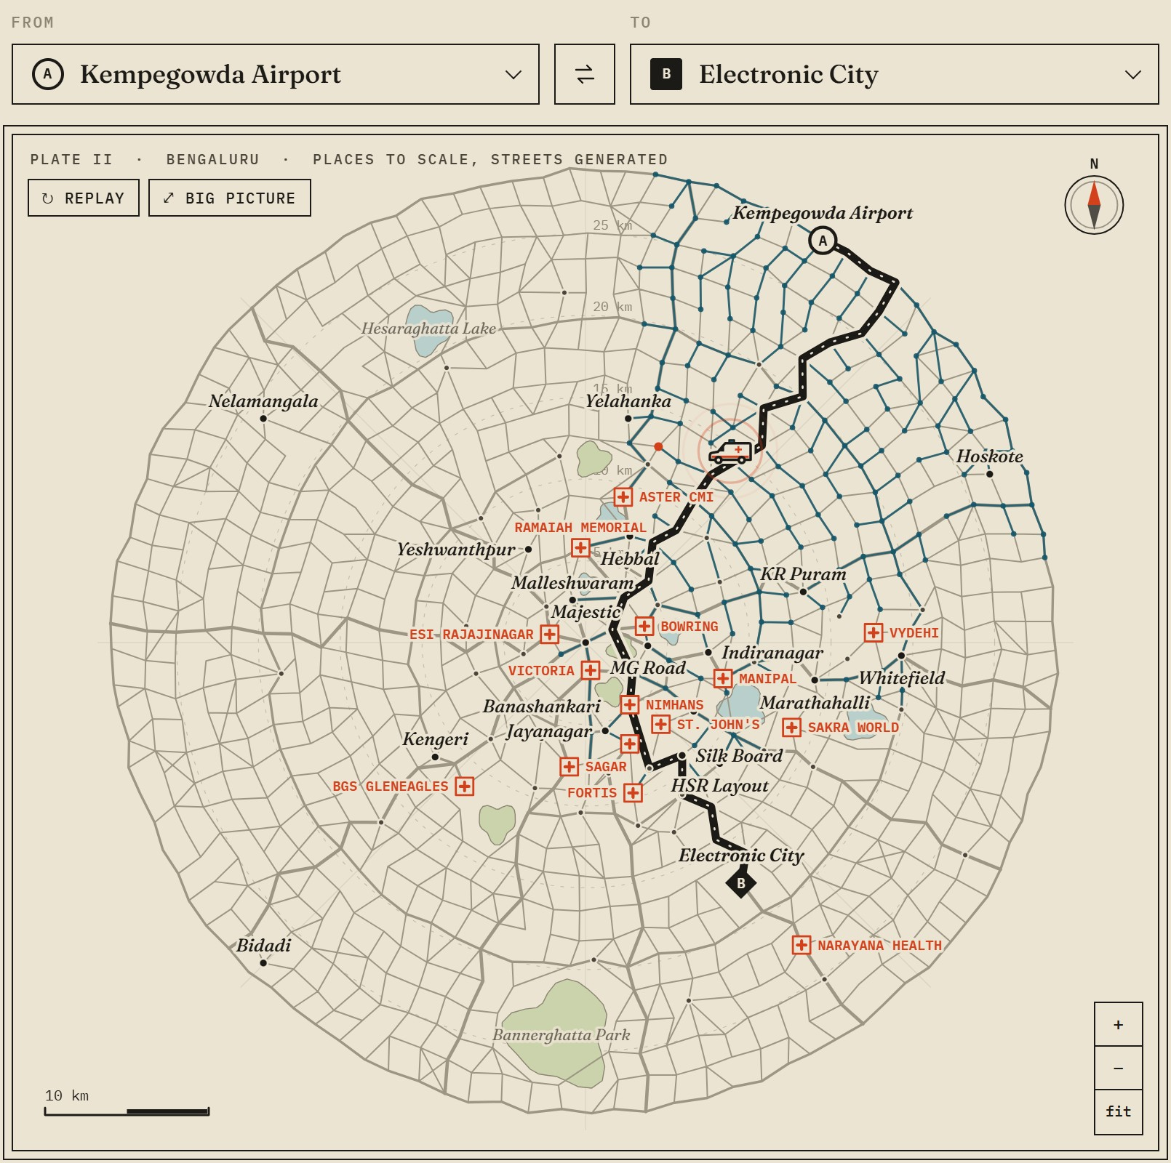
Figure 8. A* from the airport to Electronic City at 3 am: the search tree mid-flight (left), and the finished route with the ambulance on it (right).
LAYER (BOTTOM TO TOP) | CONTENT
Survey grid | Rings every 5 km and eight compass bearings from the city centre.
Water and parks | Eleven lakes and parks; no roads cross them.
Roads | Width by class (local, ring, highway); colour by congestion in six steps.
Closures | Dashed red with a cross; closed by the scene or by the user.
Search tree | Teal, in visit order; the second front of bidirectional search in brown; the newest visits in red.
Route and ambulance | Ink on a paper casing; the ambulance faces its direction of travel.
Hospitals and places | Labels are placed by priority and skipped if they would overlap; minor places appear when zoomed in.
Furniture | Scale bar, compass, zoom buttons, and a tooltip naming the road under the pointer with its current time.

5.2.3 Scene builder and "Why is the city slow?"
The scene is set in plain language rather than with technical controls. Each road's time is its free-flow time multiplied by one plus three delay terms, so every cause of delay can be shown separately:
time on a road = free-flow time × ( 1 + k × ( time of day + weather + events ) )
Here k is 1 normally and 0.45 with the siren on. Every term is zero or positive, so no scene can make a road faster than its free-flow time. That property is what keeps the A* heuristic valid in every scene (section 6.2).
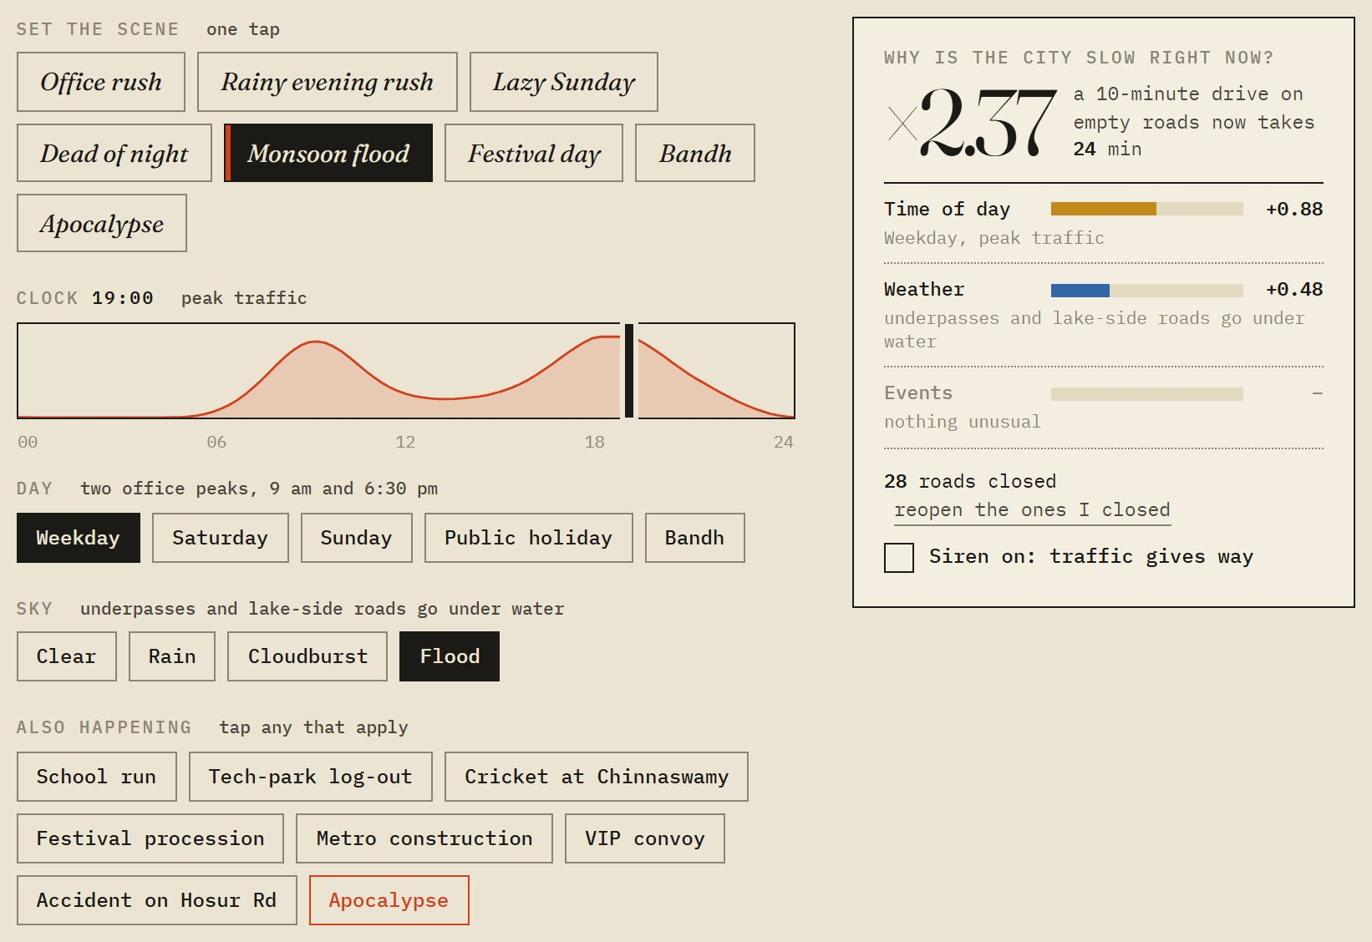
Figure 9. The scene builder set to a monsoon flood at 19:00. The panel on the right explains the slowdown and counts the roads the flood has closed.
CONTROL | OPTIONS | EFFECT ON THE MODEL
Day | Weekday, Saturday, Sunday, Public holiday, Bandh | Chooses the daily traffic curve. A weekday has two office peaks; a bandh leaves roads nearly empty.
Clock | 00:00 to 24:00 in 15-minute steps | Position on that curve. Delay is heavier in the core and at five chronic hotspots such as Silk Board.
Sky | Clear, Rain, Cloudburst, Flood | Slows every road, most near lakes and known waterlogging spots. A flood also closes the lowest-lying roads.
Also happening | School run, Tech-park log-out, Cricket at Chinnaswamy, Festival procession, Metro construction, VIP convoy, Accident on Hosur Rd, Apocalypse | Adds local jams around the places involved; some events close roads.
Siren | On or off | Multiplies all three delay terms by 0.45 for the ambulance.
Road closure | Shift-click any road | Sets that road's time to infinity; every algorithm skips it.

5.2.4 Dispatch ticket
The ticket is the output of the routing problem in readable form. It also reports how much work the search did, and compares that with the obvious alternative: Dijkstra for an A-to-B trip, or one A* run per hospital for a dispatch.
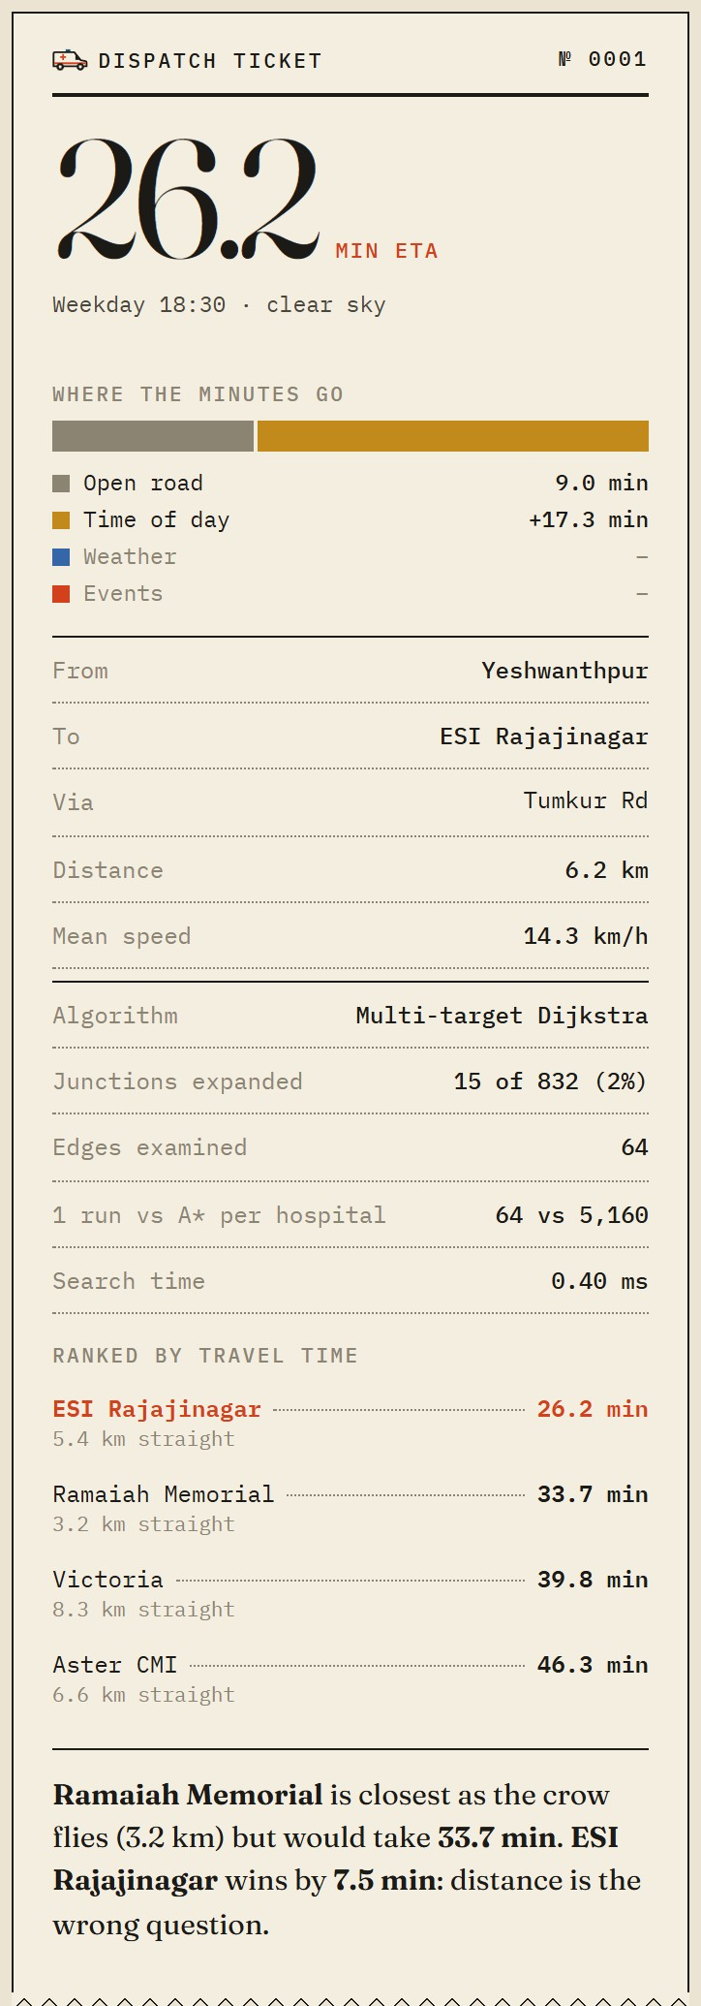 | 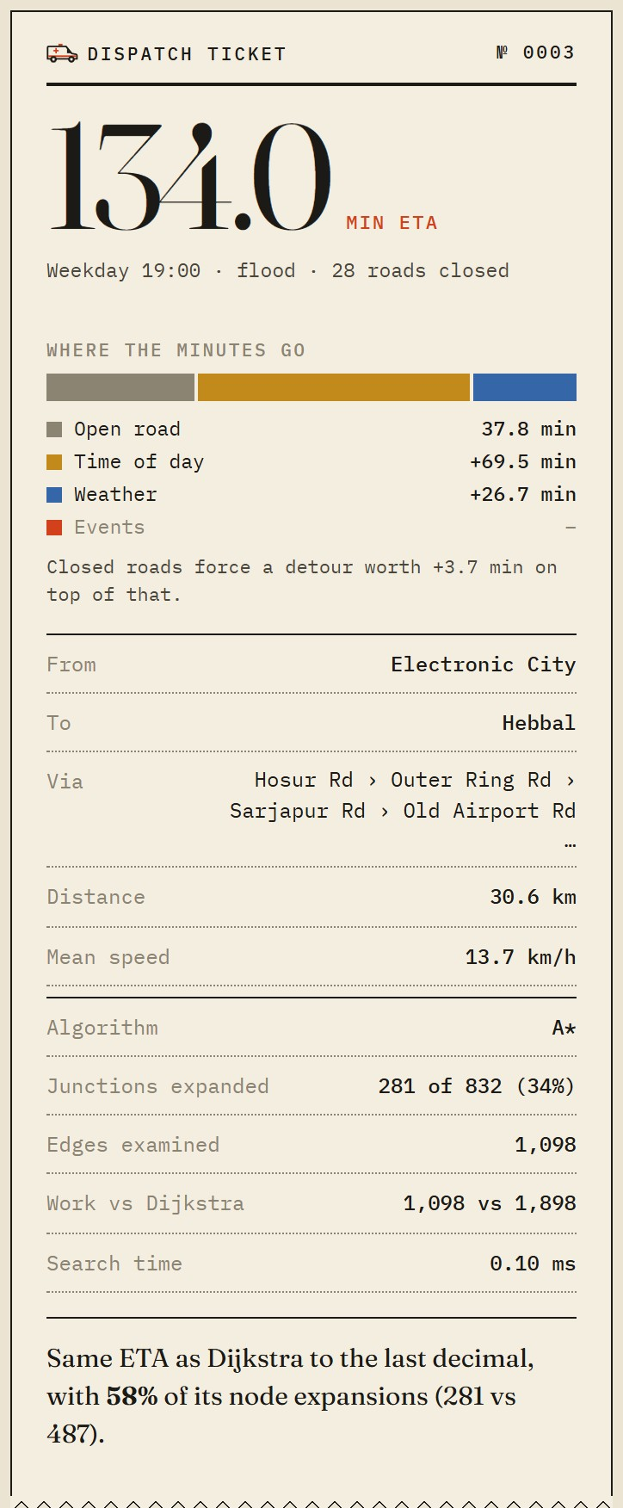 | 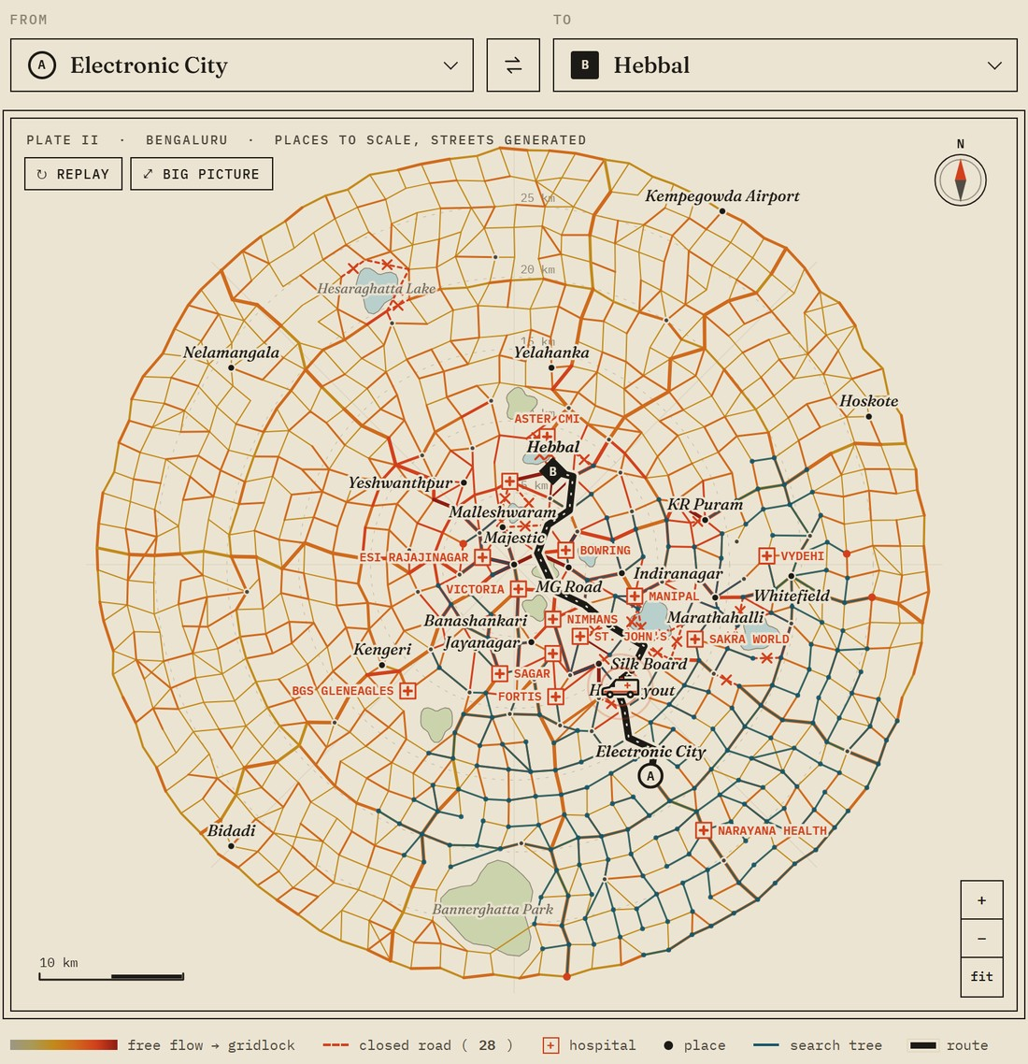
Figure 10. Left: a dispatch from Yeshwanthpur, where the closest hospital is not the fastest. Centre and right: Electronic City to Hebbal in a flood, with the ETA split by cause and the closed roads on the map.

5.2.5 Under the hood
The algorithm selector and the click tool are kept out of the way, because most viewers only need the pickers and the scene. Opening this panel lets an examiner run the same trip with each of the five algorithms and watch the ticket's statistics change.
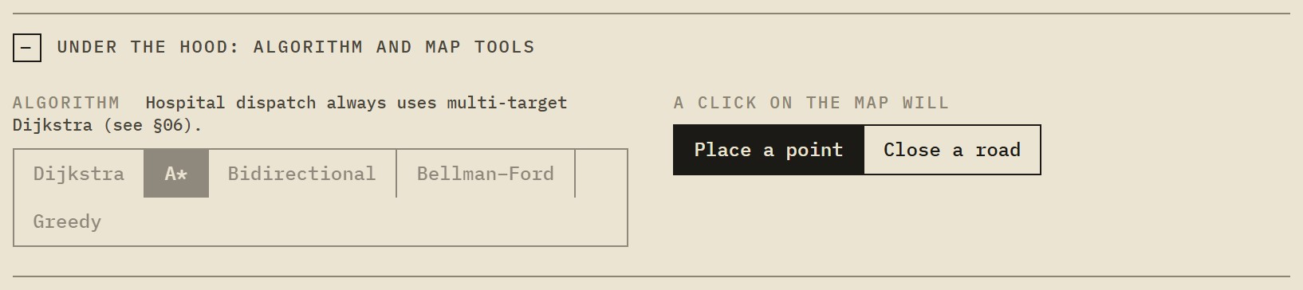
Figure 11. The collapsed panel opened: algorithm selector and click tool.

5.3 The race
All five algorithms answer the same trip on the same traffic. The shared clock counts edges examined, the unit of real work, so the result does not depend on how fast the machine is. In the run captured below (Kempegowda Airport to Electronic City), the four optimal algorithms returned the same ETA and differed only in effort; greedy best-first finished first and returned a slower route.
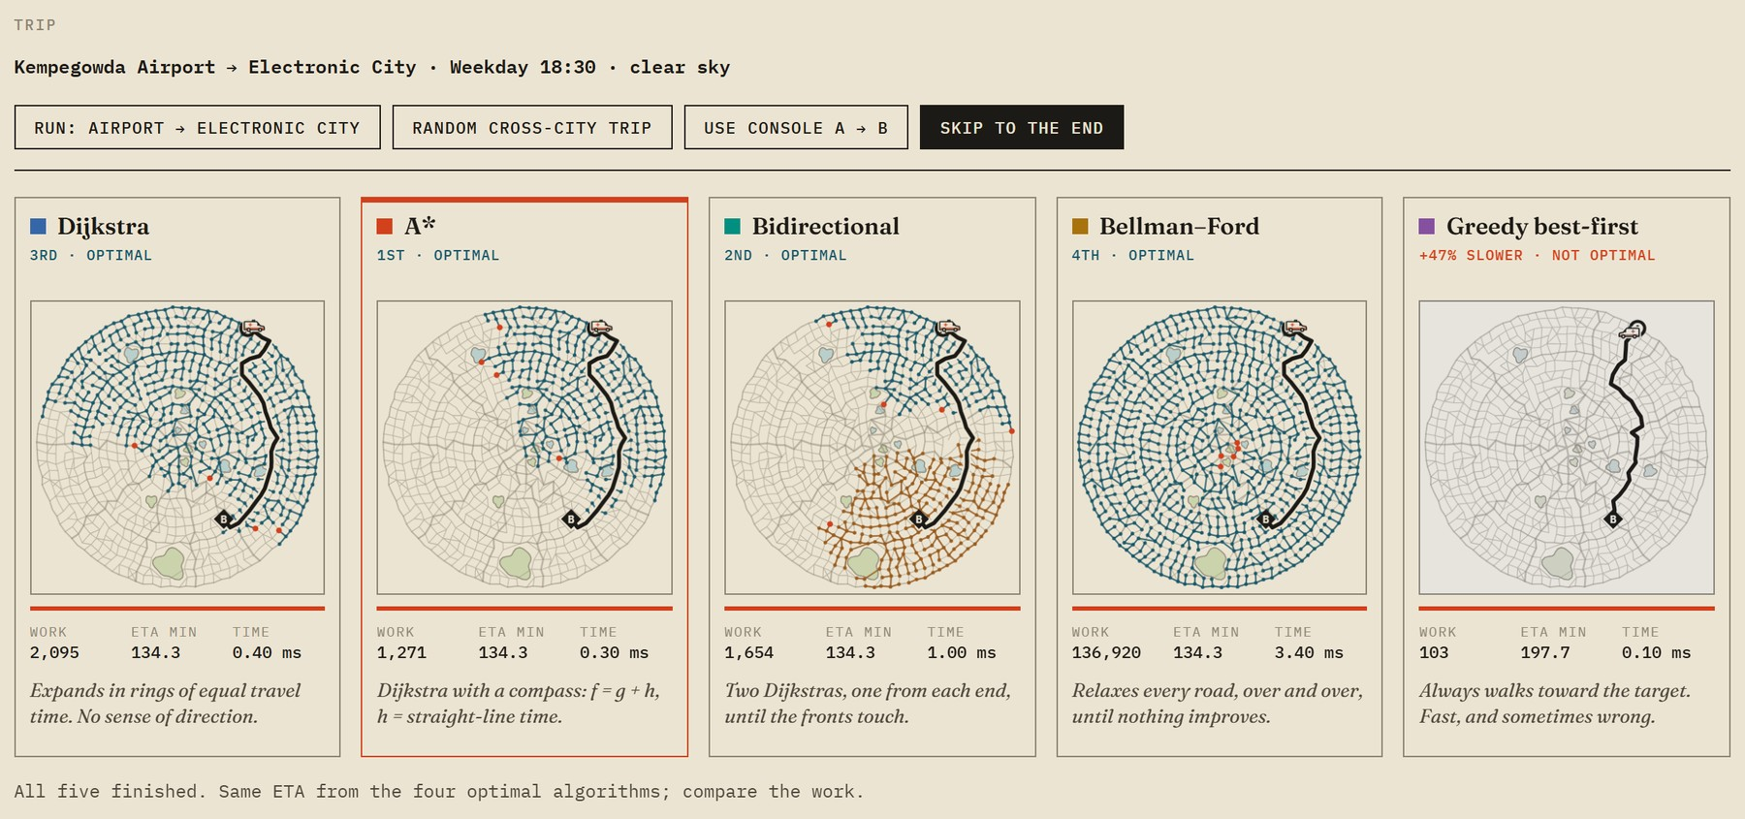
Figure 12. The race after all five have finished. A* examined the fewest edges among the algorithms that found the optimum.
ALGORITHM | RESULT | EDGES EXAMINED | ETA (MIN) | SEARCH TIME
Dijkstra | 3rd, optimal | 2,095 | 134.3 | 0.40 ms
A* | 1st, optimal | 1,271 | 134.3 | 0.30 ms
Bidirectional | 2nd, optimal | 1,654 | 134.3 | 1.00 ms
Bellman–Ford | 4th, optimal | 136,920 | 134.3 | 3.40 ms
Greedy best-first | +47% slower, not optimal | 103 | 197.7 | 0.10 ms

5.4 The big picture
Any search can be opened full screen. The viewer can pause, drag the scrubber to any step, change speed from one quarter to ten times, and switch algorithm on the same trip. A small curve on the right plots edges examined against junctions visited, with a cursor that follows the replay. Any of the five race maps can also be clicked to open it here.
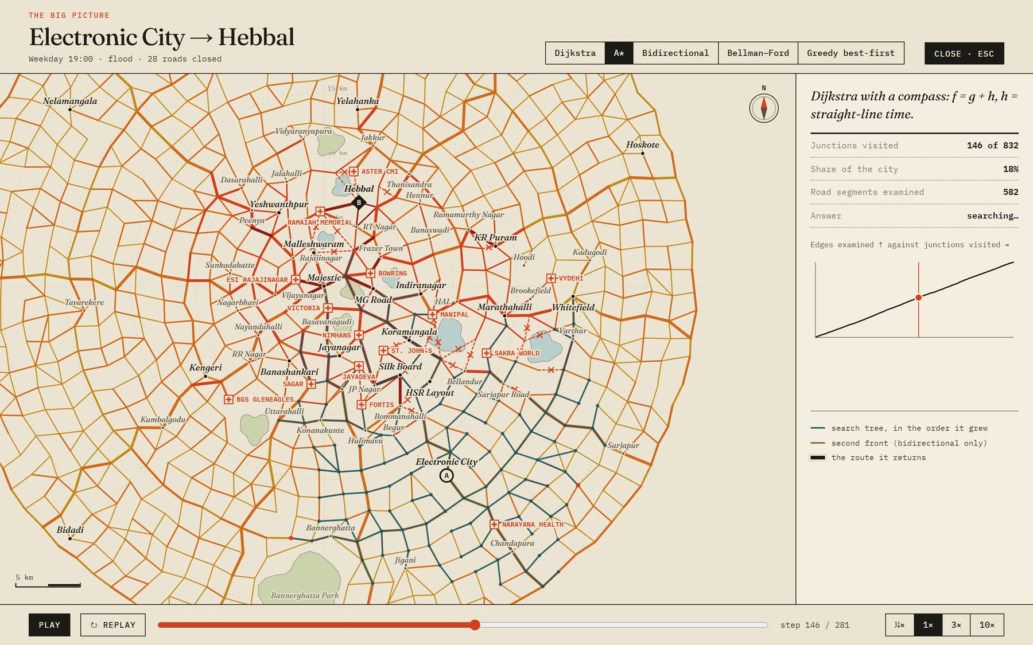
Figure 13. The big picture paused part-way through an A* search in a flood. The counters on the right are live.
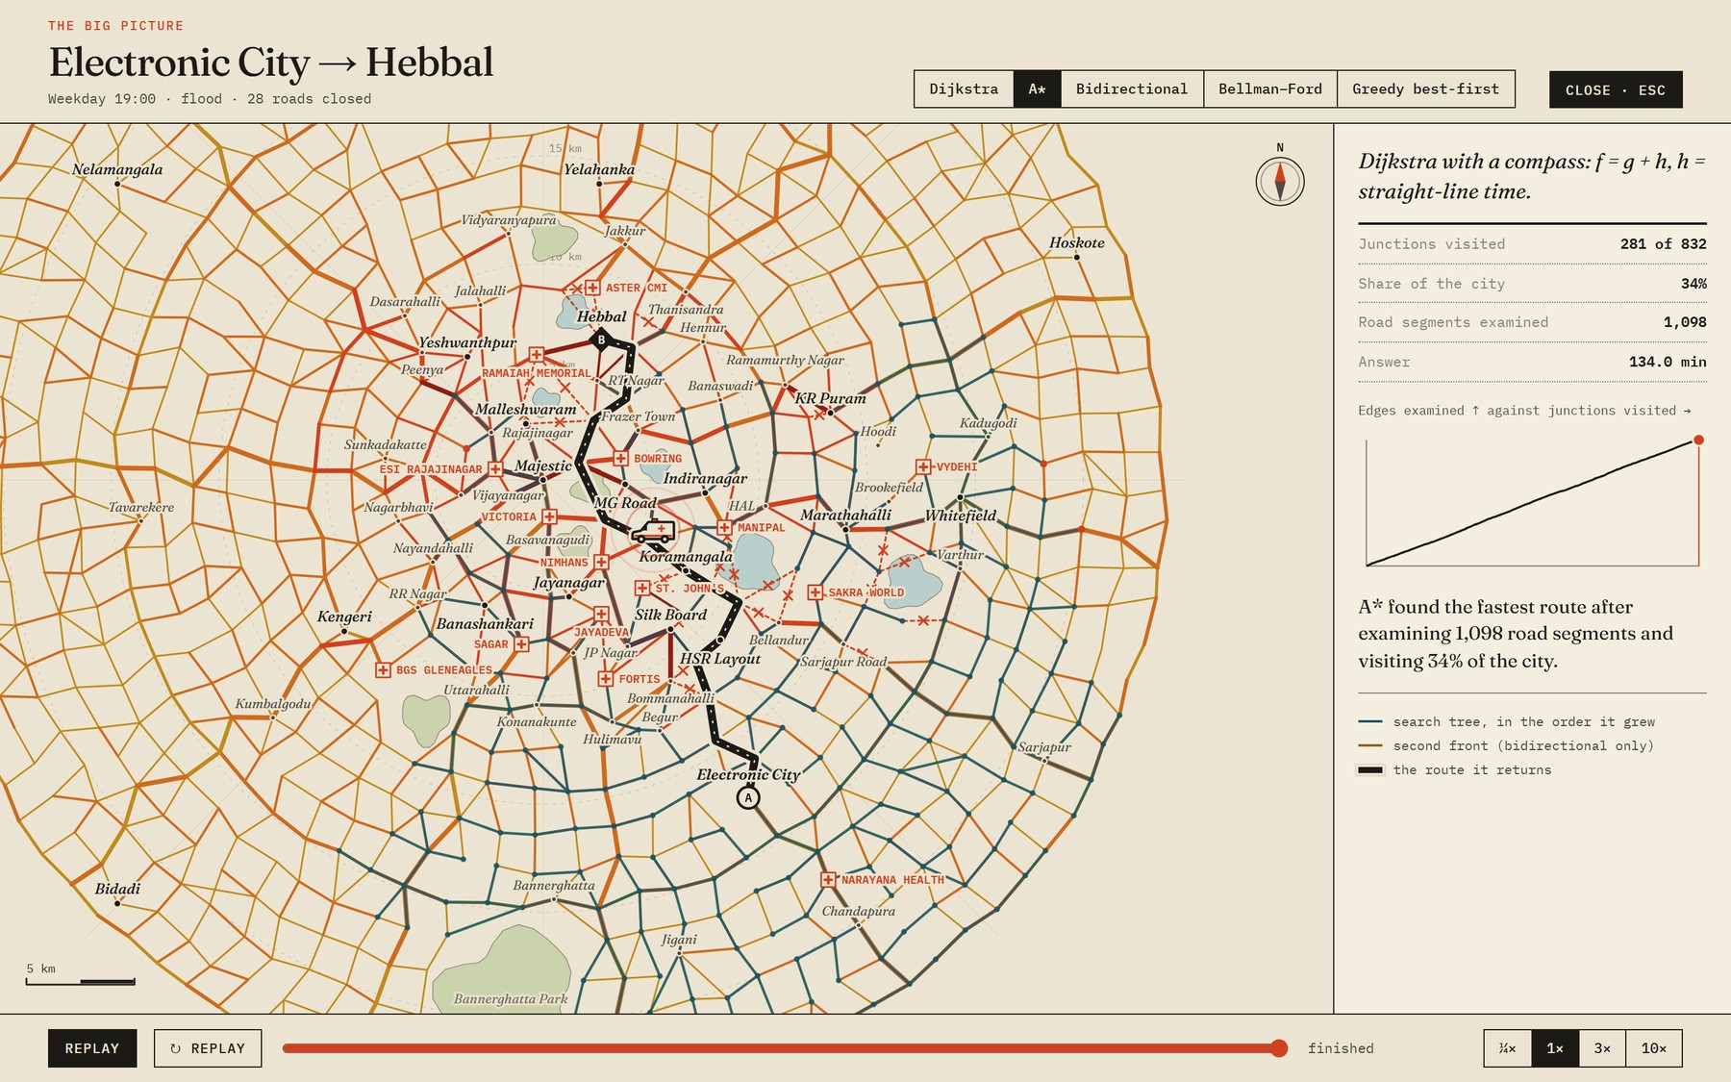 | 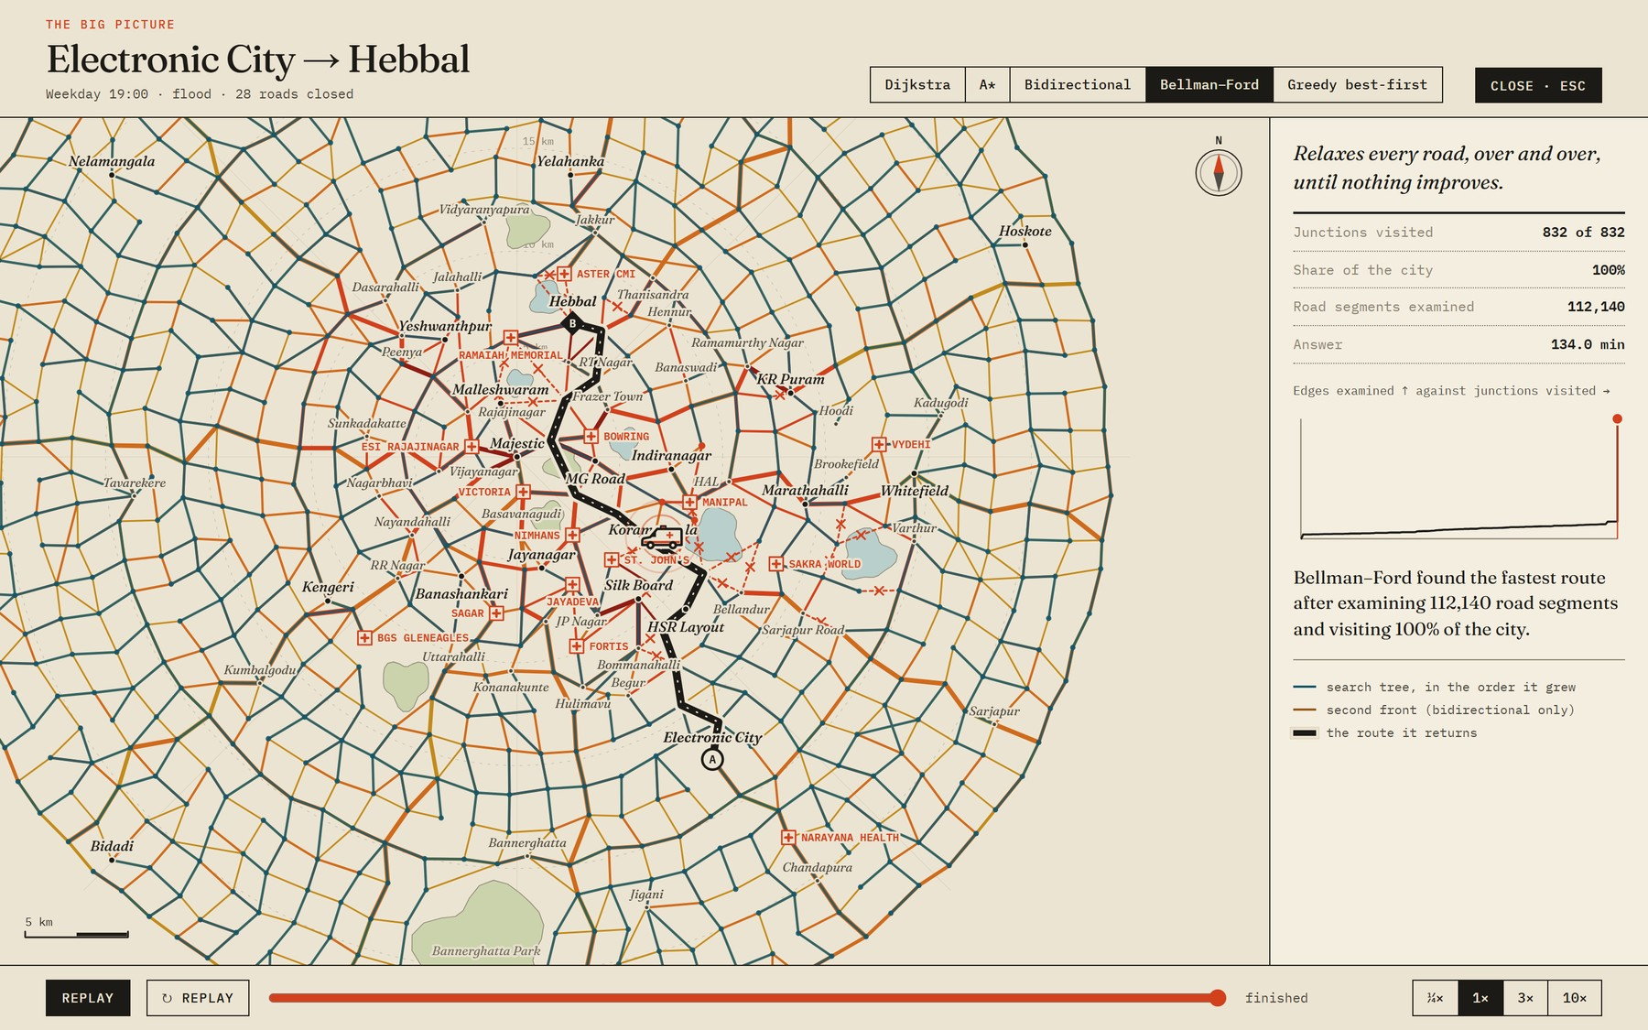
Figure 14. The same trip finished. Left: A* visited 34% of the city. Right: Bellman–Ford visits every junction and keeps working after it has seen them all.

5.5 The proof ledger
Ten claims about the implementation are tested each time the section scrolls into view. Nothing is hard-coded: each test builds its own city, runs the real algorithms and compares them with a hand-worked answer or with each other. In the captured run the summary read "10 / 10 passed in 1.2 s".

Figure 15. The proof ledger after a run: each claim, its evidence and the time it took.

5.6 The benchmark lab
The lab runs two experiments in the browser and draws the results as interactive charts with no charting library. Hovering shows a crosshair listing every algorithm at that point; clicking a name hides its line; a switch changes between a log and a linear scale. The results can be copied as CSV.
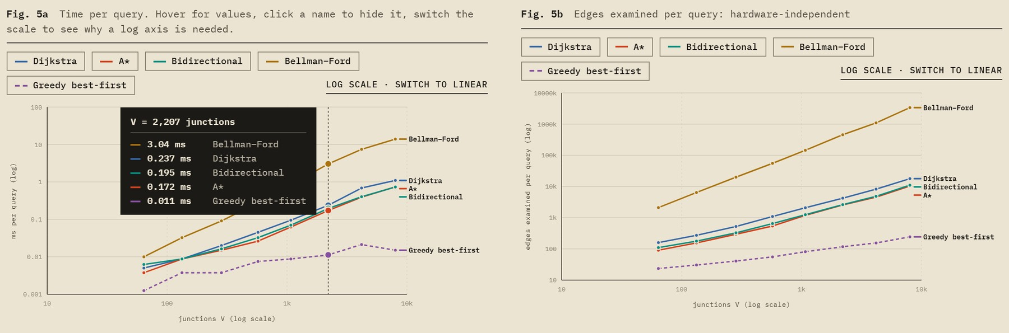
Figure 16. Experiment A: time per query and edges examined per query on eight city sizes, on log scales. A straight line on these axes is a power law.
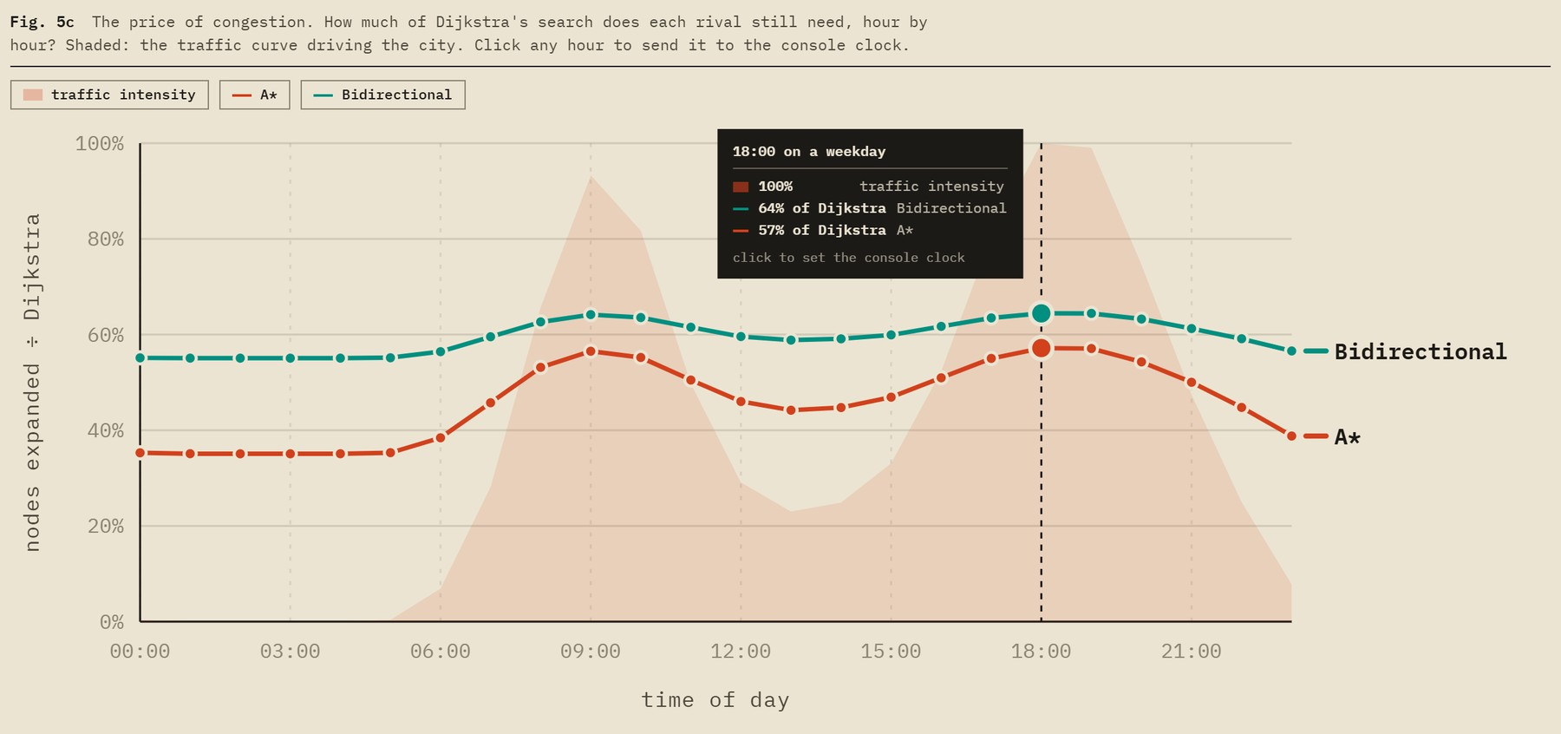
Figure 17. Experiment B: the share of Dijkstra's search that A* and bidirectional search still need, hour by hour. Clicking an hour sends it to the console clock.
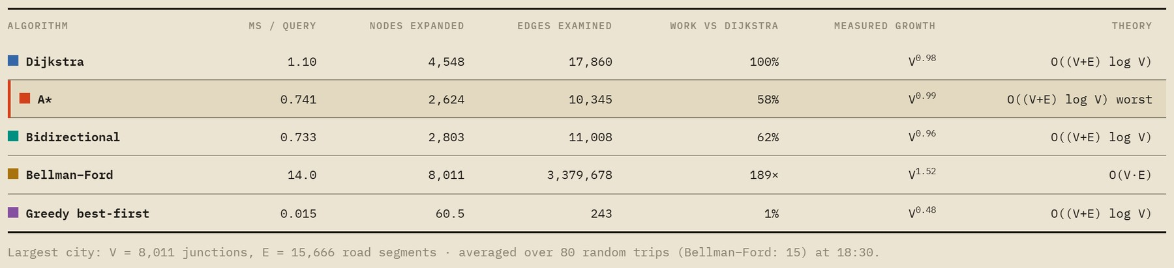
Figure 18. The results table for the largest city, with the growth exponent fitted from the data beside the theoretical bound.

5.7 Verdict section
The last content section of the page states the choice and the reasons, and is honest about where A* stops being the best option. It carries the comparison table below; the figures in its last column are filled in from the benchmark the viewer has just run.
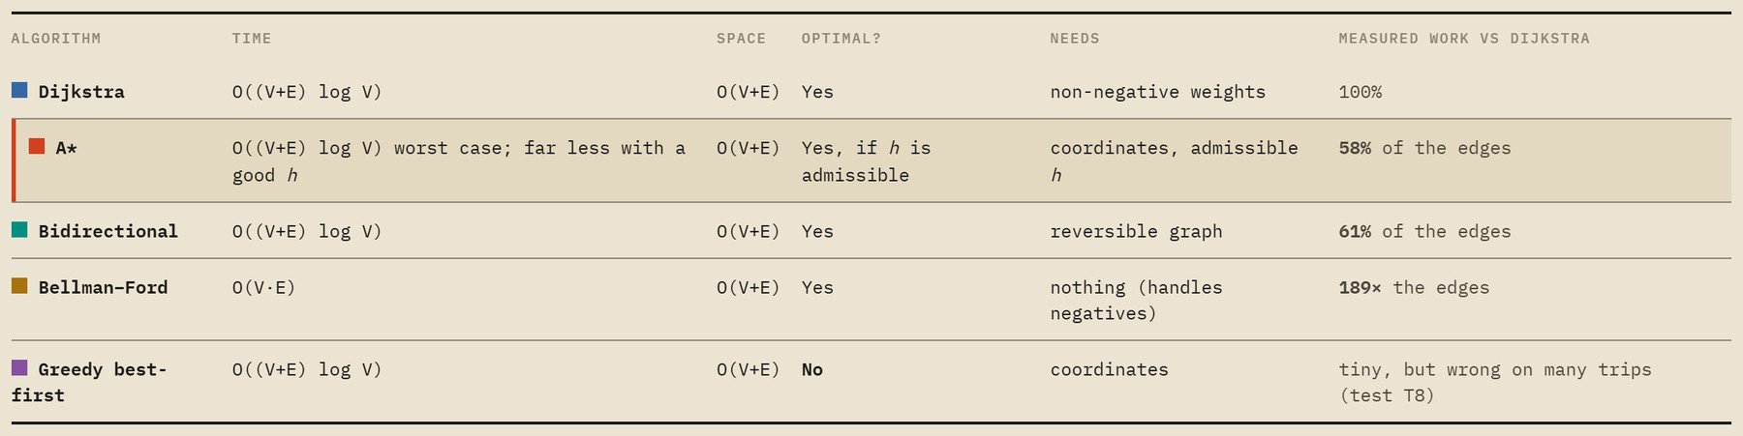
Figure 19. The comparison table in the verdict section.

5.8 Themes and small screens
A night chart re-inks the whole page, maps included. On a phone the layout becomes a single column, the map keeps its controls, and nothing scrolls sideways.
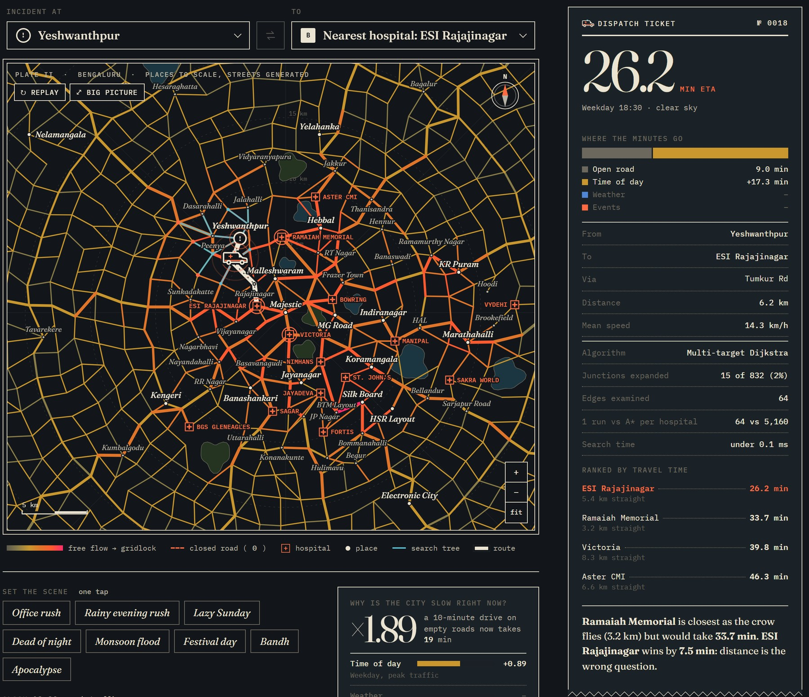
Figure 20. The console in the night chart.
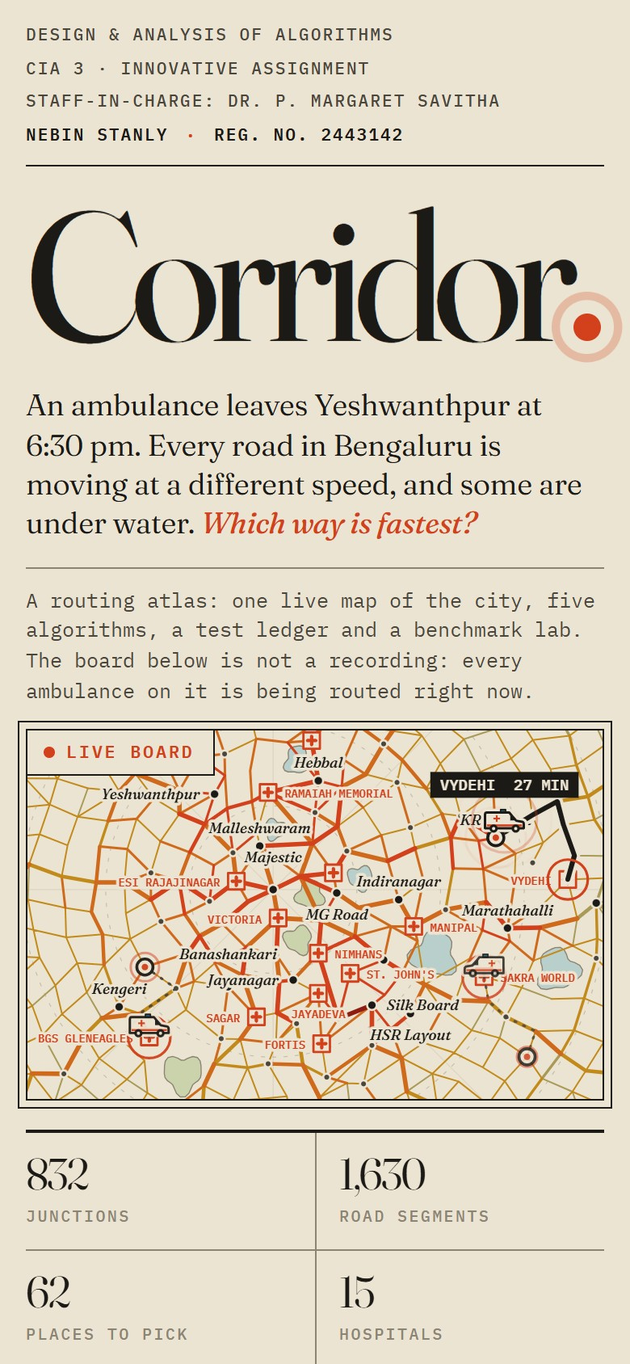 | 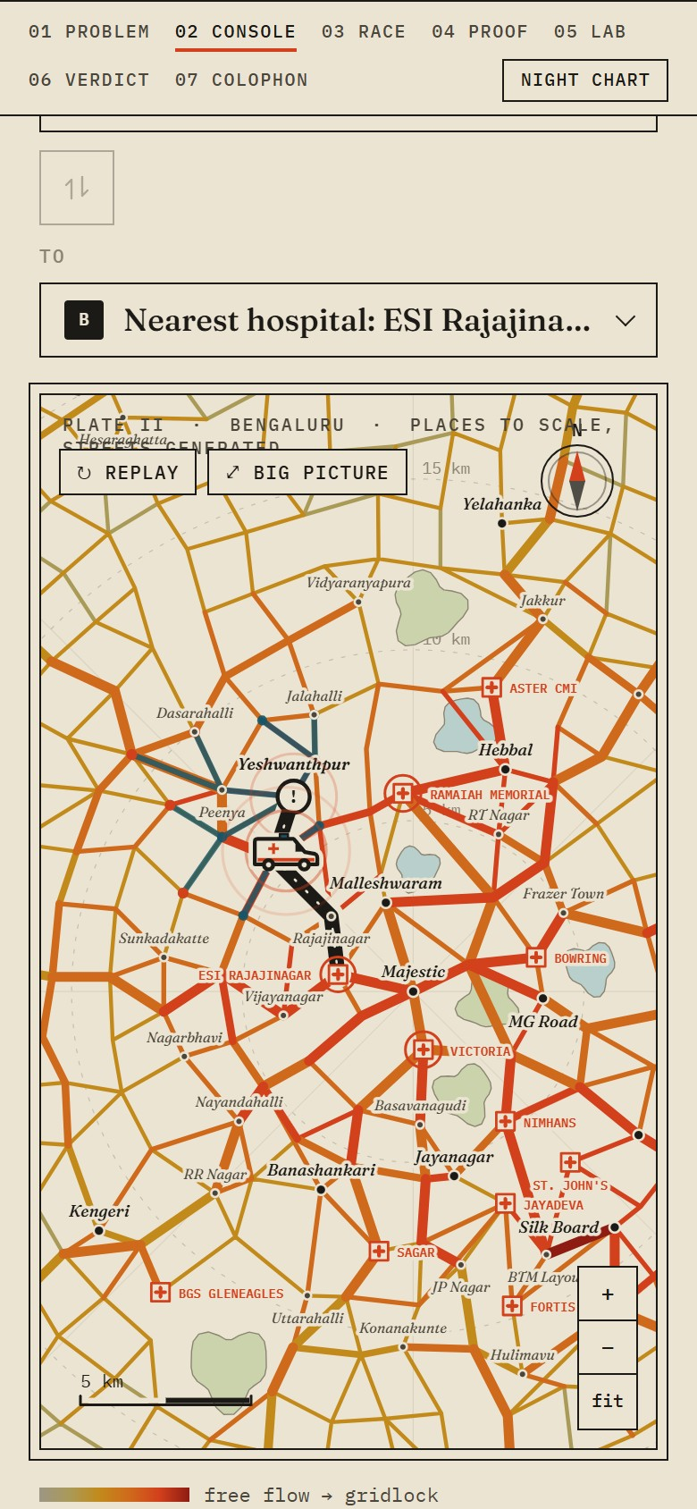
Figure 21. The masthead and the console at phone width (390 px).

6 Algorithms and design justification

6.1 The five algorithms
ALGORITHM | HOW IT SEARCHES | TIME | SPACE | OPTIMAL?
Dijkstra | Settles junctions in order of travel time from the origin, spreading in every direction. | O((V+E) log V) | O(V+E) | Yes
A* | Dijkstra ordered by time so far plus an estimate of time to go, so it leans toward the goal. | O((V+E) log V) worst case | O(V+E) | Yes, if the estimate never over-estimates
Bidirectional Dijkstra | Two searches, from the origin and from the goal, that stop when their fronts meet. | O((V+E) log V) | O(V+E) | Yes
Bellman–Ford | Re-examines every road, pass after pass, until no time improves. | O(V·E) | O(V+E) | Yes
Greedy best-first | Always moves to the junction that looks closest to the goal, ignoring time so far. | O((V+E) log V) | O(V+E) | No

6.2 Why A* for a trip from A to B
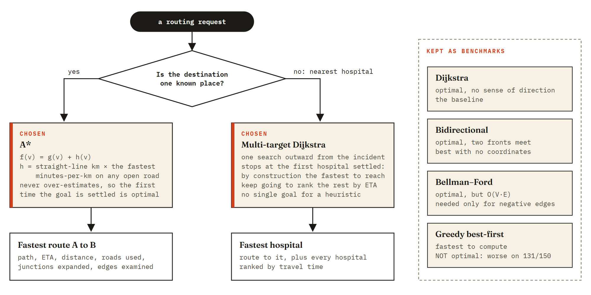
Figure 22. How the prototype chooses an algorithm, and what the others are kept for.
- The weights suit it. Travel times are never negative, and a road can never beat the straight line at the network's best speed, so a safe estimate exists.
- Nothing has to be precomputed. Faster schemes such as contraction hierarchies prepare shortcuts for fixed weights. Here weights change with the clock and roads close without warning; A* just reads the new numbers.
- It does less work for the same answer. On cities of 1,000 junctions or more, A* expanded 57% of the junctions Dijkstra did (section 8.4).
- The estimate adapts. h(v) = (the smallest minutes-per-kilometre on any open road right now) × (straight-line distance from v to the goal). It tightens when the city is fast and loosens when it jams.
The estimate is admissible: every road costs at least that minimum rate per kilometre and is at least as long as the straight line, so h never over-estimates. It is also consistent: h(u) ≤ w(u,v) + h(v) for every road. Consistency means a settled junction never needs to be reopened, and the first time the goal is settled the answer is optimal. Test T6 checks both inequalities on every junction and every road at three times of day.
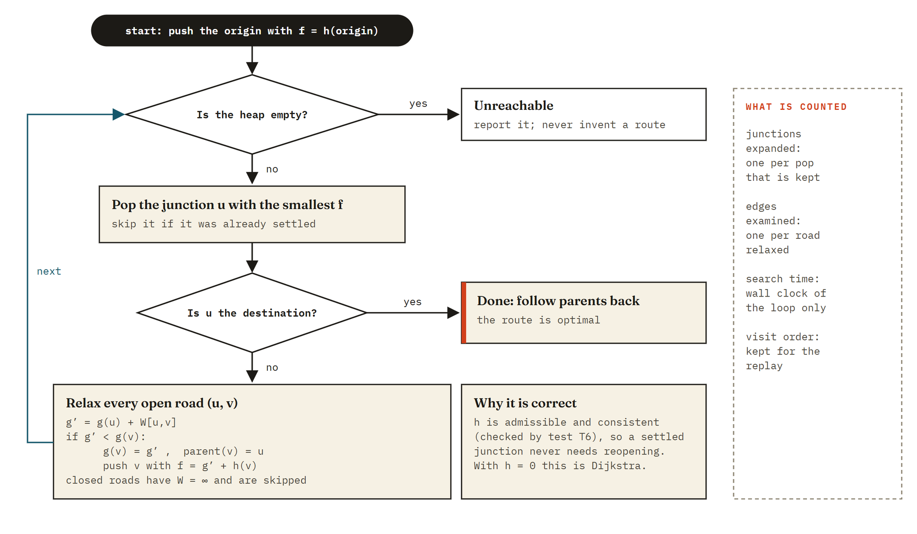
Figure 23. The A* loop as implemented. With h = 0 the same loop is Dijkstra's algorithm.

6.3 Why multi-target Dijkstra for dispatch
"Nearest hospital" has no single goal for an estimate to point at. One Dijkstra search from the incident settles junctions in order of travel time, so the first hospital it settles is the fastest to reach, and continuing ranks the rest. In the opening case this single search examined 64 edges, against 5,160 for running A* once per hospital. Test T9 confirms it returns the same hospital as the exhaustive method.

6.4 Complexity, argued
- Time. Each junction is settled once and each road is examined at most twice, once from each end. An examination may push to a binary heap at a cost of O(log V). The total is O((V+E) log V). With h = 0, A* is Dijkstra, so its worst case is the same.
- Space. Distance, parent and settled arrays take O(V); the graph takes O(V+E); the heap holds at most one entry per successful examination, O(E).
- Bellman–Ford. Up to V − 1 passes over all E roads gives O(V·E). In practice it stops after about as many passes as the graph is wide in hops.

6.5 Where A* stops being the answer
A*'s advantage is not constant. It expanded 35% of Dijkstra's junctions at 02:00 but 57% at 18:00: when every road is slow, a straight-line estimate is loose. Fewer expansions also do not convert one-for-one into milliseconds, because each push evaluates a square root. Bidirectional search is a close rival and the better choice on a network with no coordinates. For a static network of millions of junctions, methods that precompute would win outright.

7 Non-functional requirements
ID | REQUIREMENT | EVIDENCE
NFR-01 | Performance: a route is found fast enough to re-plan while the clock is dragged. | Search time on the ticket for the opening case: under 1 ms. A cross-city A* search examined 877 edges.
NFR-02 | Correctness is demonstrable, not asserted. | 10 of 10 tests pass in the browser (10 / 10 passed in 1.2 s); 120 benchmark trips cross-checked with 0 disagreements.
NFR-03 | Portability: runs without installation. | Plain HTML, CSS and JavaScript. No build step. Opens from disk or any static host.
NFR-04 | No third-party code. | No frameworks, chart libraries or map services. Two web fonts, with system fallbacks.
NFR-05 | Small footprint. | All eleven source files total 237 kB uncompressed.
NFR-06 | Responsive layout. | Checked at 390 px and 1,440 px. Horizontal overflow at phone width: 0 px.
NFR-07 | Accessibility basics. | Pickers and charts work from the keyboard; chart colours pass a colour-blind separation check in both themes; text labels never rely on colour alone.
NFR-08 | Robustness. | The scripted walk through every module for this document produced 0 page errors.
NFR-09 | Privacy. | No data is collected or sent anywhere. All computation is local.
NFR-10 | Maintainability. | The engine has no dependency on the page and can be run and tested in Node.

8 Verification and results

8.1 Test cases
ID | TEST | EVIDENCE FROM THE RUN | RESULT
T1 | Hand-checked graph | dijkstra 5 · astar 5 · bidir 5 · bellman 5 · greedy 7 | Pass
T2 | Source equals target | 5 of 5 algorithms return cost 0, path [5] | Pass
T3 | Unreachable destination | island: 0/5 found · sealed junction: 0/5 found (want 0 and 0) | Pass
T4 | Road closure forces a detour | 25 closures tested · 0 violations · last detour added 14.0 min | Pass
T5 | Cross-validation, 150 random trips | 150 pairs x 4 algorithms = 600 searches · 0 disagreements | Pass
T6 | The heuristic never lies | 9,234 inequalities checked · 0 violations | Pass
T7 | Optimal substructure | 241 prefixes compared with single-source Dijkstra · 0 mismatches | Pass
T8 | Greedy is fast, and sometimes wrong | greedy was slower on 131 of 150 trips (avg +29% ETA) · beat the optimum 0 times | Pass
T9 | Hospital dispatch = best of all hospitals | 40 incidents · 15 hospitals · 0 mismatches | Pass
T10 | Monotone world | 40 trips: night ≤ siren ≤ rush held 40 times | Pass

The tests cover the normal case (T1, T5), edge cases (T2 source equals target, T3 unreachable), behaviour under change (T4 closures, T10 scene changes), the theory the algorithms rely on (T6 heuristic, T7 optimal substructure), a deliberate negative result (T8: greedy is wrong on most trips) and the dispatch method (T9).

8.2 Stories
STORY | TRIP | ETA (MIN) | DISTANCE | JUNCTIONS EXPANDED | ROADS USED
I. Yeshwanthpur, 6:30 pm | Yeshwanthpur to ESI Rajajinagar | 26.2 | 6.2 km | 15 of 832 | Tumkur Rd
II. Silk Board in the rain | Silk Board to Fortis | 22.1 | 4.1 km | 8 of 832 | Hosur Rd
III. Monsoon flood | Electronic City to Hebbal | 134.0 | 30.6 km | 281 of 832 | Hosur Rd, Outer Ring Rd, Sarjapur Rd, Old Airport Rd …
IV. Airport to Electronic City, 3 am | Kempegowda Airport to Electronic City | 65.8 | 59.1 km | 217 of 832 | Satellite Town Ring Rd, Hennur Rd, Old Airport Rd, Hosur Rd
V. Morning gridlock, siren on | Marathahalli to Majestic | 36.8 | 17.7 km | 34 of 832 | Old Airport Rd, Old Madras Rd
VI. Match night | MG Road to Whitefield | 60.2 | 19.1 km | 32 of 832 | Old Airport Rd

Story I shows why distance is the wrong measure. Ramaiah Memorial is closest as the crow flies (3.2 km) but would take 33.7 min. ESI Rajajinagar wins by 7.5 min: distance is the wrong question.

8.3 Scenes
SCENE PRESET | AVERAGE SLOWDOWN ON EVERY ROAD | ROADS CLOSED BY THE SCENE
Office rush | × 1.93 | 0
Rainy evening rush | × 2.07 | 0
Lazy Sunday | × 1.35 | 0
Dead of night | × 1.00 | 0
Monsoon flood | × 2.37 | 28
Festival day | × 1.38 | 3
Bandh | × 1.04 | 0
Apocalypse | × 4.83 | 123

8.4 Benchmark results
Eight cities were generated, from 64 to 8,011 junctions. On each, the same 80 random trips were run by every algorithm at evening-peak traffic (15 trips for Bellman–Ford on the two largest cities), three times over, keeping the fastest pass. Times vary between machines; the edge counts do not.
JUNCTIONS | ROADS | DIJKSTRA | A* | BIDIRECTIONAL | BELLMAN–FORD | GREEDY
64 | 130 | 0.005 | 0.004 | 0.006 | 0.010 | 0.001
133 | 259 | 0.009 | 0.009 | 0.009 | 0.032 | 0.004
284 | 560 | 0.020 | 0.015 | 0.016 | 0.091 | 0.004
573 | 1,140 | 0.045 | 0.026 | 0.033 | 0.280 | 0.007
1,076 | 2,075 | 0.095 | 0.062 | 0.070 | 0.827 | 0.009
2,207 | 4,292 | 0.237 | 0.172 | 0.195 | 3.04 | 0.011
4,185 | 8,132 | 0.688 | 0.391 | 0.402 | 7.43 | 0.021
8,011 | 15,666 | 1.10 | 0.741 | 0.733 | 14.0 | 0.015

Table: milliseconds per query.
JUNCTIONS | ROADS | DIJKSTRA | A* | BIDIRECTIONAL | BELLMAN–FORD | GREEDY
64 | 130 | 159 | 90 | 110 | 2,106 | 23
133 | 259 | 273 | 155 | 178 | 6,404 | 30
284 | 560 | 524 | 296 | 327 | 19,908 | 41
573 | 1,140 | 1,091 | 542 | 649 | 55,347 | 55
1,076 | 2,075 | 2,085 | 1,183 | 1,250 | 144,731 | 81
2,207 | 4,292 | 4,230 | 2,557 | 2,623 | 456,454 | 117
4,185 | 8,132 | 8,245 | 4,542 | 4,857 | 1,096,194 | 155
8,011 | 15,666 | 17,860 | 10,345 | 11,008 | 3,379,678 | 243

Table: edges examined per query (independent of hardware).
The page writes its own findings from each run. For the run captured in this document they were:
- A* expanded 57% of the junctions Dijkstra did on cities of 1,000 junctions or more; bidirectional search expanded 61%.
- Bellman–Ford examined 189 times as many edges as Dijkstra on the largest city. Its work grew roughly as V to the power 1.5, not V squared: it needs about as many passes as the graph is wide in hops, which grows like the square root of V on a road network.
- Dijkstra's work grew almost exactly in proportion to V, because a random trip floods a roughly constant share of the city.
- All four optimal algorithms returned identical costs on 120 cross-checked trips.
- Greedy best-first examined the fewest edges by far and was slower than the optimum on 131 of 150 test trips (T8).

9 Deployment and operation
ITEM | DETAIL
Live prototype | https://h0gr1d3r-code.github.io/corridor-routing-atlas/
Source repository | https://github.com/H0GR1D3R-CODE/corridor-routing-atlas
Hosting | GitHub Pages, served from the main branch. Any static host works.
Run locally | Open index.html in a browser, or run python -m http.server 5173 in the folder and visit http://localhost:5173.
Build step | None.
Folder layout | index.html, css/style.css, and nine files in js/ (section 3.1).

10 Limitations and future work
- The street mesh between real places is generated. Loading an OpenStreetMap extract would only change the city-building function.
- Speeds and the strengths of weather, events and the siren are assumed values.
- The graph is undirected: no one-way streets, signals or turn penalties.
- Weights are a snapshot at one clock time; a real system would stream live speeds.
- Only one ambulance is routed at a time. Assigning a fleet to several incidents is a different problem.
- Next step for speed: landmark-based estimates (ALT) or customisable contraction hierarchies, which keep optimality while surviving weight changes.

11 Traceability to the assignment rubric
CRITERION | MARKS | IN THE PROTOTYPE | IN THIS DOCUMENT
Explains the routing problem, inputs, outputs and chosen algorithm | 4 | Section 01, "The problem" | §1.2, §6
Prototype works and demonstrates the solution with suitable test cases | 5 | Section 02 console; section 04 proof ledger | §5.2, §5.5, §8.1, §8.2
Explains why the algorithm is suitable and compares it with alternatives | 3 | Section 03 race; section 06 verdict | §5.3, §6.2 to §6.5
Discusses time and space complexity and gives experimental results | 4 | Section 05 lab; "Complexity, argued" | §6.4, §8.4
Explains the solution through an effective medium | 2 | The page itself is the interactive explanation | This document; §5
Creativity and meaningful practical application | 2 | Live board, scene builder, hospital dispatch, big picture | §5.1, §5.2.3, §5.4

