**ST JOSEPH ENGINEERING COLLEGE, VAMANJOOR, MANGALURU**



**SYNOPSIS**

on

**LOG ANALYZER SYSTEM**

By

**LAKSHMISHA HOLLA**

4SO24MC056

**ABSTRACT**

The proposed work introduces a **Log Analyzer system** designed to automatically detect suspicious activities and potential cyber-attacks from system and application logs using **regular expression (regex)-based pattern matching**. The analyzer scans log files in real time or offline mode to identify attack signatures such as SQL Injection, Cross-Site Scripting (XSS), Local File Inclusion (LFI), Remote Code Execution (RCE), and brute-force attempts. By using customizable regex rules defined in a configuration file, the system allows security analysts to tailor detection logic according to their environment and rapidly recognize malicious behaviors through structured alerts.

Existing log analysis approaches often rely heavily on **manual inspection or complex machine learning models** that require extensive training data, high computational power, and are not easily interpretable. Manual analysis is time-consuming, error-prone, and inefficient for large-scale systems that generate continuous streams of logs. On the other hand, automated tools in current use are either expensive, closed-source, or lack transparency in how detections are made, making it difficult for organizations to trust and customize the detection process according to their unique threat landscape.

The proposed Log Analyzer addresses these limitations by offering a **lightweight, rule-driven, and transparent** solution. It enables users to define, modify, and extend detection rules using simple regex expressions without any programming expertise. The system performs efficient log scanning and outputs alerts in structured JSON format for easy integration with SIEM or visualization dashboards. This approach ensures **real-time detection, flexibility, and cost-effectiveness**, making it an ideal solution for both educational and operational cybersecurity applications.

**Introduction**

In modern computing environments, servers, applications, and network devices generate **massive volumes of log data** that contain valuable information about system activity, user behavior, and potential security incidents. These logs serve as a primary source for identifying and investigating cyber threats such as SQL Injection, Cross-Site Scripting (XSS), Local File Inclusion (LFI), Remote Code Execution (RCE), brute-force attacks, and other malicious activities. Monitoring and analyzing this data manually is **time-consuming, error-prone, and impractical**, especially in large-scale or continuously running systems.

The topic is highly relevant because **cyber-attacks are increasingly frequent and sophisticated**, targeting vulnerabilities in web applications and network infrastructures. Timely detection of attack patterns is critical to preventing data breaches, service disruptions, and financial or reputational loss. Organizations need solutions that can **automate log analysis, identify suspicious activities in real-time, and provide actionable alerts** without requiring extensive manual intervention.

Existing solutions range from manual inspection to fully automated systems using machine learning. Manual approaches are slow and not scalable, while machine-learning-based solutions often require large datasets, complex configurations, and may lack transparency in detection logic. Recent trends show a **growing adoption of rule-based detection systems**, such as regex-driven log analyzers, which provide **fast, flexible, and interpretable solutions** for monitoring logs and detecting known attack patterns efficiently.

#### **Problem Statement**

In modern IT environments, system and application logs contain critical information about user activity and security events. However, the **sheer volume and velocity of log data** make it extremely challenging to manually monitor and detect potential attacks. Cyber threats such as SQL Injection, Cross-Site Scripting (XSS), Local File Inclusion (LFI), Remote Code Execution (RCE), and brute-force attempts often go unnoticed in traditional log inspection processes.

Existing automated solutions either rely on **manual rule creation**, which is time-consuming and error-prone, or on **machine learning approaches** that require large datasets, significant computational resources, and lack transparency in their detection logic. These limitations result in delayed or inaccurate detection, leaving systems vulnerable to exploitation.

The gap, therefore, lies in the absence of a **lightweight, flexible, and interpretable log analysis tool** that can efficiently detect known attack patterns in real time, provide actionable alerts, and allow administrators to customize detection rules easily. This project aims to bridge this gap by developing a **regex-based Log Analyzer** capable of timely detection of cyber threats while being scalable, transparent, and easy to maintain.

#### **Objectives**

The main objective of this project is to develop a **Log Analyzer** capable of detecting attack patterns in system and application logs using regex-based rules. The specific aims are:

* **Develop a real-time and offline log monitoring system** that can efficiently scan large volumes of log data.
* **Identify common cyber-attack patterns** such as SQL Injection (SQLi), Cross-Site Scripting (XSS), Local File Inclusion (LFI), Remote Code Execution (RCE), and brute-force attempts.
* **Design a flexible and customizable rule engine** using YAML-configured regular expressions to allow users to define, modify, or extend detection rules.
* **Generate structured alerts** in JSON format with relevant metadata (rule ID, severity, matched text, log line, timestamp) for easy integration with SIEM tools or dashboards.
* **Ensure system scalability and performance** for continuous log streams without causing resource bottlenecks.
* **Provide a user-friendly interface or console output** for monitoring alerts in real-time, optionally with color-coded or tabular display.
* **Enable maintainability and extendability** so that additional detection patterns or integrations (e.g., GeoIP enrichment, webhook alerts) can be added in the future.

#### **Scope of the Project**

**The project will cover:**

* Development of a **regex-based Log Analyzer** capable of scanning log files for known attack patterns.
* Detection of **common web and system attacks** including SQL Injection (SQLi), Cross-Site Scripting (XSS), Local File Inclusion (LFI), Remote Code Execution (RCE), brute-force attempts, and suspicious user agents.
* **Real-time log monitoring** using a “follow” mode and **offline log analysis** for historical logs.
* **Customizable detection rules** stored in YAML configuration files, allowing users to define, modify, or extend attack patterns.
* Generation of **structured alerts** (JSON format) with metadata such as rule ID, severity, matched text, log line, timestamp, and source.
* Basic **console or terminal output**, optionally color-coded for easier visualization during live monitoring.
* Integration potential with SIEM tools, dashboards, or webhook-based notification systems.

**The project will not cover:**

* Detection of **unknown or zero-day attacks** using machine learning or anomaly detection methods.
* Full-scale enterprise-level SIEM functionalities such as correlation across multiple systems, automated incident response, or threat intelligence feeds.
* Processing of **encrypted or proprietary log formats** without prior parsing or conversion.
* Handling **network packet inspection** or deep packet analysis; the project focuses only on **log-based detection**.
* Long-term storage, archiving, or advanced visualization dashboards (unless integrated separately).

**Boundaries:**

* The project is designed primarily as a **lightweight, flexible, and rule-based log analysis tool**.
* Its focus is on **pattern recognition from text-based logs** to detect attacks efficiently and transparently.
* It does not aim to replace full-scale enterprise SIEM solutions but can complement them.

#### **Methodology**

The methodology for developing the **regex-based Log Analyzer** is designed to ensure accurate detection of cyber-attacks from logs while maintaining scalability, flexibility, and usability.

**1. Data Collection:**

* Collect **sample logs** from web servers (Apache, Nginx), application servers, and authentication systems (SSH, web login).
* Include both normal traffic and simulated attack patterns (SQLi, XSS, LFI, RCE, brute-force attempts) for testing purposes.
* Convert any proprietary or structured logs into a **plain-text format** suitable for regex scanning.

**2. System Design:**

* Design a **modular architecture** with separate components for input handling, rule management, detection, and output reporting.
* **Input Module:** Reads log files in offline mode or follows logs in real-time (like tail -f).
* **Rule Engine:** Loads regex patterns from a **YAML configuration file** and pre-compiles them for efficient matching.
* **Detection Module:** Scans each log line, checks for matches against all rules, and applies optional whitelists.
* **Output Module:** Generates structured alerts in JSON format and optionally provides human-readable console output.
* Ensure **extensibility** to allow adding new rules, integrating with SIEM tools, or including enrichment like GeoIP lookup.

**3. Development Tools and Technologies:**

* Programming Language: **Python 3**
* Regex Engine: Python re module for pattern matching
* Configuration Format: **YAML** for storing attack rules
* Libraries: PyYAML for parsing configuration, Rich (optional) for colorized output
* IDE / Environment: Any Python-supported environment, e.g., VS Code, PyCharm

**4. Implementation Steps:**

* **Rule Definition:** Create a set of regex rules for known attack patterns.
* **Log Parsing:** Develop routines to read and process log lines efficiently.
* **Pattern Matching:** Apply regex rules to each log line and identify matches.
* **Alert Generation:** Produce structured alerts containing details such as rule ID, severity, matched text, timestamp, and source.
* **Testing:** Validate detection with both benign and malicious sample logs to tune regex patterns and reduce false positives.

Log Input (File/Stream)

│

▼

Log Parser

│

▼

Rule Engine (YAML regex)

│

▼

Detection Module (Pattern Matching + Whitelist)

│

▼

Alert Generator (JSON / Console Output)

│

▼

Optional Integration: SIEM / Dashboard / Webhook

**6. Experimentation / Evaluation:**

* Test the system using **simulated attack logs** and normal traffic to measure detection accuracy.
* Evaluate **performance** on large log files for scalability and resource usage.
* Adjust and refine **regex rules** to reduce false positives and ensure real-time detection efficiency.

**7. Deployment:**

* Deploy as a **standalone script** for real-time monitoring or batch processing.
* Optionally integrate with enterprise monitoring tools or dashboards for visualization.

#### **Tools and Technologies**

#### **1. Programming Language:**

* **Python 3.10+** – Chosen for its simplicity, wide library support, and text processing capabilities.

**2. Libraries / Frameworks:**

* **PyYAML (v6.0)** – For reading and parsing YAML configuration files containing attack detection rules.
* **re (Python Standard Library)** – For regular expression-based pattern matching in log lines.
* **Rich (v13.3.1, optional)** – For color-coded and tabular console output for live monitoring demonstrations.

**3. Data Storage / Configuration:**

* **YAML files** – Store attack patterns, severity levels, and optional whitelists in an easy-to-edit format.
* **JSON** – Output format for structured alerts, suitable for integration with dashboards or SIEM systems.

**4. Development / IDE Tools:**

* **Visual Studio Code / PyCharm** – For Python development, debugging, and testing.
* **Git / GitHub** – Version control for managing source code and configuration files.

**5. Operating System / Environment:**

* Compatible with **Windows, Linux, and macOS**.
* Requires **Python 3 interpreter** installed.

**6. Hardware Requirements (Minimal):**

* CPU: 1 GHz or higher
* RAM: 2 GB or more
* Disk: 100 MB for project files and logs (scalable based on log volume)

**7. Optional Integration Tools:**

* **Kibana / Elasticsearch** – For visualization of structured alerts (JSON output).
* **Webhook Services (Slack, Microsoft Teams, PagerDuty)** – For real-time alert notifications.

**8. Key Advantages of Selected Tools:**

* Python’s **text processing and regex capabilities** allow fast log scanning.
* YAML configuration ensures **easy rule customization** without code changes.
* JSON output ensures **compatibility with modern SIEM and monitoring tools**.
* Rich library improves **presentation and visualization** during live demonstrations.

#### **Expected Outcomes**

* **Functional Log Analyzer Tool:** A working Python-based system capable of scanning log files in **real-time and offline modes**, detecting malicious activity using **predefined and customizable regex rules**.
* **Attack Detection:** The system will accurately identify common cyber-attacks, including **SQL Injection (SQLi), Cross-Site Scripting (XSS), Local File Inclusion (LFI), Remote Code Execution (RCE), and brute-force attempts**, by matching log entries against the configured rules.
* **Structured Alerts:** Each detected event will generate **JSON-formatted alerts** containing key metadata such as rule ID, severity, matched text, log line, timestamp, and source. This facilitates integration with **SIEM tools, dashboards, or alert notification systems**.
* **Customizable Rule Engine:** Users will be able to **define, modify, and extend detection rules** easily via YAML configuration files, allowing the system to adapt to changing threat patterns or organization-specific requirements.
* **Real-time Monitoring and Visualization:** The tool will provide **console or terminal outputs** for live alerts, optionally color-coded for better readability, allowing administrators to respond promptly to suspicious activities.
* **Scalable and Lightweight:** Designed to handle large volumes of log data efficiently without significant performance overhead, making it suitable for small to medium-scale systems.
* **Practical Utility:** The final system will help **security analysts, system administrators, and organizations** to:  
  + Monitor system and application logs continuously
  + Detect attacks proactively
  + Reduce manual log inspection workload
  + Integrate alerts into security workflows for timely incident response

In essence, the project delivers a **transparent, flexible, and actionable log analysis tool** that enhances system security while being easy to deploy and maintain.

#### **Work Plan**

| **Phase** | **Duration** | **Activities / Tasks** |
| --- | --- | --- |
| **Phase 1: Requirement Analysis & Literature Review** | Week 1 | - Study existing log analysis methods and tools- Identify attack patterns to detect (SQLi, XSS, LFI, RCE, etc.)- Define system requirements and scope |
| **Phase 2: System Design** | Week 2 | - Design modular architecture (Input, Rule Engine, Detection, Output)- Define YAML rule format and alert structure- Plan software workflow and data flow diagrams |
| **Phase 3: Rule Development & Data Preparation** | Week 3 | - Create sample log data (normal and attack patterns)- Develop initial regex rules for attack detection- Test regex accuracy and refine patterns |
| **Phase 4: System Development** | Weeks 4–5 | - Implement log parser, rule engine, and detection modules in Python- Integrate YAML rule loading and JSON alert generation- Add optional console output formatting (Rich library) |
| **Phase 5: Testing & Validation** | Week 6 | - Test system with sample logs and real-world scenarios- Tune regex rules to reduce false positives and false negatives- Validate real-time follow mode and offline processing |
| **Phase 6: Documentation & Reporting** | Week 7 | - Prepare user guide, system documentation, and configuration instructions- Compile project report with abstract, methodology, outcomes, and diagrams |
| **Phase 7: Deployment & Demonstration** | Week 8 | - Deploy the system on target environment- Demonstrate live log analysis and alert generation- Showcase system features and possible integrations |

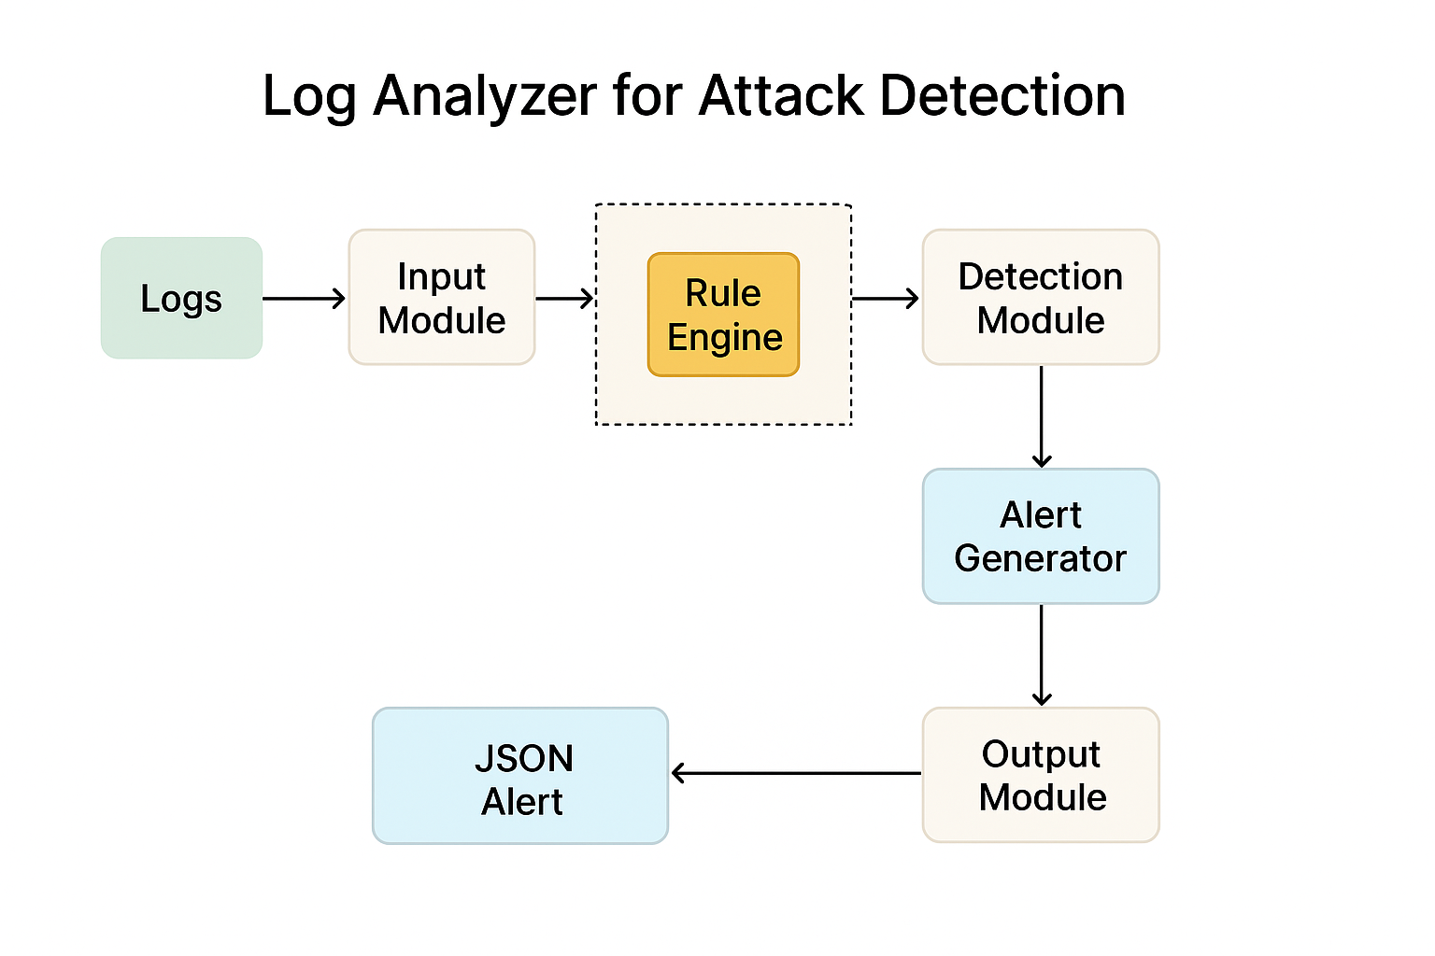

#### **References**

[1] C. Modi, D. Patel, B. Borisaniya, H. Patel, A. Patel, and M. Rajarajan, “A Survey of Intrusion Detection Techniques in Cloud,” *Journal of Network and Computer Applications*, vol. 36, no. 1, pp. 42–57, Jan. 2013.

[2] R. Sommer and V. Paxson, “Outside the Closed World: On Using Machine Learning for Network Intrusion Detection,” in *Proc. IEEE Symposium on Security and Privacy*, 2010, pp. 305–316.

[3] T. C. Lunt, “A Survey of Intrusion Detection Techniques,” *Computers & Security*, vol. 12, no. 4, pp. 405–418, 1993.

[4] Y. Kim, D. Kim, and K. Park, “An Efficient Log Analysis Framework for Detecting SQL Injection Attacks,” *International Journal of Security and Its Applications*, vol. 9, no. 7, pp. 93–104, 2015.

[5] OWASP Foundation, “OWASP Top 10 – 2021: The Ten Most Critical Web Application Security Risks,” Available: https://owasp.org/www-project-top-ten/.

[6] Python Software Foundation, “Python 3 Documentation,” Available: https://docs.python.org/3/.

[7] PyYAML Documentation, “PyYAML 6.0 Documentation,” Available: https://pyyaml.org/wiki/PyYAMLDocumentation.

[8] Rich Python Library Documentation, “Rich: Python Library for Rich Text and Beautiful Formatting in the Terminal,” Available: https://rich.readthedocs.io/en/stable.