727721EUCS042

HARSHITHA C.S

DAY 9

CE1:

INPUT:

**package** day9;

**import** org.testng.annotations.Test;

**import** org.testng.Assert;

**import** org.testng.annotations.DataProvider;

**public** **class** d9project1 {

**int** a,b,c;

@Test(dataProvider = "dp")

**public** **void** add(Integer a,Integer b) {

c=a+b;

System.***out***.println("Sum:"+c);

Assert.*assertEquals*(c,15);

}

@Test(dataProvider = "dp")

**public** **void** sub(Integer a,Integer b) {

c=a-b;

System.***out***.println("Difference:"+c);

Assert.*assertEquals*(c, 5);

}

@Test(dataProvider = "dp")

**public** **void** multiply(Integer a,Integer b) {

c=a*b;

System.***out***.println("Product:"+c);

Assert.*assertEquals*(c, 50);

}

@Test(dataProvider = "dp")

**public** **void** divide(Integer a,Integer b) {

c=a/b;

System.***out***.println("Quotient:"+c);

Assert.*assertEquals*(c, 2);

}

@DataProvider

**public** Object[][] dp() {

**return** **new** Object[][] {

**new** Object[] { 10, 5 },

**new** Object[] { 12, 6},

};

}

}

OUTPUT:

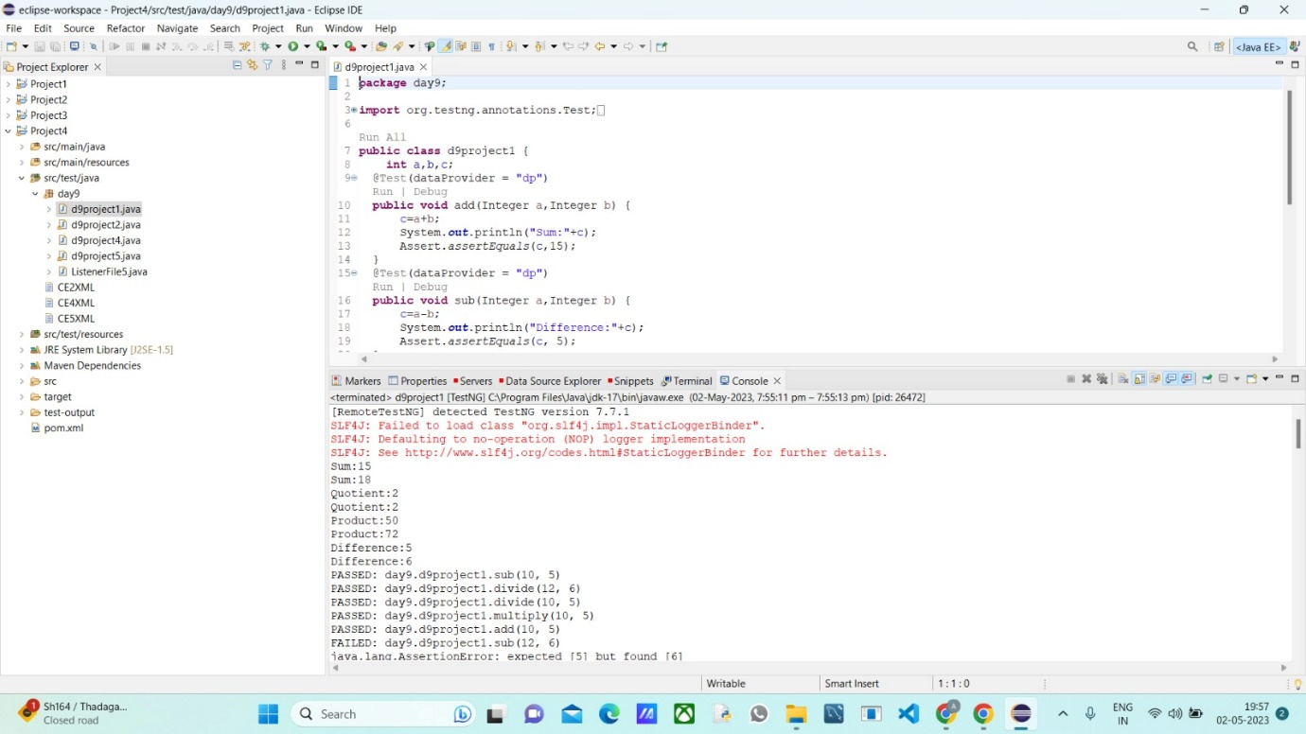

CE2 and 3:

INPUT:

**package** day9;

**import** org.testng.annotations.Test;

**import** com.google.common.base.Verify;

**import** io.github.bonigarcia.wdm.WebDriverManager;

**import** java.util.concurrent.TimeUnit;

**import** org.openqa.selenium.By;

**import** org.openqa.selenium.WebDriver;

**import** org.openqa.selenium.WebElement;

**import** org.openqa.selenium.chrome.ChromeDriver;

**import** org.openqa.selenium.chrome.ChromeOptions;

**import** org.testng.Assert;

**import** org.testng.annotations.DataProvider;

**public** **class** d9project2{

@Test

**public** **void** Testcase01() {

WebDriverManager.*chromedriver*().setup();

ChromeOptions ed= **new** ChromeOptions();

WebDriver driver=**new** ChromeDriver(ed);

driver.get("https://www.godaddy.com");

driver.manage().window().maximize();

Assert.*assertEquals*(driver.getTitle(),"Domain Names, Websites, Hosting & Online Marketing Tools - GoDaddy IN");

Assert.*assertEquals*(driver.getCurrentUrl(),"https://www.godaddy.com/en-in" );

}

@Test

**public** **void** Testcase02() {

WebDriverManager.*chromedriver*().setup();

ChromeOptions ed= **new** ChromeOptions();

WebDriver driver=**new** ChromeDriver(ed);

driver.get("https://www.godaddy.com");

driver.manage().window().maximize();

driver.manage().timeouts().~~implicitlyWait~~(5, TimeUnit.***SECONDS***);

driver.findElement(By.*xpath*("//*[@id=\"id-631b049a-e9c0-4d24-8710-c504745206dd\"]/div[2]/div[1]/ul/li[1]/button")).click();

**try** {

Thread.*sleep*(2000);

} **catch** (InterruptedException e) {

// **TODO** Auto-generated catch block

e.printStackTrace();

}

driver.findElement(By.*xpath*("//*[@id=\"id-631b049a-e9c0-4d24-8710-c504745206dd\"]/div[2]/div[1]/ul/li[1]/div/div[2]/div[1]/ul/li[2]/a")).click();

}

@Test

**public** **void** Testcase03() {

WebDriverManager.*chromedriver*().setup();

ChromeOptions ed= **new** ChromeOptions();

WebDriver driver=**new** ChromeDriver(ed);

driver.get("https://www.godaddy.com");

driver.manage().window().maximize();

driver.manage().timeouts().~~implicitlyWait~~(5, TimeUnit.***SECONDS***);

driver.findElement(By.*xpath*("//*[@id=\"id-631b049a-e9c0-4d24-8710-c504745206dd\"]/div[2]/div[1]/ul/li[1]/button")).click();

**try** {

Thread.*sleep*(2000);

} **catch** (InterruptedException e) {

// **TODO** Auto-generated catch block

e.printStackTrace();

}

driver.findElement(By.*xpath*("//*[@id=\"id-631b049a-e9c0-4d24-8710-c504745206dd\"]/div[2]/div[1]/ul/li[1]/div/div[2]/div[1]/ul/li[2]/a")).click();

**try** {

Thread.*sleep*(4000);

} **catch** (InterruptedException e) {

// **TODO** Auto-generated catch block

e.printStackTrace();

}

System.***out***.println(driver.getTitle());

**if**(driver.getTitle().equals("GoDaddy Domain Search - Buy and Register Available Domain Names")) {

WebElement search= driver.findElement(By.*name*("searchText"));

System.***out***.println(search.isDisplayed());

System.***out***.println(search.isEnabled());

WebElement buyit=driver.findElement(By.*xpath*("//*[@id=\"id-1467954b-c5e3-4b0c-9046-9fc94d8ca892\"]/section/div/div/section/div/div[1]/div/div/div[2]/button"));

System.***out***.println(buyit.isDisplayed());

System.***out***.println(buyit.isEnabled());

search.sendKeys("monkyhomie");

**try** {

Thread.*sleep*(2000);

} **catch** (InterruptedException e) {

// **TODO** Auto-generated catch block

e.printStackTrace();

}

buyit.click();

**try** {

Thread.*sleep*(6000);

} **catch** (InterruptedException e) {

// **TODO** Auto-generated catch block

e.printStackTrace();

}

// Assert.assertEquals(driver.findElement(By.xpath("//*[@id=\"search-app\"]/div/div/div/div[2]/div[1]/div[2]/div[1]/div[2]/div/div[1]/span")).getText(),"EXACT MATCH");

//Verify.verify((driver.findElement(By.xpath("//*[@id=\"search-app\"]/div/div/div/div[2]/div[1]/div[2]/div[1]/div[2]/div/div[4]/div/div/div/div[2]/button")).getText()).equals("Add to Cart"));

//Verify.verify(driver.findElement(By.xpath("//*[@id=\"search-app\"]/div/div/div/div[2]/div[1]/div[2]/div[1]/div[2]/div/div[3]/div/div[1]/div[1]/div/span[1]/span")).isDisplayed());

}

**else** Assert.*assertTrue*(**false**);

}

}

OUTPUT:

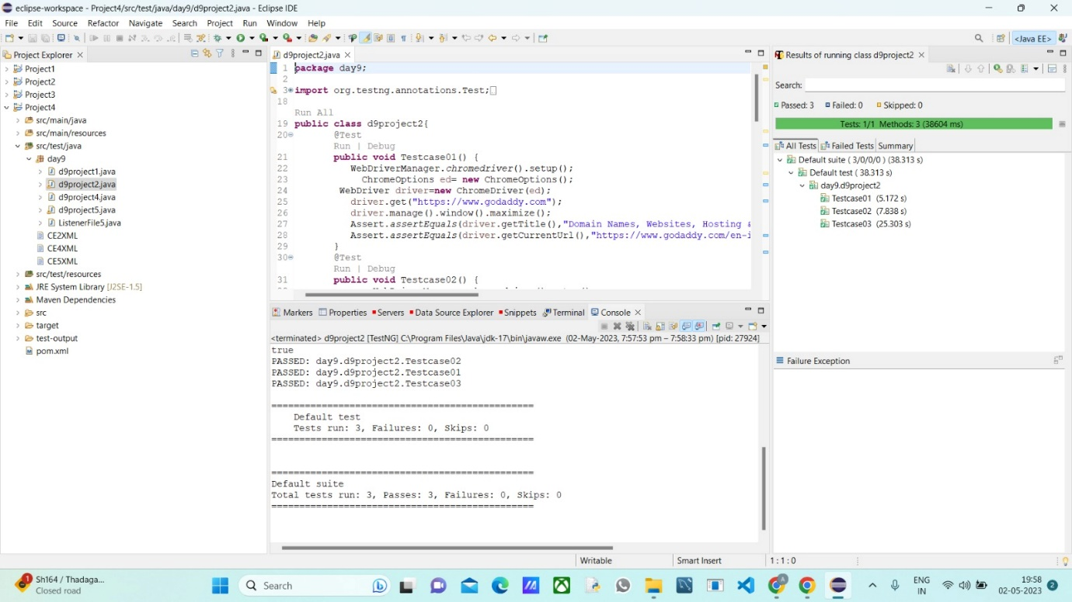

CE 4:

INPUT:

**package** day9;

**import** org.openqa.selenium.By;

**import** org.openqa.selenium.WebDriver;

**import** org.openqa.selenium.WebElement;

**import** org.openqa.selenium.chrome.ChromeDriver;

**import** org.openqa.selenium.chrome.ChromeOptions;

**import** org.openqa.selenium.edge.EdgeDriver;

**import** org.testng.Assert;

**import** org.testng.annotations.AfterMethod;

**import** org.testng.annotations.BeforeMethod;

**import** org.testng.annotations.Parameters;

**import** org.testng.annotations.Test;

**import** org.openqa.selenium.edge.EdgeOptions;

**import** org.openqa.selenium.firefox.FirefoxOptions;

**import** org.openqa.selenium.firefox.FirefoxDriver;

**import** io.github.bonigarcia.wdm.WebDriverManager;

**public** **class** d9project4 {

WebDriver driver;

@Test

**public** **void** f() **throws** InterruptedException {

Thread.*sleep*(3000);

WebElement na=driver.findElement(By.*xpath*("//*[@id=\"app\"]/div[1]/div/div[1]/div/div[2]/div[2]/form/div[1]/div/div[2]/input"));

na.sendKeys("Admin");

Thread.*sleep*(1000);

WebElement naa=driver.findElement(By.*name*("password"));

naa.sendKeys("admin123");

Thread.*sleep*(1000);

WebElement bta=driver.findElement(By.*xpath*("//*[@id=\"app\"]/div[1]/div/div[1]/div/div[2]/div[2]/form/div[3]/button"));

bta.click();

Thread.*sleep*(3000);

String url="https://opensource-demo.orangehrmlive.com/web/index.php/dashboard/index";

Assert.*assertEquals*(url,driver.getCurrentUrl());

}

@Parameters({"browser"})

@BeforeMethod

**public** **void** setup(String brows) {

**if**(brows.equals("chrome")) {

WebDriverManager.*chromedriver*().setup();

ChromeOptions co=**new** ChromeOptions();

co.addArguments("--remote-allow-origins=*");

// co.addArguments("start-maximized");

driver=**new** ChromeDriver(co);

driver.get("https://opensource-demo.orangehrmlive.com/web/index.php/auth/login");

driver.manage().window().maximize();

}

**else** **if**(brows.equals("edge")) {

WebDriverManager.*edgedriver*().setup();

EdgeOptions co=**new** EdgeOptions();

co.addArguments("--remote-allow-origins=*");

// co.addArguments("start-maximized");

driver=**new** EdgeDriver(co);

driver.get("https://opensource-demo.orangehrmlive.com/web/index.php/auth/login");

driver.manage().window().maximize();

}

**else** **if**(brows.equals("firefox")) {

WebDriverManager.*firefoxdriver*().setup();

FirefoxOptions co=**new** FirefoxOptions();

co.addArguments("--remote-allow-origins=*");

// co.addArguments("start-maximized");

driver=**new** FirefoxDriver(co);

driver.get("https://opensource-demo.orangehrmlive.com/web/index.php/auth/login");

driver.manage().window().maximize();

}

}

@AfterMethod

**public** **void** teardown() **throws** InterruptedException {

Thread.*sleep*(4000);

driver.close();

}

}

OUTPUT:

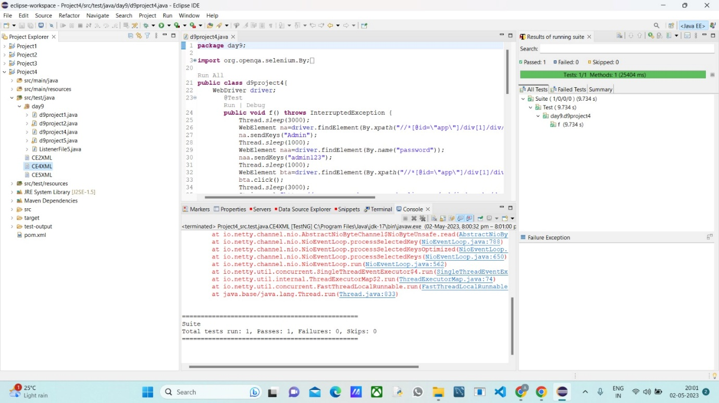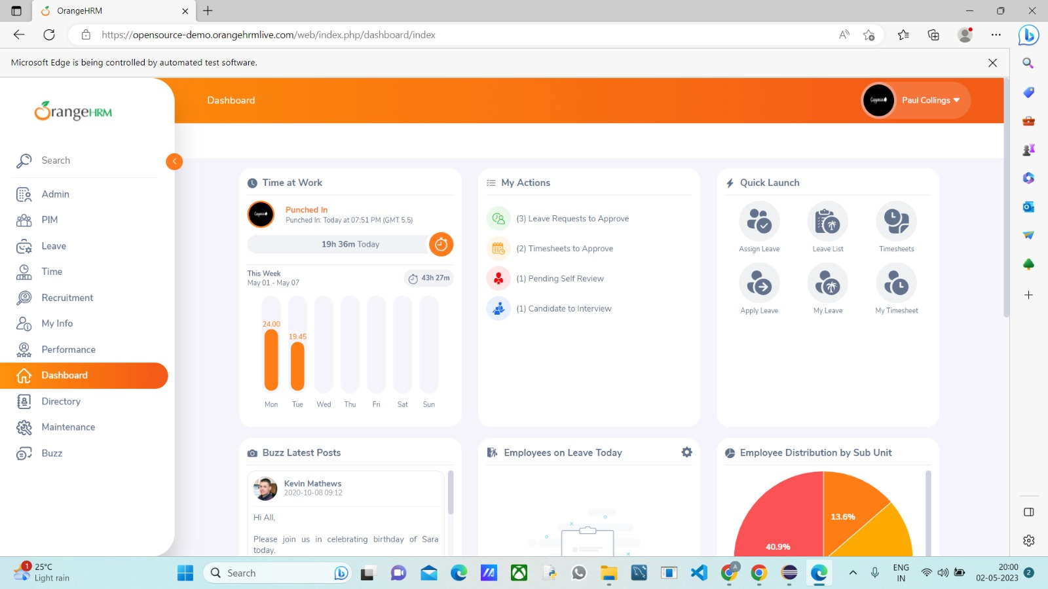

CE 5:

INPUT:

TESTNG FILE:

**package** day9;

**import** org.openqa.selenium.By;

**import** org.openqa.selenium.WebDriver;

**import** org.openqa.selenium.WebElement;

**import** org.openqa.selenium.chrome.ChromeDriver;

**import** org.openqa.selenium.chrome.ChromeOptions;

**import** org.openqa.selenium.edge.EdgeDriver;

**import** org.openqa.selenium.edge.EdgeOptions;

**import** org.testng.Assert;

**import** org.testng.annotations.AfterMethod;

**import** org.testng.annotations.BeforeMethod;

**import** org.testng.annotations.Parameters;

**import** org.testng.annotations.Test;

**import** io.github.bonigarcia.wdm.WebDriverManager;

**public** **class** d9project5 {

WebDriver driver;

@Test

**public** **void** f() **throws** InterruptedException {

Thread.*sleep*(3000);

WebElement na=driver.findElement(By.*xpath*("//*[@id=\"app\"]/div[1]/div/div[1]/div/div[2]/div[2]/form/div[1]/div/div[2]/input"));

na.sendKeys("Admin");

Thread.*sleep*(1000);

WebElement naa=driver.findElement(By.*name*("password"));

naa.sendKeys("admin123");

Thread.*sleep*(1000);

WebElement bta=driver.findElement(By.*xpath*("//*[@id=\"app\"]/div[1]/div/div[1]/div/div[2]/div[2]/form/div[3]/button"));

bta.click();

Thread.*sleep*(3000);

String url="https://opensource-demo.orangehrmlive.com/web/index.php/dashboard/index";

Assert.*assertEquals*(url,driver.getCurrentUrl());

}

@BeforeMethod

**public** **void** setup() {

WebDriverManager.*chromedriver*().setup();

ChromeOptions co=**new** ChromeOptions();

co.addArguments("--remote-allow-origins=*");

// co.addArguments("start-maximized");

driver=**new** ChromeDriver(co);

driver.get("https://opensource-demo.orangehrmlive.com/web/index.php/auth/login");

driver.manage().window().maximize();

}

@AfterMethod

**public** **void** teardown() **throws** InterruptedException {

Thread.*sleep*(4000);

driver.close();

}

}

LISTENER FILE:

**package** day9;

**import** org.testng.ITestContext;

**import** org.testng.ITestListener;

**import** org.testng.ITestResult;

**public** **class** Listenerfileday5 **implements** ITestListener{

**public** **void** onTestStart(ITestResult result) {

// **TODO** Auto-generated method stub

System.***out***.println("onTestStart"+result.getName());

}

**public** **void** onTestSuccess(ITestResult result) {

// **TODO** Auto-generated method stub

System.***out***.println("onTestSuccess"+result.getName());

}

**public** **void** onTestFailure(ITestResult result) {

// **TODO** Auto-generated method stub

System.***out***.println("onTestFailure"+result.getName());

}

**public** **void** onTestSkipped(ITestResult result) {

// **TODO** Auto-generated method stub

System.***out***.println("onTestSkipped"+result.getName());

}

**public** **void** onTestFailedButWithinSuccessPercentage(ITestResult result) {

// **TODO** Auto-generated method stub

System.***out***.println("onTestFailedButWithinSuccessPercentage"+result.getName());

}

**public** **void** onTestFailedWithTimeout(ITestResult result) {

// **TODO** Auto-generated method stub

System.***out***.println("onTestFailedWithTimeout"+result.getName());

}

**public** **void** onStart(ITestContext context) {

// **TODO** Auto-generated method stub

System.***out***.println("onStart"+context.getName());

}

**public** **void** onFinish(ITestContext context) {

// **TODO** Auto-generated method stub

System.***out***.println("onFinish"+context.getName());

}

}

OUTPUT:

