**PROPOSAL PERENCANAAN PROYEK**



**Oleh:**

**Muhammad Hadziq Fathul Hikam**

**A11.2019.12133**

1. **Project charter**
2. **Project Scope**

|  |  |
| --- | --- |
| Nama proyek |  |
| Manajer proyek |  |
| Tanggal proyek |  |
| Deskripsi proyek |  |
| Project Deliverable |  |
| Acceptance Criteria |  |
| Contraints |  |
| Assumptions |  |

1. **WBS**

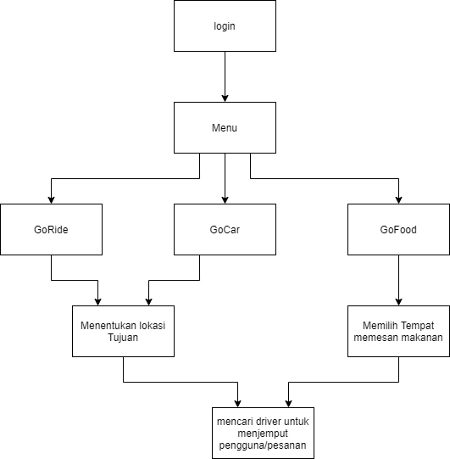

1. **Timline (Gant chart)**



1. **Estimasi biaya sesuai pekerjaan**
2. **Potensi resiko**
3. **Stakeholder yang terlibat**
4. **Software development life cycle**