## How to compile COSSIM-GUI?

This document describes the appropriate steps to compile the COSSIM Graphical User Interface in case of the user wants to modify its contents. To be noticed that if the user simply wants to use our GUI the below steps are not required.

The OMNET++ IDE, which is one of the main tools of COSSIM simulator, is based on the Eclipse platform which is an extensible Java based framework. Extensions or plugins can be written in Java language and simply added to an existing Eclipse (or OMNET++) installation extending it with new functionality. The GUI COSSIM environment consists of two OMNET++ plugins: the simulation configuration tool and the execution monitoring tool, implemented in Java.

In order to develop Java plugins for the OMNET++ environment the *Plug-in Development Environment (PDE)* must be installed into the IDE. Instructions on the PDE installation can be found in [1]. For the development of the plugins we use the *Standard Widget Toolkit (SWT)* [2] and *JFace* [3] libraries which are the user-interface toolkits for java designers in Eclipse platform and most other Eclipse projects (like OMNET++).

COSSIM-Wizard for the simulation configuration, and the execution monitoring tool have been implemented as plugins into the OMNET++ environment. The Plug-in Development Environment offers an exporting mechanism in order to create .jar executable files [1]. In the *Overview* tab of the manifest editor, which appears by opening a file from the META-INF Directory in the plugin project (MANIFEST.MF, build.properties or plugin.xml), using the *4.Export the plug-in in a format suitable for deployment using the Export Wizard,* the executable .jar file of the plugin can be exported in the specified directory in the *Destination* tab as illustrated in Figure 1 & Figure 2.

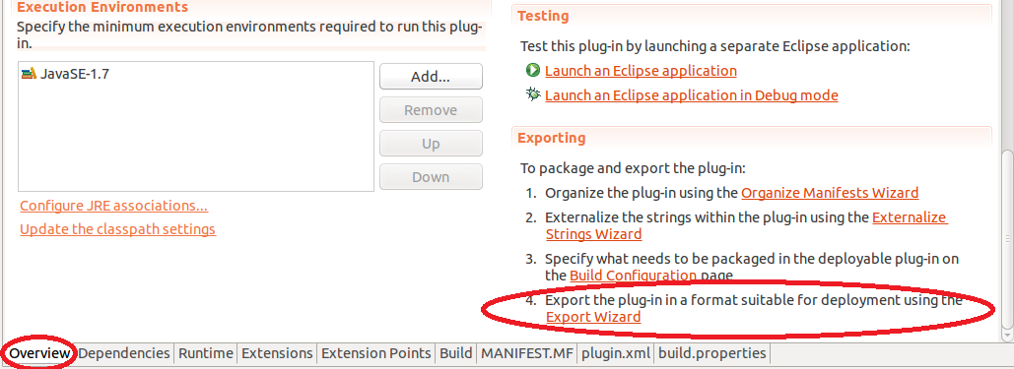

Figure 1. The Overview tab of manifest editor

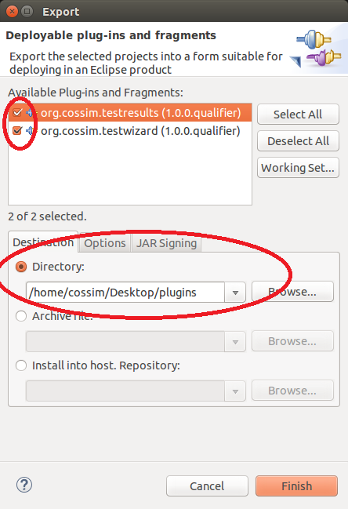

Figure 2. Export wizard for .jar files

In order to export both the configuration wizard and the monitoring tool, the check boxes in the top of the export wizard must be checked. Once the .jar files have been created, they must be copied in the <omnetpp-installation>/ide/dropins directory. By restarting the OMNET++, the .jar files will be recognized by OMNET++ environment.

## References

[1] OMNET++ IDE Developers Guide (<https://omnetpp.org/doc/omnetpp/IDE-DevelopersGuide.pdf>)

[2] SWT: The Standard Widget Toolkit (<https://www.eclipse.org/swt/>)

[3] JFace (<https://wiki.eclipse.org/JFace>)