# Subject: SCM 651 - Week 8 - HW 4 Date: 03/14/19

# **Team 2:**

|  |  |
| --- | --- |
| Funmi Esuruoso | Clayton Nygard |
| Dan Tully | Beecher E. Wilhelm III |

# **Questions and Answers:**

1. Perform a logit and probit analysis of the variables that affect whether a customer takes out a loan. Consider only main effects.
   1. Logit Analysis

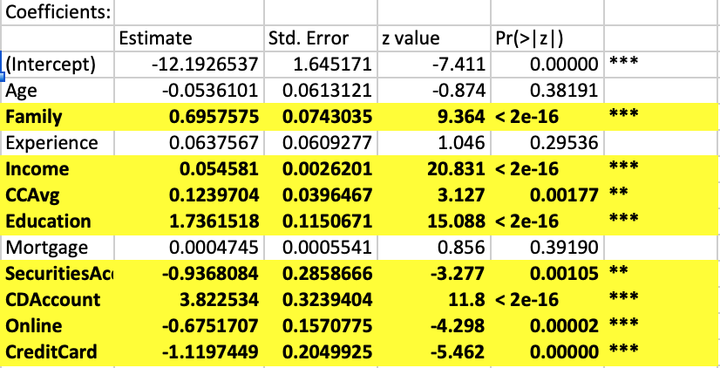

Probit Analysis

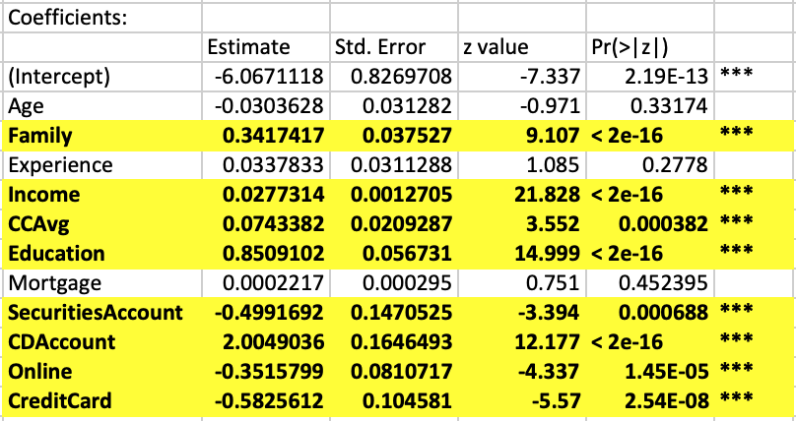

* 1. Which variables are significant?
     1. Family, Income, Credit Card Average, Education, Securities Account, CD Account, Online, and Credit Card are the significant variables.

* 1. How do the significant variables influence the likelihood of taking out a loan?
     1. Family: The likelihood of a customer taking a personal loan increases as his family size increases. (More emergencies and tighter budget)
     2. Income: The likelihood of a customer taking a personal loan “slightly” increases as his/her annual income increases. (Customer more optimistic about purchasing and borrowing.)
     3. Credit Card Average: The likelihood of a customer taking a personal loan “slightly” increases as his/her average credit card spending per month increases. (Customer looks for way to reduce interest or payments by consolidating two or more credit cards.)
     4. Education: The likelihood of a customer taking out a personal loan increases as his/her education increases. An advanced professional (3) has a higher likelihood of taking out a personal loan. Customer likely lacks disposable income while paying off student debt, so may have to borrow for purchases and emergencies.
     5. Securities Account: The likelihood of a customer taking out a personal loan decreases as his/her securities accounts with the bank increases. Customer can liquidate investment holdings to meet short-term emergencies or to make a purchase.
     6. CD Account: The likelihood of a customer taking out a personal loan increases as his/her Certificate of Deposits with the bank increases. Customer is familiar with the bank and can use CD as a collateral and borrow at a lower rate.
     7. Online: The likelihood of a customer taking out a personal loan decreases as his/her use of internet banking facilities increases. The customer is more aware of his/her options, which include PayPal, Venmo, and seller financing.
     8. Credit Card: The likelihood of a customer taking out a personal loan decreases as his/her credit cards increases. Credit cards are more convenient than visiting the bank to apply and close a personal loan.

1. Add moderating effects (interactions of variables). Which interactions make sense conceptually? Which interactions are statistically significant? How do you interpret the coefficients on these variables? Copy screen snapshots of your analysis in R to your report.

After running the analysis with moderating effects, most of the interactions had little effect on the data, suggesting that as income or education increase, the number of personal loans increased. This would likely suggest that as you make money, your credit score allows you access to more money through loans. However, the interaction of income and average credit card balance displayed an interesting result graphically in the sensitivity analysis, showing that there was an income point at which people were less likely to have any persona loans and little credit card debt (around 150K and >4K credit card debt) and when credit card debt was greater than 10K and income was under 150K, there was a greater probability of having a personal loan. The income and education moderating effects also had an interesting effect when the 0 value was added to the sensitivity analysis, which can be extrapolated to mean high school, and showed low incomes with no secondary education would likely have personal loans. As education and income increase, the likelihood of personal loans increased as well.

CCAvg and Income, and Education and Income were significant.

|  |  |  |  |  |  |
| --- | --- | --- | --- | --- | --- |
| Coefficients: | Estimate | Std. Error | z value | Pr(>|z|) |  |
| (Intercept) | 1.905818 | 0.805047 | 2.367 | 0.0179 | * |
| Education | -7.04385 | 0.676857 | -10.407 | <2e-16 | *** |
| Income | -0.0588 | 0.007082 | -8.303 | <2e-16 | *** |
| Education:Income | 0.079411 | 0.00628 | 12.646 | <2e-16 | *** |

The coefficients of the analysis of Education/Income show a negative relationship between education and income and personal loans, but as both of the variables increase, the positive slope of the education*income overcomes the negative slopes of the coefficients, meaning that the more education and more income the people have, the higher probability of a personal loan.

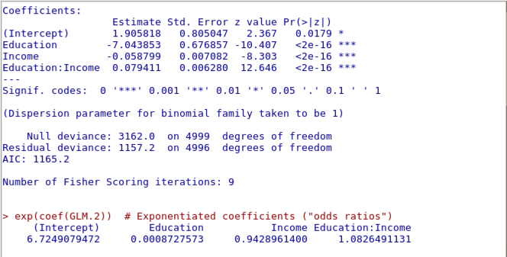

|  |  |  |  |  |  |
| --- | --- | --- | --- | --- | --- |
| Coefficients: | Estimate | Std. Error | z value | Pr(>|z|) |  |
| (Intercept) | -9.55565 | 0.430963 | -22.17 | <2e-16 | *** |
| Income | 0.060014 | 0.003118 | 19.25 | <2e-16 | *** |
| CCAvg | 1.339882 | 0.121538 | 11.02 | <2e-16 | *** |
| Income:CCAvg | -0.00861 | 0.0008 | -10.76 | <2e-16 | *** |

The coefficients of the CCAvg and Income are positive indicating that as they increase, there is higher probability of a personal loan. The moderating effects of Income*CCAvg counter the that higher probability with a negative, more of either variable reduces the likelihood of a personal loan.

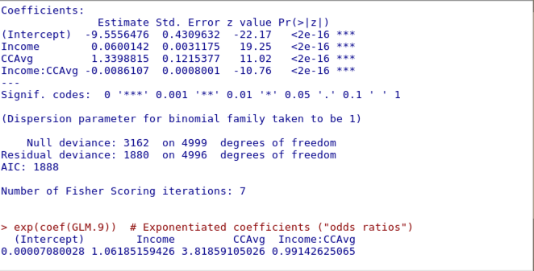

1. Create a final regression model with the variables that you feel are important (both main effects and interaction terms). Create a spreadsheet prediction of the model. Which variables have the greatest influence on the customers’ loan behavior (combined main effects and interaction effects)? Perform a sensitivity analysis as seen earlier in the semester. Copy screen snapshots of your analysis in R to your report.

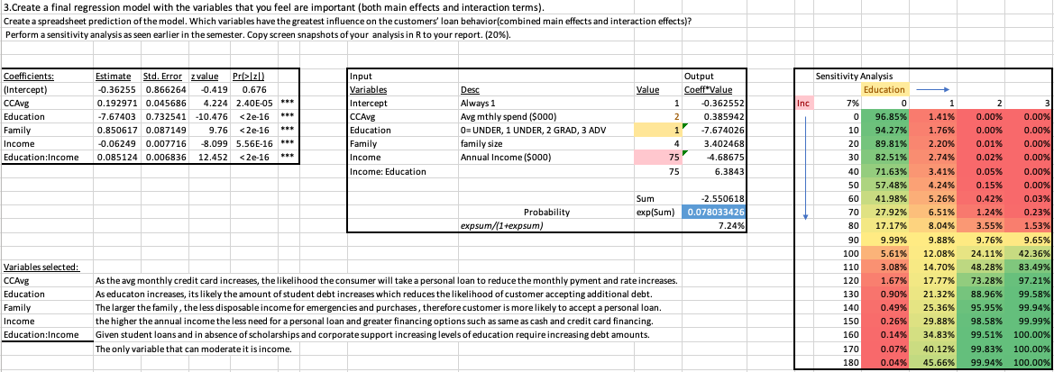

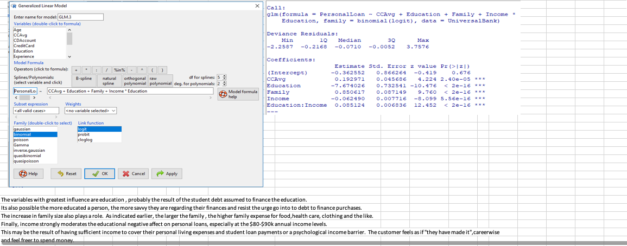

The variables with the greatest influence are as follows:

* Education, probably the result of the student debt assumed to finance the education.

It is also possible that the more educated a person, the more savvy they are regarding their finances and resist the urge go into to debt to finance purchases.

* The increase in family size also plays a role. As indicated earlier, the larger the family, the higher family expense for food, health care, clothing and the like.
* Finally, income strongly moderates the educational negative affect on personal loans, especially at the $80-$90k annual income levels. This may be the result of having sufficient income to cover their personal living expenses and student loan payments or a psychological income barrier. The customer feels as if "they have made it", career wise and feel freer to spend money.

1. Perform a neural network analysis of the variables found to be significant in the logit and probit analysis above. Copy screen snapshots of your final neural network model in R to your report.

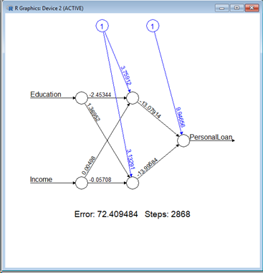

This neural network analysis includes the variables (education and income) found to be significant in the logit and probit analysis above.

1. Create a prediction model of the neural network. Using the prediction model, perform a sensitivity analysis for the neural network model similar to the logit and probit sensitivity analysis.

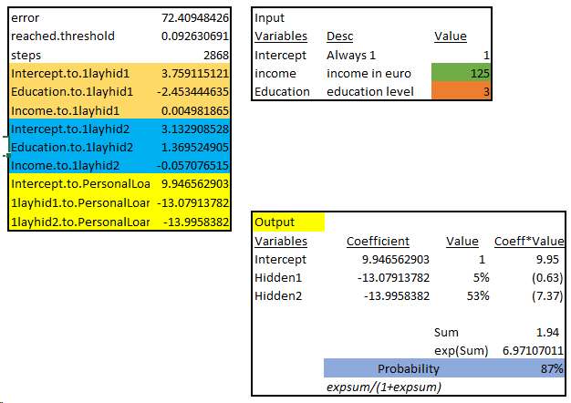

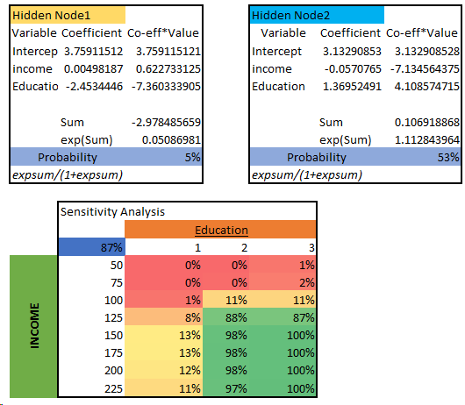

This sensitivity analysis shows that individuals with a higher education and income are more likely to open loans. This can be explained in the following ways:

* Individuals with higher education need more money to pay for the education.
* Individuals with higher income will spend more money on average.
* Individuals with higher income and education will take more financial risks.
* Individuals with higher income are more likely to be approved for loans.