TASK 1:
#include <iostream>
#include <fstream>
#include <string>
using namespace std;

int main()
{
string RecipientName, Message;

cout << "Enter recipient's name: ";
getline(cin, RecipientName);

cout << "Enter your message: ";
getline(cin, Message);

ofstream File("greeting.txt");
File << "Dear " << RecipientName << ",\n"
<< Message << "\n"
<< "Best Regards!" << endl;
File.close();

cout << "Greeting saved to greeting.txt." << endl;
return 0;
}

OUTPUT:
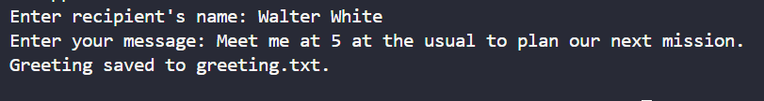

TASK 2:

#include <iostream>
#include <fstream>
#include <string>
using namespace std;

int main() {
ofstream File("diary.txt", ios::app);
string Line;

cout << "Write your diary entry (type 'exit' to stop):\n";
while (true) {
getline(cin, Line);
if (Line == "exit") break;
File << Line << "\n";
}

File.close();
cout << "Diary entry saved." << endl;
return 0;
}

OUTPUT:
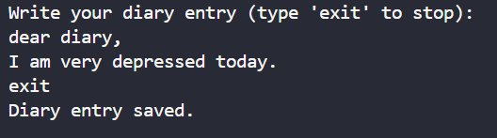

Task 3:
#include <iostream>
#include <fstream>
#include <string>
using namespace std;

int main()
{
ofstream File("signup.txt", ios::app);
string Name, Email;
char Another;

do
{
cout << "Enter name: ";
getline(cin, Name);
cout << "Enter email: ";
getline(cin, Email);

File << "Name: " << Name << ", Email: " << Email << "\n";
cout << "Registration saved. Add another? (y/n): ";
cin >> Another;
cin.ignore();
} while (Another == 'y' || Another == 'Y');

File.close();
cout << "All registrations recorded in signup.txt." << endl;
return 0;
}

OUTPUT:
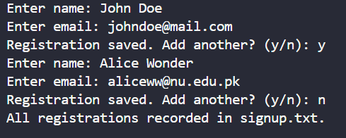

TASK 4:
#include <iostream>
#include <fstream>
#include <ctime>
using namespace std;

int main()
{
ofstream File("system_log.txt", ios::app);

time_t Now = time(0);
char *Timestamp = ctime(&Now);

// ctime adds a newline; remove it
string TimeStr(Timestamp);
if (!TimeStr.empty() && TimeStr.back() == '\n')
TimeStr.pop_back();

File << "System started at: " << TimeStr << "\n";
File.close();

cout << "Startup logged to system_log.txt." << endl;
return 0;
}

OUTPUT:

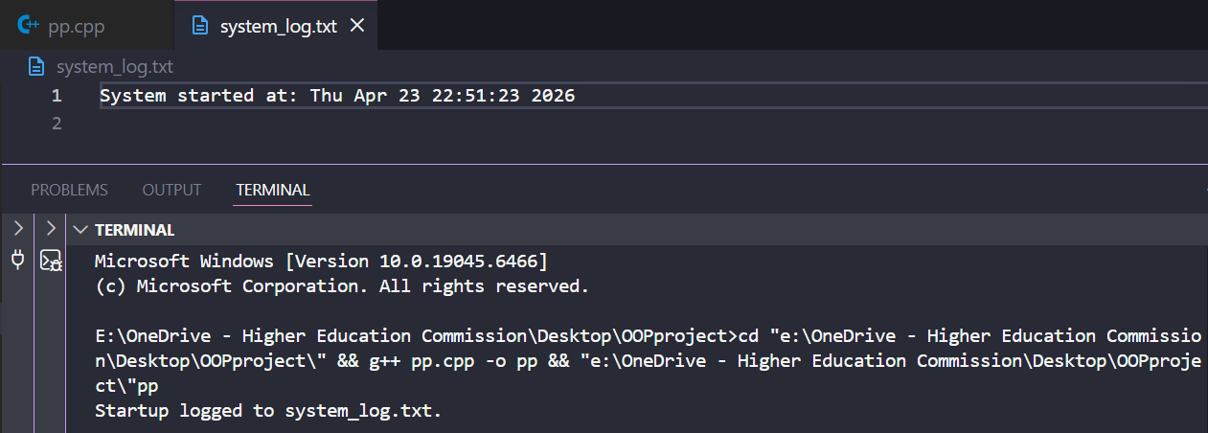

Task 6:
#include <iostream>
#include <fstream>
#include <cctype>
using namespace std;

int main()
{
ifstream File("secret.txt");
if (!File)
{
cout << "Could not open secret.txt." << endl;
return 1;
}

char Ch;
int Count = 0;
while (File.get(Ch))
{
if (isupper(Ch))
Count++;
}

File.close();
cout << "Total uppercase letters (signals): " << Count << endl;
return 0;
}

OUTPUT:
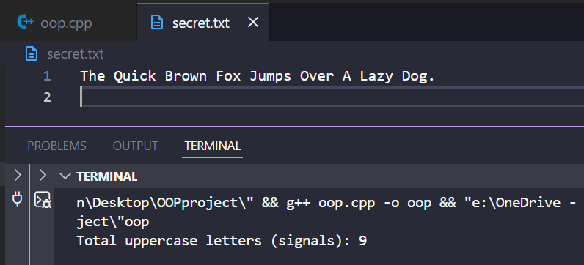

TASK 5:
#include <iostream>
#include <fstream>
#include <sstream>
#include <string>
using namespace std;

int main()
{
ifstream File("story.txt");
if (!File)
{
cout << "Could not open story.txt." << endl;
return 1;
}

string Line, Word;
while (getline(File, Line))
{
istringstream Stream(Line);
while (Stream >> Word)
cout << Word << "\n";
}

File.close();
return 0;
}

OUTPUT:
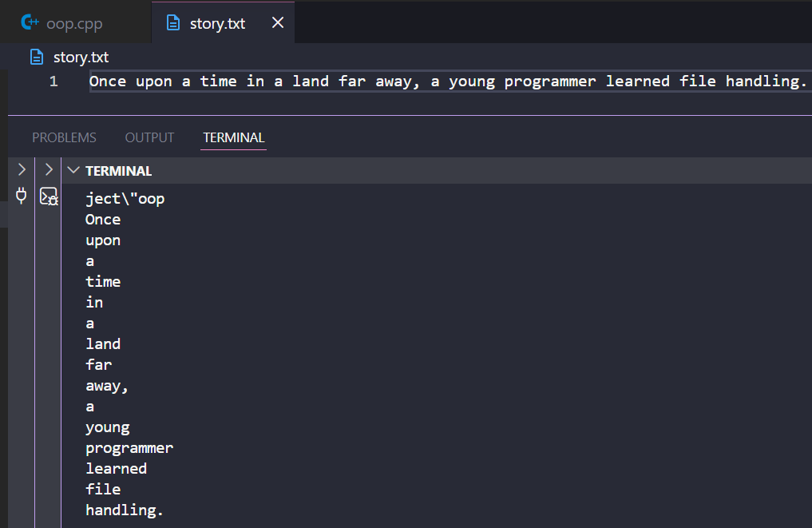

TASK 6:
#include <iostream>
#include <fstream>
using namespace std;

struct Student
{
char Name[50];
int Id;
float Gpa;
};

int main()
{
int Total;
cout << "How many students to enter? ";
cin >> Total;
cin.ignore();

Student *Students = new Student[Total];

for (int i = 0; i < Total; i++)
{
cout << "\nStudent " << i + 1 << " name: ";
cin.getline(Students[i].Name, 50);
cout << "ID: ";
cin >> Students[i].Id;
cout << "GPA: ";
cin >> Students[i].Gpa;
cin.ignore();
}

ofstream OutFile("students.dat", ios::binary);
OutFile.write(reinterpret_cast<char *>(Students), sizeof(Student) * Total);
OutFile.close();

cout << "\n--- Reading from file ---\n";
ifstream InFile("students.dat", ios::binary);
Student Temp;
while (InFile.read(reinterpret_cast<char *>(&Temp), sizeof(Student)))
{
cout << "Name: " << Temp.Name
<< ", ID: " << Temp.Id
<< ", GPA: " << Temp.Gpa << "\n";
}
InFile.close();

delete[] Students;
return 0;
}
OUTPUT:
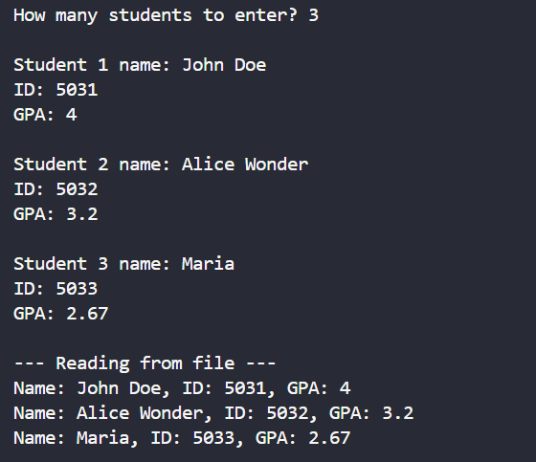

TASK 8:
#include <iostream>
#include <fstream>
#include <string>
using namespace std;

int main() {
ifstream File("article.txt");
if (!File) {
cout << "Could not open article.txt." << endl;
return 1;
}

File.seekg(0, ios::end);
streampos FileSize = File.tellg();
File.seekg(FileSize / 2);

string Line;
getline(File, Line);

cout << "--- Preview from halfway point ---\n";
for (int i = 0; i < 10 && getline(File, Line); i++)
cout << Line << "\n";

File.close();
return 0;
}

OUTPUT:
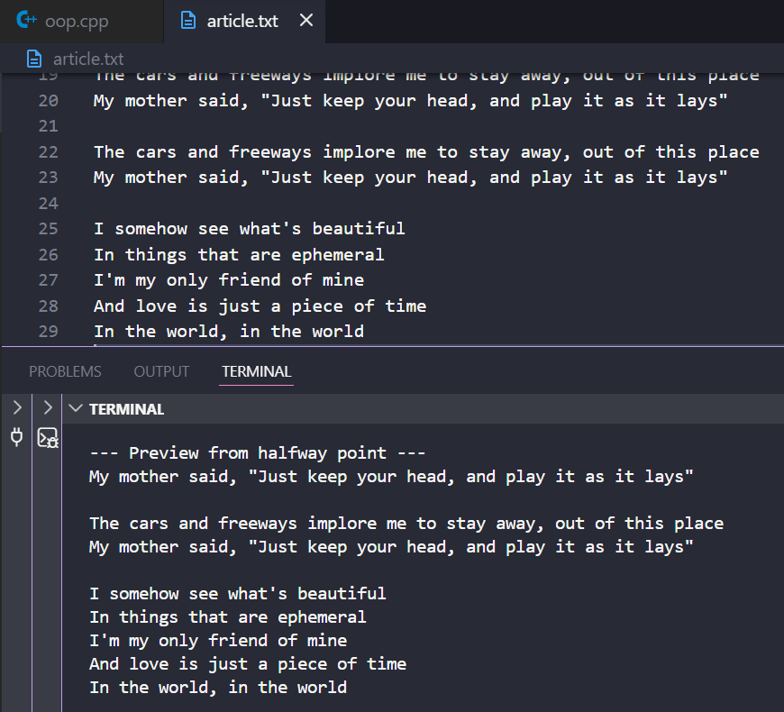

TASK 9:
#include <iostream>
#include <fstream>
#include <string>
using namespace std;

int main()
{
fstream File("draft.txt", ios::in | ios::out);
if (!File)
{
cout << "Could not open draft.txt." << endl;
return 1;
}

string Content, Line;
while (getline(File, Line))
Content += Line + "\n";

size_t Pos = Content.find("teh");
if (Pos == string::npos)
{
cout << "Typo 'teh' not found." << endl;
File.close();
return 0;
}

File.seekp(Pos);
File.write("the", 3);
File.close();

cout << "First occurrence of 'teh' corrected to 'the'." << endl;
return 0;
}
OUTPUT:
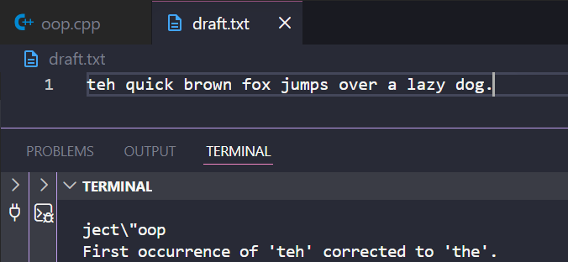

TASK 11:
#include <iostream>
#include <fstream>
#include <sstream>
#include <string>
#include <cctype>
using namespace std;

int main()
{
ifstream InFile("article.txt");
if (!InFile)
{
cout << "Could not open article.txt." << endl;
return 1;
}

int TotalChars = 0, TotalWords = 0, TotalLines = 0, TotalPunct = 0;
string Line, Word;

while (getline(InFile, Line))
{
TotalLines++;
TotalChars += Line.size();

for (char Ch : Line)
if (ispunct(Ch))
TotalPunct++;

istringstream Stream(Line);
while (Stream >> Word)
TotalWords++;
}
InFile.close();

ofstream OutFile("report.txt");
OutFile << "===== File Analysis Report =====\n"
<< "Total Characters : " << TotalChars << "\n"
<< "Total Words : " << TotalWords << "\n"
<< "Total Lines : " << TotalLines << "\n"
<< "Punctuation Marks: " << TotalPunct << "\n";
OutFile.close();

cout << "Report saved to report.txt." << endl;
return 0;
}

OUTPUT:
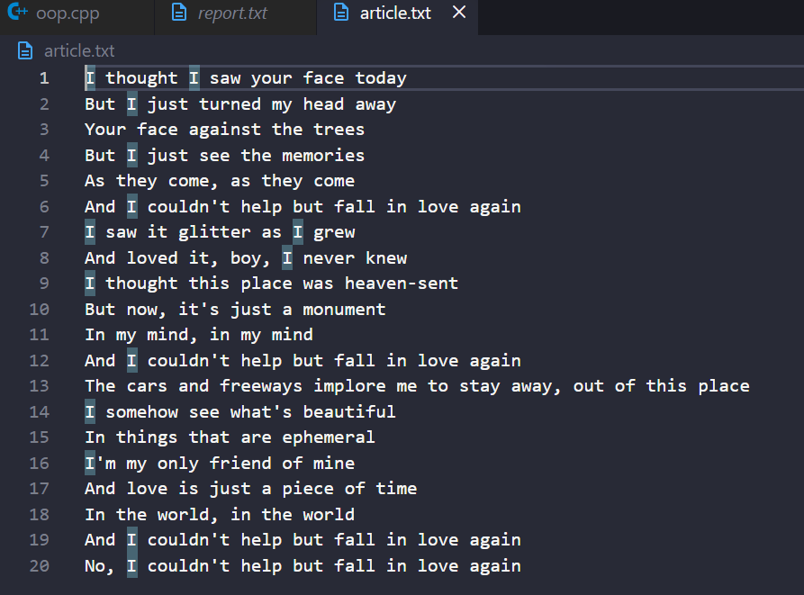
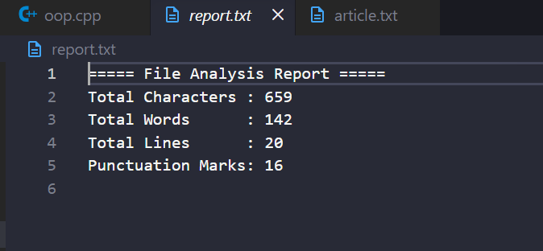

TASK 10:
#include <iostream>
#include <fstream>
#include <string>
using namespace std;

int main()
{
ofstream File("backup_log.txt", ios::app);
string Entry;

cout << "Enter log messages (type 'quit' to stop):\n";
while (true)
{
cout << "> ";
getline(cin, Entry);
if (Entry == "quit")
break;

File << Entry << "\n";
File.flush();
cout << "File size after entry: " << File.tellp() << " bytes\n";
}

File.close();
return 0;
}
OUTPUT:
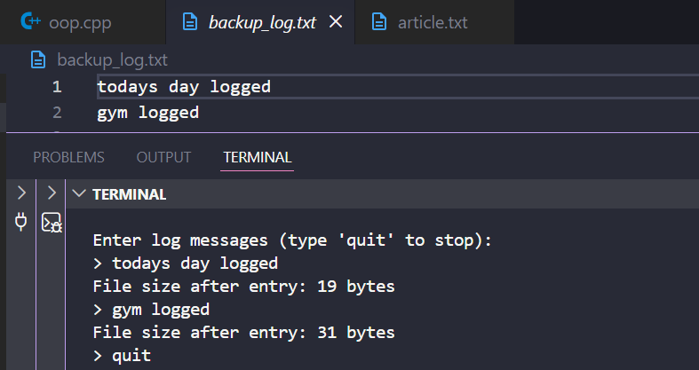

TASK 12:
#include <iostream>
#include <fstream>
#include <string>
using namespace std;

int main() {
ifstream File("article.txt", ios::binary);
if (!File) {
cout << "Could not open article.txt." << endl;
return 1;
}

long long Offset;
cout << "Enter byte offset to jump to: ";
cin >> Offset;

cout << "Pointer position before seek: " << File.tellg() << "\n";
File.seekg(Offset);
cout << "Pointer position after seek : " << File.tellg() << "\n";

cout << "\n--- Next 100 characters ---\n";
char Ch;
int Count = 0;
while (Count < 100 && File.get(Ch)) {
cout << Ch;
Count++;
}
cout << "\n";

File.close();
return 0;
}
OUTPUT:
