**ANALYSIS OF POWER OF GOOD DESIGN ON THE GAPMINDER DATA**

**Introduction**

This task is to analyses "The Power of Good Design" by carefully choosing three essential concepts from a thorough list of 10. Our main goal is to use these design concepts in the R programming language to solve a real-world problem. The first step of our duty is to precisely define the problem we are facing, whether it is a crucial choice, a complicated investigation, or a complex situation that requires careful analysis. Provide detailed information on the dataset that serves as the foundation of your inquiry, including its source and its significance to the subject being studied. Concurrently, specify the strategic techniques you want to use, creating a clear yet comprehensive strategy that can be summarized in a brief two-page paper. In this endeavor, we will priorities the art of simplicity by examining the gapminder data obtained by the gapminder package in R. This specific example illustrates the core of a problem description that is relevant and feasible. Data visualization is essential for the success of any project. This serves as both a visual story and a means to clarify how your selected design principles are tied to the details of the dataset. Within your documentation, clarify the significance of these visual representations as integral elements that strengthen the implementation of the chosen design concepts, rather than being simple decorative additions.

**Data design concepts chosen**

For this project, we have deliberately selected three crucial design ideas that will act as the guiding foundations of our data analysis endeavour: "Is Innovative," "Makes a Product Useful," and "Is Aesthetic" as elaborated below.

1. Demonstrates innovativeness: Embraces progressive thinking in analysis.

The notion of innovation advocates for a deviation from traditional approaches, compelling us to investigate novel views and creative solutions. Within the scope of our analysis of data project, this particular aspect will demonstrate our incorporation of inventive approaches into our problem-solving methodology. We will showcase how innovation serves as a catalyst, enhancing the standard and complexity of our investigations, via the utilisation of advanced analytical tools and innovative visual depiction.

1. Enhancing Product Utility: Emphasising Pragmatism in Data-Driven Solutions

This section explores the fundamental concept of utility, which is a crucial component in good design. In this context, we will explain how our studies are deliberately designed to produce practical and actionable findings. Our objective is to develop solutions that not only have theoretical relevance but also provide practical value for decision-makers by connecting our techniques with the demands of end-users. We will demonstrate the practical influence of this concept on the effectiveness of our analytical results by using concrete examples and applications.

1. Enhances Visual Appeal to Facilitate Better Comprehension

The use of aesthetics in data analysis goes beyond mere visual appeal; it is crucial for effectively communicating information with clarity and influence. This section will examine the incorporation of aesthetic concepts into our data visualisations and documentation. Our objective is to improve the overall understanding of our analysis by emphasising unified design, colour palettes, and user-friendly layouts. We will illustrate the interdependent connection between aesthetics and successful communication in the field of data analysis through concrete instances and demonstrations.

**Data analysis and visualization**

We are going to create a visualization using the gapminder dataset taken from the gapminder package in R.

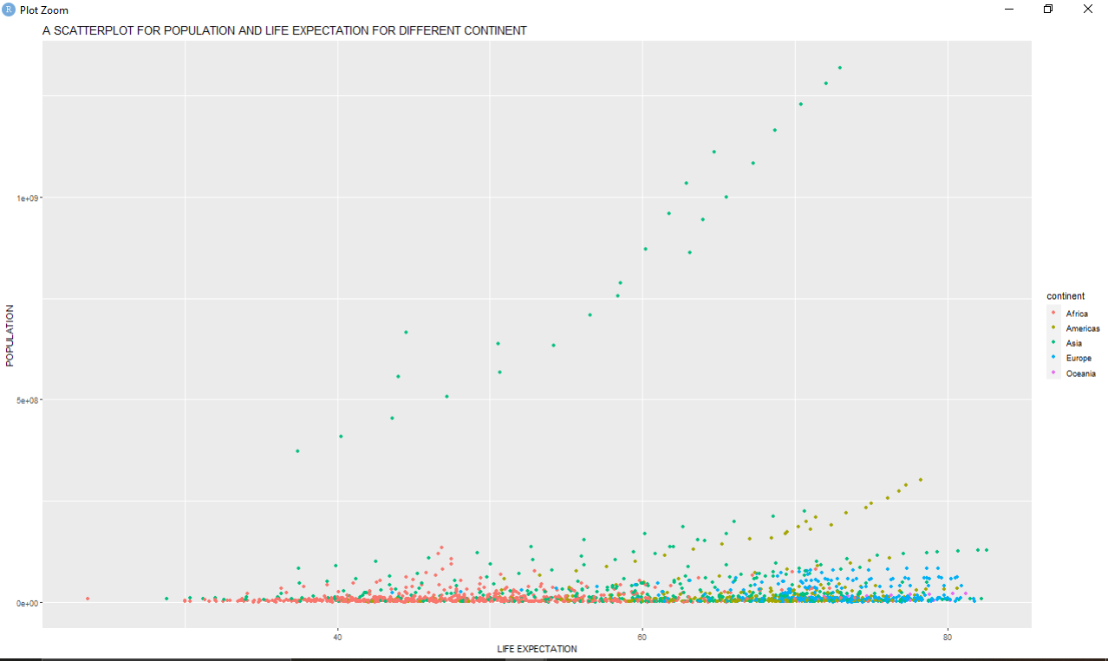

Examining the subject matter within the framework of design principles:

1. Demonstrates Innovation: The recognition of Asia as the region with the longest lifespan and a significant population is in line with the concept of innovation. The novelty comes in our capacity to identify patterns and extract significant insights through the scatterplot. This acknowledgment enables us to investigate and comprehend the distinctive attributes of several continents, promoting inventive thinking in our analysis of the facts.
2. Enhances Product Utility: The observed association between population growth and life expectancy reflects the notion of maximising the usefulness of our analysis. Within this framework, the product refers to the scatterplot, while its value comes in the practical and valuable insights it offers. Our study establishes a clear correlation between population and longevity, providing decision-makers with a helpful tool to make educated choices based on this concrete link.
3. Demonstrates Aesthetic Appeal: The scatterplot's depiction of the distinction of nations, their life expectations, and populations complies with the notion of aesthetics. The aesthetic quality of the plot enhances comprehension of the data. The precise positioning of Asia, Americas, and Europe on the diagram, together with the use of different colours or forms to represent each region, heightens the overall visual attractiveness. This well-considered design not only enhances the visual appeal of the storyline but also enables a more captivating and easily understandable presentation of the content.

To summarize, our examination of the gapminder dataset demonstrates the incorporation of essential design concepts. By employing creative and original ideas, we are able to identify distinctive patterns within the data. The efficacy of our approach becomes apparent when we establish correlations between populations and life expectancy. The aesthetic style of our scatterplot improves both the clarity and appearance, making sure the data is not only informative but also displayed in an entertaining and easily understandable way. By following to these guidelines for design, our analysis of data becomes an influential instrument for comprehending and making informed decisions.

We are going to create another plot to prove that the principles of good design holds. The next plot created will be a boxplot created from the GDP of different continents for the year 1952 and 2007.

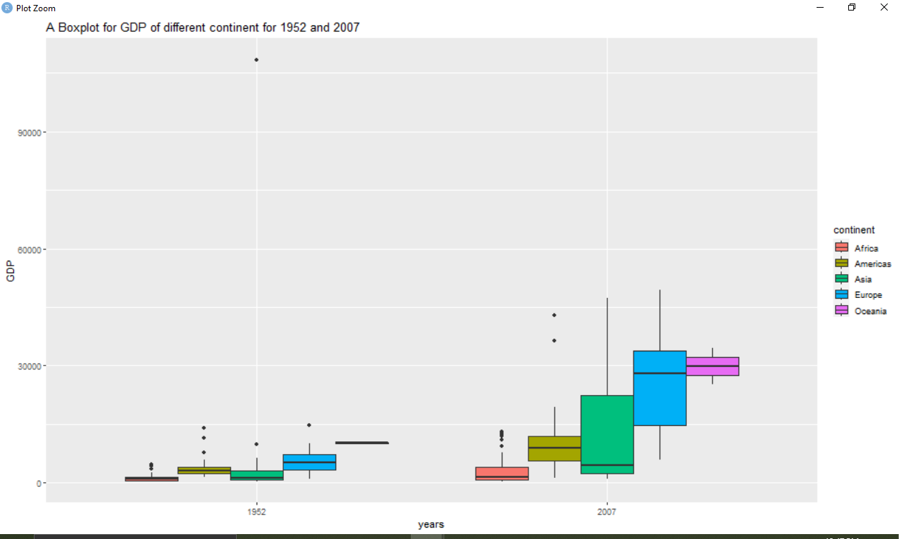

Illustrating Design Principles Using Boxplot Analysis:

1. Demonstrates ingenuity: The application of an a boxplot to illustrate GDP patterns across regions for the period between 1952 and 2007 demonstrates ingenuity in our analytical methodology. Through the use of this visual depiction, we creatively capture the spread of GDP values, offering a nuanced comprehension of economic inequalities throughout continents during the course of time. The utilization of different hues for each continent also amplifies ingenuity, enabling a visually comprehensible juxtaposition between the years 1952 and 2007.
2. Enhances Product Utility: The observation of GDP fluctuations in both 1952 and 2007 highlights the usefulness of our analysis. The boxplot is a useful tool that allows stakeholders to quickly understand the state of the economy of several continents. The unequivocal differentiation between regions and the discernment of patterns over time provide decision-makers with effective insights, in accordance with the idea of ensuring that our study is not only instructive but also pragmatically valuable.
3. Aesthetic Consideration: The intentional utilization of colors to distinguish continents and emphasize patterns enhances the visual attractiveness of our boxplot. The design choices optimize clarity and aesthetic engagement, resulting in a storyline that is both aesthetically beautiful and easily understandable. The deliberate positioning of the regions on the map, together with a well-defined key, contributes to the general visual attractiveness, in line with the notion that aesthetically pleasing elements improve the conveyance of information.

To summarize, our boxplot study of GDP patterns between 1952 and 2007 demonstrates the incorporation of fundamental design concepts. By means of innovation, we utilize a visual depiction that surpasses traditional plots, offering a distinctive viewpoint on economic facts. The value of our study is apparent as it enables stakeholders to get insights on fluctuations in continental GDP. The inclusion of aesthetic factors, such as the use of color coding and well-defined design features, improves the overall visual attractiveness, guaranteeing that our study is not only instructive but also visually captivating. By adhering to these design standards, our data visualization becomes an influential tool for effectively communicating intricate economic patterns across continents throughout the selected years.