07/09/2022

## INTRODUCTION

## WHAT IS A GOOD DESIGN?

Dieter Rams, an industrial designer, characterized good design as making a product practical and understandable, innovative, aesthetically pleasing, inconspicuous, honest, durable, meticulous in every aspect, ecologically friendly, and requiring the least amount of design as feasible. Good design is what designers aim towards. The idea of “good design” seems deceptively obvious. It raises the question of what exactly it entails in terms of a certain set of elements as something designers may practice. Design is a discipline that helps us comprehend, interact with, and improve the world around us, notably by making people’s lives better. Users who are displeased with the design will pay a price, as will the brand’s reputation. The following are the three principles used for this assignment; 1. Good design is aesthetic. 2. Good design is honest 3. Good design is long-lasting

## 1. GOOD DESIGN IS AESTHETIC.

Because the items we use on a daily basis have an impact on who we are and how we feel, their aesthetic value is essential to their utility. However, only artistically pleasing things can be created. Form should never come before function, but it should always come after. We should be mindful of how aesthetics affect users and strive to delight them with your product’s visual appeal.

## 2. GOOD DESIGN IS HONEST

It doesn’t transform a product into something more inventive, potent, or useful than it actually is. It doesn’t make empty promises to the customer in an effort to trick them. The lesson here is very clear. We ought to be open and transparent with our customers about the services we provide. We need to make sure we keep our promises, regardless of how they are presented—whether through a visual affordance, iconography, or even marketing. Your design should only be as original, potent, and/or valuable as it purports to be because users want promises kept, not false hopes dangled before them. You can contribute to keeping this balance by thinking about the solution(s) it offers to what problems and designing for those.

## 3. GOOD DESIGN IS LONG LASTING

It doesn’t follow trends, therefore it never comes across as outdated. Even in today’s disposable society, it endures for many years in contrast to trendy design. Designing purely for aesthetic purposes is risky and typically useless. What is in style now will, at best, be out of style the next day and, at worst, be a joke in 10 years. Good design never appears stale or out of date. The unwelcome trademark styling that links a product to a specific age and renders it disposable can be avoided with classic, clean designs.

In R this can be explained using the data visualization shown below. Start by loading the packages to be used in this visualization together with the data. The gapminder dataset offered by dslabs package will be used. Several spreadsheets that were made accessible by the Gapminder Foundation were used to construct this dataset.

library(ggplot2) # for data visualization.  
library(dslabs) # for accessing the dataset

## Warning: package 'dslabs' was built under R version 4.2.1

library(dplyr) # for data manipulation

##   
## Attaching package: 'dplyr'

## The following objects are masked from 'package:stats':  
##   
## filter, lag

## The following objects are masked from 'package:base':  
##   
## intersect, setdiff, setequal, union

data(gapminder) # loading the dataset

From the gapminder dataset, A common perspective is that the globe is divided into two groups of countries: 1. Western culture: long lifespans and low fertility rates 2. Lower life expectancy and higher fertility rates in developing nations 3. Data from Gapminder can be used to assess the veracity of this viewpoint. There are two distinct groups that stand out, with North America, Northern and Western Europe, New Zealand, and Australia making up the wealthy group. We establish groups based on the following finding:

gapminder <- gapminder %>%   
 mutate(dollars_per_day = gdp/population/365,# represent dollar per day earned   
 group = case_when(  
 region %in% c("Western Europe", "Northern Europe","Southern Europe",   
 "Northern America",   
 "Australia and New Zealand") ~ "West",  
 region %in% c("Eastern Asia", "South-Eastern Asia") ~ "East Asia",  
 region %in% c("Caribbean", "Central America",   
 "South America") ~ "Latin America",  
 continent == "Africa" &   
 region != "Northern Africa" ~ "Sub-Saharan",  
 TRUE ~ "Others"))  
#turn this group into factor  
gapminder <- gapminder %>%   
 mutate(group = factor(group, levels = c("Others", "Latin America",   
 "East Asia", "Sub-Saharan",  
 "West")))

1970 versus 2010 income distributions will be the question in hand and we want to know how this two years are related. To check how the distributions have changed, use facet grid. First, we’ll concentrate on the west and the rest of the world. Four histograms are created. This is shown below.

past_year <- 1970  
present_year <- 2010  
years <- c(past_year, present_year)  
gapminder %>%   
 filter(year %in% years & !is.na(gdp)) %>%  
 mutate(west = ifelse(group == "West", "West", "Developing")) %>%  
 ggplot(aes(dollars_per_day)) +  
 geom_histogram(binwidth = 1, color = "black") +  
 scale_x_continuous(trans = "log2") +   
 facet_grid(year ~ west)

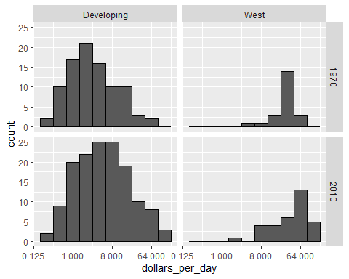 Before interpreting the results of this figure, it is important to note that more nations are represented in the 2010 histograms than in the 1970 histograms, as indicated by the larger total counts. This is due, in part, to the fact that some nations were established after 1970. For instance, throughout the 1990s, the Soviet Union broke up into various nations. Another factor is that in 2010, data was accessible for more nations. We recreate the graphs using only the nations for whom both years of data are available. Utilize the intersect function:

country_list_1 <- gapminder %>%   
 filter(year == past_year & !is.na(dollars_per_day)) %>%   
 pull(country)  
  
country_list_2 <- gapminder %>%   
 filter(year == present_year & !is.na(dollars_per_day)) %>%   
 pull(country)  
   
country_list <- intersect(country_list_1, country_list_2)

86% of the world’s population is represented by these 108, therefore this subset ought to be representative. By simply adding country%in% country list to the filter function,remake the plot, but only for this subset:

gapminder %>%   
 filter(year %in% years & !is.na(gdp)& country %in% country_list) %>%  
 mutate(west = ifelse(group == "West", "West", "Developing")) %>%  
 ggplot(aes(dollars_per_day)) +  
 geom_histogram(binwidth = 1, color = "black") +  
 scale_x_continuous(trans = "log2") +   
 facet_grid(year ~ west)

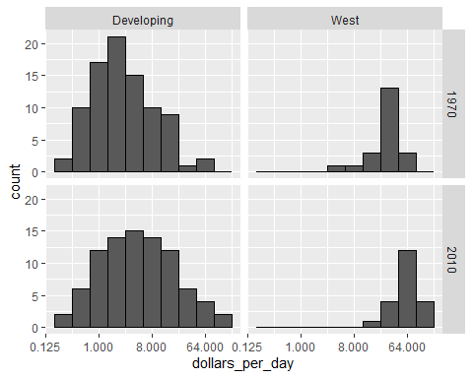 We can now see that while the poorer countries appear to have made greater progress in absolute terms, the richer ones have become slightly richer. In instance, we observe a marked increase in the percentage of emerging nations earning more than $16 per day. We may recreate the boxplots we created before, adding the year 2010, and then using facet to compare the two years to determine which particular locations improved the most.

gapminder %>%   
 filter(year %in% years & country %in% country_list) %>%  
 mutate(year = factor(year)) %>%  
 ggplot(aes(group, dollars_per_day, fill = year)) +  
 geom_boxplot() +  
 theme(axis.text.x = element_text(angle = 90, hjust = 1)) +  
 scale_y_continuous(trans = "log2") +  
 xlab("")

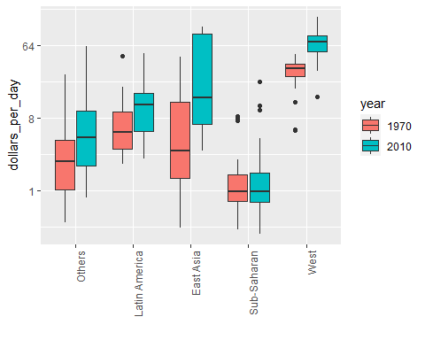 According to the prior data analysis, the income gap between wealthy and developing nations has significantly shrunk over the past 40 years. To see this, we created a number of histograms and a boxplots. checking the above plots, we see that the principles of good design are illustrated with the plots shown. for good design is aesthetic we see aesthetics properties being displayed in the plots. for good design is honest is clearly shown by the codes which were used to create the plot therefore this principle is followed. For good design is long lasting we see the plot as a long lasting product that stays for long not unless the codes used to produce these plot change therefore this principle is observed quite well.