**UNDERSTANDING HOUSING DYNAMICS WITH R ANALYSIS IN FL AND NY**

**INTRODUCTION**  
Suzie's search for the ideal home presents a dilemma: pick between New York's fast-paced lifestyle and Florida's relaxed atmosphere. Equipped with an abundance of information, her representative has examined home values and crime statistics, establishing the framework for a thorough investigation. With the help of R's powerful features, we explore the core of this investigation and solve the puzzles raised by Suzie's questions. Is there a higher expense of living in the city that rarely sleeps than in the peace and quiet of Florida? What story do these two states' crime statistics tell, and how do these relate to the range of home prices? Come along on this trip with us as we analyze the data and create visuals that not only address Suzie's inquiries but also direct her toward making a decision that is in line with her own objectives and goals.

**DATA USED AND ITS STRUCTURE**

The data used in this analysis is currently named ‘file from midterm’ with information containing location, house prices and crime rates. The file is in xlsx format thus using the read_xlsx() function in R’s we load the data and store it in an object called house_and_crime_data. Turning our attention to Florida's housing market, the dataset presents Suzie with a mosaic of options. Florida offers a wide range of possibilities for housing, with costs ranging from $120,321 to $402,315 in the Sunshine State. The associated crime ratings, which range from 1 to 8, show different aspects of safety. While some areas struggle with marginally higher rates of crime, others have exceptionally low rates. Suzie is urged to take a comprehensive approach since the data intriguingly implies that there might not be a clear-cut relationship between crime ratings and home values. Using R's analytical skills to analyze the complex link between these variables will be crucial as she weighs her relocation possibilities and will help to make sure that her choice is in line with her priorities and preferences. After calling the structure of the data we obtained the following information as displayed in the screenshot below.

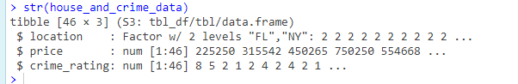

Using this data we are going to perform an analysis and determine answers to the questions provided by Suzie.

**ANALYSIS OF HOUSE AND CRIME DATA**

1. **Is it more expensive or less expensive to live in FL or NY?**

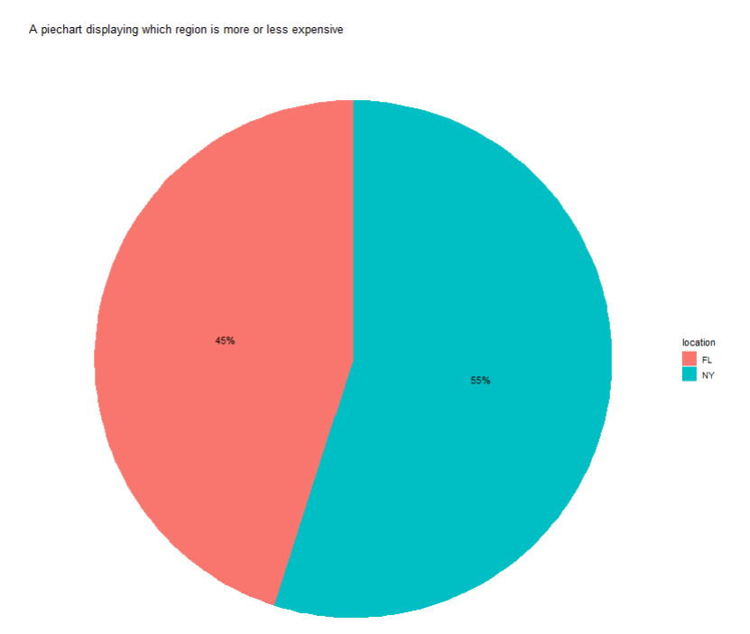

There is a clear difference in the cost of living between New York (NY) and Florida (FL) based on the thorough analysis that was conducted using the pie chart that shows the costs of houses in these two states. New York is clearly the more costly location, as seen by its impressive 55% share of all house prices. The fact that New York owns the bulk of the shares highlights a property market that is marked by higher costs, making living there comparatively more expensive.   
  
On the other hand, Florida—designated by the FL label and accounting for 45% of all home prices—becomes the less expensive option. This discovery is consistent with a lower percentage of housing costs in the sample being allocated to Florida, suggesting that living expenses are lower in this area. Thus, drawing conclusions from the information obtained from the pie graph study, it is confirmed that the state of NY is considered to be more costly, whilst Florida is set up as the somewhat more economical choice for potential residents.

1. **Is the crime rate higher in FL or NY (Note a low score in crime means lower crime)?**

We will examine a visually striking depiction of the crime rates in Florida (FL) and New York (NY) in our investigation of the second topic. A treemap will be used for this. The purpose of this dynamic graphic is to clarify whether rates of crime are greater in one area than another by dissecting the complex relationships between crime incidents in these various locales. Specifically, we will take into consideration the notion that a lower crime score denotes a less crime-ridden area. The treemap is an effective tool for comparing and illuminating crime dynamics, and it offers insightful information on the safety environments in Florida and New York. The treemap plot is displayed below.

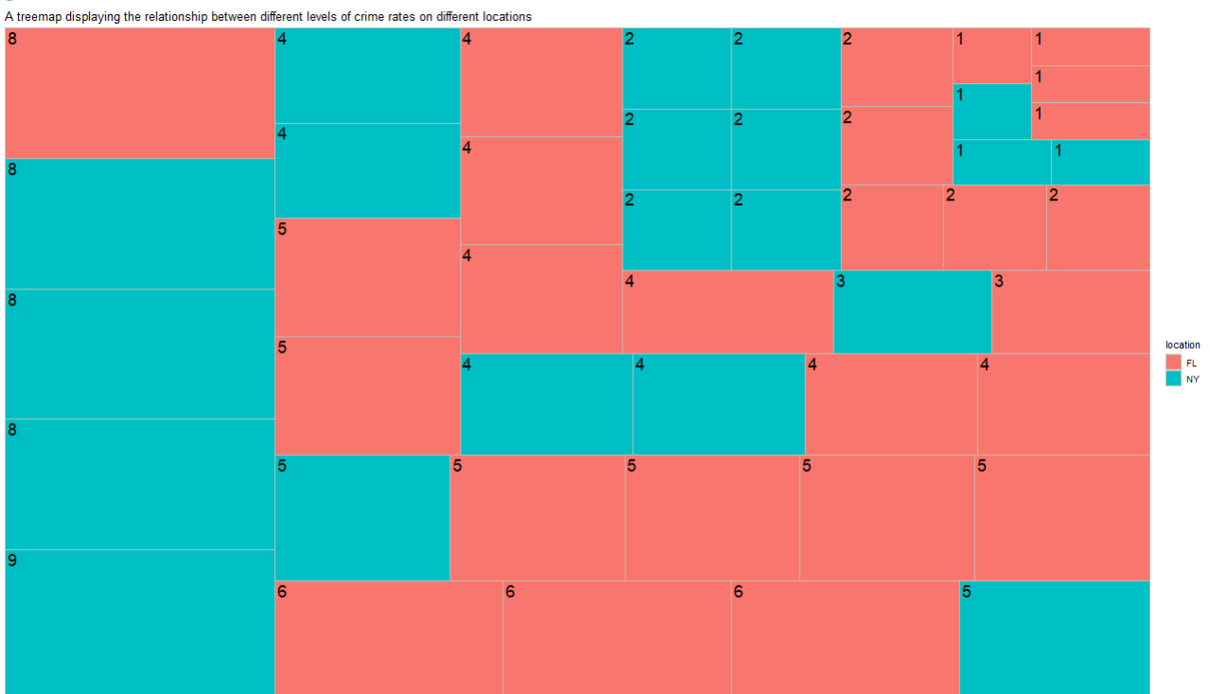

The treemap analysis reveals distinctive patterns in crime rates between New York (NY) and Florida (FL), allowing for a comprehensive assessment of their relative safety landscapes. Examining each crime rate category, several key observations arise.

In the lowest criminal activity category (score 1), FL surpasses NY with a count of 4, indicating a higher frequency of criminal activities even in the state with the lowest crime rate. Moving to the second crime rate level (score 2), NY stands out with an elevated count, nearing 6, suggesting a higher crime rate compared to FL.

At the third crime rate level (score 3), both states show comparable numbers, indicating a similar rate of crime. However, as we progress to the fourth crime rate (score 4), FL registers a higher count nearing 6, signifying a greater crime rate, while NY reports a lower count.

In the fifth crime rate level (score 5), FL takes the lead with a substantial count of 6, indicating a higher crime rate, while NY reports a modest count of 2, illustrating a comparatively lower rate of crime. Notably, at the sixth crime rate level (score 6), FL records a count of 3, suggesting a higher crime rate, while NY reports no crime counts.

Moving forward, in the eighth crime rate level (score 8), NY exhibits a higher count equivalent to 3, indicating a greater crime rate, whereas FL registers just 1, showcasing a relatively lower rate of crime. Finally, in the most severe crime rate level (score 9), only NY displays a count, concluding that NY has a greater rate of this specific type of crime as FL has no tallies at this level. Taking into account these findings, it can be deduced that, overall, the crime rate appears to be higher in Florida (FL) than in New York (NY). Despite some variations across different crime rate categories, the cumulative evidence suggests that Florida exhibits a more substantial frequency of criminal activities when compared to New York.

1. **Is the crime rate higher in lower or higher house price areas?**

When investigating the relationship between crime rates and home values, we concentrate on deciphering the complex dynamics using a scatterplot. With a focus on determining if crime rates are often greater in locations with greater or lesser house prices, this graphic representation seeks to clarify the connection between crime levels and housing prices. The scatterplot is an effective tool for identifying possible relationships and trends, offering important information about the intricate relationship between socioeconomic variables and the frequency of crime.

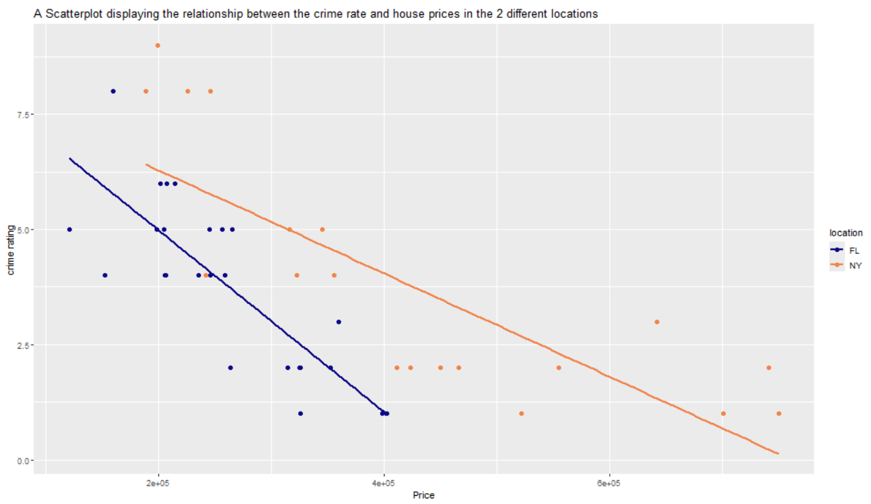

The examination of the relationship between crime rates and home prices, as indicated by the scatterplot, provides detailed information about the complex interplay between two crucial variables. There is a clear negative link that exists in both FL and the region of NY, meaning that home values tend to decrease as crime rates rise and vice versa. This can be proved by the line of best fit provided in the scatterplot. There is an interesting pattern in New York where the most costly homes—those over $400,000—have lower crime rates. This suggests that the safer the wealthier districts, the higher the cost of housing. On the other hand, Florida's homes under $400,000 show a relative decrease in crime rates, highlighting the link between more reasonably priced homes and reduced crime rates. One significant difference appears in New York: neighborhoods with high rates of crime, especially those above 7.5, are primarily composed of lower-class dwellings, suggesting that these communities are more vulnerable to high crime rates. This thorough analysis highlights the complicated relationships that exist between housing costs, crime rates, and socioeconomic indicators. It also offers important insights into the many variables that shape local safety environments.

1. **If you were Suzie, where would you move based on the questions above?**

Suzie's decision to move is aided by the thorough examination of crime statistics and housing costs, which gives her important information. According to the data, there is a clear pattern in New York (NY) where there is a correlation between lower crime rates and expensive properties, especially those that cost more than $400,000. This implies that residing in wealthy communities in New York is often safer. However, Florida (FL) shows a relative decrease in rates of crime in neighborhoods with more reasonably priced homes—many of which are under $400,000. Based on her financial capabilities and lifestyle preferences, Suzie may find adequate possibilities in any region, given her preference for a less criminalized area. However, the data suggests that New York might be a better option if Suzie places a higher value on living in a wealthy area with fewer crimes.

1. **On average what location will she be able to pay off her house first based on average** **housing prices and income she will receive?**

As Suzie further refines her decision-making process, additional factors come into play that may significantly impact her relocation choice. Suzie has provided supplementary information, including a $100,000 down payment for the house. Additionally, she outlines the prospective job opportunities in each location, with a job earning potential of $120,000 per year in New York and $75,000 per year in Florida. These financial considerations introduce a crucial dimension to Suzie's decision, influencing her ability to afford a home and maintain a desirable lifestyle in either New York or Florida. After performing some few data cleaning we came up with the following barplot.

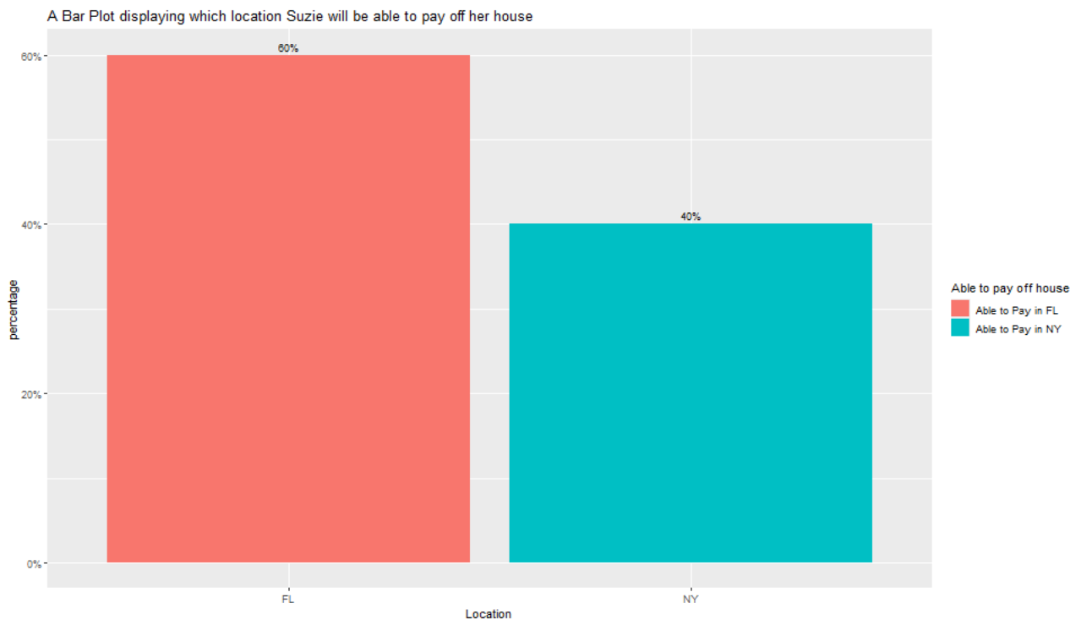

It is clear that Suzie stands a higher chance of paying off her house within the FL region as opposed to NY (New York) based on the data that was collected and the bar plot showing the proportion of various locations where Suzie is capable of paying off her house. The following are the main observations:   
  
1. FL Address:   
- Ratio: 60%   
- Findings: Suzie has a good 60% chance of paying off a home in the Florida region. This is explained by the fact that she will be making $75,000 a year after moving to Florida in addition to a hundred thousand dollars she has saved. The sum of $175,000 is comparatively more advantageous when buying a home in Florida.   
  
2. Location in New York:   
- Ratio: 40%   
- Observations: Suzie is less likely to pay off an apartment in the NY area, as indicated by the 40% rate. Her annual salary in New York is $120,000, so when she adds her $100,000 savings, the total comes to $220,000. The 40% chance suggests that this amount is less beneficial in light of NY house prices.   
  
In summary, taking into account the financial aspects, Suzie is more inclined to relocate to Florida, where her income and savings match the local home market more favorably. Suzie finds the FL location more realistic because it offers a larger likelihood to be able to finance off a home.

1. **Where should she move and why?**

Suzie's decision on her new location is guided by a lucid picture that emerges from the data. The bar plot illustrates the difference in housing prices between NY and FL. In NY, most homes are over $400,000, whereas in FL, the price range is more reasonable. The treemap plot analysis of crime statistics shows that FL is generally a safer option due to its lower crime rates at all levels. In both places, there is a negative correlation between crime rates and housing prices, according to the scatterplot research, with higher-priced homes often having lower crime rates. The ability of Suzie to pay off a home is crucial, and the bar plot showing average income and housing costs shows that Suzie can buy a home in Florida at a higher percentage (60%) than in New York (40%). The total financial scenario benefits FL when extra financial information is taken into account, such as a $100,000 down payment and annual income. Therefore, FL is the best option for Suzie since it satisfies her preferences for lower crime rates and more favorable home affordability. It also has a higher possibility of being able to pay off a house, cheaper housing prices, and usually lower crime rates.