**AN R-BASED ANALYTICAL INVESTIGATION OF NY AND FL**

**Introduction**

Suzie, on the verge of making a decision that will change her life, muses over the possibility of moving to either the famous streets of NY or the tranquil settings of FL. Her agent has carefully examined data, highlighting home prices and violence ratings for potential dwellings, understanding the significance of this decision. We use the powerful tool R to go on a data-driven journey to help Suzie with her decision-making. Our journey aims to unearth important insights: Is the peace and quiet of FL more expensive than the attraction of NY? What are the differences in the crime rates between the two states in question, and is there any variance in the rates across different price ranges for homes? We use R's aptitude for analysis to create visually stunning stories that provide Suzie the knowledge she needs to make an educated decision about her future residence.

**Data summary**

Regarding the housing market in NY, the data indicates a wide range of home values and associated crime scores. Suzie has a plethora of options to choose from, with housing costs ranging from $188,752 to $750,250. It's interesting to note that the crime ratings, which range from 1 to 9, show a mixed picture. While some regions have remarkably low rates of crime, others struggle with somewhat higher ones. Remarkably, there seems to be a mixed relationship between housing prices and crime rates; there are examples of less expensive residences having both high and low crime rates. Suzie is drawn to explore the dataset more deeply by the complex interactions between the variables, using R's analytical powers to identify trends that would influence her choices. The screenshot provided below displays the summary of the data.



**Data visualizations and analysis.**

In our project we are supposed to answer some few questions that Suzie need to know so that she can decide which location she will move to. We are going to answer this question using the data and providing necessary visualizations for Suzie’s clarity.

* **Is it more expensive or less expensive to live in FL or NY?**

This is the first question asked by Suzie and we are going to use a barplot to display this information. The bar plot is displayed below.

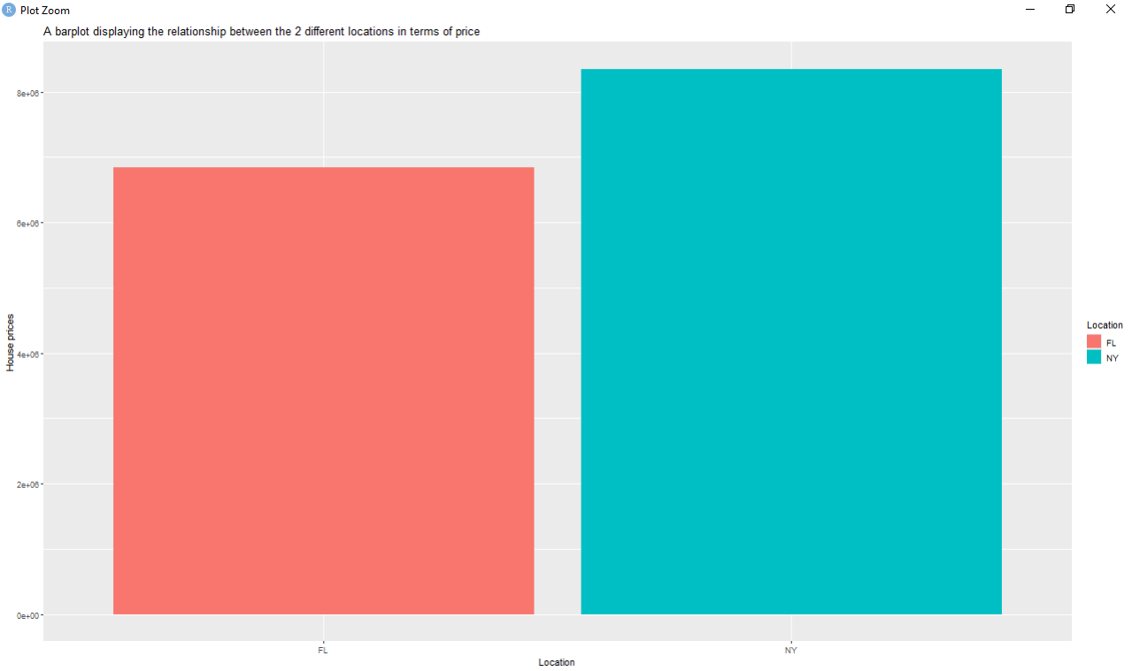

We visually evaluated the association between location (FL and NY) on the x-axis and property prices on the y-axis in the barplot created from the dataset. The conclusions derived from this graphical depiction clearly indicate a significant difference in the cost for living between FL and NY.   
A closer look reveals that there is a tendency toward more expensive homes in the region of NY. According to the barplot, prices in NY only go as high as $750,250, suggesting a significant upper tier in the market for real estate. However, the bars associated with the FL region always show lower values; the cost of a house in this area does not exceed $405,000. Living in NY appears to be more costly than in FL, based on the glaring difference in home price distribution.   
To summarize, our barplot visual analysis confirms that housing costs are higher in NY, whereas FL appears to be a more affordable choice for Suzie's possible transfer.

* Is the crime rate higher in FL or NY (Note a low score in crime means lower crime)?

In The second question we are asked which region between the NY and FL have a higher crime rate. In this case we are going to create a grouped barplot so that it can efficiently display the information for the two regions. The plot is shown below.

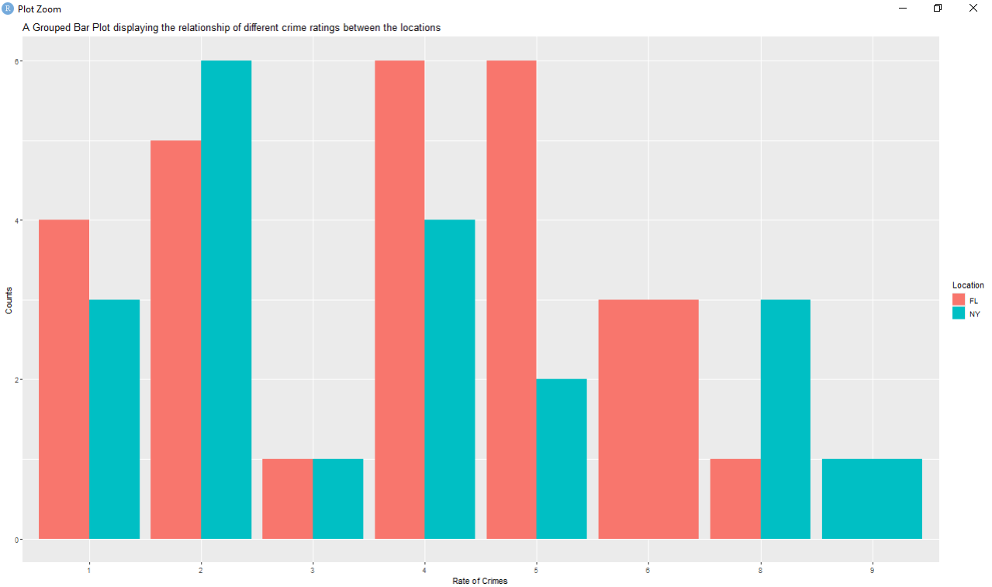

A thorough examination of the crime rates in FL and NY can be done using the insights obtained through grouped bar plot, which plots crime ratings on the x-axis and matching counts on the y-axis. These are the findings:   
1. Crime Rate 1: FL records a greater count (more than 3) in the lowest criminal activity category (score 1) than NY, where the number of crimes is lower than 3. This suggests that FL has a greater frequency of crime even in the state with the lowest crime rate.   
2. Crime Rate 2: NY sticks out with a larger count (almost 6), suggesting a greater crime rate, for the second criminal activity level (score 2). FL, on the other hand, registers a lower number, indicating a comparatively lower level of crime in this area.   
Crime Rate 3: NY and FL are tied for third place at this level of crime (score 3). Comparable numbers in both regions suggest a similar rate of crime in this category.   
4. Crime Rate 4: FL has a higher count (almost 6) at the 4th rate of crime level (score 4), suggesting a greater crime rate. Conversely, NY records a total of 4, indicating that there are fewer crimes in this category.   
5. Crime Rate 5: FL stands first with a greater count of 6, indicating a higher crime rate, in the fifth criminal activity level (scoring 5). With a total of just 2, NY has a comparatively lower rate of crime in this area.   
6. Crime Rate 6: Upon reaching the sixth rate of crime tier (score 6), a noteworthy finding is noted. FL records a count of 3, suggesting a greater crime rate in this particular category, but NY reports no crime counts.   
7. Crime Rate 8: NY shows a higher count (which is equivalent to 3) for the eighth criminal activity level (score 8), indicating a greater crime rate. FL, on the other hand, has just 1, showing a comparatively lower rate of crime in this category.   
8. Crime Rate 9: Lastly, only NY exhibits a count in the ninth criminal activity level (score 9), which is the most severe of all criminality levels. Since FL has no tallies at this level, it can be concluded that NY has a greater rate of this particular type of crime.   
In summary, it can be inferred from the observations of crime rates that, in general, NY has a higher crime rate than FL in a number of different crime rate categories.

* Is the crime rate higher in lower or higher house price areas?

In the third question we are going to create a scatter plot where we take the price variable on the x-axis and crime rating variable on the y-axis then color the points with location variable’s levels. The plot is displayed below.

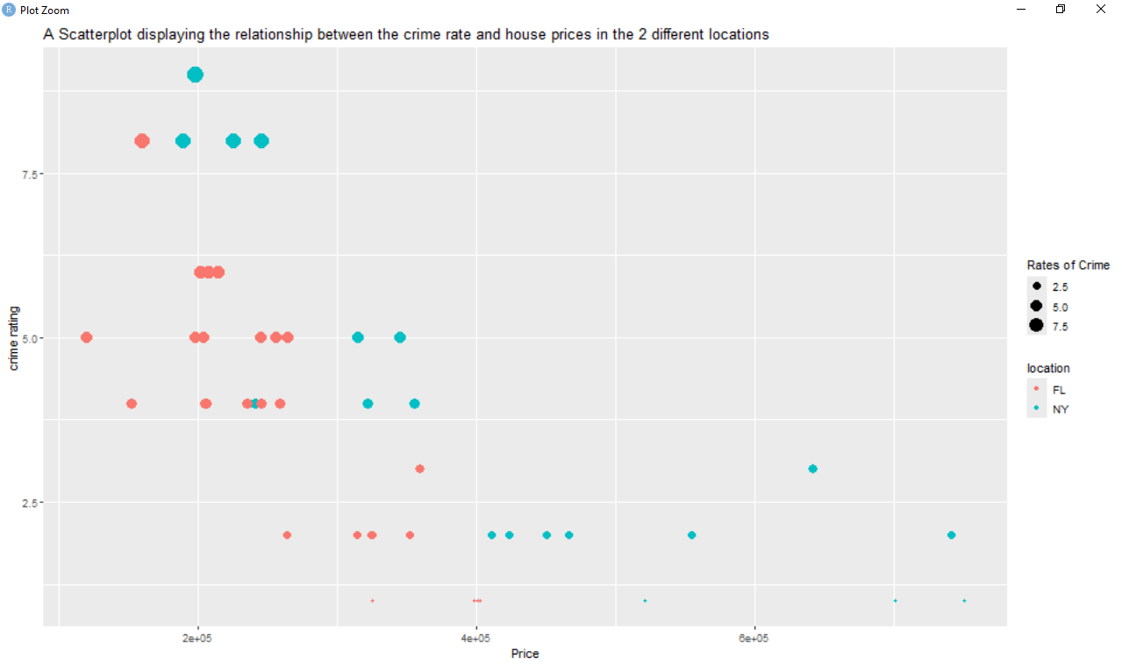

We can make deft inferences about the correlation between these variables and their relationship with housing prices based on the observations obtained from the scatterplot, which shows the relationship between the rate of crime (y-axis) and the cost of housing (x-axis), along with the size of points representing different regions. The main conclusions are as follows:   
1. There Is a Negative link between Criminal Activity and Home Prices: The scatterplot clearly illustrates this link. This suggests that home values typically decline when crime rates rise and vice versa. There is a persistent negative link seen in Florida (FL) and New York (NY).   
2. Expensive Homes in NY with Lower Crime Rates: It's interesting to note that most expensive homes—especially those that cost more than $400,000—are found in New York. Remarkably, the scatterplot shows that the crime rate is lower in these more expensive homes. This points to a trend in which New York neighborhoods with more costly housing typically have lower crime rates.   
3. Cheaper Homes in Florida with Relatively Low Crime Rates: On the other hand, homes in the Florida area are often less expensive, frequently priced under $400,000. These Florida homes show a relative drop in crime rates despite their reduced values; the scatterplot shows that crime rates are usually less than 5. This pattern implies that cheaper residences in Florida have comparatively lower crime rates.   
4. High Rates of Crime in New York at Lower Property Prices: It is important to remember that New York distinguishes out when it comes to having high crime rates. Crucially, the majority of the high crime rates—above 7.5—are reported in homes that are less expensive. This suggests that lower-class neighborhoods in New York are more likely to have greater rates of crime.   
As a whole, the scatterplot research highlights a glaringly obvious inverse connection between criminal activity and home values, with more expensive homes—particularly in New York—generally having lower crime rates. On the other hand, cheaper homes—particularly in New York—might be linked to greater crime rates. A more complex understanding of the relationship between real estate prices and the level of crime in various regions is made possible by the fact that lower-priced properties in Florida show a proportionate decrease in crime rates.

* If you were Suzie, where would you move based on the questions above?

Given the thorough examination carried out previously, if I were Suzie, I would decide to go to Florida. All of the observations point to Florida having a more reasonable cost of living than New York, with reasonably priced homes and a lower crime rate Suzie would be better off relocating to Florida due to the state's general cost-effectiveness, safety, and income balance. Thus, moving to Florida in search of a better living environment would be the data-driven choice.

As Suzie considers her relocation options, she shares crucial additional details for consideration. With $100,000 available for a down payment, she weighs a job offering $120,000 per year in New York against a position offering $75,000 per year in Florida. These financial factors add depth to Suzie's decision-making process, highlighting the intersection of income, available funds, and job opportunities in her choice of a new home.

* On average what location will she be able to pay off her house first based on average housing prices and income she will receive?

The housing data is converted into a cleaner version using the `dplyr` package in a R code segment, producing the dataset `cleaner_housing_data}. The first step is to filter the data so that only entries with a dwelling price of below or equivalent to $220,000 are kept. The `mutate()` and `case_when()` functions are then used to generate a new variable, `able_to_pay_off_house}. Based on predetermined price thresholds, this variable acts as a suggestion indication, counseling Suzie on the best place to pay off her residence. The terms state that it is advised to "pay in NY" if the cost of residence is between $175,000 and $220,000. If, on the other hand, the cost is $175,000 or less, the recommendation would be "Pay in FL." This code segment essentially simplifies the data to give Suzie wise advice that is in keeping with her budget and housing affordability concerns. For this part we create a piechart that will show us the proportion that Suzie can be able or can afford to pay off house in either NY or FL.

The piechart is shown below.

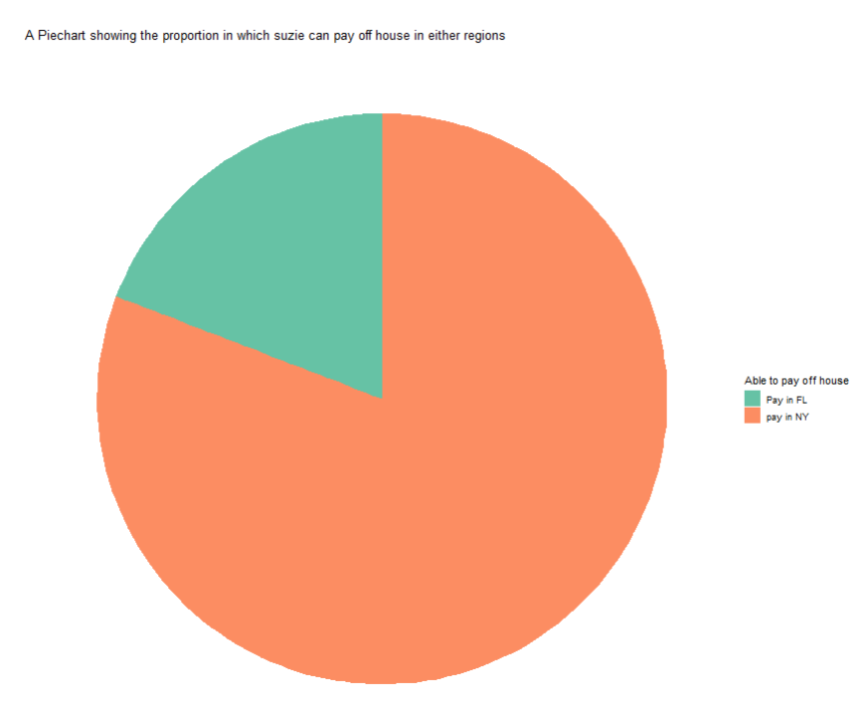

Given the above pie chart analysis's findings, it's clear that Suzie, whose yearly income is $120,000 and her down payment is $100,000, has a better chance of paying off her home in the NY area. The higher percentage of the pie chart that represents the NY part indicates that a higher percentage of her income is being used to pay off a home in this area. On the other hand, the smaller portion that is ascribed to Florida (FL) suggests that Suzie will have a relatively narrower window of opportunity to pay off a property in this area given the designated wage and the amount set aside for the house. Suzie would therefore be more likely to pay off an apartment in New York, according to the pie chart's visual portrayal, which is based on average cost of housing, income, and allotted funds.

* Where should she move and why?

Moving to Florida is Suzie's best option, according to the comprehensive research. When housing costs and crime rates are compared, Florida routinely comes out on top, which supports Suzie's objective of choosing wisely financially while putting safety first. Florida is a more sensible and financially feasible option when taking into account the whole cost of life, including housing costs, even with New York's potential for greater income. The additional details including a $100,000 deposit further support the financial sustainability of relocating to Florida. Suzie's potential of paying off her residence was specifically examined, and the results, shown in the pie graph, highlight how feasible it is to do so in New York even with a lower wage and less money available. In conclusion, Florida is the best place for Suzie to relocate due to a combination of cheaper housing costs, reduced rates of crime, and financial concerns, all of which will contribute to a safer, more responsible, and sustainable future.