**STORYTELLING AND SUCCESS STORIES ON OECD BETTER LIFE INDEX**

INTRODUCTION

**Storytelling and success stories in data visualization**

**Definition.**

The focus of this piece is on the utilization of storytelling and success stories in data visualization, specifically in relation to the OECD Better Life Index. Data storytelling involves presenting a coherent narrative that incorporates data and analytics to support the story's premise. This approach utilizes a variety of data forms, such as scatter plots, timelines, pie charts, and heat maps, to create a compelling narrative that offers a conclusive message and a course of action. There are several advantages to using data storytelling, including adding value, increasing trust, and promoting engagement with the audience. The Better Life Index data is obtained from the Organization for Economic Cooperation and Development and is stored in a file called index_data.csv. The data can be read using the read_csv function in the R programming language, which is included in the tidyverse meta package. The primary goal of the Better Life Index is to promote discussions about measuring societal well-being and to equip citizens with the knowledge and skills needed to actively participate in the process of creating laws that govern daily life.

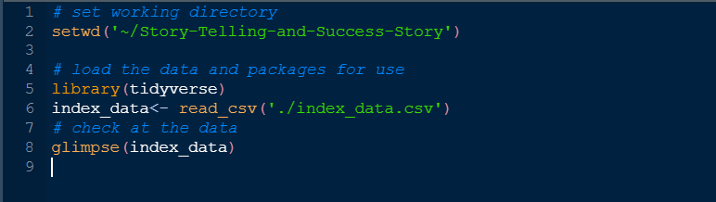

Once the data is loaded, it is necessary to perform data cleaning to improve the accuracy of the results. Data cleaning involves the process of correcting or removing inaccurate, corrupt, improperly formatted, duplicated, or incomplete data from a dataset. To accomplish this task in R, the tidyverse package provides a straightforward solution. The package includes functions such as mutate, filter, and select, which are useful for performing data cleaning tasks. A screenshot below illustrates how these functions can be used in R code.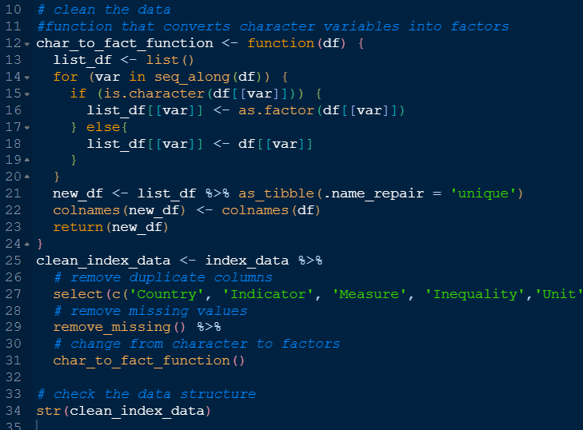

In the provided screenshot, there is a function that converts variables containing character data values to categorical data values. This function was used to convert character data to categorical data, and any missing variables with NA were removed. Additionally, duplicate columns were removed using the select function, and the necessary columns were selected for analysis.

To demonstrate the effectiveness of data visualization in creating stories, we plotted several variables from the cleaned data. Our analysis focused on the levels of gender inequality across various countries. To create a visual representation of this data, we used a bar plot, which is an effective visualization technique. An example of this plot is provided below..

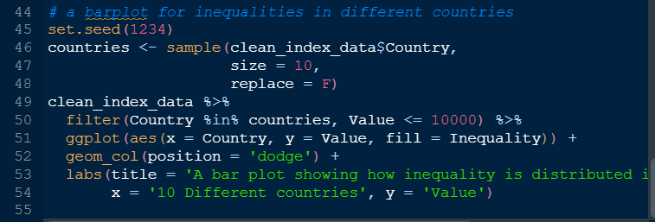

The code provided above involves several steps. Initially, we selected ten countries at random and filtered our data by choosing only the data related to these countries. Next, we used the geom_col() function to generate a bar plot. In this plot, the Value variable was plotted on the y-axis while the x-axis represented the Country variable. Additionally, the bars were color-coded based on different levels of the Inequality variable. The resulting bar plot is presented below.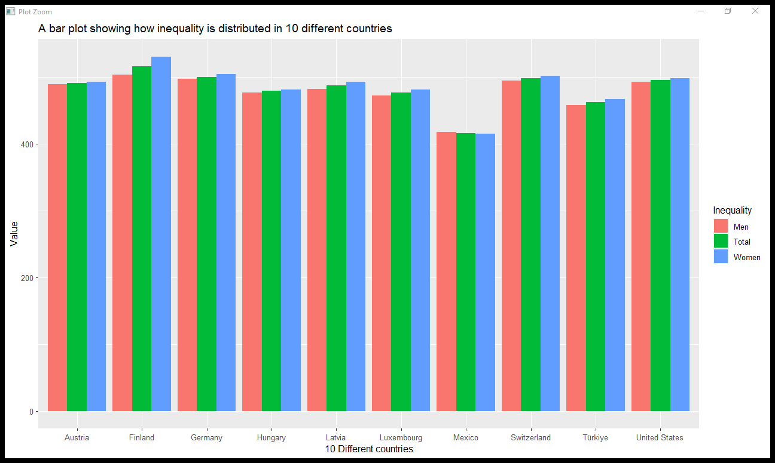

The bar plot shown above illustrates the relationship between the Value variable (y-axis) and Country variable (x-axis), with different colors representing different levels of the Inequality factor variable. Across all the selected countries, the highest bar corresponds to the inequality level for women, indicating that these countries exhibit significant bias against women. Finland, Germany, and Switzerland have the highest levels of inequality, while the level of inequality for men is somewhat lower than that of women.

This visualization effectively communicates a story about the data, highlighting the importance of using visualizations in successful storytelling.

To further emphasize the significance of data storytelling, we can create another plot using a treemap. This visualization technique provides insight into what data storytelling is and how it aids in providing information to users. The following code was used to generate this treemap plot.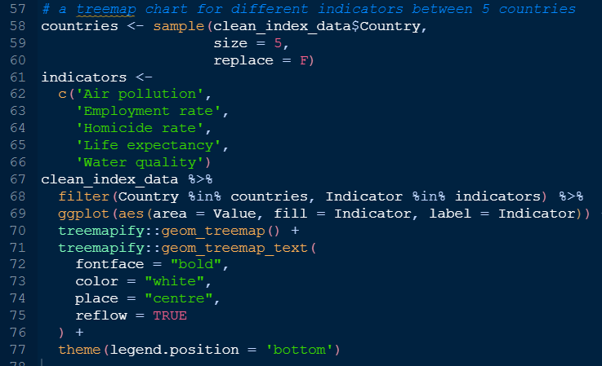

To generate the treemap plot shown below, we began by randomly selecting five countries and five indicators. We then used these selections to filter the data before plotting the treemap.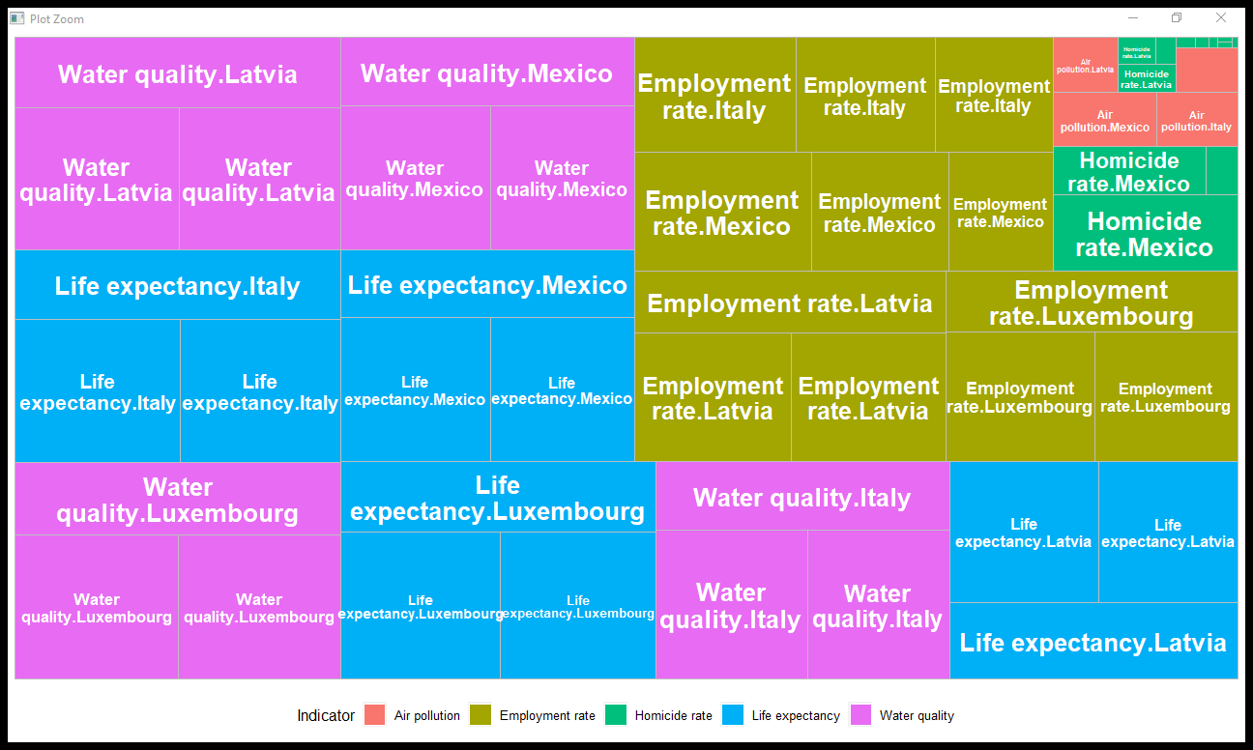

To summarize, the passage discusses the use of data visualization techniques to tell success stories of different countries based on the OECD Better Life Index. Barplots and treemaps are used as examples to compare the different dimensions and subcategories of the index, respectively. The treemap plot shows how different indicators from five different countries relate to each other, while the bar plot shows the levels of inequality between men and women in different countries. Data visualization is an effective tool to communicate complex information in an easy-to-understand format and engage audiences in important insights. The use of data storytelling can showcase the progress made by different countries and highlight the areas that need improvement.